Data Analysis and Machine-Learning

Chapter 10.6.

ML Modelling Applications (5)

*Parameter Tuning for Various Types of ML/Deep-Learning Models:*

*SVM, Random Forest, XGB, LightGBM, CatBoost,*

*Neural Network, Keras(CNN),*

*and Stacking Model*



*Data is the new science.*

*Big Data holds the answers.*

*- Pat Gelsinger*

1. Introduction

Continuing from the last chapter, this subchapter will demonstrate parameter tuning techniques for various types of machine-learning and deep-learning models, including (1) Generalized Linear Models, Support Vector Machine, (2) LightGBM, Catboost (boosting models), (3) Neural Network and CNN (Deep-learning models), and (4) Stacking Models. Along with the model tuning techniques, better visualization techniques using *ax patches* and *pandas crosstab* are to be introduced during the EDA process, together with *encoding* techniques for target variable with classification data. Students’ academic performance xAPI dataset is used for demonstrations (for specific information and citations regarding the dataset, consider following papers: (1) Amrieh, E. A., Hamtini, T., & Aljarah, I. (2016). Mining Educational Data to Predict Student’s academic Performance using Ensemble Methods. International Journal of Database Theory and Application, 9(8), 119-136., (2) Amrieh, E. A., Hamtini, T., & Aljarah, I. (2015, November). Preprocessing and analyzing educational data set using X-API for improving student's performance. In Applied Electrical Engineering and Computing Technologies (AEECT), 2015 IEEE Jordan Conference on (pp. 1-5). IEEE.

2. EDA (Exploratory Data Analysis) and Visualizations of Variables

import numpy as np

import pandas as pd

import matplotlib.pyplot as plt

import seaborn as sns

rawData = pd.read_csv('Your File Path\\xAPI-Edu-Data.csv')

rawData.head()



rawData.info()

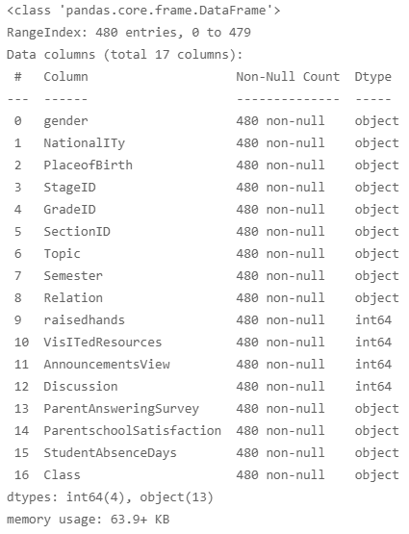

rawData.describe()

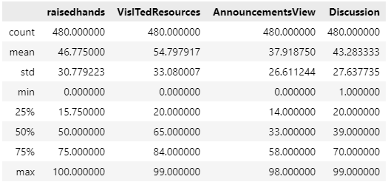

rawData.columns

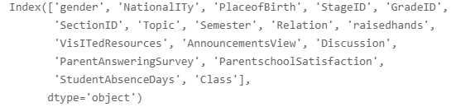

rawData['gender'].value_counts()

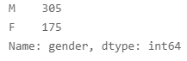

rawData.rename(columns = {'NationalITy': 'Nationality'}, inplace=True)

rawData.head()

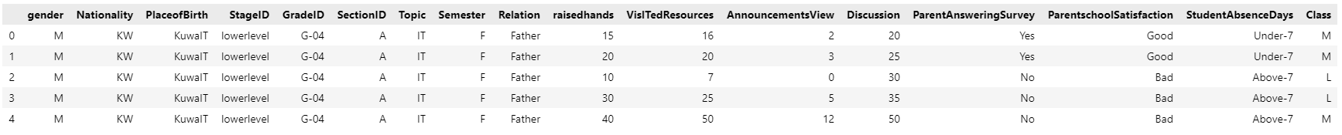

rawData['Nationality'].value_counts()

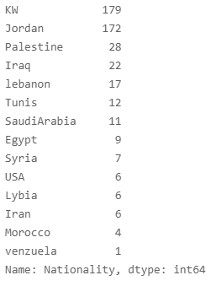

rawData['PlaceofBirth'].value_counts()

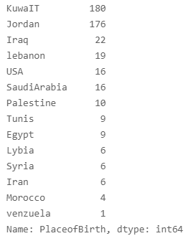

rawData['raisedhands'].unique()

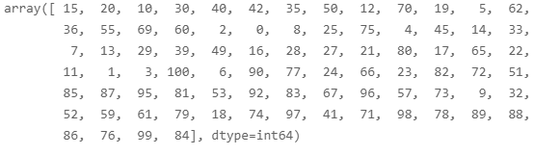

rawData['raisedhands'].value_counts()

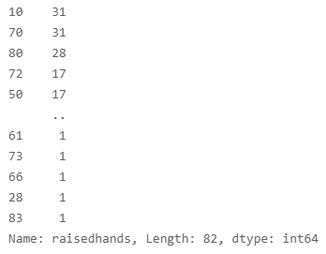

plt.figure(figsize=(20,5))

sns.countplot(data=rawData, x='raisedhands')

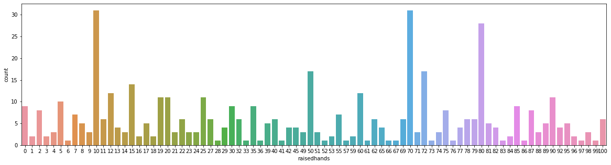

sns.histplot(data=rawData, x='raisedhands')

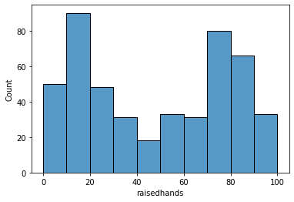

rawData.rename(columns={'VisITedResources': 'Visitedresources'}, inplace=True)

rawData.head()

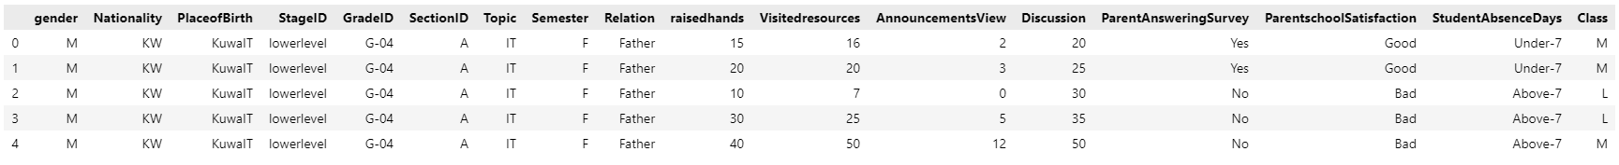

rawData['Visitedresources'].value_counts()

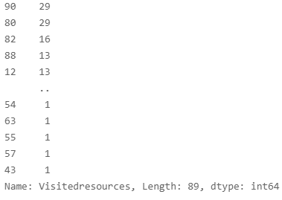

sns.histplot(data=rawData, x='Visitedresources')

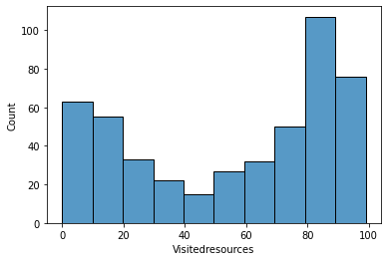

rawData.AnnouncementsView.value_counts()

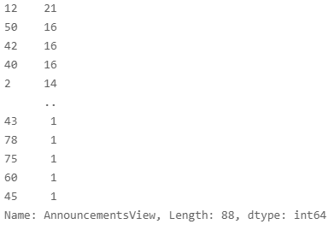

sns.displot(data=rawData, x='AnnouncementsView')

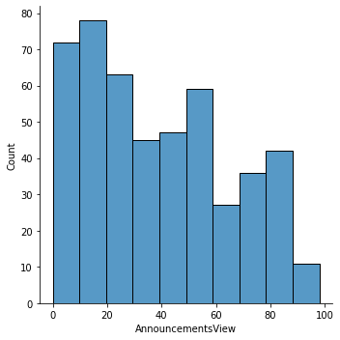

rawData.Discussion.value_counts()

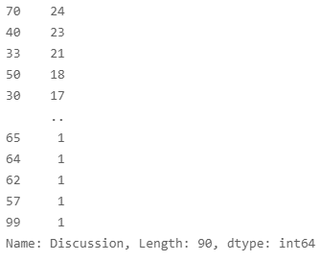

sns.displot(data=rawData, x='Discussion')

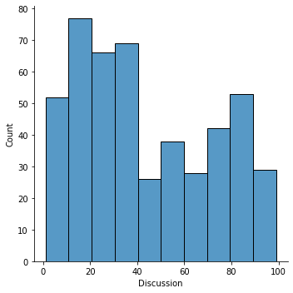

rawData['gender'].value_counts()

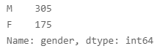

rawData['Class'].value_counts()

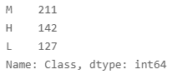

plt.figure(figsize=(10,5))

sns.countplot(data=rawData, x='gender', hue='Class', hue_order=['H', 'L', 'M'], order=['F', 'M'])

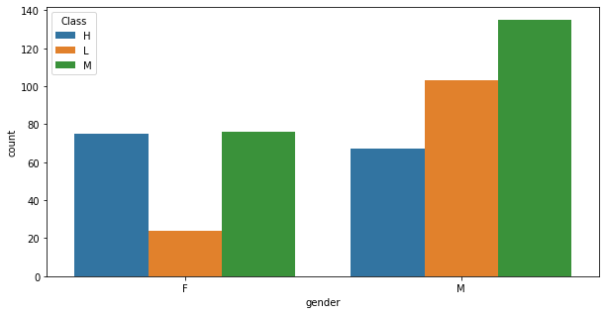

pd.crosstab(rawData['gender'],rawData['Class']).plot.bar(rot=0)

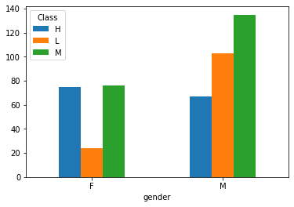

pd.crosstab(rawData['gender'],rawData['Class'], normalize='index').plot.bar(rot=0)

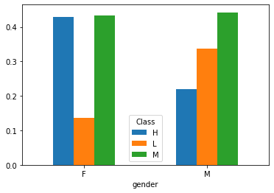

ax = pd.crosstab(rawData['gender'], rawData['Class'], normalize='index').mul(100).plot(kind='bar', rot=0)

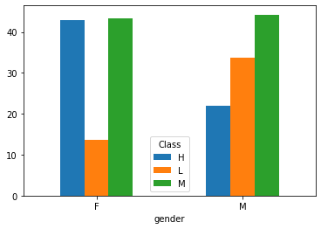

ax.patches

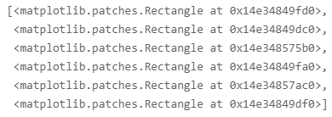

p=ax.patches[0]

p.get_bbox()



p.get_bbox().bounds



ax = pd.crosstab(rawData['gender'], rawData['Class'], normalize='index').mul(100).plot(kind='bar', rot=0, figsize=(10,4))

for p in ax.patches:

    x, y, width, height = p.get_bbox().bounds

    ax.annotate('{:.02f}%'.format(height), (x+width/2, height*1.01), ha='center')

plt.sca(ax)

plt.box(False)

plt.show()

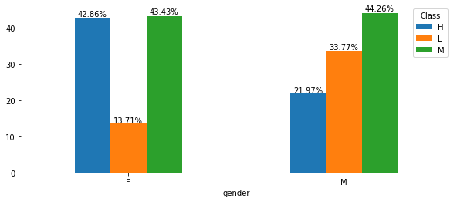

ax = pd.crosstab(rawData['gender'], rawData['Class'], normalize='index').mul(100).plot(kind='barh', rot=0, figsize=(18,4))

for p in ax.patches:

    x, y, width, height = p.get_bbox().bounds

    ax.annotate('{:.02f}%'.format(width), (width*1.01, y+height/2), va='center')

plt.sca(ax)

plt.box(False)

plt.show()

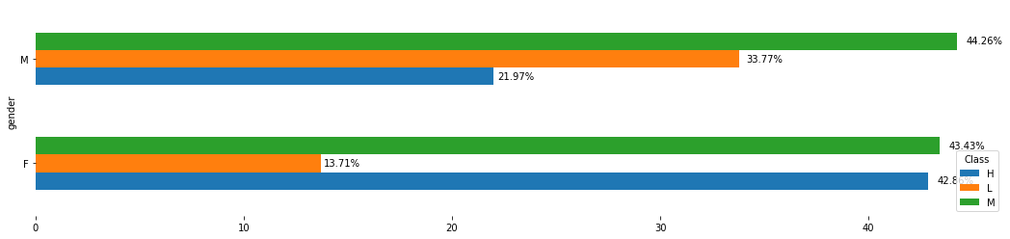

ax = pd.crosstab(rawData['gender'], rawData['Class'], normalize='index').mul(100).plot(kind='barh', rot=0, figsize=(15,4))

for p in ax.patches:

    x, y, width, height = p.get_bbox().bounds

    ax.annotate('{:.02f}%'.format(width), (x+width/2, y+height/2), ha='center', va='center')

plt.sca(ax)

plt.box(False)

plt.show()

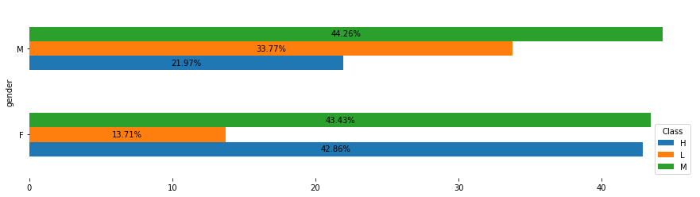

plt.figure(figsize=(20,8))

sns.countplot(data=rawData, x='Nationality', hue='Class')

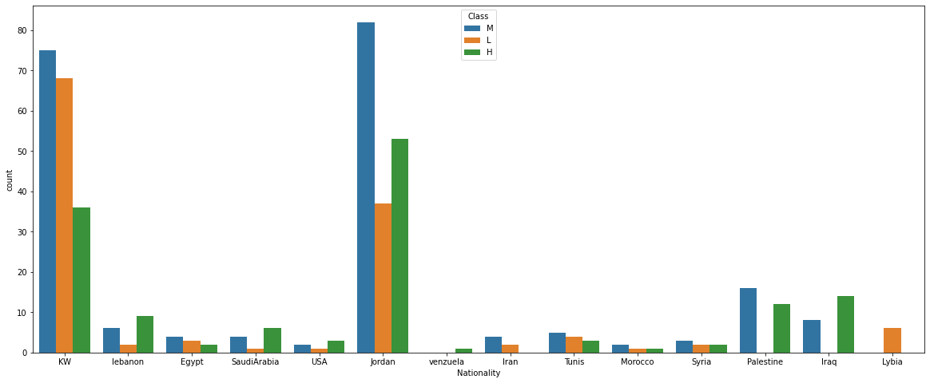

ax = pd.crosstab(rawData['Nationality'], rawData['Class'], normalize='index').mul(100).plot(kind='bar', rot=0, figsize=(15,8))

for p in ax.patches:

    x, y, width, height = p.get_bbox().bounds

    ax.annotate('{:.02f}%'.format(height), (x+width/2, height*1.05), ha='center')

plt.sca(ax)

plt.box(False)

plt.show()

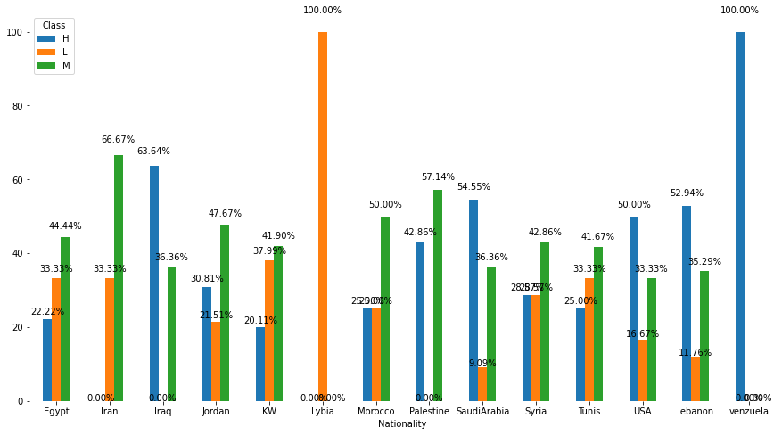

rawData['Relation'].unique()



rawData['Class']

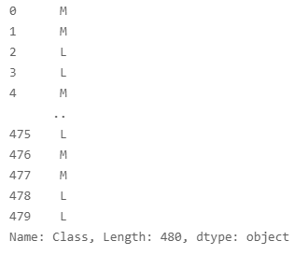

ax = pd.crosstab(rawData['Relation'], rawData['Class'], normalize='index').mul(100).plot(kind='bar', rot=0, figsize=(15,4))

for p in ax.patches:

    x, y, width, height = p.get_bbox().bounds

    ax.annotate('{:.02f}%'.format(height), (x+width/2, height*1.03), ha='center')

plt.sca(ax)

plt.box(False)

plt.show()

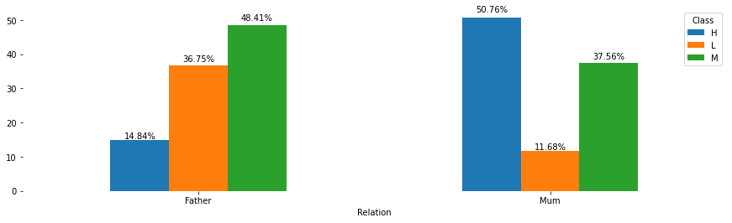

rawData['Relation'].value_counts()

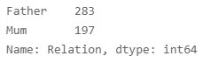

rawData['Class'].value_counts()

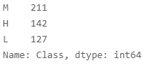

ax = pd.crosstab(rawData['Relation'], rawData['Class'], normalize='index').mul(100).plot(kind='bar', rot=0, figsize=(15,5))

for p in ax.patches:

    x, y, width, height = p.get_bbox().bounds

    ax.annotate('{:.02f}%'.format(height), (x+width/2, height*1.03), ha='center')

plt.sca(ax)

plt.box(False)

plt.show()

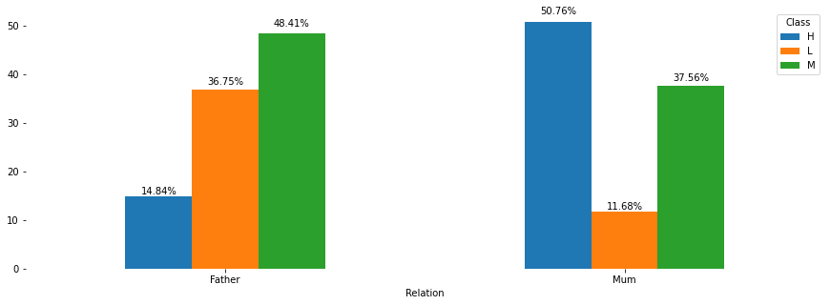

rawData['ParentAnsweringSurvey'].value_counts()

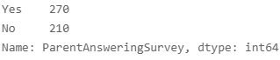

ax = pd.crosstab( rawData['ParentAnsweringSurvey'], rawData['Class'], normalize='index').mul(100).plot(kind='bar', rot=0, figsize=(15,5))

for p in ax.patches:

    x, y, width, height = p.get_bbox().bounds

    ax.annotate('{:.02f}%'.format(height), (x + width/2, height * 1.02), ha='center', )

plt.sca(ax)

plt.box(False)

plt.show()

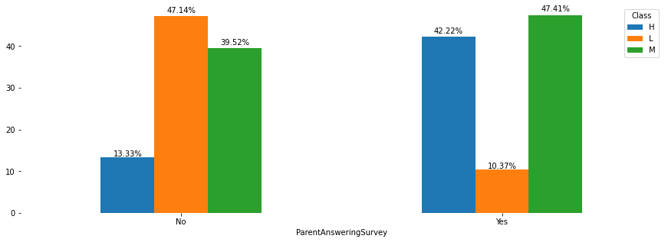

rawData['ParentschoolSatisfaction'].value_counts()

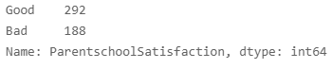

ax = pd.crosstab( rawData['ParentschoolSatisfaction'], rawData['Class'], normalize='index').mul(100).plot(kind='bar', rot=0, figsize=(15,5), )

for p in ax.patches:

    x, y, width, height = p.get_bbox().bounds

    ax.annotate('{:.02f}%'.format(height), (x + width/2, height * 1.02), ha='center', )

plt.sca(ax)

plt.box(False)

plt.show()

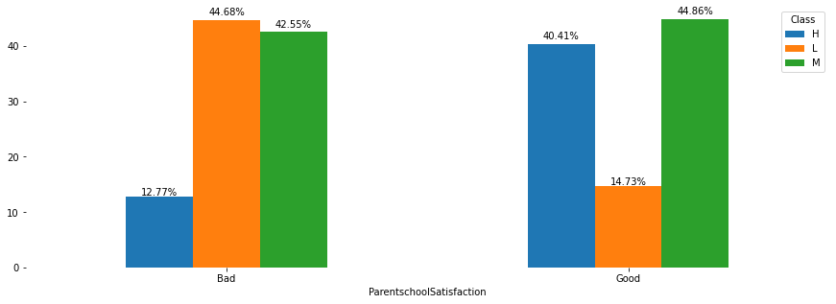

rawData['StudentAbsenceDays'].value_counts()

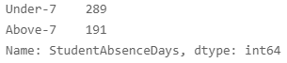

ax = pd.crosstab( rawData['StudentAbsenceDays'], rawData['Class'], normalize='index').mul(100).plot(kind='bar', rot=0, figsize=(15,5), )

for p in ax.patches:

    x, y, width, height = p.get_bbox().bounds

    ax.annotate('{:.02f}%'.format(height), (x + width/2, height * 1.02), ha='center', )

plt.sca(ax)

plt.box(False)

plt.show()

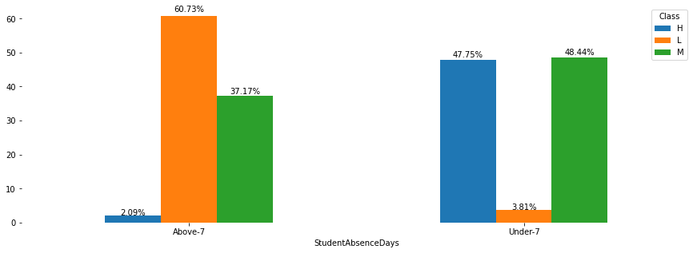

sns.histplot(data=rawData, x='raisedhands', hue='Class')

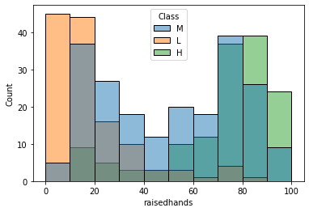

sns.histplot(data=rawData, x='raisedhands', hue='Class', multiple='fill')

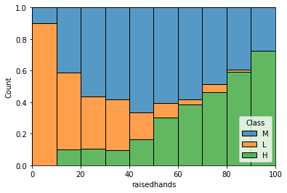

sns.histplot(data=rawData, x='AnnouncementsView', hue='Class', multiple='fill')

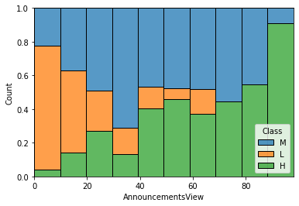

sns.histplot(data=rawData, x='Discussion', hue='Class', multiple='fill')

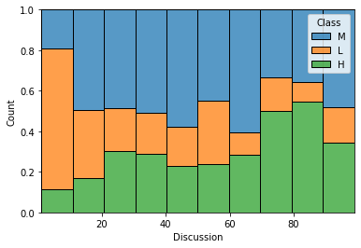

sns.jointplot(data=rawData, x='raisedhands', y='AnnouncementsView', hue='Class')

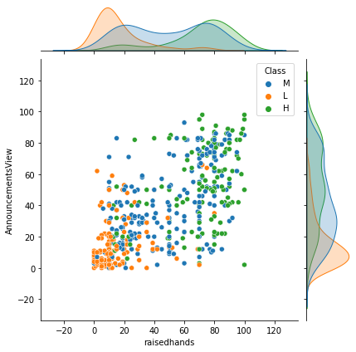

rawData['raisedhands'].value_counts()

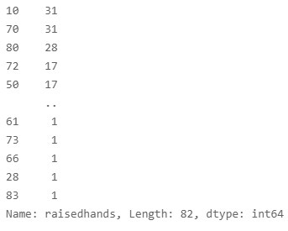

rawData['AnnouncementsView'].value_counts()

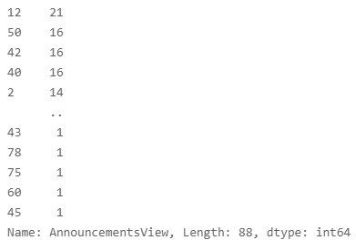

rawData['Visitedresources'].value_counts()

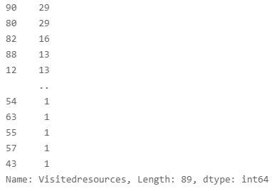

plt.figure(figsize=(20,7))

sns.scatterplot(data=rawData, x='raisedhands', y='AnnouncementsView', size='Visitedresources', hue='Class', hue_order=['L', 'M', 'H'], sizes=(30,500), palette = "Blues")

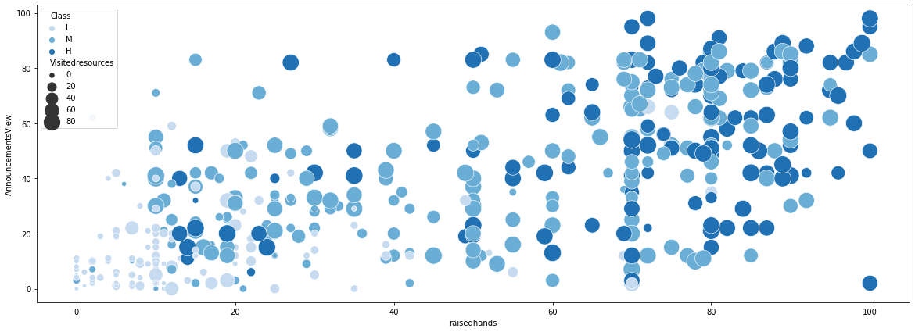

3. Simple Preprocessing

drop_columns = ['Nationality', 'PlaceofBirth', 'StageID', 'GradeID', 'SectionID', 'Topic', 'Semester']

x = rawData.drop(columns=drop_columns)

x.columns

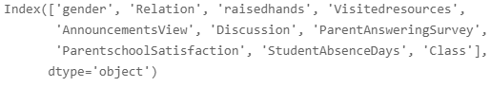

cat_columns = ['gender', 'Relation', 'ParentAnsweringSurvey', 'ParentschoolSatisfaction', 'StudentAbsenceDays']

x = pd.get_dummies(data=x, columns=cat_columns)

y = x['Class']

x = x.drop(columns='Class')

4. Modelling and Parameter Tuning Demonstrations

from sklearn.model_selection import train_test_split, StratifiedKFold, GridSearchCV

x_train, x_test, y_train, y_test = train_test_split(x, y, test_size=0.3)

4.1. Generalized Linear Model

from sklearn.linear_model import LogisticRegression

from sklearn.metrics import classification_report

folds = StratifiedKFold(n_splits=5, random_state=True, shuffle=True)

model = LogisticRegression(solver='saga', penalty='elasticnet')

params = dict(

    C=[0.00001, 0.0001, 0.001, 0.01, 0.1, 1, 10, 100, 1000, 10000],

    class_weight = ['balanced', None],

    multi_class = ['auto', 'ovr', 'multinomial'],

    max_iter = [100, 300, 500, 1000],

    l1_ratio = [0, 0.3, 0.5, 0.8, 1]

)

search = GridSearchCV(model, cv=folds, param_grid=params, scoring='roc_auc_ovr')

search.fit(x_train, y_train)

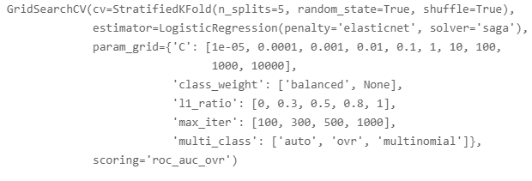

display(search.best_params_)

display(search.best_score_)

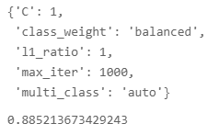

bestModel = search.best_estimator_

yhat_train = bestModel.predict(x_train)

yhat_test = bestModel.predict(x_test)

print(classification_report(y_train, yhat_train))

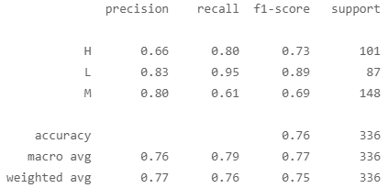

print(classification_report(y_test, yhat_test))

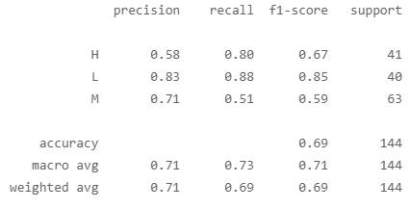

plt.figure(figsize=(15,5))

plt.xticks(rotation=80)

plt.bar(x.columns, bestModel.coef_[0])

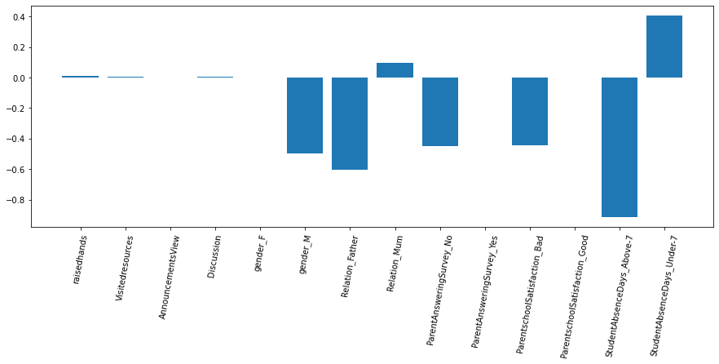

import eli5

from eli5.sklearn import PermutationImportance

eli5.show_weights(bestModel, feature_names = x.columns.tolist())

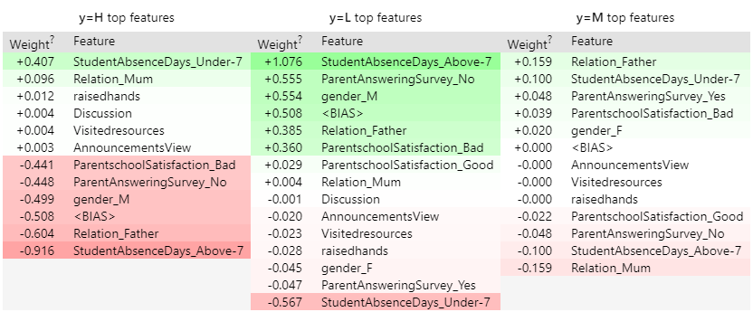

4.2. Support Vector Machine

from sklearn.svm import SVC

model = SVC(probability=True)

params = dict(

    C = [0.0001, 0.001, 0.01, 0.1, 1, 10, 100, 1000, 10000, 100000],

    gamma = [0.000001, 0.00001, 0.0001, 0.001, 0.01, 0.1, 1, 10, 100, 1000]

)

search = GridSearchCV(model, param_grid=params, cv=folds, scoring='roc_auc_ovr')

search.fit(x_train, y_train)

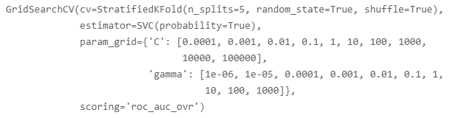

display(search.best_params_)

display(search.best_score_)



bestModel = search.best_estimator_

bestModel



yhat_train = bestModel.predict(x_train)

yhat_test = bestModel.predict(x_test)

print(classification_report(y_train, yhat_train))

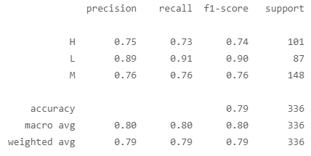

print(classification_report(y_test, yhat_test))

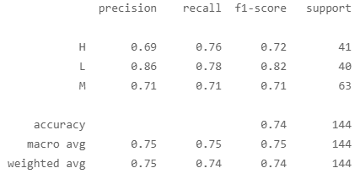

perm = PermutationImportance(bestModel, random_state=123).fit(x_train, y_train)

eli5.show_weights(perm, feature_names = x_train.columns.tolist())

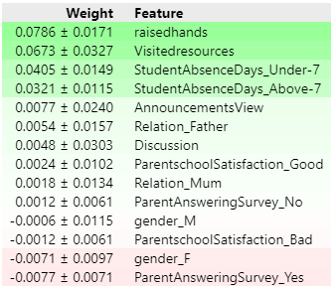

4.3. Random Forest

from sklearn.ensemble import RandomForestClassifier

from sklearn import preprocessing

encoder = preprocessing.LabelEncoder()

y_train_label_encode = encoder.fit_transform(y_train)

y_test_label_encode = encoder.fit_transform(y_test)

encoder.classes_



y_train_label_encode

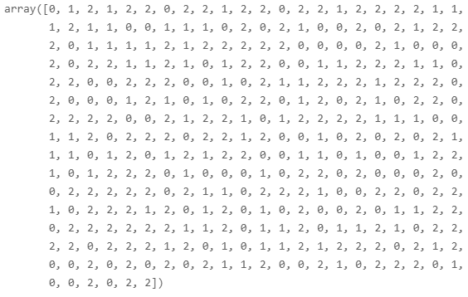

y_train

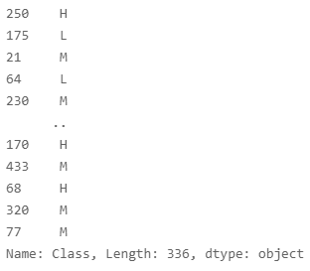

model = RandomForestClassifier()

params = dict(

    n_estimators = [100, 300],

    criterion = ['gini', 'entropy'],

    max_depth = [None, 3, 5, 7, 11, 17, 19, 21],

    min_samples_split = [2,3,5,7,9,11],

    min_samples_leaf = [1,2,3,5,7,9,11]

)

search = GridSearchCV(estimator = model, param_grid=params, cv=folds, scoring='roc_auc_ovr')

search.fit(x_train, y_train)

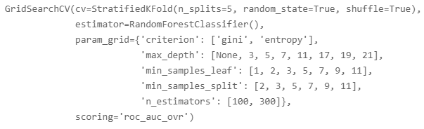

display(search.best_params_)

display(search.best_score_)

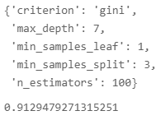

bestModel = search.best_estimator_

yhat_train = bestModel.predict(x_train)

yhat_test = bestModel.predict(x_test)

print(classification_report(y_train, yhat_train))

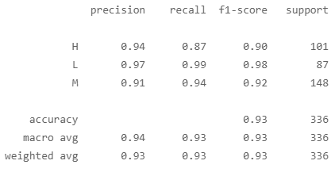

print(classification_report(y_test, yhat_test))

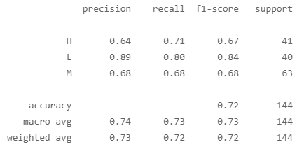

importance = bestModel.feature_importances_

indices = np.argsort(importance)

plt.figure(figsize=(12,10))

plt.barh(x_train.columns[indices], importance[indices], align='center')

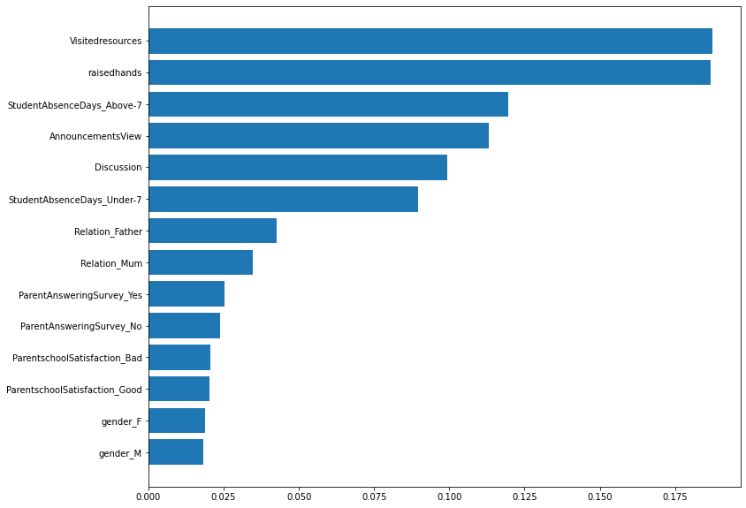

4.4. XGBoost

import xgboost as xgb

model = xgb.XGBClassifier()

params = dict(

    n_estimators = [100, 300, 500, 1000],

    max_depth = [None, 3, 5, 7, 11, 17, 19, 21],

    colsample_bytree = [0.2, 0.5, 0.7, 1],

    reg_lambda = [0.001, 0.01, 0.1, 1, 10, 100, 1000, 10000]

)

search = GridSearchCV(estimator= model, param_grid= params, cv=folds, scoring = 'roc_auc_ovr')

search.fit(x_train, y_train)

display(search.best_params_)

display(search.best_score_)

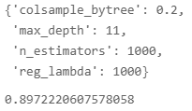

bestModel = search.best_estimator_

yhat_train = bestModel.predict(x_train)

yhat_test = bestModel.predict(x_test)

print(classification_report(y_train, yhat_train))

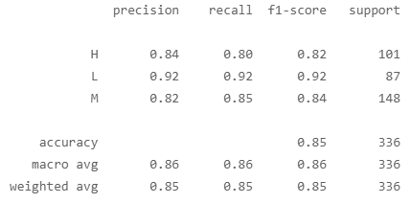

print(classification_report(y_test, yhat_test))

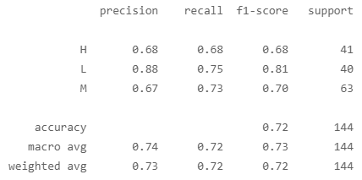

importance = bestModel.feature_importances_

indices = np.argsort(importance)

plt.figure(figsize=(12,10))

plt.barh(x_train.columns[indices], importance[indices], align='center')

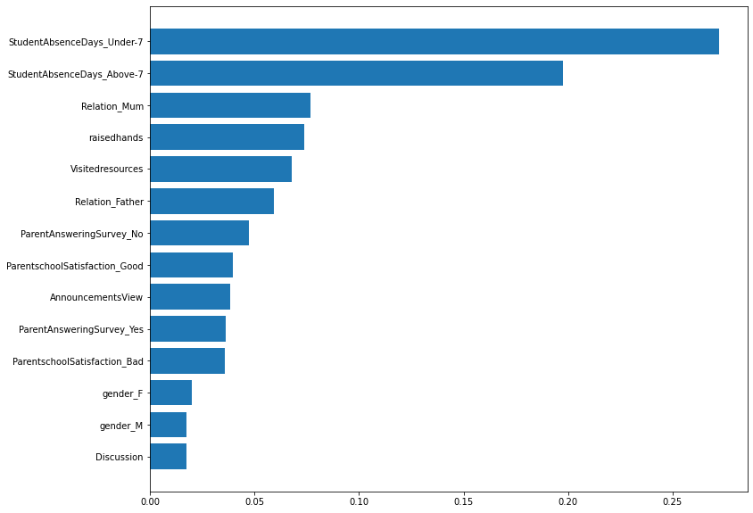

4.4. LightGBM

import lightgbm as lgb

lgbModel = lgb.LGBMClassifier()

params = {

    'n_estimators': [50, 100, 300],

    'num_leaves': [32, 64, 128],

    'colsample_bytree': [0.1, 0.5, 1],

    'min_data_in_leaf': [1,5,10]

}

search = GridSearchCV(lgbModel, param_grid=params, cv=folds, scoring='roc_auc_ovr')

search.fit(x_train, y_train)

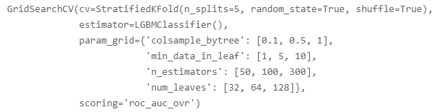

display(search.best_params_)

display(search.best_score_)

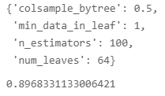

bestModel = search.best_estimator_

yhat_train = bestModel.predict(x_train)

yhat_test = bestModel.predict(x_test)

print(classification_report(y_train, yhat_train))

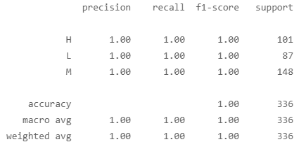

print(classification_report(y_test, yhat_test))

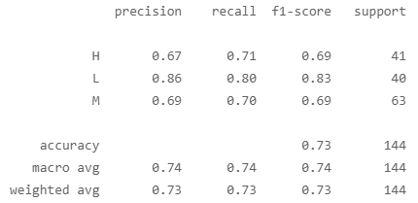

4.4. CatBoost

#In contrast to xgboost or lightgbm, catboost is less sensitive to parameter tuning.

#Generally, the internal algorithm of catboost autonomously processes the overfitting and polymorphism problems,

#which is why parameter tuning is not a must for catboost models.

import catboost as cb

from sklearn.model_selection import cross_val_score

model = cb.CatBoostClassifier()

result = cross_val_score(model, x_train, y_train, cv=folds)

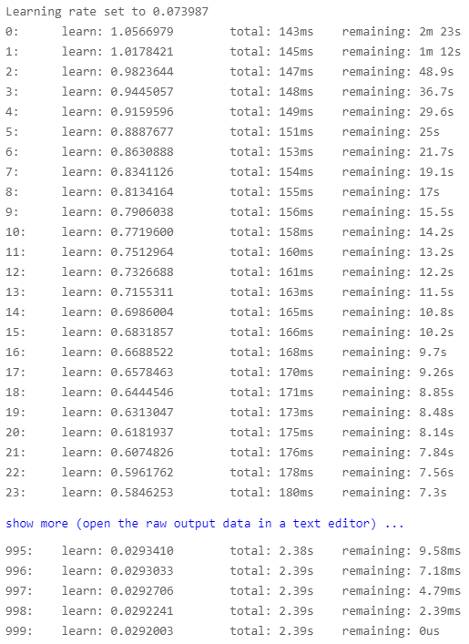

result.mean()



model = cb.CatBoostClassifier().fit(x_train, y_train)

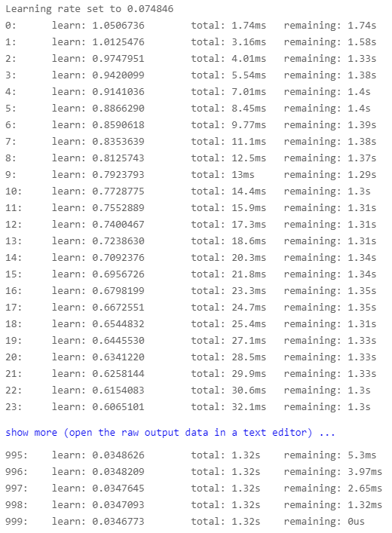

yhat_train = model.predict(x_train)

yhat_test = model.predict(x_test)

print(classification_report(y_train, yhat_train))

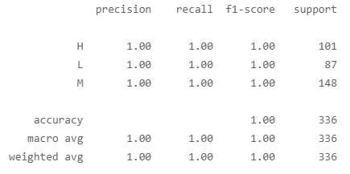

print(classification_report(y_test, yhat_test))

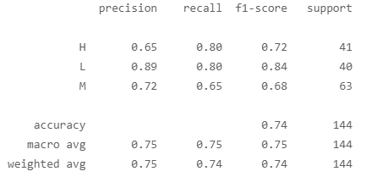

importance = model.feature_importances_

indices = np.argsort(importance)

plt.figure(figsize=(12,10))

plt.barh(x_train.columns[indices], importance[indices], align='center')

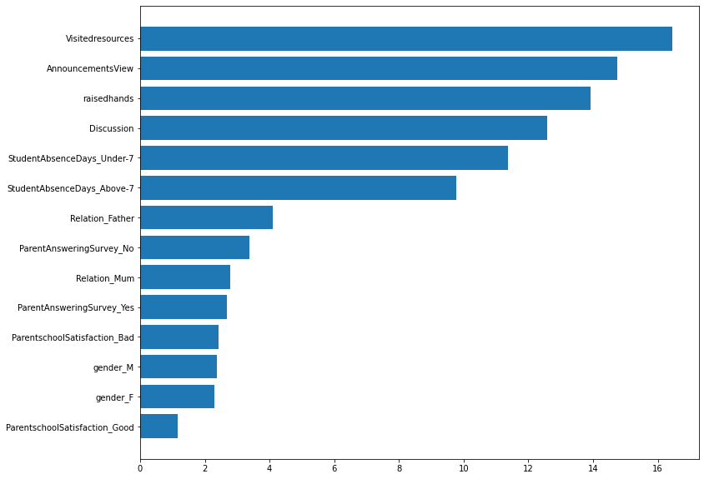

4.5. Neural Network

from sklearn.neural_network import MLPClassifier

nnModel = MLPClassifier()

params = dict(

    hidden_layer_sizes = [ (2048), (16,16,16,16), (128,16), (256,64,8) ],

    activation = ['logistic', 'tanh', 'relu'],

    alpha = [0.0001, 0.001, 0.01, 0.1, 1, 10, 100, 1000],

    learning_rate = ['constant', 'invscaling', 'adaptive'],

    max_iter = [200, 1000, 10000]

)

search = GridSearchCV(nnModel, param_grid = params, cv=folds)

search.fit(x_train, y_train)

nnModel = MLPClassifier(hidden_layer_sizes=(4096, 512, 8), activation='logistic', alpha=0.001, learning_rate='invscaling', max_iter=100000).fit(x_train, y_train)

yhat_train = nnModel.predict(x_train)

yhat_test = nnModel.predict(x_test)

print(classification_report(y_train, yhat_train))

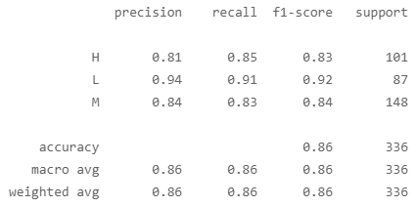

print(classification_report(y_test, yhat_test))

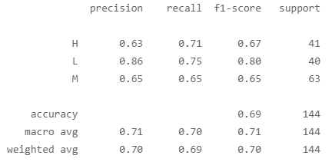

4.6. Stacking Models

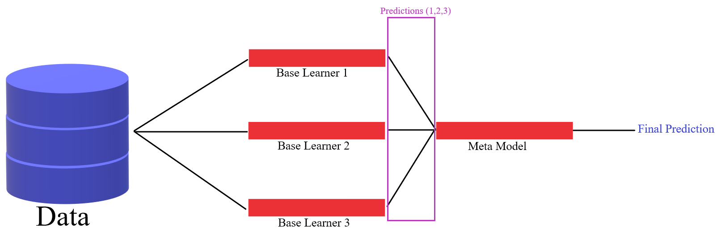

from sklearn.pipeline import make_pipeline

from sklearn.ensemble import StackingClassifier, RandomForestClassifier

from sklearn.linear_model import LogisticRegression

from sklearn.svm import SVC

from sklearn.neighbors import KNeighborsClassifier

from sklearn.tree import DecisionTreeClassifier

from sklearn.model_selection import train_test_split, StratifiedShuffleSplit

estimator = [

    ('randomForest', RandomForestClassifier(n_estimators=2000, max_features=14)),

    ('svm', make_pipeline(SVC(kernel='linear')))

]

model = StackingClassifier(estimators=estimator, final_estimator=LogisticRegression(), cv=folds)

model.fit(x_train, y_train)

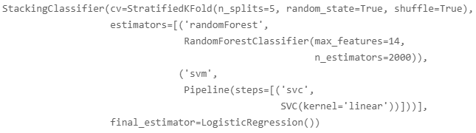

yhat_train = model.predict(x_train)

yhat_test = model.predict(x_test)

print(classification_report(y_train, yhat_train))

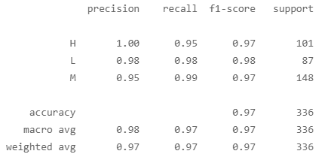

print(classification_report(y_test, yhat_test))

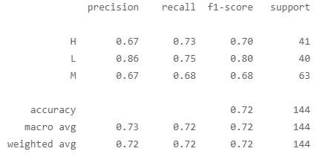

layer1 = [

  ('svm', SVC(C=1000, gamma=0.0001) ),

  ('knn', KNeighborsClassifier(n_neighbors=4) ),

  ('randomForest', RandomForestClassifier(n_estimators=2000, criterion='entropy', max_depth=None, min_samples_leaf=3,) ),

]

layer2 = [

  ('xgb', xgb.XGBClassifier(colsample_bytree=0.2, max_depth=5, n_estimators=2000, reg_lambda=100) ),

  ('lgb', lgb.LGBMClassifier(colsample_bytree=0.5, min_data_in_leaf=5, n_estimators=2000, num_leaves=32) ),

  ('cb', cb.CatBoostClassifier( verbose = 0 ) ),

]

x_train, x_test, y_train, y_test = train_test_split(x, y, train_size = 0.8 )

folds = StratifiedKFold(n_splits=10, shuffle=True)

layer2 = StackingClassifier( estimators=layer2, final_estimator=LogisticRegression(), cv=folds )

model = StackingClassifier( estimators=layer1, final_estimator=layer2, cv=folds )

model.fit( x_train, y_train )

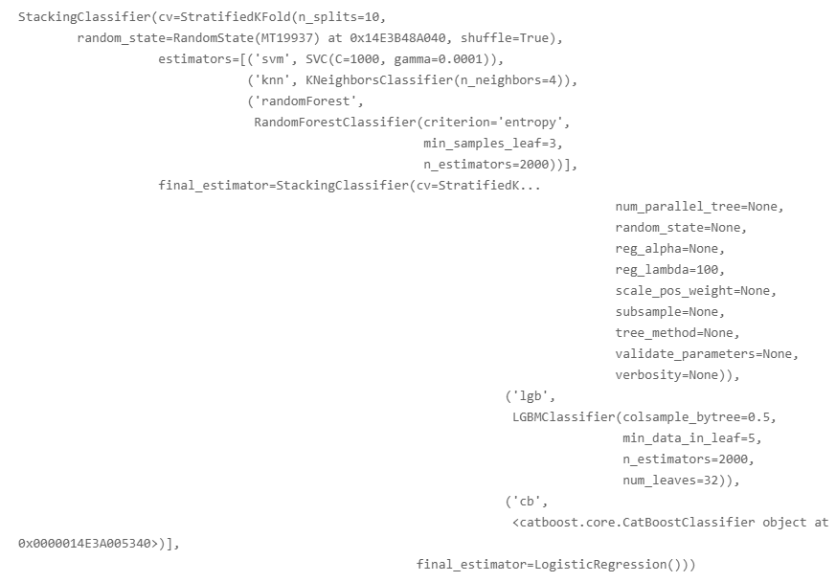

yhat_train = model.predict(x_train)

yhat_test = model.predict(x_test)

print(classification_report(y_train, yhat_train))

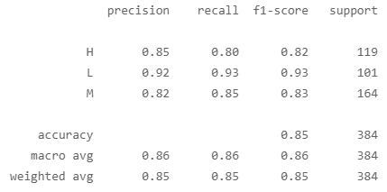

print(classification_report(y_test, yhat_test))

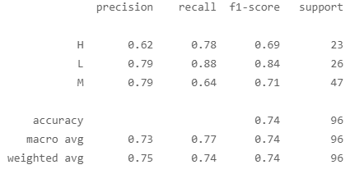

4.6. Keras

from sklearn.preprocessing import LabelEncoder

encoder = LabelEncoder()

y_label_encode = encoder.fit_transform(y)

encoder.classes_



import tensorflow as tf

y_categorical = tf.keras.utils.to_categorical(y_label_encode, 3)

y_categorical

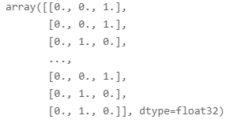

x = tf.constant(x, dtype=tf.float64)

x.shape

model = tf.keras.models.Sequential()

model.add(tf.keras.layers.Dense(8192, activation='relu', input_shape=x.shape))

model.add(tf.keras.layers.Dropout(0.5))

model.add(tf.keras.layers.Dense(1024, activation='relu'))

model.add(tf.keras.layers.Dropout(0.5))

model.add(tf.keras.layers.Dense(128, activation='relu'))

model.add(tf.keras.layers.Dense(3, activation='softmax'))

model.compile(

    loss='categorical_crossentropy',

    optimizer=tf.keras.optimizers.Adam(0.01),

    metrics=['AUC']

)

hist = model.fit(x, y_categorical, epochs=100, validation_split=0.2, batch_size=100)

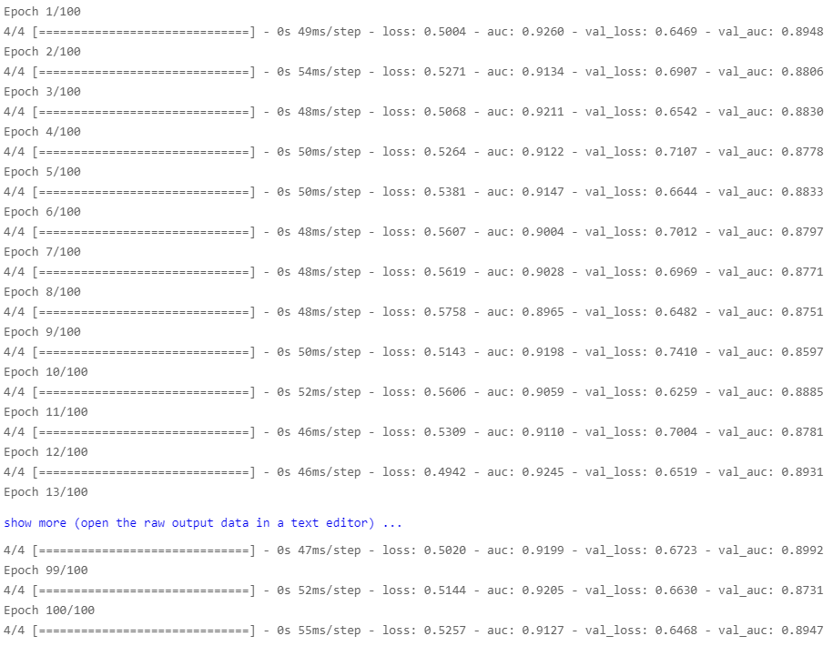

4.7. CNN

x_array = x.numpy()

x_array

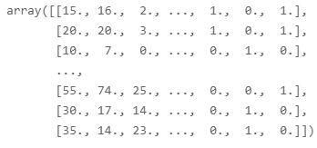

x_reshape = x_array.reshape(-1, 14, 1)

print( x_reshape.shape )

print( y_categorical.shape )



model = tf.keras.models.Sequential()

model.add( tf.keras.layers.Conv1D(64, 3, activation='relu', input_shape=(14,1)))

model.add( tf.keras.layers.MaxPool1D(3) )

model.add( tf.keras.layers.Dropout(0.5) )

model.add( tf.keras.layers.Flatten() )

model.add( tf.keras.layers.Dense(128, activation='relu') )

model.add( tf.keras.layers.Dropout(0.5) )

model.add( tf.keras.layers.Dense(3, activation='softmax') )

model.compile(

    loss='categorical_crossentropy',

    optimizer = tf.keras.optimizers.Adam(0.01),

    metrics = ['AUC']

)

hist = model.fit(x_reshape, y_categorical, epochs = 1000, validation_split=0.2, batch_size=100 )

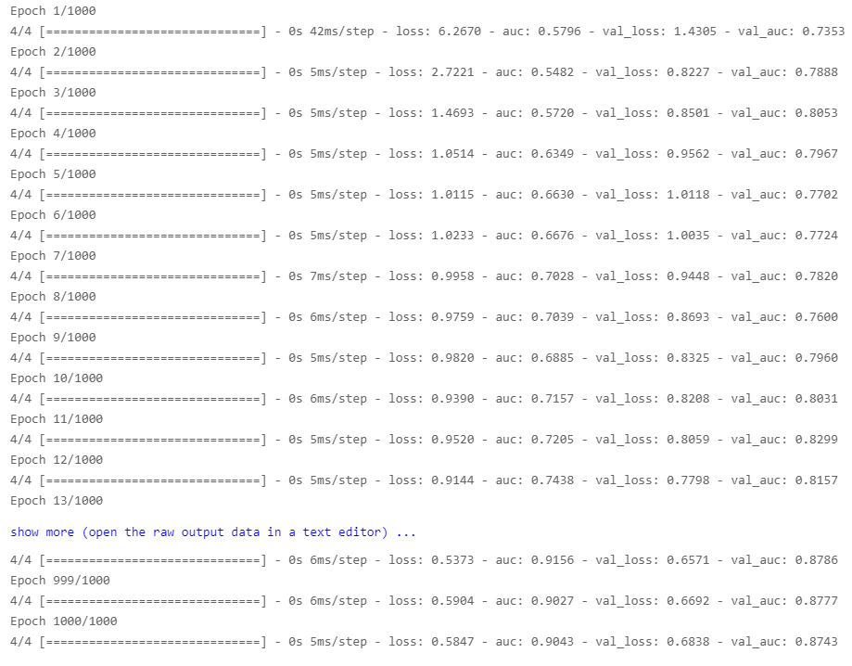

hist = model.fit(x_reshape, y_categorical, epochs = 10000, validation_split=0.2, batch_size=100 )

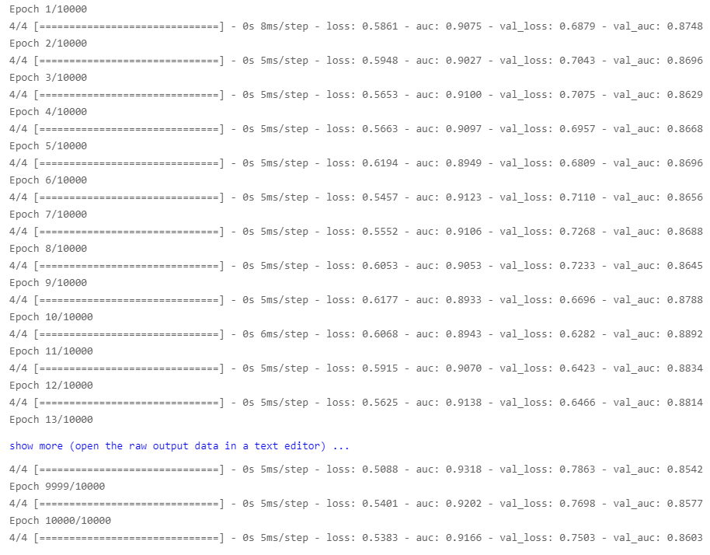

plt.plot(hist.history['loss'], label='train loss(errors)')

plt.plot(hist.history['val_loss'], label='test loss(errors)')

plt.legend()

plt.ylim(0,7)

plt.grid()

plt.show()

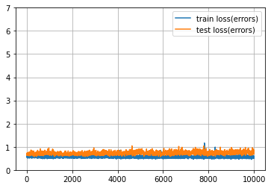

plt.plot(hist.history['loss'], label='train loss(errors)')

plt.plot(hist.history['val_loss'], label='test loss(errors)')

plt.legend()

plt.grid()

plt.show()

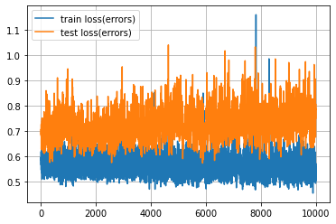

plt.plot(hist.history['auc'], label='train auc')

plt.plot(hist.history['val_auc'], label='test auc')

plt.legend()

plt.ylim(0.5, 2)

plt.grid()

plt.show()

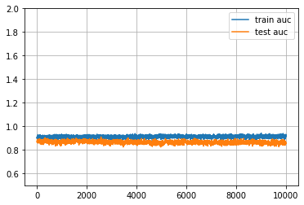

plt.plot(hist.history['auc'], label='train auc')

plt.plot(hist.history['val_auc'], label='test auc')

plt.legend()

plt.grid()

plt.show()

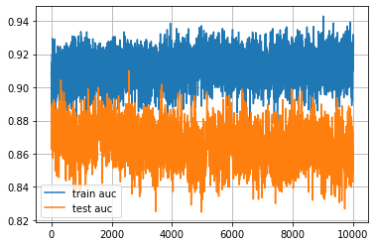

5. Appendix (interpreting Encoded Y variable vs. original Y variable: comparison)

import numpy as np

import pandas as pd

import matplotlib.pyplot as plt

import seaborn as sns

rawData = pd.read_csv('Your File Path\\xAPI-Edu-Data.csv')

drop_columns = ['NationalITy', 'PlaceofBirth', 'StageID', 'GradeID', 'SectionID', 'Topic', 'Semester', ]

x = rawData.drop(columns=drop_columns)

cat_columns = ['gender', 'Relation', 'ParentAnsweringSurvey', 'ParentschoolSatisfaction', 'StudentAbsenceDays', ]

x = pd.get_dummies(data=x, columns=cat_columns)

x

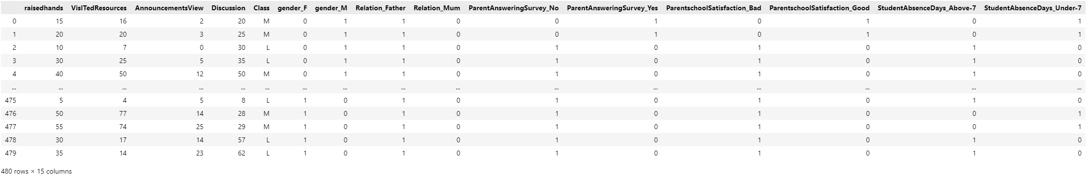

y = x['Class']

x = x.drop(columns='Class')

y

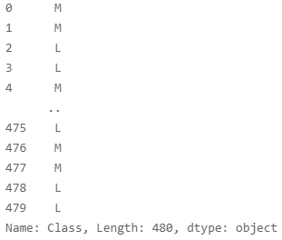

from sklearn.model_selection import train_test_split, StratifiedKFold, GridSearchCV

x_train, x_test, y_train, y_test = train_test_split(x, y, train_size=0.7)

from sklearn.linear_model import LogisticRegression

from sklearn.metrics import classification_report

folds = StratifiedKFold(n_splits=5, random_state=True, shuffle=True)

model = LogisticRegression()

model.fit(x_train, y_train)

model.predict(x_test)

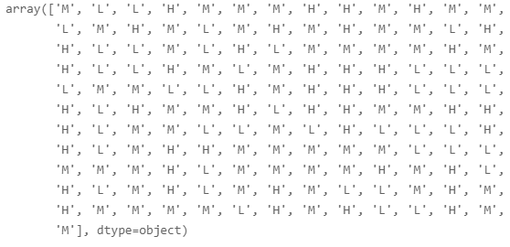

from sklearn.metrics import confusion_matrix, ConfusionMatrixDisplay

yhat_train = model.predict(x_train)

yaht_test = model.predict(x_test)

ConfusionMatrixDisplay(confusion_matrix=confusion_matrix(y_train, yhat_train),).plot()

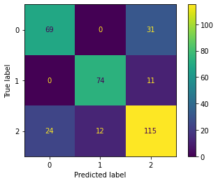

import eli5

from eli5.sklearn import PermutationImportance

eli5.show_weights(model, feature_names = x.columns.tolist())

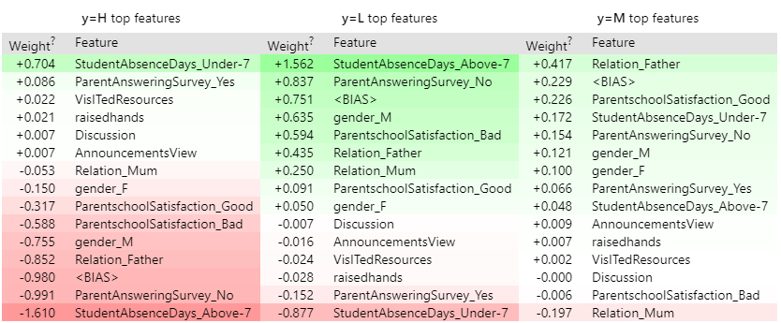

#Encoded Y variable

from sklearn import preprocessing

encoder = preprocessing.LabelEncoder()

y_train_label_encode = encoder.fit_transform(y_train)

y_test_label_encode = encoder.fit_transform(y_test)

model = LogisticRegression(max_iter=100000000).fit(x_train, y_train_label_encode)

encoder.classes_

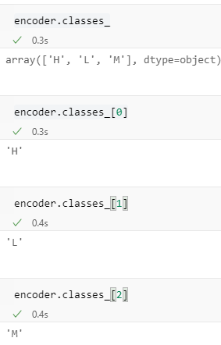

y_train

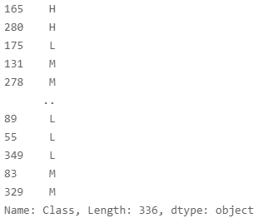

y_train_label_encode

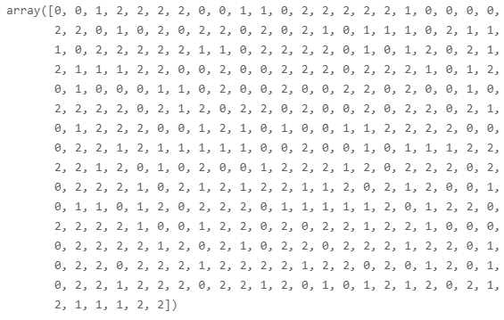

yhat_train = model.predict(x_train)

yhat_test = model.predict(x_test)

ConfusionMatrixDisplay(confusion_matrix=confusion_matrix(y_train_label_encode, yhat_train),).plot()

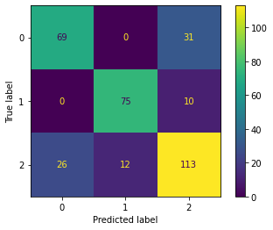

eli5.show_weights(model, feature_names = x.columns.tolist())

