Data Analysis and Machine-Learning

Chapter 6.3:

Support Vector Machine (3)

Applications Part.1: Logistic Regression



Now that we have understood the (1) mathematical and algorithmic frameworks of the SVM and (2) specific parameters, let us apply SVM for modelling with actual datasets.

In this chapter, let us start with the application of logistic regression model for review and comparison, before getting into SVC for classifications.

1. Classification of Iris Sample Data

#Import Essential Libraries

import numpy as np

import pandas as pd

from sklearn import datasets

#Load sample data

iris = datasets.load_iris()

iris.keys()

OUTPUT:

dict_keys(['data', 'target', 'frame', 'target_names', 'DESCR', 'feature_names', 'filename'])

iris['feature_names']

OUTPUT:

['sepal length (cm)', 'sepal width (cm)', 'petal length (cm)', 'petal width (cm)']

iris['target_names']

OUTPUT:

array(['setosa', 'versicolor', 'virginica'], dtype='<U10')

iris['target']

OUTPUT:

array([0, 0, 0, 0, 0, 0, 0, 0, 0, 0, 0, 0, 0, 0, 0, 0, 0, 0, 0, 0, 0, 0, 0, 0, 0, 0, 0, 0, 0, 0, 0, 0, 0, 0, 0, 0, 0, 0, 0, 0, 0, 0, 0, 0, 0, 0, 0, 0, 0, 0, 1, 1, 1, 1, 1, 1, 1, 1, 1, 1, 1, 1, 1, 1, 1, 1, 1, 1, 1, 1, 1, 1, 1, 1, 1, 1, 1, 1, 1, 1, 1, 1, 1, 1, 1, 1, 1, 1, 1, 1, 1, 1, 1, 1, 1, 1, 1, 1, 1, 1, 2, 2, 2, 2, 2, 2, 2, 2, 2, 2, 2, 2, 2, 2, 2, 2, 2, 2, 2, 2, 2, 2, 2, 2, 2, 2, 2, 2, 2, 2, 2, 2, 2, 2, 2, 2, 2, 2, 2, 2, 2, 2, 2, 2, 2, 2, 2, 2, 2, 2])

#Define features(x) and target(y)

features = pd.DataFrame(data=iris['data'], columns=iris['feature_names'])

target = pd.DataFrame(data=iris['target'], columns=['target'])

#Divide train and test data (e.g., 80:20)

from sklearn.model_selection import train_test_split

x_train, x_test, y_train, y_test = train_test_split(features, target, test_size=0.2, shuffle=True,random_state=123)

#Logistic regression

from sklearn.linear_model import LogisticRegression

logitModel = LogisticRegression(max_iter=100000).fit(x_train, y_train.values.ravel())

yhat = logitModel.predict(x_train)

#Evaluation

from sklearn.metrics import f1_score, accuracy_score, roc_auc_score, classification_report, ConfusionMatrixDisplay, \

    confusion_matrix

confusion_matrix(y_train, yhat)

OUTPUT:

array([[37, 0, 0], [ 0, 43, 1], [ 0, 1, 38]], dtype=int64)

disp = ConfusionMatrixDisplay(confusion_matrix=confusion_matrix(y_train, yhat), display_labels=iris['target_names'])

disp.plot()

OUTPUT:

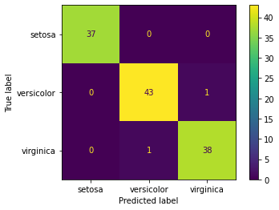

#F1-score and accuracy score

display(f1_score(y_train, yhat, average = None))

display(accuracy_score(y_train, yhat))

OUTPUT:

array([1. , 0.97727273, 0.97435897])

0.9833333333333333

f1_score(y_train, yhat, average='weighted')

OUTPUT:

0.9833333333333333

#Test Scores and Evaluation

yhat = logitModel.predict(x_test)

disp = ConfusionMatrixDisplay(confusion_matrix=confusion_matrix(y_test, yhat), display_labels=iris['target_names'])

disp.plot()

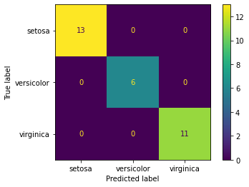

f1_score(y_test, yhat, average=None)

OUTPUT:

array([1., 1., 1.])

f1_score(y_test, yhat, average='weighted')

OUTPUT:

1.0

accuracy_score(y_test, yhat)

OUTPUT:

1.0

2. Classification of Breast Cancer Sample Data

#Import Essential Libraries

import numpy as np

import pandas as pd

from sklearn.metrics import accuracy_score, roc_auc_score, f1_score, classification_report, \

    confusion_matrix, ConfusionMatrixDisplay

from sklearn import datasets

from sklearn.linear_model import LinearRegression, LogisticRegression

from sklearn.svm import SVC, SVR

from sklearn.model_selection import train_test_split

#Load sample dataset

cancer = datasets.load_breast_cancer()

cancer.keys()

OUTPUT:

dict_keys(['data', 'target', 'frame', 'target_names', 'DESCR', 'feature_names', 'filename'])

cancer['feature_names']

OUTPUT:

array(['mean radius', 'mean texture', 'mean perimeter', 'mean area', 'mean smoothness', 'mean compactness', 'mean concavity', 'mean concave points', 'mean symmetry', 'mean fractal dimension', 'radius error', 'texture error', 'perimeter error', 'area error', 'smoothness error', 'compactness error', 'concavity error', 'concave points error', 'symmetry error', 'fractal dimension error', 'worst radius', 'worst texture', 'worst perimeter', 'worst area', 'worst smoothness', 'worst compactness', 'worst concavity', 'worst concave points', 'worst symmetry', 'worst fractal dimension'], dtype='<U23')

cancer['target_names']

OUTPUT:

array(['malignant', 'benign'], dtype='<U9')

cancer['target']

OUTPUT:

array([0, 0, 0, 0, 0, 0, 0, 0, 0, 0, 0, 0, 0, 0, 0, 0, 0, 0, 0, 1, 1, 1, 0, 0, 0, 0, 0, 0, 0, 0, 0, 0, 0, 0, 0, 0, 0, 1, 0, 0, 0, 0, 0, 0, 0, 0, 1, 0, 1, 1, 1, 1, 1, 0, 0, 1, 0, 0, 1, 1, 1, 1, 0, 1, 0, 0, 1, 1, 1, 1, 0, 1, 0, 0, 1, 0, 1, 0, 0, 1, 1, 1, 0, 0, 1, 0, 0, 0, 1, 1, 1, 0, 1, 1, 0, 0, 1, 1, 1, 0, 0, 1, 1, 1, 1, 0, 1, 1, 0, 1, 1, 1, 1, 1, 1, 1, 1, 0, 0, 0, 1, 0, 0, 1, 1, 1, 0, 0, 1, 0, 1, 0, 0, 1, 0, 0, 1, 1, 0, 1, 1, 0, 1, 1, 1, 1, 0, 1, 1, 1, 1, 1, 1, 1, 1, 1, 0, 1, 1, 1, 1, 0, 0, 1, 0, 1, 1, 0, 0, 1, 1, 0, 0, 1, 1, 1, 1, 0, 1, 1, 0, 0, 0, 1, 0, 1, 0, 1, 1, 1, 0, 1, 1, 0, 0, 1, 0, 0, 0, 0, 1, 0, 0, 0, 1, 0, 1, 0, 1, 1, 0, 1, 0, 0, 0, 0, 1, 1, 0, 0, 1, 1, 1, 0, 1, 1, 1, 1, 1, 0, 0, 1, 1, 0, 1, 1, 0, 0, 1, 0, 1, 1, 1, 1, 0, 1, 1, 1, 1, 1, 0, 1, 0, 0, 0, 0, 0, 0, 0, 0, 0, 0, 0, 0, 0, 0, 1, 1, 1, 1, 1, 1, 0, 1, 0, 1, 1, 0, 1, 1, 0, 1, 0, 0, 1, 1, 1, 1, 1, 1, 1, 1, 1, 1, 1, 1, 1, 0, 1, 1, 0, 1, 0, 1, 1, 1, 1, 1, 1, 1, 1, 1, 1, 1, 1, 1, 1, 0, 1, 1, 1, 0, 1, 0, 1, 1, 1, 1, 0, 0, 0, 1, 1, 1, 1, 0, 1, 0, 1, 0, 1, 1, 1, 0, 1, 1, 1, 1, 1, 1, 1, 0, 0, 0, 1, 1, 1, 1, 1, 1, 1, 1, 1, 1, 1, 0, 0, 1, 0, 0, 0, 1, 0, 0, 1, 1, 1, 1, 1, 0, 1, 1, 1, 1, 1, 0, 1, 1, 1, 0, 1, 1, 0, 0, 1, 1, 1, 1, 1, 1, 0, 1, 1, 1, 1, 1, 1, 1, 0, 1, 1, 1, 1, 1, 0, 1, 1, 0, 1, 1, 1, 1, 1, 1, 1, 1, 1, 1, 1, 1, 0, 1, 0, 0, 1, 0, 1, 1, 1, 1, 1, 0, 1, 1, 0, 1, 0, 1, 1, 0, 1, 0, 1, 1, 1, 1, 1, 1, 1, 1, 0, 0, 1, 1, 1, 1, 1, 1, 0, 1, 1, 1, 1, 1, 1, 1, 1, 1, 1, 0, 1, 1, 1, 1, 1, 1, 1, 0, 1, 0, 1, 1, 0, 1, 1, 1, 1, 1, 0, 0, 1, 0, 1, 0, 1, 1, 1, 1, 1, 0, 1, 1, 0, 1, 0, 1, 0, 0, 1, 1, 1, 0, 1, 1, 1, 1, 1, 1, 1, 1, 1, 1, 1, 0, 1, 0, 0, 1, 1, 1, 1, 1, 1, 1, 1, 1, 1, 1, 1, 1, 1, 1, 1, 1, 1, 1, 1, 1, 1, 1, 1, 1, 0, 0, 0, 0, 0, 0, 1])

#Define Features and Target

features = pd.DataFrame(data = cancer['data'], columns=cancer['feature_names'])

target = pd.DataFrame(data=cancer['target'], columns=['target'])

features.head()

OUTPUT:

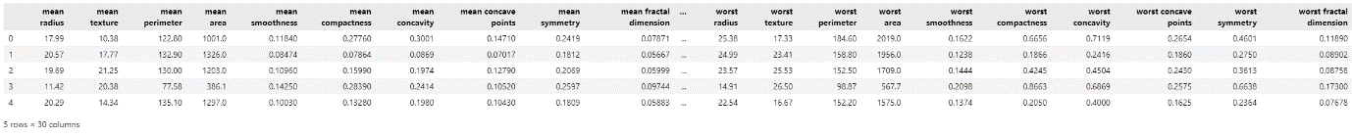

target['target'].unique()

OUTPUT:

array([0, 1])

target['target'].value_counts()

OUTPUT:

1 357

0 212

Name: target, dtype: int64

features['mean radius'].value_counts()

OUTPUT:

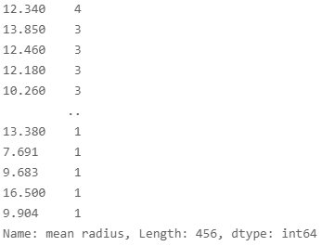

#Train-test split (80:20)

x_train, x_test, y_train, y_test = train_test_split(features, target, test_size=0.2, shuffle=True, random_state=123)

#Logistic Regression

logitModel = LogisticRegression(max_iter=100000).fit(x_train, y_train.values.ravel())

yhat = logitModel.predict(x_train)

#Evaluation

display(accuracy_score(y_train, yhat))

display(f1_score(y_train, yhat))

OUTPUT:

0.9560439560439561

0.965034965034965

#Confusion Matrix

cm = confusion_matrix(y_train, yhat)

cm

array([[159, 12],

[ 8, 276]], dtype=int64)

disp = ConfusionMatrixDisplay(cm, display_labels=cancer['target_names'])

disp.plot()

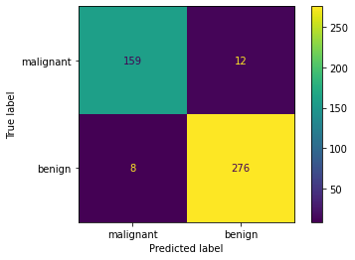

#Test Data Evaluation

yhat = logitModel.predict(x_test)

display(accuracy_score(y_test, yhat))

display(f1_score(y_test, yhat))

OUTPUT:

0.9824561403508771

0.9864864864864865

cm = confusion_matrix(y_test, yhat)

disp = ConfusionMatrixDisplay(cm)

disp.plot()

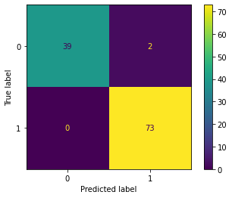

disp = ConfusionMatrixDisplay(cm, display_labels=cancer['target_names'])

disp.plot()

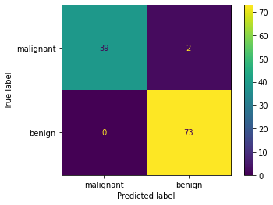

3. Classification of Spam Mail Sample Data

#Import Libraries

import numpy as np

import pandas as pd

from sklearn.model_selection import train_test_split

from sklearn.linear_model import LogisticRegression

from sklearn.metrics import f1_score, accuracy_score, roc_auc_score, confusion_matrix, ConfusionMatrixDisplay

#Import Data

spam = pd.read_csv('YOUR FILE PATH\\spam.data', sep=' ', header=None)

spam

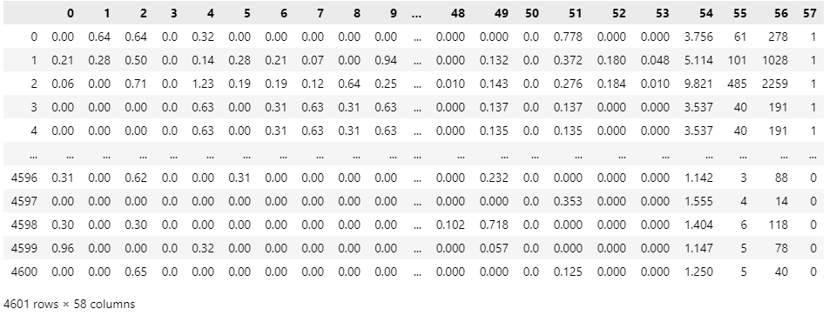

features = spam.loc[:, 0:56]

features

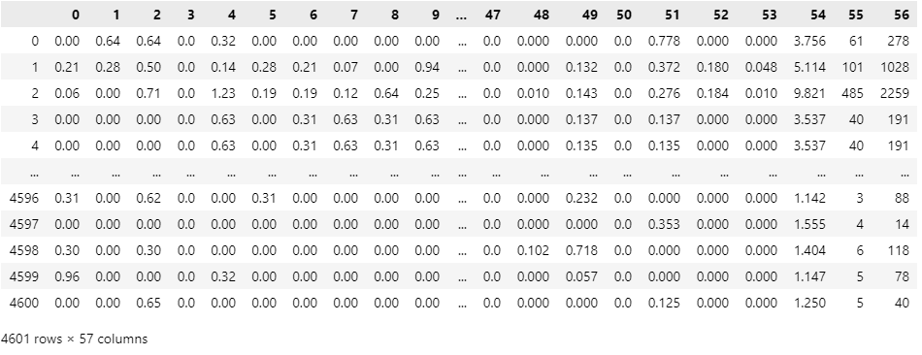

target = spam.loc[:, 57]

target

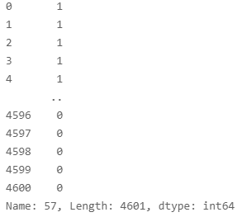

target = spam[57]

target

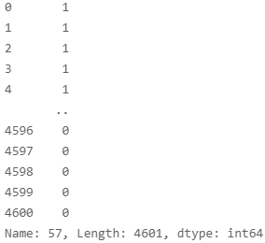

#Train test split (80:20)

x_train, x_test, y_train, y_test = train_test_split(features, target, test_size=0.2, shuffle=True, random_state=123)

#Logistic Regression

logitModel = LogisticRegression(max_iter=10000).fit(x_train, y_train)

yhat = logitModel.predict(x_train)

#Evaluation

display(accuracy_score(y_train, yhat))

display(f1_score(y_train, yhat))

display(roc_auc_score(y_train, yhat))

OUTPUT:

0.9277173913043478

0.906993006993007

0.9214348044326036

cm = confusion_matrix(y_train, yhat)

disp = ConfusionMatrixDisplay(cm)

disp.plot()

OUTPUT:

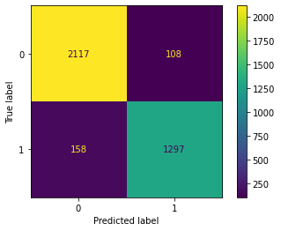

#Test Evaluation

yhat = logitModel.predict(x_test)

display(accuracy_score(y_test, yhat))

display(f1_score(y_test, yhat))

display(roc_auc_score(y_test, yhat))

OUTPUT:

0.9370249728555917

0.9185393258426967

0.9327252250017365

cm = confusion_matrix(y_test, yhat)

disp = ConfusionMatrixDisplay(cm)

disp.plot()

