Stanford Guided Tour
Using Garmin GPS 35-PC

AA272C
3/16/09
Mike Ackermann
Tom Chouinard
Dave Stauffer

Table of Contents

1 Introduction 3
2 Experimental Setup 4
3 Software Functionality 5
4 Results 6
5 Challenges 9
6 Conclusions 10
7 References 11

List of Figures

Figure 1. Experimental Setup 4
Figure 2. MATLAB GUI Demonstrating User Navigation 7
Figure 3. Position from a Reference Location in ENU Coordinates 9

List of Tables

Table 1. Immobile Position Accuracy Study 8

Introduction
Global Positioning Systems (GPS) are in wide use today both commercially and for military purposes. There are over 400 million civilian users of GPS in applications from automobile navigation to cellular phone positioning1. Yet, many users have no idea how the GPS “black box” works. The goal of the AA272C group project was to familiarize students with how GPS satellites and receivers work, and how to get useful information from real GPS measurements. The particular group project described in this paper is The Stanford Guided Tour.
The Stanford Guided Tour was a test of the feasibility to use GPS to guide prospective students, and others, on a tour of Stanford University. Specifically, the Garmin GPS 35-PC receiver measurements were loaded in real time into a software package to calculate user position, and guide users to a desired point of interest (POI). This process was conveniently wrapped into a user friendly Matlab driven Graphical User Interface (GUI).
Almost all universities have guided tours of some sort, but they are typically led by a tour guide of the human form. The idea of using an electronic tour guide, facilitated by the power of GPS, allows the user to roam a university’s campus in a fashion they desire. No longer are tours bound by schedules and popular tourist locations. An independent user with their own Garmin receiver can explore a multitude of stored landmarks, in any order they desire, and at any time they desire. The nagging questions of strangers tagging along on a human guided tour are eliminated, and the university tour is transformed into a personal experience, whose guests are controlled by the user.
For marketing purposes, all universities provide guided tours to expose prospective students to faculty, the student body, and the general campus atmosphere. These tours tend to be free and typically include a current student as the walking guide leading a small group of these prospective students throughout various parts of campus on prescribed routes to the sound of canned anecdotes. This type of tour is standard practice and has been in effect for quite some time.
Common in museums and places of historic intrigue, which can also include university campuses, some modern tours have handheld electronic devices that play audio about specific points of interest, but are dependent on user input. A patron is responsible for identifying his or her location and instructing the handheld device to lecture about a specific point of interest. More basic tours will include a button on a wall that plays information about the nearby display. In such tours, which are often dedicated to the indoors, the user is again at the mercy of a standard route and is armed with a very little amount of situational awareness.
Other modern tours are based on radio frequency (RF). Audio narratives are based on the physical proximity of the RF device user to points of interest. These tours allow the user some freedom to choose a route, but the user will not have any awareness of the local geography.
There have even been recent developments in GPS-guided tours, in which a tour is often conducted by a car-mounted GPS device2. Generally, these tours provide the user awareness of the local geography, often a city district, with some maps and directions, but typically do not allow the user freedom to choose the tour route.
These common tour options tend to be biased toward story-telling with very limited story-showing aspects. For both the university and prospective student, it would be beneficial to show more and tell less, while providing a tour experience that can be adaptable to the interests and speed of the user. Such a tour can be flexibly guided in allowing the user to deviate from a recommended route and still maintain its marketing utility. With a basic GPS receiver and computer, the technology of a handheld GPS tour guide can be demonstrated as an improvement to existing methods of guided tours.

Experimental Setup
The Garmin GPS 35-PC is a rather old receiver, yet perfectly capable of meeting the demands set by a guided tour, with a few technology upgrades. The GPS receiver output is through a serial port, which was converted to a USB port, for use with a current laptop computer. Because much of Stanford University is not accessible by automobile, it was necessary to convert the power source of the receiver to a 9V battery that could easily be carried by the user on foot. The last upgrade was to ensure compatibility with Windows Vista, which was a bit of an issue, but after some COM port adjustments communication with the receiver was established.
In order to ensure optimal signal reception while in a maze a buildings, the receiver was held overhead to increase the amount of sky in view. The final experimental set up consisted of a user holding a laptop connected to the GPS receiver, which was mounted atop a baseball bat held by a guest along for the tour. This can be seen in the picture below:

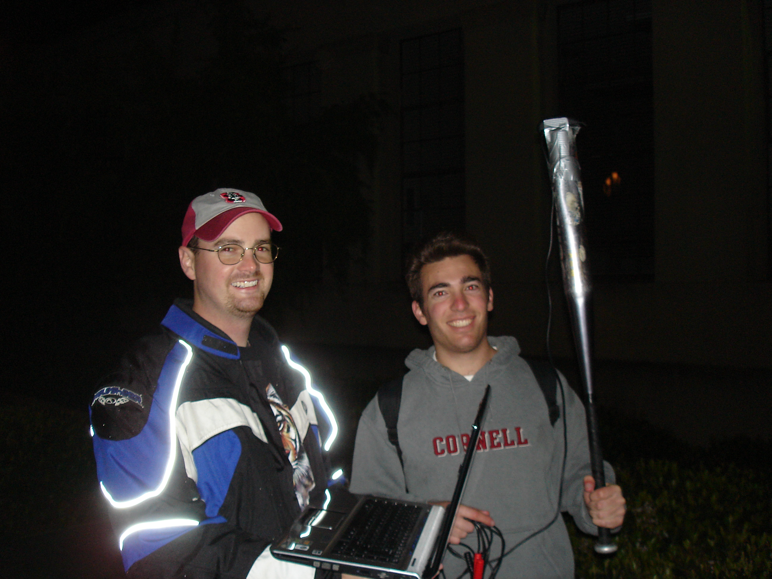
Figure 1. Experimental Setup

Software Functionality
Guiding a user to a desired location using GPS is not a trivial problem. The software package employed to perform this task at Stanford University was wrapped in an attractive GUI, but behind the interface was a considerable amount of logic.
The first feat the software completed was to find the desired data from the receiver in real time. The receiver constantly updated two data files, the receiver data file, and the ephemeris data file. The ephemeris file was only updated when new data was received for a new satellite, or a long enough time had passed since the last data was received. The receiver file was more dynamic and was updated every second with the pseudoranges and other necessary information of all the satellites currently in view. The software package read these two files as they were being written in real time, and then decided which parts of the files to use in the next position and guidance solution. It is obvious that the most recent receiver data entry was to be used, as that would be the most current data, but the software also needed to find the correct ephemeris data for each of those satellites, and only those satellites. In some cases ephemeris data was available for satellites not in view, and in other cases a satellite in view did not have any ephemeris data. Cases like these, and others, were all handled by the real time reading portion of the software package.
Once the required data had been found the next step was to calculate the user’s current position. The first piece of logic to do this determines where exactly each satellite was in its orbit. One must start with an initial guess of the user’s position and then iterate the satellite position down to a set tolerance. This was done by varying the transmission time of the signal until the time and place that each satellite sent its respective data aligned with the range to the user divided the speed of light. An important step here was to account for the rotation of the earth during the transmit time. With the position of the satellites known, the next step was to determine the user’s estimated position. This was also an iterative method that employed the least squares solution of all the satellite pseudoranges, corrected by both satellite and receiver clock biases3. In this specific software package, convergence was reached when the solution was within 10 centimeters of the previous iteration. When converged, the user’s position was known for that 1 Hz epoch and a guidance algorithm could be utilized. After this, the whole process was repeated for the next epoch. It is important to note that the positions of the satellites and user were stored for post processing.
With the user’s position known, a guidance algorithm was used to calculate the heading needed to arrive at the next closest point of interest. The guidance software was developed to compare the user’s direction of travel to prescribed points of interest. In guiding the user to the first or next undiscovered point of interest, the software provided visual forward, backward, left and right directions that update as the user traveled along a deliberate path.
First, the position history of the user was stored as a continuously updating data set. The software calculated the distance from the user to each of the points of interest and then compared the distances to the set that the user had already been to. The software read the position history in reverse and calculated an average East-North heading vector based on a minimum threshold distance traveled of fifteen meters. That is, the position history was read back in time, until the user was fifteen meters away from their current position. Then, the average heading between all of the positions in the last fifteen meters and the current position was used as the heading for the next guidance solution. An East-North bearing was also calculated as the relative vector of the user’s position to the position of the next closest undiscovered point of interest. The angle between the heading and bearing vectors was calculated and transformed to a range of eight discrete directions: forward, slight left, left, sharp left, backward, sharp right, right, and slight right. These directions updated as the heading and bearing vectors updated and provided guidance to the closest undiscovered point of interest, regardless of the user’s route.
Independent of guidance, the software’s foremost priority was disseminating information based on the user’s position. When the user traveled within a threshold distance to each point of interest, an audio and visual presentation was triggered. The customizable audio and visual presentation provided the user with an appropriate set of information about the current point of interest. After its completion, the guidance software was switched to the next closest undiscovered point of interest and the process repeated until all points of interest were reached or until the software was disabled by the user.
Making this whole process much easier for the user to understand was the job of the GUI. The GUI was also implemented within MATLAB using the built-in GUIDE program. This program was used to create a .fig file that established the overall layout of the GUI. This layout included which axes showed up where, and which buttons called which function callbacks. The supporting .m function contained the code run during those callbacks.
Upon opening the GUI, the initial plots were displayed, and a welcome audio message was played. Then, when the user pressed the START button, the GUI called the GPS main loop sub-function. The GUI remained in an infinite ‘while’ loop unless the user pressed the PAUSE button, to temporarily pause, the RESET button to reinitialize all the values, or closed the GUI to quit entirely. Once in the main loop, the GUI called the calculations described in the earlier paragraphs. The updated distance and bearing information, user position on the map, and the number of satellites in view was then updated on the GUI. If the user was within the threshold of a previously unvisited landmark, then the audio and picture files for that landmark were displayed.

Results
The result of all of this work was an electronic tour guide of Stanford University. The output to the screen as seen by the user is shown in Figure 2.

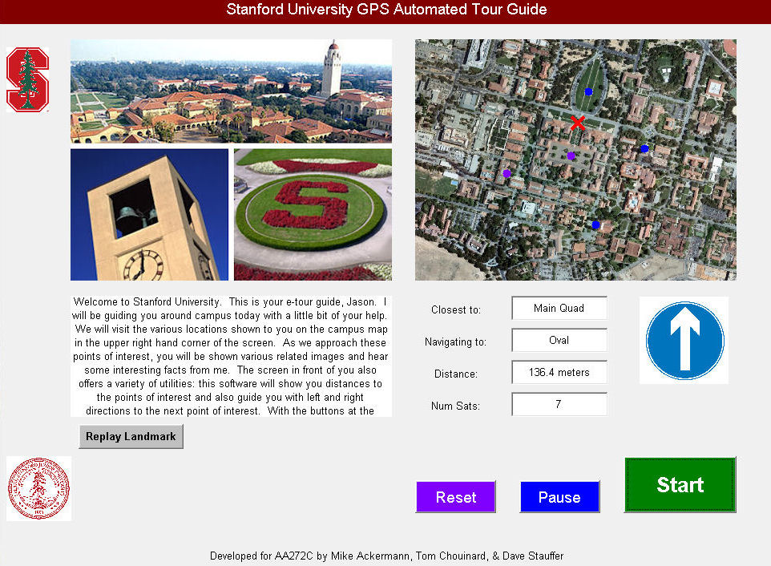
Figure 2. MATLAB GUI Demonstrating User Navigation

The GUI turned out very well. The inherent sub-function aspect of the GUI is conducive to spiral development. At first, there were just the photos on the left, and the map with the blinking user position on the right. All the extra information about navigating was displayed directly to the command window. This allowed debugging and testing to begin right away. Moreover, the technical GPS position determination, and real-time bearing calculations were troubleshot early, and then the GUI was updated and polished towards the end of the development. However, once the final version was in place, it was easy to navigate and tell that the code was working with nothing besides the information displayed directly on the GUI.
The guidance software was coupled with the on-screen map to provide the user with as much assistance as possible. The map provided geographical context that allowed the user to gauge relative distances to choose and alter routes at his or her discretion. Concurrently, the on-screen left-right directions provided the software’s suggestions based on the user’s path.
The best results were obtained when the user chose a sensible, deliberate route and obeyed the provided directions. When this happened, the software successfully guided the user around campus to the points of interest with few questionable directions. The guidance software worked best out in the open, such as near the Oval, where the received signal was ideal and local obstructions were minimal. While still effective, the guidance was somewhat limited near locations with poor signal quality due to significant obstruction, such as near Hoover Tower. The software was also limited by the combination of the coordinates of the points of interest and the proximity threshold distance that would trigger the software to provide point of interest information. For example, while it was easy to enter within the threshold distance of Durand Building, the Oval, and the Main Quad, it was physically difficult to come close enough to the coordinates of Hoover Tower and the Stanford Bookstore. This challenge could be addressed by increasing the threshold distance to the points of interest, or by choosing more accessible coordinates of points of interest.
The guidance software successfully transitioned to guide the user to the next point of interest immediately after disseminating information about the last discovered point of interest. The software was also successful in not repeating guidance to points of interest already discovered.
Being that a guided user is inherently mobile; an immobile test was also performed so that the data from that test could be analyzed in a position accuracy study. From standing still for about fifteen minutes the data in Table 1 was obtained.

Table 1. Immobile Position Accuracy Study
Measurement | Value
EDOP | 0.65
NDOP | 0.90
VDOP | 2.17
TDOP | 1.28
GDOP | 2.77
Mean Num. Sats. | 7.57
σ_{E} | 3.63 m
σ_{N} | 4.17 m
σ_{U} | 14.72 m

Over the same fifteen minute period, while standing still, the following is a plot of the position solution in an ENU coordinate system. Notice that the position has its largest variance in the up direction, and about the same, smaller value, in the east and north directions. This is because most of the satellites in view were overhead, so that lateral directions were easily resolvable from the satellite measurements, but directly up and down was not easily resolvable.
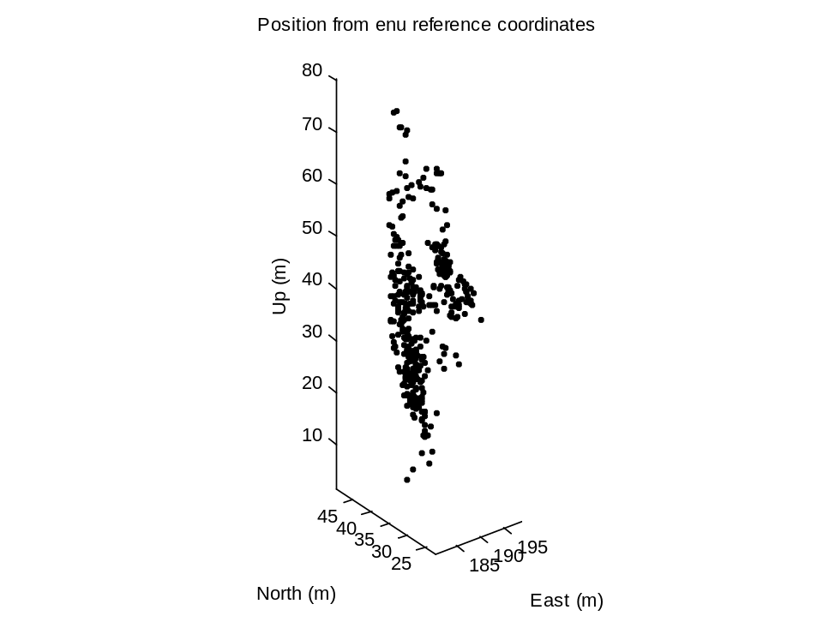
Figure 3. Position from a Reference Location in ENU Coordinates

Although there was a significant standard deviation in the up direction, this was not as great of an issue for this particular application as it may seem. The guidance of the user depended only on the east and north position solutions to determine a left or right heading. Therefore, it was really the standard deviation in east and north measurements that mattered. The ~4m value of east and north standard deviations was an acceptable variance in this case, as buildings are many tens of meters long, and the guidance is only intended to get the user to the front of the building.

Challenges
In its earlier versions, the software had difficulty with real time processing of the receiver and ephemeris data streams. Specific problems included handling receiver data with fewer than four visible satellites, accepting updated ephemeris data and working with receiver and ephemeris data from a different number of satellites. The software was corrected and successfully addressed these issues with smarter cross-checking logic and the ability to wait for a sufficient amount of satellite data.
Based on the proximity threshold and the geometry of the points of interest, position accuracy was not a significant problem. This affected the guidance software more than the audio playback near the points of interest. In early versions, the guidance software initially provided erratic directions because position accuracy could cause extreme changes of the user’s heading vector at each epoch. By averaging previous positions over a minimum distance traveled, the software was able to provide smoother directions based on a more reliable user heading.
Multipath was not specifically investigated, but was minimized within reason. Because of the dynamic environment of a campus tour, a typical user will have received data that suffers from unavoidable multipath effects, which did result in a few position jumps. Also, the software had little ability to mitigate the effects of the ionosphere due to the receiver configuration, and a troposphere model was not employed due to its smaller effect.

Conclusions
After many tests and software upgrades, the performance of the receiver and software package proved that it was indeed possible to navigate a university campus using nothing but GPS. A user employing the experimental setup as described in this paper was able to successfully navigate to five different Stanford University landmarks. There are numerous areas for improvement, but even this rudimentary software package, and older model receiver were able to perform the desired task. One such area of improvement would be to use real time differential GPS. Having a second receiver constantly broadcast a position correction would be very useful in mitigating errors from the ionosphere, troposphere and satellite clock bias. This would further improve position accuracy and make finding guidance headings a much easier process. Also the ability to use dual frequencies would allow the elimination of ionosphere errors completely.
As stated earlier, the GUI was easy to implement in a spiral development fashion, where new functionality is added piece by piece. One downside to this is that it is hard to say when to stop. The current stopping point was basically determined by the end of the class, rather than by running out of ideas. The GUI is perfectly adequate as is, but some potential upgrades are listed below.
- Plot a track history of where the user has been
- Allow at least 3 different zoom levels on the map
- Visually display when the user is off the map
- Include a built in Help button
- Included Spanish or other language options in the text and audio files

The GUI was initially developed at a separate location, and was designed such that the map and landmarks could be easily swapped and replaced. This modular approach allows the program to be easily ported to other school campuses, national parks, or other similar outdoor attractions worldwide.
This project showed the proof of concept for GPS based tours, but most people will not want to walk around campus with a heavy laptop and a large, power hungry GPS receiver. The ideal platform would be a cell phone with downloadable applications. These smart phones currently have GPS, a display screen, and audio capabilities, so all the necessary hardware exists and is readily available. The cell phone application would then play the audio files and display its own version of the MATLAB GUI.

References

1. AA272C Course Notes, Enge, Per & Segall, Paul 2009.
2. Travel by GPS, http://www.travelbygps.com/TourGuide.php, Turner Endeavors, 4 March 2009.
3. Global Positioning Systems 2nd Edition, Misra, Pratap & Enge, Per. 2001.

