

**2024年《机器学习》线上学习**

**测验习题+编程作业**

**（个人版）**



**课 程：** 机器学习

**姓 名：** 朱屹昊

**学 号：** 2022217579

**完成时间：** 5.2

|  |  |  |  |
| --- | --- | --- | --- |
| **“机器学习-Coursera测验习题”评分细则** | | | |
| **成绩等级** | **具体表现** | **教师评分** | |
| 优秀（100-90] | 能够在规定时间内完成Coursera测验作业；内容充实详尽；过程分析详细清楚；心得体会充分； | □ |  |
| 良好（90-80] | 能够在规定时间内完成编程作业；内容较充实；较好完成数据分析过程和算法介绍；心得体会良好； | □ |  |
| 中等（80-70] | 能够在规定时间内完成编程作业；2）有简单的数据分析、算法介绍和心得体会； | □ |  |
| 及格（70-60] | 能够在规定时间内完成编程作业；达到最低的内容量。 | □ |  |
| 不及格（<60） | 未完成； | □ |  |

|  |  |  |  |
| --- | --- | --- | --- |
| **“机器学习-编程作业”评分细则** | | | |
| **成绩等级** | **具体表现** | **教师评分** | |
| 优秀（100-90] | 能够在规定时间内完成编程作业；内容充实详尽；过程分析详细清楚；心得体会充分； | □ |  |
| 良好（90-80] | 能够在规定时间内完成编程作业；内容较充实；较好完成数据分析过程和算法介绍；心得体会良好； | □ |  |
| 中等（80-70] | 能够在规定时间内完成编程作业；2）有简单的数据分析、算法介绍和心得体会； | □ |  |
| 及格（70-60] | 能够在规定时间内完成编程作业； | □ |  |
| 不及格（<60） | 未完成； | □ |  |

一．总体介绍

摘要：

测验习题3

第二部分：Supervised Machine Learning Regression and Classification

1. Coursera测验习题-展开介绍

# 第一单元

Classification with logistic regression

利用逻辑回归进行分类

1. Which is an example of a classification task?
2. Based on a patient's blood pressure, determine how much blood pressure medication (a dosage measured in milligrams) the patient should be prescribed.
3. Based on a patient's age and blood pressure, determine how much blood pressure medication (measured in milligrams) the patient should be prescribed.
4. Based on the size of each tumor, determine if each tumor is malignant (cancerous) or not.

我的答案:B

1. Recall the sigmoid function is $g(z)=\frac{1}{1+e^{-z}}$

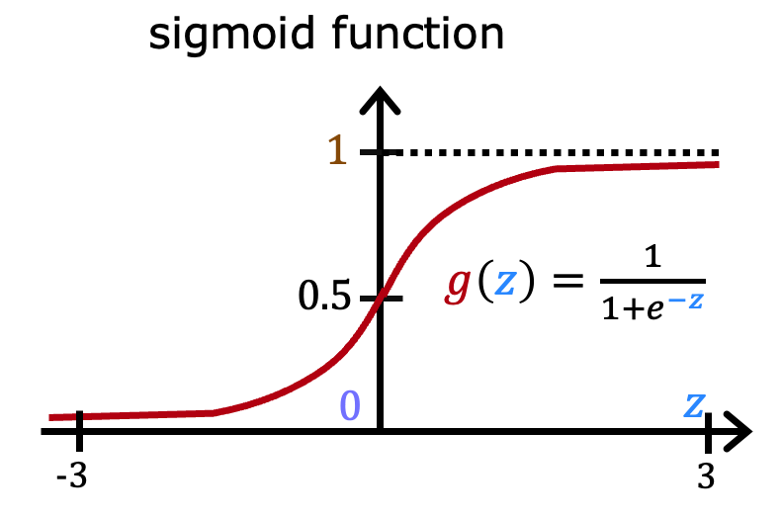

If z is a large positive number, then:

1. $g(z)$ will be near 0.5
2. $g(z)$ is near one (1)
3. $g(z)$ will be near zero (0)
4. $g(z)$ is near negative one (-1)

我的答案:B

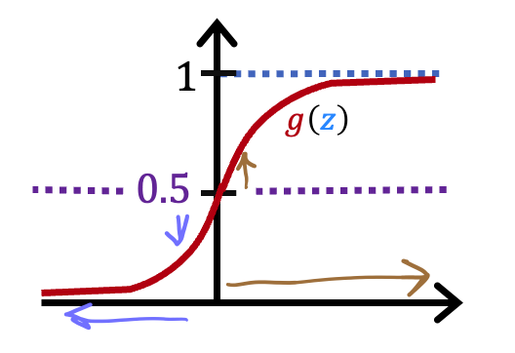

A cat photo classification model predicts 1 if it's a cat, and 0 if it's not a cat. For a particular photograph, the logistic regression model outputs $g(z)$ (a number between 0 and 1). Which of these would be a reasonable criteria to decide whether to predict if it’s a cat?

1. Predict it is a cat if $g(z)$ < 0.7
2. Predict it is a cat if $g(z)$ < 0.5
3. Predict it is a cat if $g(z)$ = 0.5
4. Predict it is a cat if $g(z)$ >= 0.5

我的答案:D

1. True/False? No matter what features you use (including if you use polynomial features), the decision boundary learned by logistic regression will be a linear decision boundary.
2. True
3. False

我的答案:B

# 第二单元

Cost function for logistic regression

逻辑回归的代价函数

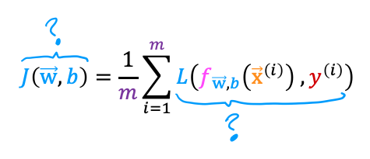

In this lecture series, "cost" and "loss" have distinct meanings. Which one applies to a single training example?

1. Loss
2. Cost
3. Both Loss and Cost
4. Neither Loss nor Cost

我的答案:A

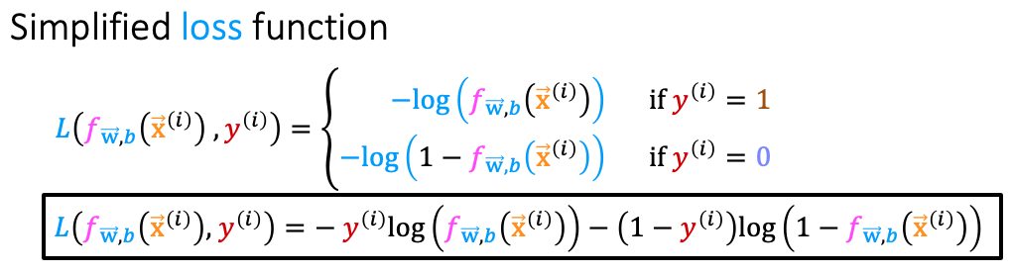

For the simplified loss function, if the label $y^{(i)}=0$，then what does this expression simplify to?

$log⁡(1-f_{\vec{w},b}(x^{(i)}))+log(1-f_{\vec{w},b}(x^{(i)}))$

$log⁡(f_{\vec{w},b}(x^{(i)})$

$-log⁡(1-f_{\vec{w},b}(x^{(i)}))$

$-log⁡(1-f_{\vec{w},b}(x^{(i)}))-log(1-f_{\vec{w},b}(x^{(i)}))$

我的答案:A

# 第三单元

Gradient descent for logistic regression

逻辑回归的梯度下降

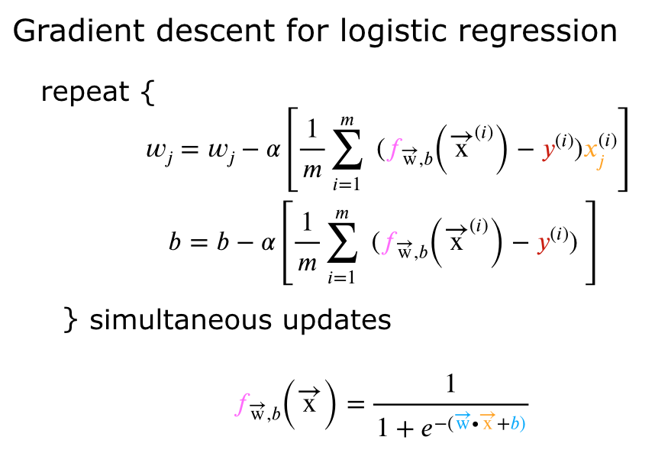

Which of the following two statements is a more accurate statement about gradient descent for logistic regression?

1. The update steps are identical to the update steps for linear regression.
2. The update steps look like the update steps for linear regression, but the definition of $f_{\vec{w},b}(x^{(i)})$ is different.

我的答案:A

# 第四单元

The problem of overfitting

过拟合问题

1. Which of the following can address overfitting?
2. Apply regularization
3. Select a subset of the more relevant features.
4. Remove a random set of training examples
5. Collect more training data

我的答案: A、B、D

1. You fit logistic regression with polynomial features to a dataset, and your model looks like this.

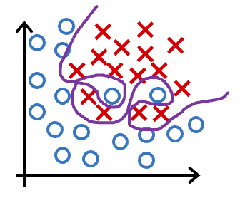

What would you conclude? (Pick one)

1. The model has high bias (underfit). Thus, adding data is likely to help
2. The model has high bias (underfit). Thus, adding data is, by itself, unlikely to help much.
3. The model has high variance (overfit). Thus, adding data is, by itself, unlikely to help much.
4. The model has high variance (overfit). Thus, adding data is likely to help

我的答案:C

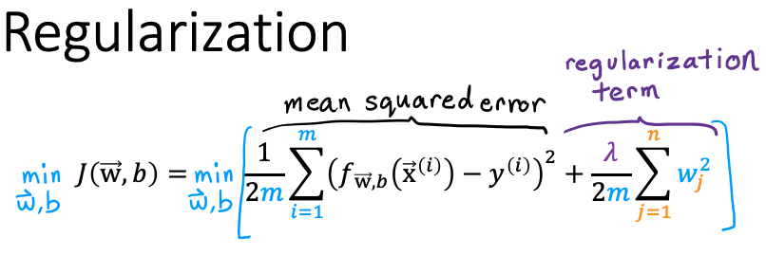  
Suppose you have a regularized linear regression model.  If you increase the regularization parameter $\begin{aligned}λ\end{aligned}$, what do you expect to happen to the parameters $w_{1},w_{2},...,w_{n}$？

1. This will reduce the size of the parameters $w_{1},w_{2},...,w_{n}$
2. This will increase the size of the parameters $w_{1},w_{2},…,w_{n}$

我的答案:A

三、编程作业-展开介绍

对自己所学章节的学习内容的代码截图、分析说明和心得体会。

Week 2 practice lab Linear regression 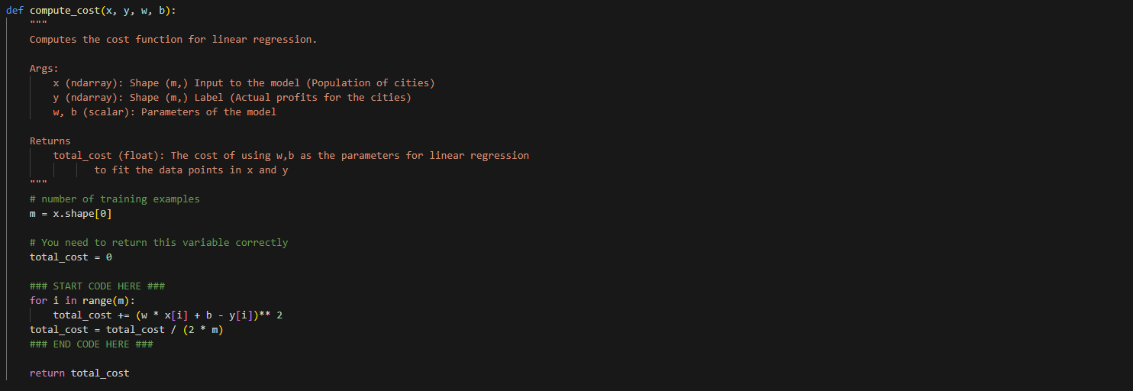

结果：

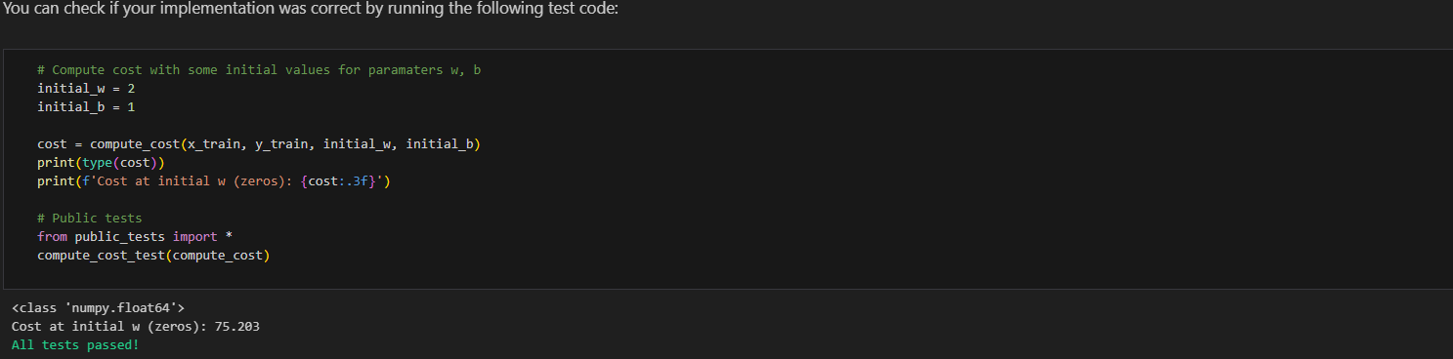

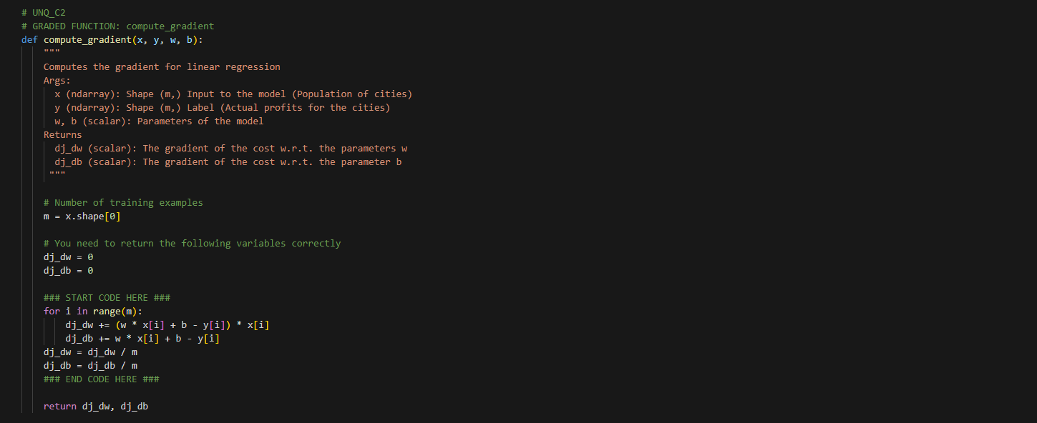

结果：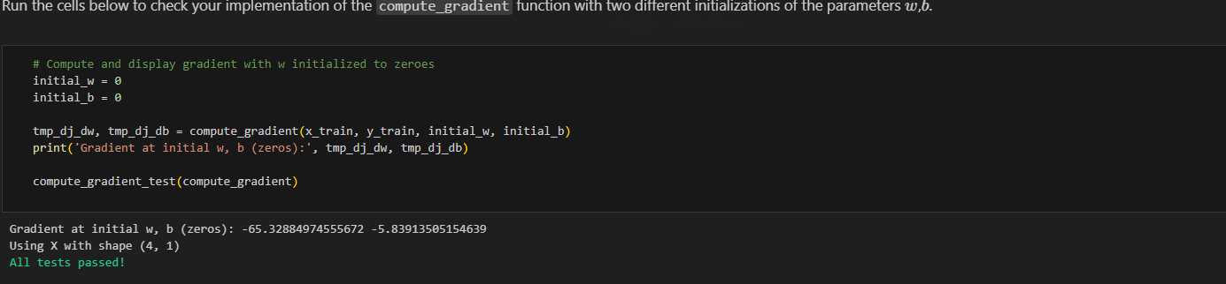

Week 3 practice lab logistic regression 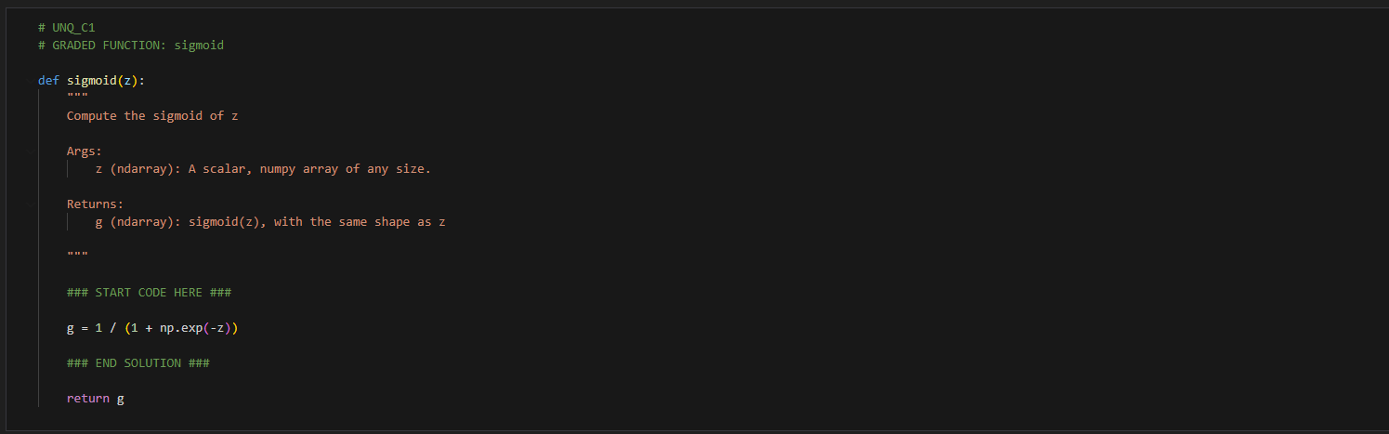

结果：

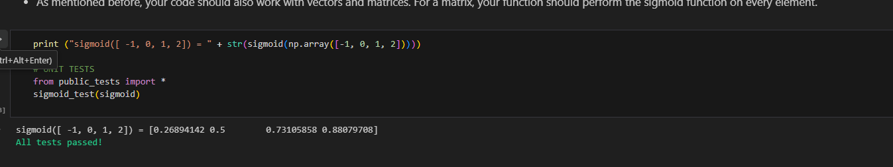

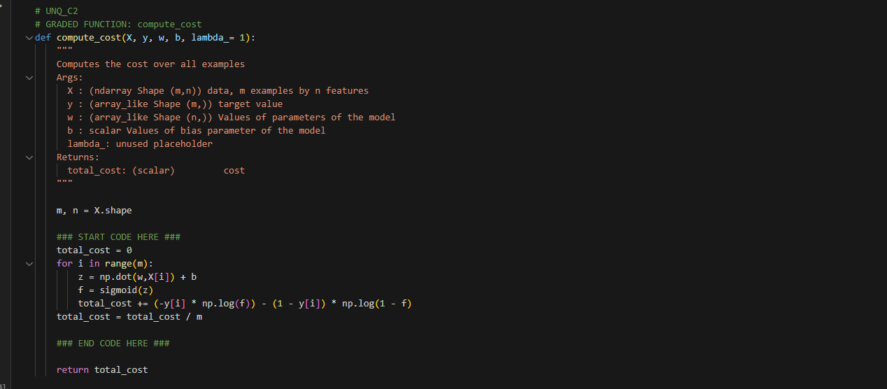

结果：

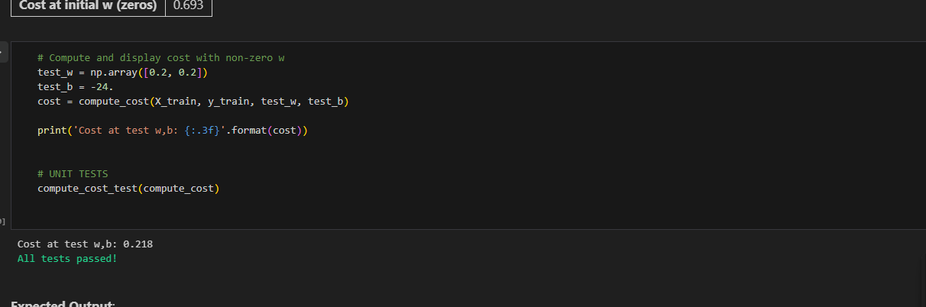

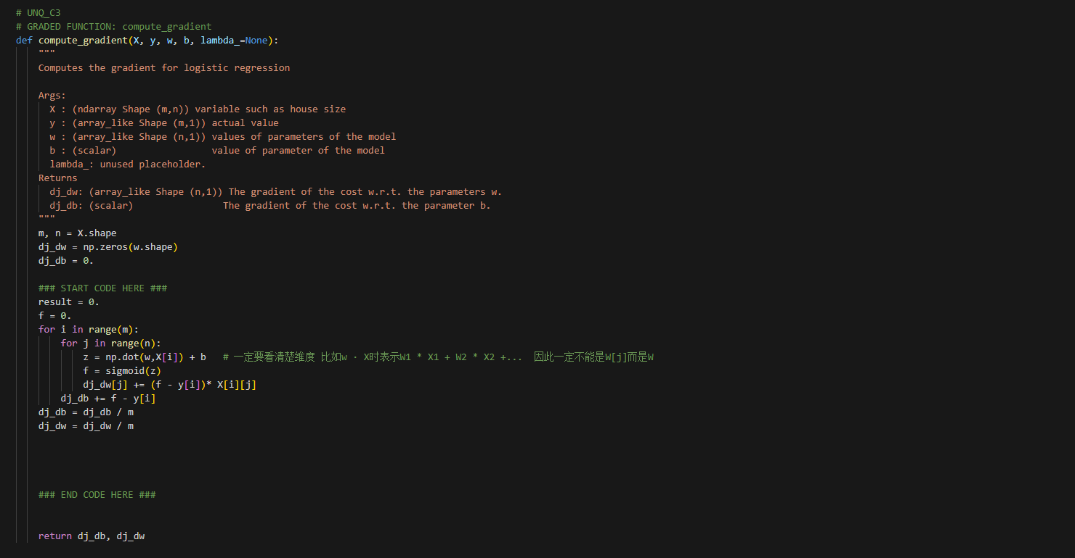

结果：

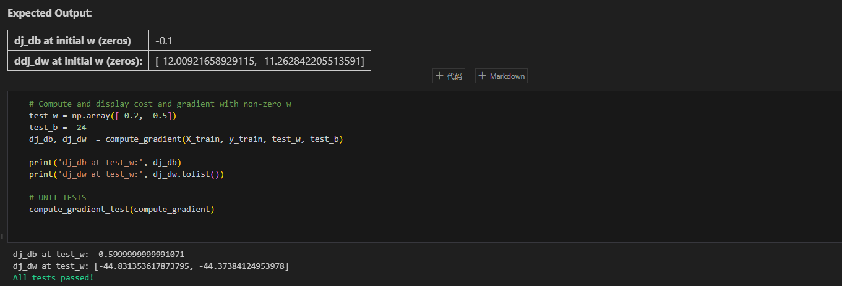

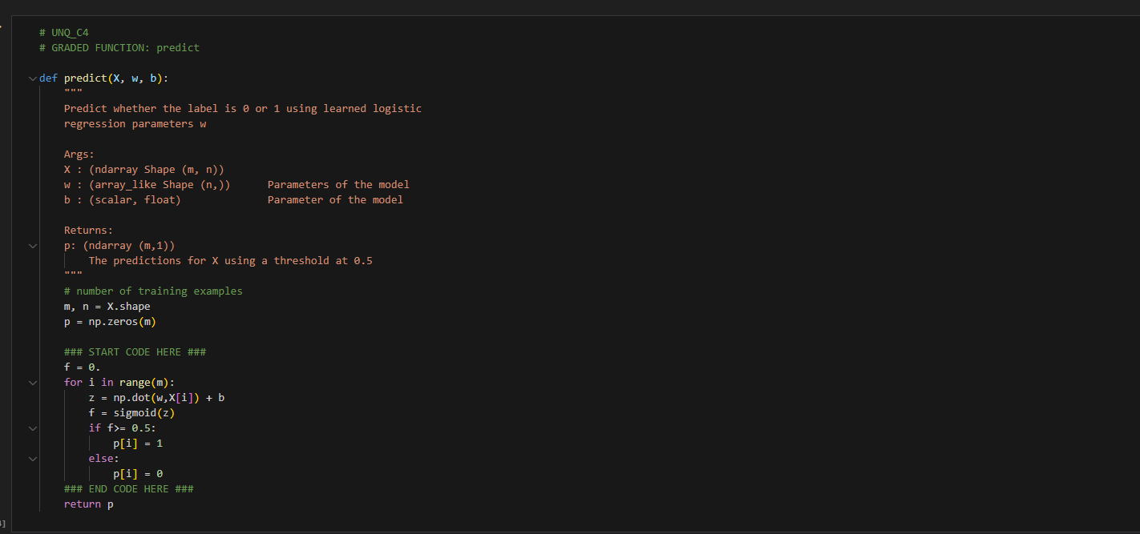

结果：

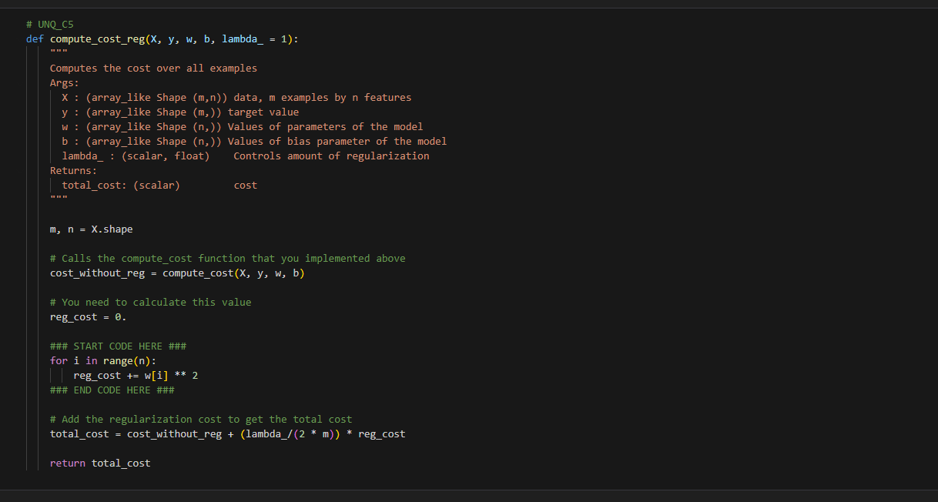 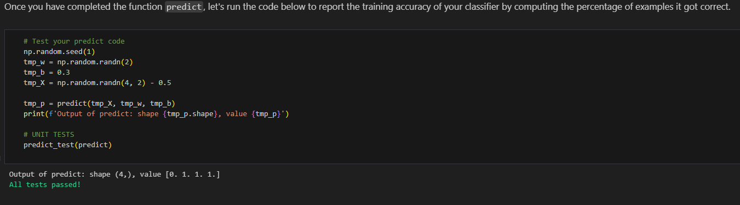

结果：

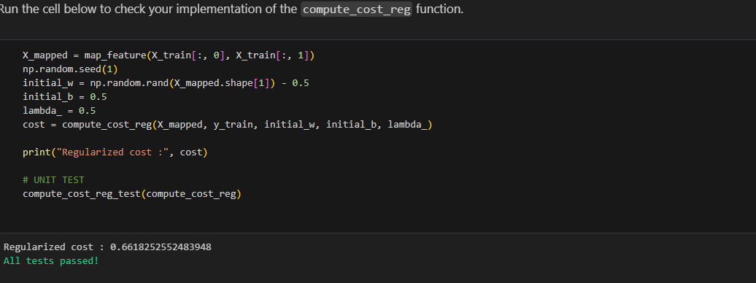

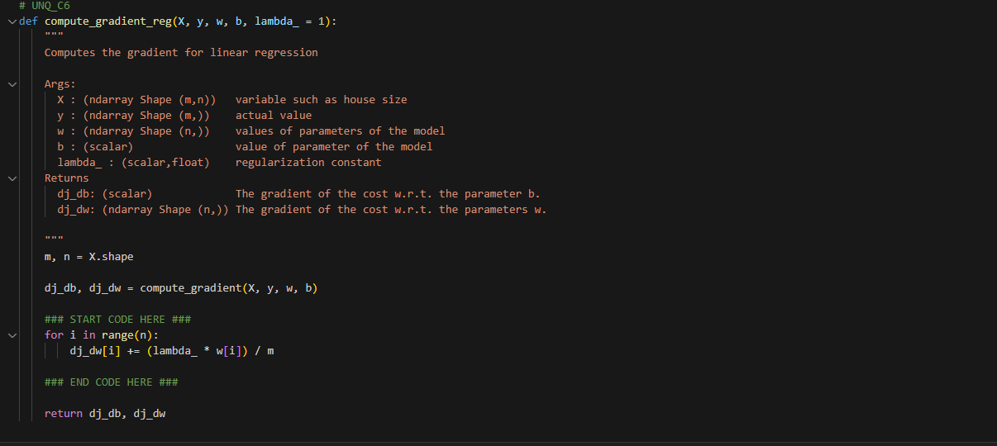

结果：

