

2024年《机器学习》线上学习
测验习题+编程作业
（个人版）



课 程： 机器学习
姓 名： 张棣
学 号： 2022217613
完成时间： 2024.5.3

“机器学习-Coursera测验习题”评分细则
成绩等级 | 具体表现 | 教师评分
优秀（100-90] | 能够在规定时间内完成Coursera测验作业；内容充实详尽；过程分析详细清楚；心得体会充分； | 
良好（90-80] | 能够在规定时间内完成编程作业；内容较充实；较好完成数据分析过程和算法介绍；心得体会良好； | 
中等（80-70] | 能够在规定时间内完成编程作业；2）有简单的数据分析、算法介绍和心得体会； | 
及格（70-60] | 能够在规定时间内完成编程作业；达到最低的内容量。 | 
不及格（<60） | 未完成； | 

“机器学习-编程作业”评分细则
成绩等级 | 具体表现 | 教师评分
优秀（100-90] | 能够在规定时间内完成编程作业；内容充实详尽；过程分析详细清楚；心得体会充分； | 
良好（90-80] | 能够在规定时间内完成编程作业；内容较充实；较好完成数据分析过程和算法介绍；心得体会良好； | 
中等（80-70] | 能够在规定时间内完成编程作业；2）有简单的数据分析、算法介绍和心得体会； | 
及格（70-60] | 能够在规定时间内完成编程作业； | 
不及格（<60） | 未完成； | 

一．总体介绍
摘要：
Coursera测验习题
第二章 多变量线性回归
第三章 分类+过拟合（正则化）

编程作业
第一部分：Supervised Machine Learning Regression and Classification
二、Coursera测验习题-展开介绍
第二章 多变量线性回归
第一单元
Multiple linear regression
多变量线性回归、
- In the training set below, what is ？Please type in the number below (this is an integer such as 123, no decimal points).
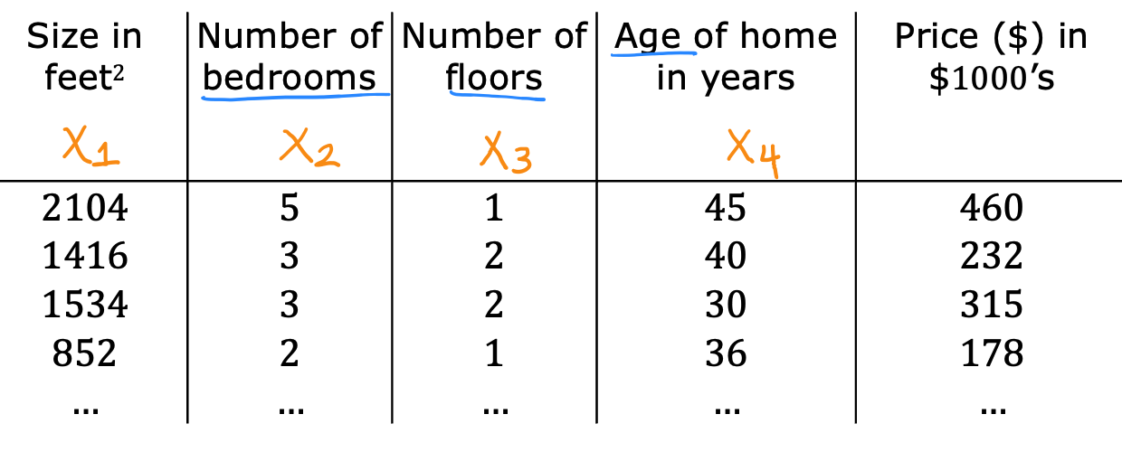
Answer : 30

- Which of the following are potential benefits of vectorization? Please choose the best option.
- It makes your code run faster
- It can make your code shorter
- It allows your code to run more easily on parallel compute hardware
- All of the above
Answer :D

- True/False? To make gradient descent converge about twice as fast, a technique that almost always works is to double the learning rate alpha.
Answer : False

第二单元
Gradient descent in practice
梯度下降的实践

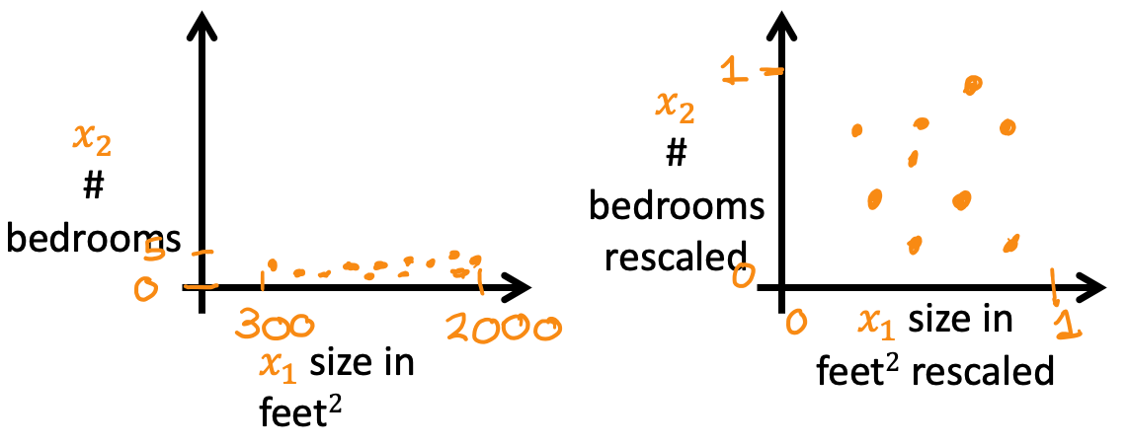
Which of the following is a valid step used during feature scaling?

- Subtract the mean (average) from each value and then divide by the (max - min).
- Add the mean (average) from each value and and then divide by the (max - min).
Answer : A
- Suppose a friend ran gradient descent three separate times with three choices of the learning rate and plotted the learning curves for each (cost J for each iteration).
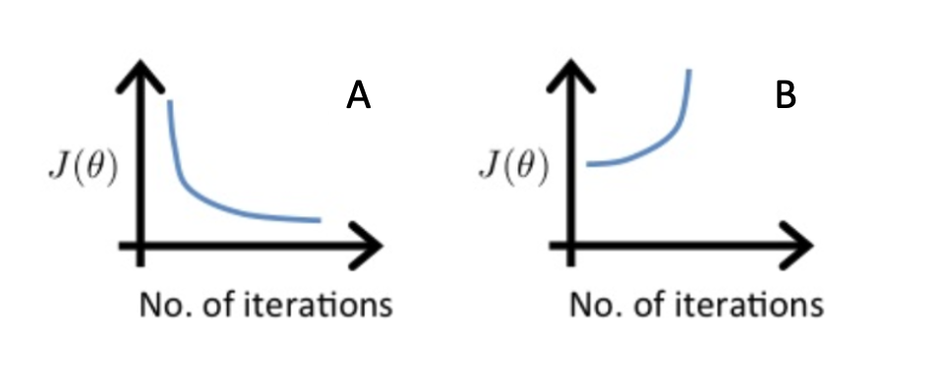
For which case, A or B, was the learning rate likely too large?
- case B only
- Neither Case A nor B
- case A only
- Both Cases A and B
Answer: A

- Of the circumstances below, for which one is feature scaling particularly helpful?
- Feature scaling is helpful when all the features in the original data (before scaling is applied) range from 0 to 1.
- Feature scaling is helpful when one feature is much larger (or smaller) than another feature.
Answer: B

- You are helping a grocery store predict its revenue, and have data on its items sold per week, and price per item. What could be a useful engineered feature?
- For each product, calculate the number of items sold times price per item.
- For each product, calculate the number of items sold divided by the price per item.
Answer: A

- True/False? With polynomial regression, the predicted values 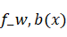 does not necessarily have to be a straight line (or linear) function of the input feature x.
Answer: True

第三章 分类+过拟合（正则化）
第一单元
Classification with logistic regression
利用逻辑回归进行分类

- Which is an example of a classification task?
- Based on a patient's blood pressure, determine how much blood pressure medication (a dosage measured in milligrams) the patient should be prescribed.
- Based on a patient's age and blood pressure, determine how much blood pressure medication (measured in milligrams) the patient should be prescribed.
- Based on the size of each tumor, determine if each tumor is malignant (cancerous) or not.
Answer: B
- Recall the sigmoid function is 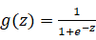
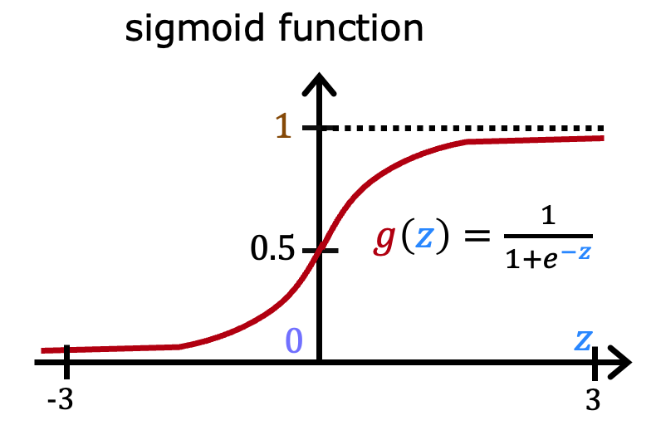
If z is a large positive number, then:
- 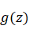will be near 0.5
- is near one (1)
- will be near zero (0)
- is near negative one (-1)
Answer: B

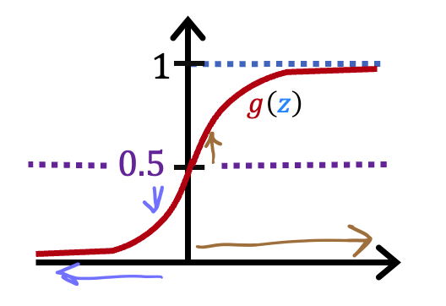
A cat photo classification model predicts 1 if it's a cat, and 0 if it's not a cat. For a particular photograph, the logistic regression model outputs (a number between 0 and 1). Which of these would be a reasonable criteria to decide whether to predict if it’s a cat?
- Predict it is a cat if < 0.7
- Predict it is a cat if < 0.5
- Predict it is a cat if = 0.5
- Predict it is a cat if >= 0.5
Answer: D

- True/False? No matter what features you use (including if you use polynomial features), the decision boundary learned by logistic regression will be a linear decision boundary.
Answer: False

第二单元
Cost function for logistic regression
逻辑回归的代价函数

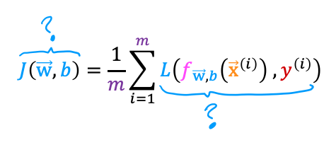
In this lecture series, "cost" and "loss" have distinct meanings. Which one applies to a single training example?
- Loss
- Cost
- Both Loss and Cost
- Neither Loss nor Cost
Answer: A

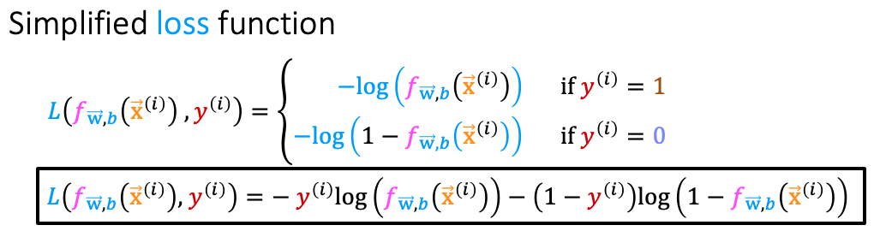
For the simplified loss function, if the label 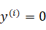，then what does this expression simplify to?
- 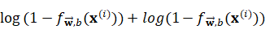
- 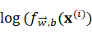
- 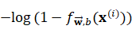
- 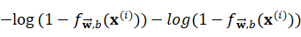
Answer: A

第三单元
Gradient descent for logistic regression
逻辑回归的梯度下降

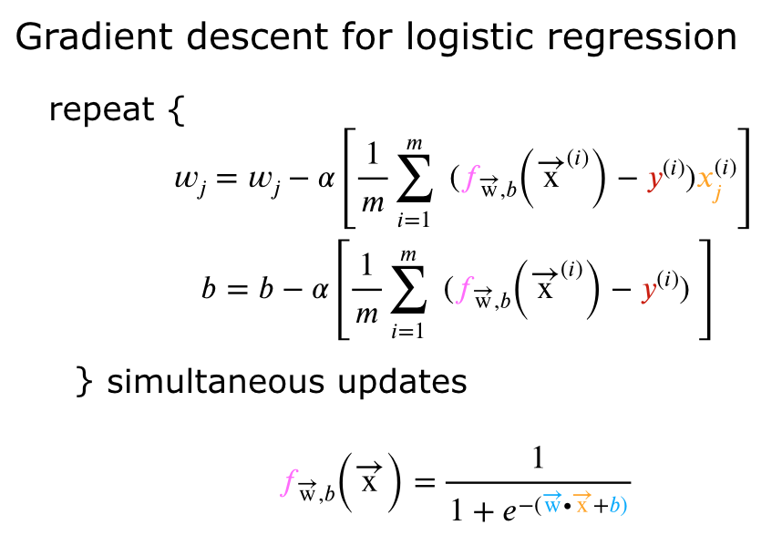
Which of the following two statements is a more accurate statement about gradient descent for logistic regression?
- The update steps are identical to the update steps for linear regression.
- The update steps look like the update steps for linear regression, but the definition of 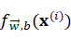is different.
Answer: A

第四单元
The problem of overfitting
过拟合问题
- Which of the following can address overfitting?
- Apply regularization
- Select a subset of the more relevant features.
- Remove a random set of training examples
- Collect more training data
Answer: A、B、D

- You fit logistic regression with polynomial features to a dataset, and your model looks like this.
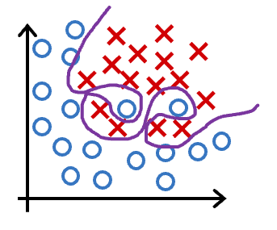
What would you conclude? (Pick one)
- The model has high bias (underfit). Thus, adding data is likely to help
- The model has high bias (underfit). Thus, adding data is, by itself, unlikely to help much.
- The model has high variance (overfit). Thus, adding data is, by itself, unlikely to help much.
- The model has high variance (overfit). Thus, adding data is likely to help
Answer: C

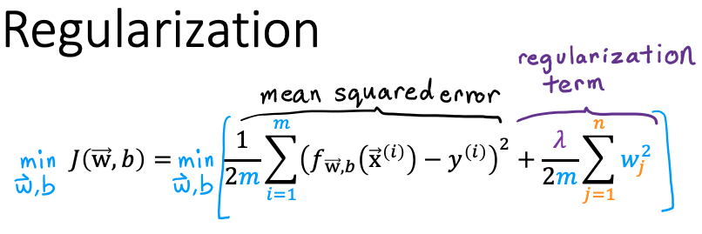
Suppose you have a regularized linear regression model. If you increase the regularization parameter , what do you expect to happen to the parameters 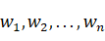？
- This will reduce the size of the parameters
- This will increase the size of the parameters 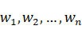
Answer: A
三、编程作业-展开介绍
第一部分：Supervised Machine Learning Regression and Classification
Week2
Ex1
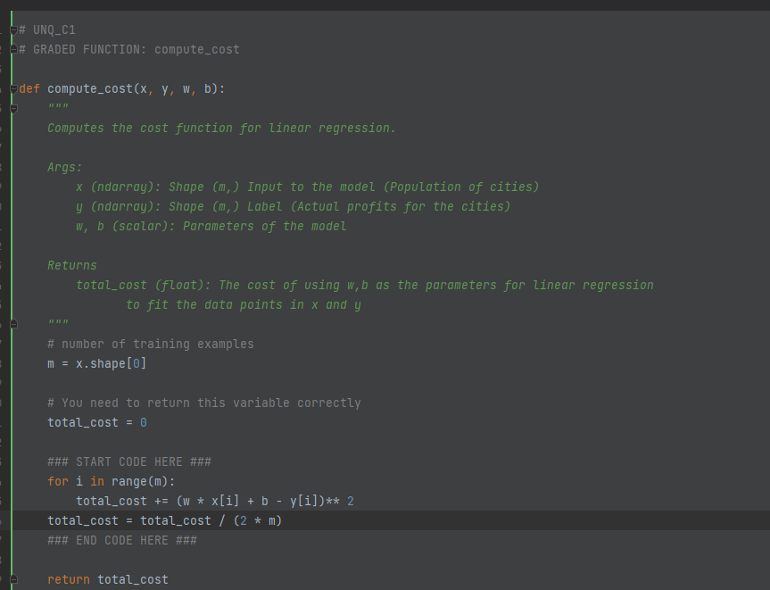
使用for循环遍历每个样本。在循环中，它计算预测值（w * x[i] + b）与实际值（y[i]）之间的差的平方，并将这些差的平方累加到total_cost变量中。最后，它将total_cost除以(2 * m)来计算平均损失。使用了平方误差损失函数来度量预测值与实际值之间的差异，达到计算线性回归模型的成本的目的。

Ex2
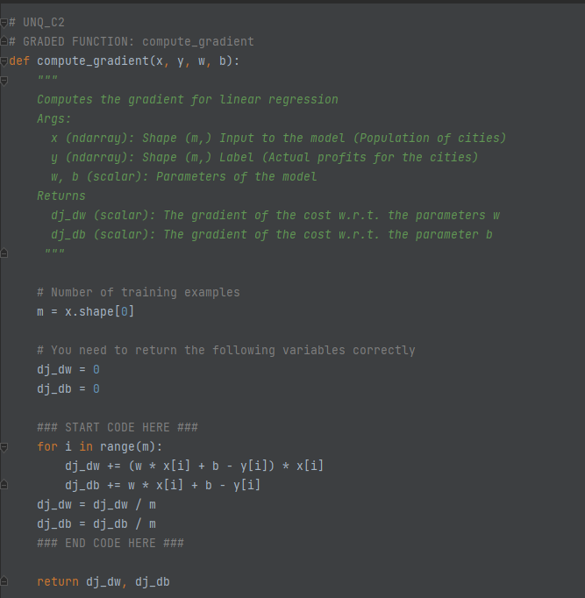
计算线性回归模型的梯度。for循环遍历每个样本。在循环中，它计算了对于参数w的梯度，即(w * x[i] + b - y[i]) * x[i]，并将其累加到dj_dw变量中。它还计算了对于参数b的梯度，即w * x[i] + b - y[i]，并将其累加到dj_db变量中，最后将dj_dw和dj_db分别除以m，以计算平均梯度。

Week3
Ex1
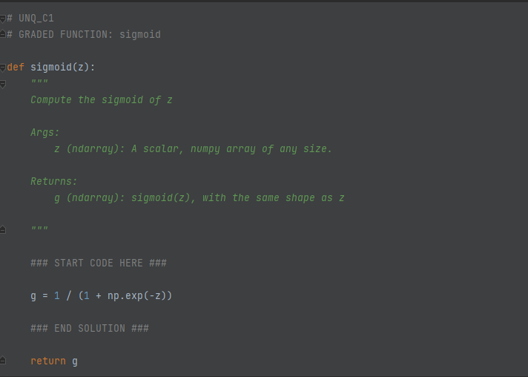
sigmoid函数，用于将输入的z转换为一个介于0和1之间的值，定义是：g(z) = 1 / (1 + e^(-z))，其中e是自然对数的底数。使用numpy的exp函数计算e^(-z)，然后将其加上1，最后将1除以这个结果，得到sigmoid值g。

Ex2
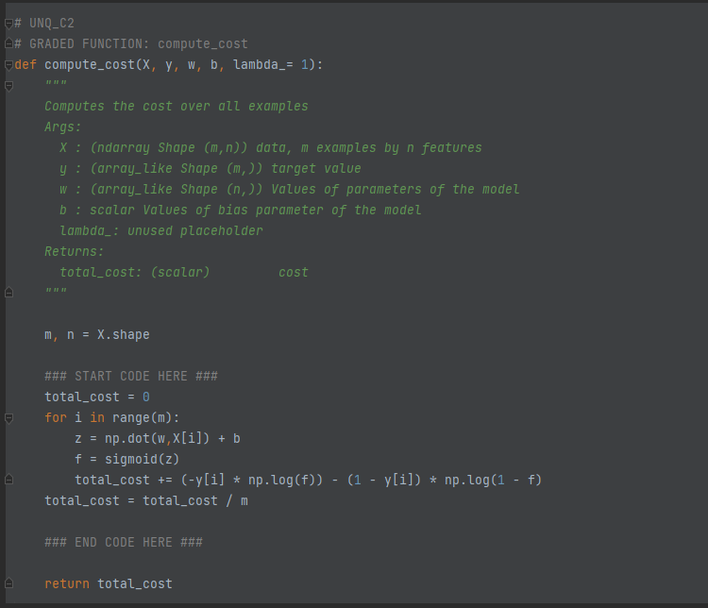
逻辑回归的交叉熵损失函数。初始化总成本total_cost为0。然后使用for循环遍历每个样本。在循环中，它首先计算z，即np.dot(w, X[i]) + b，其中np.dot表示矩阵乘法。然后，它将z传递给sigmoid函数，得到f，即sigmoid(z)。sigmoid函数在前文提到是一个转换函数。交叉熵损失函数的定义是：
L(y, f) = -y * log(f) - (1 - y) * log(1 - f)
其中，y是实际标签（0或1），f是逻辑回归模型的预测值。
当y=1时，第一项 -y * log(f) 贡献到损失函数中，当预测值f越接近1时，损失越小。当y=0时，第二项 (1 - y) * log(1 - f) 贡献到损失函数中，当预测值f越接近0时，损失越小。
故计算交叉熵损失函数的两个部分：-y[i] * np.log(f)和(1 - y[i]) * np.log(1 - f)。然后，将这两个部分相加，并将其累加到total_cost变量中。
最后，将total_cost除以m，以计算平均损失。

Ex3
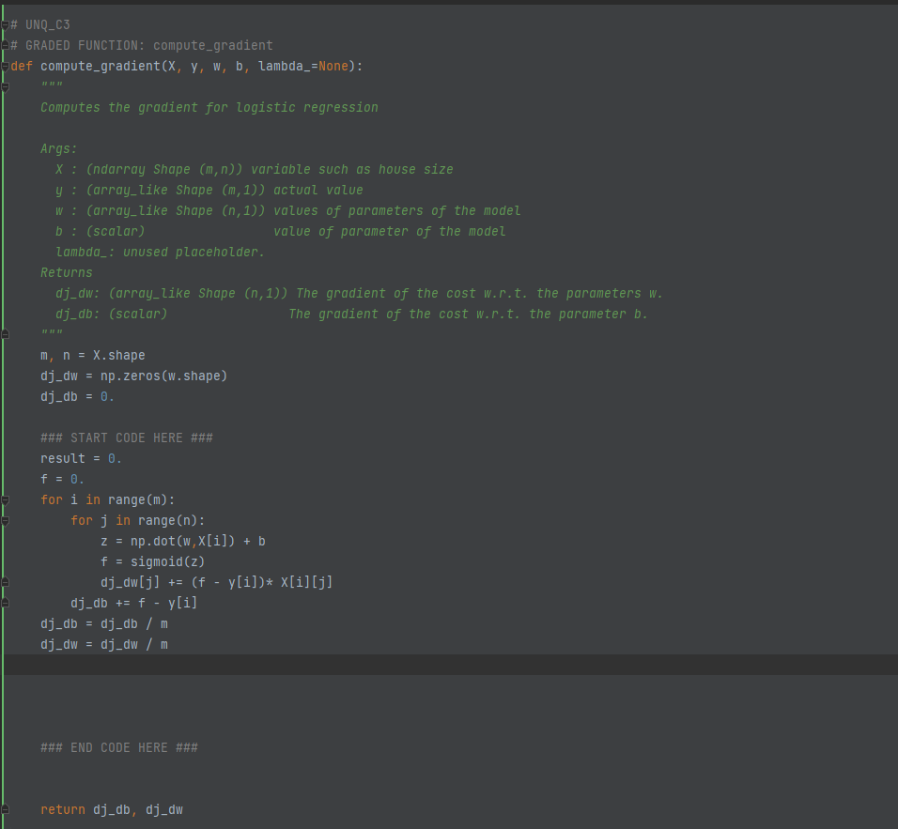
使用两个for循环遍历每个样本和每个特征。在循环中，首先计算z，即np.dot(w, X[i]) + b，其中np.dot表示矩阵乘法。然后，将z传递给sigmoid函数，得到f，即sigmoid(z)。然后计算对于参数w的梯度，即(f - y[i]) * X[i][j]，并将其累加到dj_dw[j]变量中。同时计算对于参数b的梯度，即f - y[i]，并将其累加到dj_db变量中。最后将dj_dw除以m，以计算平均梯度。
计算成本函数对于参数w和b的梯度，用于更新参数以最小化成本函数。

Ex4
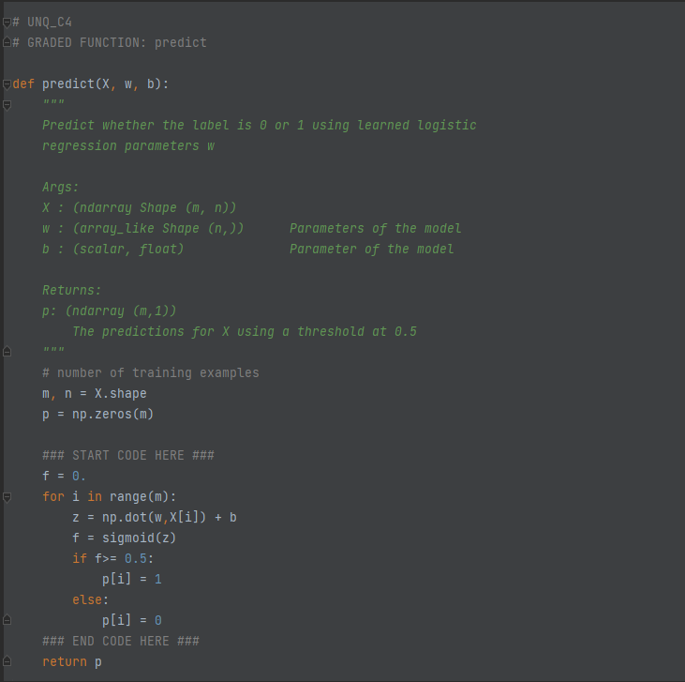
此函数功能为：使用训练好的逻辑回归模型参数w和b对X进行预测的结果。
使用for循环遍历每个样本。在循环中，首先计算z，即np.dot(w, X[i]) + b，其中np.dot表示矩阵乘法。然后将z传递给sigmoid函数，得到f，即sigmoid(z)。
再使用一个阈值0.5来判断预测值f。如果f大于等于0.5，就将预测值p[i]设置为1，否则设置为0。最后返回预测值p。

Ex5
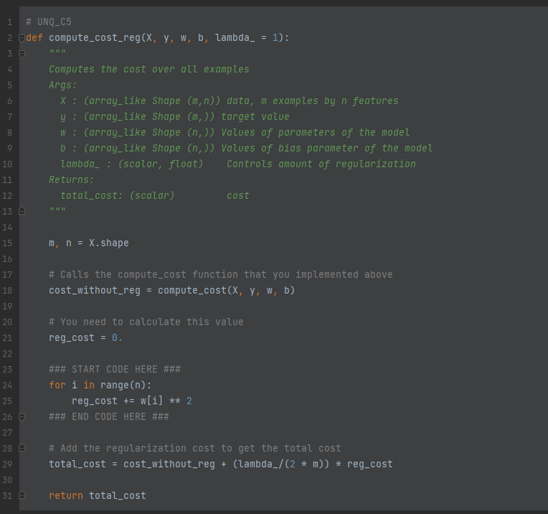
前文Ex2中提到compute_cost函数，是用于计算逻辑回归模型的成本函数。在这里调用该函数，用于计算没有正则化项的成本cost_without_reg。初始化正则化成本reg_cost为0。然后使用一个for循环遍历每个特征。在循环中，它将每个参数w[i]的平方累加到reg_cost变量中。最后计算带有正则化项的总成本total_cost，通过将cost_without_reg与正则化成本相加，并乘以(lambda_ / (2 * m))来控制正则化的数量。其中正则化参数lambda_由外部输入。这个函数的返回值是total_cost，它表示使用w和b作为逻辑回归模型参数来拟合X和y数据点的带有正则化项的成本。

Ex6
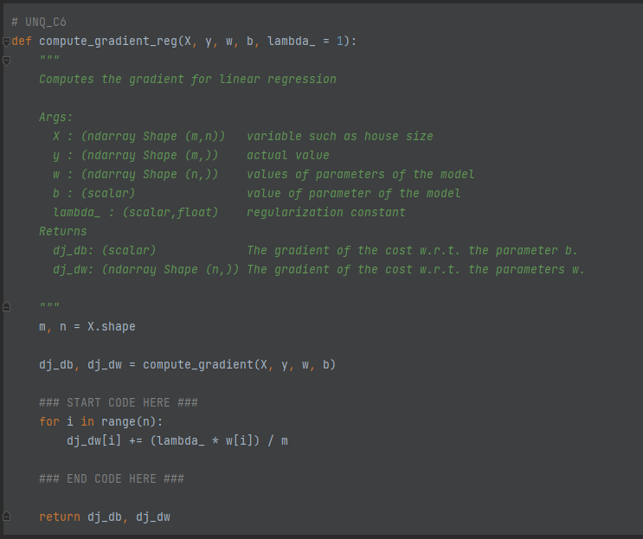
调用Ex3实现的compute_gradient函数，计算没有正则化项的梯度dj_db和dj_dw。再使用一个for循环遍历每个特征。在循环中，它将每个参数w[i]的梯度增加(lambda_ * w[i]) / m。这是正则化项的梯度，用于惩罚参数w的大小。返回带有正则化项的梯度dj_db和dj_dw，它们分别表示成本函数对于参数b和w的梯度。

