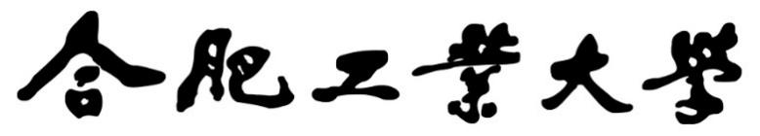

2024年《机器学习》线上学习
测验习题+编程作业
（个人版）



课 程： 机器学习
姓 名： 汪明灿
学 号： 2022217614
完成时间： 5.1

“机器学习-Coursera测验习题”评分细则
成绩等级 | 具体表现 | 教师评分
优秀（100-90] | 能够在规定时间内完成Coursera测验作业；内容充实详尽；过程分析详细清楚；心得体会充分； | 
良好（90-80] | 能够在规定时间内完成编程作业；内容较充实；较好完成数据分析过程和算法介绍；心得体会良好； | 
中等（80-70] | 能够在规定时间内完成编程作业；2）有简单的数据分析、算法介绍和心得体会； | 
及格（70-60] | 能够在规定时间内完成编程作业；达到最低的内容量。 | 
不及格（<60） | 未完成； | 

“机器学习-编程作业”评分细则
成绩等级 | 具体表现 | 教师评分
优秀（100-90] | 能够在规定时间内完成编程作业；内容充实详尽；过程分析详细清楚；心得体会充分； | 
良好（90-80] | 能够在规定时间内完成编程作业；内容较充实；较好完成数据分析过程和算法介绍；心得体会良好； | 
中等（80-70] | 能够在规定时间内完成编程作业；2）有简单的数据分析、算法介绍和心得体会； | 
及格（70-60] | 能够在规定时间内完成编程作业； | 
不及格（<60） | 未完成； | 

一．总体介绍
摘要：总体介绍自己做了哪几章的Coursera测验习题和第几次的编程作业。
完成部分：
测验习题1和2
第一部分Advanced Learning Algorithms
- Coursera测验习题-展开介绍

测验习题1
第一单元
Supervised vs unsupervised learning
有监督学习与无监督学习

- Which are the two common types of supervised learning? (Choose two)
- Clustering
- Regression
- Classification
Answer: B、C

- Which of these is a type of unsupervised learning?
- Regression
- Classification
- Clustering
Answer: C

第二单元
Regression
- For linear regression, the model is
Which of the following are the inputs, or features, that are fed into the model and with which the model is expected to make a prediction?
- and
Answer : A

- For linear regression, if you find parameters and so that is very close to zero, what can you conclude?
- This is never possible -- there must be a bug in the code.
- The selected values of the parameters and cause the algorithm to fit the training set really poorly.
- The selected values of the parameters and cause the algorithm to fit the training set really well.
Answer: B
第三单元
Train the model with gradient descent
使用梯度下降法训练模型

- Gradient descent is an algorithm for finding values of parameters w and b that minimize the cost function J.
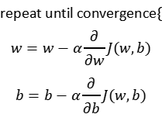
When 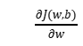is a negative number (less than zero), what happens to after one update step?
- stays the same
- decreases
- increases.
- It is not possible to tell if will increase or decrease.
Anawer : C
- For linear regression, what is the update step for parameter b?
- 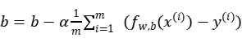
- 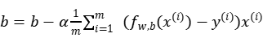
Answer: A

测验习题2
第一单元
Multiple linear regression
多变量线性回归

- In the training set below, what is ？Please type in the number below (this is an integer such as 123, no decimal points).
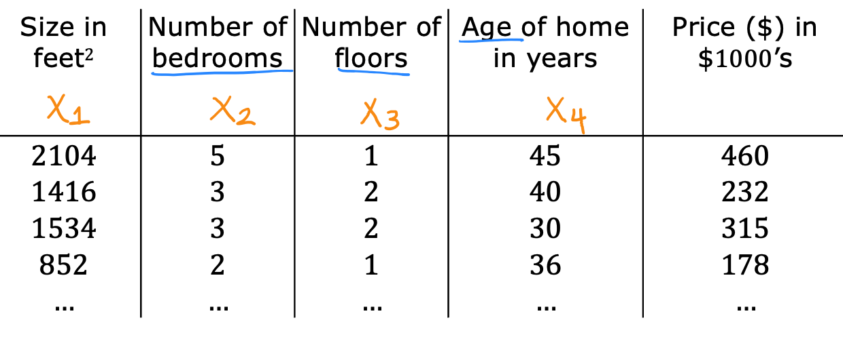
Answer : 30
- Which of the following are potential benefits of vectorization? Please choose the best option.
- It makes your code run faster
- It can make your code shorter
- It allows your code to run more easily on parallel compute hardware
- All of the above
Answer :D
- True/False? To make gradient descent converge about twice as fast, a technique that almost always works is to double the learning rate alpha.
- False
- True
Answer : A
第二单元
Gradient descent in practice
梯度下降的实践

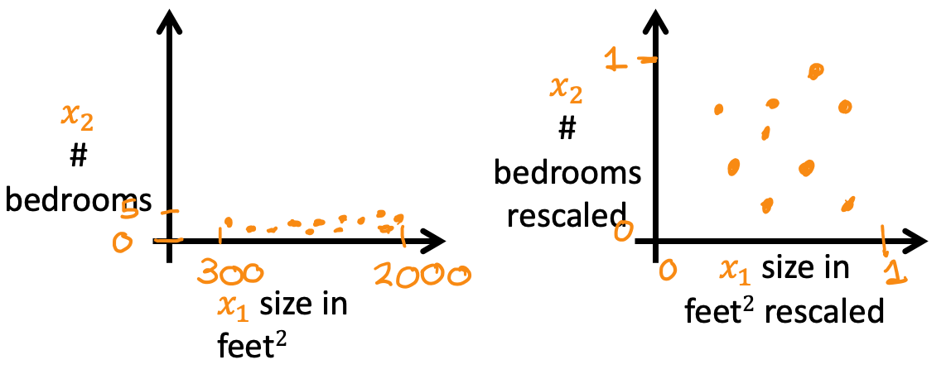
Which of the following is a valid step used during feature scaling?

- Subtract the mean (average) from each value and then divide by the (max - min).
- Add the mean (average) from each value and and then divide by the (max - min).
Answer : A
- Suppose a friend ran gradient descent three separate times with three choices of the learning rate and plotted the learning curves for each (cost J for each iteration).
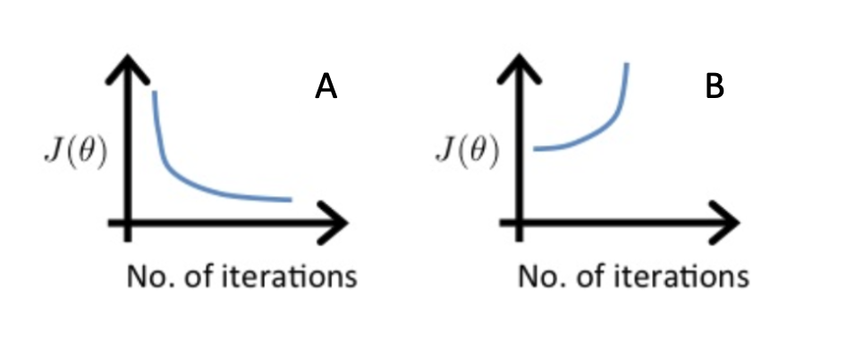
For which case, A or B, was the learning rate likely too large?
- case B only
- Neither Case A nor B
- case A only
- Both Cases A and B
Answer:A
- Of the circumstances below, for which one is feature scaling particularly helpful?
- Feature scaling is helpful when all the features in the original data (before scaling is applied) range from 0 to 1.
- Feature scaling is helpful when one feature is much larger (or smaller) than another feature.
Answer:B
- You are helping a grocery store predict its revenue, and have data on its items sold per week, and price per item. What could be a useful engineered feature?
- For each product, calculate the number of items sold times price per item.
- For each product, calculate the number of items sold divided by the price per item.
Answer:A
- True/False? With polynomial regression, the predicted values does not necessarily have to be a straight line (or linear) function of the input feature x.
- True
- False
Answer:A

三、编程作业-展开介绍
对自己所学章节的学习内容的代码截图、分析说明和心得体会。

Week1—Neural Networks for Handwritten Digit Recognition, Binary
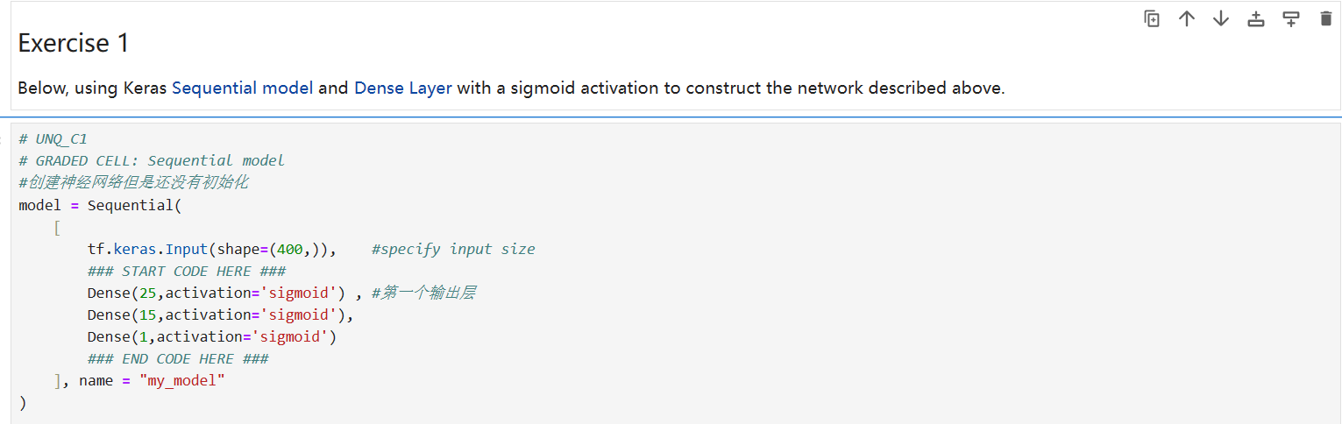
结果：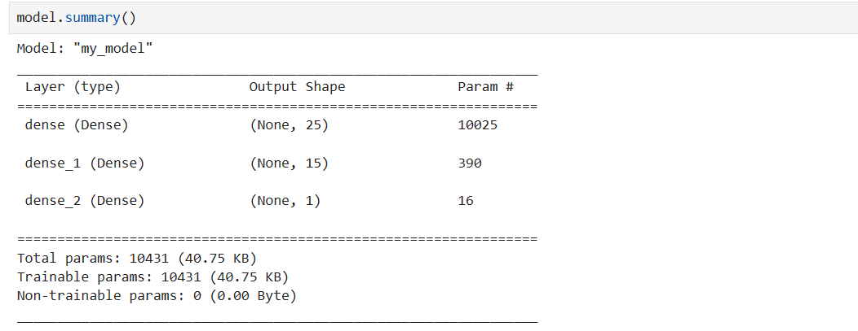
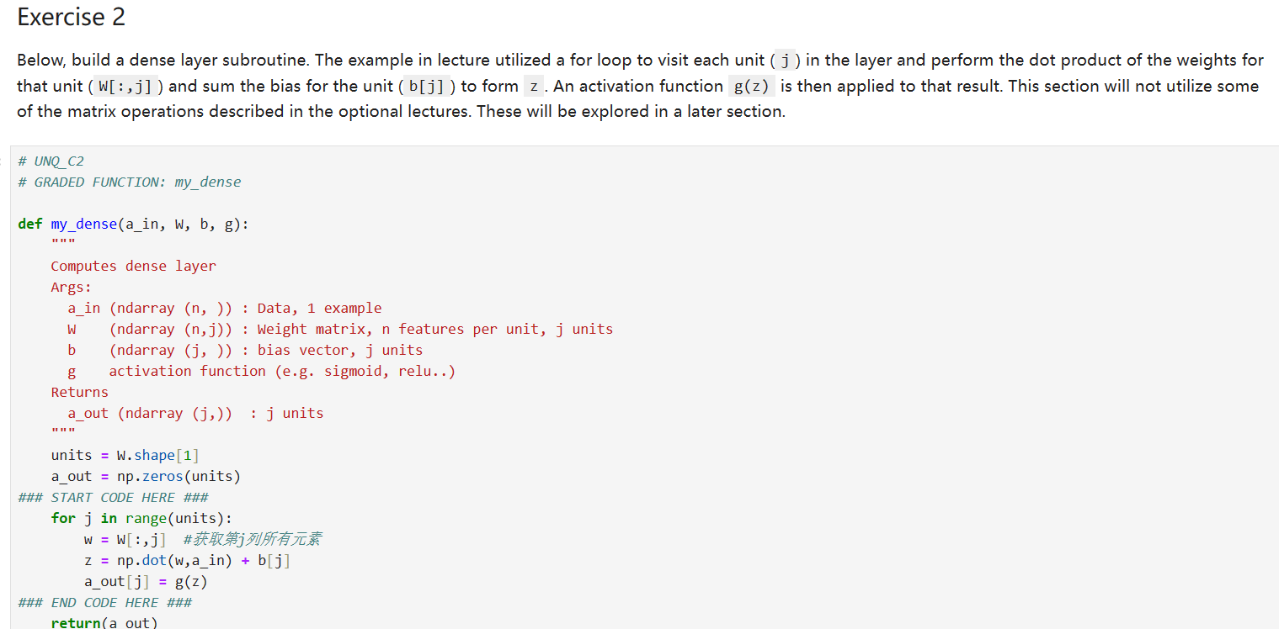
结果：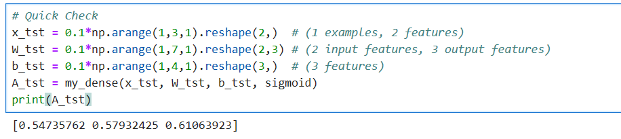
Week2—Neural Networks for Handwritten Digit Recognition, Multiclass
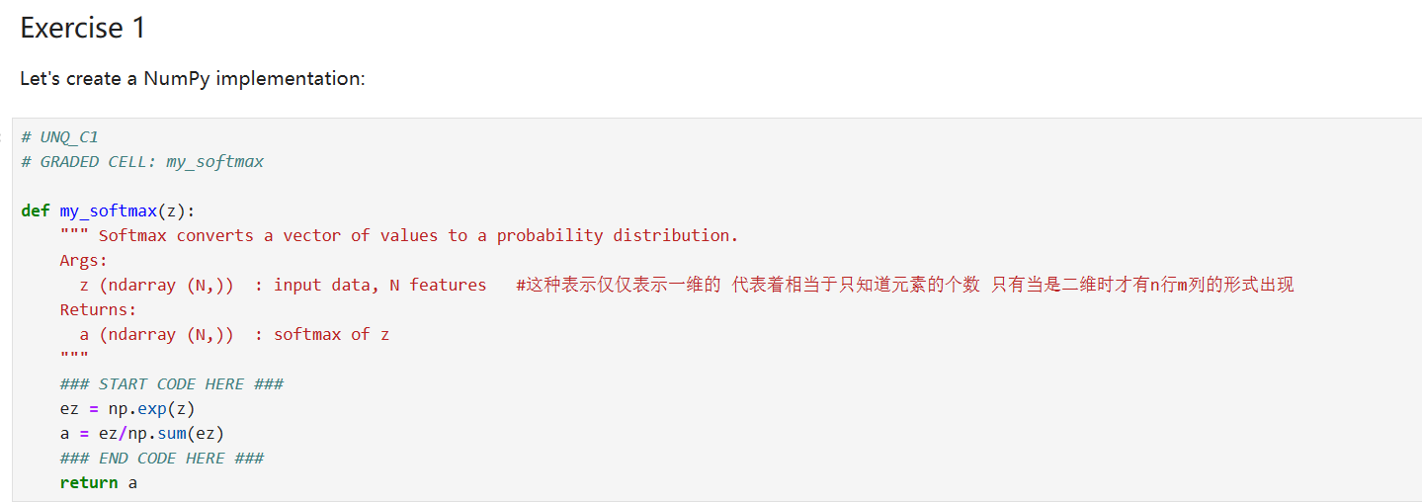
结果：
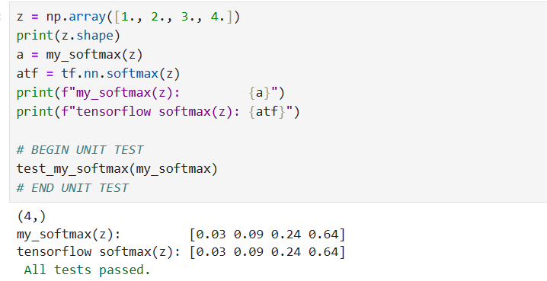

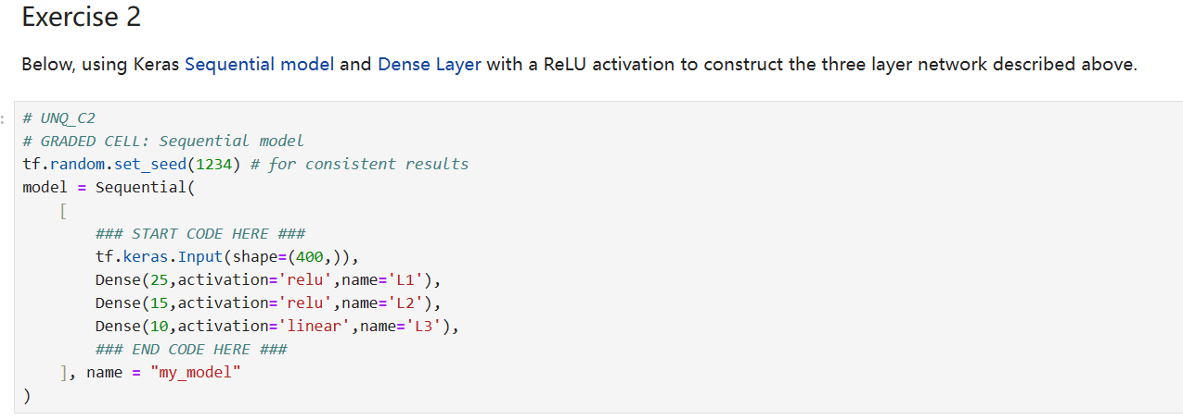
结果：
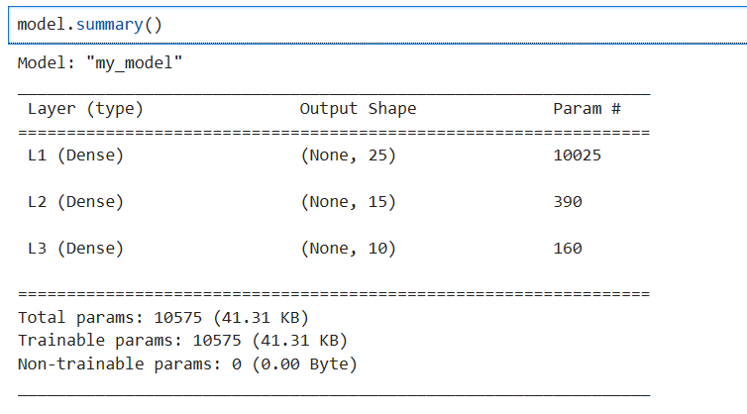
Week3—Practice Lab - Advice for Applying Machine Learning
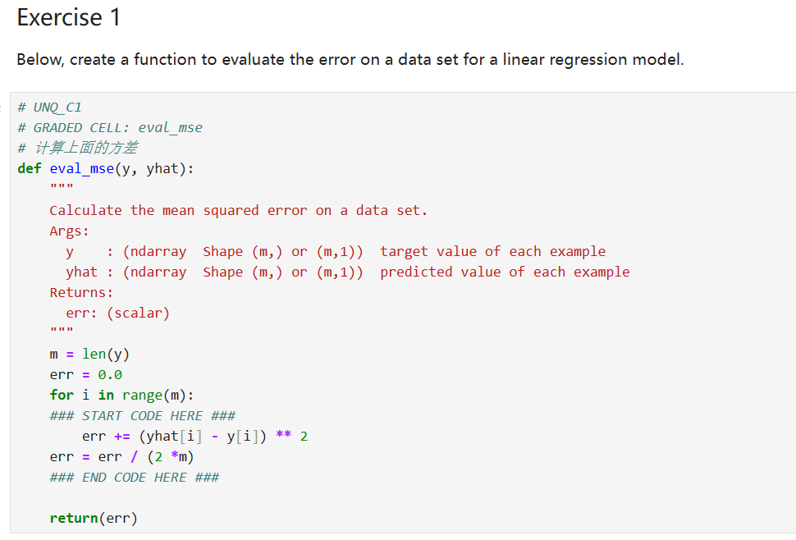
结果：
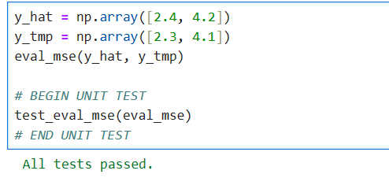
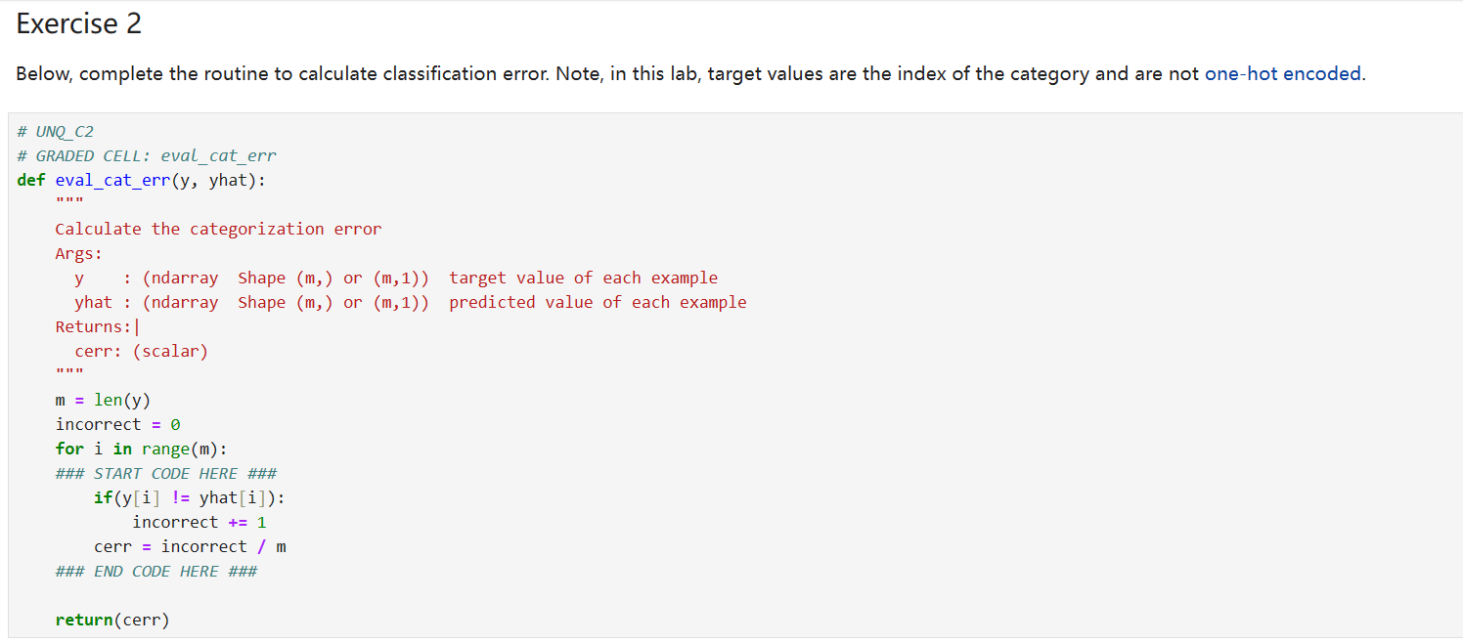

结果：
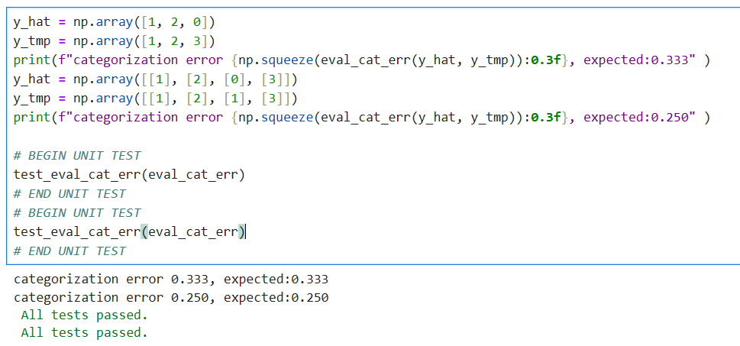
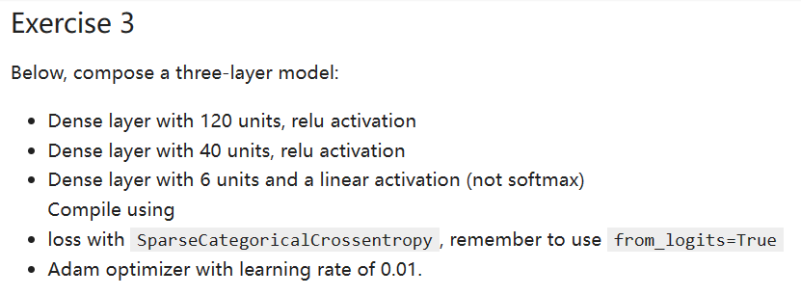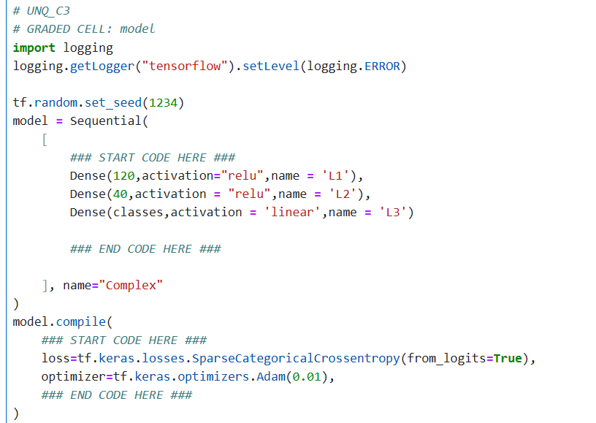
结果：
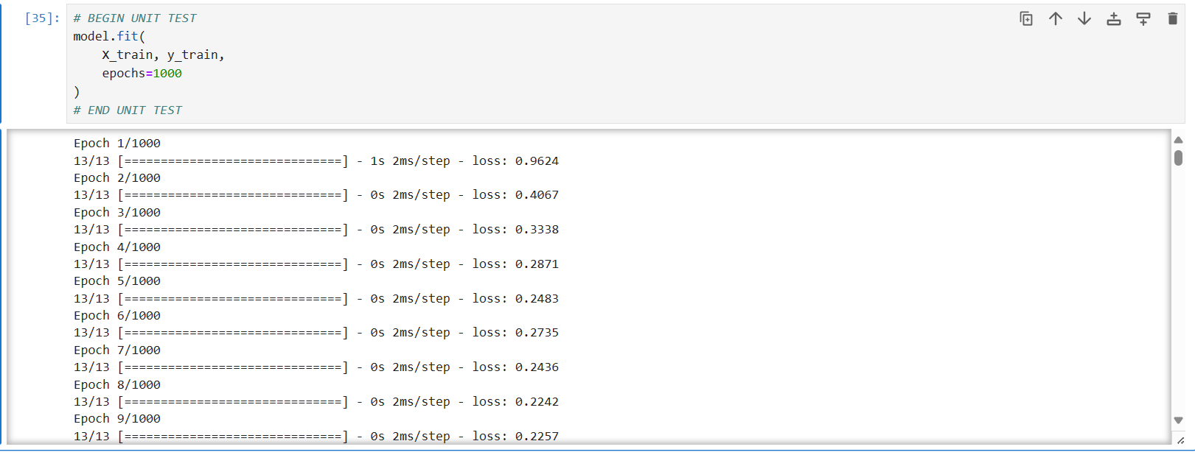
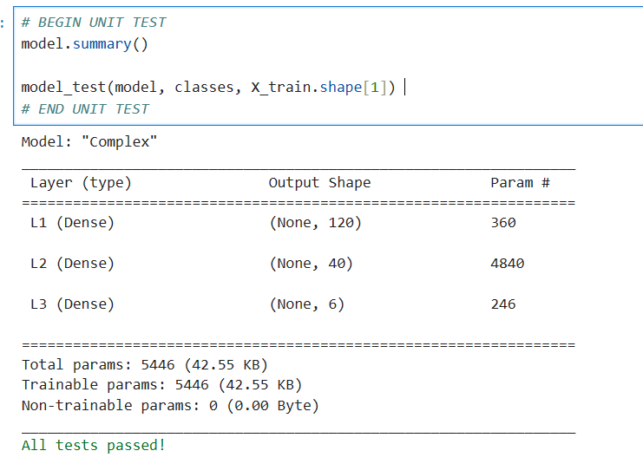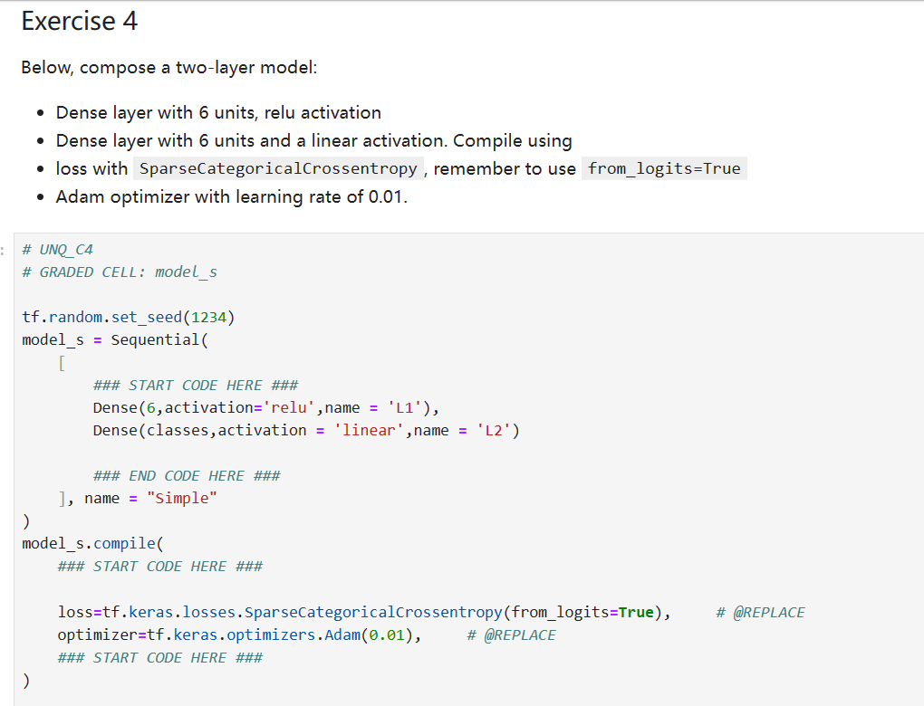
结果：
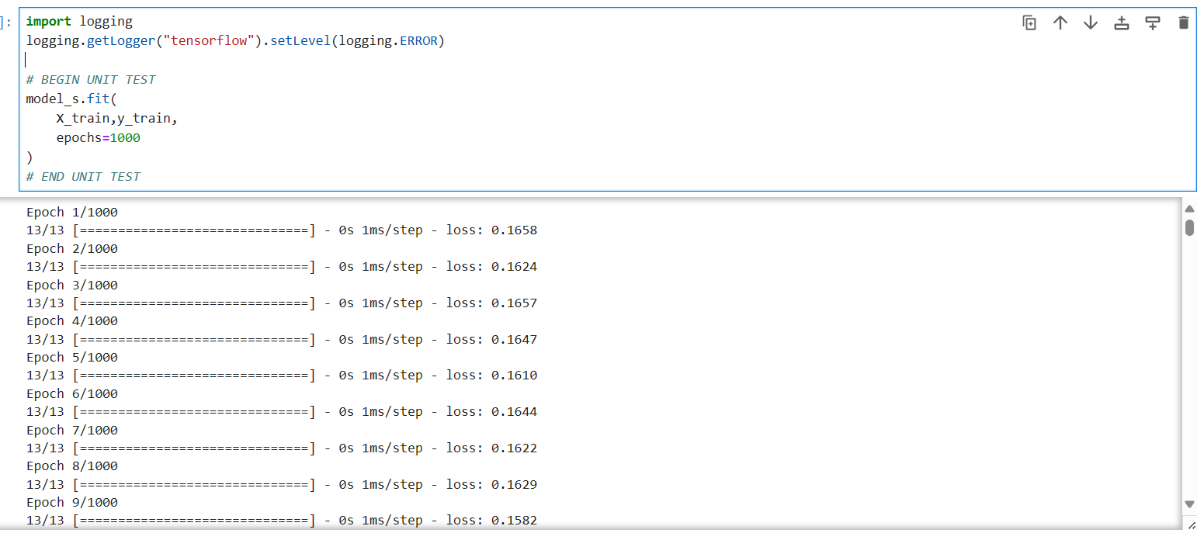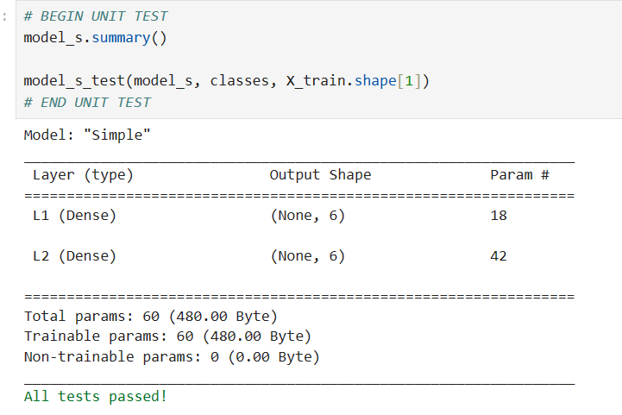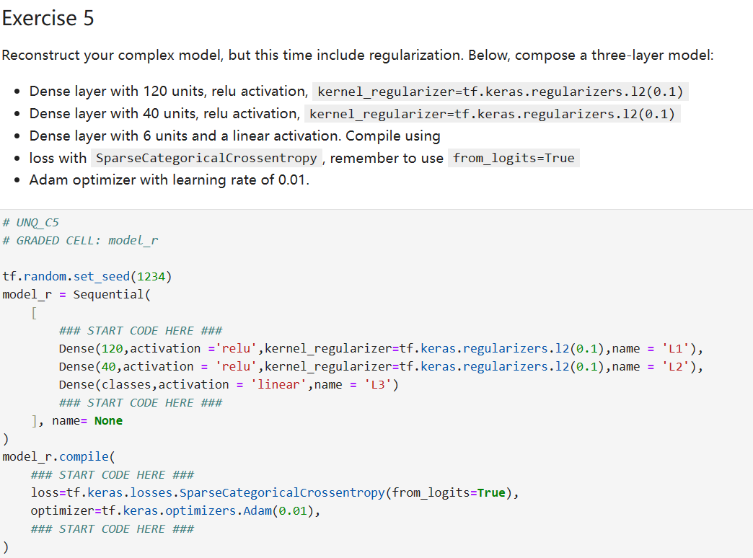
结果：
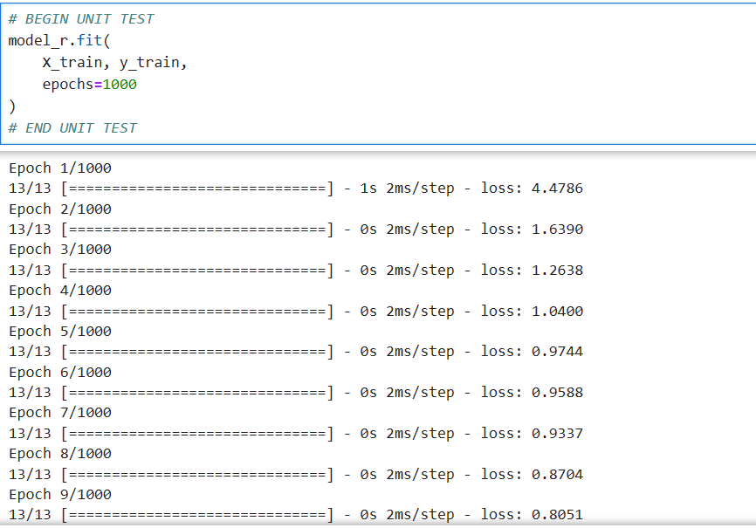
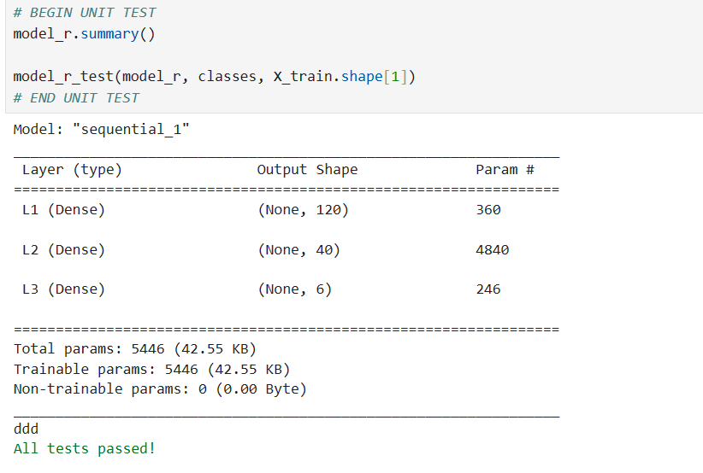
Week4—Decision Trees
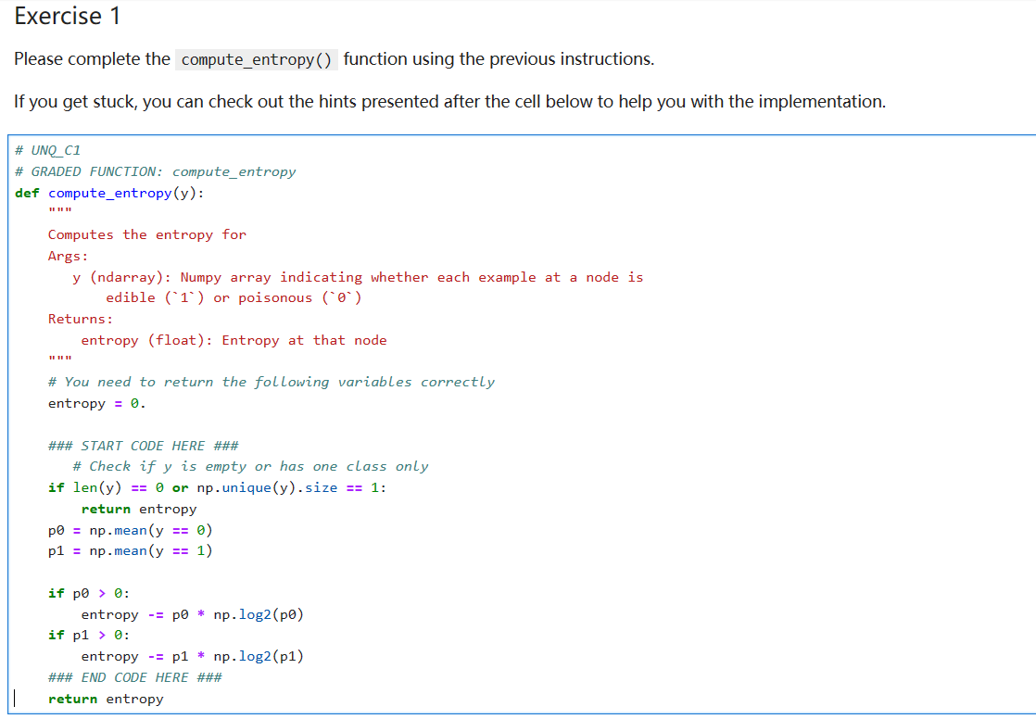
结果：
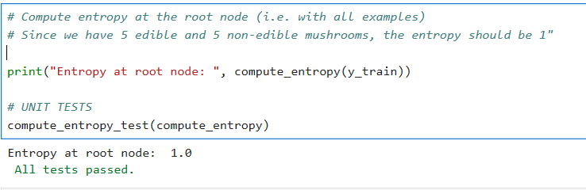
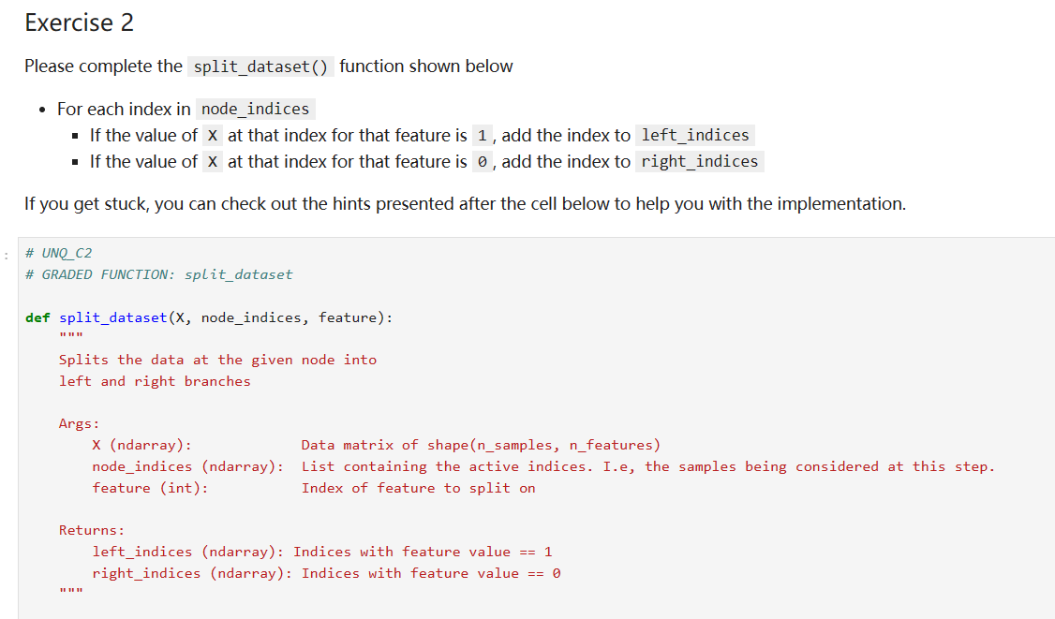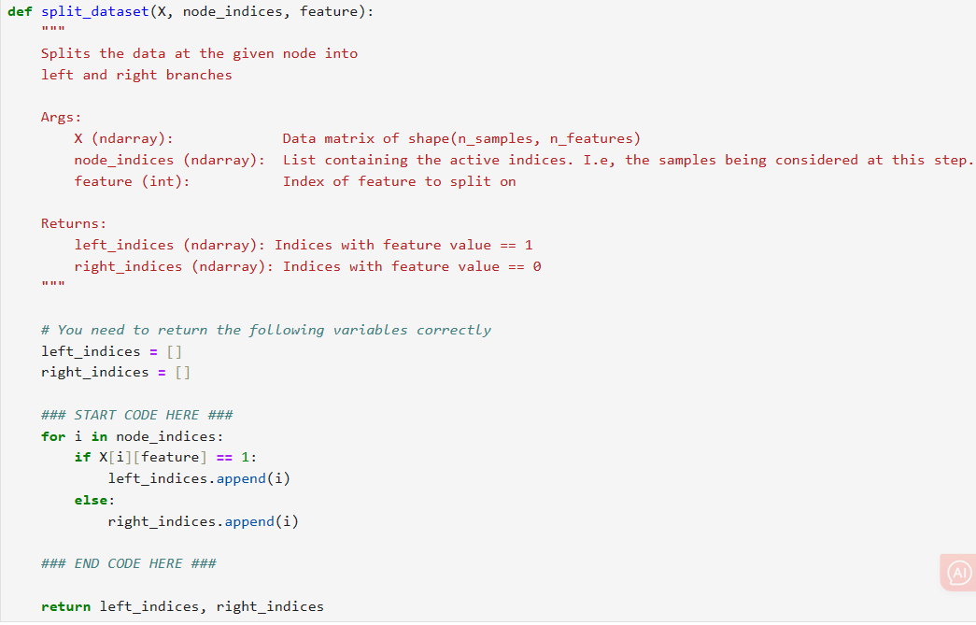
结果：
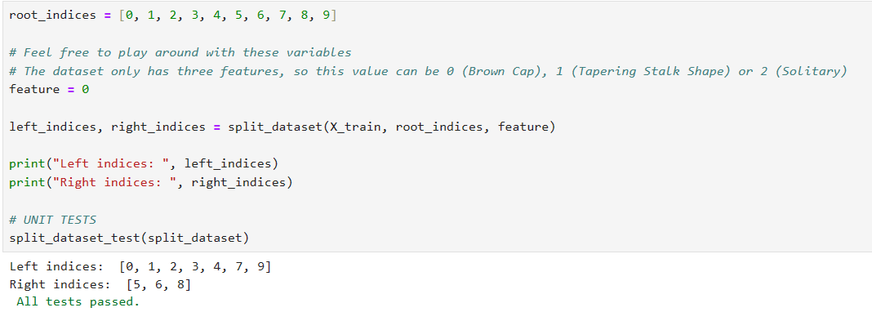
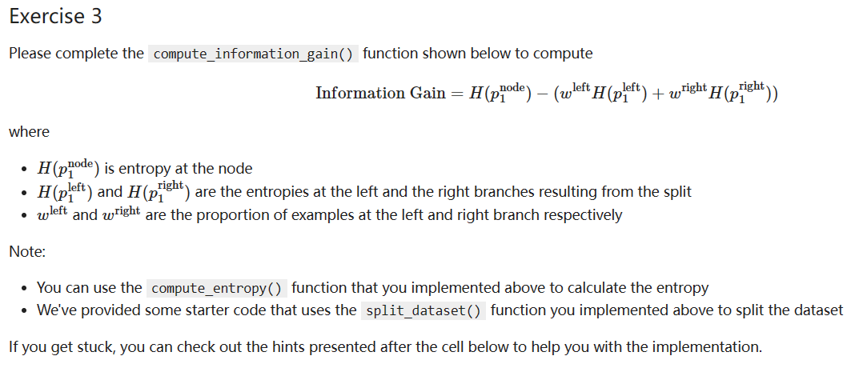
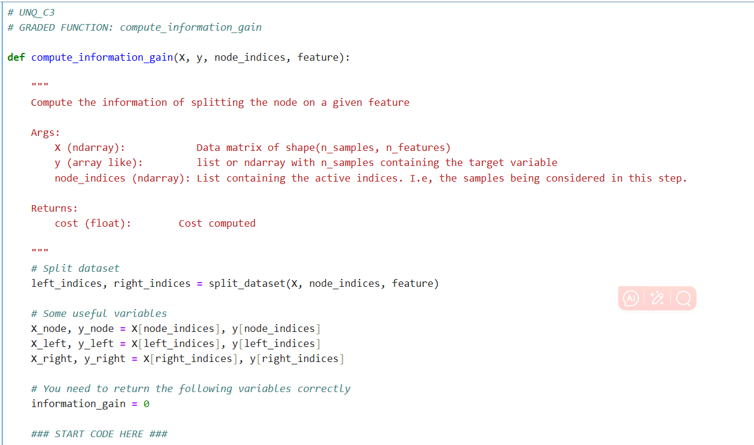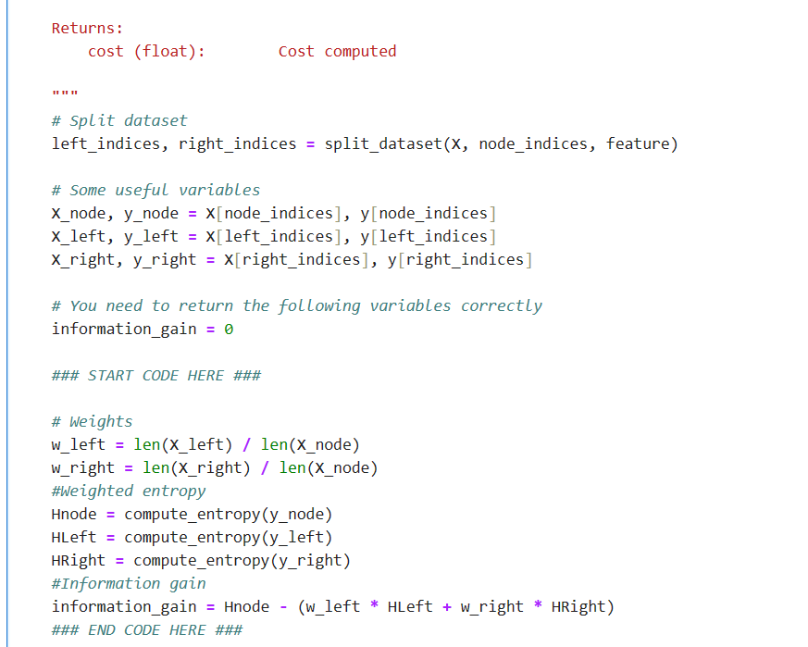
结果：
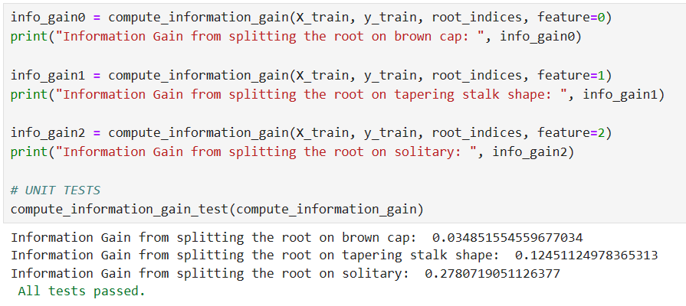
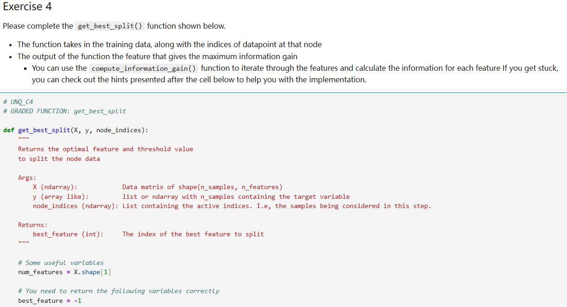
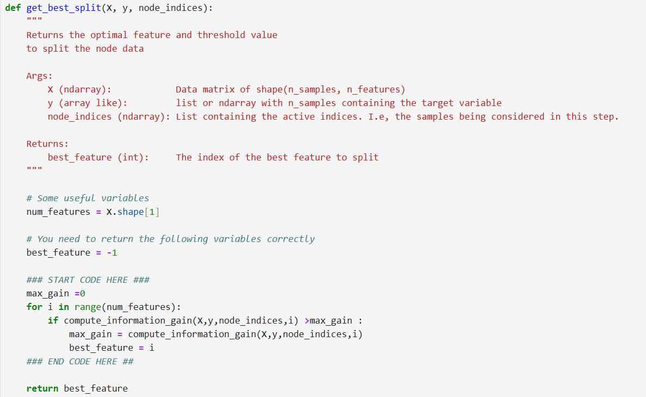
结果：
