Prepared for Rochdale Council demo prep - Tuesday 19 May 2026
Schoolgle School Improvement Assessor
Visual demo prep sheet: explain the product, the data layers, and why this is different from normal school reporting.
Core message
Schoolgle helps councils, trusts and schools move from disconnected data and manual reporting to one source-labelled improvement workflow: data to insight to evidence to action to inspection readiness.
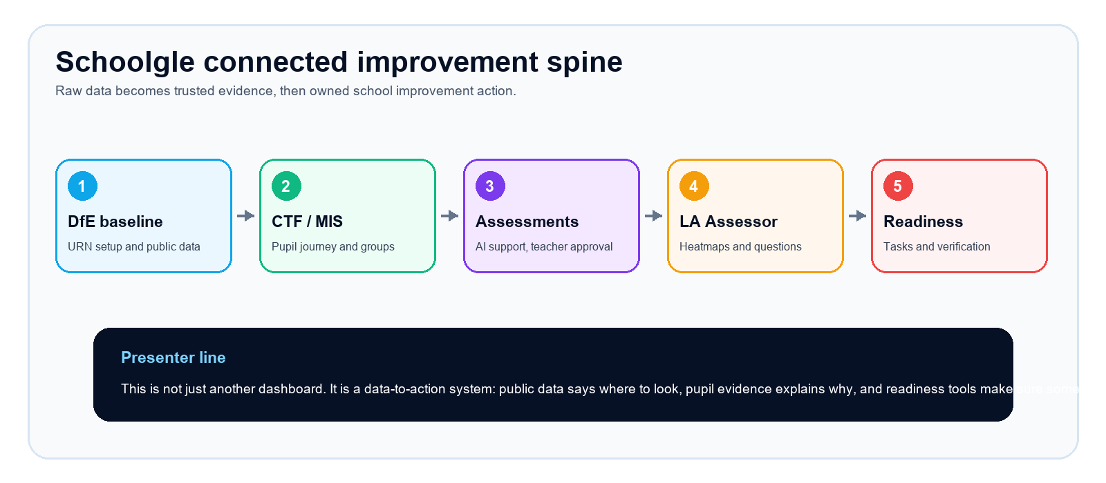

PRESENTER FLOW
Simple run of show
Start with the LA/trust view  - Works out of the box from school URNs and DfE data.  - Shows the schools to look at first.  - Saves manual spreadsheet and report production. | Add the evidence layers  - School assessment captures show the current self-view.  - CTF/MIS unlocks pupil journey and subgroup analysis.  - Assessment Creator creates teacher-approved evidence during the year. | Finish with action  - Trust/LA Assessor identifies the pattern.  - Ofsted Readiness turns concerns into evidence checks and tasks.  - Reports can support governors, reviews and inspection prep.
One sentence to keep repeating
This is not just showing numbers. It is helping leaders ask better questions, evidence the answer, produce the report and make sure the right action happens.
What makes this different  - Useful from public DfE data before upload.  - Stronger when CTF/MIS and assessment data are connected.  - Source labels prevent muddled claims.  - AI supports analysis and report production, not hidden judgement. | Who this helps  - Councils without enough data analyst capacity.  - School improvement teams preparing visits.  - Headteachers preparing governor reports and Ofsted evidence.  - Teachers who need lighter assessment workflows.
Demo caveat
Screenshots use the current local demo environment. Rochdale would have its own schools, URNs, LA comparators and connected assessment data. Treat demo values as example data unless Rochdale provides them.

DEMO STOP
1. Trust / LA Assessor: overview layer
Use this screen to explain that Schoolgle starts by bringing the trust or local authority picture together: data captures, DfE context, key findings and schools to investigate first.
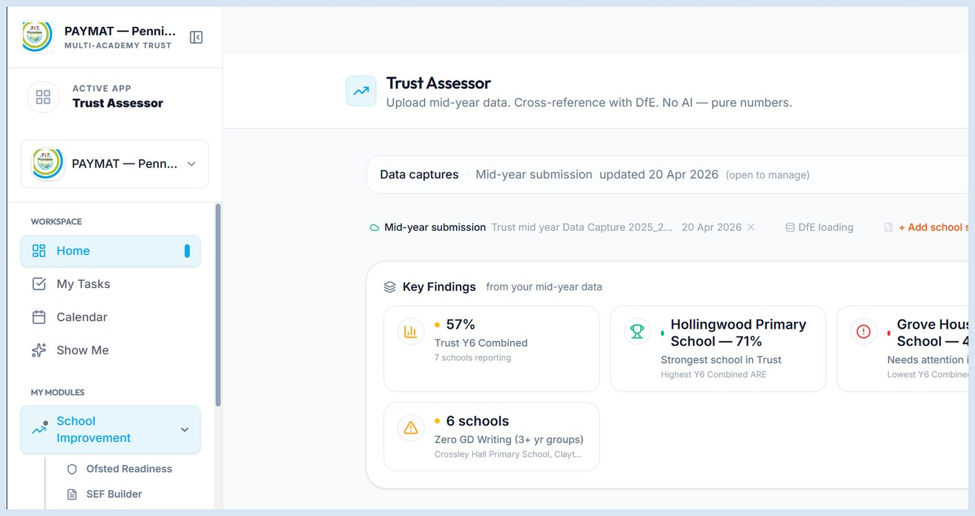
What to say  - Command centre for school improvement conversations.  - Separates current school-submitted assessment from public DfE data.  - Saves rebuilding Excel reports for every meeting. | Why it matters  - Prioritise which schools need conversation first.  - See patterns across schools, not isolated reports.  - Generate questions for improvement visits.

DEMO STOP
2. Assessment Intelligence: evidence during the year
Use this screen to explain the next layer: create short assessment checks, support marking and moderation, and feed teacher-approved evidence back into the assessment spine.
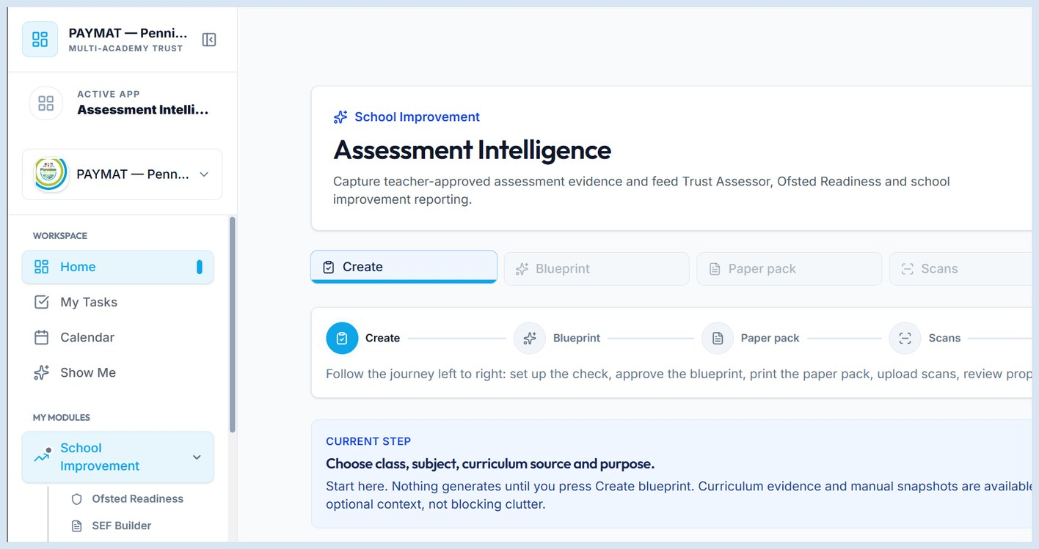
What to say  - Moves beyond historic data.  - Teachers create targeted checks linked to curriculum.  - AI supports marking; the teacher approves the judgement. | Why it matters  - Creates Ofsted-relevant evidence during the year.  - Can reduce reliance on generic testing packages.  - Supports governor meetings and review reports.

DEMO STOP
3. Ofsted Readiness: from insight to action
Use this screen to explain the bridge: data concerns should not sit in a dashboard; they should become evidence checks, tasks, owners and verification.
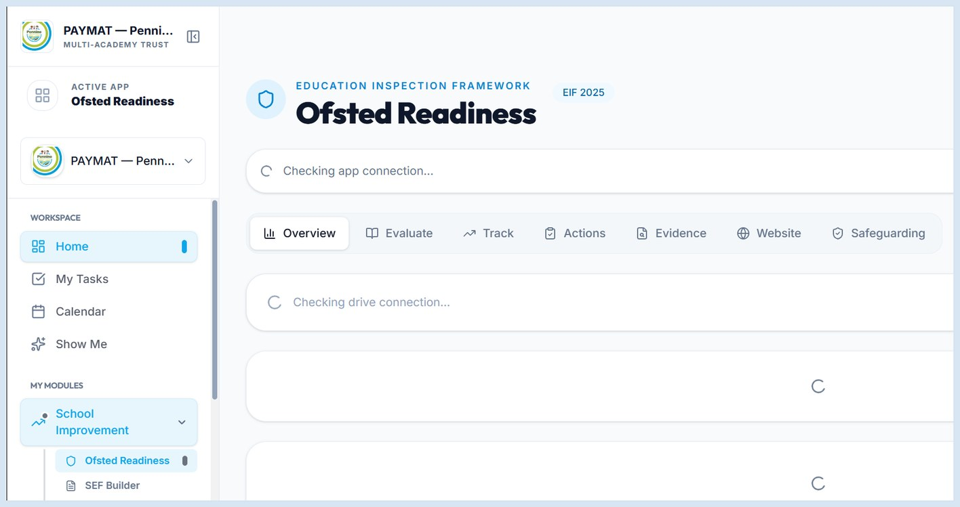
What to say  - Trust Assessor identifies the signal.  - Ofsted Readiness holds evidence, actions and follow-up.  - The goal is ongoing readiness, not inspection panic. | Why it matters  - Leaders can evidence what they did in response to data.  - Actions are owned and visible.  - Readiness becomes a cycle, not a one-off report.

PRESENTER CRIB SHEET
Close the demo with the so what
The buyer pain  - Schools and councils have data, but not enough time or analyst capacity.  - Public data is useful but rear-view.  - Current school data needs validation and evidence.  - Governor and review reports take too long to write manually. | The Schoolgle answer  - Start with every school from DfE and URN data.  - Layer in assessment, CTF/MIS and teacher-approved evidence.  - Generate report-ready summaries with source labels.  - Push concerns into readiness tasks and evidence checks.
Closing line
The product is not just showing Rochdale numbers. It is helping Rochdale ask better questions, evidence the answers, produce the reports, and make sure the right actions happen before Ofsted or school improvement reviews.
If they ask what data we need  - Minimum: school list and URNs.  - Recommended: termly assessment exports.  - Best layer: CTF/MIS pupil-level data with FSM, SEND, EAL and context flags. | If they ask about AI  - AI supports marking, moderation and narrative.  - Teacher or leader approval is the control point.  - The system labels DfE, school-submitted and teacher-approved data. | If they ask about reports  - Use the same source-labelled data for governors and review visits.  - Reports can be generated whenever needed.  - Aim: remove manual report-writing burden from busy schools.

