Introduction to Operating Systems – 19.09.19

* Module accessed through 50% CA and 50% Exam
* Will be learning DOS (Disk Operating System)
* Labs are graded out of ten in brightspace.
* User defined functionality / Functionality defined Usability
* UDF: Functions are added based on users, and how they use a system.
* DFU: Functions are designed, and users are expected to follow those functions.
* Computers have limited resources, “Control System” allocates resources to processes without it’s (the control mechanism) allocated resources being consumed.
* If this were not true, computers may crash. Or become overloaded, leading to large idle times for components = inefficient
* Kernel manages the hardware, sits between hardware and operating system.
* Kernel is a hardware process and cannot be accessed by the operating system without enough permissions.
* Kernel = Control System
* Kernel operations take precedence over every other process.
* (Speculation: This implies the existence of a process scheduler in the Kernel?)
* On Start-up, Kernel’s first task will be to check all components (BIOS)
* Kernel =? BIOS
* Kernel =? Firmware
* Shell Above Kernel = User accessible (through normal means)
* Shell = Command line interface, Command Prompt. E.G Windows PowerShell, WINDOWS, DEBIAN, etc
* User Applications, I.E Cuda, CS;GO, Adobe Photoshop, any app really.
* Hardware > Kernel > Shell > Applications *(This is priority based, Kernel has highest priority, followed by Shell, etc)*
* Each level can only access one level below.
* However, calls can be put in to get past this, I.E SYSTEMCALL.
* Application – contacts SHELL – SHELL contacts KERNEL – KERNEL utilises HARDWARE
* Scheduler =? Kernel
* Services – Windows
* Utilities – Windows
* These “SYSTEMCALLS” are used to contact lower levels of hardware.
* “trap” = Kernel prevents certain operations from occurring to prevent error *(Application requests to use memory that another program is using, etc)*

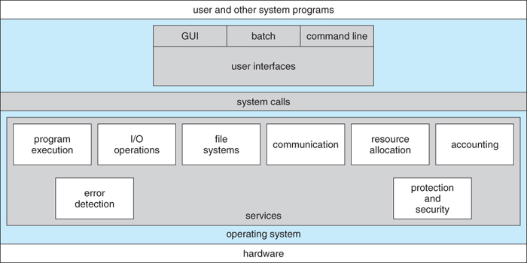

* Operating System: System… (*Moved too fast to get the definition, check Brightspace notes)*
* Windows Key + R > Then type “cmd” > Press Enter
* ^ This opens a command line interface
* Desktop > Tower/Monitor computer setup
* Client = User
* Server = Processes operations, or distributes resources to Clients *(usually over the internet)*
* “Service” = Command a user requests, and a action that the server does in response.
* “Cloud” = Web-Based servers
* Most servers run a Linux distribution, as Linux has the most development time in servers. = More functions, easier to use, more resource efficient
* Unix > Linux
* Unix precursor to Linux
* Most operating systems are descendants of Unix (All of the ones you care to mention, really)
* Android originally camera OS
* All electronics us OS’s, most are specialised Linux distributions for specific tasks.
* ADA – VERY BASIC LANGUAGE/OS setup – very safe, doesn’t crash – runs on heart monitors, manufacturing systems
* Types of OS = Personal Computers, Servers, Mobile Electronics, Embedded
* **IMPORTANT: SIGN IN AND SETUP THE CISCO ACADEMY, YOU GOT AN EMAIL. START READING THE FIRST CHAPTER.**
* Open source = free, all beneficial modifications must be given free, can’t be sold.