User Documentation

Installation
1. Download project.tgz and put it into the folder you want your web documents to be created in
2. Extract the files in project.tgz using the command tar xzvf project.tgz
3. Set the permissions with the command chmod –R 777 391_photoshare
4. Run setup_w16.sql to initialize the database tables

User Manual Main Page (index.php)
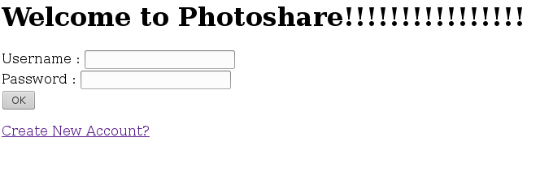

This is the login page that is displayed when the website is accessed. You can either login or register.

User management Module

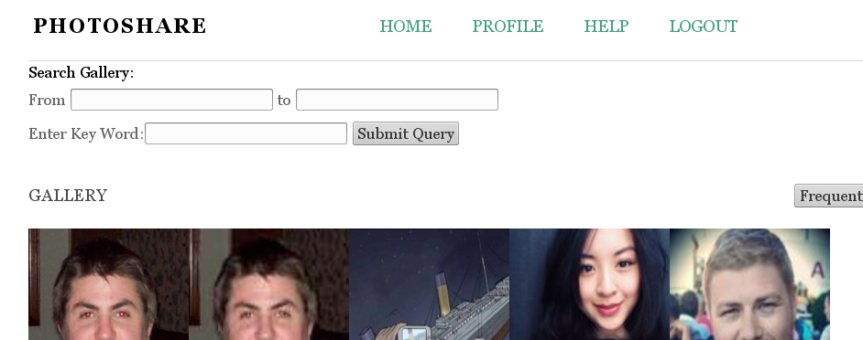

Once you have clicked the sign in button, you be redirected to the main page with the top 5 photos. If the user name or password is invalid then you cannot login.

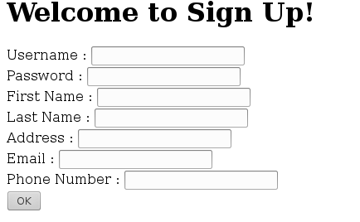

If you click the register button on the sign in page, you will be redirected to provide some basic information

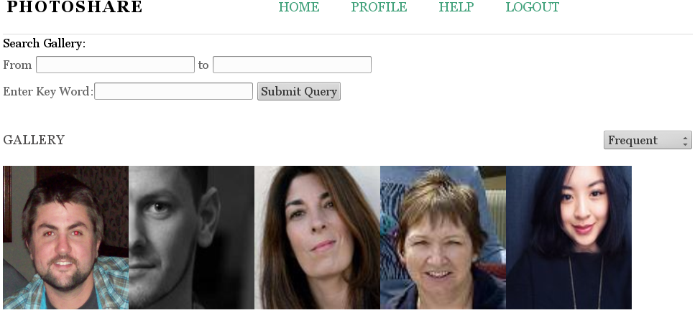

If the user signs is or registers successfully, the main page will be accessed.

Logout


The logout button is displayed in the header at the top of the webpage. Clicking this button will simply logout the user

Upload Module
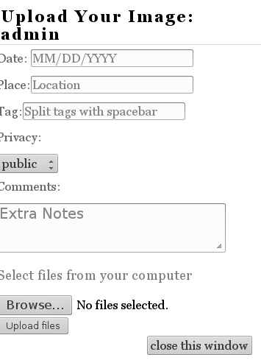

To upload an image, click on the upload button in the profile page. A window will open to this page where you can select an image and input some information about it.

A success message will be displayed if the image was uploaded.

Search Module

If you click profile or home you can search images.

You can search by keyword or by dates or frequency. You will only be returned pictures permitted for you to see. Eg. You pictures, pictures uploaded by friends in groups, and public pictures.
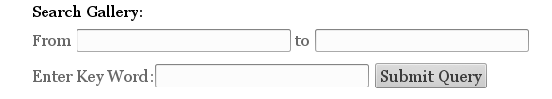

Results will be displayed to you.
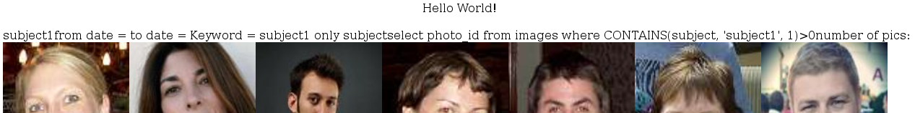

Display Module

If you click on profile, you will be shown a table of your pictures. You can then update or delete images by clicking on them.

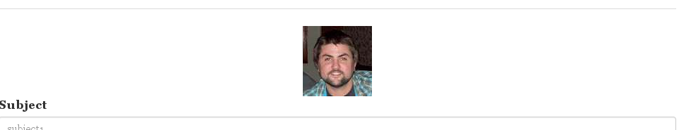

Updating
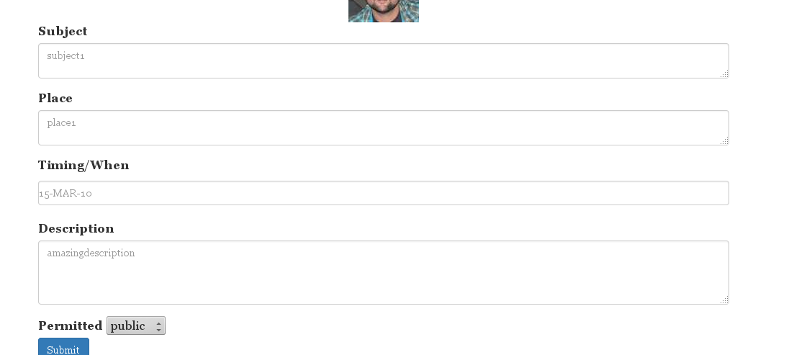

Deleting


Security Module

Groups: Users can login, create groups, and add and remove friends to these groups. Only restriction is the group name must be unique to the user that is logged in.

Register: Users registers with a unique username. We check if the username is already in the database, preventing the same users to have the same username.

Logging In: Users cannot login without providing a valid username and password or else the page dies.

Images: Images have a unique owner in the database. Each image can only be viewed by users who have permission to see the image. For example the user who views the picture is in the same group as the user who uploads the image. Or the image can be set to public.

Data Analysis Module

If the user logged in, is an admin, they will have the ability to access admin.php page where they can do searches on images and users. They can also view some analytics about the data cube.
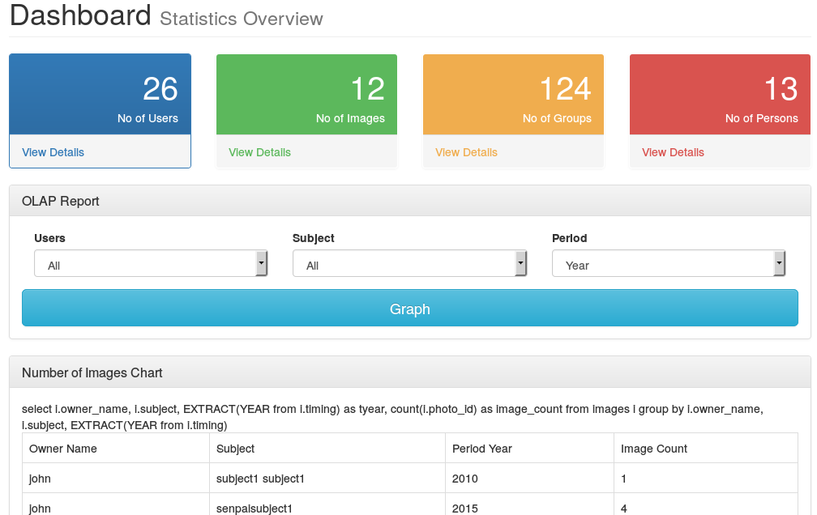

Groups

If the user logged in, they will have the ability to access group window where they can do create groups and add/remove users.

