

Department of Electrical & Computer Engineering

Airborne Sampling/Sensing of Distal Volcanic Ash

Project Group Meeting 10

Agenda

Date: Friday 3rd June 2016

Time: 2 - 3 pm

Venue: VH 457

Chair: Parth Thakur

Secretary: Jake Campbell

1. Apologies:

* None

1. Minutes:

* (Attached)

1. Matters arising

* Arrival of sensors
* Test rig
  + Filter test rig
  + Fall rate test rig

4. Correspondence

* Info from the CAA
* Order of OPC-N2

5. Progress Reports:

* Jake Campbell –Modelling
* Jamie Van de Laar – test rig
* Parth Thakur – Electrostatic sensors
* Michael Shanaher – Telemetry
* Ryan Taylor - Sampling

6. Other business:

* NIL

Volcanic Ash test rig:

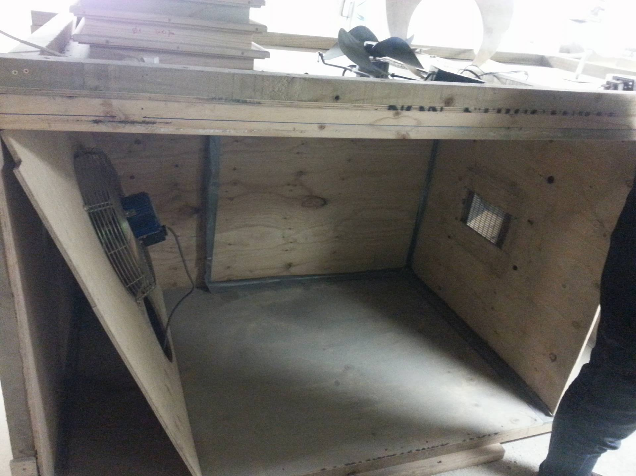

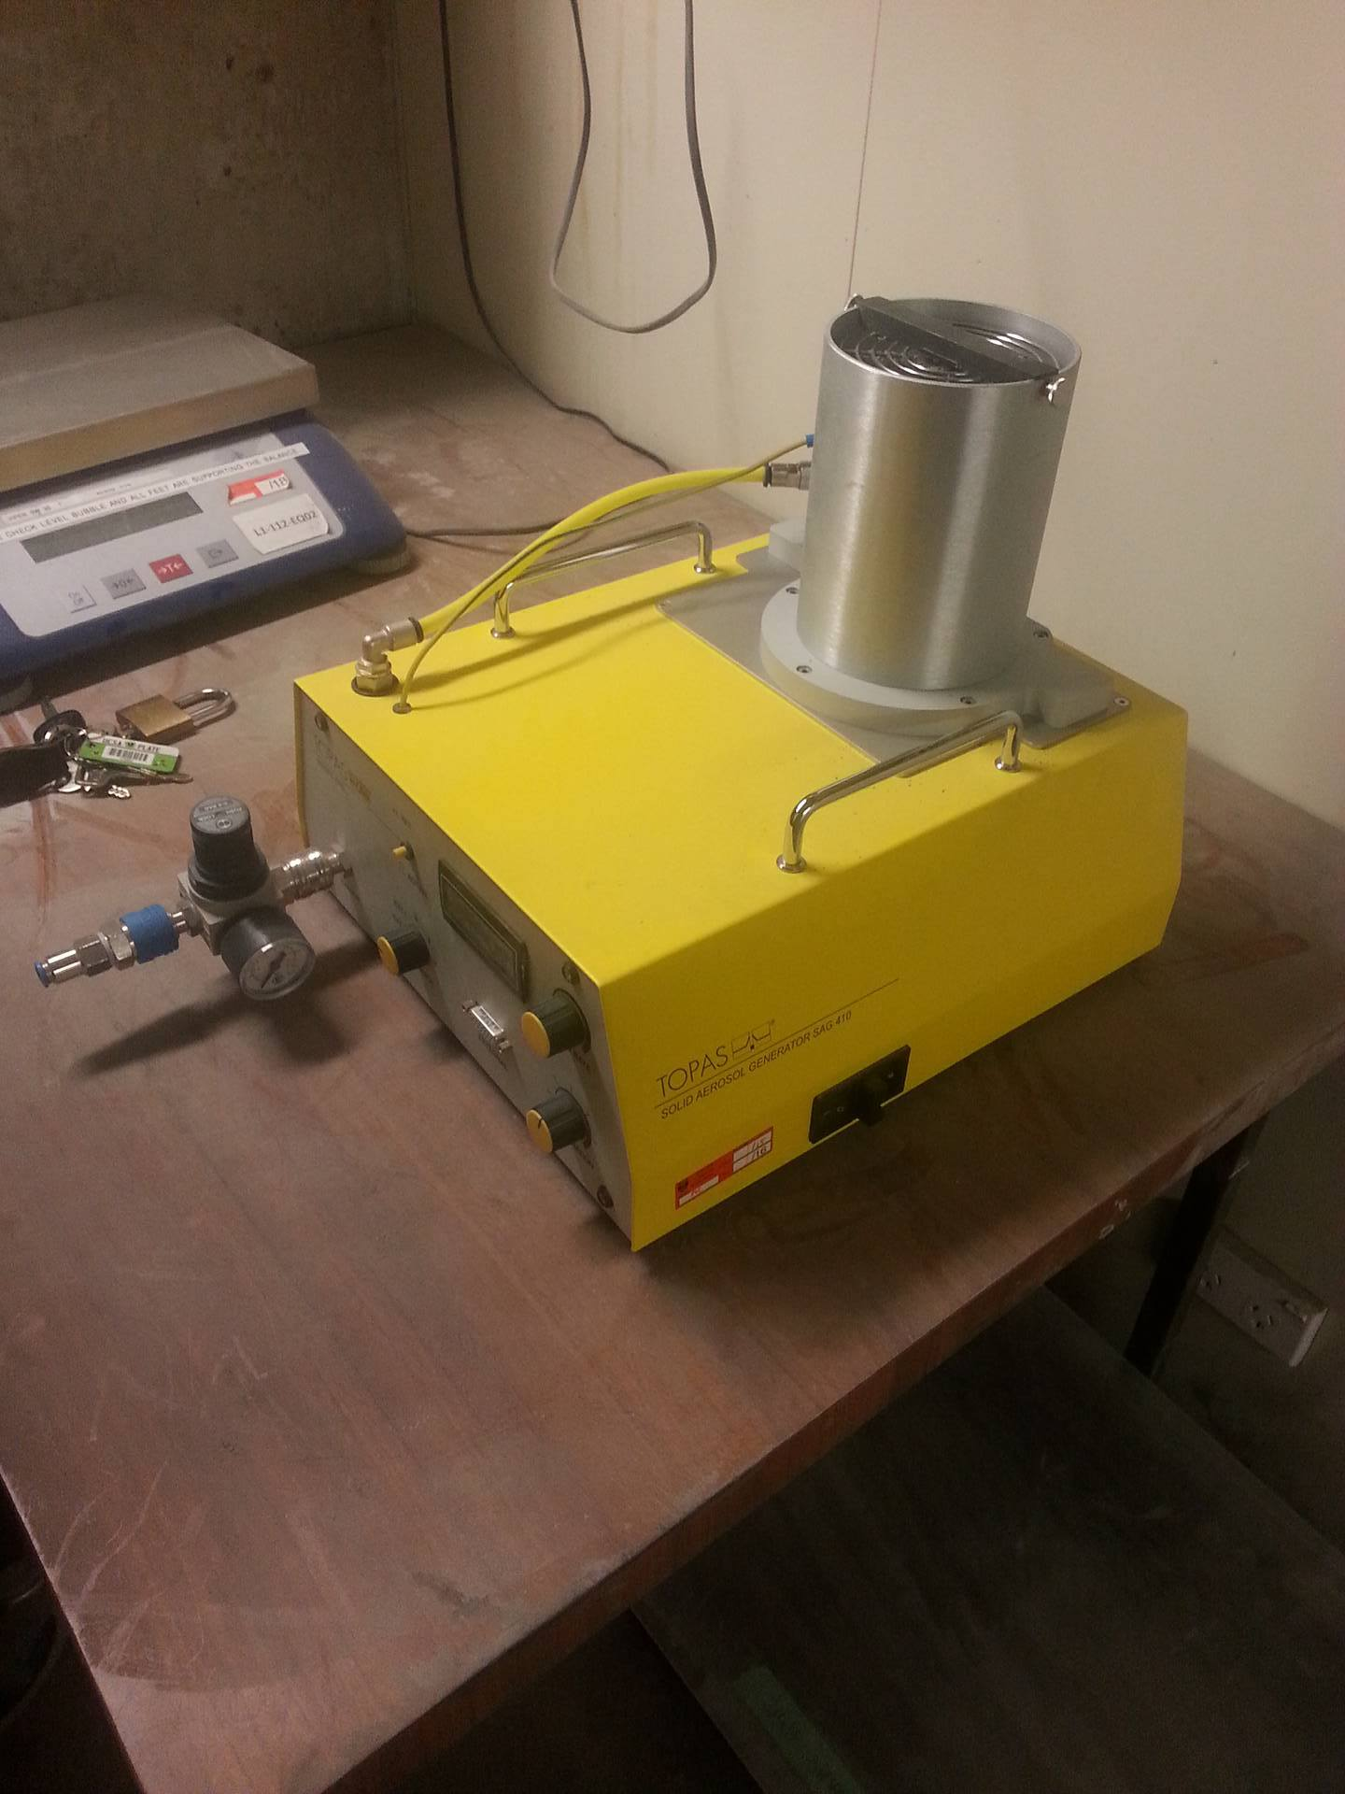

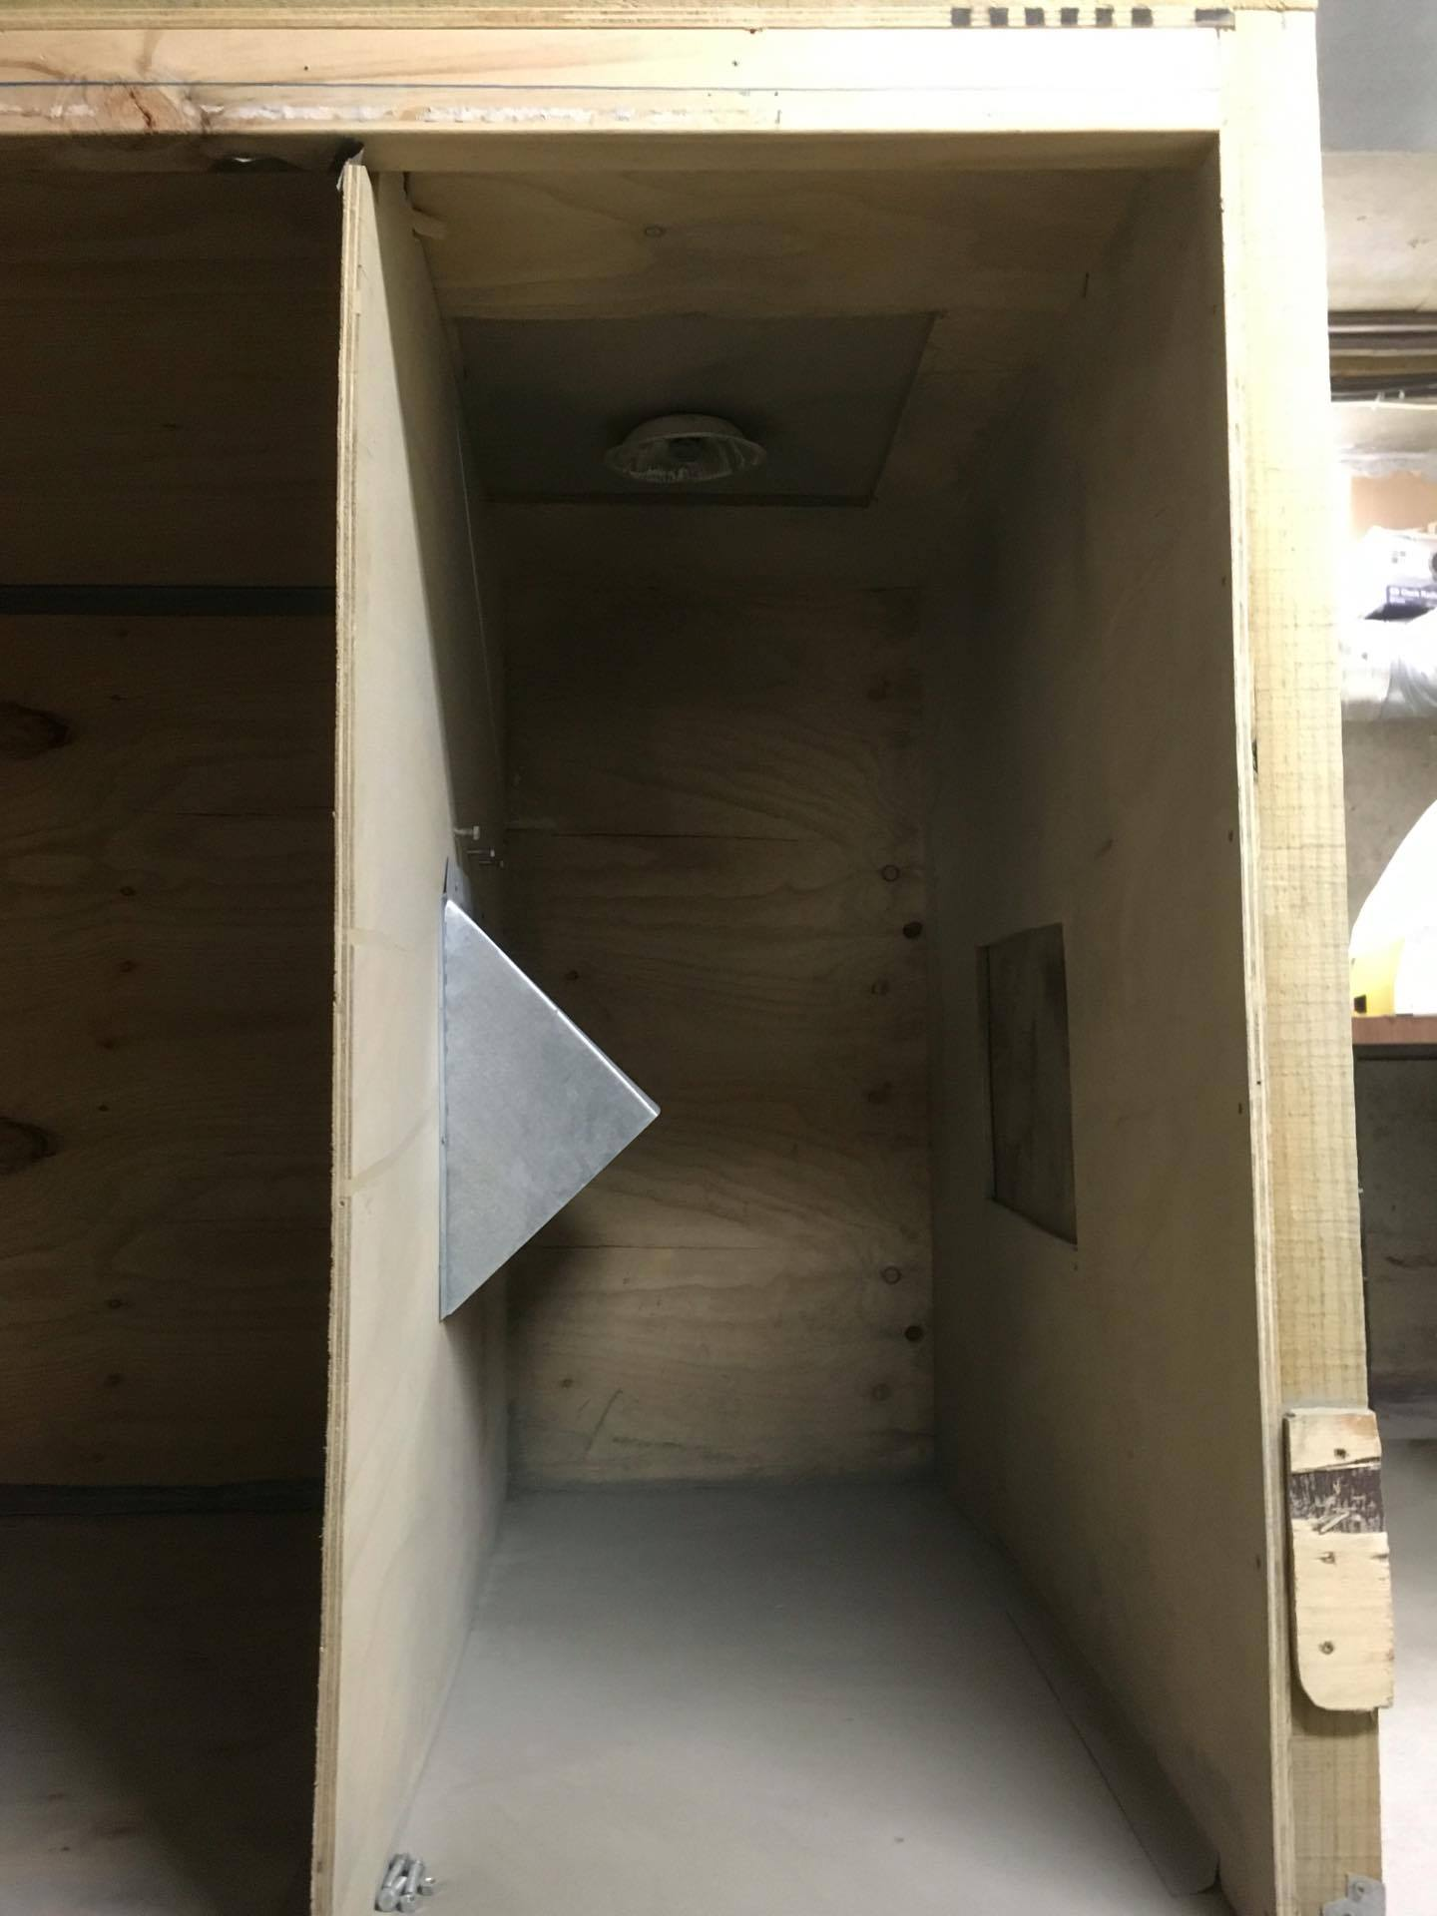

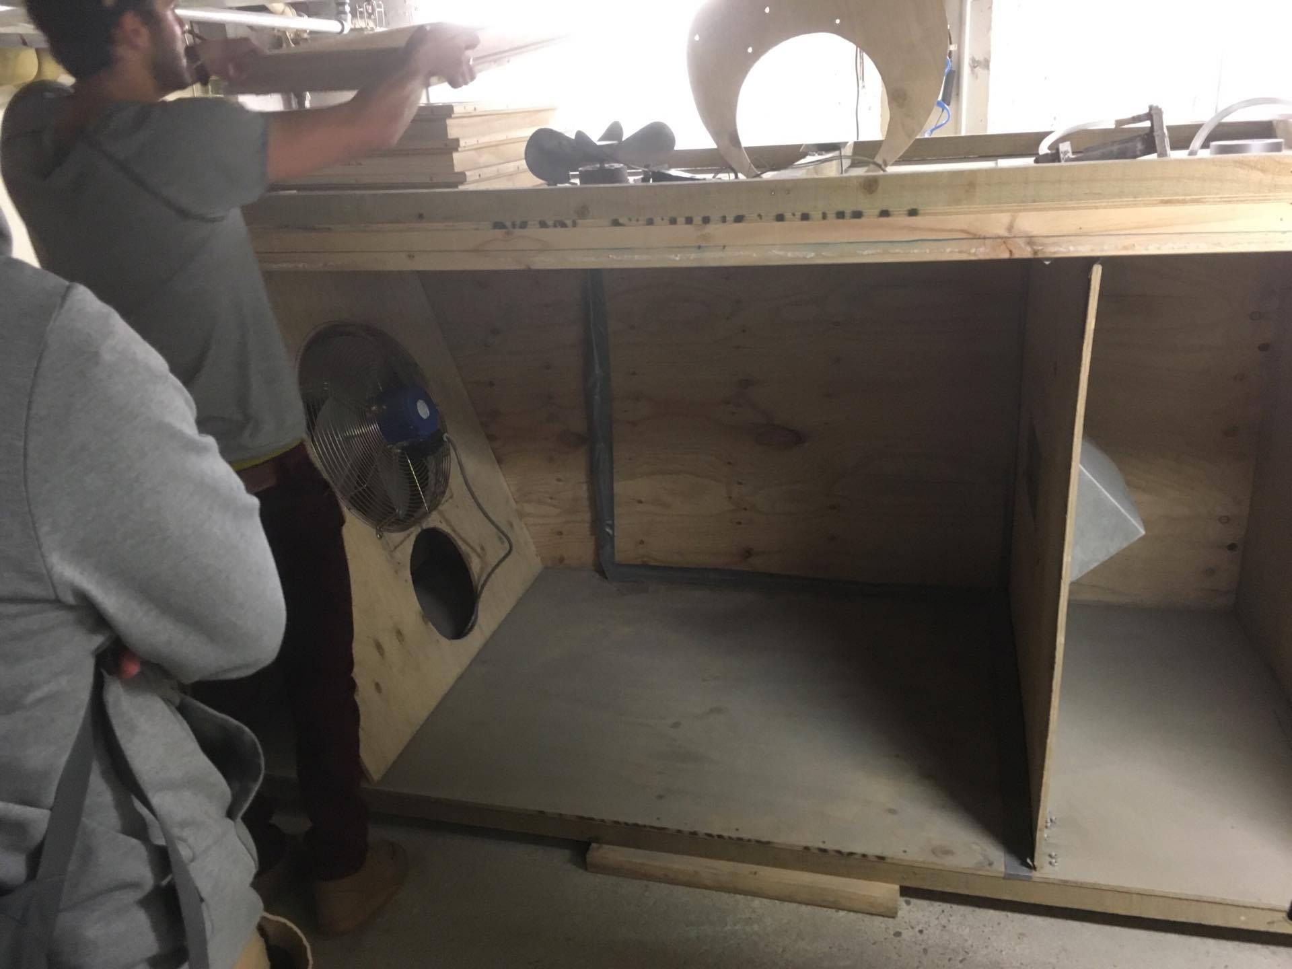

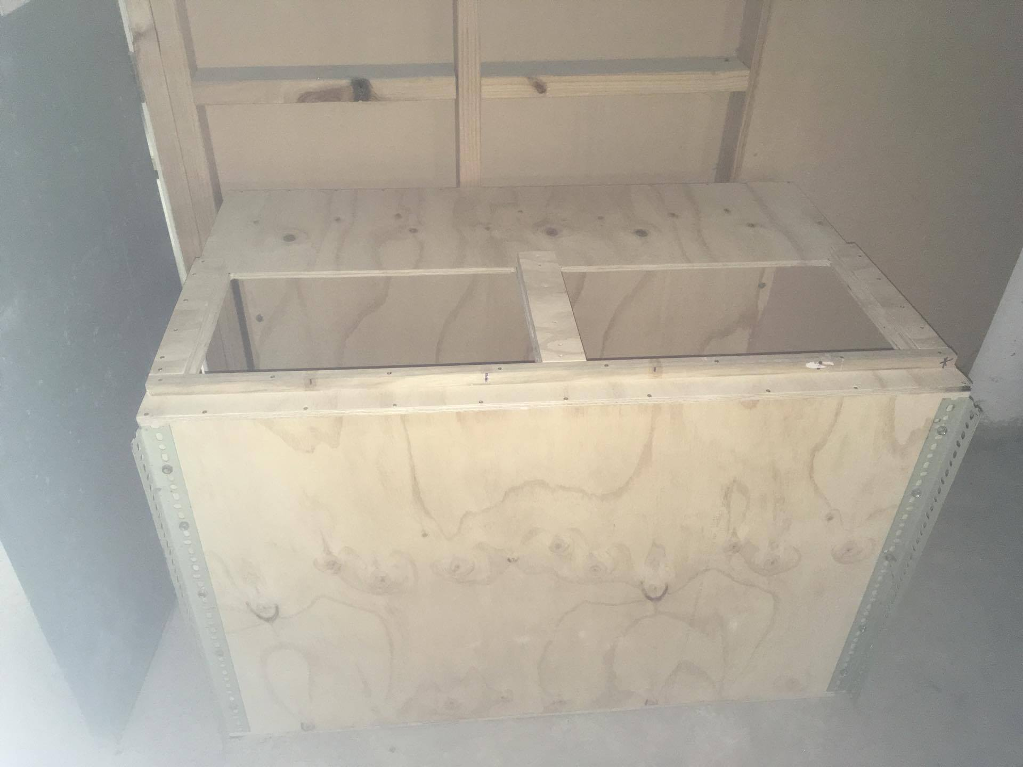

Minutes

**Minutes of the weekly meeting 18 March 2016**

**Present:**

Maan Alkaisi, Adrian Weller, Jamie Van de Laar, Jake Campbell, Parth Thakur, Ryan Taylor, Mike Shanaher

**1. Apologies:**

* NIL

**2. Minutes from last meeting**

* (look at Minutes, may 6 2016.doc)

**3. Matters arising**

* NIL

**4. Correspondence**

* Talk to Kelvin Barnsdale about CAA regulations for UAV fail safe system.
* Got in touch with George Williams to look at UC’s test rig.

**5. Progress Reports:**

* Jamie Van de Laar

Contacted University Mech. Department for wind tunnel.

Found source for MDF but will not have access for a while.

Aerosol Test rig will not be useful for static sensors.

No particle sensors have arrived.

Look at shooting ash particles from aerosol generator

* Jake Campbell

Looking at modelling how the environment effects the plane and its flight path.

Look at how all individual components will fit together.

* Mike Shanaher

Ran standard Pixhawk configurations on the UAV.

Currently trying to connect a radio controller.

Look at developers guide to operate the plane to our specifications.

* Parth Thakur

Electrostatic sensor will have small voltage rise so will need signal amplification.

Look at different signal circuits.

* Ryan Taylor

Concept development of ash capture system.

Tape has to be bigger than 23mm dia.

System can simplified and 3D printed.

Overall dimension: ~ 60 x 70 mm. Subject to change?

What if plane lands on water?

* Adrian

OPC sensors ordered, no updates on its location.

No Cost for shipping yet, can easily send the wind tunnel fan if required.

Can get in touch with CAA to ask about high altitude testing.

6. **Other business:**

* NIL

**Meeting ACTION LIST**

|  |  |  |
| --- | --- | --- |
| **ACTION** | **ASSIGNED TO** | **DUE DATE** |
|  |  |  |
|  |  |  |
|  |  |  |

**Next meeting date: Friday 03 June 1400hrs**