

Department of Electrical & Computer Engineering

Airborne Sampling/Sensing of Distal Volcanic Ash

Project Group Meeting #14

Agenda

Date: Friday July 15th 2016

Time: 10.30 am

Venue: VH 457

Chair: Mike Shanaher

Secretary: Parth Thakur

1. Apologies

No apologies

2. Minutes

(Attached)

3. Matters arising

* RFD900+ modem bundle
* Plane Interior- Fig 1
* Wind Tunnel- Fig 2

4. Correspondence

5. Progress Reports:

* Ryan – Ash sample capture – cyclone separator
* Mike – Telemetry
* Jamie – Sensor testing
* Jake – Temperature monitoring and airflow
* Parth - Electrostatic sensor

6. Other business:



Figure 1. Plane Interior

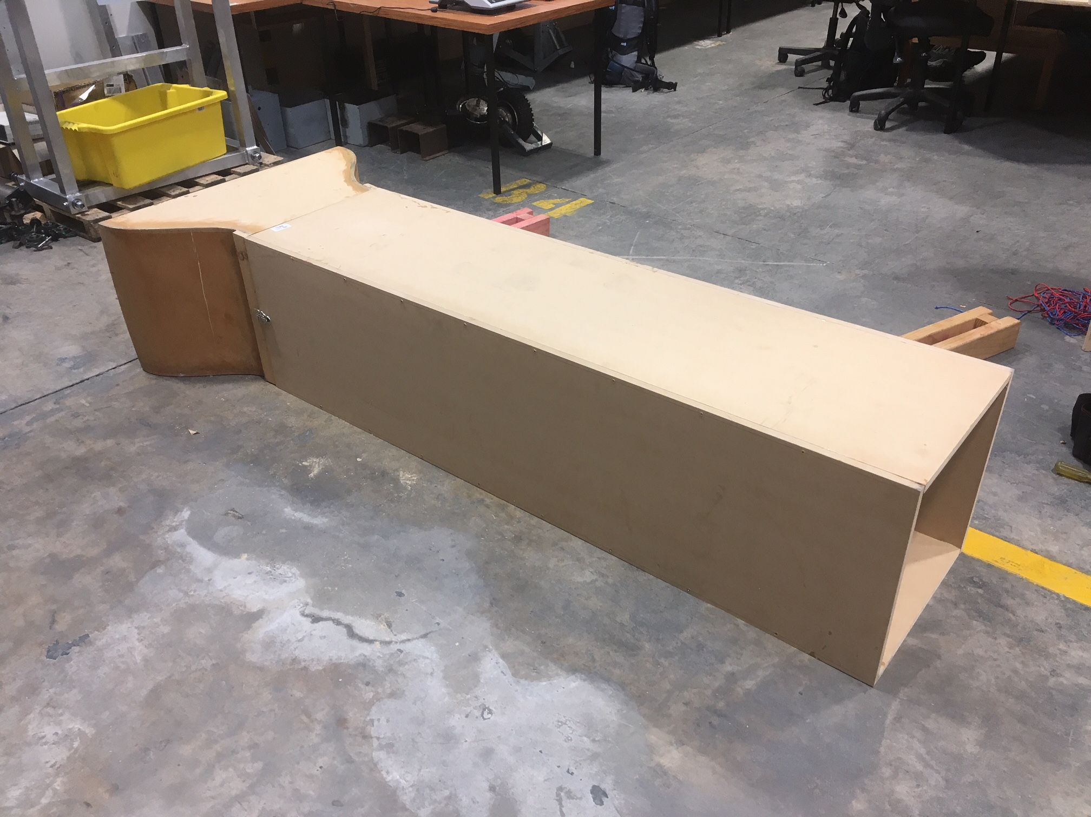

Figure 2. Wind Tunnel

Minutes from last meeting below:



Department of Electrical & Computer Engineering

Airborne Sampling/Sensing of Distal Volcanic Ash

Project Group Meeting #13

Minutes

**Minutes of the weekly meeting 8 July 2016**

**Present:**

Maan Alkaisi, Adrian Weller, Jamie Van de Laar, Jake Campbell, Ryan Taylor, Mike Shanaher

**1. Apologies:**

* Parth Thakur

**2. Minutes from last meeting**

* (look at Minutes, July 1 2016)

**3. Matters arising**

* No matters arising from previous meetings

**4. Correspondence**

* UC finance messaged Mike stating that he should pay for the airspeed sensor via Paypal and contact their department for funds.

**5. Progress Reports:**

* Ryan Taylor
  1. Took a more calculated approach and redesigned the cyclone collector.
  2. Needs to now focus on building the wind tunnel so that he can test prototypes correctly.
  3. Julian, the mechatronics technician has car batteries that he can provide but they may not work. Maan suggested seeing what portable supplies are available from the power electronics lab.
* Mike Shanaher
  1. Mike talked about organising the payment for the airspeed sensor. He will talk to the finance department directly and place a new order, likely by credit card.
  2. Testing of updated firmware was supposed to be conducted. After difficulties uploading firmware Mike suggested that the most likely cause was a lack of SD cardmounted on the Pixhawk. He will purchase one and try again.
  3. He has had a brief look into long range radio telemetry modules. In order to achieve the expected range we may need, we are likely going to have to purchase an off the shelf set that may cost between 300 and 400 dollars.
* Jamie Van de Laar
  1. Now at the stage of using the Aerosol generator to achieve a consistent ash concentration representative of what we expect to encounter at altitude.
  2. Has slightly modified the embedded ash sensing software to calculate particle size distributions as percentages of total mass concentration.
  3. Connectors for the OPC have been made so can now start work with interfacing to the raspberry pi.
* Jake Campbell
  1. Jake has produced a MATLAB script to compute the centre of mass of the aircraft based on the mass and position of the UAV’s electronics.
  2. The plan for next week is to consider the entire aircraft design and how the electronics are going to be mounted within the fuselage.
  3. Need to start looking at expected flight paths which will influence air frame selection, power capacity and temperature control.
* Adrian
  1. Adrian suggested visiting UC somewhere close to the first week of August. We have pencilled in a date of Friday, 5th August to meet.
  2. Adrian is expecting to contact the CAA regarding requirements for conducting test flights.

6. **Other business:**

* Following meetings were re-scheduled to a time of 1030, Friday.

**Meeting ACTION LIST**

|  |  |  |
| --- | --- | --- |
| **ACTION** | **ASSIGNED TO** | **DUE DATE** |
| Each to continue work on their own part of the project as detailed above |  |  |
|  |  |  |
|  |  |  |

**Next meeting date: Friday 15 July, 10:30am**

