

Table of Content

**1. Our Team** 3

1.1 Kalin Chervenkov 3

1.2 Nikola Peshev 3

1.3 Boris Savov 3

1.4 Dimitar Bodurov 3

**2.** **Our Goals** 4

2.1 Block Diagrams 5

**3. Realization Path** 6

3.1 Firstly 6

3.2 Secondly 6

3.3 Lastly 6

**4. Issues passed** 7

**5. Used Technologies** 8

**6. Future ideas** 8

# **Our Team**

## 1.1 Kalin Chervenkov

* + Frontend Developer
  + [KSChervenkov19@codingburgas.bg](mailto:KSChervenkov19@codingburgas.bg)

## 1.2 Nikola Peshev

* + Backend Developer
  + [NDPeshev19@codingburgas.bg](mailto:NDPeshev19@codingburgas.bg)

## 1.3 Boris Savov

* + Designer
  + [BNSavov19@codingburgas.bg](mailto:BNSavov19@codingburgas.bg)

## 1.4 Dimitar Bodurov

* + Scrum Trainer
  + [DTBodurov19@codingburgas.bg](mailto:DTBodurov19@codingburgas.bg)

# **Our Goals**

We wanted to create an intuitive system with great ease of use to empower Burgas’s fire station. Through all the time we were in close relations with the MVR and the Burgas Fire Department. We took close care to make it automated and easy to work with.

## **Block Diagrams**

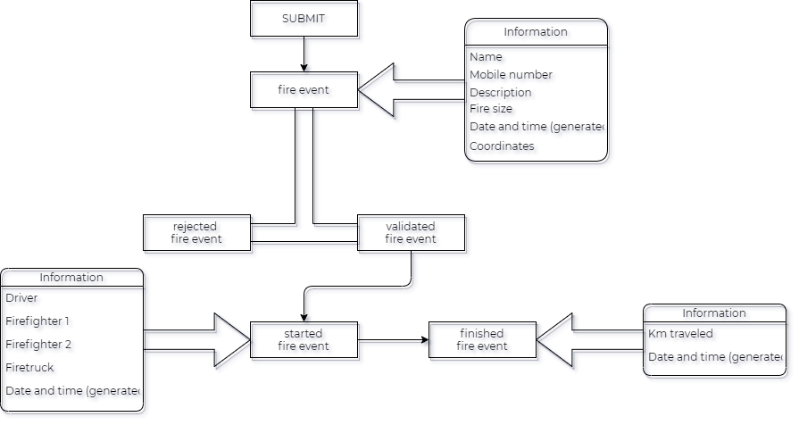

# **3. Realization Path**

## 3.1 Firstly

* + We wrote an Email to the Burgas Fire Station to get all the information required to start our project. Then we Started organizing our tasks.

## 3.2 Secondly

* + The first thing we did was the main page and the design sketches. Then we started with our login and report forms

## 3.3 Lastly

* + After we were done with the main page, we started doing the dispatcher and driver sites. The data storage we are using is “localstorage” and we had a great time doing the main logic behind it.

# 

# **4. Issues passed**

The first problem we had was our organization. To fix that we got together and made a “master” plan. We debated on how to shape the workflow of our users with differing versions. When we put it all together we got to work.

When writing the backend code, we had a big issue with objects losing their classes when read from the local storage we used for saving our data. To fix that we implemented a new way of reading items from it.

We had problems with the order of operation in the frontend, because we relied a lot on using event listeners.

# **5. Used Technologies**

Html, SASS, JavaScript – main languages

Butter.js, Leaflet.js, Charts.js, OSRM leaflet, rellax.js - libraries

Visual Studio Code – IDE

Teams – communication

Photoshop – Graphic design

Github – source control system

Microsoft Word, PowerPoint – Documentation and presentation

# **6. Future ideas**

We still have to implement a lot of useful functions and features. Some of them are:

1. Implement a better hosting and storage solutions
2. Adding more information for the average user
3. Add more event statistics
4. Translate the website
5. Add more animations