Part 1 – Using AWS PartyRock
Step 1: Open PartyRock
Open your web browser and go to:
https://partyrock.aws
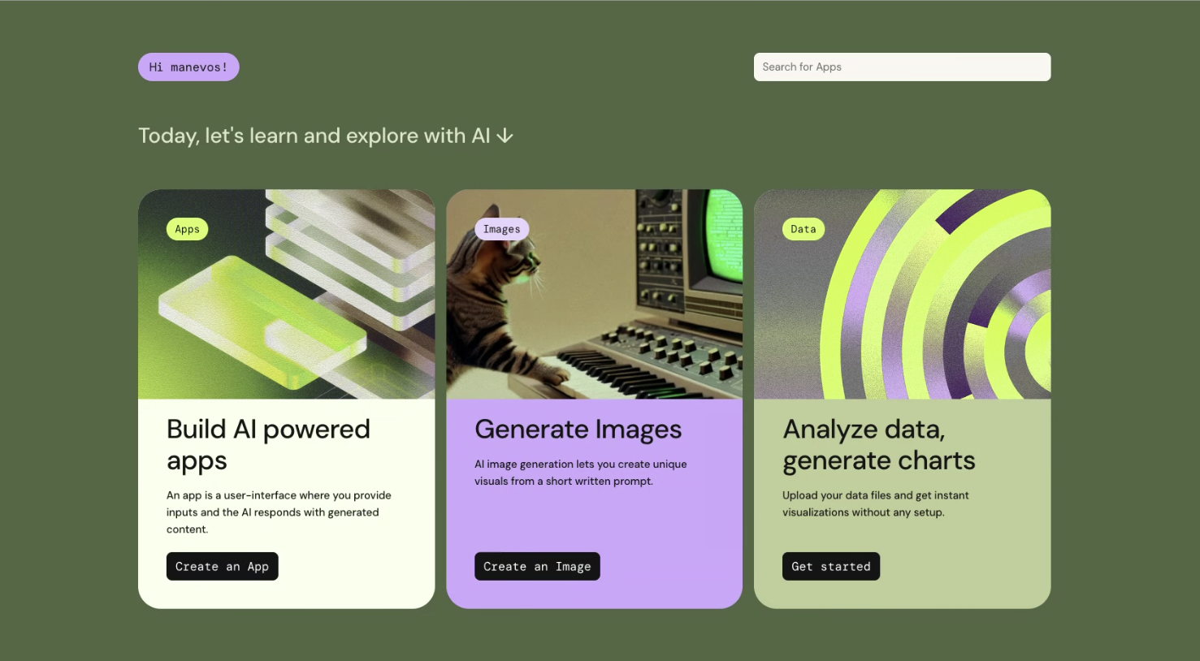

Step 2: Sign In
- Click Sign In.
- Select Continue with Amazon.
- Log in using your Amazon account.
  - If you do not have one, click Create your Amazon account.
  - Follow the prompts.
  - Verify your email if requested.
Note: PartyRock is free to use with an Amazon account.

Step 3: Explore the Home Page
After logging in you will see:
- Featured AI Apps
- Search Bar
- My Apps
- Create App button
Take a few minutes to explore the interface.

Step 4: Open a Chat or AI App
Depending on your instructor's directions:
- Open the provided PartyRock app or
- Create a simple AI app that accepts text input.

Step 5: Paste Your Prompt
Copy your completed prompt.
Example:
Role:
You are an experienced career counselor.
Context:
I am a Biology major interested in medical careers.

Task:
Recommend five careers and explain how AI is changing each profession.

Format:
Create a table.

Constraints:
Limit to 500 words and use language appropriate for college students.
Paste the prompt into the prompt box.

Step 6: Generate the Response
Click:
Generate
Wait for PartyRock to create the response.

Step 7: Save Your Results
Choose one:
- Copy and paste into your report
- Take a screenshot
- Print to PDF
Label this section:
PartyRock Output

Part 2 – Using ChatGPT
Step 1: Open ChatGPT
Go to:
https://chatgpt.com
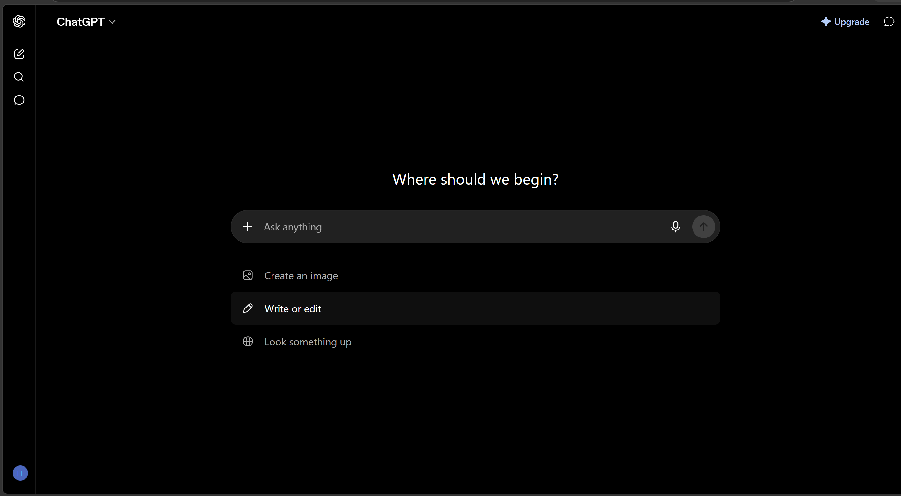

Step 2: Sign In
Click:
Log In
Use:
- Google
- Microsoft
- Apple
- Email address
Create a free account if needed.

Step 3: Start a New Chat
Click:
New Chat

Step 4: Paste Your Prompt
Paste the exact same prompt you used in PartyRock.
Do not change the wording.
This allows you to compare the responses fairly.

Step 5: Submit the Prompt
Press:
Enter
Wait for ChatGPT to respond.

Step 6: Save the Response
Copy the entire response into your report.
OR
Take a screenshot.
Label it:
ChatGPT Output

Part 3 – Using Microsoft Copilot
Step 1: Open Copilot
Go to:
https://copilot.microsoft.com
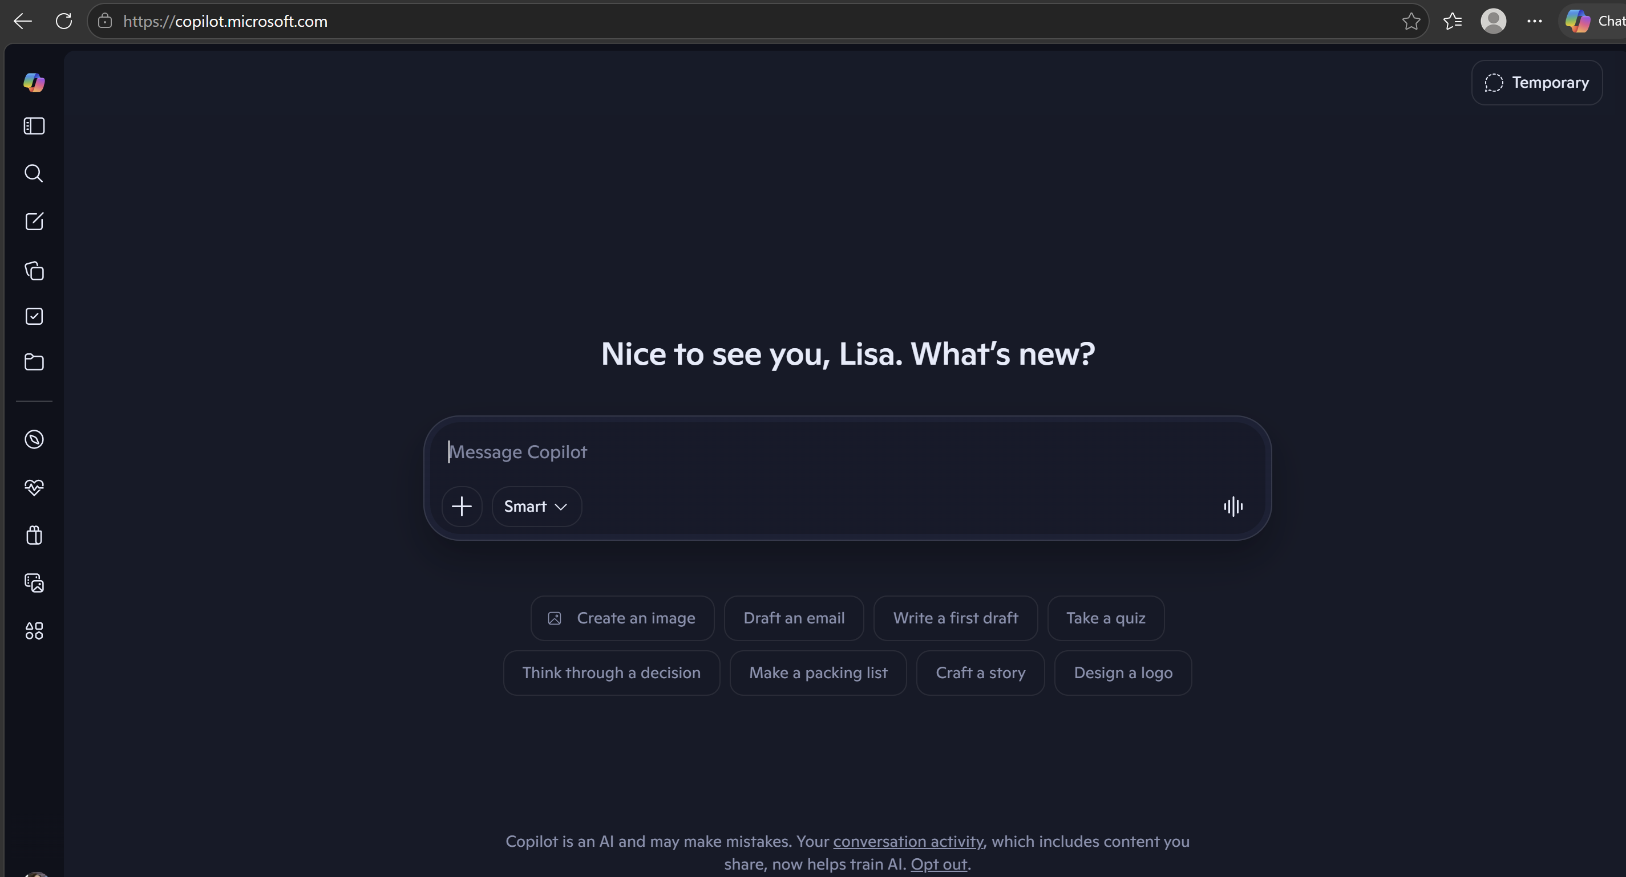

Step 2: Sign In
Click:
Sign In
Use your Microsoft account.
If needed:
Create a free Microsoft account.

Step 3: Start a New Conversation
Click:
New Chat

Step 4: Paste the Same Prompt
Paste the exact prompt used with PartyRock and ChatGPT.
Remember:
Do not change the wording.

Step 5: Submit the Prompt
Press:
Enter
Allow Copilot to generate a response.

Step 6: Save the Response
Copy the response into your report.
OR
Take a screenshot.
Label:
Microsoft Copilot Output

