5 April 2018

Dr Cathy Wilkinson

Executive Director

Environment Protection Authority

200 Victoria Street

CARLTON VIC 3053

Dear Dr Wilkinson

Regulatory Impact Statement for the proposed Environment Protection (Residential Noise) Regulations 2018

I would like to thank the staff of the Environment Protection Authority (EPA) for working with our team on the preparation of the Regulatory Impact Statement (RIS) for the proposed *Environment Protection (Residential Noise) Regulations 2018*. The current Regulations are scheduled to sunset in October 2018.

Under section 10 of the *Subordinate Legislation Act 1994*, the Commissioner for Better Regulation is required to provide independent advice on the adequacy of all RISs prepared in Victoria. The Commissioner’s role is to advise on the adequacy or otherwise of the analysis presented in the RIS, rather than the merits or otherwise of policy or regulatory proposals. A RIS is deemed to be adequate when it contains analysis that is logical, draws on relevant evidence, is transparent about assumptions made, and is proportionate to the proposal’s expected effects. The RIS also needs to be clearly written, so that it provides a suitable basis for public consultation.

I am pleased to advise that the final version of the RIS received by us on 3 April 2018 meets the adequacy requirements of the *Subordinate Legislation Act 1994*.

The *Environment Protection (Residential Noise) Regulations 2008* (‘current Regulations’) manage residential noise by specifying what is considered ‘unreasonable noise’. It is an offence to cause ‘unreasonable noise’ from any residential premises under the requirements of the *Environment Protection Act 1970*. The Regulations primarily prohibit the use of specific items of noise-generating equipment, such as air conditioners and electric power tools, at certain times — if their use can be heard from another residence. The Regulations also contain limited exemptions to the application of these restrictions. Police and local government officers refer to the prescribed items and prohibited times to determine whether to investigate and manage noise issues, without having to specifically measure noise levels in each case to determine ‘unreasonableness’.

The RIS outlines the problems associated with unreasonable residential noise such as its effects on human health and productivity, and outlines the range of regulatory and non-regulatory approaches used to manage residential noise in Victoria. To inform development of the RIS, the EPA used information from surveys of local governments, police officers and the community about the operation of the current Regulations, and exposure to residential noise. Based on this information, and initial consultation with stakeholders, the EPA considers that residential noise remains a significant problem that is likely to increase as urban development and the shift to medium and high density living continues, and that the Regulations should be re-made to continue to manage residential noise in future.

Based on an analysis of several options for improving the effectiveness of the current Regulations, the EPA proposes two changes going forward. These apply to the use of air conditioners:

* a reduction in the prohibited times that apply to the use of air conditioners — as a result, air conditioners would be able to be used for an extra hour each evening; and
* a full exemption from the application of prohibited times for the use of air conditioners during Heat Health Alert periods (issued by the Department of Health and Human Services when the temperature reaches a threshold level above which heat-related illness and mortality increases substantially) — this would mean no restriction on the use of air conditioners during these times.

The RIS also discusses a suggestion to change restrictions on ‘concrete pours’ (undertaken during construction activities). However, the EPA recommends no change to these restrictions as it considers that there is insufficient evidence to show that the additional benefits of earlier concrete pours will outweigh the negative impacts on residents.

In addition to re-making the Regulations with the changes outlined above, the EPA states that it will explore other initiatives to complement the operation of the Regulations. Examples include providing clear information to local government, police and the community about roles and responsibilities regarding residential noise management, and developing toolkits to help community members resolve their residential noise issues. The EPA will consider these options following public consultation on the RIS and draft Regulations.

As you know, it is government practice that this letter be published with the RIS when it is released for public consultation.

Should you wish to discuss any issue raised in this letter, or the implications of new information or policy options identified through the public consultation process for your proposal, please do not hesitate to contact me on (03) 9092 5800.

Yours sincerely

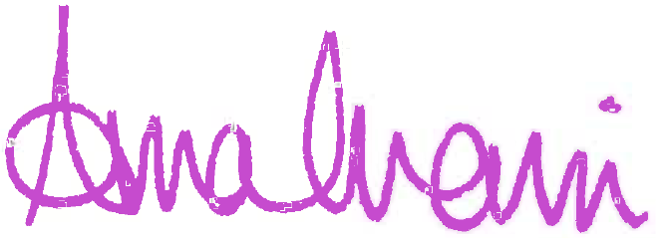

Anna Cronin

Commissioner for Better Regulation