
Regulatory Impact Statement
Supreme Court (Fees) Regulations

5 June 2014
Courts and Tribunal Service
Supreme Court (Fees) Amendment Regulations
Regulatory Impact Statement

This Regulatory Impact Statement (RIS) has been prepared to fulfil the requirements of the Subordinate Legislation Act 1994 and to facilitate public consultation on the proposed Supreme Court (Fees) Amendment Regulations. A copy of the proposed Regulations is provided as an attachment to this RIS.
Public comments and submissions are invited on the proposed Regulations, in response to the information provided in this RIS. All submissions will be treated as public documents. Written comments and submissions should be marked “Supreme Court (Fees) Amendment Regulations” and addressed to

Manager
Courts Policy
Civil Justice Division
Department of Justice
GPO Box 4356
Melbourne Victoria 3000

Alternatively, comments and submissions can be emailed to
legalpolicysubmissions@justice.vic.gov.au
All comments and submissions must be received no later than 5pm on
Friday 4 July 2014.

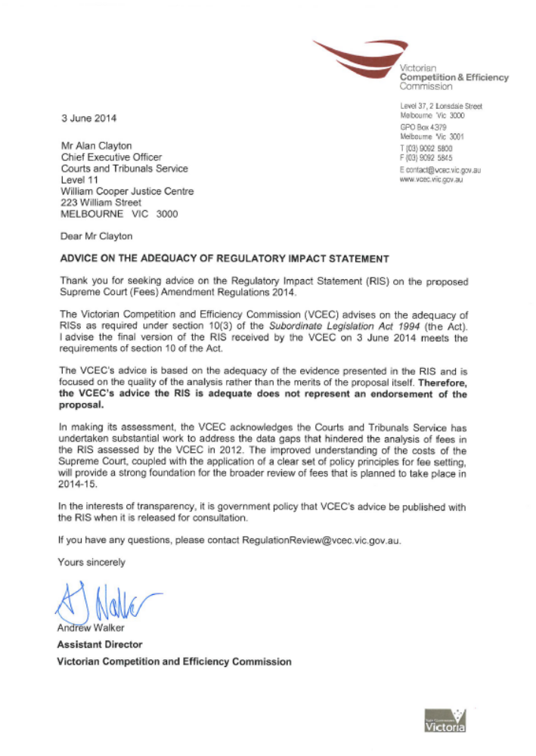

Table of Contents
Executive Summary 2
1 Introduction 8
2 Nature and Extent of the Problem 16
3 Costing and Assessment 22
4 Commercial Court Options 29
5 Court of Appeal 40
6 Consultation and Implementation 44
Appendix 1 Modelled Costs of Court Processes 45
Appendix 2 Fee Change Summary 47
Appendix 3 Proposed Amendment Regulations 51

Executive Summary

Background
The civil justice system provides the means by which disputes between parties can be resolved, legal rights enforced and remedies obtained through binding orders, and in the case of the Supreme Court, probate granted. Court fees are charges by which the cost (or a proportion of the cost) of services delivered in a civil jurisdiction are recovered. In the case of civil matters before the Supreme Court, the Supreme Court (Fees) Regulations 2012 set the fees payable by litigants and applicants appearing in that Court.
The Supreme Court is the superior court for the State of Victoria. The Trial Division of the Supreme Court has original and unlimited jurisdiction in civil cases (unless otherwise excluded by statute). The Supreme Court also hears appeals from other Victorian courts and VCAT.
Typically, civil matters considered at the Supreme Court are complex in nature and the Supreme Court will be a court of choice when track record, expertise, timeliness and the standing of the Court are a consideration. This is reflected in the costs (and fees) of the Supreme Court relative to other courts
Over the past few years, the Supreme Court has sought to reform its civil jurisdiction in order to improve service delivery. Reforms introduced at the Commercial Court and at the Court of Appeal, which have been approved by government, are designed to meet Court users’ expectations and have increased efficiency in the delivery of Court services.

Nature of the Problem Being Addressed
The current fees for matters at the Commercial Court and at the Court of Appeal do not take into account the cost of reforms, which have been introduced or are in the process of being introduced. Specifically, those reforms involve the recruitment of new Registry staff and Judicial Registrars to case manage matters and, in the case of the Commercial Court, an e-enabled registry system designed to provide a 24/7 service to litigants and other Court users.
Early introduction of the reforms has been well received by Court users and have already begun to expedite the resolution of cases.
The early reforms were implemented on a trial basis, with funding provided through to 30 June 2014. Given that the initial reforms have been successful in achieving their objectives of providing a sought after and specialised service, the full and continued implementation of those reforms is recommended. The RIS proposes to meet the ongoing costs of providing the service through an increase in fees to the users of those services.
The total cost of the reforms to be recovered is $1,225,527, comprising Commercial Court costs ($960,873) and Court of Appeal costs ($264,654).

Objectives of proposed changes
The proposed regulations prescribe adjustment to the fees imposed on users. The new arrangements aim to set fees that:
• are based on efficient and transparent costs
• encourage optimal use of Court services
• do not unnecessarily impede access to justice
• provide for transition with minimum disruption to Court operations and users.

Principles
The design and assessment of options for amending the current Commercial Court and Court of Appeal fees have been guided by the following principles.
- The fee structure should reflect the role of the Court of Appeal and the Commercial Court in Victoria’s civil justice system.
- Access to justice is to be safeguarded.
- Fees should be applied equitably.
- The fee structure should support and enable efficient Court operations.

Court of Appeal
A range of options has been considered for amending Court of Appeal fees. Given that the amount to be recovered is relatively small, a brief analysis of those options is set out in this RIS. The preferred approach is to change the structure of the commencement fee, so that there is a single commencement fee and to target other amendments at those fees where there is very low cost recovery.

Commercial Court Options
The following range of options has been identified to address the problems with the Commercial Court fee structure.
- Increase Commencement fees in the trial division of the Supreme Court. Under this option, all Commencement Fees in the trial division would increase, not just those in the Commercial Court.
- Increase all existing Commercial Court fees. This option would increase all fees applying to the Commercial Court to fund the recently introduced reforms.
- Targeted increase of existing Commercial Court fees. This option would increase specific fees applying to the Commercial Court where the reforms have changed the way cases are managed and where there is currently low cost recovery.
In each case, the extent of the fee increase would be limited to meeting the cost of the reforms.

Approach and Analysis
In analysing the suitability of the options, the current review undertook a detailed analysis of the costs of service provision and considered opportunities for adjusting the existing fees structure within the framework of the current legislation. The options were then analysed using Multi Criteria Analysis and the level of cost recovery was determined in line with Victorian Government cost recovery guidelines.
Cost of service provision
The Supreme Court has only recently used costing activity to inform the size of individual fees; previously this data was not routinely captured. In developing this RIS, detailed process mapping based on activity based costing principles was used to assess the costs of Court services for each option.
This analysis included
- in-depth mapping of the processes undertaken by Court staff and judicial officers
- estimation (to the nearest minute) of the time spent by Court staff and judicial officers to deliver the service
- application of the above data to calculate costs incurred based on the salaries and oncosts
A subsequent combination of staff interviews and data sampling of times related to activities were then validated against known operational Court costs. The modelled costs of Court processes are provided at Appendix 1.
Multi Criteria Analysis
The identified options were assessed using Multi Criteria Analysis, a qualitative decision tool commonly used to systematically compare options within a structured and transparent framework. The criteria applied in this analysis are the Principles discussed above. The following table sets out the scores assigned to each option.

Table 1: Summary of Multi Criteria Analysis
Criteria | Option 1 | Option 2 | Option 3
The fee structure should reflect the role of the Commercial Court in Victoria’s civil justice system. | 2 | 3 | 3
Access to justice is to be safeguarded | 0 | -1 | -1
Fees should be applied equitably | -1 | 2 | 4
The fee structure should support and enable efficient Court operations | 1 | 2 | 2
Score | 2 | 6 | 8

Preferred Option
The preferred Option is Option 3 - Targeted increase of existing Commercial Court fees. This will ensure that the current reforms are retained and costs be equitably levied on those aspects of service which have been significantly enhanced. This option also better aligns Court service fees to the costs incurred by the Court in providing those services.

Comparison of Current and Proposed Regulations
The proposed Regulations amend the existing Supreme Court (Fees) Regulations 2012 to give effect to the fees set out in Tables 2 and 3 below. Because the fees are expressed in the Regulations as fee units, Tables 2 and 3 also indicate the anticipated value of the new fees in 2014-15. From 1 July 2014, all Court fees will increase by 3.1 per cent in line with other government fees.
Table 2 Proposed amendments to Commercial Court fees
Option 3 | 2013-14 Fees | Proposed fee  (2013-14 price) | Percentage change | Anticipated 2014-15 fees
Commencement with entry to list | $3,759.50 | $3,759.50 | 0.0% | $3,876.70
Commencement - general C&E Corporations matters heard by a judge | $961.70 | $961.70 | 0.0% | $991.70
 | $961.70 | $2,797.80 | New Fee | $2,885.00
Defence & Counterclaim Third party Notices | $961.70 | $961.70 | 0.0% | $991.70
Setting down fee (includes trial day 1) | $1,136.30 | $1,136.30 | 0.0% | $1,171.70
Hearing days – days 2-4 | $590.60 | $642.00 | 8.7% | $662.00
Hearing days – days 5-9 | $986.10 | $1,155.60 | 17.2% | $1,191.60
Hearing days – days 10+ | $1,647.40 | $1,797.60 | 9.1% | $ 1,853.60
AsJ led matters | $961.70 | $961.70 | 0.0% | $991.70
Public Examinations Leave to Issue Summons fee | $961.70 | $961.70 | 0.0% | $991.70
Public Examinations Daily Hearing fee | $ | $642.00 | New fee | $662.00
Appeals from AsJs Application fee | $350.50 | $385.20 | 9.9% | $397.20
Appeals from AsJs Hearing fee | $ - | $770.40 | New Fee | $794.40
Interlocutory process | $350.50 | $770.40 | 119.8% | $ 794.40
Mediation fee – per half day | $318.40 | $ 385.20 | 21.0% | $397.20
Table 3 Proposed amendments to Court of Appeal fees
Court of Appeal  Targeted increases | 2013-14 fee | Proposed fee  (2013-14 value) | Percentage change | Anticipated 2014-15 fees
Notice of appeal | $3,306.30 | A single Commencement fee of  $3306.30 | 0.0% | $3,409.30
Leave application from the Supreme Court | $350.50 | A single Commencement fee of  $3306.30 | 843.3% | $3,409.30
Leave application from other jurisdictions | $961.70 | A single Commencement fee of  $3306.30 | 243.8% | $3,409.30
Setting down & 1st hearing day | $1,136.30 | $1,977.30 | 74.0% | $2,039.00
2nd and subsequent hearing days | $590.60 | $1,309.60 | 121.7% | $1,350.50
Application fee | $350.50 | $770.40 | 119.8% | $794.40
Tables 2 and 3 also show the extent to which the proposed fees differ from current fees. Appendix 2 provides further comparative tables of the current and the proposed fees.

Implementation
If the preferred approach for both the Court of Appeal and the Commercial Court is implemented, changes will take effect shortly after the Regulations being made. It is anticipated that this would occur in August 2014.
Implementation of the fee changes will be supported by training of Court staff, and modifications of operations systems, forms and the Court website.
Notification of the changes will be announced in the Victoria Government Gazette and on the Court website.
The Courts and Tribunal Service and the Supreme Court will monitor data related to fees, such as filing volumes, to assess any impact arising from implementation. This analysis will inform future consideration of fee structures across the Court.
The draft regulations are at Appendix 3.

- Introduction

The Supreme Court of Victoria
The state of Victoria provides access to dispute resolution and rights enforcement processes to meet a range of needs. The processes provided by the Magistrates’ Court, the County Court and the Supreme Court of Victoria constitute a system for the resolution of progressively more complex disputes, while VCAT provides specialised mechanisms for a well-defined range of matters.
The system affords potential litigants with substantial choice of mechanisms for dispute resolution. Within that system:
- The Magistrates' Court can determine most disputes over money or property up to the value of $100,000, however in certain circumstances the Court can hear cases with an unlimited value.
- The County Court has an unlimited monetary jurisdiction in civil matters which is largely concurrent with the jurisdiction of the Supreme Court. In some areas, it has exclusive jurisdiction.
- The Supreme Court is the superior Court for the State of Victoria. The Trial Division of the Supreme Court has original and unlimited jurisdiction in civil cases (unless otherwise excluded by statute). The Court also hears appeals on questions of law from the Magistrates' Court and appeals on questions of law arising from decisions by ordinary and senior members of the Victorian Civil and Administrative Tribunal (VCAT). The Court exercises supervisory jurisdiction over other Courts and VCAT. The Court of Appeal within the Supreme Court hears appeals from the Trial Division of the Court and the County Court.
- Since its inception, VCAT’s purpose has been to provide Victorians with a low cost, accessible, efficient and independent tribunal delivering high quality dispute resolution.
The Supreme Court will be a court of choice when track record, expertise, timeliness and the standing of the court are a consideration. This is reflected in the costs (and fees) of the Supreme Court relative to other courts.
This RIS relates only to increases in fees for the Court of Appeal and the Commercial Court that have arisen to support reforms in those courts. The reforms are designed to improve the flow of work through the courts.
Given the scale of the proposed increases, this RIS gives greater weight of consideration to issues connected to the increased funding of $960,873 required for the Commercial Court reforms than to increases associated with the cost of reforms in the Court of Appeal, which is $264,654.

The Commercial Court
Over the past few years, the Supreme Court has sought to reform its civil jurisdiction in order to improve service delivery. Since 2009, the Commercial Court has been a specialist Court within the Commercial and Equity Division, handling some of the most complex and specialised civil matters before the Supreme Court.
The establishment of a separate Commercial Court Registry in late 2013, featuring legally trained staff and a soon to be appointed Judicial Registrar, support the provision of active judicial case management. Judicial case management of complex civil matters is a key expectation of the legal profession, and one the Supreme Court is keen to meet. Such an approach can also increase the efficiency of the Court, through the appropriate allocation of judicial and Registry resources.
The Supreme Court will shortly restructure the Commercial and Equity Division as the Commercial Court. The new Commercial Court will manage all work that previously flowed into the Commercial Court and the Civil and Equity Division, with the exception of Probate, as well as some other categories that are not commercial in character, or do not require active judicial management.
Previously, applicants could elect (and pay for) direct entry to a specialist list that provided intensive judge-led case management. Under the recently proposed reforms, more cases before the Commercial Court will be subject to intensive case management either by judicial officers or specialised Registry staff, in order to achieve timely resolution of disputes.
At present senior judicial officers (Supreme Court Judges and Associate Judges) manage defended cases. If the proposed reforms are enacted, a Judicial Registrar and legally qualified registry staff will be actively involved in assisting judicial officers in preparing matters for trial and disposing, where possible and appropriate, of matters not requiring a full trial.
The Commercial Court is piloting an e-enabled registry system designed to provide a 24/7 service to litigants and other Court users, based on a proof of concept system that has operated in the Technology, Engineering and Construction list of the Supreme Court since 2011. Following a pilot in the Commercial Court, the new system is expected to be progressively rolled-out across all the rest of the Supreme Court.
As part of an overall package of reforms, the establishment of a dedicated Commercial Court Registry, featuring a Judicial Registrar and legally qualified staff, requires support through the introduction of revised fees. Current funding for Commercial Court reform will sunset on 30 June 2014. The proposed fees will cover the new costs, including the funding of these positions.

The Court of Appeal
The Court of Appeal hears appeals from criminal and civil trials heard by judges of the Supreme Court and the County Court. It also hears some appeals from proceedings that have come before VCAT.
Applicants have no choice of jurisdiction for appeals because the legislation governing appeals determines the course of appeals through the justice system. Some Appeals require Leave of a Judge or Leave of the Court of Appeal before a Notice of Appeal can be filed.
The Court of Appeal has had substantial success in reducing the number of pending criminal cases. Figure 1 shows the impact of revised case flow management arrangements in the Court of Appeal. These arrangements are part of a packet of measures, referred to as the Venne Reforms, that have been effective in both lowering the demand for criminal appeals and dealing with appeals more expeditiously. The principles behind the Venne Reforms are to be applied to civil appeals and provide insights for better case flow management in other Divisions of the Court. The reduction shown here to the end of 2012 has been sustained by the Court and it is now seeking to extend the successful reforms to civil matters.
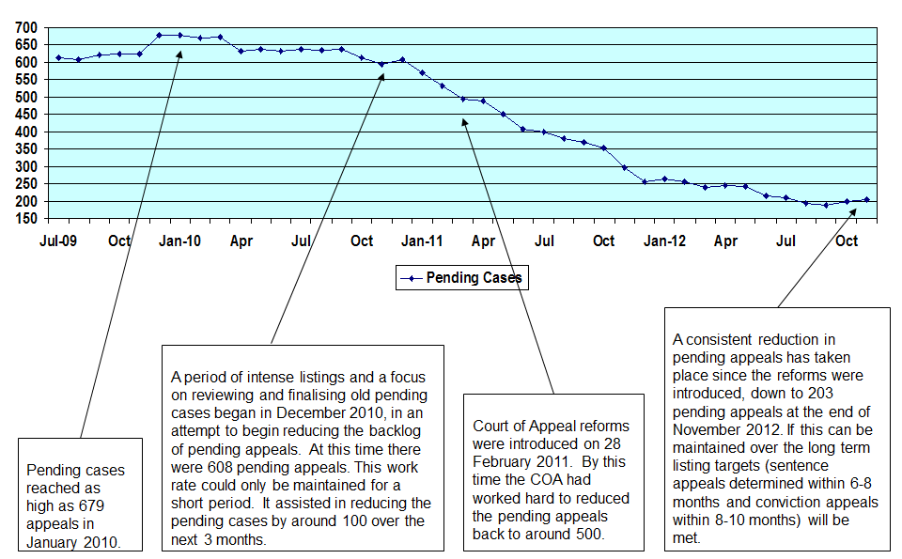
Figure 1: The impact of reforms on reducing the number of criminal matters before the Court of Appeals
Over the same period, the number of lodgments at the Court had decreased, but the backlog decreased at a faster rate. The rate of decrease in Victoria compares favourably with the performance of corresponding Courts in other States and Territories where pending caseloads have either increased or decreased at a far slower rate. In addition, Court of Appeal registry staff report that the average time for resolution of appeals has shortened and that there has been a decrease in the number of lodgments without merit, indicative of changes the reforms intended. Both of these features will continue to be closely measured to ascertain if these trends maintain.
The Court of Appeal’s experience with criminal matters indicates that judge led case review, clear guidance on lodgment requirements and alignment of registry processes with judicial processes combined with higher levels of registry expertise improves case flow management and the timeliness of Court operations. Similar reforms have only recently been introduced at the Commercial Court, however there is insufficient quantative data at this stage to illustrate that they have had the same impact as that experienced at the Court of Appeal, however early anecdotal reports suggest that this is likely.

Principles
The design and assessment of options for amending the current fees have been guided by the following principles:
- The fee structures should reflect the role of the Court of Appeal and the Commercial Court in Victoria’s civil justice system.
The Commercial Court is a specialist court focussing on complex commercial litigation supported by judicial officers with considerable judicial and commercial expertise. Court users pay a premium fee for direct entry to most Commercial Court lists, whereby an intensive case management approach is designed to facilitate timely resolution of matters, the majority of which can be expected to settle before trial as a result of the Court’s case management practices. The Commercial Court reforms will extend intensive case management to defended cases before the Court, when and where appropriate. The fee structure can reasonably reflect the level of expertise and the provision of intensive case management services.
The flow of matters to the Court of Appeal is determined by legislation rather than the applicant’s choice of Court. By its nature, it provides a safety net for applicants who consider that they have not been dealt with fairly by other court processes. Additionally, the Court deals with highly complex matters, which are normally considered by a panel of three judges. It therefore has a high cost with just over 200 cases considered in 2012-13. These considerations point to the need for a fee structure that balances the cost of the Court with the fact that there is no choice of jurisdiction for applicants.
- Access to justice is to be safeguarded
Access to a fair and impartial justice system is a fundamental tenet of the rule of law. Individuals, corporations or others should be reasonably able to avail themselves of a fair and impartial court system as a forum for resolving civil disputes and enforcing legal rights. Access is limited or denied if the cost of using the court system is prohibitive, or at least so great as to be a major disincentive for a significant number of potential Court users.
In the context of the Commercial Court, it is likely that Court fees will be a small proportion of total litigation costs, except for self-represented litigants. Waiver provisions are in place where payment of fees may cause financial hardship.
Access is of particular importance for commencing proceedings in the Court of Appeal because applicants have no choice of jurisdiction. Fee waivers are available and are granted to about eight per cent users of the Court.

- Fees should be applied equitably
Equity may be relevant to Court fees in two ways. First, fees may be regarded as equitable if those who benefit from a Court service pay for that service and are not subsidising the costs of services that they do not use. Second, fees may also be regarded as equitable if those with proportionately greater means pay more than those with lesser means. This second view is relevant also to ensuring access to justice is safeguarded (Principle 2).
- The fee structure should support and enable efficient Court operations
The net cost per finalisation of civil matters (excluding Probate) at the Supreme Court of Victoria is $4,960, lower than the national average which is $5,621. While this measure is indicative of efficiency, the manner in which the fees are structured can also have a major bearing.
The fee structure can have an impact on the number and type of matters brought to Court. Having regard to the availability of mechanisms to resolve disputes, the fee structure should encourage optimal use of available mechanisms across the civil justice system so that the right level of service is being provided to the right entity at the right time.
The Commercial Court fees are broadly similar to those charged in other similar Courts and the Court’s record of performance and efficiency compares favourably with those Courts, particularly in relation to Commercial Court matters – see Table 4.
Table 4 Commercial Court – fees comparison with other Courts
Fee | Victoria- Current | Federal Court |  |  | NSW
Fee | Individual or Corp  (specialist list fees) | Individual | Corporation | Public Corporation | Individual | Corporation
Commencing | Total $3,759.50 | $1,080 | $3,145 | $4,720 | $999 | $2,737
Commencing | $961.70 (Writ)
Commencing | $350.50 (Summons)
Commencing | $2,447.30(Commercial Court entry fee)
Setting down | $0 | $2,156 | $5,244 | $7,866 | $1,995 | $4,560
Hearing Fees days 2-4 | $590.60 | $1,078 | $2,098 | $3,147 | $795 | $1,824
Total fees if matter proceeded to 4 day trial | $5,531.30 | $6,470 | $14,683 | $22,027 | $5,379 | $12,769
Interlocutory application | $350.50 | $395 | $965 | $1,450 | $366 | $838

Depending on the type of action or actions brought, applicants have, to varying degrees, a choice of Court for commercial litigation because the Commercial Court of the Supreme Court, the County Court and the Federal Court share overlapping jurisdictions
Similarly, Court of Appeal Notice of Appeal fees are comparable the courts of appeal in other States and Territories.
- Victoria - $3,306.30
- Federal Court - $3,360 for individuals with higher fees applying to corporations and publicly listed companies
- New South Wales - $3,325 for individuals and $6,743 for corporations
A well-designed fee structure can provide incentives for all participants in the judicial process to resolve matters as efficiently as possible, thereby minimising the total cost of litigation. Fee structures should not result in administrative complexity, which inevitably increases costs. Fee structures should encourage the timely resolution of matters.

Role of Supreme Court (Fees) Regulations
The Supreme Court (Fees) Regulations 2012 are the statutory instrument of the Supreme Court Act 1986. The current Regulations expire on 15 December 2017.
The Supreme Court (Fees) Regulations set the charges for specific services provided to litigants and applicants. The level at which fees are set takes into account the actual cost of service provision, Victorian Government cost recovery policy, and fundamental principles such as equity, appropriateness and access to justice.

Current fees
The full annual cost of the Commercial Court is $12.629 million (in 2013-14 dollars), which includes direct and indirect costs related to both judicial and administrative operations. Section 3 provides further detail and discussion on these costs.
Table 5 sets out the current fees charged by the Commercial Court that are subject to this RIS. It should be noted that there are other Court fees, such as photocopy and search fees, that will continue to apply to matters before the Commercial Court, which are not subject to this RIS.

Table 5: Current fees for Commercial Court matters
Fees subject to RIS consideration | Current fee
Commencement with entry to list | $3,759.50
Commencement - general commercial  matters and Defence & Counterclaim | $961.70
Setting down fee (includes trial day 1) | $1,136.30
Hearing days – days 2-4 | $590.60
Hearing days – days 5-9 | $986.10
Hearing days – days 10+ | $1,647.40
Appeals from AsJs | $350.50
Interlocutory process | $350.50
Mediation fee – per half day | $318.40

Currently, commencement fees for matters before the Commercial Court differentiate between cases where applicants have chosen either direct entry to lists that are case managed by judges or general commencement in what is presently known as the Commercial and Equity Division of the Supreme Court. In other words, two alternative commencement fees exist with their application depending on whether the case is to be intensively case managed by a judge.
Based on the number of transactions in 2012-13 in the Commercial Court, about 23 per cent of its costs were recovered from the collection of these fees.
The full annual cost of the Court of Appeal is $6.539 million, which includes direct and indirect costs related to both judicial and administrative operations. About 9 per cent of these costs are currently recovered through fees.
Table 6 sets out the current fees utilised by the Court of Appeal that are subject to this RIS. It should be noted that there are other Court fees, such as photocopy and search fees, that will continue to apply to matters before the Court of Appeal, which are not subject to this RIS.

Table 6: Current fees for Court of Appeal matters
Court of Appeal  Targeted increases | Current fee
Notice of appeal | $3,306.30
Leave application from the Supreme Court | $350.50
Leave application from other jurisdictions | $961.70
Setting down & 1st hearing day | $1,136.30
2nd and subsequent hearing days | $590.60
Application fee | $350.50

This Regulatory Impact Statement
In accordance with the requirements of the Subordinate Legislation Act 1994 and the Victorian Guide to Regulation, a Regulatory Impact Statement (RIS) is required because changes to the Court’s fee structure may impose “a significant economic or social burden on a sector of the public”.
The RIS also provides the opportunity to assess the proposed Regulations in terms of their objectives and effect, alternative approaches to achieving those objectives, and an assessment of the costs and benefits of the regulations and the alternatives.
- Nature and Extent of the Problem
The fees that are the subject of this RIS are for civil matters brought to the Commercial Court and Court of Appeal only. The principal trigger for the fees amendment has been the introduction of reforms of those Courts that have been supported by government, but are unfunded beyond 30 June 2014.
The Government has indicated that the cost of the reforms is to be recovered by way of fee increases. In total, the reforms to the Commercial Court and to the Court of Appeal are expected to cost around $1.2m in 2013-14 dollars.
The amendment of fees for the Commercial Court and the Court of Appeal is grounded in the review principles set out in Section 1 and the Victorian Government’s policy principles underpinning cost recovery arrangements as set out in the Cost Recovery Guidelines (the Guidelines). The cost recovery principles are designed to achieve the right balance of equity and efficiency objectives in the provision of government services. They are:
- Full cost recovery, noting that there are situations where it may be desirable to recover less than full cost, or not to recover costs at all
- Appropriateness of cost recovery, ensuring that charges fall on those who benefit and that they are cost effective and practical
- Nature of cost recovery charges so that they reflect efficient costs, are simple to understand and cross subsidies are avoided
- Implementation is based on consultation, transparency and charges are monitored and reviewed regularly
In considering options for amending fees, both the review principles set out in Section 1 and these cost recovery principles have been taken into account.
Commercial Court issues
The full cost recovery principle requires that fees be set on a full cost recovery basis because it ensures that both efficiency and equity objectives are met, unless there are compelling reasons to charge less than full cost for a service.
The following considerations are relevant to the recovery of Commercial Court costs through fees.

The need to extend reforms beyond June 2014
The reforms to Commercial Court operations are designed to improve the timeliness of dispute resolution by ensuring that all appropriate matters listed in the Court are subject to intensive case management. Depending on the type of matter, case management will be provided by Judges, Associate Judges, a Judicial Registrar and/or legally trained registry staff.
The early success of the Commercial Court in providing intensive case management resulted in increasing numbers of both initiations and pending cases that potentially threaten access to the Court. Nevertheless, the growth of case numbers also indicates that Court users value the high level of intervention of judicial officers and a focus on expedition in managing and concluding matters through Court processes. It would therefore be appropriate to adjust fees so that the additional costs fall on those who will benefit from the service.
In the event that the proposed fee changes are not approved, registry and case management arrangements that were in place for most of 2013 would be used. Due to the cost of the reforms, the Court is unable to implement them unless specific funding is available.
Should the reforms not be implemented, the expected gains (a reduction in number of pending cases and in the time to finalisation) are unlikely to materialise.
Alignment of Court fees with Court costs
Commercial Court fees have, in the past, been set on the basis of the global costs of the Supreme Court rather than on the basis of the costs of the Commercial Court.
As a result, the alignment between the costs of the Commercial Court and fees is poor. Table 7 indicates the current level of alignment between Commercial Court costs and its fee structure.

Table 7: Comparison of Commercial Court fees and costs
Fees subject to RIS consideration | Current fee | Current Cost | Fees as a percentage of costs
Commencement with entry to list | $3,759.50 | $9,740.10 | 39%
Commencement - general commercial matters and Defence & Counterclaim | $961.70 | Range*:  $704.50  $1,646.80 | 136%  58%
Setting down fee (includes trial day 1) | $1,136.30 | $14,610.60 | 8%
Hearing days – days 2-4 | $590.60 | $7,786.80 | 8%
Hearing days – days 5-9 | $986.10 | $7,786.80 | 13%
Hearing days – days 10+ | $1,647.40 | $7,786.80 | 21%
Appeals from AsJs | $350.50 | $6,188.00 | 6%
Interlocutory process | $350.50 | $6,080.40 | 6%
Mediation fee – per half day | $318.40 | $2,509.30 | 13%
*Does not include case management costs, which are not otherwise included in the fee structure
Redesigning Commercial Court fees to reflect its cost structure alone will require a more holistic review of Court fees than is possible with the current RIS objectives. Courts and Tribunals Service intends to embark on a holistic review of Supreme Court civil fees over the course of 2014-15. Implementing such a review may require amendments to the regulation making powers in the Supreme Court Act 1986.
Nevertheless, the options considered in this RIS are assessed in terms of the costs of providing services in the Commercial Court rather than the costs of providing services in the Supreme Court generally. This approach will improve equity in the application of Court fees that can be further improved in the 2014-15 review.
Role of private benefit poorly recognised
While full cost recovery should result in the efficient utilisation of Court resources, the substantial public benefits of having a civil justice system suggests that optimal use of these services may need government funding support.
There are both substantial public and private benefits achieved through the operations of the Commercial Court and, accordingly, it is reasonable that there be a mix of private and public funding for those Court operations.
The civil justice system plays an important role in providing legal certainty, which assists in fostering economic growth and vitality of any society by providing expert, legally grounded dispute resolution processes for disputes between people, companies or other organisations. Legal rights and obligations are enforced and private and property rights are protected. The civil justice system provides both the means for enforcement of private agreements and legislation in individual cases, and the environment in which laws and obligations are honoured. It provides the means to recover a debt but also the environment in which people, companies and organisation comply with their financial obligations.
Additionally, the Supreme Court of Victoria is a superior Court and therefore its decisions are binding on lower Courts. Decisions of the Supreme Court of Victoria create precedents, which have the effect of clarifying both the common and statute law and thus making the likely outcomes of litigation more predictable. By improving parties' ability to assess the likely outcome of litigation, the direct settlement of matters between parties is encouraged, which in turn will reduce the call on Court resources.
Private benefits clearly relate to the ability to enforce private claims and obtain restitution for losses incurred due to the fault of others. Given that the matters before the Commercial Court are generally complex and often involve substantial monetary value there are substantial private benefits arising from the operations of the Commercial Court.
Despite the very evident value of public benefit associated with the Court’s civil jurisdiction, there has been little objective analysis on how this might be quantified reliably. There are no economic evaluations or academic research to provide an independent assessment to quantify the value of public benefit. The level of cost recovery by civil Courts range from reasonably low (for example, around 17 per cent in New Zealand) to high (over 80 per cent in the United Kingdom) indicating there is a wide range in the way public benefit has been reflected in civil court fees.
Recognising public benefits as a consideration in setting fees should improve access and result in more optimal use of Court resources.
While the levels of public and private benefit accruing to users of the Supreme Court civil division has not been definitively measured, given the nature of the cases heard and the litigants involved, Courts and Tribunals Service believes that the majority of benefit arising from the proposed reforms to be private in character. This position is consistent with the findings of other jurisdictions where similar issues were addressed. Changes proposed in this RIS will aim to ensure that fee increases are borne by those who derive a private benefit, though this is unlikely to significantly alter the overall balance of private and public benefit of Court users as a whole.
As indicated in Section 2, Commercial Court fees currently raise a potential 23 per cent of that Court’s costs and Court of Appeal fees currently raise a potential 9 per cent of its costs. As a result, full cost recovery of the cost of reforms is considered reasonable, because the benefits of the reforms are primarily private benefits and the overall level of cost recovery is not high.
Cost differentials not addressed
The current fees for the Commercial Court do not reflect cost differentials for different types of matters and different Court processes. As can be seen in Table 7, the cost of commencements vary considerably by type of matter but uniform fees are being charged.
The need for amendments to Court fees to support Commercial Court reforms also presents an opportunity to begin the process of better aligning Court fees with types of matters and methods of dispute resolution. Such an alignment would improve both equity and efficiency.
Implications of poor structure
Other practical considerations indicate that the current fee structure needs reform. For example, because of the complexity of the fee structure and its poor alignment with the work of the Court, some fees (such as additional hearing fees and mediation fees) are undercollected.
A fee structure that is administratively simple and well aligned with judicial and administrative processes will mean that fee collection can be more efficient. Fees that correspond to different types of matters and different judicial mechanisms will mean the fee structure is easier to understand for both Court users and Registry staff.
Court of Appeal Issues
The Court of Appeal faces similar challenges in relation to the fees it currently charges. The following considerations are relevant to the recovery of Court of Appeal costs through fees.
Current reforms unfunded beyond June 2014
The Court of Appeal has introduced a case management approach similar to that provided by the Commercial Court. Case flow management in the Civil Division of the Court of Appeal is being revised based on the application of the Venne principles that have been successfully used in the Criminal Division of the Court. This approach results in shorter time to finalisation but requires intensive case management from the time the matter is lodged with the Court.
The costs related to case management cannot be recovered through the current fees. As with the Commercial Court, if no funding is available to support the reforms in 2014-15, registry arrangements that were in place in 2013 would be used. Given the success of the reforms during the trial period, the Courts and Tribunals Service considers that returning to the 2013 arrangements is not optimal, and that continuing the reforms will allow the Court to maintain the high and specialised level of case preparation and service delivery, the higher number of applications finalised and decreased delays faced by applicants.
Alignment of Court fees with Court costs
As with the Commercial Court, the current Court of Appeal fees are based on global Supreme Court costs and do not reflect the higher costs associated with the Court of Appeal hearings where three judges hear a matter.
The current fee structure is based on parity with the related Federal Court fee rather than on the costs of the Court of Appeal. Prior to the work undertaken for this RIS there has been no previous analysis of the extent to which the current fee reflects the costs of the Court.
As a result, the alignment between the costs of the Court of Appeal and fees is poor. Table 8 indicates the current level of alignment between Court of Appeal costs and its fee structure.
Table 8: Comparison of Court of Appeal fees and costs
Court of Appeal | Current fee | Current Cost | % Cost Recovery
Notice of appeal | $3,306.30 | $4,464.53 | 74.1%
Leave application from the Supreme Court | $350.50 | $14,318.86 | 2.4%
Leave application from other jurisdictions | $961.70 | $14,318.86 | 6.7%
Setting down & 1st hearing day | $1,136.30 | $26,599.43 | 4.3%
2nd and subsequent hearing days | $590.60 | $26,599.43 | 2.2%
Application fee | $350.50 | $14,318.86 | 2.4%

As noted previously in relation to the Commercial Court, redesigning Court of Appeal fees to reflect its cost structure alone will require a more holistic review of Court fees than is possible with the current RIS objectives. Courts and Tribunals Service will address this issue as part of a larger review of the Supreme Court fee structure over the course of 2014-15. In the interim, this RIS will improve the current situation and will facilitate further reform.
3 Costing and Assessment

Costing methodology
The steps used to determine the quantum of amended fees are described below. The steps involved using a supply-chain model to measure, as accurately as possible, the costs of individual activities, then applying a scaling factor to those estimates to derive a cost including overheads. Fees were then calculated using data on the expected volume of transactions.
- Determine the cost of the Commercial Court
The analysis used in this RIS adopts activity based costing methodology based on 2012-13 data because it is the most recent full year of expenditure and it has been audited.
Data was extracted from the Human Resources and Finance areas of the Court to determine the breakdown of costs for each of the divisions of the Supreme Court. The Court of Appeal and the Commercial Court are two such divisions. Indirect and overhead costs were included for this analysis. In addition, costs were added (in 2012-13 dollars) that related to the proposed reforms, including the cost of staff who will be needed to implement the reforms but who have not yet been recruited. A number of costs were excluded that did not relate to hearing matters, for example, consultant costs related to a review of registry were excluded.
This step identified the full cost of the Commercial Court in 2012-13 dollars to be $12,320,771 and Court of Appeal costs to be $6,379,527.
- Supply chain mapping of Court activity
Supply chain modelling of Court processes was completed on the basis of discussion with registry staff and Judges’ Associates. Court processes (or groups of activities) were identified through discussion with staff, Registrars, Associates and Judges. Each activity was measured in terms of the particular resource and the time required performing such tasks. All tasks were assigned a time to quantify and evaluate the resource drivers of each phase throughout the process, and measure the frequency and intensity of demands placed on resources by activities.
Times were allocated to each activity, taking account of the fact that times for some Court processes are highly variable, such as interlocutory hearings and judgement writing, so rules were used to determine the appropriate allocation of resources. For example, 60% of interlocutory hearings lasted ½ a day, or 80% of trials need 3 days for judgment writing.
Activities were grouped together to calculate the costs of each of the Court processes under consideration. For example, interlocutory hearings have been costed from the point where a summons is issued through to when orders are made. See Appendix 1 for the list of all activities grouped for each Court service.
Trials have been costed from the time a trial is listed for hearing until a judgment is written, taking account of the cost of additional days over and above the first hearing day. See Appendix 1 for a summary of the costs of Court processes.
The results of the analysis were verified using top-down financial costing to balance the modelling outputs of resources calculated to perform all tasks over a 12-month period with the full-time employee balance sheet of the Court’s Finance and Human Resource division.
- Determination of full 2013-14 costs for comparison with current fees
Current fee schedules are in 2013-14 dollars and it is important to compare fees and costs for the same year. For this reason, the full costs identified at Step 1 for 2012-13 have been escalated to reflect 2013-14 values and the cost of Court processes estimated at Step 2 have been adjusted to take account of indirect and new future costs.
The following adjustments were made to estimate full 2013-14 costs:
Financial data from 2012-13 (Step 1) was escalated by 2.5% to give an estimate of 2013-14 full costs. Escalating by 2.5% was done because this is the indexation factor that the government applied to 2012-13 fees in order to determine 2013-14 fees. This is therefore the closest like to like that can be achieved for comparing 2012-13 costs with current fees.
The Commercial Court costs identified in the 2012-13 budget spreadsheet are $12,320,771 (adjusted for the cost of reforms, including future wage costs). When multiplied by 2.5%, the estimated 2013-14 full cost of the Commercial Court is $12,628,790. For the Court of Appeal the full 2013-14 cost estimate is $6,539,015.
To identify the full 2013-14 costs of Court processes that were identified at Step 2 the following adjustments were made:
The preliminary costing of Court processes was determined using current (2014) staff costs and costing rules used for budget funding submissions. The preliminary full costings were:
- Court of Appeal - $5,073,388
- Commercial Court - $10,118,112
A scaling factor to apply to the preliminary costs arising from the supply chain modelling (Step 2) was determined as the ratio between the full cost 2013-14 estimate and the preliminary cost arising from the supply chain modelling, i.e. $12,628,790/$10,118,112 or 24.8 per cent for the Commercial Court and $6,539,015/$5,073,388 or 28.9 per cent for the Court of Appeal. Escalating by this method means that the indirect costs identified as part of the Step 1 costing process (see below) are brought to bear on the costs arising from the Step 2 modelling.
The difference between the modelling of current processes and full anticipated annual costs in 2013-14 dollars is explained by:
- some costs are not in included in the modelling, such as indirect costs and some judicial services costs. This includes the costs of both the Chief Justice’s office and the CEO’s office. These costs are normally distributed across all Court processes and this approach is to be continued for the costs arising from the Commercial Court and Court of Appeal reforms.
- full staffing of the Registry had not been finalised when the modelling was undertaken. The cost of all positions needed to implement the reforms in full (including the Commercial Court Judicial registrar and other positions in the Court of Appeal and Commercial Court) are included, however, as an adjustment in the anticipated cost base – see Step 1. If the new fees are successfully introduced these resources will be incorporated in the modelling for the 2014-15 review.
- Determining the cost of various judicial processes
The scaling factor determined in Step 3 was applied to the preliminary costs of the judicial processes as determined in Stage 2.
Weighted averages have been applied to the costs of some processes to avoid administrative and user confusion.
For example, the most significant of these is interlocutory hearings which can be heard by a Judge or an Associate Judge but it is not known at the time the summons is prepared and the fee paid who will hear it. In 2012-13, Judges presided over 529 interlocutory hearings and Associate Judges presided over 537 interlocutory hearings. Similarly, hearings can last for a very short time, say 40 minutes, or in some cases, can exceed one day. The minimum time a judge sets aside for an interlocutory hearing is ½ day. Judges will generally hear the matters that appear to be the more complex. Therefore, the preliminary average cost of an interlocutory application heard by a judge was $8,620. The preliminary average cost of an interlocutory application heard by an Associate Judge is $2,759.The preliminary weighted average is $4,826 and thus the scaled weighted average equates to $6,023. It is this weighted cost that has been used to compare interlocutory fees and costs.
One alternative to using weighted averages to calculate these fees may be to change the point at which the fee is paid. However, waiting for a determination as to who will hear a matter before a fee is paid may encourage a litigant to seek to influence the decision of who will hear the matter, so as to reduce the cost of litigation, even if the most appropriate judicial officer would not be hearing the matter.
From an efficiency perspective, it will also mean that duplicated administrative processes are required – first to issue the summons for the interlocutory hearing and later to collect the fee once it is known whether a Judge or an Associate Judge will hear the matter. Separating the collection of the fee from the point at which the summons is issued will introduce administrative duplication and increase the likelihood that fees are not collected at all and that debts would need to be pursued. At the moment no summons is issued if a fee is not paid, which is an efficient administrative practice.
Table 9 provides a breakdown of the costs of Court activities and Table 10 provides a breakdown of costs by major expense categories.
Table 9: Commercial Court costs by major activities
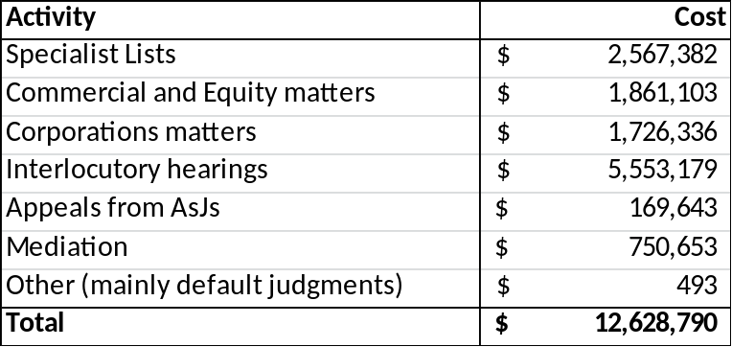

Table 10: Commercial Court costs by major expense categories
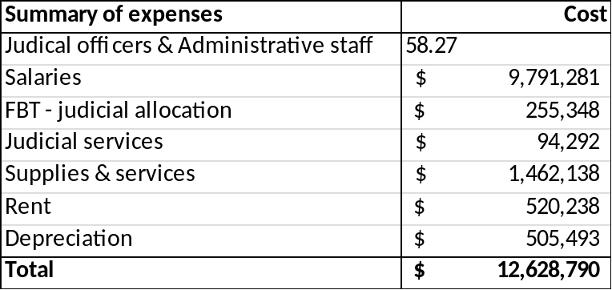
For the Court of Appeal, the relevant tables are Tables 11 and 12.
Table 11: Court of Appeal Costs by major activities
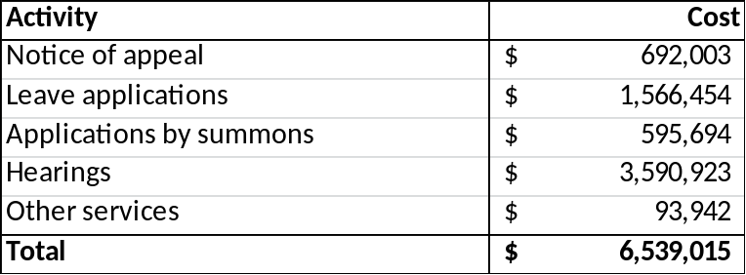
Table 12: Court of Appeal costs by major expense category
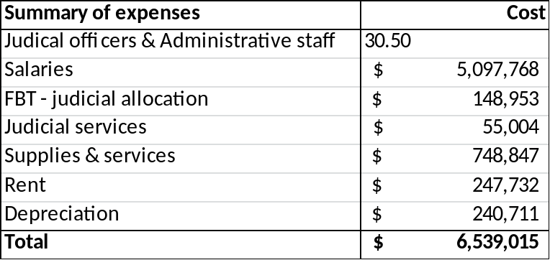
- Determination of the fee
For the RIS, the need to recover $960,873 for the Commercial Court and $264,654 for the Court of Appeal in additional fees has determined the quantum of fees in each of the options considered.
The following is a worked example of how fees were calculated for the new hearing fee for appeals from Associate Judges.
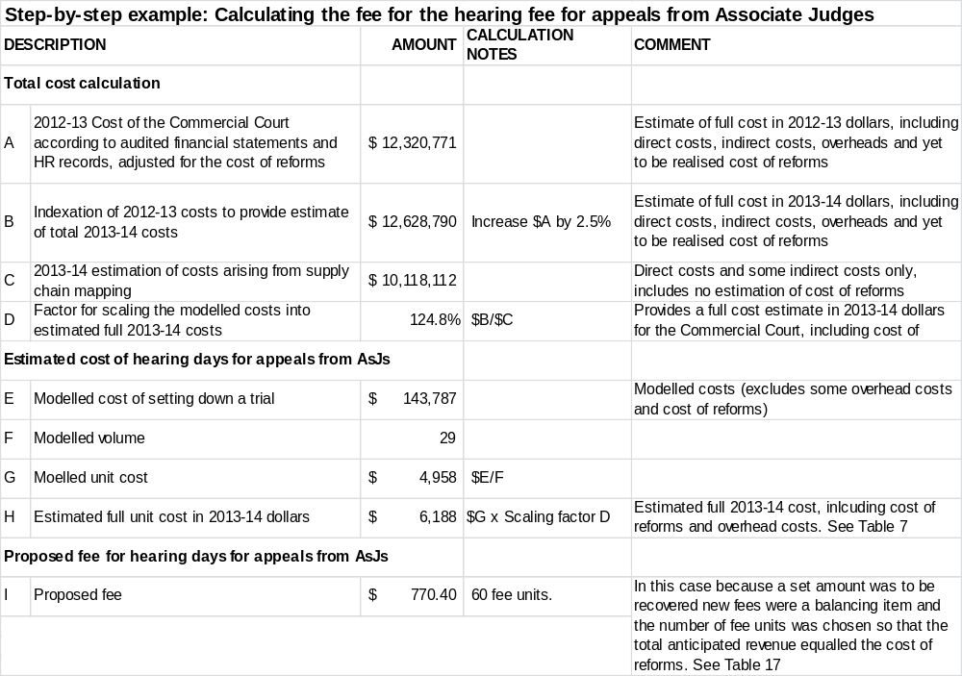
The holistic review foreshadowed for 2015-15 will give greater consideration to he appropriate levels of cost recovery for different types of matters and Court processes.
Analysis methodology
The identified options were assessed using Multi Criteria Analysis, a qualitative decision tool commonly used to systematically compare options within a structured and transparent framework. This approach is favoured when there are limited robust techniques that enable the effects of changes to the fees to be expressed in dollar terms.
Additionally, Multi Criteria Analysis can be used in circumstances (such as the setting of Court fees) when it is not possible to quantify and value the main benefits, for example, equity considerations, or access to justice.
Analysis
The assessment tables in this RIS compare possible options for a revised fees structure in terms of the Principles articulated in section 1. Each criterion was weighted equally, reflecting the Supreme Court's view that each principle is equally important in determining the level of fees needed to support the effective operations of the Commercial Court and Court of Appeal. Additionally, the transitional effects of each option were considered unlikely to differ materially, so transitional issues were not included as a criterion.
The current fee structure is assigned a zero against each principle. The assessment uses positive scores to indicate increasingly better-expected outcomes and negative scores to indicate increasingly poorer outcomes. The following scale has been used throughout the paper:
1 Very marginally better
2 Marginally better
3 Clearly better
4 Considerably better
5 Significantly better

4 Commercial Court Options
Each of the options considered here for amendments to Commercial Court fees reflects changes to Court processes arising from reforms that provide intensive case management for all matters defended in the Commercial Court.
As a result, the proposed commencement fees take account of changes in the way an estimated 362 matters per annum will be managed:
- An estimated 212 matters that are currently covered by a general application fee will be nominated by judges for intensive case management and will therefore attract an additional entry to list fee
- An estimated additional 150 matters that pay the general application fee will be managed by Associate Judges in a new category of Associate Judge led matters that is reflected in the fee structure for Options 2 and 3.
The proposed options also assume that the number of direct entry to list matters will remain constant at an estimated 109 matters per annum. Additionally there will be no change to the way in which matters that are not defended will be finalised.
Options 2 and 3 also share the following elements.
- They introduce a categorisation of matters that is an outcome of the wider application of judge led case management. The costs of judge led matters and Associate Judge led matters have been separately considered (the exception being the cost of interlocutories that was addressed in Section 3, Costing and Assessment). Associate Judge led matters therefore attract fees that are generally lower than those for Judge led matters. Associate Judge led matters include statutory wind-ups under the Corporations Act and Public Examinations, among others.
- Neither option applies the new entry to list fee to matters in the Arbitration List as these matters are different in nature to the complex commercial matters generally before the Court and will not experience the same level of intensive case management. In 2012-13 there were only five matters heard in this list.
The following options were considered for addressing the problems outlined in Section 2.
- Increase commencement fees in the trial division of the Supreme Court. Under this option, all commencement fees in the trial division would increase, not just those in the Commercial Court.
- Increase all existing Commercial Court fees. This option would increase all fees applying to the Commercial Court to fund the recently introduced reforms.
- Targeted increase of existing Commercial Court fees. This option would increase specific fees applying to the Commercial Court where the reforms have changed the way cases are managed and where there is currently low cost recovery.
In the following discussion each option is compared with 2013 Court processes and related fees, which are the current fees effective as of 1 July 2013. It is these Court processes that represent the “base case” that would be in effect in the event that no specific funding was available for the proposed reforms.

Option 1. Increase commencement fees in the trial division of the Supreme Court only
This option proposes distributing the cost of the Commercial Court reforms by increasing the commencement fees across the trial division of the Supreme Court. The level of increase would be based on a distribution of the ongoing costs of the Commercial Court reforms across the total number of Civil Court users, excepting the Court of Appeal.
The cost increase that needs to be recovered is $960,873. A significant proportion of this cost will be collected because the Commercial Court reforms mean that more cases in the Commercial Court will attract the higher direct entry to list fee – taking the number of cases on judge managed lists from 109 to 321.
After this adjustment is made, the remainder of the increased costs of the Commercial Court are evenly spread over all commencements in the Trial Division of the Supreme Court.
With 7,445 anticipated commencements, the additional cost per commencement is $49.40.
Table 13 below illustrates the extent of the increase by comparing the current and proposed commencement fees. This table provides a comparison based on 2013-14 fees - from 1 July 2014 fees will rise by 3.1 per cent. For further details, see Appendix 2, which provides the fee unit equivalent of these fees and the applicable percentage increases.
Table 13 Option 1 - fees and expected revenue
Option 1 | Current fee | Estimated Number | Expected Revenue | Proposed fee | Estimated Number | Expected Revenue
Commencement in the Commercial Court with entry to list | $3,759.50 | 109 | $409,785.50 | $3,808.90 | 321 | $1,222,656.90
General Commencement fee | $961.70 | 7336 | $7,055,031.20 | $1,011.10 | 7124 | $7,203,076.40
Total |  | 7445 | $7,464,816.70 |  | 7445 | $8,425,733.30
Additional amount collected |  |  |  |  |  | $960,916.60
Notes
1. Estimated numbers are based on actual 2012-13 initiations
2. “Commencement in the Commercial Court with entry to list” fee is a composite of two fees in the Regulations - commencement (1A.1) and entry to list (1A.8)
Advantages
There are two main advantages to this option:
- the quantum increase in fees is very small and is therefore unlikely to reduce access to the Court
- the small number of fee changes will be administratively easy to manage.
Disadvantages
This option presents significant equity issues because all Court users would pay an extra fee, albeit small, whereas only the users of the Commercial Court will benefit from the reforms.
Crucially, this option does not align the fee increases with the actual costs of the service provided, contrary to the principles of the Victorian Cost Recovery Guidelines.
Assessment
Table 14 sets out an assessment of Option 1
Table 14: Assessment of Option 1
Criteria | Score | Comment
The fee structure should reflect the role of the Commercial Court in Victoria’s civil justice system. | 2 | Increases acknowledgement that the SCV is the Court of choice when track record, expertise, timeliness and the standing of the Court are a consideration.
Access to justice is to be safeguarded | 0 | Increases are modest are unlikely to constitute a significant impediment to potential Court users
Fees should be applied equitably | -1 | Fee increases are applied inequitably as they are levied on all users of the civil division, not just those using the Commercial Court where the reforms have been implemented.
The fee structure should support and enable efficient Court operations | 1 | Even a modest fee increase can prompt users to consider cheaper alternative forms of resolution.
TOTAL | 2

Option 2. Increase of all existing Commercial Court fees.
This option takes account of the organisational changes in the Commercial Court whereby a greater proportion of matters will commence with direct entry to list and be intensively case managed. Such matters will primarily be matters that currently come before a Supreme Court Judge.
A range of Corporations Act matters, including but not limited to Applications to set aside a Statutory Demand and Statutory Demand Default Wind-ups, are currently dealt with by Associate Judges and these matters will continue to be case managed by Associate Judges, with a separate commencement fee. Associate Judges will also manage additional Corporations Act matters nominated by judges as part of a regular review of applications.
A new daily hearing fee will be introduced for Public Examinations.
Once these management processes have been applied, Option 2 proposes distributing the cost of the Commercial Court reforms evenly across all the fees of that Court.
Based on 2012-13 data, and taking account of the Commercial Court reforms 3,272 annual fee transactions can be expected in the Commercial Court, excluding file searches and photocopying. An additional 212 cases are expected to attract a new “Entry to List” fee.
The cost increase that needs to be recovered is $960,873, which will be partially covered by the increase in the number of cases commencing paying the entry to list fee and otherwise covered by a per transaction increase of $154.60. The following table illustrates how this method would apply. Table 15 provides a comparison based on 2013-14 fees. From 1 July fees will rise by 3.1 per cent. See Appendix 2, which provides the fee unit equivalent of these fees and the applicable percentage increases, for further details.

Table 15 –Option 2 - fees and expected revenue
Option 2 | Current fee | Estimated Number | Expected Revenue | Proposed fee | Estimated Number | Expected Revenue
Commencement with entry to list | $3,759.50 | 109 | $409,785.50 | $3,914.10 | 109 | $426,636.90
Commencement - general C&E Corporations matters heard by a judge¹ | $961.70 | 362 | $348,135.40 | $1,116.30 | 212 | $236,655.60
 |  |  |  | New Fee2  $2797.80 | 212 | $593,133.60
Defence & Counterclaim  Third party notices | $961.70 | 65 | $62,510.50 | $1,116.30 | 65 | $72,559.50
Setting down fee (includes trial day 1)³ | $1,136.30 | 94 | $106,812.20 | $1,290.90 | 0 | $ -
Hearing days – days 2-4 | $590.60 | 90 | $53,154.00 | $745.20 | 90 | $ 67,068.00
Hearing days – days 5-9 | $986.10 | 46 | $45,360.60 | $1,140.70 | 46 | $52,472.20
Hearing days – days 10+ | $1,647.40 | 17 | $28,005.80 | $1,802.00 | 17 | $ 30,634.00
AsJ led matters | $961.70 | 1063 | $1,022,287.10 | $1,116.30 | 1213 | $1,354,071.90
Public Examinations Daily Hearing fee⁴ | $ - | 0 | $ - | $154.60 | 18 | $2,782.80
Appeals from AsJs Application fee | $350.50 | 28 | $9,814.00 | $505.10 | 32 | $16,163.20
Interlocutory process | $350.50 | 958 | $335,779.00 | $505.10 | 958 | $483,885.80
Mediation fee – per half day | $318.40 | 300 | $95,520.00 | $473.00 | 300 | $141,900.00
Total |  | 3132 | $2,517,164.10 |  | 3060 | $3,477,963.50
Additional amount collected |  |  |  |  |  | $960,799.40
¹ Assumes 212 matters will be judge managed and will be subject to the new fee structure. 150 matters will be referred to AsJs for managing.
² The new fee will not apply to matters in the Arbitration List
³ The setting down fee will be retained as a transition fee, and will be reviewed in 2014-15
⁴ Additional hearing day fees will apply to Public Examinations but not to other AsJ managed Corporations matters. Consequently, Public Examinations are listed as a different category of matter.

Advantages
By spreading the costs of the reforms across all the Commercial Court fees, the increase of individual fees is relatively modest taking into account that the more complex and high profile matters are likely to be taken to the Commercial Court.
Increases are limited to Commercial Court fees only and are therefore reasonably equitable.
Disadvantages
Commencement fees for some matters will experience a higher proportionate increase. Fee waiver arrangements are in place to mitigate any disincentive this option may create for some users to access the court system.
The uniform nature of the fee increases does not acknowledge the currently varying levels of cost recovery for the services provided.

Assessment
Table 16 sets out an assessment of Option 2
Table 16: Assessment of Option 2
Criteria | Score | Comment
The fee structure should reflect the role of the Commercial Court in Victoria’s civil justice system. | 3 | Fee increases reflect the level of expertise and the provision of intensive case management services
Access to justice is to be safeguarded | -1 | Significant increase of some commencement fees could present an impediment to potential Court users, although waiver provisions are in place and there are alternative jurisdictions available to applicants.
Fees should be applied equitably | 2 | Fee increases apply only to those services that used by Commercial Court litigants
The fee structure should support and enable efficient Court operations | 2 | Commencement fee increase can serve prompt users to consider cheaper alternative forms of resolution.  Other fee increases should encourage the timely resolution of matters.
TOTAL | 6

Option 3. Targeted increase of existing Commercial Court fees.
This option proposes distributing the cost of the Commercial Court reforms across those fees for services where
- the reforms have changed the way in which cases are managed and
- where there is currently very low cost recovery.
As with Option 2, the major change to processes in the Commercial Court is that the Court will employ intensive case management principles so that, from initiation, more cases will experience intensive case management designed to support the timely resolution of disputes. With the exception of Associate Judge led cases referred to below, this option effectively applies the current commencement fee to all commencements in the Commercial Court. This will be given effect by the introduction of a new “Entry to List” fee that will apply to those matters nominated by judges for intensive case management.
Two new categories of matters have been identified to distinguish the majority of corporations matters that are heard by Associate Judges:
- Associate Judge led Corporations Act matters
- Public Examinations.
Importantly, a significant number of Corporations Act matters, estimated at 150 annually, will be managed by Associate Judges. These will be matters that judges have nominated for Associate Judge management and are expected to include matters that are not defended as well as other matters. It is proposed that these matters will continue to attract the current commencement fee.
In the course of the civil fees project setting down fees, hearing days 2-4 fees, interlocutory hearings, appeals from Associate Judges and mediations have been identified as matters where fees are very low relative to cost – see Table 6. It is proposed to increase these fees to the extent needed to recover the cost of reforms after the change to the commencement fee mentioned above is applied. Even so, the increases are regarded as within what might be reasonable if a full revision of the Commercial Court fees was given effect.
New hearing fees will be introduced for Public Examinations and Appeals from Associate Judges in order to better align the fee structure to Court processes and costs.
Below is a worked example to illustrate what the new process will involve and highlights the points at which fees will be charged.
Worked example – new process and fee charging points
The costs accrued in respect of matters in the special lists of the Commercial Court comprise judicial, registry and Court administration resourcing.

Commencement
At the commencement of a proceeding, registry staff will administer the filing and issuance of the writ, statement of claim and summons. This includes the creation of the proceeding on the case management system, the scheduling of the first directions hearing, sealing of documents and preparation of the Court file in anticipation of the first directions hearing. The Court file and case management system will continue to be maintained and updated throughout the life of the proceeding.

The first directions hearing is included in the initial filing and entry fee. Prior to this hearing, the Registrar will prepare summaries of each new proceeding and table at a weekly allocation meeting attended by the judges of the Commercial Court and are allocated accordingly, which will then trigger a notification to the parties prepared and distributed by the registry. Usually, appearances by the defendants are also filed prior to the first directions hearing.

Directions and Pleadings
Attendance by the parties’ legal representatives is obligatory at the first directions hearing. At this hearing, the judge will hear from counsel as to the nature and peculiarities of the dispute as well as its major issues. Preliminary estimates on the trial length and any other relevant information will also be provided to the Court, following which timetabling orders for the further conduct of the proceeding are made. The matter may also be fixed for trial at the first hearing depending on the nature, urgency and complexity of the proceeding.

Following the first directions hearing and assuming the matter is contested, any responding pleadings, such as a defence, a defence & counterclaim and/or a third party notice will be filed. The latter two, attract a further fee given that they launch fresh claims in the proceeding.

Further directions hearings may be convened as and when required to facilitate the orderly conduct of the proceeding. No additional fees are incurred at this stage, as any subsequent directions hearing will be in consequence of an adjournment from the previous directions hearing thereby dispensing with any requirement to file an additional summons for directions, which incurs the fee.

If the matter has not already been set down for trial, typically it will be set down either at one of these directions hearings or “on the papers”. As matters entered into the specialist lists pay an entry fee, a setting down fee is not required. For those matters not entered into these lists but otherwise managed by one of the Commercial Court judges a setting down fee is payable. Both the entry and the setting down fee include the first day hearing fee of the trial.

Following the close of pleadings a pre-trial directions will be convened, at which the judge, will make orders for the preparation of Court books, witness statements and any other orders necessary to facilitate preparation for the trial.

Trial
The trial of the proceeding will incur hearing fees if the hearing goes beyond one day. At the conclusion of the trial, the judge will usually reserve judgment. The judge will subsequently, consider the evidence tendered and submissions made at trial, consider and draft reasons and then hand down judgment. The handing down of judgment will mark the conclusion of the proceeding’s life.

General
Throughout the proceeding, there may be any number of interlocutory disputes; that is, disputes over the conduct of the proceeding such as the adequacy or otherwise of discovery or pleadings. These will attract a fee if the application is by summons.

Any appeals from these interlocutory decisions, if made by an Associate Judge, will usually go before the judge managing the proceeding. These appeals also attract a fee which is payable upon filing.

At any stage of the proceeding the parties may attend mediation before either an Associate Judge or Judicial Registrar. This will also incur a fee.

The following diagram illustrates the features discussed in this example.

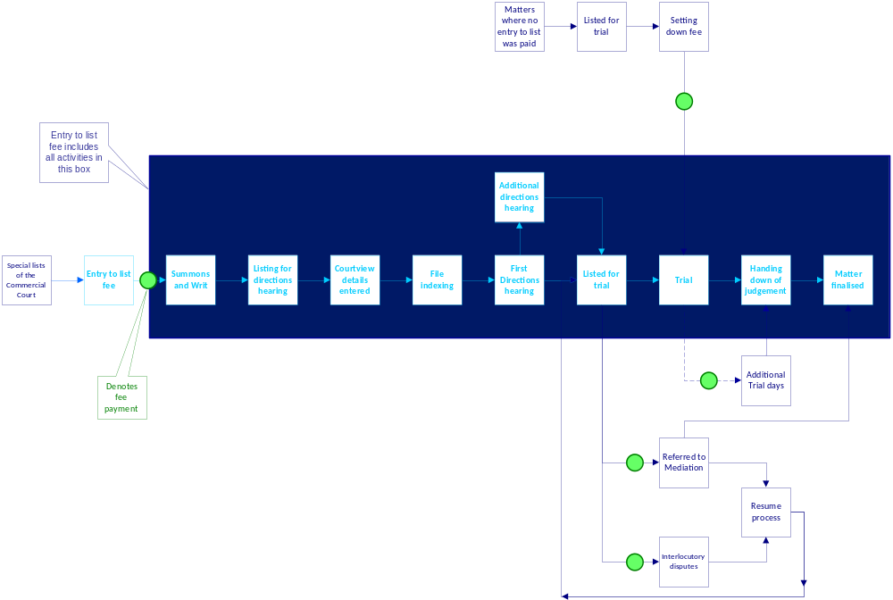

Table 17 sets out the indicative fee increases for the Commercial Court. Table 17 provides a comparison based on 2013-14 fees. From 1 July fees will rise by 3.1 per cent. See Appendix 2, which provides the fee unit equivalent of these fees and the applicable percentage increases, for further details.

Table 17: Option 3 - fees and expected revenue
Option 3 | Current fee | Anticipated Number | Expected Revenue | Proposed fee | Anticipated Number | Expected Revenue
Commencement with entry to list | $3,759.50 | 109 | $409,785.50 | $3,759.50 | 109 | $409,785.50
Commencement - general C&E  Corporations matters heard by a judge¹ | $961.70 | 362 | $348,135.40 | $961.70 | 212 | $203,880.40
 |  |  |  | New Fee²  $2797.80 | 212 | $593,133.60
Defence & Counterclaim  Third party Notices | $961.70 | 65 | $62,510.50 | $961.70 | 65 | $62,510.50
Setting down fee (includes trial day 1)³ | $1,136.30 | 94 | $106,812.20 | $1,136.30 | 0 | $-
Hearing days – days 2-4 | $590.60 | 90 | $53,154.00 | $642.00 | 90 | $57,780.00
Hearing days – days 5-9 | $986.10 | 46 | $45,360.60 | $1,155.60 | 46 | $53,157.60
Hearing days – days 10+ | $1,647.40 | 17 | $28,005.80 | $1,797.60 | 17 | $30,559.20
AsJ led matters | $961.70 | 1063 | $1,022,287.10 | $961.70 | 1213 | $1,166,542.10
Public Examinations Leave to Issue Summons fee | $961.70 | 18 | $17,310.60 | $961.70 | 18 | $17,310.60
Public Examinations Daily Hearing fee⁴ | $- | 0 | $ - | $642.00 | 18 | $11,556.00
Appeals from AsJs Application fee | $350.50 | 28 | $9,814.00 | $385.20 | 32 | $12,326.40
Appeals from AsJs Hearing fee | $- | 0 | $- | $770.40 | 29 | $22,341.60
Interlocutory process | $350.50 | 958 | $335,779.00 | $770.40 | 958 | $738,043.20
Mediation fee – per half day | $318.40 | 300 | $95,520.00 | $385.20 | 300 | $115,560.00
Total |  | 3150 | $2,534,474.70 |  | 3107 | $3,494,486.70
Additional amount collected |  |  |  |  |  | $960,012.00
¹ Assumes 212 matters will be judge managed and will be subject to the new fee structure. 150 matters will be referred to AsJs for managing.
² The new fee will not apply to matters in the Arbitration List
³ The setting down fee will be retained as a transition fee, and will be reviewed in 2014-15
⁴ Additional hearing day fees will apply to Public Examinations but not to other AsJ managed Corporations matters. Consequently, Public Examinations are listed as a different category of matter.

Advantages
The specific and targeted nature of this option ensures that the fee increases are applied to those services that have been significantly enhanced by the investment made by the Court.
This option represents a better correlation between the fees imposed for Court services and the costs the Court incurs in delivering them. The increases begin to address the currently varying levels of cost recovery for the services provided.
Disadvantages
The increases of some of the targeted fees are significant. However, these matters are generally of a complex commercial nature involving corporations rather than private individuals. Such applicants generally have a choice of court for most matters. Waivers can be sought where appropriate.

Assessment
Table 18 sets out an assessment of this option
Table 18: Assessment of Option 3
Criteria | Score | Comment
The fee structure should reflect the role of the Commercial Court in Victoria’s civil justice system. | 3 | Fee increases apply to those services that have been significantly enhanced.  Fee increases reflect the level of expertise and the provision of intensive case management services
Access to justice is to be safeguarded | -1 | Significant increase of targeted fees could present an impediment to potential Court users, although waiver provisions are in place and there are alternative jurisdictions available to applicants
Fees should be applied equitably | 4 | Fee increases are limited to those services that have been significantly enhanced and/or where there are currently relatively low levels of cost recovery.
The fee structure should support and enable efficient Court operations | 2 | Commencement fee increase can serve prompt users to consider cheaper alternative forms of resolution.  Other fee increases should encourage the timely resolution of matters.
TOTAL | 8

Preferred Option
This option would be better than the current arrangements and better than the other options considered in the RIS. The fee increases are limited to only those services which have been significantly enhanced and better align fees to the costs of delivering those services.
Accordingly, Option 3 is the preferred option.

5 Court of Appeal
The primary objective of Court of Appeal amendments is to recover the cost of reforms that introduce
- judge led case review
- clear guidance on lodgment requirements and
- alignment of registry processes with judicial processes combined with higher levels of registry expertise to civil case management.

These reforms will improve case flow management and the timeliness of Court operations.
More active case management and more active registry engagement with cases as they are lodged with the Court will have the effect of making the processes for dealing with leave applications and notices of appeal similar, thereby suggesting that a single commencement fee should be charged. Such an approach will remove the need for successful leave applications to pay a separate Notice of Appeal fee, but it also means that unsuccessful leave applicants will pay a higher fee. Nevertheless, the reform to Court processes is better reflected in a single commencement fee than in the continuation of two fees.
The Court of Appeal processes have been modelled and costed as set out in Section 3. Several options have been considered for amending the Court of Appeal fees:
- Change the structure of the commencement fee, so that there is a single commencement fee and target other amendments at those fees where there is very low cost recovery
- A single commencement fee plus increase all fees by a set dollar amount of $329
- A single commencement fee plus increase all fees by the same percentage increase (15.6%).
As with the Commercial Court fee options, all options are based on the proposed reforms, which will see intensive case management of all matters upon receipt of an application. As a result, a common commencement fee (being the current Notice of Appeal fee) is charged for all applications. Applications for leave that are successful would not be required to pay an additional Notice of Appeal fee.
Given the relatively small amount of fees to be recovered, the analysis of the options presented below for the Court of Appeal is less detailed than is the analysis of the Commercial Court fees.

Option 1
Option 1 is the preferred approach. As with the other options, it restructures the commencement fee so that a single fee is charged irrespective of whether the applicant is applying for leave to appeal or is lodging a notice of appeal (an appeal as of right).
No other fee is then payable until such time as a hearing is scheduled, unless the applicant lodges a related application in which case the Application fee applies.
The remaining costs of the Court of Appeal reforms are recovered by way of increases to the setting down fee, the second and subsequent hearing day fee and the application fee.
The preferred approach is set out in Table 19. Table 19 provides a comparison based on 2013-14 fees. From 1 July fees will rise by 3.1 per cent. See Appendix 2, which provides the fee unit equivalent of these fees and the applicable percentage increases, for further details.
Table 19: Proposed amendments to Court of Appeal fees
Option 1¹ | Current fee | Anticipated Number² | Expected Revenue | Proposed  fee | Anticipated Number³ | Expected Revenue
Notice of appeal | $3,306.30 | 143 | $472,800.90 | A single Commencement fee of  $3306.30 | 202 | $667,872.60
Leave application from the Supreme Court | $350.50 | 60 | $21,030.00 | A single Commencement fee of  $3306.30 | 202 | $667,872.60
Leave application from other jurisdictions | $961.70 | 34 | $32,697.80 | A single Commencement fee of  $3306.30 | 202 | $667,872.60
Setting down & 1st hearing day | $1,136.30 | 113 | $128,401.90 | $1,977.30 | 113 | $223,434.90
2nd and subsequent hearing days | $590.60 | 11 | $6,496.60 | $1,309.60 | 11 | $14,405.60
Application fee | $350.50 | 49 | $17,174.50 | $770.40 | 49 | $37,749.60
Totals |  | 410 | $678,601.70 |  | 375 | $943,462.70
Additional amount  recovered |  |  |  |  |  | $264,861.00
¹ Fees not listed here remain unchanged.
² Assumes waivers are provided for 8% of all transactions
³ The lower future anticipated numbers is because leave applicants will not have to pay a separate Notice of Appeal fee
.
As indicated in the notes to Table 19, the proposed fees assume that a reasonable proportion of applicants (8%) will be successful in applying for fee waivers.
The primary advantage of the proposed fees is that the fee that all applicants expect to pay – the Notice of Appeal fee – does not change. While it will be applied to a wider group of matters, successful leave applicants will avoid paying two fees. Secondly, the costs of reforms are paid only by Court of Appeal users. Other Supreme Court users are not subsidising the cost of reform.
All current applicants to the Court of Appeal will expect to have to pay the current Notice of Appeal fee. As the quantum of the commencement fee does not change under Option 1, it is anticipated that this change to the fee structure will not be a disincentive to apply or a barrier to justice.
There may be some concerns about the equity involved in setting a single commencement fee, however this is balanced by the more appropriate nature of a single fee and the availability of waiver provisions, which will continue as they are currently. Given that the single commencement fee will be the same as the current Notice of Appeal fee, it is unlikely that the rate of waiver applications will increase.
There is a significant change in the commencement fee for appeals from the Supreme Court, which to date have attracted only a summons fee.
It should be noted that there is no difference in the amount of work involved in resolving an appeal from the Supreme Court than there is from any other jurisdiction. This low fee is an anomaly that will be removed with the new fee arrangement, which is a fairer and more equitable fee.
Changes to the Setting Down, Hearing fees and the other application fee have the effect of better reflecting the costs involved in these services than is currently the case.

Option 2
Option 2 (see Table 20):
- takes account of enhanced case management processes by charging a single commencement fee
- increases all major fees for the Court of Appeal by a set amount of $329.
Table 20: Option 2 – fees and expected revenue
Option 2¹ | Current fee | Anticipated Number² | Expected Revenue | Proposed  fee | Anticipated Number³ | Expected Revenue
Notice of appeal | $3,306.30 | 143 | $472,800.90 | A single Commencement fee of  $3636.80 | 202 | $734,330.60
Leave application from the Supreme Court | $350.50 | 60 | $21,030.00 | A single Commencement fee of  $3636.80 | 202 | $734,330.60
Leave application from other courts & VCAT | $961.70 | 34 | $32,697.80 | A single Commencement fee of  $3636.80 | 202 | $734,330.60
Setting down & 1st hearing day | $1,136.30 | 113 | $128,401.90 | $1,465.30 | 113 | $165,578.90
2nd and subsequent hearing days | $590.60 | 11 | $6,496.60 | $919.60 | 11 | $10,115.60
Application fee | $350.50 | 49 | $17,174.50 | $679.50 | 49 | $33,295.50
Totals |  | 410 | $678,601.70 |  | 375 | $943,320.60
Additional amount  recovered |  |  |  |  |  | $264,718.90
¹ Fees not listed here remain unchanged.
² Assumes waivers are provided for 8% of all transactions
³ The lower future anticipated numbers is because leave applicants will not have to pay a separate Notice of Appeal fee
As with all options, the advantage of this option is that it only affects the users of the Court of Appeal and is therefore not cross-subsidised by other Court users.
It is also useful because the flat dollar increase serves to increase the proportion of the smaller fees that are recovered. Table 8 shows that these smaller fees are recovering proportionately lower costs than the Notice of Appeal fee.
Compared with Option 1 the disadvantage of this option is that it places a higher burden on unsuccessful leave applications. Fee waiver arrangements are in place to mitigate any disincentive this option may create for some users to access the court system.

Option 3
Option 3 (see Table 21)
- takes account of enhanced case management processes by charging a single commencement fee
- increases all major fees for the Court of Appeal by a uniform 15.6 per cent.
Table 21: Option 3 fees and expected revenue
Option 3¹ | Current fee | Anticipated Number² | Expected Revenue | Proposed  fee | Anticipated Number³ | Expected Revenue
Notice of appeal | $3,306.30 | 144 | $476,107.20 | A single Commencement fee of  $3822.00 | 202 | $772,044.00
Leave application from the Supreme Court | $350.50 | 61 | $21,380.50 | A single Commencement fee of  $3822.00 | 202 | $772,044.00
Leave application from other jurisdictions | $961.70 | 35 | $33,659.50 | A single Commencement fee of  $3822.00 | 202 | $772,044.00
Setting down & 1st hearing day | $1,136.30 | 113 | $128,401.90 | $1,313.60 | 113 | $148,436.80
2nd and subsequent hearing days | $590.60 | 11 | $6,496.60 | $682.70 | 11 | $7,509.70
Application fee | $350.50 | 50 | $17,525.00 | $405.20 | 50 | $20,260.00
Totals |  | 414 | $683,570.70 |  | 376 | $948,250.50
Additional amount  recovered |  |  |  |  |  | $264,679.80
¹ Fees not listed here remain unchanged.
² Assumes waivers are provided for 8% of all transactions
³ The lower future anticipated numbers is because leave applicants will not have to pay a separate Notice of Appeal fee

As with the other options, the main advantage is that the costs of reforms are met by the Court users who will benefit from them.
The disadvantage is that the uniform percentage increase of 15.6 per cent increases the commencement fee in a way that does not reflect the underlying cost structure of the Court of Appeal.
In summary, Option 1 is preferred because:
- it does not change the anticipated commencement fee and is therefore creating no additional barriers to access
- the fees that do increase are currently recovering very low proportions of their costs and therefore the new fees are better aligned to Court costs.

6 Consultation and Implementation
The proposed regulations have been developed following consultation with the Supreme Court.
Public consultation has not been conducted prior to the development of the proposed arrangements, so the release of this RIS constitutes the principal opportunity for consultation with Court users. Issue of the RIS will be announced in the Victoria Government Gazette and advertised on the Supreme Court and the Department of Justice websites, as well as in The Herald Sun newspaper. In addition, notification will be sent to the principal legal professional bodies, the Victorian Bar, the Law Institute of Victoria and Australian Corporate Lawyers Association, as well as to Victoria Legal Aid and to the Federation of Community Legal Centres. Public comment will be received for 28 days following release of the RIS, as required by the Subordinate Legislation Act 1994. This is less than the preferred period of consultation as specified by the Victorian Guide to Regulation, however a lengthier period would not have been feasible in light of the expiry of funding on 30 June 2014.
If the preferred approach for both the Court of Appeal and the Commercial Court is implemented, changes will take effect shortly after the Regulations being made. It is anticipated that this would occur in August 2014.
It should be noted that the costing for the new fee schedules has been done on the basis of full year costs and is the same as would apply if the new fees were to take effect on 1 July 2014. This approach has been taken to avoid over-recovery in 2014-15 and in future years.
Implementation of the changes to the fees structure will be supported by training of Court staff, modifications of operations systems, forms and the Court website.
Notification of a decision to make or not to make the Regulations will be announced in the Victoria Government Gazette, the Herald Sun newspaper and on the websites of the Department of Justice and the Supreme Court.
The Courts Tribunal Service and the Supreme Court will monitor data related to fees, such as filing volumes, to assess any impact arising from implementation. This analysis will inform further work in considering future changes to regulations to the remaining areas of the Court.

Appendix 1 Modelled Costs of Court Processes
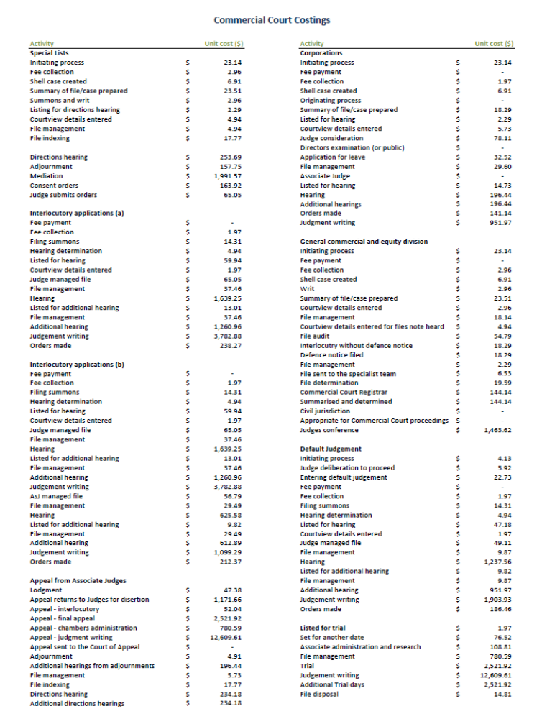
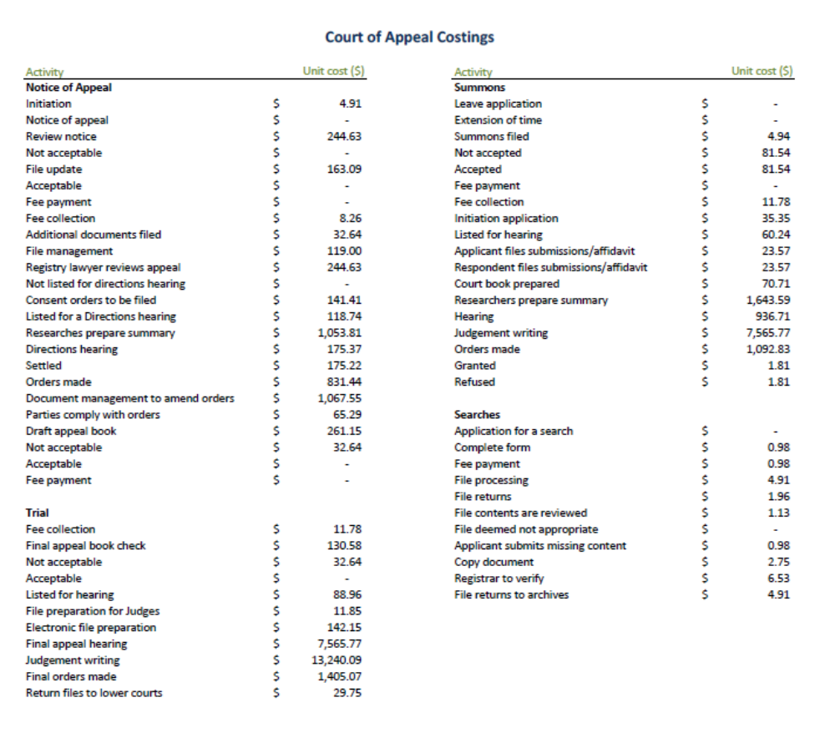
Appendix 2 Fee Change Summary
The tables set out in this appendix show the percentage changes in fees proposed for Options 2 and 3 for the Commercial Court and the preferred option for the Court of Appeal.

The tables presented here relate primarily to 2013-14 fee charges. A 3.1 per cent increase to the value of a fee unit will take effect on 1 July 2014 and therefore the fees for 2014-15 will increase accordingly. The anticipated effect of this change is reflected in the tables below.

Option 2 – Commercial Court
Option 2 – Comparison of current and proposed fees
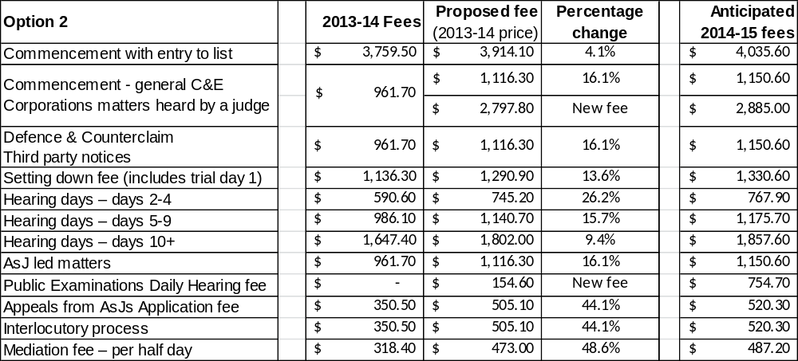

Option 2- Comparison of current and proposed fee units
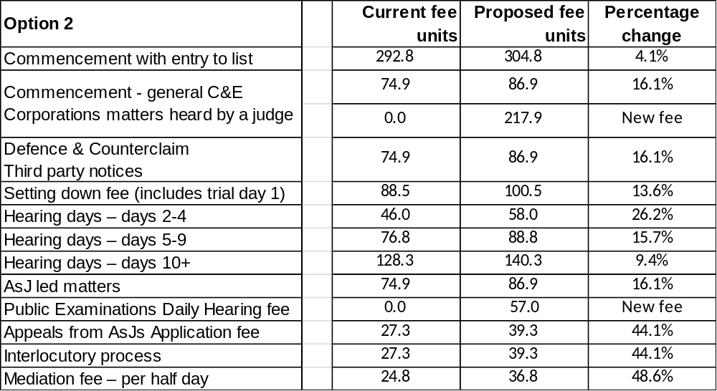

Option 3 – Commercial Court
Option 3 - Comparison of current and proposed fees
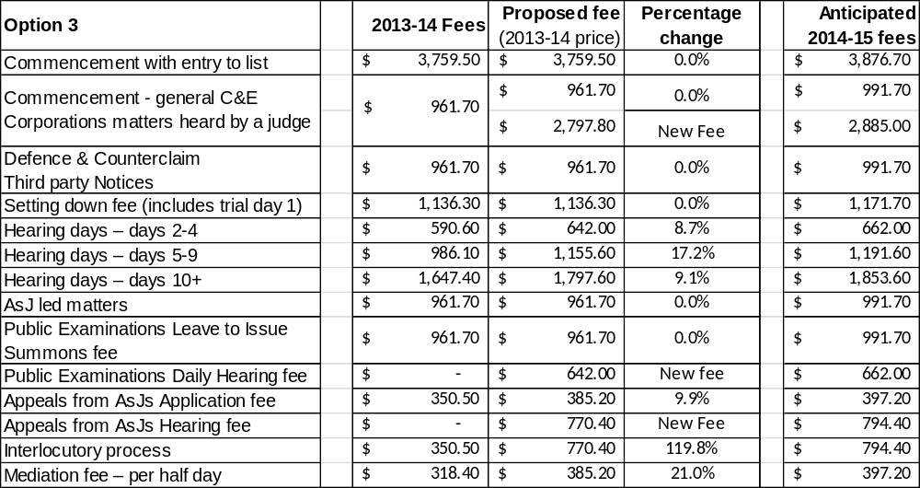

Option 3- Comparison of current and proposed fee units
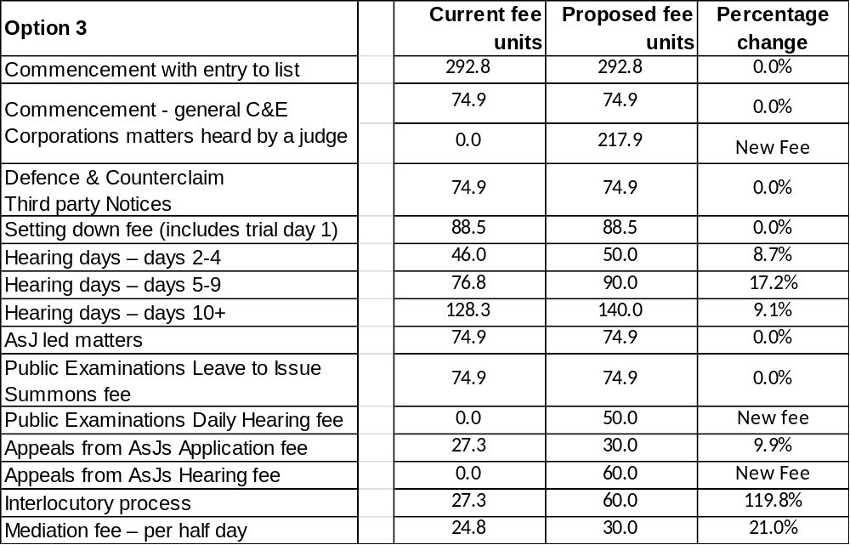

Court of Appeal
Comparison of current and proposed fees 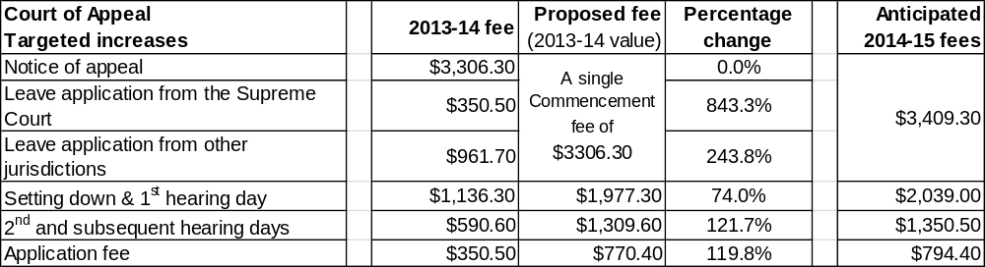
Comparison of current and proposed fee units
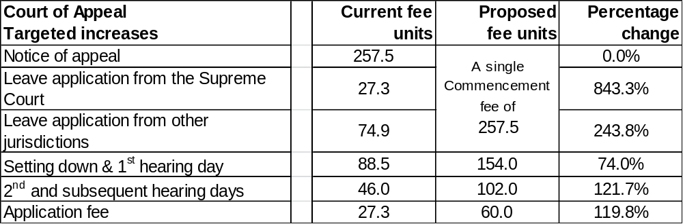
Appendix 3 Proposed Amendment Regulations

Supreme Court (Fees) Amendment Regulations 2014

The Governor in Council makes the following Regulations:

Dated:
Responsible Minister:
ROBERT CLARK
Attorney-General
Clerk of the Executive Council

1 Objective
The objective of these Regulations is to amend the Supreme Court (Fees) Regulations 2012 to provide for a new fee structure for the Court of Appeal and the Commercial Court.

2 Authorising provision
These Regulations are made under section 129 of the Supreme Court Act 1986.

3 Commencement
These Regulations come into operation on 1 August 2014.

4 Principal Regulations
In these Regulations, the Supreme Court (Fees) Regulations 2012 are called the Principal Regulations.

5 Definitions
(1) In regulation 5 of the Principal Regulations—
(a) in the definition of Chapter III for “2004” substitute “2014”;
(b) in the definition of Chapter V for “2003” substitute “2013”;
(c) the definition of Commercial List is revoked;
(d) for the definition of hearing fee substitute—
“hearing fee means the fee payable for a hearing under item 1.15, 1.16A, 1A.11, 1A.12 or 1A.13 of the Schedule”.
(2) In regulation 5 of the Principal Regulations insert the following definitions—
"commencement of an appeal includes an application for leave to appeal;
entry to list fee means the fee payable for entry of a matter into a list under item 1.11 or 1A.8 of the Schedule;
excluded proceeding means—
(a) a proceeding commenced under Chapter V pursuant to Rule 16.1 of Chapter V; or
(b) a proceeding in the Arbitration List;
Judge managed list of the Commercial Court means the following—
- the Admiralty List;
- the Arbitration List;
- the Commercial List;
- the Corporations List;
- the Intellectual Property List;
- the Taxation List;
- the Technology, Engineering and Construction List (TEC List);
- any other list in the Commercial Court managed by a Judge of the Court.
setting down fee means the fee payable for setting a matter down for hearing under item 1.11, 1.12 and 1A.10 of the Schedule;”.
6 When fees are payable
In regulation 7 of the Principal Regulations after “hearing fee” insert—
“, a setting down fee or an entry to list fee”.
7 Payment of hearing fees
In regulation 8(3) of the Principal Regulations after “Court” insert—
“or, if no notice is issued, by the day of hearing”.
8 New Regulation 8A inserted
After regulation 8 of the Principal Regulations insert—
“8A Payment of setting down and entry to list fees
(1) Subject to any order of the Court, a setting down fee or an entry to list fee in relation to any proceeding is payable by the plaintiff, appellant or other party seeking the hearing or the entry of a matter to a list.
(2) A setting down fee must be paid—
(a) on the filing of the notice of trial; or
(b) if no notice of trial is required, within 28 days of the order setting the matter down for trial.
(3) An entry to list fee must be paid at the time the matter is entered into the relevant list.”.
- Fees
(1) In the heading to Part 1 of the Schedule to the Principal Regulations after “OFFICE” insert—
“AND COURT OF APPEAL REGISTRY OTHER THAN FEES IN THE COMMERCIAL COURT”.
(2) After the heading to Part 1 of the Schedule to the Principal Regulations insert—
“The fees in this Part apply in relation to all proceedings in the Court except—
(a) any proceeding in the Commercial Court under Part 1A; and
(b) fees payable in the office of the Registrar of Probates under Part 2.”.
(3) In the Schedule to the Principal Regulations—
(a) in item 1.1 omit “Chapter V,”;
(b) in item 1.8 for “including” substitute “other than in”;
(c) after item 1.8 insert—
“1.8A Commencement of an interlocutory application within a proceeding in the Court of Appeal
60 fee units”.
(4) For items 1.11 and 1.12 of the Schedule to the Principal Regulations substitute—
“1.11 Setting down or otherwise entering a proceeding (other than an appeal to the Court of Appeal) into a list
88.5 fee units
Note: The setting down fee includes the fee for the first day of hearing
1.12 Setting down an appeal to the Court of Appeal
154 fee units
Note: The setting down fee includes the fee for the first day of hearing”.

(5) In item 1.13 of the Schedule to the Principal Regulations —
(a) in paragraph (b) for “II; or” substitute “II”;
(b) paragraph (c) is revoked.
(6) In item 1.14 of the Schedule to the Principal Regulations for “or the Personal Injuries List” substitute “, the Personal Injuries List, the Major Torts List, the Professional Liability List or the Probate List.”.
(7) In item 1.15 of the Schedule to the Principal Regulations omit “hearing an appeal by the Court of Appeal or for”.
(8) After item 1.16 of the Schedule to the Principal Regulations insert—
“1.16A For hearing an appeal by the Court of Appeal—
for day 2 and subsequent days—per day or part of a day;
102 fee units”.
10 New Part 1A inserted into Schedule
After Part 1 of the Schedule to the Principal Regulations insert—
“PART 1A—FEES PAYABLE IN THE COMMERCIAL COURT
The fees in this Part apply to any proceeding in the Commercial Court.

COMMENCEMENT OF PROCEEDINGS
1A.1 Commencement of any proceeding (other than an appeal) under Chapter I, Chapter II, Chapter V, Chapter VII or Chapter VIII
74.9 fee units
1A.2 Commencement of—
(a) a counterclaim under Order 10 of Chapter I; or
(b) a third party proceeding; or
(c) a claim by a third or subsequent party under Order 11 of Chapter I 74.9 fee units

1A.3 Commencement of an appeal to a single Judge of the Court
30 fee units

INTERLOCUTORY APPLICATIONS
1A.4 Commencement of an interlocutory application within a proceeding other than a proceeding in a Judge managed list of the Commercial Court
27.3 fee units
1A.5 Commencement of an interlocutory application within a proceeding in a Judge managed list of the Commercial Court other than an excluded proceeding
60 fee units
1A.6 Commencement of an interlocutory application within an excluded proceeding in a Judge managed list of the Commercial Court
27.3 fee units
JUDGMENTS IN DEFAULT
1A.7 Filing judgment in default of appearance or defence
27.3 fee units
ENTRY INTO LIST
1A.8 Entering a proceeding, other than an excluded proceeding, into a Judge managed list of the Commercial Court (including a summons for directions)
217.9 fee units

1A.9 No fee is payable for entering a proceeding under Part 2 of Order 7 of Chapter II into the Taxation List

SETTING DOWN FOR TRIAL
1A.10 For setting down a proceeding for trial
88.5 fee units
Note: The setting down fee includes the fee for the first day of hearing

HEARING FEES
1A.11 For hearing a trial—
- for days 2 to 4—per day or part of a day;
50 fee units
- for days 5 to 9—per day or part of a day;
90 fee units
- for day 10 and subsequent days—
per day or part of a day
140 fee units

1A.12 For hearing a public examination under Chapter V—
per day or part of a day
50 fee units
1A.13 For hearing by a single Judge of an appeal—
per day or part of a day
60 fee units
TAKING ACCOUNTS, ASSESSMENTS, ETC.

1A.14 Attendance before an Associate Judge, a judicial registrar or a Court official for the purpose of investigation, inquiry or assessment, including the taking of accounts, in respect of each day's attendance before the Associate Judge, judicial registrar or Court official—
- for the first hour or part of an hour the Associate Judge, judicial registrar or Court official is occupied;
29.7 fee units
(b) for each subsequent hour or part of an hour the Associate Judge, judicial registrar or Court official is occupied
14.8 fee units
MEDIATION

1A.15 For every sitting of a Judge, an Associate Judge, a judicial registrar or a Court official at mediation—
per half day or part thereof
30 fee units

SEALING DOCUMENTS
1A.16 Sealing any document or certificate other than—
(a) a copy required for service; or
(b) a judgment, order or warrant; or
(c) a document under Rule 7.13(1) of Chapter I; or
(d) a certificate under Rule 80.16 of Chapter I; or
(e) any document or certificate for which a separate fee is prescribed by these Regulations or any other Regulations
3.8 fee units.”.
11 Fees payable in the Office of the Registrar of Probates

In item 2.1(a) of the Schedule to the Principal Regulations for “2A.03 or Rule 4A.03” substitute “2.03 or Rule 4.03”.

ENDNOTES
¹ Reg 4: S.R. No. 145/2012 as amended by S.R. Nos 1/2013 and 117/2013.

Victorian Competition and Efficiency and Commission, Multi Criteria Analysis Guidance Note
Victoria Government Gazette No S 123, 15 April 2014. The value of a fee unit will increase from $12.84 to $13.24 on 1 July 2014
Productivity Commission, Report on Government Services, (2014) Chapter 7
Productivity Commission, Report on Government Services (2014) Chapter 7.
The Federal Court and the Supreme Court of NSW are provided for reference as these Courts hear similar volumes of cases, share jurisdiction in a wide range of matters and are regarded by the legal profession as alternatives to the Supreme Court of Victoria when considering to commence litigation.
Department of Treasury and Finance, Cost Recovery Guidelines (January 2013)
Victorian Guide to Regulation, Department of Treasury and Finance , page 32
Cost Recovery Guidelines (January 2012), Department of Treasury and Finance
For example, see page 19 Civil Fees Review Consultation Paper 2012, New Zealand Ministry of Justice.
Victorian Competition and Efficiency and Commission, Multi Criteria Analysis Guidance Note
The scale used here is an ordinal scale that provides a meaningful ranking, but does not measure the level of fit. For example, with the qualitative criteria for the options assessment, an assessment of 6 can be said to be better than an assessment of 5 which is better than an assessment of 4, but an assessment of 6 is not twice as good as an assessment of 3.

