SUPREME COURT (FEES) REGULATIONS 2018
Regulatory Impact Statement
Courts Policy and Dispute Resolution
22 June 2018



Supreme Court (Fees) Regulations 2018 Regulatory Impact Statement
This Regulatory Impact Statement (RIS) has been prepared to fulfil the requirements of the Subordinate Legislation Act 1994 and to facilitate public consultation on the proposed Supreme Court (Fees) Regulations 2018 (the Proposed Regulations). A copy of the Proposed Regulations is provided as an attachment to this RIS.
Public comments and submissions are invited on the Proposed Regulations, in response to the information provided in this RIS.
In the interests of ensuring transparency and accountability, except where confidentiality is specifically sought, all submissions will be managed as public documents. We will publish contents of a submission, and author, on the Engage Victoria website. In accordance with the Victorian Guide to Regulations, submissions will be provided to the Scrutiny of Acts and Regulations Committee of Parliament when making the Proposed Regulations. Submissions may also be accessible from other websites outside the department’s control.
You can choose to make a confidential submission by marking your submission ‘private and confidential’. You can also choose to make an anonymous submission by not providing your name. In those cases, we will not publish your name in the report.
Responses can be emailed to supremecourtfees2018@justice.vic.gov.au or posted to:

Supreme Court Fees
Courts Policy and Dispute Resolution
Department of Justice and Regulation
GPO Box 4356
MELBOURNE VIC 3000

Alternatively, responses can be submitted online through the Engage Victoria website: www.engage.vic.gov.au

All comments and submissions must be received no later than 5pm on Friday 3 August 2018.

Table of Contents
Supreme Court (Fees) Regulations 2018 Regulatory Impact Statement
Table of Contents i
Glossary of acronyms and terms iii
Executive summary 4
1. Background 13
Areas of the Court 13
Why are there fees for court services? 14
The Existing Fee Regulations 15
Why is a Regulatory Impact Statement necessary? 15
Objectives 15
2. The Nature of the Problem 16
3. Policy context and guiding principles 19
4. Other considerations 24
Differential fees – Divisions and Lists 24
Differential fees - Users 24
Waiver 26
Level of cost recovery 26
5. Costing Methodology 32
Step 1: Identification of cost centres 32
Step 2: Determining costing samples 33
Step 3: Process modelling 33
Step 4: Estimating efficient costs 35
Step 5: Setting fee values 36
Step 6: Revenue estimates 38
6. Options 39
Criteria for assessing options 39
The base case 40
Options 42
Option 1: Modification of current arrangements 47
Option 2: Full cost recovery 52
Option 3: Restructured Fees (Preferred Option) 57
Comparison of options 62
7. The preferred option 64
The role of the Supreme Court in Victoria’s civil justice system 68
Equity 69
Efficiency 69
A simpler fee structure 69
Total fees 69
8. Implementation, monitoring and evaluation 70
Implementation 70
Monitoring 70
Mid-term evaluation 71
Attachment 1 Proposed fees for 2018-19 (expressed in 2018-19 dollars) 73
Attachment 2 Proposed fees for 2018-19 (expressed in 2018-19 fee units) 78
Attachment 3 Comparison of current fees with proposed fees 82

Glossary of acronyms and terms
Acronym or term | Meaning
Activity-based costing | The costing methodology used to determine the direct costs identified in this document. This methodology is explained in detail in Section 5.
CBR | Commissioner for Better Regulation
Corporate costs | The costs of providing corporate services to the Court including the cost of human resource management, financial services, infrastructure maintenance and communications costs.
CSV | Court Services Victoria. CSV was established in 2014 and is an independent statutory authority which provides the administrative services and facilities necessary for the Victorian courts and VCAT to operate independently of the direction of the executive branch of government. The Victorian Courts and VCAT are funded by the Government through CSV. There are no separate funding arrangements set out in the State Budget specifically for the Supreme Court.
Efficient costs | The costs that would be incurred by a normally efficient organisation in carrying out the relevant tasks.
Direct costs | The direct costs of salaries and wages, leave provisions and superannuation, measured through activity costing.
DJR | Department of Justice and Regulation
Fees | Fees charged by the Court, in accordance with fee regulations under the Supreme Court Act 1986.
Fee Unit | Supreme Court fees increase annually in accordance with the annual indexation of fee units that applies to all government fees and charges.  The ’current fees’ and the ‘proposed fees’ in this RIS are based on the fee unit value for 2018-19 to enable comparison. The fee unit value for 2018-19 was published in the Government Gazette on 29 March 2018 and is $14.45.
FTE | Full-time equivalent
HR | Human resources
KPI | Key Performance Indicators
Original jurisdiction | The jurisdiction deciding a matter for the first time.
Overhead costs | The costs associated with the Court’s judicial officers and employees such as training, information technology, and rent.
VCAT | Victorian Civil and Administrative Tribunal
Workload | A measure of resource usage derived from the activity-based costing methodology, which considers FTE and the direct costs of the Court’s judicial officers and employees.

Executive summary
This Regulatory Impact Statement (RIS) discusses the proposed Supreme Court (Fees) Regulations 2018 (the Proposed Regulations), which will determine fees payable at the Supreme Court of Victoria (the Supreme Court) for civil proceedings issued under the Supreme Court Act 1986 (the Act). The Proposed Regulations are due to commence operation in September 2018, and replace the Supreme Court (Fees) Interim Regulations 2017 (the Existing Fee Regulations), which will expire on 1 October 2018.
The RIS explains how the efficient cost of the Supreme Court’s various activities in issuing, managing, and hearing proceedings, including activities associated with the Probate Office, the Costs Court, and the provision of ancillary services by the Prothonotary, were estimated.
Three possible options for restructuring the Supreme Court’s fees are presented. The design of these options considers the estimated costs, the broader public benefits that the Supreme Court provides, and specific policy considerations. Each of the options is assessed against criteria that reflect the stated objectives in replacing the Existing Fee Regulations, and a preferred option is suggested. The Proposed Regulations presented in the RIS have been drafted to reflect this preferred option.
The RIS also provides details of proposed arrangements for implementation, monitoring and evaluation of the proposed new fee structure.

Background
The civil justice system provides the means by which disputes between parties can be resolved, legal rights enforced, and remedies obtained through binding orders.
The Supreme Court is the superior court for the State of Victoria. It deals with the most serious criminal and civil cases, and these are heard in the Court’s Trial Division. The Trial Division comprises the Criminal Division, the Common Law Division, and the Commercial Court. Civil cases are heard in the Common Law Division or in the Commercial Court, and fees payable in these two civil divisions are the subject of this RIS.
The Supreme Court also provides services through the Probate Office, which deals with all applications for grants of probate and administration related to Victorian property and assets. The Costs Court determines matters relating to costs arising from court proceedings, and also hears costs disputes between legal practitioners and their clients. Fees charged by the Probate Office and the Costs Court are also included in this RIS.
The Court of Appeal hears appeals against criminal and civil decisions made by other Victorian courts or the Victorian Civil and Administrative Tribunal (VCAT). Fees payable in civil matters in the Court of Appeal are also the subject of this RIS.
Typically, civil matters considered by the Supreme Court are complex in nature, and the Supreme Court will be a court of choice when track record, expertise, timeliness and the standing of the court are a consideration. These considerations are reflected in the costs (and fees) of the Supreme Court, relative to other courts.
Over the past few years, the Supreme Court has sought to reform its civil jurisdiction in order to improve service delivery. Since 2011, a wide range of initiatives, designed to meet Supreme Court users’ expectations, have increased efficiency in the delivery of court services. See Section 2 for more details regarding court reforms.

Fees
Civil fees are charges that cover the cost, or a portion of the cost, of court services provided in relation to civil matters. Charging fees for dealing with civil matters is the practice of all Australian states and territories. Civil fees send an important signal to the community about the costs involved in providing services, and, when they generate private benefits, ensure those who benefit from the services help to pay for them.
The current fees were set by the Supreme Court (Fees) Regulations 2012 which were established in 2012 for a period of five years and amended in 2014. The operation of these fees was extended in 2017 by the Existing Fees Regulations. The fees have been adjusted each year in accordance with Victorian Government policy of automatically indexing certain fees for inflation annually, so that the value of fees is maintained in real terms.
During 2016-17 total revenue from fees charged by the Supreme Court amounted to approximately $19.354 million in 2018-19 terms. Under the Proposed Regulations, fee revenue is expected to be approximately $20.229 million.

Nature of the Problem
The Existing Fee Regulations expire on 1 October 2018. It is necessary that new fee regulations be made before 1 October 2018 if the Supreme Court is to charge fees lawfully after this date. If the Supreme Court is unable to charge fees, while other Victorian jurisdictions continue to do so, demand for Supreme Court services is likely to increase dramatically and have a detrimental effect on the Supreme Court’s ability to resolve matters in a timely manner. This increased demand would effectively inhibit access to justice and diminish the role of the Supreme Court in Victoria’s justice system.
The current fee structure has remained largely unchanged since 2012. However, since 2012, a series of reforms instituted by the Supreme Court have changed the manner in which services are delivered. In many instances, the Existing Fee Regulations do not appropriately reflect the manner in which services are now delivered or the cost of delivering these services.

Cost Recovery Policy
Victoria’s Cost Recovery Guidelines underpin the preparation of this RIS and the Proposed Regulations.
The Cost Recovery Guidelines require fees to be set on the basis of efficient costs, which account for direct and indirect costs. An analysis of full costs is considered the mandatory starting point for developing a fee structure, and full cost recovery is the default pricing position. Full cost recovery promotes the efficient allocation of resources, is transparent, and avoids or reduces the need to rely on general taxation revenue.
However, the Cost Recovery Guidelines also recognise that there are circumstances in which full cost recovery might not be possible or appropriate, for example, where full cost recovery is not practical or legal, or where charging the full cost could undermine other policy objectives, such as access to justice.

Costing principles
The costing principles provide a framework for identifying the full cost of the Supreme Court’s activities, and the application of a costing framework supports transparency in its cost structure.
These costing principles provide a framework for identifying the full cost of the Supreme Court’s activities.
- The full costs are to be identified including direct and indirect costs.
- Corporate and overhead costs are to be allocated to each area of the Court.
- Volumes and Costs are to be based on escalated 2018-19 data and 2018-19 dollars.
- The fee structure is to reflect efficient operations.
- Court activities are to be modelled to determine the different costs of services provided within the different areas of the Court.
Further detail on these principles is set out in Section 3.
The purpose of establishing a detailed cost structure is to ensure that the varying costs associated with different areas of the Supreme Court, and with various types of services provided, can be identified, allocated, and accounted for. The analysis and modelling in this RIS is based on actual financial outcomes and case-throughput data from 2015–16. All costing was completed in 2016-17 and adjusted to take account for escalations in the Consumer Price Index (CPI) and changes in fee unit values. The costs used in this RIS are therefore estimated 2018-19 costs. Using the costing principles, the following methodology was adopted, and steps completed:
- Determine the classes of matters for activity costing.
- Estimate the direct costs for different classes of matters.
- Determine and allocate indirect costs.
- Finalise the classes of matters to be reflected in the fee structure.
- Estimate efficient costs.
The steps referred to above are explained in Section 5.

Guiding Principles
The following principles have been adopted to guide the development and assessment of the fees structure for the Supreme Court:
- The fee structure should reflect the role of the Supreme Court in Victoria’s civil justice system.
- Access to justice is to be safeguarded.
- Fees should be applied equitably.
- The fee structure should support and enable efficient court operations.
- The fee structure should be easy for users to understand, and for the Supreme Court to administer.
After identifying the cost of the Supreme Court’s activities, the guiding principles were used as criteria to assess the options for the new fee structure.
There is an inherent tension between reflecting identified costs, and giving effect to the policy objectives of the guiding principles referred to above. In particular, the analysis underpinning this RIS has sought to balance the value of the imposition of fees with ensuring that access to justice is maintained.
The fee structure options and Proposed Regulations reflect the balance struck between those considerations.

Cost recovery
In common with jurisdictions worldwide, in Victoria it is considered appropriate that users of the civil justice system should contribute to meeting the cost of court services provided, where users gain an element of private benefit from the services. For example, parties which use the Supreme Court for the resolution of a private contractual dispute seek to benefit from the services provided by the Supreme Court. The level of fees charged can reflect the cost of the service required, so higher fees tend to apply in jurisdictions dealing with highly complex civil matters.
The percentage of costs that is recovered through fees is generally referred to as the level of cost recovery. According to the Cost Recovery Guidelines, full cost recovery is the default pricing position, though as noted previously, it is accepted that this level of cost recovery might not always be possible or appropriate. In addition, section 129(2) of the Supreme Court Act 1986 states that “it is not necessary for the amount of any fee to be related to the cost of providing the service”.
The cost recovery levels for fees in the Proposed Regulations vary according to the balance of the public and private benefits, and the cost of service delivery.
In 2016-17, the total cost of operating the Supreme Court was $71.565 million. During 2016-17, the fees charged by the Supreme Court amounted to approximately $19.354 million (both figures scaled to 2018-19 dollars). The current overall level of cost recovery (excluding the cost of criminal matters) is 33.9 per cent. As a result of the proposed changes to fees in the Proposed Regulations, it is expected that cost recovery would rise to 35.4 per cent.

Fee options
The three options for fees examined in detail in this RIS were selected from a larger range of options considered. More information on these options can be found in Section 6.
In determining the preferred option, the three options have been scored against assessment criteria designed to reflect the overall objectives in restructuring the Supreme Court’s fees (the guiding principles), and against a base case of no regulations (meaning no fees). Details of the assessment process are provided in Section 6.

Option 1 Modification of Current Arrangements (Not preferred)
This option represents a modification of current arrangements. It incorporates a differential fee structure and revised fee categories (as detailed below in relation to Option 3), but the costings would not reflect the anticipated impacts of service reforms leaving many fees broadly at the same level as those charged currently. Generally, fees for individuals would be either the same or lower under Option 1 than in those charged currently. The current statutory waiver arrangements would also continue to apply, permitting the waiver of fees for individuals on grounds of financial hardship.
This option would not resolve problems with the current fee structure, such as the misalignment with the current cost of service provision and the manner in which services are provided (set out in Section 2). This option would also perform poorly against the assessment criteria.
Under Option 1 the total revenue for fees is expected to be approximately $20.074 million per annum (in 2018-19 dollars).

Option 2 Full Cost Recovery (Not preferred)
Option 2 sets fees at full cost recovery for all matters for which a fee may be charged lawfully.
This option would involve a simplification of fees, though it would increase almost all fees by a significant margin (with the exception of Probate Office fees, which would fall).
However, while increasing fees under this option would suggest that total fee revenue would rise to $39.066 million (in 2018-19 dollars), it might have some offsetting effects that would reduce the extent of the increase in revenue. Litigators who have a choice of jurisdiction would likely choose to commence proceedings either in the County Court or (more likely) in an alternative non-Victorian jurisdiction, such as the Federal Court of Australia or the Supreme Court of New South Wales.
A reduction in initiations would not decrease the Supreme Court’s costs proportionally or quickly, as a major proportion of the Supreme Court’s costs relate to judicial salaries. In light of the ongoing nature of judicial appointments, a reduction in initiations would leave the Supreme Court with high cost but under-utilised resources. Given the difficulty in estimating the scale of any such potential reduction, this effect has not been incorporated into the estimated level of cost recovery under Option 2.
It could be possible, conceptually, to adjust fees to account for the effect of reduced volumes on average costs, as a way to try to maintain the target level of overall cost recovery. Again, however, because it is not feasible to determine the likely extent of the demand response in practice, the fee estimates for this option in this RIS are based on existing costs and volumes.
Consistent with the Victorian Guide to Regulation, fees in the full cost recovery option do not consider the nature of the services, and are not modified to account for broader policy considerations, or the public and private benefits generated by the Supreme Court.
This option would not resolve problems with the current fee structure, such as the misalignment with the manner in which services are provided, and would perform poorly against the assessment criteria, particularly those relating to access to justice.

Option 3 Restructured Fees (Preferred option)
The Proposed Regulations have been framed to give effect to Option 3, which is the preferred option. This option acknowledges the impact of recent reforms on the manner in which service delivery (and the cost of that delivery) has changed since the current fee structure was provided in the regulations introduced in 2012. The inclusion of this impact means that the proposed fees will more closely reflect the different cost structures of each area of the Supreme Court.
This option features the following characteristics:
Differential fees
Option 3 would introduce three-tiered fee levels, called ‘Corporate’, Standard’, and ‘Concession’.
Corporate Fee | Payable by larger corporate users and government users. This fee level would be set at or close to 100% cost recovery.
Standard Fee | Payable by individuals, small businesses with a turnover of less than $200,000 per annum and registered charities and not-for-profit organisations. This fee level would be set at 50% of the corporate fee level, reflecting the generally higher capacity of corporations to pay court fees, in comparison to individuals and smaller businesses.
Concession Fee | This fee rate would apply to Health Care Card holders. It would be set at 50% of the Standard Fee level (to a maximum of $300, or 20.7 fee units).
Waiver | A full waiver would continue to be available where payment of the fee would present financial hardship. Automatic waivers would also be available for some users.

This introduction of differentiated fees would aim to maximise cost recovery from larger corporate and government users, while minimising the potential for fees to become a barrier to justice for other users. The fees proposed at the Corporate Fee level under Option 3 broadly reflect the full, efficient cost of the Supreme Court’s activities in providing those services.
Fee waivers will continue to apply, permitting the waiver of fees for individuals on grounds of financial hardship.
Fee categories
Currently fees are listed separately even though in some instances they are paid simultaneously, for example, a commencement fee and an entry to list fee in the Commercial Court. The proposed fee structure recognises these relationships and for most matters fees are grouped as follows:
Commencement Fees | Applying to the application that lodges a matter with the Supreme Court in the first instance.
Case Management Fees | Relating to court activities that might or might not occur, depending on how a matter progresses. These activities include, for example, mediation fees, fees for interlocutory applications, and fees for appealing the decisions of associate judges who may be hearing interlocutory matters.
Setting down fees | Covering the cost of listing a matter for trial or appeal.
Hearing fees | For the days of a trial or for days of an appeal in the Court of Appeal.
Other hearing fees | For hearings, other than trial days, such as interlocutory hearings, appeals from an associate judge or judicial registrar, or public examination in the Trial Division. Generally the first hearing day has been included in the application fee for interlocutories and appeals from associate judges, but these matters can go to a second day, as can hearings related to public examinations of company directors. A first day hearing fee has been included for those few matters where a first hearing day is not covered by an application fee.

Fees are also charged for a range of ancillary services, such as searches and photocopying, as well as for admission to the legal profession.
Under Option 3, the total revenue for fees is expected to be approximately $20.229 million per annum (in 2018-19 dollars).

Comparison of Proposed Regulations and Existing Fee Regulations
Court of Appeal
Key changes include:
- Different commencement fees for Appeals and Extension of Time applications (currently a single fee applies), recognising the different costs in providing these services.
- New fees have been set for Commercial Court matters and non-Commercial Court matters, again recognising the different costs of service delivery, primarily due to the greater complexity of Commercial Court matters.
- Hearing fees distinguish between the trial days and other hearings (for example the second and subsequent days of interlocutory hearings).
- For standard fee payers, most fees are lower than the current fee.
- Cost recovery levels will decrease from 7.4 per cent to 7.3 per cent, resulting in a reduction in total fee revenue for the Court of Appeal from $0.682 million to $0.677 million.

Commercial Court
Key changes include:
- A new commencement fee for wind-up applications, set at a lower rate to other commencement fees because of the lower cost structure, and the public interest value in making these proceedings more accessible.
- For standard fee payers, the commencement fee is considerably lower, but most fees are higher than current fees to reflect the cost of service provision.
- Where the objector in a taxation appeal proceeding requests the objection to be treated as an appeal, the objector would be liable for the commencement fee upon filing for directions.
- A new 15th day and subsequent trial day fee.
- Cost recovery levels will increase from 25 per cent to 33.2 per cent, resulting in an increase in total fee revenue for the Commercial Court from $5.304 million to $7.032 million.

Common Law Division
Key changes include:
- For commencements, the Corporate Fee is based on full cost recovery, with the Standard Fee being 50 per cent of the Corporate Fee and the Concession Fee being 25 per cent of the Corporate Fee, and capped at $300 (20.7 fee units).
- The Mediation fee is set at a half day rate, rather than the current hourly rate. This aligns with the rate at which this fee is set in the Commercial Court.
- For standard fee payers, commencement and hearing fees are lower, but case management fees are higher.
- Cost recovery levels will decrease from 17.9 per cent to 17.4 per cent, resulting in a reduction in total fee revenue for the Common Law Division from $3.991 million to $3.890 million.

Costs Court
Key changes include:
- Commencement fees are based on the value of the claim, as opposed to the originating jurisdiction, as this better reflects the cost of service provision.
- Fees have been introduced for matters involving costs disputes between solicitors and clients. The costs of providing these services had previously been absorbed by the Supreme Court. The introduction of these fees is consistent with government expectations that at least some of the costs of service delivery should be recouped from those who benefit from the service, given that some of the benefit provided is private.
- Fees have also been introduced for case management services.
- Cost recovery levels will increase from 23.1 per cent to 33.7 per cent, resulting in an increase in total fee revenue in this area from $0.131 million to $0.191 million.

Probate Office
Key changes include:
- The most common fee – the Grant of Representation fee - is differentiated by value with the introduction of an extended ad valorem or sliding scale. This feature has been introduced to reflect the differing capacities of applicants to pay probate fees.
- The thresholds were identified based on a review of estate values from 2015-16, which revealed that more than half of all applications were for estates valued at less than $500,000. Thresholds were chosen to maximise the availability of the lower fee for the greatest number of applicants.
- Over half of all applications relate to estates valued up to $500,000. Applicants in these matters would pay a lower fee, based on full cost recovery. This reduction represents a saving of $264.40 per application or 81 per cent for over 12,000 applicants per annum.
- Applications related to estates valued at more than $500,000, but less than $1 million (approximately 4,700 per annum), will pay the same amount as the current fee.
- Fees related to higher valued estates are set above full cost recovery. Applications for estates valued at more than $1 million would pay higher fees on a sliding scale to a maximum of $2,051.90 for estates valued in excess of $3 million.
- Fees for other services provided by the Probate Office are also based on full cost recovery.
- Fees for matters that are determined judicially are set in accordance with fees in the Common Law Division.
- Despite reductions in some fees and overall cost recovery, the Probate fees overall continue to over-recover significantly. Cost recovery levels will decrease from 425.7 per cent to 389.2 per cent, resulting in a decrease in total fee revenue for the Probate Office from $7.896 million to $7.220 million.

Administrative fees
Key changes include:
- Most Standard Fees are lower than the current fees.
- A reduction of Admission Fees (for admission to the legal profession or as a public notary).
- The introduction of fees for the issue of warrants (currently no fee is applied).
- Cost recovery levels would decrease from 69.4 per cent to 62.7 per cent, resulting in a decrease in total fee revenue from Administrative fees from $1.350 million to $1.220 million.
Comparisons of the current fee structure with the proposed fees (Option 3) can be found in Attachment 3. The Proposed Regulations are in a separate attachment.

Implementation, monitoring and evaluation
The Proposed Regulations will have a lifespan of no more than 10 years.
It is anticipated that the proposed, revised, fee arrangements will be presented more clearly, which will flow on to more efficient administrative processes. Nevertheless, the Supreme Court acknowledges that there will be some significant, but manageable, transition risks.
The ongoing reform of the Supreme Court’s operations has been underpinned by strong transition planning, and implementation of the proposed changes to the fee structure will be incorporated into these processes. This change process will include training of court staff, and modifications of operations systems, forms, and the Supreme Court website. Notification of the changes will be announced in the Victoria Government Gazette and on the Supreme Court website.
Courts Services Victoria and the Supreme Court will monitor data related to fees, such as filing volumes, to assess any impact arising from implementation. This analysis will inform future consideration of fee structures across the Supreme Court.
Following implementation in September 2018, the new fee regime will be monitored for a period of at least 18 months to ensure that any remaining or emerging implementation risks are managed effectively.
Any emerging problems could be managed through providing information to users, changing administrative practices, and, if necessary, amendments to the Proposed Regulations.
The fee structure introduced in 2018 will be evaluated after five years. Key Performance Indicators (KPIs) for the evaluation will be determined as part of the implementation stage, prior to new fees commencing.
More details regarding implementation, monitoring and evaluation are set out in Section 8.

Background
The civil justice system plays an important role in providing legal certainty. This certainty assists in fostering economic growth and vitality of a society by providing expert, legally-enforceable dispute resolution processes for disputes between people, companies or other organisations. Legal rights and obligations are enforced, and private and property rights are protected. The civil justice system provides both the means for enforcement of private agreements and legislation in individual cases, and the environment in which laws and obligations are honoured. It provides the means to recover a debt but also the environment in which people, companies and organisation comply with their financial and legal obligations. Significantly, the civil justice system also provides the means by which people can seek redress for individual harms, such as personal injuries or conditions arising from dust diseases.
Victoria provides access to dispute resolution and rights enforcement processes to meet a range of needs. The processes provided by the Magistrates’ Court, the County Court and the Supreme Court of Victoria constitute a system for the resolution of progressively more complex disputes, while VCAT provides specialised mechanisms for a well-defined range of civil matters.
The civil justice system also provides potential litigants with a choice of mechanisms for dispute resolution. Within that system:
- The Supreme Court is the superior court for the State of Victoria. The Trial Division of the Supreme Court has original and unlimited jurisdiction in civil cases (unless otherwise excluded by statute). The Supreme Court also hears appeals on questions of law from the Magistrates' Court, and appeals on questions of law arising from decisions by ordinary and senior members of the VCAT. The Supreme Court exercises supervisory jurisdiction over other courts and VCAT. The Court of Appeal within the Supreme Court hears appeals from the Trial Division of the Supreme Court, the County Court and in some instances, from VCAT.
- The County Court has an unlimited monetary jurisdiction in civil matters, which is largely concurrent with the jurisdiction of the Supreme Court. In some areas, the County Court has exclusive jurisdiction.
- The Magistrates' Court can determine most civil disputes up to the value of $100,000. However, in certain circumstances, the Court can hear cases with an unlimited value.
- Since its inception, VCAT’s purpose has been to provide Victorians with a low cost, accessible, efficient and independent tribunal, delivering high quality dispute resolution of civil disputes and other non-criminal matters.
The Supreme Court will be a court of choice when track record, expertise, the complexity of matters, timeliness and the standing of the court are a consideration. These considerations are reflected in the costs (and fees) of the Supreme Court relative to other courts.

Areas of the Court
The Supreme Court deals with the most serious criminal and civil cases, and these are heard in the Court’s Trial Division. The Trial Division comprises the Criminal Division, the Common Law Division, and the Commercial Court. Civil cases are heard in the Common Law Division or in the Commercial Court. Each division of the Court contains a number of different Lists, where matters are categorised by area of specialty.
Once a matter is filed for commencement in the Supreme Court, it will be put into a List with other cases that deal with a similar subject area. Recent court reforms have extended the number of specialist Lists that deal with specialist areas of the law, and have expedited the process by which cases are allocated to a particular List. These Lists are managed by a judge with expertise in that particular area.
The specialist Lists are as follows:
Common Law Division  - Civil Circuit  - Confiscation and Proceeds of Crime  - Dust Diseases  - Employment and Industrial  - Judicial Review and Appeals  - Major Torts  - Personal Injuries  - Professional Liability  - Property  - Testators Family Maintenance  - Trusts Equity and Probate  - Valuation Compensation and Planning | Commercial Court  - Admiralty  - Arbitration  - Corporations  - Intellectual Property  - Insurance  - Taxation  - Technology Engineering and Construction
The Court of Appeal hears appeals against criminal and civil decisions made by other Victorian courts and VCAT. Fees payable in the Court of Appeal are covered by the Existing Fee Regulations and are included in this RIS.
The Supreme Court also provides services through the Probate Office and the Costs Court. The Probate Office deals with all applications for grants of probate and administration. The Costs Court determines matters relating to costs arising from court proceedings and also hears costs disputes between legal practitioners and their clients.
In addition, the Supreme Court charges fees for ancillary services that cover a range of matters, such as admission to the legal profession, the issuing of summons, the inspection of files, and the certification of the contests of a register

Why are there fees for court services?
Civil fees are charges that cover the cost, or a portion of the cost, of court services provided in relation to civil matters.
Adequate funding of the Supreme Court ensures it can provide fair, effective and efficient resolution of civil disputes, and exercise its supervisory jurisdiction over other courts and VCAT. These mechanisms are essential to a strong Victorian economy, and a fair and just society.
Taxpayers also share in the substantial economic and social benefits that are generated by an effectively-functioning civil court system. It is therefore appropriate that, to some extent, the Supreme Court’s activities are subsidised by taxpayers. However, since taxpayers do not necessarily share in the substantial private benefits that some Supreme Court users might obtain when their proceedings are resolved by the Supreme Court, it is also appropriate that court users make a direct contribution towards costs, through the payment of fees.
Charging fees for dealing with civil matters is Victorian Government policy, and is reflected in Victoria’s Cost Recovery Guidelines. Requiring payment for court services is also a practice shared by all Australian states and territories, and by most overseas jurisdictions. Charging fees sends an important signal to the community about the costs involved in providing court services, and, when the services generate private benefits, it ensures that those who benefit from services help to pay for them.

The Existing Fee Regulations
The current fees are set by the Supreme Court (Fees) Interim Regulations 2017 (the Existing Fee Regulations), which were made under section 129 of the Supreme Court Act 1986. The Existing Fee Regulations set the charges for specific services provided to litigants and applicants. The level at which fees are set takes into account the actual cost of service provision, Victorian Government cost recovery policy, and fundamental principles such as equity, appropriateness and access to justice. The Existing Fee Regulations expire on 1 October 2018.

Why is a Regulatory Impact Statement necessary?
As court fees impose an economic burden on the community, under the provisions of the Subordinate Legislation Act 1994, a RIS must be prepared and released for public consultation prior to the Existing Fee Regulations being replaced. The RIS sets out:
- the case for replacing the Existing Fee regulations;
- the cost of service provision;
- three fee options, including a preferred option; and
- the level of the proposed fees to be imposed under the preferred option.
By issuing the RIS, the Government provides the community with the opportunity to assess the Proposed Regulations in terms of their objectives and effect, alternative approaches to achieving those objectives, and an assessment of the costs and benefits of the Proposed Regulations and the alternatives.
The Proposed Regulations provided in a separate attachment to this RIS set out the proposed fees payable by users of court services upon replacement of the Existing Fee Regulations.

Objectives
The Proposed Regulations set out new proposed fees. The Proposed Regulations aim to set fees that:
  - encourage the optimal use of court services;
  - are based on efficient and transparent costs;
  - do not impede access to justice; and
  - introduce fees and fee structures that are easier for users to understand, and for the Supreme Court to administer.
See Section 3 for more details.

The Nature of the Problem
Replacing the Existing Fee Regulations responds to several problems. Firstly, new fee regulations are necessary if the Supreme Court is to continue charging fees. Additionally, the Existing Fee Regulations do not reflect the manner in which court services are delivered, and do not allow for fees to be charged at the most appropriate levels or in the most efficient way.

Expiry of Existing Fee Regulations
The current Supreme Court fees are set by the Existing Fee Regulations, which will expire on 1 October 2018. In the absence of fee regulations, the Supreme Court could not legally charge fees from this date onwards.
If no fees were charged, it is highly likely that the Supreme Court would become the first port-of-call for the vast majority of civil disputes for which it has jurisdiction, because its decisions are binding and the service would be free. Very large increases in applications could be expected, many of which could be more appropriately dealt with by other jurisdictions, and some of which might be frivolous or vexatious. Crucially, the increase in demand would lead to lengthy delays, effectively inhibiting access to justice and undermining the Supreme Court’s role in Victoria’s civil justice system.
If no fees were charged, the Government would need to reconsider how best to manage demand in order to safeguard access to justice.
In the absence of new fee regulations, court users (many of whom would stand to gain substantial private benefits) would not be contributing to the costs of the Supreme Court, and the burden of this cost would fall entirely on taxpayers.

Alignment with Court reforms
Since the current fees were set, the Supreme Court has embarked upon a major reform program, significantly changing the way services are provided. Since 2012, reforms have been progressively implemented across the Court of Appeal, the Commercial Court, and the Common Law Division. In brief, these reforms have included the restructure of court operations, and the recruitment of registry based lawyers resulting in:
  - increased case management capability, leading to matters being handled more expeditiously, and reducing the need for parties to attend court, delivering court users significant cost and time savings;
  - restructured listing arrangements that have ensured that cases are assigned promptly to the most appropriate area of the Supreme Court, and where appropriate to a designated judge with specialist knowledge; and
  - realignment of registry processes that has delivered greater internal efficiencies, and provided court users with enhanced access to staff handling their cases.
While these reforms have led to significant improvements in the experience of court users, and the Supreme Court’s ability to manage its work, the current fee structure (in particular the points at which fees are levied) does not reflect the manner in which services are now delivered.

Alignment with costs
The current fee structure does not reflect the cost of service delivery and, as a result, the contribution that users make through the payment of fees is poorly aligned to costs. Many aspects of the current fee structure are based on global costs of the Supreme Court, rather than on the specific delivery costs of particular services.
The costs of service delivery differ across different areas of the Supreme Court. For example, some services are delivered primarily by lower cost administrative staff, whereas other services require the input of higher cost judicial officers. Therefore, the absence of separate costings has resulted in unintended differences in the levels of cost-recovery, which in turn has caused large and unintentional variations in the costs of specific services being covered by consolidated revenue (meaning by taxpayers). Examples of the misalignment between costs and fees are illustrated in the table below (figures expressed in 2018-19 dollar values and fee units).
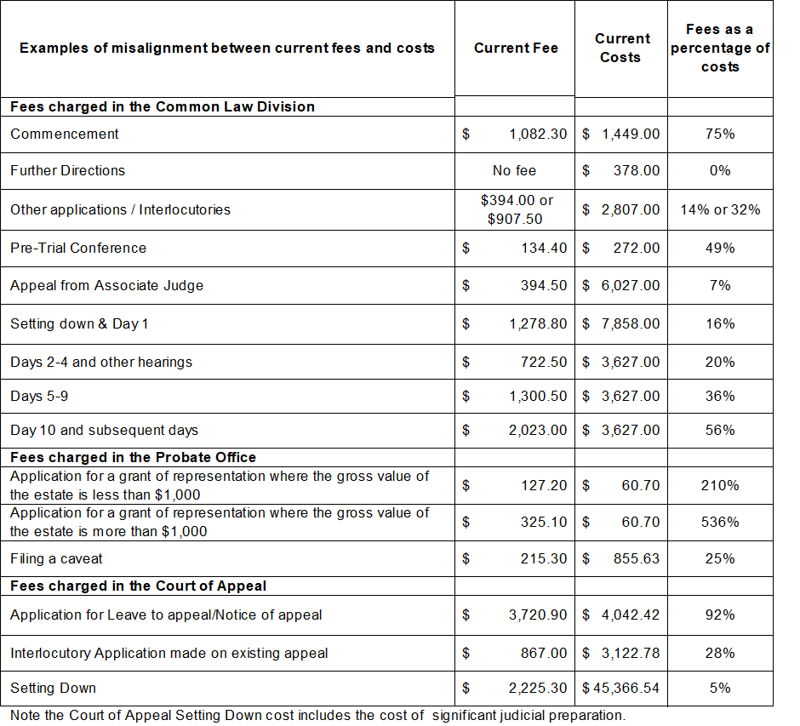
The robust costing methodology used in this RIS (as set out in Section 5) provides a mechanism for allocating costs for different types of matters on the basis of the actual workload involved in resolving them. It also takes into account the direct costs and the indirect costs associated with Supreme Court’s operations. The fees proposed in this RIS therefore generally reflect the costs of service delivery better.

Block Fees
The calculations that informed many current fees took into account a bundle of costs, including a range of judicial, quasi-judicial or administrative costs, which were not identified discretely.
Block fees are used routinely by courts and tribunals to avoid charging a large number of small fees for each stage of a dispute resolution process, and to avoid possible delays in the dispute resolution process. Block fees can be more efficient to administer and simpler for court users to understand. Block fees can also be efficient in encouraging optimal use of services if they reflect true costs, and most applicants use the services covered by these fees.
Currently however, because there is a poor correlation between the fees and the work of the Supreme Court, the uniform block commencement fee covers a wide range of unidentified costs, resulting in significant under-recovery in some areas and over-recovery in others. For example, in the Common Law Division, the work of associate judges and registrars in resolving matters is not reflected in the fee structure but absorbed into the uniform block commencement fee.

Other problems
Replacing the Existing Fee Regulations provides an opportunity to reconsider the inclusion of rarely-used fee points, and provides an opportunity to present the fees in a simplified and easily understood form.
The development of new fee regulations also provides an opportunity to improve fee collection practices. Previously, some fees were not collected routinely due to a combination of factors, such as the complexity of the current fee structure, its misalignment with the costs of service delivery, a lack of means within the current regulations to provide for fee recovery, and inadequate systems to detect non-payment quickly. Over the past two years, the Supreme Court has introduced processes involving regular monitoring by registry staff which have minimised this fee payment problem. While effective, this approach is resource-intensive and adds to the cost of fee collection.
Due to recent reforms of the Court’s management of taxation appeals matters (set out in Order 7 of the Supreme Court (Miscellaneous Civil Proceedings) Rules 2008), these matters are now managed and heard in the Commercial Court’s Taxation List. The making of new regulations provides the opportunity to resolve a fee anomaly relating to these taxation appeals. Currently, cases where the objector requests that a taxation objection be treated as an appeal to the Supreme Court are exempt from commencement and interlocutory fees. This exemption exists primarily because these matters are required to be filed by the Commissioner of State Revenue on behalf of the objector. The making of new regulations presents an opportunity to remove this exemption. In similar cases brought before VCAT, fees are imposed on the objector.
Lastly, the current fee structure lacks a clear, coherent and robust set of policy principles to inform judgements about its design, and decisions about the appropriate proportion of costs to recover.

Policy context and guiding principles

Government Policy
Under Victoria’s Cost Recovery Guidelines, an analysis of full costs is considered the mandatory starting point for developing a fee structure, and full cost recovery is the default pricing position. Full cost recovery promotes the efficient allocation of resources, is transparent, and avoids or reduces the need to rely on general taxation revenue. Deviation from full cost recovery is permissible where there are clearly stated policy principles or objectives to support such a course.
In relation to designing fee arrangements, the Cost Recovery Guidelines advise, among other things, that fees should:
  - advance the objectives of efficiency, equity, and fiscal sustainability;
  - recover costs directly from those who benefit from the service;
  - be cost-effective and practical in the administration of fees;
  - avoid volatility;
  - be easy to understand;
  - be decided in consultation with relevant parties;
  - be transparent; and
  - be monitored and reviewed regularly.
The Costing Principles and the Guiding Principles set out below have informed the development of the proposed fee structure. Consideration has also been given to section 129(2) of the Supreme Court Act 1986, which states that “it is not necessary for the amount of any fee to be related to the cost of providing the service”.

Costing Principles
The following Costing Principles have guided the identification of the full cost of service provision in each area of the Supreme Court and, the identification of the appropriate cost base for setting fees. These principles also support transparency in the Supreme Court’s cost structure.
- The full costs of delivering Court services are to be identified including direct and indirect costs
Indirect costs include the following:
      - overhead costs that are not associated with salary costs, such as training and information technology (IT) costs;
      - corporate costs including the costs of the Supreme Court’s Chief Executive Officer (CEO), and office and corporate services such as human resources (HR) and finance;.
      - rental costs and other similar costs; and
      - the Supreme Court’s share of the costs of Court Services Victoria (CSV) services.
- Corporate and overhead costs are to be allocated to areas of the Court
To the extent that it is possible, corporate costs are to be allocated to the area of the Court (for example, Lists) that incurs the costs. Remaining costs are to be allocated on a pro rata workload basis (as determined by the activity-costing methodology, because workload is the best measure of the relative resource usage of the Lists), unless the costs relate specifically to certain types of matters (when they would be allocated on a per-matter basis).
- Volumes and costs are to be based on escalated 2018-19 data and 2018-19 dollars
The costs analysis used workload volumes from 2015-16. These volumes were subsequently revised to 2017-18 workload volumes to account for volume adjustments at the Commercial Court and the Costs Court. This adjustment was made because the Commercial Court experienced atypical volumes in 2015-16 due to very large one-off proceedings, whereas the Costs Court restructured its management of cases in March 2016. In both approaches, year-to-date data was used to provide a more reliable benchmark for future activity. All costing was completed in 2016-17, and figures have been revised to reflect 2018-19 dollar values subsequently.
- The fee structure is to reflect efficient Court operations
The cost of efficient processes or systems is to be reflected in the fee structure. For example, the fee structure should recognise that finalising a matter through mediation is less costly than requiring a matter to go to trial.
- Court activities are to be modelled to determine costs of services provided within different areas of the Supreme Court
This modelling is used to identify the different cost structures of different types of services provided across the Supreme Court. This methodology recognises that the cost of delivery varies across Divisions and the stage of proceedings. For example, the costs of delivering services in the Commercial Court are higher than the costs of the Common Law Division, and different fees can reflect these different costs.

Guiding Principles
The design and assessment of options for the Proposed Regulations have been guided by the following principles:
- The fee structure should reflect the role of the Supreme Court in Victoria’s civil justice system
The Supreme Court is the superior court in Victoria and exercises a supervisory jurisdiction over other Victorian jurisdictions. The costs related to this role, over and above the costs of dealing with matters, are not recovered from court users.
Given the complexity of matters generally considered by the Supreme Court, the cost of service provision is high, reflective of the fact that management of these matters requires the input of many high value judicial and non-judicial resources. Many of these costs are fixed, and are important to retain in order to ensure the Supreme Court is able to maintain its capacity to provide the range and quality of services users expect to obtain in a superior court.
The fee structure needs to ensure an alignment between costs, fees, the high level of service, and the reputation of the Supreme Court.
- Access to justice is to be safeguarded
Access to a fair and impartial justice system is a fundamental tenet of the rule of law. The concept of access to justice figures prominently in all discussions of court fees. A well-functioning justice system should provide timely and affordable justice. This means delivering fair and equitable outcomes as efficiently as possible, and resolving disputes early, expeditiously, and at the most appropriate level.
The following considerations have been taken into account in supporting access to justice in the course of the fees review:
- The level of fees is a consideration where access would be limited or denied for a significant number of potential court users if the cost were prohibitive, or at least so great as to be a major disincentive to taking a matter to court, especially where applicants have no choice of court. However, as Supreme Court fees generally constitute less than 10 per cent of total user costs (the majority being the costs of legal advice), in many cases a change in Court fees alone might not materially change access (although this is not the case for self-represented litigants). Through the reforms introduced recently, the Supreme Court has sought to lower overall costs for court users by reducing the number of court appearances and the time taken to finalise cases, and facilitating early resolution through mediations and other interventions. Additionally as part of the Government’s broader commitment to access to justice, the court is currently increasing the accessibility of its website and hardcopy materials, and will shortly pilot a legal assistance service to improve supports to self-represented litigants.
- Access to justice might be a relevant consideration for corporate users where full cost recovery charges would be very high and would present a potential impediment. In this case, charging less than full cost recovery might be warranted to protect access to justice. For example, the full cost of Setting Down a matter in the Court of Appeal is $45,366.44.
- Over-use of court services, as might occur if there were no fees in place, in preference to other court or VCAT mechanisms, potentially creates delays in dealing with matters, and effectively limits access to justice for other users. In this sense, fees set at an appropriate level can improve access to justice as they can encourage users to use the most appropriate jurisdiction to meet their particular needs, and reduce unnecessary congestion.
- The availability of fee waivers and concession fees for individuals also support access to justice.
- Fees should be equitable
Fees can be regarded as equitable if those who benefit from a court service pay for that service, and are not subsidising the cost of services they do not use (horizontal equity). Fees can also be regarded as equitable if those with proportionately greater means pay more than those with lesser means (vertical equity), increasing access for the latter.
As a general rule, court users should not pay for services they do not use. For example, users should not pay the cost of a trial if their matter is finalised without a trial.
Where there are public benefits that are not recognised in the fees that are charged (i.e., the fees are too high), services tend to be under-consumed. Governments often subsidise the cost of such services so that optimum levels of consumption occur.
It follows that where there are substantial public benefits, such as in the provision of appeal or judicial review mechanisms, lower levels of cost recovery may be appropriate.
- The fees structure should promote efficient court operations
The fees in the Proposed Regulations are set on the basis of efficient costs. If there are inefficiencies in current processes that could be resolved, the costs arising from inefficient practice are excluded from the costs on which fees are based. This approach encourages efficient court operations.
From an efficiency perspective, the proposed fee structure should be based on the resolution of matters at the earliest stage, and management of matters to resolution before trial. Such a focus is regarded as the most efficient. Similarly, fees should encourage the use of the lowest cost, but most effective, dispute resolution mechanisms available within the Supreme Court.
The fee structure should be sufficiently streamlined to support efficient administrative processes.
- Fees should be easy for court users to understand and for the Supreme Court to administer
Fee advice to court users should be easy to understand, including by those who have no legal training, as well as for the Supreme Court to administer.

Applying the Costing Principles and Guiding Principles
Development of this RIS has sought to give effect to the principles set out above, to provide transparent and reasonable explanations for changes to the current fee structure, and to retain the relativities between fees charge in the Supreme Court of Victoria and those charged in other jurisdictions
The Costing Principles and the Guiding Principles underpin the development of the options set out in this RIS. By nature, there is some tension between these principles. This tension means that decisions must be made about how, and the extent to which, the application of one principle (for example, access to justice) will be pursued in favour of another (for example, efficiency).
In practice, a balance is to be found between the competing principles. This balance reflects the intent of the Cost Recovery Guidelines – that users of government services are mindful of the costs associated with providing those services. The extent to which fees are charged means that the cost of government services are, to a greater or lesser extent, borne by the taxpayer.
Charging fees for court services is a mechanism that assists users in selecting the most appropriate service for their needs. It also ensures that, where appropriate, users bear some of the cost of those services, to the extent that they are able. The existence of fee waiver arrangements means that individuals experiencing financial hardship can still access court services when necessary.

Cost recovery
Along with other jurisdictions in the Victorian civil justice system, the Supreme Court generates public benefits, and this is reflected in the fact that funding for the system is broadly met by the State. This funding ensures that people who might otherwise be deterred by cost can seek redress, and the flow of public benefits is maintained. At the same time, the Government considers it appropriate that users should contribute to meeting some of the cost of services provided by that system to the extent that they gain private benefits from it, for example, the resolution of a private contractual dispute.
The percentage of costs that is recovered through fees is generally referred to as the level of cost recovery. According to the Cost Recovery Guidelines, an analysis of full costs is the mandatory starting point for developing a fee structure, and full cost recovery is the default pricing position. Full cost recovery is preferred because it promotes the efficient allocation of resources, is transparent, and avoids or reduces the need to rely on general taxation revenue.
The Cost Recovery Guidelines also recognise however that there are circumstances in which full cost recovery might not be possible or appropriate, for example, when full cost recovery is not practical, or where charging the full cost could undermine other policy objectives.
The Cost Recovery Guidelines, section 129(2) of the Supreme Court Act 1986, and the principles referred to above have informed cost recovery considerations for the proposed fees. Accordingly, cost recovery levels for fees in the Proposed Regulations vary, though the overall level of cost recovery would be around 35 per cent.

Other considerations
A range of other considerations has been examined in the context of identifying options for resolving the problems identified in Section 2.
While these matters could be resolved independently, by separate fee options, and each would represent an improvement on the current arrangements, considering each matter separately would be likely to lead to an incoherent response. Given their specific nature, these matters have been considered as components of the broader options that are discussed in Section 6 - Options.

Differential fees – Divisions and Lists
As noted in Section 2, the Supreme Court has traditionally relied upon global costing measures in setting fees, resulting in significant under-recovery in some areas and over-recovery in others. By identifying the specific costs of service delivery across the different Divisions and Lists, it is possible to more closely align fees to costs. This approach was adopted by VCAT when it remade its fee regulations in 2016, and is considered in this RIS.

Differential fees - Users
A differential fee structure allows for the levels of specific fees to be adjusted on the basis of who is using a court service. The Cost Recovery Guidelines allow for differential fees to be considered for different types of user (for example, Standard and Corporate), where appropriate.
The Supreme Court of Victoria is one of only two jurisdictions in Australia that does not have a differentiated fee structure with Corporate and Standard fees levels. The Supreme Court of New South Wales and the Federal Court of Australia operate differential fee rates for Corporate and Standard fee payers, and the VCAT fee regulations, which were made in 2016, introduced similar differential rates in that jurisdiction.
The Supreme Court Act 1986 was amended in 2014 to specifically enable the introduction of differentiated fees. Consistent with Supreme Court fees in most other Australian jurisdictions, differentiated fees are considered in this RIS.
In general, the Government considers that the fee structure should reflect the principle that those fee payers with the ability to pay more should do so, and conversely, those without the ability to pay should still be able to seek access to justice. While the categories of Corporate, Standard and Concession fee levels are used as proxies for ability to pay, some individuals might be wealthy enough to pay the full fee, and some corporations might struggle to do so.
Setting different fees for different classes of party recognises differences between corporations and most individuals, as:
  - corporations can generally claim court costs as business expenses, making them tax deductible, whereas they are not tax deductible for individuals (unless the matter relates to earning an income);
  - unlike corporations, individuals have human rights that require the protection of the courts, so access to justice for individuals involves a unique dimension of significant public interest;
  - although access to justice is also important for businesses (and the economy more broadly), because it allows their activities and interactions with others to be protected by the rule of law, corporations generally have proportionally greater resources and means than individuals;
  - cases involving corporations are usually more complex, and therefore consume more court resources; and
  - corporations are more likely to pursue litigation only where there is a clear financial interest in doing so, making price signals more effective.
In this sense, different fees for different classes of parties support more equitable fee arrangements. The following distinctions are proposed:

Corporate Fee | Payable by larger corporate users and government users. This fee level would be set at or close to 100% cost recovery.
Standard Fee | Payable by individuals, small businesses with a turnover of less than $200,000 per annum and registered charities and not-for-profit organisations.This fee level would be set at 50% of the corporate fee level, reflecting the generally higher capacity of corporations to pay court fees, in comparison to individuals and smaller businesses.
Concession Fee | This fee rate would apply to Health Care Card holders. It would be set at 50% of the Standard Fee level (to a maximum of $300, or 20.7 fee units).
Waiver | A full waiver would continue to be available where payment of the fee would present financial hardship. Automatic waivers would also be available for some users, such as those in receipt of pro bono assistance or legal aid, or those serving a term of imprisonment or otherwise detained in a public institution.

Concession Fee
The Proposed Regulations would introduce a Concession fee category. This would be set at 50 per cent of the Standard fee, to a maximum value of $300 for 2018-19 (20.7 fee units) and would be payable by Health Care card holders. A Concession fee category was introduced at VCAT in 2016. The maximum value of $300 for Concession fees at the Supreme Court was chosen in recognition of the corresponding value of $150 set for VCAT in 2016, and the expectation that future fee regulations of the County Court and of the Magistrates’ Court would look to set rates between these two fee levels.
The Concession fee category recognises that Health Care Card holders have already been assessed as having limited means, and are likely to struggle to pay a full fee.
Those eligible for a Concession fee can still apply for a waiver.
With the introduction of a more affordable Concession fee, it is expected that fewer people seeking access to Supreme Court would need to rely on a full fee waiver.

Waiver
The widespread practice of fee waiver arrangements in civil jurisdictions is closely linked with the themes of access and equity, and the availability of fee waivers is often regarded as an indicator of accessibility. Upon consideration of a written application, the Prothonotary (and Deputy Prothonotaries) can waive a fee where they consider that payment will cause financial hardship. In most instances, fee waivers are only granted to people representing themselves.
In 2016-17, the Supreme Court waived fees to the value of $59,386 (scaled to 2018-19 dollars), or less than 0.3 per cent per cent of total fee revenue. The majority of applications for waivers were for matters heard in the Common Law Division, and over 80 per cent of the 60 applications were approved.
Full fee waivers are currently the main mechanism available to the Supreme Court to ensure that a lack of financial means does not become a barrier to accessing justice.
Waivers would continue to be available to those court users who can demonstrate to the satisfaction of the Prothonotary that full payment of the fee would cause financial hardship. As a further measure, automatic fee waivers would be available to those in receipt of pro bono assistance or legal aid, or those serving a term of imprisonment or otherwise detained in a public institution. These waiver arrangements are incorporated in the Proposed Regulations, providing certainty to users and streamlining of administrative processes.

Level of cost recovery
The differing levels of cost recovery for the fees proposed by this RIS have been determined with reference to a number of factors; the balance of public and private benefits; access and affordability for different Divisions and Lists; and choice of jurisdiction. More detail regarding these factors is provided below.
As noted previously, while it is Government policy to recover fees at full cost, this might not always be possible or appropriate. Determining the appropriate rate of cost recovery is difficult, as reflected in the variation of the rates of recovery across national and international jurisdictions. For example, in the United Kingdom, the High Court aims for 100 per cent cost recovery, whereas the level of cost recovery for the Supreme Court of New South Wales is just over 42 per cent, a rate similar to comparative jurisdictions in Queensland (37 per cent) and South Australia (32 per cent). Comparisons of cost recovery ratios between jurisdictions should be regarded as indicative only, as it is not always possible to examine all the relevant cost variables.
Other than those fees amended in 2014, the current Supreme Court fees are based on a mix of benchmarks with other courts (most notably the Federal Court of Australia), historical fees structures and global cost recovery targets.
As none of these jurisdictions has publicly provided a clear reasoning for setting fees, these benchmarks provide limited guidance in establishing appropriate levels of cost recovery. As a result, rather than setting cost recovery in Victoria to match another jurisdiction, or a measure based on those jurisdictions (e.g., an average level of cost recovery), the Proposed Fees and the options presented in this RIS have been developed using, and assessed against, the three factors listed below.

1 – Public and Private Benefits
In determining the level of fees, consideration has been given to the balance of public and private benefits produced by the Supreme Court. Broadly speaking, economists regard public benefits as those that enhance the wider community, whereas private benefits confer an advantage to individuals.
Private benefits: In relation to private benefits, the Productivity Commission notes that:
“When individuals and businesses engage in civil litigation, it is generally because they have a private interest in the matter being brought…[A] party would not contest a matter in court unless the expected private benefits of taking action outweighed the expected private costs…The private benefits to a party of winning a case may be financial (for example, payment of damages) or non-financial (for example, vindication of one’s reputation).”
Private benefits relate to the ability to enforce private claims and obtain restitution for losses incurred due to the fault of others. For example, matters before the Commercial Court are generally complex and often involve substantial monetary value. Substantial private benefits therefore arise from the operation of the Commercial Court.
Public benefits: The Productivity Commission notes that public benefits include:
- “the ‘rule of law’ — where the ‘shadow’ of the formal justice system helps enforce legal rights, deters parties from engaging in unlawful conduct, and encourages informal resolution when rights are breached;
- the setting of precedents or clarification of the law; and
- the protection of vulnerable parties for whom safety or liberty is at risk.”
The Supreme Court provides a range of public benefits. By providing expert, legally enforceable dispute resolution processes for disputes between people, companies or other organisations, the civil justice system facilitates the economic growth and vitality of a jurisdiction. Through the doctrine of precedence, the litigation of matters in courts produces judgments that give predictability to the likely outcome of similar disputes, reducing the need for future court-based litigation.
The civil justice system provides both the means for enforcement of private agreements and legislation in individual cases, and the environment in which laws and obligations are honoured. For example, it provides the means to recover a debt, but also the environment in which people, companies and organisation comply with their financial and legal obligations.
Proceedings that typically provide strong public benefit might be expected to have lower levels of cost recovery compared to those that provide high levels of private benefit. This balance has been considered when developing the fee options.
Recognising public benefits as a consideration in setting fees should improve access and result in more optimal use of court resources.

2 – Access and affordability across different areas of the Supreme Court
Given the importance of court services in a contemporary democracy, affordable access to these services is highly regarded. It is widely accepted that court services should be affordable to those seeking them, and that consideration should be given to different levels of cost recovery for different classes of users. This consideration is expressed in the provision of safeguards for individuals who may face financial hardship in meeting the full cost of the fees. Most jurisdictions have a waiver system in place, irrespective of the level of cost recovery.
Against this, the services of the Supreme Court must be affordable to the extent that optimal use of the Supreme Court is assured. Some Divisions or Lists of the Supreme Court are inherently more costly than others. For example, usually three judges sit on Court of Appeal trials, whereas the majority of Probate matters can be resolved without judicial input. Taking into account the differing costs between Divisions and Lists of the Supreme Court and the importance of maintaining access to justice, it is appropriate for cost recovery levels to differ between Divisions and Lists within the Supreme Court.

3 – Choice of jurisdiction
The issue of affordability across each area of the Supreme Court is also balanced with the level of choice afforded to an applicant.
For some matters, applicants have no choice of jurisdiction, whereas in other matters there might be one or more alternative dispute resolution mechanisms available to court users.
For example, the County Court, with fees currently set at about 80 per cent of those of the Supreme Court, has mirror jurisdiction in many civil matters. The major exceptions are appeals and probate, where there is no mirror jurisdiction. Additionally, many matters before the Commercial Court could be lodged with the Common Law Division or with the County Court, and in some circumstances with the Magistrates’ Court, so there is considerable choice of jurisdiction for lodgement of some matters.
While parties always have the option of whether or not to commence a proceeding, in general, where there is no choice of jurisdiction in relation to a matter, it is reasonable to adopt lower cost recovery levels.
Cost recovery levels – factors for each Division or List
In practice, these three factors – public benefit, access and affordability, and choice of jurisdiction – interact. Consideration of future cost recovery levels for Supreme Court fees needs to take account of each matter and how they interact with each other.
Taking account of these issues, the following factors were considered in determining levels of cost recovery across the areas of the Supreme Court.

Court of Appeal
- The Court of Appeal is the highest cost division of the Supreme Court, which taken independently of other factors suggests that its fees should be the highest.
- However, there is very high public benefit in providing a mechanism for appealing the decisions of Victoria’s courts because Court of Appeal decisions provide precedent, enabling other jurisdictions to deal with similar cases in a consistent, predictable manner. This benefit would suggest that lower levels of cost recovery are reasonable.
- Applicants have no choice regarding jurisdiction, as there is no alternative, if they decide to appeal. Generally, where there is no choice for consumers, fees should be set so that they encourage optimum use of the service in question. If Court of Appeal fees are set too high, some users who should legitimately access the court would not make an application. If fees are set too low, the Court could be inundated with work, which would detract from the Court’s ability to properly discharge its duties.

Taken together, these factors suggest that the level of cost recovery in relation to Court of Appeal fees should be relatively low.

Commercial Court
- Matters before the Commercial Court are commercial in nature, and can be expected to deliver considerable private benefits to successful litigants. Matters are generally valued at $500,000 or more, which can often indicate that the applicants have considerable capacity to pay court fees, even while they may also face substantial costs for legal representation. The high level of private benefit and capacity to pay indicates that higher levels of cost recovery are reasonable.
- In most instances applicants are able to exercise choice about whether to take a matter to the Commercial Court. The jurisdiction of the County Court mirrors that of the Supreme Court, providing applicants with a choice of court. Applicants will choose the Supreme Court if they consider that the Supreme Court has special expertise, the matter is regarded as complex or if applicants specifically want the standing of the Court to be associated with the outcome of their matter.
- The Commercial Court is a high cost division of the Supreme Court, which suggests that its fees should be relatively high. The higher costs arise from a combination of the level of judge-led case management in its Lists, and the greater number of hearing days required to resolve matters.

Taken together, these factors suggest that the level of cost recovery for Commercial Court fees should be relatively high.

Common Law Division
- The range of matters dealt with in the Common Law Division is diverse, ranging from personal injury matters, to professional liability, to judicial review and appeal. In many cases the applicants in these matters consider that they have faced significant personal harm and are seeking redress. While resolving these matters confers considerable private benefit, there is also a significant public benefit arising from access to a mechanism to deal with such matters. This factor indicates that the level of cost recovery should be lower than for the Commercial Court.
- In most instances applicants are able to exercise choice about whether to take a matter to the Supreme Court. The jurisdiction of the County Court mirrors that of the Supreme Court, providing applicants with a choice of court. Applicants will choose the Supreme Court if they consider that the Supreme Court has special expertise, the matter is regarded as complex or if applicants specifically want the standing of the Court to be associated with the outcome of their matter.
- The Common Law Division has significantly lower cost structures than those of the Court of Appeal or the Commercial Court, which suggests that its fees should be lower. The lower costs arise from the greater involvement of associate judges, and the lower number of hearing days required to resolve matters.
Taken together, these factors suggest that a high level of cost recovery for fees in the Common Law Division might not be appropriate because it would not reflect the balance of private and public benefits arising from resolving the range of matters heard in this division.

Costs Court
- The Costs Court hears and determines matters relating to costs arising from court proceeding. It also hears costs disputes between legal practitioners and their clients.
- The Costs Court is a relatively low cost court, where most matters are dealt with administratively, with the major costs being those of an associate judge and a judicial registrar.
- The balance of interests met for matters in the Costs Court are in favour of the private interests of legal practitioners and/or their clients. Nevertheless, there is a public benefit in having a relatively low-cost mechanism available to determine such matters.
Taken together, these factors suggest that the level of fees for costs applications should fairly reflect costs, with those deriving the greatest private benefit and generally with the greatest means to pay (matters brought by solicitors) paying closer to full cost, with some discount for the level of public benefit delivered through the Costs Court.

Probate Office
- The Probate Office deals with all applications for grants of probate and administration, and maintains a register of all grants issued by the Supreme Court and all wills deposited with the Court for safekeeping.
- The Probate Office is low cost, with almost all matters being administratively determined.
- The balance of interests met for probate matters are in favour of the private interests of beneficiaries of estates. Nevertheless, there is a public benefit in having a relatively low-cost mechanism available to determine such matters.
- Probate Office fees are relatively low when compared to those charged in other jurisdictions. Although the rationale for high probate fees in other Australian jurisdictions, or the level of cost recovery they involve, is unclear, it could reflect a general acceptance that high or over-recovery of costs is seen as acceptable given the nature of probate matters.
- Probate Office fees often represent only a small proportion of overall transaction costs – legal fees will typically be in excess of $3,000.
- Fees at the Probate Office currently significantly over-recover costs (425.7 per cent cost recovery).
- Because of their very high volumes, a reduction of the current fees for the most common services – Application for Grant of Representation and Online Advertising fees – would significantly lower the overall level of cost recovery.
Taken together, these factors suggest that it is possible to significantly reduce the Probate Office fees for the majority of users.

Costing Methodology
The Proposed Fees are set on the basis of efficient costs. If there are inefficiencies in current processes that could be resolved, the costs arising from inefficient practice are excluded from the costs on which fees are based.
The approach set out below identifies the steps taken to establish the efficient costs of services for which fees are charged.

Step 1: Identification of cost centres
The first step in costing the activities of the Supreme Court was to determine the potential for different cost profiles in different parts of the Court, and to separate those profiles for costing. Identification of these ’cost centres’ ensured that the cost of activities was correctly attributed to specific areas of the Court where those activities occurred, minimising the potential for subsequent cross-subsidisation.
While in practice each List in each Division has its own cost structure, the experience of judicial officers and other officers of the Court supported the separation of court activities into the following costing centres:

The Court of Appeal
The Court of Appeal has its own jurisdiction and only hears appeals on matters already determined by another court. The Court of Appeal has its own Registry and only judicial officers appointed to the Court of Appeal can hear matters in that Court.

The Commercial Court
The Commercial Court hears high-end commercial litigation in judge-managed Lists and a range of other matters related to the workings of corporations. The Commercial Court has its own Registry and, generally, specialised judicial officers hearing matters in the Commercial Court do not work across the other Divisions of the Supreme Court.

The Common Law Division
The Common Law Division is the remainder of the Trial Division of the Supreme Court dealing with civil matters. It hears a wide range of civil matters including: claims in tort or contract law; claims involving professional negligence, personal injury and defamation; and proceedings relating to the Supreme Court's supervisory jurisdiction over other Victorian courts, tribunals and public officials, such as applications for judicial review and appeals on a question of law. The Common Law Division has its own Registry and, generally, judicial officers only hear matters in this Division, though on occasion they will sit in other Divisions of the Supreme Court.

The Costs Court
While structurally part of the Common Law Division, the Costs Court hears only applications for costs and related matters. Matters are more frequently determined by a Costs Registrar than a judicial officer, and the Costs Court utilises different dispute resolution mechanisms from other Lists in the Common Law Division. The Costs Court clearly stands alone as a separately identifiable division of the Supreme Court, with a markedly different cost structure.

The Probate Office
The Probate Office, under the direction of the Registrar of Probates, disposes of the majority of Applications for Grants of Representation. A relatively small number of clearly identified matters are transferred from the Probate Office to the Common Law Division and resolved there.

Administrative fees
These fees are administered by the Prothonotary on behalf of other parts of the Supreme Court. This area clearly stands alone as a separately identifiable area of the Court. It has responsibility for the administrative finalisation of many matters, such as receiving enforcement orders from other Courts. The matters determined by this area of the Court are routinely finalised administratively.
Having identified these costing centres, activity costing was undertaken to determine the costs of dealing with matters in each of these centres.

Step 2: Determining costing samples
The Commercial Court and the Common Law Division comprise multiple Lists, and the time required to cost each type of matter in each List was prohibitive. Discussions with court officials and analysis of court data identified Lists that could serve as proxies for other Lists, given the similarities in the way that matters are dealt with, and the extent of the relative involvement of judicial officers and administrative staff. The table below outlines the extent to which a proxy List can appropriately model the costs for a List which cannot be otherwise accurately costed due to the time this would require. For example, in the Commercial Court, proxy Lists could be used for the purposes of modelling for 81 per cent of matters, compared to the Costs Court where 100 per cent of matters could be appropriately modelled. The following activities were assessed as representative samples with high validity:
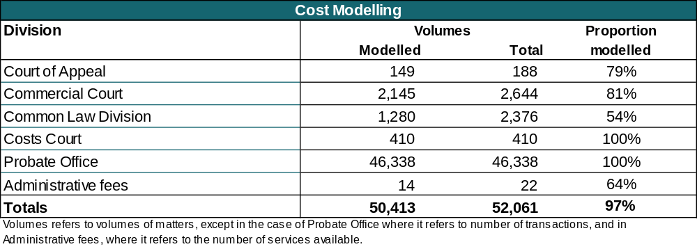

Step 3: Process modelling
Process modelling was used as a mode of activity-based costing, to identify activities that are undertaken to manage and deal with matters from the point at which they are lodged with the Supreme Court until they are finalised.
For example, the steps identified for two different types of matters, one in the Commercial Court and one in the Common Law Division, are as follows.
Common Law Division | Commercial Court
1. Lodgement | 1. Lodgement
2. File creation | 2. File creation
3. Transfer to Common Law lawyers for assessment | 3. Judge conference
4. Summary meeting
5. Pre-directions triage
6. First directions hearing | 4. First directions hearing
7. Mediation | 5. Mediation
8. Further Directions | 6. Further Direction
9. Pre-trial directions
10. Listed for trial | 7. Listed for trial
Given that the type of judicial officer and the level of staff can vary between the Divisions and Lists of the Court, quite different costs can be associated with the same activity in different Divisions and Lists.It should be noted that, while the Common Law Division appears to utilise more steps in its case management and dispute resolution practices, the average cost of dealing with matters in the Common Law Division is lower than the average cost of dealing with matters in the Commercial Court. Primarily the differences relate to the type of matter being heard by these two divisions of the Supreme Court.
An average expenditure was determined for each step in the process, taking account of who is undertaking the activity (for example, a Victorian public service (VPS) staff member or a Justice of the Supreme Court) and possible variations in the time taken to complete an activity, as is the case with some types of hearings. No other activities were measured, such as attending meetings or staff supervision. (See Step 4 for how these costs were incorporated.)
A monetary value was allocated to the identified activities using the Costing Guidelines for submissions to the Department of Treasury and Finance for funding of new initiatives based on salaries in effect on 1 July 2016. The costs include salaries and some on-costs, such as superannuation and annual leave, as well as an allowance for some overhead costs.
The process modelling identifies both the costs and the relative resource usage of different types of matters in different Divisions and Lists. It is possible to compare the direct costs identified for one type of matter in one Division or List, with the costs of dealing with similar or different matters in other Divisions and Lists. Maintaining these relativities between the different Divisions and Lists is important for deriving efficient costs, as discussed below.
All costing was completed in 2016-17 and used 2016-17 costs. In order to present costs and proposed fees in 2018-19 terms the following adjustments were made:
- the 2018-19 value of the Victorian fees unit ($14.45) was used as the relevant fee unit value; and
- the 2016-17 costs were escalated by 2.1 per cent to take account of cost increases for 2017-18, and by a further 2.0 per cent to take account of cost increases for 2018-19 costs, based on the Consumer Price Index (CPI), These percentages were the latest available CPI figures from the Australian Bureau of Statistics at the time the costings were finalised.
The costs used throughout this RIS are therefore estimated 2018-19 costs. The current fees are the fees that will apply from 1 July 2018 and the Proposed Fees reflect the value of the 2018-19 fee unit value.

Step 4: Estimating efficient costs
As indicated above, the activity-based costing was based on salaries and some on-costs, however not all costs were included in the calculations.
The total or efficient costs related to each type of matter handled in each List cannot be discovered through process modelling, because there are a range of expenses, including indirect costs, that are not taken into account through the process modelling. For example:
- the only direct costs that are counted are the costs that arise when an application is ’touched’ or considered in some way;
- costs related to administration or corporate governance are not captured in the costs;
- costs related to judicial officers conferring with each other on issues related to cases are not included;
- costs relating to the supervision of staff are not included, e.g., the costs related to providing direction, checking work where relevant, and managing staff performance;
- corporate costs, such as the costs of the CEO’s Office, financial management, human resource management, information and communications technology, and the provision of hearing rooms and accommodation are not included;
- the costs of administrative support services for judges’ chambers and the costs of judges’ associates are not fully identified in the process modelling. This is because only a proportion of their work relates to specific cases, and the modelling only captures when matters are specifically worked on by a judicial member or a staff member. For example, clerical support workers ensure files are ready and available for judges, but these clerical tasks were not included in the activities that were costed; and
- the cost of shared services provided by CSV that are charged to the Supreme Court are not included in activity based costing.
To take account of these costs the option of using a default overhead and on-cost rate of 75 percent of the wage rate was contemplated. However, such an approach was considered to duplicate some costs, such as superannuation costs, that were already included in the Supreme Court cost estimates
A comparison was undertaken of salaries and the total costings, and it was found that the costings already included a 35 per cent mark-up on wages and salaries (representing a number of on-costs). The Supreme Court therefore escalated the wage costings by 40 per cent (to reach the default 75 per cent mark-up) to take account of other costs not included, such as rent and building maintenance, depreciation and some measure of costs such as IT equipment and services costs. This 40 per cent adjustment to the direct salary costs was made as an estimate of full costs.
Following this adjustment, the total estimated cost was compared to total court costs related to civil matters, to ensure that the calculated total or ’efficient’ costs are less than budgeted costs. This comparison indicates that the costs identified through activity-based costing and the escalation of those costs by 40 per cent to allow for overhead costs are at least 7.7 per cent less than would occur if the activity-based costs were escalated to actual costs. Accordingly, the allowance for efficient costs is potentially of the order of 7.7 per cent and the costing of matters has been conservative.
The resulting total costs for each type of matter have been used as the basis for developing fee options.

Step 5: Setting fee values
Having identified the costs of activities for a number of Lists in each Division, the costs of activities were averaged to determine an average cost for each activity for each Division.
For most matters fees have been grouped as follows:
Commencement Fees | Applying to the application that lodges a matter with the Supreme Court in the first instance.
Case Management Fees | Relating to court activities that might or might not occur, depending on how a matter progresses. These activities include, for example, mediation fees, fees for interlocutory applications, and fees for appealing the decisions of associate judges who may be hearing interlocutory matters.
Setting down fees | Covering the cost of listing a matter for trial or appeal.
Hearing fees | For the days of a trial or for days of an appeal in the Court of Appeal.
Other hearing fees | For hearings, other than trial days, such as interlocutory hearings, appeals from an associate judge or judicial registrar, or public examination in the Trial Division. Generally the first hearing day has been included in the application fee for interlocutories and appeals from associate judges, but these matters can go to a second day, as can hearings related to public examinations of company directors. A first day hearing fee has been included for those few matters where a first hearing day is not covered by an application fee.

Regarding the grouping of fees, preferred fee options were then calculated on the following basis:
- To reflect access to justice considerations: the Corporate Fee is generally based on full costs (with some Corporate fees set below full cost recovery due to access to justice considerations); the Standard fee is 50 per cent of the Corporate fee; and the Concession Fee is 50 per cent of the Standard Fee, and capped at $300 (20.7 fee units). The actual amounts vary marginally from this guide to take account of the need to express fees in fee units to one decimal point. In this way, modelled costs drive fee amounts and generally determine the fees for Corporate Fee payers.
- For commencement fees, the costs include costs from the initial lodgement of a matter up to and including the first opportunity to finalise a matter. This is the first directions hearing for a contested matter or a default judgment if the matter is not contested. This approach promotes the principle of more efficient Supreme Court operations.
- Where case management fees are concerned, in order to minimise the number of fee points, fees for similar types of case management activities were allocated the same fee. Generally this was based on the lowest cost in the range of activities, in order to avoid over-recovery of costs for any fee type. This approach facilitates better understanding and use of the fee structure.
- In some cases, fee differentiation for case management fees was considered necessary, for example, to differentiate between urgent interlocutories that often require rescheduling of some court activities, and routine interlocutory applications that are listed in accordance with existing court activities. This approach reflects the equity principle of aligning fees to costs. Again, the modelled costs were used to set the Corporate Fee, with fee discounts for Standard Fees and Concession Fees.
- Setting down costs reflect the cost of preparing a matter for hearing. Given the very high cost of ‘setting down’, the Corporate Fees for setting down have been set well below full cost recovery to reflect the access to justice principle and relativities with fees in other jurisdictions.
- Fees for trial days have been set in day ranges for each Division – Day 1, Days 2 to 4, Days 5 to 9 and the 10th and subsequent days for the Common Law Division and Days 10 – 14 and the 15th and subsequent days for the Commercial Court. The average cost of one trial day includes the cost of any necessary research or judgment writing. There is no proposed differentiation of further hearing day fees after Day 1 in the Court of Appeal because very few matters go to a further day. Hearing fees become more expensive as a trial progresses, to provide an incentive to settle a matter as early as possible, reflecting the principle of enabling more efficient Court operations.
- For costing centres that have hearings, an ’other hearing fee’ has also been set to provide a basis for charging fees for hearings other than trial day hearings. This is to account for the fact that there have been some hearing activities that have not attracted a fee until now, and is consistent with government expectations that users should contribute to the cost of service provision.

Step 6: Revenue estimates
Revenue estimates provided in this RIS were initially calculated in 2016-17 dollars. Adjustments have been made to present the revenue estimates consistently with the recently revised fee unit value, which has been announced for 2018-19.
In order to present current revenue in 2018-19 terms, the following adjustments have been made for revenue calculations arising from the Existing Fee Regulations:
- revenue estimates were escalated to allow for the increasing value of the fee unit value as follows:
      - in 2017-18 the fee unit value increased by 2.0 per cent; and
      - in 2018-19 the fee unit value will increase by 1.6 per cent;
- current revenue for 2017-18 was modelled to take account of the increase in the fee unit value and then adjusted to take account of a decrease in actual 2016-17 revenue, arising from lower activity volumes; and
- 2018-19 revenue estimates are based on the 2018-19 fee unit value and the decrease in 2016-17 commencement volumes and interlocutory application volumes on a List by List basis. No adjustment has been made for a possible change in 2017-18 activity volumes.

The overall impact of these changes is summarised below:
Summary of changes in modelled revenue related to the Existing Fee Regulations:
Year | Current Revenue Estimate ($m) | Source and alignment
2016-17 | $20.218 | Modelled revenue estimates based on 2015-16 activity volumes, but calculated in 2016-17 dollars.
2017-18 | $19.045 | Modelled revenue adjusted for the increase in 2017-18 fee unit value and decrease in Commercial Court activities.
2018-19 | $19.354 | Modelled revenue adjusted for the 2018-19 fee unit value.

Options
The options considered in this section reflect the application of the policies and principles set out in this RIS. Each of the options is assessed against criteria to compare the advantages and disadvantages. In each case, the assessment is against the base case that would arise in the event that the regulations were not replaced and, therefore, no fees would be charged for Supreme Court services.

Criteria for assessing options
Using the principles that have guided the Supreme Court fees review, and in light of the issues with the current fee schedule, and the objectives of reviewing Supreme Court fees, the criteria and weightings set out in the table below have been adopted for assessing the suitability of fee options.
Criteria | Weighting
1. Reflect the role of the Supreme Court | 30%
2. Equity | 30%
3. Efficiency | 30%
4. Simplicity | 10%

In light of the significance of access to justice for effective Supreme Court operations and its importance to stakeholders, a separate criterion was considered for this issue. However, it has not been pursued because elements of access to justice arise from all the four criteria above: supporting the Supreme Court’s intended role; equity considerations; efficiency; and simplicity. Therefore, access to justice considerations have been included in the discussion of each of the other criteria (see below).

1 – The role of the Court
The Supreme Court is the highest civil jurisdiction in Victoria and typically deals with the State’s most serious and complex matters. As such, it is a high cost jurisdiction. However, the fee structure needs to balance the high cost with the importance of providing access to justice and the fact that, in many cases, parties can seek resolution at other lower cost jurisdictions. The Supreme Court’s fee structure plays a significant role in encouraging efficient use of Supreme Court services. Low fees, that could encourage litigants to bring matters to the Supreme Court, without first considering lower cost jurisdictions such as the County Court or alternative dispute resolution options, could undermine the Supreme Court’s role in the civil justice system. Similarly, high fees, which could discourage genuine claims, could undermine the social, economic, environmental or regulatory systems of Victoria.
A good alignment between costs and fees, taking account of the mixture of public and private public benefits provided by the Supreme Court, would send effective price signals to users and help ensure that Supreme Court services were neither over- nor under-used.
Because of the significance of the role of the Supreme Court in the civil justice system as the highest court in Victoria, and the Court that deals with the most serious cases and makes decisions that are binding and of high standing, this criterion is given a weight of 30 per cent.

2 – Equity
Equity is one of the benchmark criteria arising from the Cost Recovery Guidelines. A fee structure should be designed so that those users who benefit from a court service pay for that service and do not subsidise the cost of services they do not use (horizontal equity). Another relevant consideration is that those with greater financial means contribute proportionately more than those with lesser means (vertical equity).
In the Supreme Court, the fee structure should have strong horizontal equity where, as far as possible, costs should be based on specific activities rather than on a generic court-wide cost base.
Vertical equity considerations might mean that applicants with lesser means pay lower fees for the same service, i.e., fees are discounted to provide for capacity to pay. Generally, where court and tribunal fees are concerned, the monetary value of matters is taken as a proxy for the capacity to pay, although this can only be regarded as a partial indicator. For example, it is recognised that while the monetary value of certain matters, particularly those in the Commercial Court, would suggest a capacity to pay, this capacity is not universal. Similarly, certain court users such as incorporated entities are generally considered to have a greater capacity to pay, whereas others, such as those in possession of a Health Care card, would be considered as having a very limited capacity to pay.
Equity has been allocated an overall weighting of 30 per cent, with horizontal and vertical equity considered of equal importance.

3 – Efficiency
The fee structure should support Supreme Court operations that enable the appropriate resolution of matters at the earliest stage and help lower overall transactional costs for court users. Minimising the costs of proceedings is an overarching obligation of the Civil Procedure Act 2010.
Efficiency has been allocated a weighting of 30 per cent.

4 – Simplicity
The fee structure should be able to be presented in plain English and be easily understood by all users, including those who do not have legal training. At the same time the fee structure should be simple for Supreme Court staff to administer.
Simplicity has been allocated a weighting of 10 per cent.

The base case
The Victorian Guide to Regulation requires that the options presented in the RIS be assessed against the base case of no regulation and, therefore, no fees. To compare the options discussed below with the base case, it is necessary to make some other assumptions about how the Supreme Court would operate under such no-fee arrangements. Those assumptions are:
- the Supreme Court is likely to receive a significant increase in applications because the service would be free to the user;
- enabling legislation would not be amended to limit the scope of the Supreme Court’s responsibilities;
- current funding levels would be maintained but not increased in response to increased demand; and
- there would be continuing restrictions on other resources, such as the infrastructure available to the Supreme Court for its operations (for example, hearing rooms) and, associated with that, limits to the number of judicial officers and Supreme Court staff who could be employed.
The base case has been assigned a score of zero for each criterion, making its total score zero. The assessment of the base case against the criteria is shown in the table below. This table also sets out the meaning of each zero score.
Criterion | Weighting | Score | Weighted Score | Describing the base case in terms of the assessment criteria
Reflect the role of the Supreme Court | 30% | 0 | 0 | If there were no fees there would be a large increase in the number of users who would file at the Supreme Court because it would be free to obtain decisions that are binding and of high standing. This over-use would compromise access to justice.
Equity | 30% | 0 | 0 | Without fees, vertical equity does not exist. No users are required to pay fees, even if they have substantial means.  Horizontal equity is also irrelevant because the concept of only paying for services that are used is not relevant.
Efficiency | 30% | 0 | 0 | Large volumes of applications would undermine the efficiency of Supreme Court operations. Matters would not be heard expeditiously. Considerable re-engineering of processes would be required to maintain an acceptable level of service delivery.
Simplicity | 10% | 0 | 0 | Fee structure is very easy to understand, as there are no fees.
Total | 100% | 0 | 0

An option can be regarded as better than having no fees if it scores higher than zero. The higher the score the better the option is considered to be. The following scoring system has been used:
10 Very much better than the base case
7 Much better than the base case
5 Better than the base case
0 Same as the base case
-5 Worse than the base case
-7 Much worse than the base case
-10 Very much worse than the base case
Under this scoring system the maximum score for an option is 10.

Options
Development of the RIS has provided the opportunity to thoroughly revise the Supreme Court’s fee structure, and to consider a range of options. The salient features of each option and reasons for pursuing them, or otherwise, are set out below.
As indicated in the following table, the options being examined in detail in this RIS are:
Option 1. Modification of current arrangements.
Option 2. Full cost recovery.
Option 3. Restructured fees (preferred option).
Other options discussed in the following table have not been fully assessed because they present significant risks for efficient practice, or because they would be far more difficult for users to understand and navigate than the current fee structure.

Short title | Main features | Summary comparison with the base case
A. The status quo | The current fee structure would be maintained. Some rarely-used fee points could be removed to make the fee scale a little easier for users to understand. | Compared with the base case, Option A:  - supports the Supreme Court’s role well;  - horizontal equity is better than the base case but is not strong;  - vertical equity is reasonable;  - is less simple for users; and  - efficiency is better.  Given the opportunity to undertake a thorough review, this option has not been examined in detail.
B. Modification of current fee arrangements  (Option 1 below) | The current fee structure would be adjusted to account for changing costs over time and would incorporate differential fees and some revised fee categories. It would not reflect the changes in service delivery, leaving many fees broadly at the same level as those currently charged. | Compared with the base case, Option B:  - better supports the Supreme Court's role;  - improves horizontal equity but is not strong;  - improves vertical equity;  - would be more efficient; and  - is not as simple for users.  The fee structure would be more complex to administer than the base case but considerably better than the status quo. This is Option 1, which is considered below in more detail.
C: Full cost recovery  (Option 2 below) | Fees would be set at full cost recovery for all matters for which a fee may be charged lawfully. Almost all fees would increase, some significantly. There would be some simplification of the structure, compared to current fees (but this option is less simple than the base case). | Compared with the base case, Option C:  - supports the role of the Supreme Court by encouraging use of other jurisdictions, where appropriate, but is worse than the base case as the very high level of fees would discourage genuine claims;  - has very strong horizontal equity with fees truly reflecting  - the costs of services that are actually used;  - vertical equity is worse; and  - is not as simple for users.  This is Option 2, which is considered below in more detail.
D. Different fees for different lists | Fees would be set for each List and administrative activity, and a differentiated fee structure applied. | Compared with the base case, Option D:  - supports the Supreme Court’s role well;  - improves horizontal access as fees reflect costs; and  - improves vertical access by introducing differentiated fees; and  - creates a fee structure more complex to administer than the base case, and considerably worse than the status quo or other options, because there would be multiple fee schedules, and users might be motivated to lodge matters inappropriately in lower-cost lists, leading to inefficiencies as those lists would become congested.  This option has not been examined in more detail because of the highly complex fee structure it would create.
E. Restructured fees  (Option 3 below – preferred option) | The current structure would be significantly revised to acknowledge the impact of reforms to service delivery and fees would be based on the different costs centres of the Supreme Court, rather than on global costs. Differential fees based on classes of court users would be introduced and categorisation of fees grouped around areas of activity would also feature. | Compared with the base case, Option E:  - better supports the Supreme Court's role;  - has stronger horizontal equity, but not as strong as some other options;  - vertical equity is better, and is more efficient; and  - is not as simple for users but addresses existing problems, such as the misalignment of court services and the cost of their provision  This is Option 3, which is considered below in more detail.
F. Invoicing for services rendered | Fees would generally be set in accordance with Option E in that a three-tiered fee structure would be in place. However, fees would be more highly disaggregated by stage of proceeding. For example, an hourly fee component would apply for a directions hearing. At the conclusion of a matter, an invoice would be sent covering the services that were provided. Invoices could be sent out more regularly for long-running matters or higher-valued matters. | Compared with the base case, Option F:  - does not support the role of the Court as it does not appropriately respond to access to justice considerations;  - has stronger horizontal equity;  - improves vertical access due to differential fees;  - would require extensive new administrative systems;  - would be subject to human error; and  - many users would not be able to quickly or accurately estimate fees, resulting in justifiable complaints. Directions hearings, for example, can last anywhere from 10 minutes to two days, and the length of the hearing may only become apparent once it has commenced.  This option has not been examined in detail because:  - the benefits in terms of improved horizontal equity would be outweighed by the administrative costs of maintaining and enforcing such a system;  - the uncertainty it might create for those taking cases to court; and  - the need to monitor and manage debt would undermine efficiency.
G. Single fee | Fees would be differentiated by the Division of the Court in order to generally reflect different cost structures, but a single upfront fee would apply with no other fees charged irrespective of when or how a matter was settled. | Compared with the base case, Option G:  - does not support the role of the Court;  - has worse vertical access as the fee is likely to be very high;  - has very poor horizontal equity; and  - would be very easy to users to understand and for the Court to administer  This option has not been examined in detail because:  - the single fee would necessarily have to be very high if it were to reflect all potential costs; and  - the very poor horizontal equity would mean that all users would contribute to the cost of other activities, for example a trial, even if their matter did not require one.

Option 1: Modification of current arrangements
This option represents a modification of the existing fee structure with adjustments for changing costs over time.
The option is a ‘minimal change’ approach. It would incorporate a differential fee structure with Corporate, Standard and Concession fees, as well as revised fee categories with fees for most matters grouped as Commencement fees, Case Management fees, and Hearing fees. However, its costing would not acknowledge the process reforms recently introduced by the Supreme Court.
As this option would not reflect the impact of service reforms, it would leave many fees broadly at the same level as those currently charged. Generally, fees for individuals would be either the same or lower under Option 1 than those charged currently. The current waiver arrangements would also continue to apply, permitting the waiver of fees for individuals on grounds of financial hardship.
The Corporate Fee rate would be set closer to, or in several cases at, cost recovery, while Concession fees would be set at half the rate of Standard fees (to a maximum of $300 or 20.7 fee units).
The following tables demonstrate the fees payable under Option 1. These tables also show the changes in fees that would occur compared with the current fee structure.
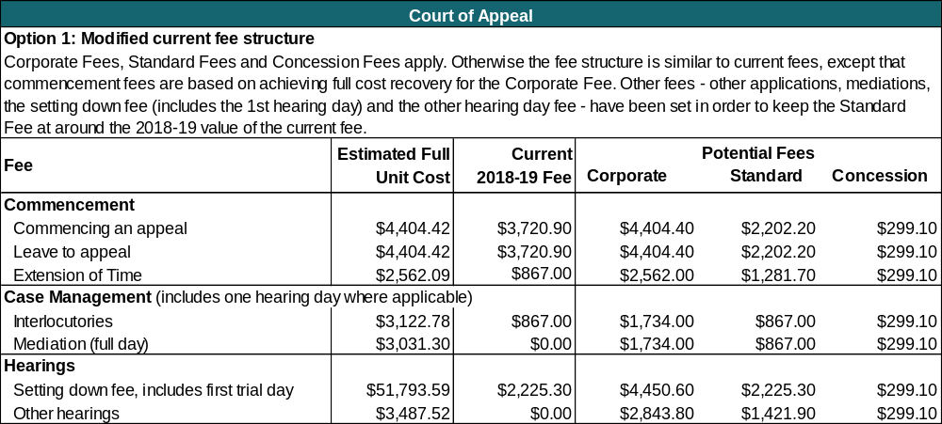
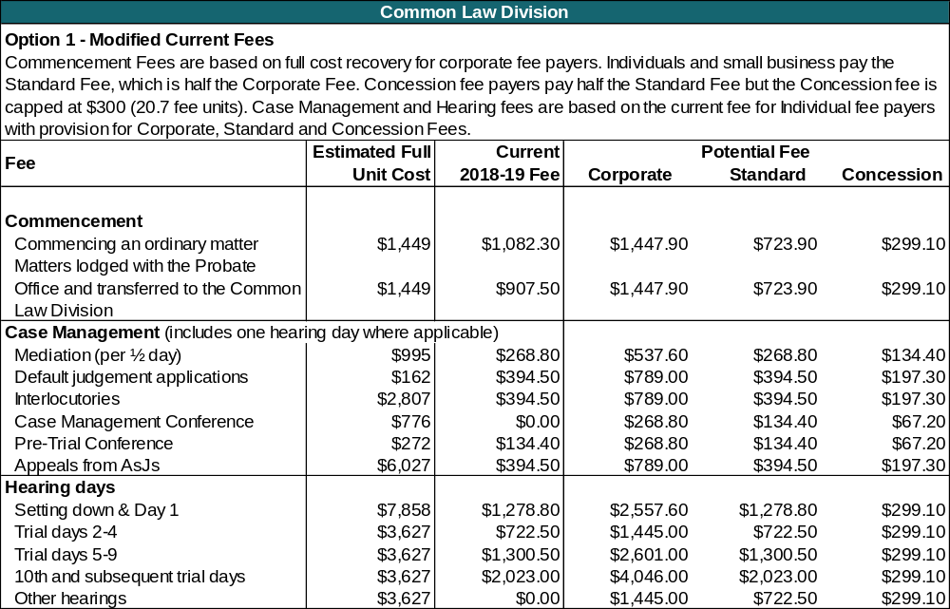
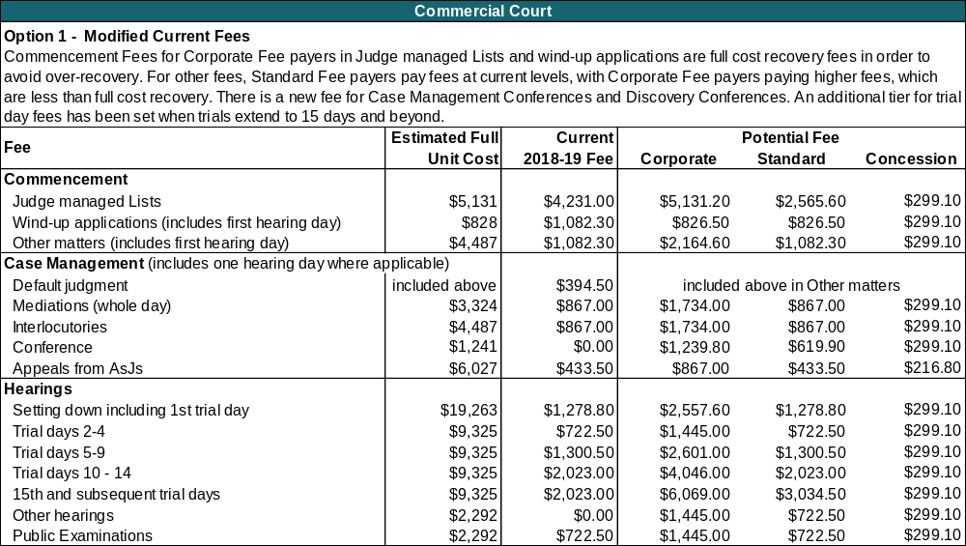

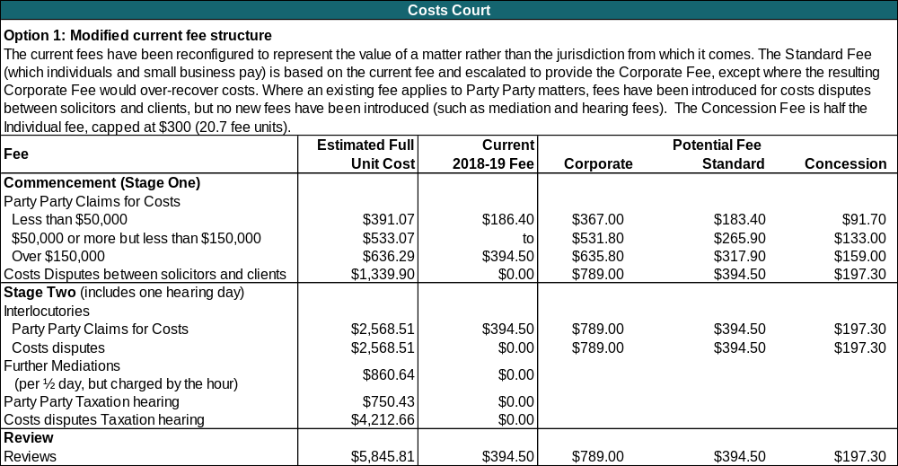
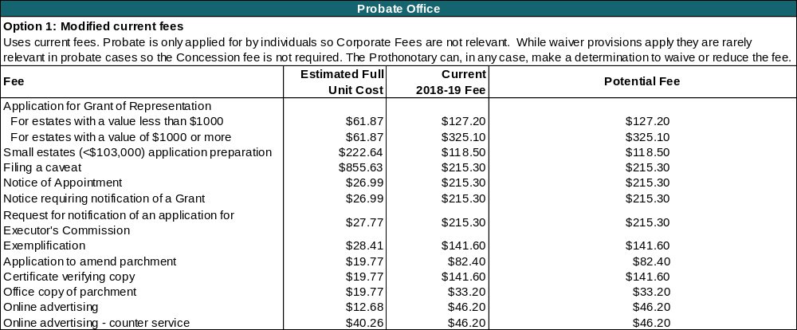

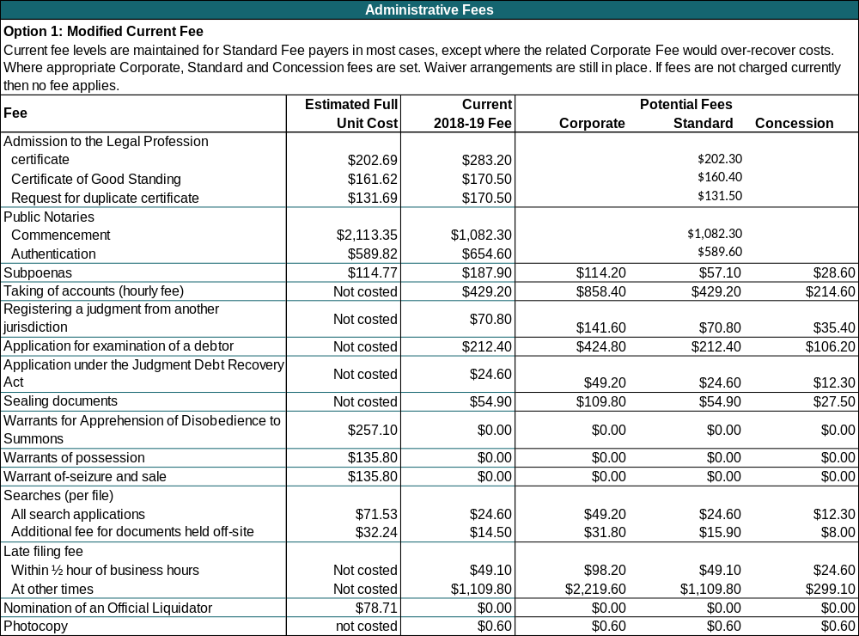
Under Option 1 the total revenue for fees is expected to be approximately $20.074 million per annum (in 2018-19 dollars).
Overall, fee revenue would increase, largely as a result of the introduction of Corporate Fees. The highest fee increases would occur in the Commercial Court (approximately 30 per cent).
Against the base case, where no fees are charged, the advantages of Option 1 are as follows:
- the imposition of fees means that users would have an incentive to consider whether an alternative jurisdiction might be more appropriate;
- access to justice would be improved as there would be fewer matters inappropriately commencing at the Supreme Court, allowing appropriate matters to be dealt with in a timely manner; and
- government would recover some of the costs of service provision.
Against the base case, where no fees are charged, the disadvantage of Option 1 is that the imposition of a fee structure inevitably means that the simplicity of no fees in the base case is lost. As such, this option would be regarded as more complex than the base case.
Additionally, the existing problems with the current fee structure, such as fees being unreflective of services provided (and the cost of their provision), would remain unresolved.
Using the assessment criteria and scoring scheme set out above, Option 1 scores 3.8 points.

Assessment of Option 1
Criterion | Weighting | Score | Weighted score | Comment
Reflect the role of the Supreme Court | 30% | 5 | 1.5 | Better than the base case. It supports the Supreme Court's role because it better aligns costs, fees and the Court’s reputation, although not as well as Option 3 which is more closely calibrated to reflect the recent operational reforms.
Equity | 30% | 5 | 1.5 | Horizontal equity is improved because users are paying differential fees for different services.  Vertical equity is improved as those with the capacity to pay (e.g. corporate fee payers) are asked to pay more.
Efficiency | 30% | 5 | 1.5 | The Supreme Court would be more efficient compared with the base case as the reduced demand would be more manageable. Matters would be dealt with in a timely manner and staff would be able to offer greater assistance to users. Better than Option 2 but not as good as Option 3 in terms of allocative efficiency, as the price signal is not as well calibrated.
Simplicity | 10% | -7 | -0.7 | Would be much worse than the base case, as, like Option 3, it introduces a multi-tier fee structure. It is worse than Option 2 which introduces only a single tier structure.
Total |  |  | 3.8

Option 2: Full cost recovery
This option represents a modification of the existing fee structure but would impose fees at full cost recovery levels.
It would provide for revised fee categories with fees for most matters grouped as Commencement fees, Case Management fees, and Hearing fees. It would have a flat fee structure with the same fee being charged to all users for each service.
The full cost recovery option is presented here with minor modifications for policy considerations. Therefore, there is no fee discount provided for individuals or Health Care card holders but the current waiver arrangements, whereby fees can be waived on grounds of financial hardship, still apply. The higher fees would mean that their payment would cause more people financial hardship and therefore more people would qualify for a waiver. More users being eligible for a waiver could result in an increase in the number of inappropriate or vexatious cases.
Under full cost recovery, almost all fees would increase significantly, many by over 100 per cent. The highest fee increases would occur in the Court of Appeal (766 per cent), the Common Law Division (226 per cent) and in the Commercial Court (206 per cent), though fees in the Probate Office would decrease (80 per cent). Compared to current arrangements, these increases could present considerable barriers to justice for most court users. The high fees would likely mean that few court users would be able to afford Court of Appeal fees, and many Trial Division users would seek to initiate proceedings at other Victorian jurisdictions, putting pressure on the County Court which shares jurisdiction on many matters, or interstate courts. The latter would lead to a loss in fee revenue and would also have broader ramifications for the Victorian economy, such as business losses for Victorian law firms and the Victorian Bar. The loss in fee revenue would also represent a net financial cost because many of the Supreme Court’s costs (including judicial staff) are effectively fixed, so costs would not decrease in line with the reduced case load.
Considerable barriers to justice are presented by the fee increases under Option 2, which would seriously undermine the role of the Supreme Court and the civil justice system in Victoria.
The following table below demonstrates the impact of full cost recovery on the fee schedule under Option 2. This table also shows the increase in fees that would occur compared with the 2017-18 fee structure (in 2018-19 values).
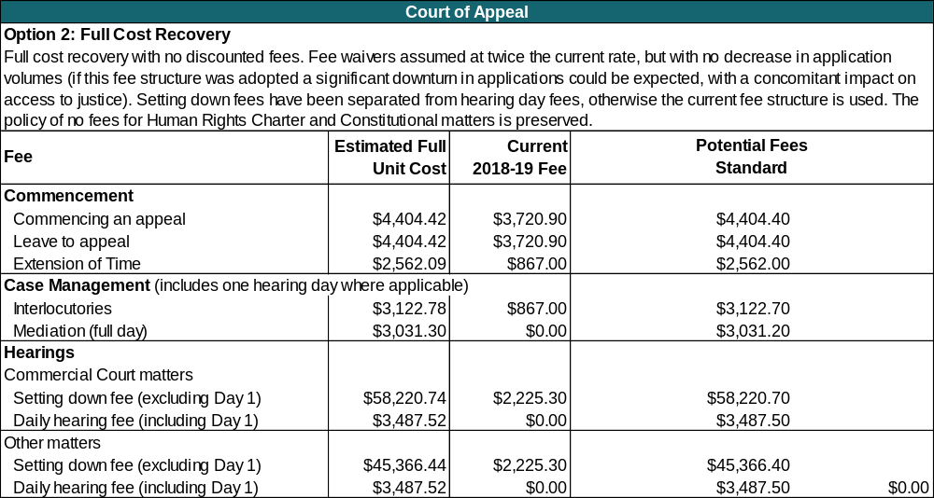
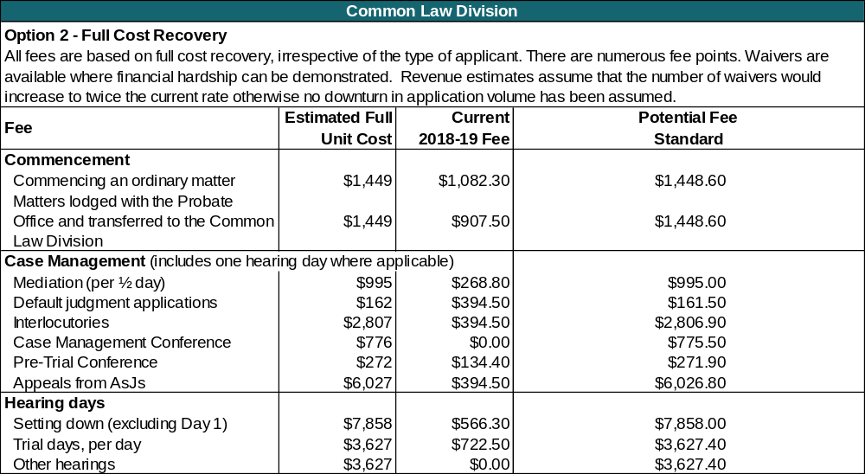
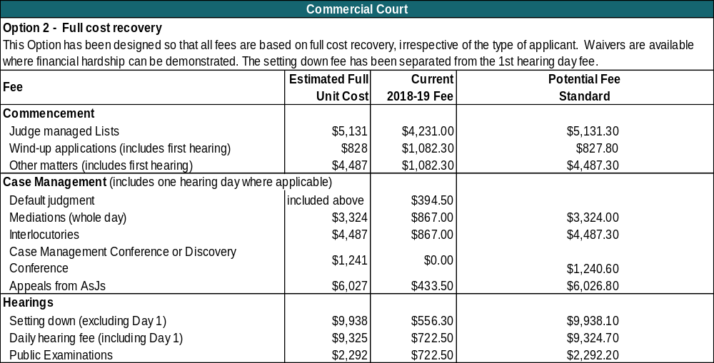

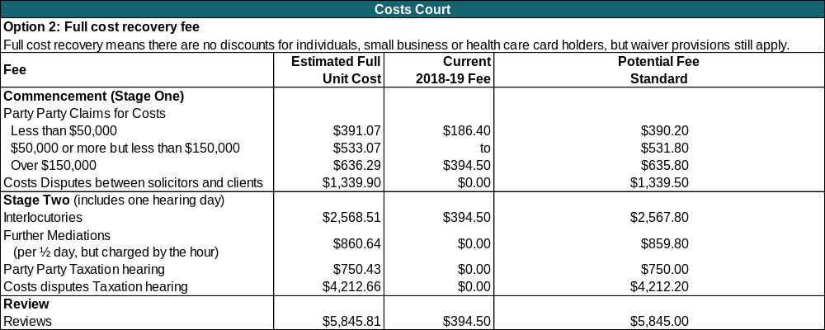

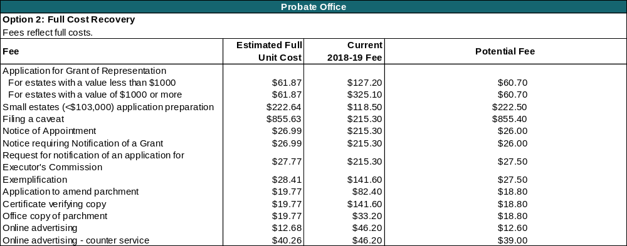
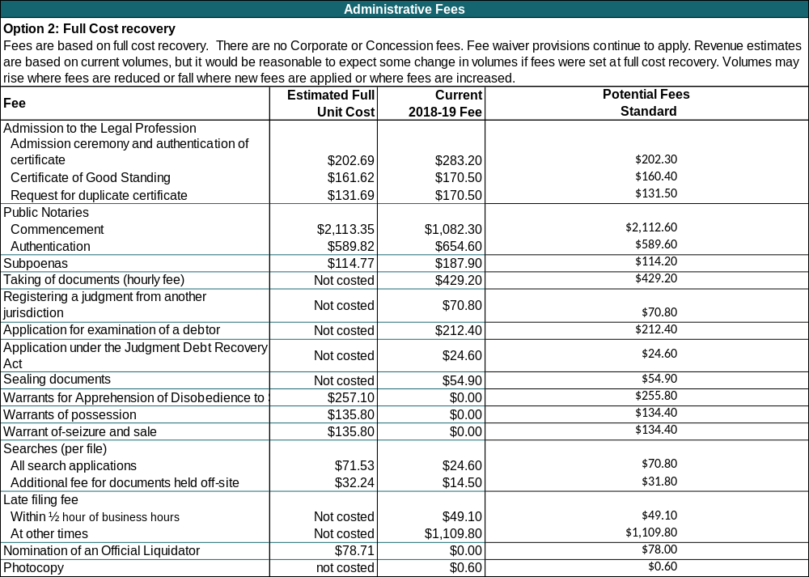
Assuming demand levels were to remain unchanged, overall fee revenue would increase significantly – by an additional $19.713 million compared with the current fee structure. The highest fee revenue increases would occur in the Commercial Court (an additional $10.536 million) and in the Common Law Division (an additional $9.095 million). In reality however, there is likely to be major reduction in demand for Supreme Court services, as parties who would have an option to initiate in jurisdictions, with lower fees, would be more likely to do so. Given the very high cost of fees in the Court of Appeal, (for example the Setting Down fee for Court of Appeal Commercial Court matters would increase from $2,225.30 to $45,366.40), it is very likely that fewer parties would commence matters there.
Against the base case, where no fees are charged, the advantages of Option 2 are as follows:
- fee revenue would increase (despite the reduction in volume of matters).
- the imposition of very high fees would mean that users would have a major incentive to consider whether an alternative jurisdiction may be more appropriate.
- there would be a perceived improvement in efficiency because the anticipated lower application volumes would support more timely resolution of matters.
- Probate Office fees would decrease to reflect costs.
Against the base case, where no fees are charged, the disadvantages of Option 2 are as follows:
- the role of the Supreme Court may be diminished because many applicants may choose to file in other jurisdictions, due to the high costs of fees;
- access to justice would be restricted, particularly where only the Supreme Court has jurisdiction, for example in the Court of Appeal;
- given the increased level of fees, a sharp increase in waiver applications could be expected, increasing the administrative burden on staff required to process them; and
- the increase in waivers could then in turn lead to a potential increase in inappropriate applications.
In summary, it is likely that the Option 2 fee structure would result in a high rate of cost recovery and a greater perceived efficiency, but would significantly reduce access to justice.
Against the base case and using the assessment criteria set out above, Option 2 scores -3.5 points.

Assessment of Option 2
Criterion | Weighting | Score | Weighted Score | Comment
Reflect the role of the Supreme Court | 30% | -5 | -1.5 | Worse than the base case. While the presence of fees would provide incentives to choose the most appropriate jurisdiction, the very high level of fees under this option would discourage genuine claims.
Equity | 30% | 0 | 0 | Vertical access is much worse than the base case, given the high level of some fees and the fact that these are not adjusted to reflect the ability of users to pay. Horizontal access is better as fees truly reflect the costs of services that are actually used.  The overall effect is considered to be neutral, when compared to the base case.
Efficiency | 30% | -5 | -1.5 | Court users might attempt to commence matters in the incorrect area e.g., at the Common Law Division rather than at the Commercial Court, because fees there would be lower, resulting in further intervention by the Court. It might also result in more waivers being granted, facilitating potentially inappropriate cases.
Simplicity | 10% | -5 | -0.5 | Would be worse than the base case, simply because there is a fee structure. However because it has only one tier, it would be better than Option 1 and Option 3.
Total | 100% |  | -3.5

Option 3: Restructured Fees (Preferred Option)
This option represents a restructure of the existing fee structure to account for changes in the manner and in the costs of service delivery.
It would incorporate a differential fee structure with Corporate, Standard and Concession Fees. This option would also provide for revised fee categories with fees for most matters grouped as Commencement fees, Case Management fees, and Hearing fees. Ancillary fees and other fees currently imposed by the Prothonotary would be streamlined with some new fees added for Pronothotary services that do not currently attract a fee.
This option acknowledges the impact of recent reforms on service delivery (and the cost of that delivery) since the current fees commenced in 2012. This means that the proposed fees will more closely reflect the different cost structures of each area of the Supreme Court.
Differential fees aim to maximise cost recovery from corporate and government users, while minimising the potential for fees to become a barrier to justice for other users. The fees proposed at the Corporate Fee level under Option 3 broadly reflect the full, efficient cost of the Supreme Court’s activities in providing those services (with reductions made where necessary to safeguard access to justice).
Fee waivers will apply permitting the waiver of fees for individuals on grounds of financial hardship, while Concession Fees are available to Health Care card holders.
The following tables set out the fees that would be payable under Option 3.
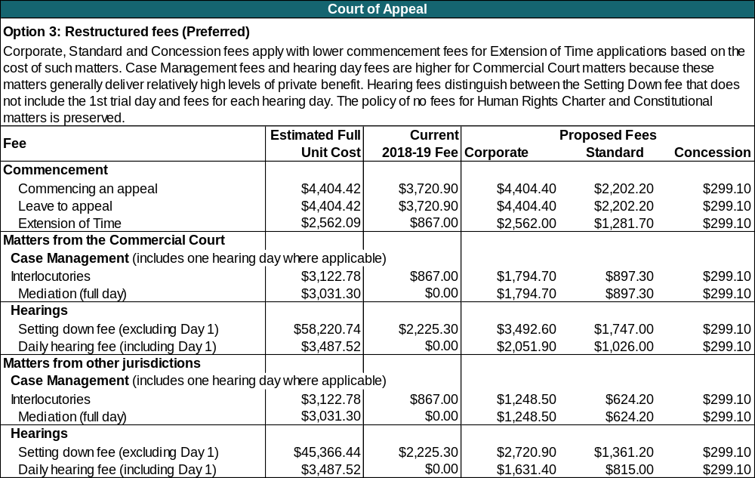
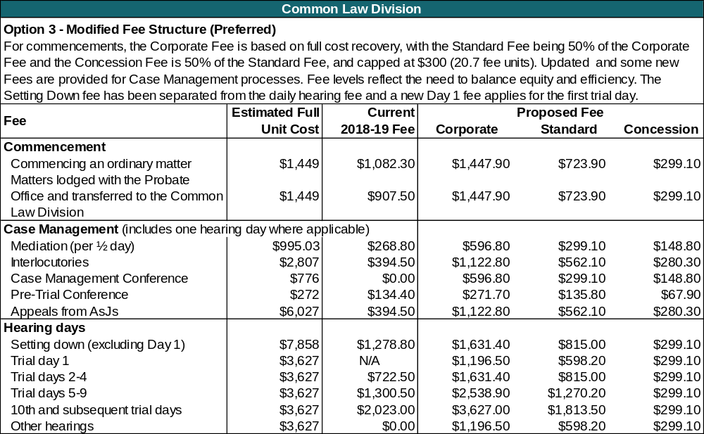
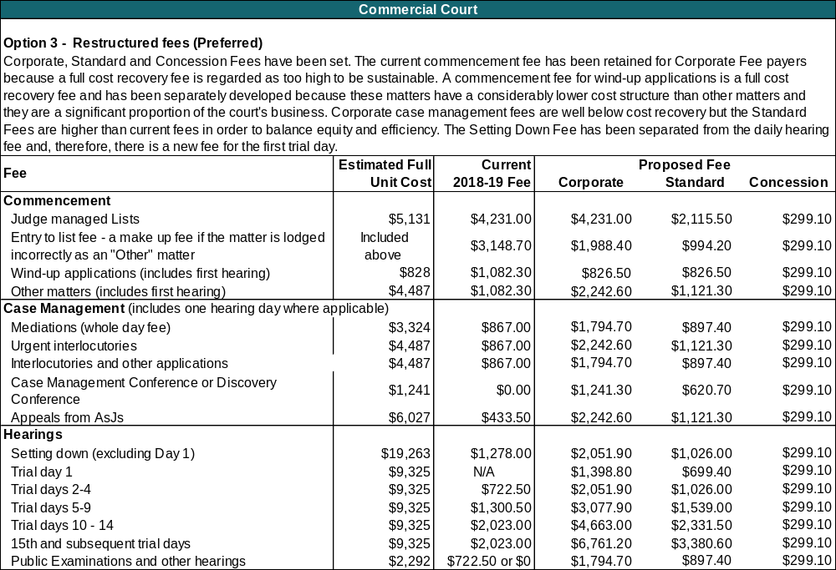
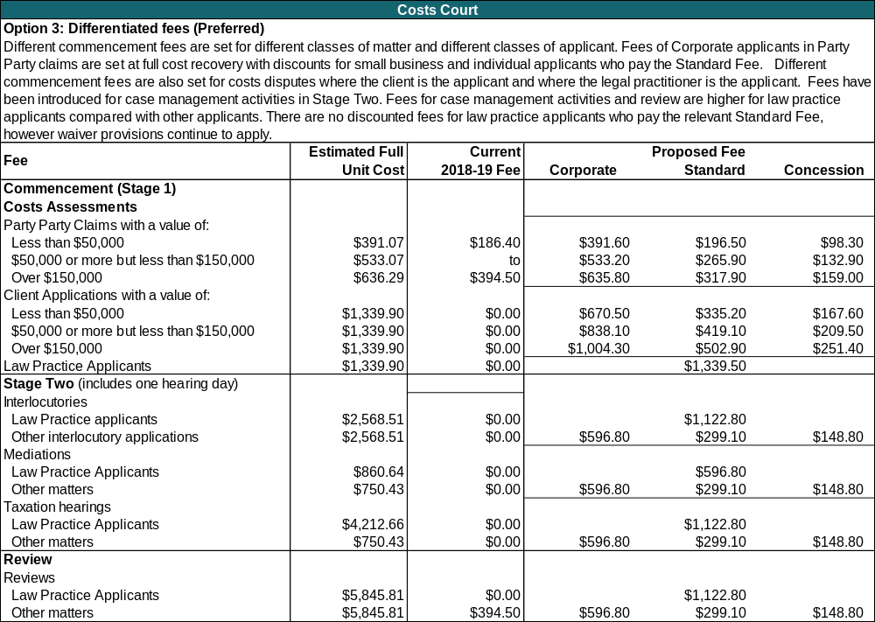

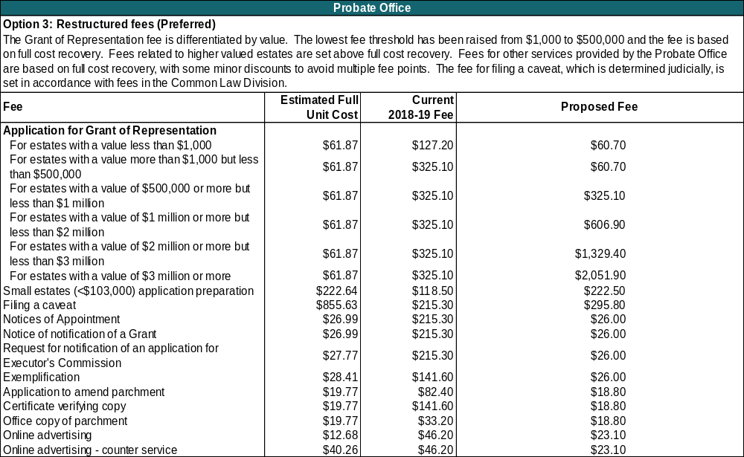

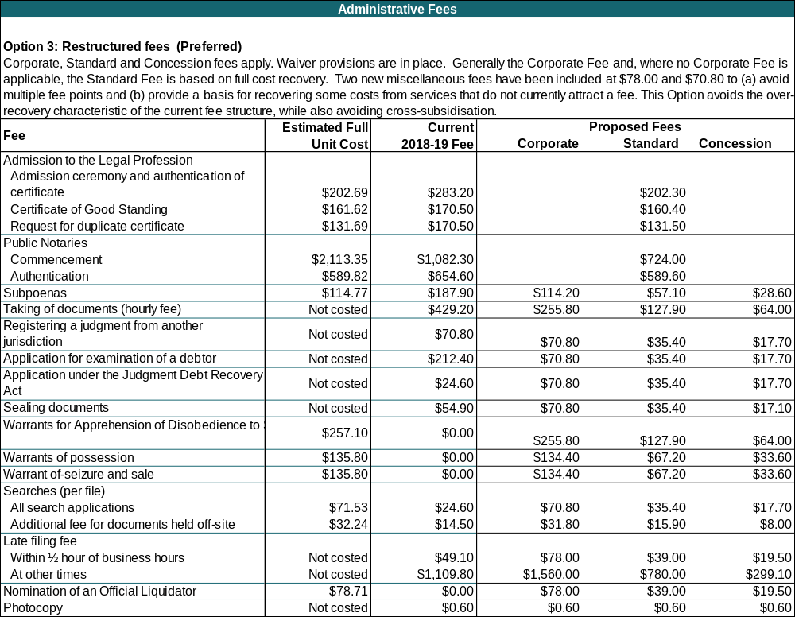
Under Option 3, the total revenue for fees is expected to be approximately $20.229 million per annum (in 2018-19 dollars). This would represent an increase of $0.876 million compared to the current fee structure.
Under Option 3, fees for Standard Fee payers would be broadly similar to the current fees, while Corporate Fee payers would pay fees set close to or at cost recovery levels in many instances (with reductions made to safeguard access to justice where necessary). In the case of Corporate Fee payers, the highest fee increases would occur in the Costs Court and in the Commercial Court.
Against the base case, where no fees are charged, the advantages of Option 3 are as follows:
- the Supreme Court’s role in the civil justice system would be better supported. The Corporate Fee would send good price signals to users about the cost of bringing a matter to the Supreme Court. This signal would help to inform applicant choice between the Supreme Court and other jurisdictions, while maintaining access to justice. Frivolous or vexatious claims would be constrained, to some extent, by the imposition of the Concession Fee. The fee would work in conjunction with other means noted earlier to control such claims (see Section 4);
- there would be better horizontal and vertical equity as fees reflect the costs of service delivery, and those with the capacity to pay more would be required to do so; and
- the fee structure aligns closely with the service reforms which have been designed to enable resolution as early as possible.
Cost recovery levels across the Supreme Court would be improved, increasing to 35.4 per cent, from a current level of 33.9 per cent.
Against the base case, where no fees are charged, the disadvantages of Option 3 are as follows:
- high corporate fees might encourage parties to initiate in other jurisdictions, potentially transferring demand either to the County Court or to other non-Victorian jurisdictions; and
- the fee structure would not be as easy for users to understand, in comparison to no fees.
Against the assessment criteria set out in section 6, Option 3 scores 5.9 points, which is better than the other two options.

Assessment of Option 3
Criterion | Weighting | Score | Weighted Score | Comment
Reflect the role of the Supreme Court | 30% | 7 | 2.1 | Much better than the base case as Option 3 better aligns costs, fees and the reputation of the Supreme Court. Better than Option 1, because it is more closely calibrated to reflect the recent operational reforms.
Equity | 30% | 5 | 1.5 | Much better than the base case.  Vertical equity is improved as those with the capacity to pay are required to do so.  Horizontal access is improved as users are paying different rates for different matters.
Efficiency | 30% | 7 | 2.1 | Very much better than the base case, and stronger than the other options. Fees are aligned to court operations which have been reformed to enable early resolution where appropriate. However, they do not reflect the full cost of court activities.
Simplicity | 10% | -7 | -0.7 | Would be much worse than the base case, as, like Option 1, it introduces a multi-tier fee structure. Because it a multi-tier structure, it is worse than Option 2 which introduces only a single tier structure.
Total | 100% |  | 5

The following table summarises the assessment of the three options against the base case, whereby no fees would be charged for Supreme Court services.

Comparison of options
Criterion | Option 1 | Option 2 | Option 3 | Comment relative to base case
Reflect the role of the Supreme Court | 1.5 | -1.5 | 2.1 | Option 3 scores highly because it aligns costs, fees and the reputation of the Supreme Court much better.
Equity | 1.5 | 0 | 1.5 | Horizontal equity is improved by all options because users are paying differential fees for different services. Option 3 better reflects costs and takes into account recent reforms. Vertical equity is improved by Options 1 and 3 as those users with the capacity to pay (e.g., corporate fee payers) are asked to pay more, though under Option 2 it is much worse because all users pay the same fee regardless of their ability to pay.
Efficiency | 1.5 | -1.5 | 2.1 | Option 2 is the most inefficient as it significantly increases transactional costs for users. Option 1 performs strongly as fees are aligned to court operations which have been reformed to enable early resolution where appropriate, though not as strongly as Option 3 where there is the strongest alignment of all options in this regard.
Simplicity | -0.7 | -0.5 | -0.7 | While the presence of any fee structure means that all options perform worse than the base case, Option 1 and Option 3 introduce a multi-tier system so are more complex than Option 2.
Total | 3.8 | -3.5 | 5

The major strengths and weaknesses of each of the options are as follows:
- Option 1 provides some modification of the current fee structure and would improve access to justice, and potentially encourage users to file at the most appropriate jurisdiction. However, it would not reflect current Supreme Court reforms.
- Option 2 would charge fees at full cost recovery levels and would significantly delineate the Supreme Court from lower cost jurisdictions that tend to deal with less complex matters. However, this option could present significant barriers to justice (except for probate matters) as many fees would be out of the reach of many court users (e.g., the Setting Down fee in the Court of Appeal would be $45,366.40).
- Option 3 is the strongest option. The fee structure aligns with recent service reforms and the fees reflect the cost of delivery. It also provides strong price signals to encourage users to select the appropriate jurisdiction for their needs, has strong vertical and horizontal equity, and responds to the problems associated with the current fees. While the fee structure more transparently relates to the services and their costs, it could be more complex for users to initially understand.

The preferred option
Option 3 is the preferred option. This option acknowledges the impact of recent reforms on the way services are delivered (and the cost of that delivery) since the current fees commenced in 2012. This means that the proposed fees will more closely reflect the different cost structures of each area of the Supreme Court.
This option features the following characteristics:

Differential fees
Three tiered fee levels, called ‘Corporate’, ‘Standard’, and ‘Concession’ aim to maximise cost recovery from larger corporate and government users, while minimising the potential for fees to become a barrier to justice for other users. The fees proposed at the Corporate Fee level under Option 3 are based, as a starting point, on the full, efficient cost of the Supreme Court’s activities in providing those services. The Standard fee is 50 per cent of the Corporate Fee and the Concession Fee is 50 per cent of the Standard Fee, capped at $300 (or 20.7 fee units).
Where a request for service is made on behalf of multiple parties, the highest applicable differential fee will apply. For example, if there are two plaintiffs in a proceeding and one of the plaintiffs is a Corporate Fee payer and the other is a Standard Fee payer, then the fee payable would be at the Corporate Fee payer rate.
Fee waivers would continue to apply, permitting the waiver of fees for individuals on grounds of financial hardship, with the additional provision of automatic waivers to certain categories of fee payers (being those in receipt of pro bono assistance or legal aid, or those serving a term of imprisonment or otherwise detained in a public institution). The Concession Fee level would provide a discount to Health Care Card holders.

Fee categories
For most matters, fees have been grouped as follows:
Commencement Fees | Applying to the application that lodges a matter with the Supreme Court in the first instance.
Case Management Fees | Relating to court activities that might or might not occur, depending on how a matter progresses. These activities include for example, mediation fees, fees for interlocutory applications and fees for appealing the decisions of associate judges who may be hearing interlocutory matters.
Setting down fees | Covering the cost of listing a matter for trial or appeal.
Hearing fees | For the days of a trial or for days of an appeal in the Court of Appeal.
Other hearing fees | For hearings, other than trial days, such as interlocutory hearings, appeal from an associate judge or judicial registrar or public examination in the Trial Division. Generally the first hearing day has been included in the application fee for interlocutories and appeals from associate judges but these matters can go to a second day, as can hearings related to public examinations of company directors. A first day hearing fee has been included for those few matters where a first hearing day is not covered by an application fee.

Fees are also charged for a range of ancillary services, such as searches and photocopying, as well as for admission to the legal profession.
This categorisation of fees better aligns with Supreme Court operations and is expected to significantly improve users’ understanding of Supreme Court fees and the administration of fees by staff. Currently the fee structure is opaque, as the fees set might not relate to the cost of providing the service, nor is it clear that they are imposed when the service is rendered.

Summary of key features by court area
Court of Appeal
Key changes include:
- different commencement fees for Appeals and Extension of Time applications (currently a single fee applies), recognising the different costs in providing these services;
- different fees have been set for Commercial Court matters and non-Commercial Court matters (except for commencement fees), again recognising the different costs of services delivery, primarily due to the greater complexity of Commercial Court matters;
- hearing fees distinguish between the trial days and other hearings (for example the second and subsequent days of interlocutory hearings);
- for Standard Fee payers, most fees are lower than the current fee; and
- cost recovery levels would decrease from 7.4 per cent to 7.3 per cent, resulting in a reduction in total fee revenue for the Court of Appeal from $0.682 million to $0.677 million.

Commercial Court
Key changes include:
- a new commencement fee for wind-up applications, set at a lower rate to other commencement fees because of the lower cost structure, and the public interest value making these proceedings more accessible;
- where the objector in a taxation appeal proceeding requests that the objection be treated as an appeal, the objector would be liable for the commencement fee upon filing for directions;
- for Standard Fee payers, the commencement fee is considerably lower, but most Standard Fees are higher than current fees to reflect the high cost of service provision;
- a new 15th day and subsequent trial day fee is introduced; and
- cost recovery levels would increase from 25 per cent to 33.2 per cent, resulting in an increase in total fee revenue for the Commercial Court from $5.304 million to $7.032 million.

Common Law Division
Key changes include:
- for commencements, the Corporate Fee is based on full cost recovery, with the Standard Fee being 50 per cent of the Corporate Fee and the Concession Fee being 50 per cent of the Standard Fee, and capped at $300 (20.7 fee units);
- the Mediation fee would be set at a half day rate, rather than the current hourly rate. This aligns with the rate at which this fee is set in the Commercial Court;
- for Standard Fee payers, Commencement and Hearing fees are lower, but most case management fees are higher; and
- cost recovery levels would decrease from 17.9 per cent to 17.4 per cent, resulting in a reduction in total fee revenue for the Common Law Division from $3.991 million to $3.890 million.

Costs Court
Key changes include:
- commencement fees would be based on the value of the claim, as opposed to the originating jurisdiction, as this better reflects the cost of service provision;
- fees would be introduced for matters involving costs disputes between solicitors and clients. The costs of providing these services had previously been absorbed by the Supreme Court. The introduction of these fees is consistent with government expectations that at least some of the costs of service delivery should be recouped from those who benefit from the service, given that some of the benefit provided is private;.
- fees have also been introduced for case management services; and
- cost recovery levels would increase from 23.1 per cent to 33.7 per cent, resulting in an increase in total fee revenue in this area from $0.131 million to $0.191 million.

Probate Office
Key changes include:
- the most common fee - Grant of Representation fee - is differentiated by value with the introduction of an extended ad valorem or sliding scale. This feature would be introduced to reflect the differing capacities of applicants to pay probate fees;
- the thresholds were identified based on a review of estate values from 2015-16 data which revealed that more than half of all applications were for estates valued at less than $500,000. Thresholds were chosen to maximise the availability of the lower fee for the greatest number of applicants;
- over half of all applications relate to estates valued up to $500,000. These applicants would now pay a lower fee, based on full cost recovery. This represents a saving of $264.40 or 81 per cent for over 12,000 applicants per annum;
- applications related to estates valued at more than $500,000 but less than $1 million (approximately 4,700 per annum) would pay the same as the current fee;
- fees related to higher valued estates are set above full cost recovery. Applications for estates valued at more than $1 million would pay higher fees on a sliding scale to a maximum of $2,051.90 for estates valued in excess of $3 million;
- fees for other services provided by the Probate Office would be based on full cost recovery;
- fees for matters that are determined judicially would be set in accordance with fees in the Common Law Division; and
- despite reductions in some fees and overall cost recovery, the Probate fees overall would continue to over recover significantly. Cost recovery levels would decrease from 425.7 per cent to 389.2 per cent, resulting in a decrease in total fee revenue for the Probate Office from $7.896 million to $7.220 million.

Administrative fees
Key changes include:
- most Standard Fees would be lower than the current fees;
- a reduction of Admission Fees;
- introduction of fees for the issue of warrants (currently no fee is applied); and .
- cost recovery levels would decrease from 69.4 per cent to 62.7 per cent, resulting in a decrease in total fee revenue from Administrative fees from $1.350 million to $1.220 million.
Under Option 3 the total revenue for fees is expected to be approximately $20.229 million per annum (in 2018-19 dollars).
The following sections of the RIS discuss the advantages and disadvantages of the preferred option in comparison with the current fee structure, for each of the criteria used to assess the fee options. A detailed table of the proposed fees and the current fees (in 2017-18 dollars) is provided at Attachment 3.

The role of the Supreme Court in Victoria’s civil justice system
Option 3 better supports the Supreme Court’s role within the civil justice system in Victoria compared to the other options and represents a significant improvement on the current arrangements. The fee levels better reflect the fact that the Supreme Court is a high cost jurisdiction (due to the high level of involvement of high cost judicial officers and staff). This in turn sends effective price signals to potential court users who might instead choose a less expensive, alternative jurisdiction.
The imposition of a differential fee structure, that aligns fees more closely to costs, discourages parties from using the Supreme Court where another jurisdiction would be more appropriate and less costly. Similarly, vexatious, frivolous and ill-founded claims would be discouraged.
Option 3 better supports access to justice in the following ways:
- the introduction of a tiered fee structure also means that fee levels would either remain broadly unchanged or lower than the current fee for most Standard Fee payers;
- Waiver arrangements would continue to be available in cases where the Prothonotary has assessed that the payment of a fee may cause financial hardship. Furthermore, waivers would be automatically available to those in receipt of pro bono assistance or legal aid, or to those serving a term of imprisonment or otherwise detained in a public institution;
- the new Concession Fee category would recognise that Health Care card holders have already been assessed as having limited means and are likely to struggle to pay a full fee;
- in many cases, the Standard and Concession Fees are lower than the current fee, so cost of fees is likely to be less of a determining factor in a user’s decision to take a matter to court. The proposed fees will therefore make it easier for individuals and small businesses to do so. As a result however, there may be increases to application volumes by these parties; and.
- the fee structure would continue to apply no fees in Human Rights Charter cases.
Conversely, the disadvantages of the proposed fee structure compared with the current fee structure are that Corporate Fee payers would be charged higher fees. Higher fees might discourage corporate users from bringing matters to court or might encourage them to commence proceedings in other jurisdictions, potentially creating greater demand for the County Court, or shifting service provision outside the Victorian civil justice system completely. Given that fees typically comprise less than 10 per cent of overall costs incurred, and the level of the fee change, it is not anticipated that the fee increases will have a significant impact in this regard.

Equity
Option 3 would improve both horizontal and vertical equity compared to the current fee structure.
- horizontal equity, where court users pay for the services they access and do not pay for services they do not use, would be better because fees are more closely aligned to costs. This means for example that parties are not subsidising the costs of other trials when they have settled early; and
- vertical equity, where court users who can afford to pay more do so, would also be improved. The introduction of a tiered structure involving Corporate, Standard and Concession Fee levels means that fees would be lower for those with less ability to pay.

Efficiency
Reforms introduced across the civil division of the Supreme Court have driven efficiencies, and the alignment of fees with costs under Option 3 would now support this. The proposed fee structure would support the resolution of matters at the earliest stage and the management of matters to resolution before trial. In addition, the fee structure would encourage the use of the lowest cost but most effective dispute resolution mechanisms available both within the Supreme Court and across the Victorian civil jurisdiction.

A simpler fee structure
The fee structure would be easier for Supreme Court users to understand because it better reflects the provision of services as fee points would be more closely aligned with service delivery. Where more than one fee was imposed simultaneously, for example an Originating Motion fee and an Entry to List fee in the Commercial Court, these would be expressed as a single Commencement fee. The fees would also be presented in plain English.

Total fees
The total revenue expected to be recovered under the proposed fees is estimated to increase $0.876 million in comparison with current fees.

Implementation, monitoring and evaluation
The introduction of the revised fee schedule will require careful short-term and long-term management at the Supreme Court. Monitoring and evaluation of the Proposed Regulations may indicate that further amendment is required to fees over the life of the Regulations.

Implementation
It is anticipated that the revised fee structure will enable better user understanding of fees, and flow-on to more efficient administrative processes. At the same time, the extent of the changes to the fee structure, and the way the new structure is presented to Supreme Court users, will result in transition risks that the Supreme Court will need to manage.
The Supreme Court has commenced transition planning on the basis that the new fee structure would introduce tiered fees (Corporate, Standard and Concession) and that different fees will apply in different areas of the Court. However, the quantum and structure of the fees will not be finalised until the formal consultation process has been completed.
Preparation for the new fee regime involves:
- reconfiguration of the Supreme Court’s electronic case management system;
- risk identification and mitigation;
- a communications plan to ensure that judicial officers, staff and Supreme Court users have easy access to accurate information about changes to fees;
- staff training to ensure there is minimum disruption to Supreme Court processes upon commencement of the new fee structure;
- provision of information to judicial officers so that they are aware of the new fee arrangements;
- updating online information and systems, and hard copy forms and brochures; and
- updating staff manuals.

Monitoring
Following implementation, the Supreme Court will closely monitor the new fee regime for a period of at least 18 months to ensure that any remaining or emerging implementation risks are effectively addressed. Monitoring will enable the Supreme Court to establish if:
- there are any unintended consequences of the changes;
- the fee schedules are easy for users to understand and for the Supreme Court to administer;
- the fees continue to accurately reflect costs; and
- projections of fee volumes and fee revenue were correct.
Particular focus will be placed on changes such as:
- the outcomes of the introduction of differentiated Corporate, Standard and Concession Fees, especially with regard to the proportion of applicants in each fee category; and
- whether the waiver arrangements are effective from both the user’s perspective and administratively.
Emerging problems with the Proposed Regulations could be managed through providing further information to users, changing administrative practices, or if considered necessary, amending the regulations.

Mid-term evaluation
In accordance with government policy, the fee structure introduced in 2018 will be independently evaluated in 2023, to assess the impact of the new fee structure.
The evaluation will draw on, and build from, the information from the early monitoring of the fee changes to:
- determine the extent to which the objectives of the current review have been achieved, with particular focus on whether the new fee structure has successfully aligned with process changes and costs of delivery introduced by recent reforms to Supreme Court operations;
- identify the impact on users’ access to justice;
- enable Supreme Court users to comment on the fee structure and raise issues of concern;
- review the costs structures to account for any further changes to operational delivery;
- identify opportunities to improve the fee structure prior to the expiry of the regulations; and
- identify opportunities, risks and issues that should be considered before the fees are restructured.
The evaluation will need to take account of a range of factors that may affect Supreme Court operations other than the impact of the revised fee schedule. These factors might include, for example, any changes to the jurisdiction of the Supreme Court over the period, changes to the role of other bodies responsible for dispute resolution, and changes in the economy that could be expected to be reflected in the volume of applications. Primarily, the evaluation will test the hypothesis that the revised fee schedule introduced in 2018 will progressively deliver better outcomes than the current fee schedule for the following objectives:
- supporting the Supreme Court’s role in Victoria’s civil justice system as measured by:
      - feedback from Supreme Court users;
      - maintenance or increase in the volume and proportion of matters commenced at the Supreme Court; and
      - lower levels of vexatious or frivolous claims (that detract time from dealing with genuine matters);
- improving equity as measured over the period by:
      - changes in the proportion of users paying Standard and Concession Fees, who are also applying for fee waivers; and
      - examination of the rationale for accepting or rejecting waiver and Concession Fee applications;
- improving efficiency as measured by:
      - decreases in judicial officer and registry staff resource usage per application;
      - improved case flow as assessed by the Supreme Court; and
      - a decrease in problems with fee processing reported by registry staff;
- simplicity of fees and fee structures that are easier for users to understand and for the Supreme Court to administer as measured by:
      - increased user satisfaction with the fees schedule;
      - increased staff satisfaction with fees processing; and
      - decreases in complaints about the fee schedule.

The baseline data for the evaluation will be the data collected and analysed for this RIS. Information and data for the evaluation will be drawn from several sources such as:
- the Supreme Court’s case management system data;
- the Supreme Court’s financial management system data;
- stakeholder consultation on the strengths and weaknesses of the revised fee schedule;
- judicial officer and staff satisfaction surveys; and
- Supreme Court user satisfaction surveys, which will be designed carefully to ensure they reflect satisfaction in relation to the issues about which information is being sought.
Regard may also be had to County Court data to see if there has been an increase in commencements there (at the expense of initiating at the Supreme Court), although it is likely to be very difficult to attribute any such movement to fee changes alone (as quality and timeliness are likely to be more influential factors).
The evaluation will necessarily require the collecting and storing of five years’ of operational data and survey information from a number of sources. This data will be managed by the Supreme Court’s Business Analysis Team over the course of the next five years, in order to ensure that it is accessible for an evaluation, when required.
The Department of Justice and Regulation will be responsible for ensuring that the mid-term evaluation is completed, and for liaising with the Commissioner for Better Regulation about its adequacy and transparency. The evaluation is expected to occur over a period of at least six months, in order to allow sufficient time for stakeholder consultation, data collection and analysis.
During the implementation phase for the new fee schedule, the department will determine whether any additional KPIs for the mid-term evaluation are necessary, or if processes need to be implemented to ensure that the relevant data is collected and available at the time of the evaluation

Attachment 1 Proposed fees for 2018-19 (expressed in 2018-19 dollars)
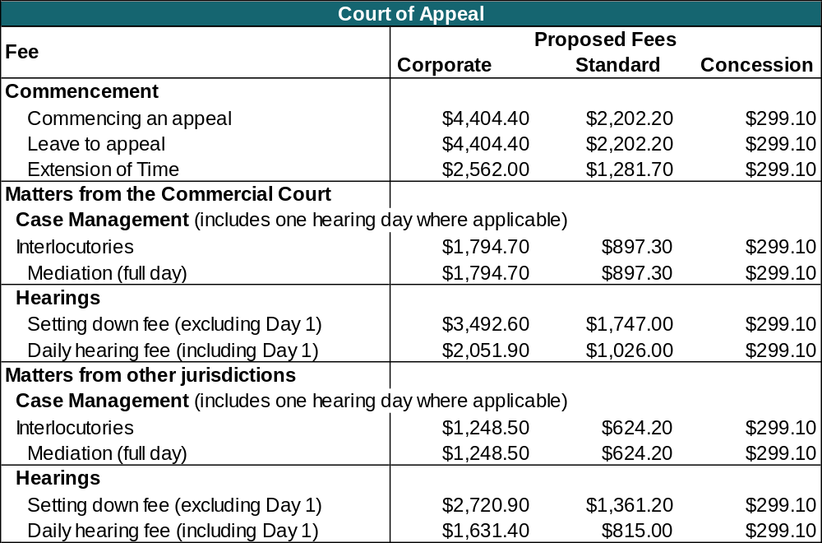

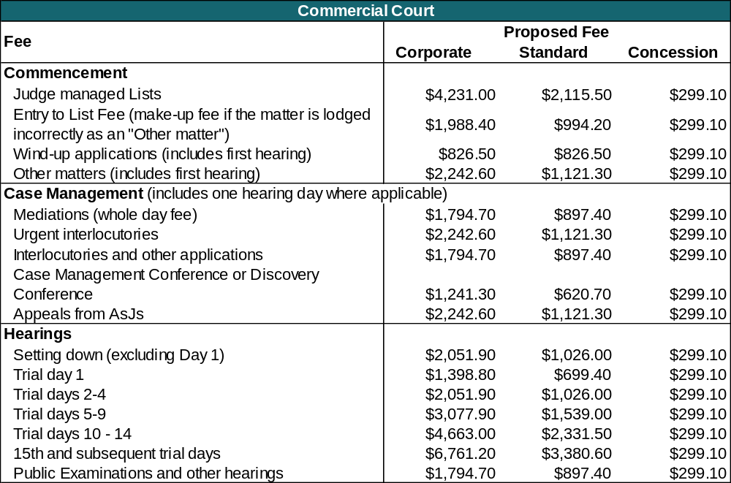
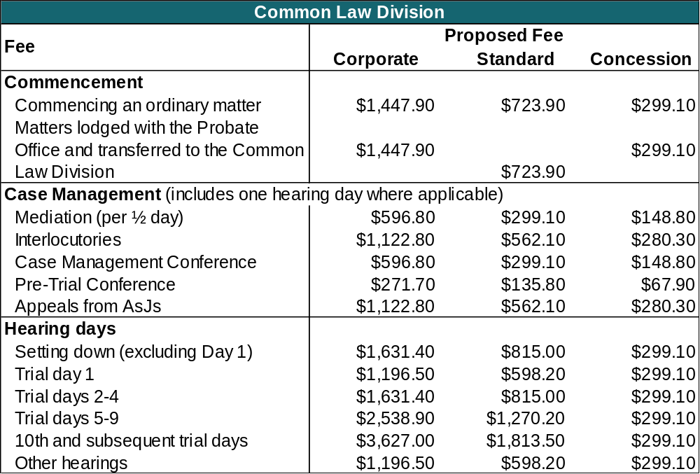

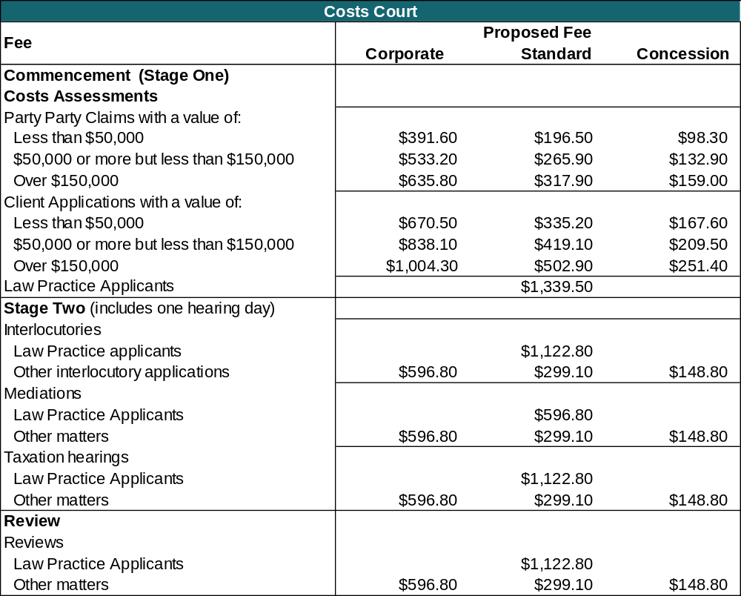

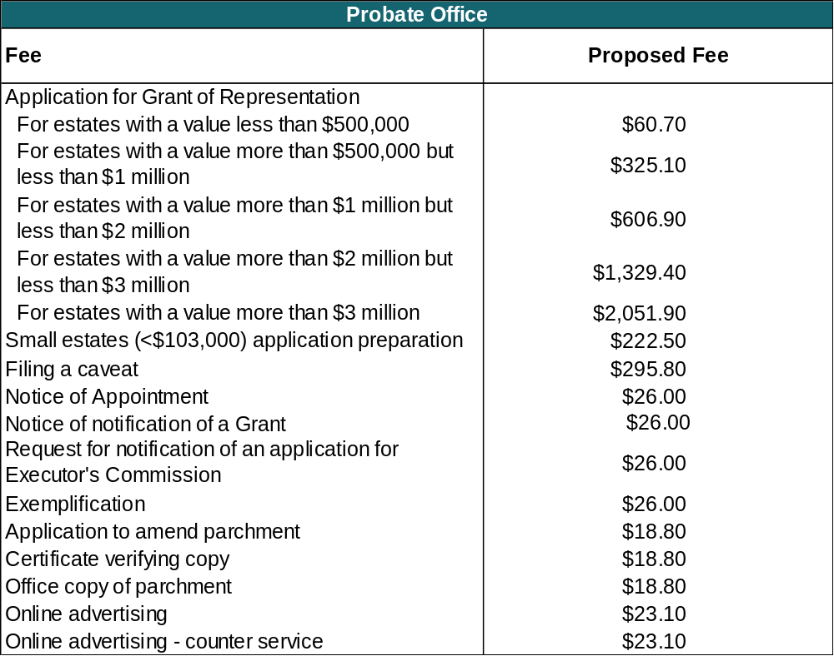
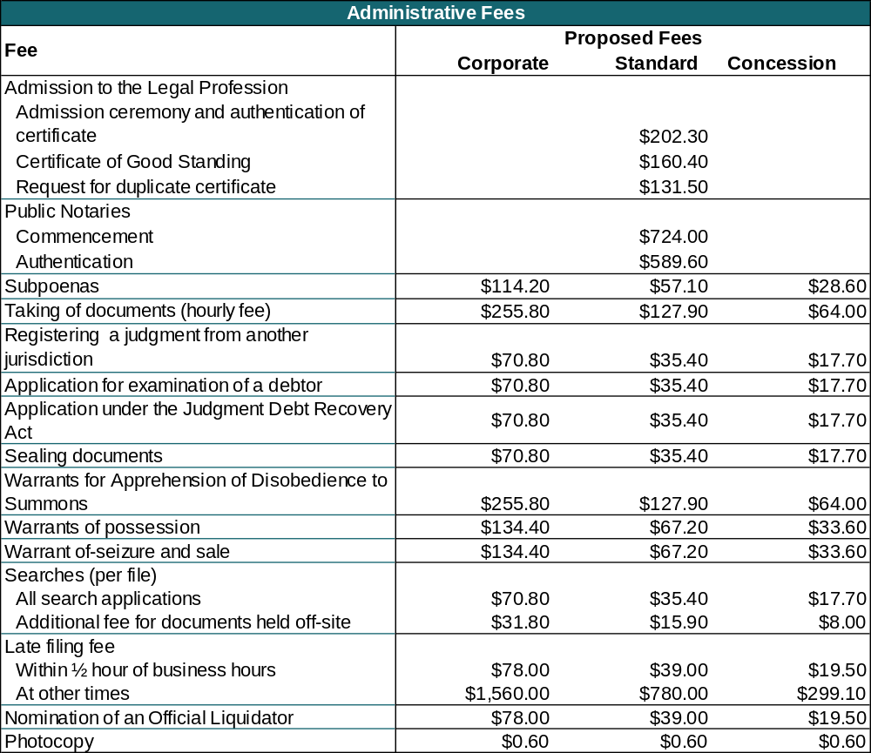

Attachment 2 Proposed fees for 2018-19 (expressed in 2018-19 fee units)
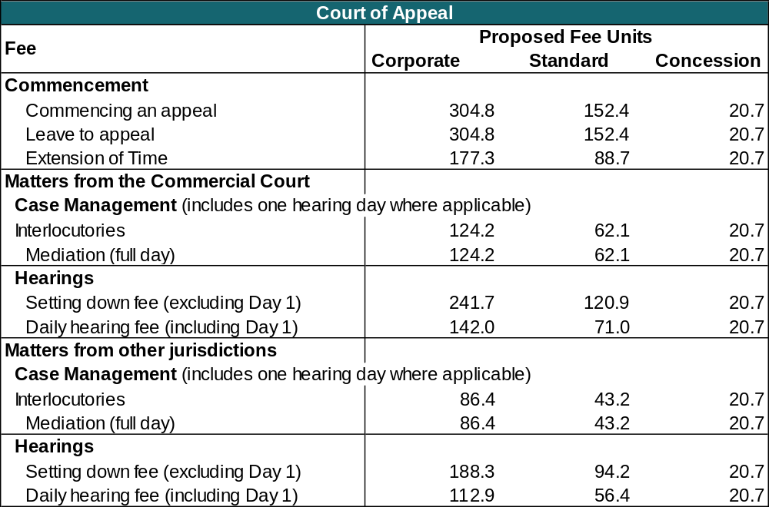

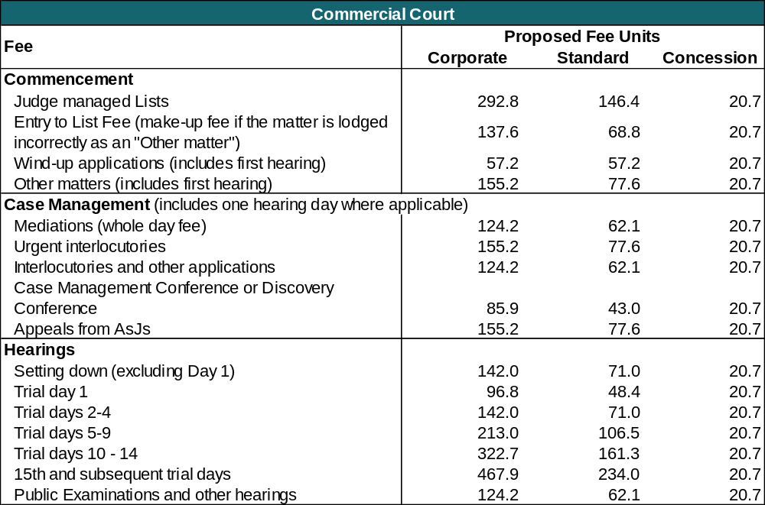

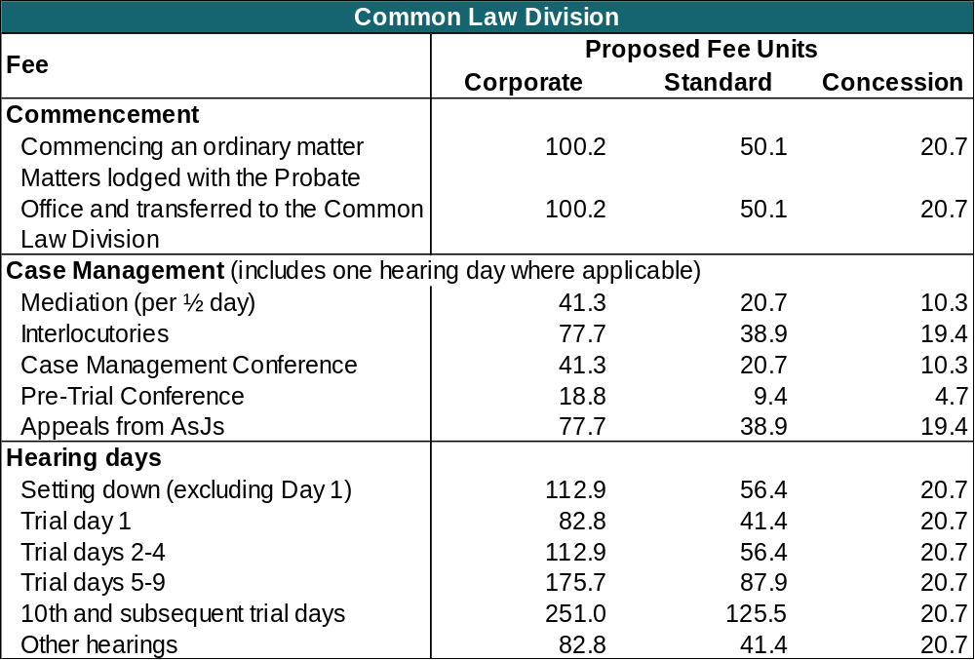
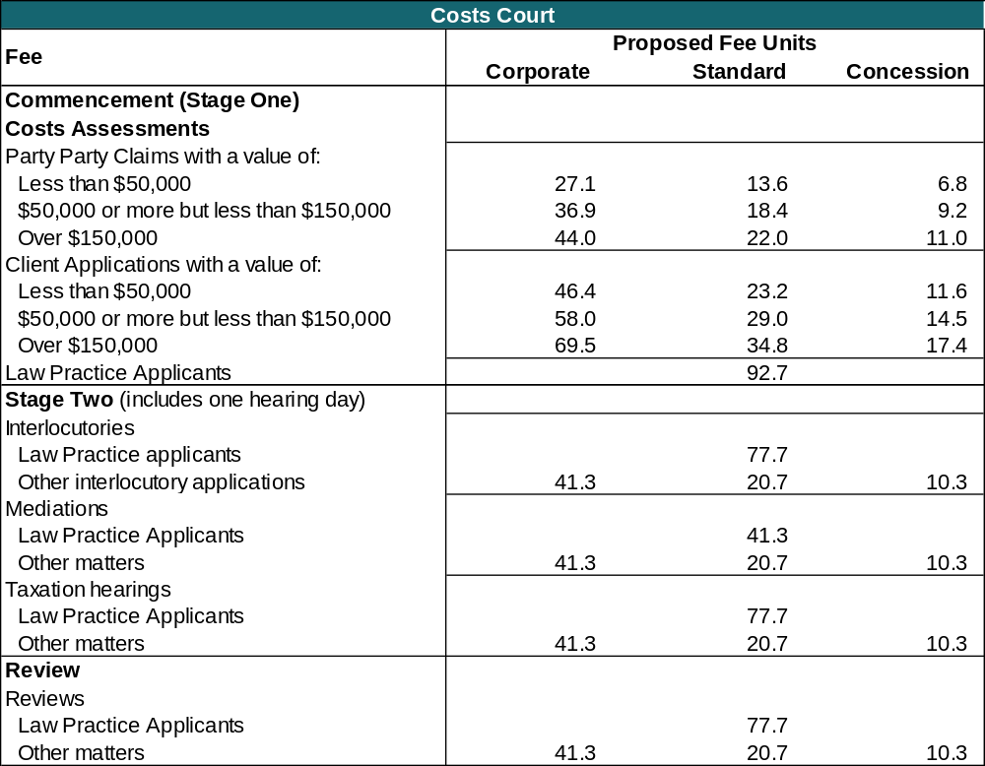

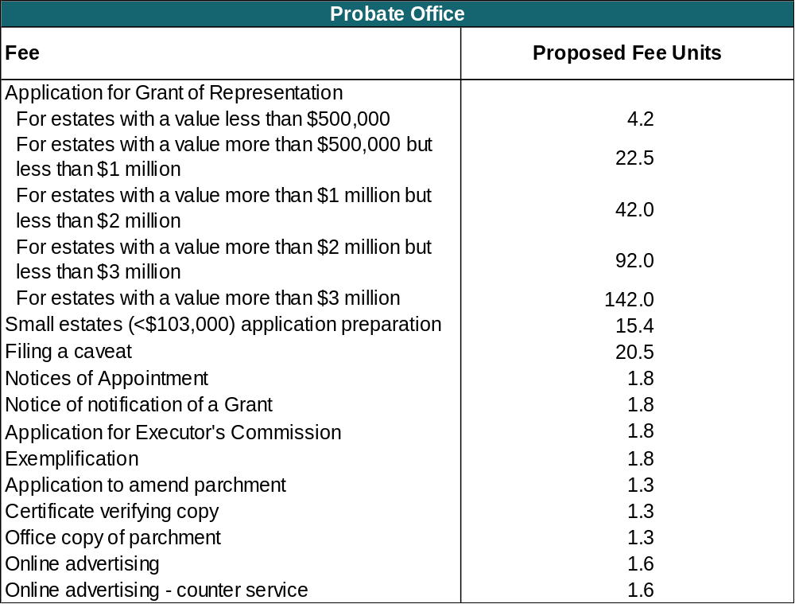

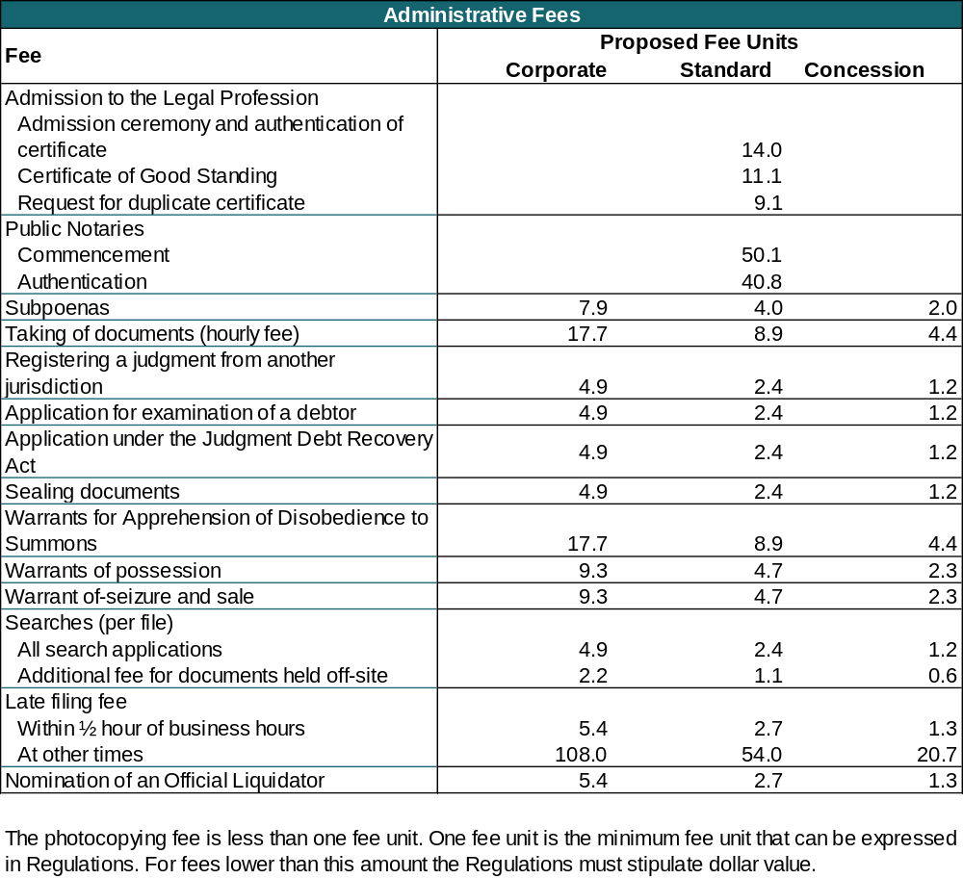

Attachment 3 Comparison of current fees with proposed fees
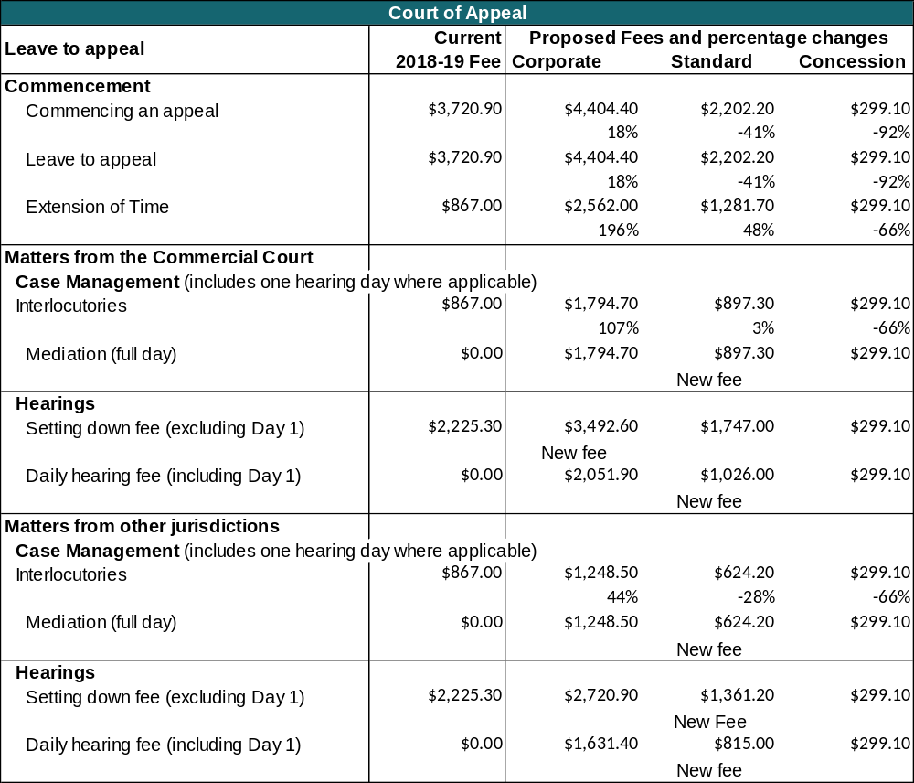

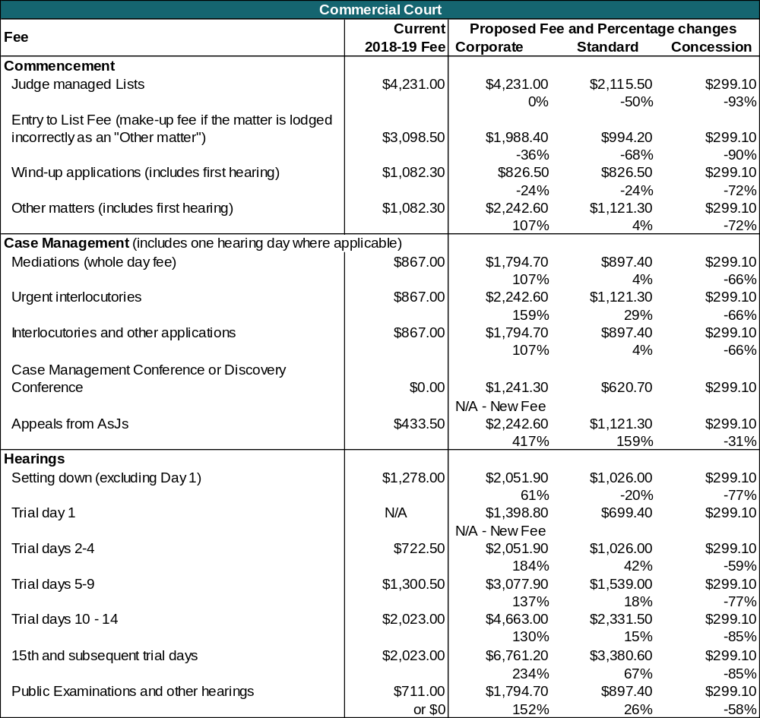

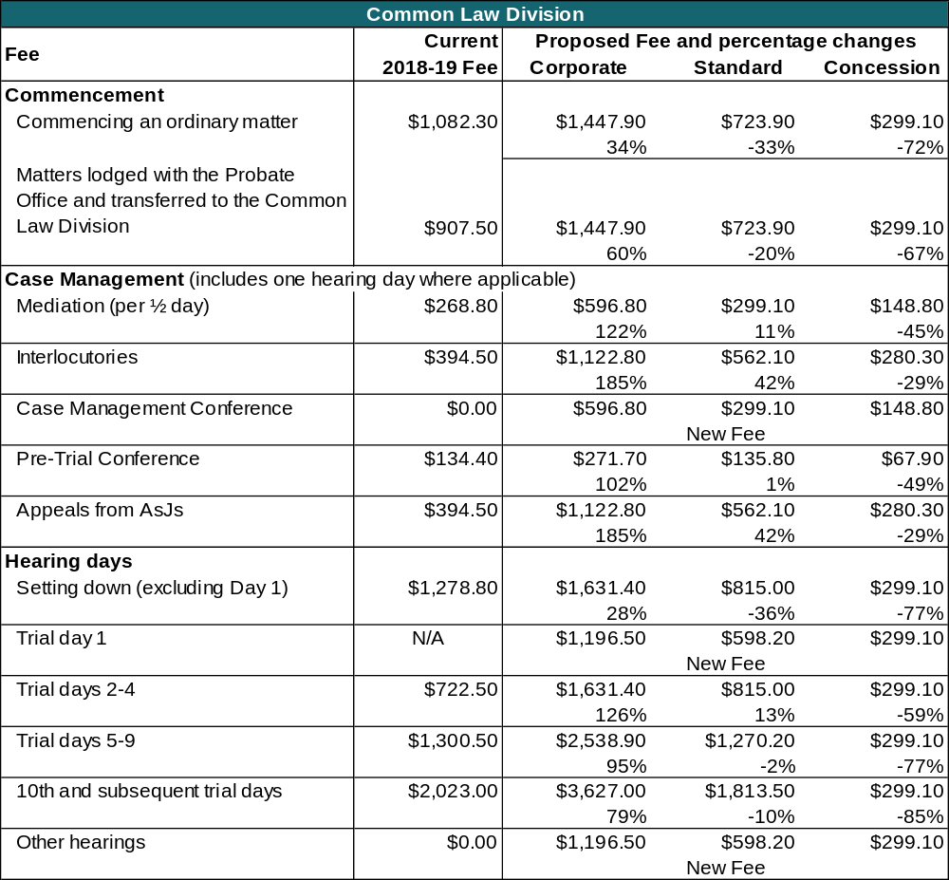

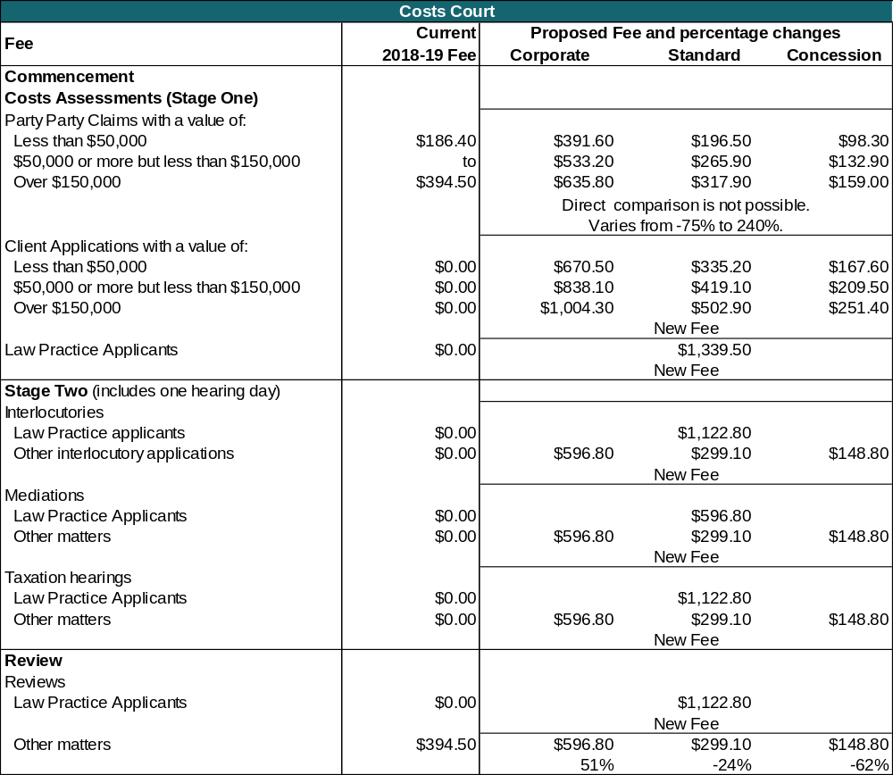

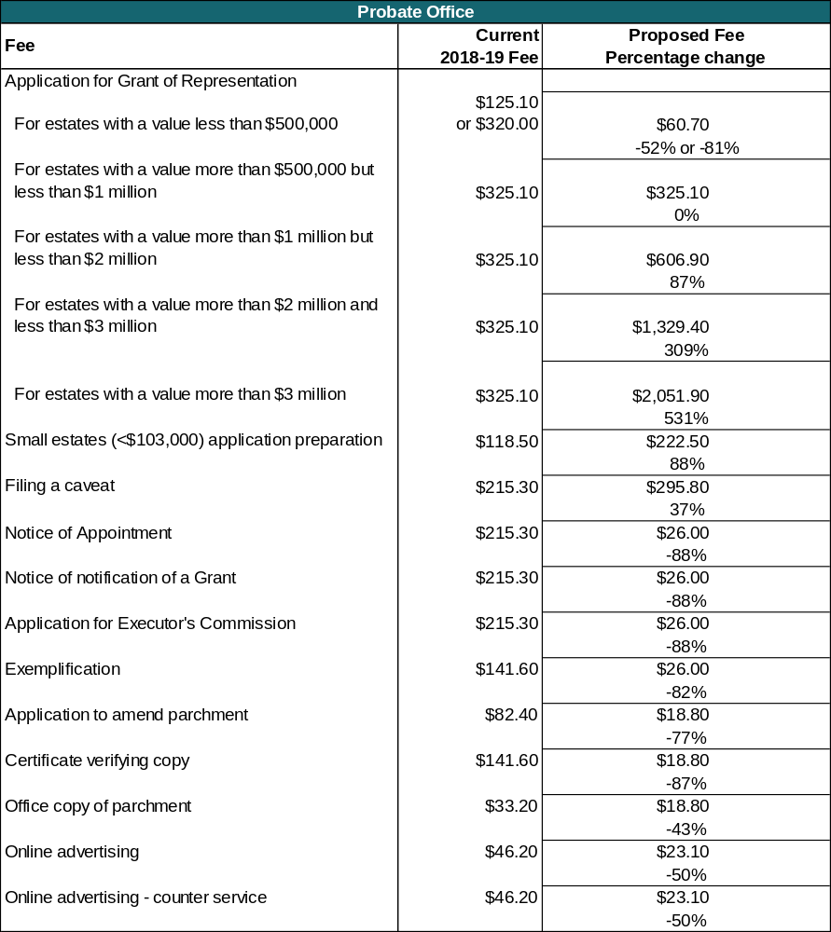

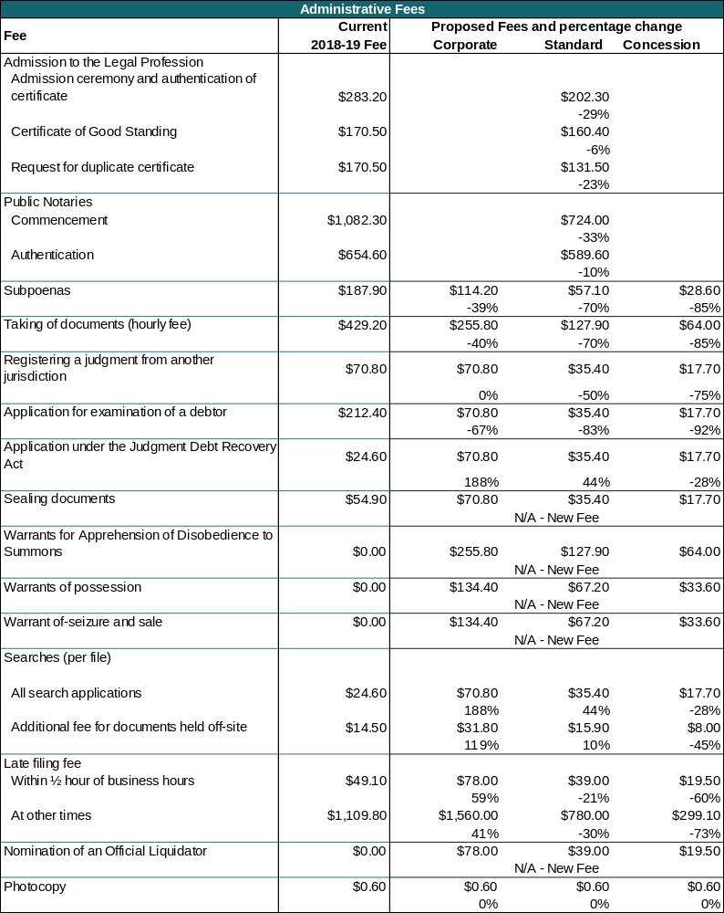

Unlike most regulations which sunset after 10 years, the 2012 regulations were only put in place for 5 years, due to insufficient historical cost data. The Supreme Court now has more complete costs data on which to base the new fees.
Department of Treasury and Finance, January 2013.
2015-16 is the last full financial year for which financial and workload data is available.
See Guiding Principles on page 10.
Judges can be removed from office only under exceptional circumstances, and the decision has to be made by Governor in Council following a resolution by both houses of Parliament (section 87AAB Constitution Act 1975).
Department of Treasury and Finance, November 2016.
Public sector users are proposed to be charged at the corporate level to reflect vertical equity (ability to pay) considerations.
According to the Australian Bureau of Statistics (ABS), 59.4 per cent of actively trading businesses in Australia have a turnover of less than $200,000 (Counts of Australian Businesses, ABS, February 2017). This threshold is used by VCAT and by the Supreme Court of New South Wales.
An entity registered in accordance with the provisions of the Australian Charities and Not-for-Profit Commission Act 2012 of the Commonwealth
See Order 7, Supreme Court (Miscellaneous Civil Proceedings) Rules 2008.
Chapter 2, Cost Recovery Guidelines, Department of Treasury and Finance, January 2013.
Section 5 of the Subordinate Legislation Act 1994 causes all regulations to sunset on the tenth anniversary of the date on which they come into effect, unless they are repealed as a result of some other regulatory provision.
Only a small proportion of fees collected are held by the Supreme Court. Of the $19.354 million in fees collected in 2016-17, only $1.1 million, or 5.7 per cent was retained by the Court. The remainder was remitted to the Victorian Government’s consolidated fund and to the Court Fee Pool administered by CSV.
For example, the cost of staffing resources for the intensive case management practices at the Supreme Court’s busiest area, the Common Law Division, is not factored into the calculation of current fees.
For example, the ‘Production of a File at another Jurisdiction or Tribunal’ service has not been used, and it is proposed to abolish this fee.
Notice to the Profession – Proceedings in the Commercial Court Taxation List, 9 March 2017.
There are fewer than 25 such cases per annum.
The Federal Court of Australia and the Supreme Court of New South Wales also impose fees for proceedings of this type.
The Timbercorp proceedings and matters brought by the Assistant Commissioner for Taxation temporarily added an additional 25 per cent to case volumes.
The Productivity Commission used the term ’access to justice’ to mean, “making it easier for people to resolve their disputes” - Productivity Commission 2014, Access to Justice Arrangements, Inquiry Report No. 72, page 3.
Productivity Commission, 2014, Access to Justice Arrangements, Inquiry Report No. 72, page 553.
For most matters, applicants have a choice of jurisdiction. Where fees reflect costs and those fees are lower than Supreme Court fees, the applicant may choose to lodge in a lower jurisdiction. In this way, higher fees at the Supreme Court can encourage allocative efficiency.
Cost Recovery Guidelines, Department of Treasury and Finance, January 2013, page 21.
The total costs of the Supreme Court being $57.151 million, and estimated revenue being $20.229 million.
Cost Recovery Guidelines, Department of Treasury and Finance, January 2013, page 21.
The other jurisdiction being the Supreme Court of Tasmania.
Public sector users are charged at the corporate level to reflect vertical equity (ability to pay) considerations.
According to the Australian Bureau of Statistics (ABS), 59.4 per cent of actively trading businesses in Australia have a turnover of less than $200,000 (Counts of Australian Businesses, ABS, February 2017). This threshold is used by VCAT and by the Supreme Court of New South Wales.
An entity registered in accordance with the provisions of the Australian Charities and Not-for-Profit Commission Act 2012 of the Commonwealth
Amendments to the Supreme Court Act 1986 made in 2014 have enabled the Supreme Court to provide for differential fees.
Section 129(3) Supreme Court Act 1986.
Report on Government Services 2017, Productivity Commission.
An approach recommended by the Standing Committee of Attorneys-General in 2010 and adopted by most jurisdictions sought parity with Federal Court fee structures.
Only Victoria has a transparent approach to cost recovery as set out in Cost Recovery Guidelines, Department of Treasury and Finance, January 2013.
Productivity Commission 2014, Access to Justice Arrangements, Inquiry Report No. 72, pages 536-7.
As above.
For example, while many Corporate fees at the Commercial Court are set at or very near full cost recovery, in some instances this approach would have significantly increased the corresponding Individual fee, so a lower fee level was suggested.
Costs here are very high when compared to other areas of the Supreme Court due to the very high level of judicial officer involvement, and the fact that most hearings involve the presence of at least three judges (some even require the sitting of five judges).
In general terms, the Judicial Review and Appeals List in the Common Law Division covers proceedings relating to the judicial review of, or statutory appeal from, the conduct or decisions of the County Court and other lower jurisdictions and other external persons or bodies. In contrast, the Court of Appeal hears appeals against civil judgments made by the County Court and the Supreme Court.
As an example of a public benefit, the outcome of a successful personal injury class action against a major business or industry could ensure that changes are made to minimise the cause of the initial harm so others in future are afforded greater protections.
While probate for estates with property in Victoria can only be granted in Victoria, the following comparisons with other jurisdictions are provided to illustrate the equivalent fee levels in other jurisdictions. For example, Victoria currently charges a flat fee of $320.00 for an application for a grant of probate for estates valued at more than $100,000 (85 per cent of applications fall into this category). For an estate valued at more than $100,000, Queensland charges $682.80, Tasmania charges $784.30, South Australia charges $780.00, the Australian Capital Territory charges $884.00, the Northern Territory charges $1,225.00, and in NSW, the comparable fee is $773.00. Because NSW operates an ad valorem scale, the fee for an estate valued between $500,000 and $1,000,000 is $1,525.00 rising to $5,646.00 for estates valued at more than $5,000,000.
Excluding the Costs Court, the Probate Office and Administrative fees. The latter are managed by the Prothonotary on behalf of all areas of the Court, however for administrative purposes they are structurally located within the Common Law Division.
For example, some low volume activities, such as registration of interstate judgments, used search activity as a proxy. Some other activities, such as photocopying, were not costed as the fee is set in part to discourage overuse of this facility.
As a result, some costs are high because of the higher level of involvement of high cost judicial officers, for example Setting Down fees.
At the time of costing on-costs and overhead costs included in the activity base, costs ranged between 7.7 per cent of salary for the Court’s CEO and 27.5 per cent of salary for its judicial officers, with additional flat allowances of between $13,747 for VPS officers and $85,075 for judicial officers.
The seasonally-adjusted all groups CPI.
Sometimes this approach has meant that when expressed in fee units, the Standard Fee is slightly less than 50 per cent of the Corporate Fee, and the Concession Fee is slightly less than 50 per cent of the Standard Fee.
In addition, a higher fee for urgent interlocutories can be used as a price signal to users.
The current fee regulations provide for different fees in these ranges up to the tenth and subsequent days. Commercial Court matters are increasingly utilising additional trial days beyond the tenth day. In 2015-16 there were more trial days in the tenth and subsequent days range than there were in the lower trial day ranges. Therefore, an additional range for trial days has been proposed for that division of the Court. By comparison the number of trial days in the tenth and subsequent days range in the Common Law Division is considerably lower than the number of days in any other range.
Earlier settlements of matters reduce overall costs for Court users. The level of cost recovery in relation to fees is provided in the tables in Section 7.
Volumes were adjusted to account for atypical increases in Commercial Court.
Victorian Guide to Regulation, Department of Treasury and Finance, November 2016, page 34.
Commencements in all divisions are set at or very near full cost recovery.
Section 129(3) Supreme Court Act 1986.
While the Productivity Commission’s Access to Justice Arrangements Report in 2014 estimated that court fees comprise approximately 10 per cent of all costs incurred by Court users (page 553) - the remainder primarily being the cost of legal representation – the Government considers that more than a doubling of fees would represent a significant increase on an already expensive course of action.
This could be regarded as a positive example of allocative efficiency, because fees reflect the cost of bringing matters to the Supreme Court, however other jurisdictions might not have the capacity to manage the increased demand, leading to delays.
The fall off in commencements is likely to have a net economic cost to the State, as a decline in judgments handed down by the Supreme Court would diminish its influence as an authoritative court, leading to fewer businesses likely to brief local lawyers.
For example, two new miscellaneous fees have been included at $78.00 and $70.80 to avoid multiple fee points.
Chapter 2, Cost Recovery Guidelines, Department of Treasury and Finance, January 2013.
For example, Setting Down fees tend to be highest fee category in all Divisions.

