Challenge Report

|  |  |
| --- | --- |
| Organization | Bavarian Forest National Park |
| Primary contact | Prof. Dr. Marco Heurich |
| Challenge Title | Deep Learning-based Classification of Tree Species and Standing Dead Trees on Architecture of Amazon Web Service |
| Team | CORSNAV Research Group |
| Supporting professors | Prof. Dr. Peter Krzystek |
| Date | 26 April 2020 |

# Overview

Bavarian Forest National Park was founded in 1970 and serves as the first national park in Germany. It is located immediately in the Germany’s border with the Czech Republic. The national park holds a distinct dubbed “let nature be nature”, meaning any human intervention is off-limits within the large protected areas and thus natural processes including catastrophic events have always been allowed to occur there. Unfortunately, it recently suffered from the bark beetle infestations which resulted in massive tree deaths over the large portion of the forest. As this problem might also affect the wildlife inhabiting the forest, a compromise such as tree rejuvenation is met to prevent further loss.

Knowledge of forest composition including the species of trees and amount of deadwood is an important factor to the rejuvenation process. Thus, a forest inventory is regularly conducted across sample plots scattered over the forest area which provides representational information about the region. This process often requires multiple survey teams and can last for days because the vast area of the forest. As an alternative, airborne laser scanner (ALS) can be used to capture 3D visual data comprising point clouds of a large area with high precision and shorter period of time.

To derive information from the visual data, artificial intelligence (AI) can be trained using select algorithms to detect single trees along with their species, or their health status. In this challenge, deep learning as a subset of AI was chosen to accomplish the task of categorizing singles trees into their appropriate species and their health status.

# Problem

How can we achieve a higher classification accuracy as the AI tries to categorize single trees?

Machines can make predictions which trees belong to which category if they are ‘trained’ optimally before, with enough reference samples. This process is called ‘machine learning’. There are several known learning algorithms such as ‘random forest’ or ‘logistic regression’, which were experimented by the CORSNAV Research Group at the Munich UAS to classify a single tree into their respective species as well as to detect deadwood. The classification accuracy of these algorithms, however, still left room for improvement (around 70-80%). The reason for this were the small amount of reference samples from all category and because of the complex structure of the forest, the algorithms themselves faced difficulty in differentiating between living and dead trees.

# Approach

The CORSNAV Research Group found a potential in ‘deep learning’, which is a sub-field of machine learning. With deep learning, it is possible to improve the classification accuracy further beyond 80%. It mimics the function of neural networks in human brain and learns hierarchically, starting from the local patterns like leaves or branches of a tree to the complex scenes like the complete tree itself. Moreover, it has the ability to accomodate a big amount of reference samples needed for the training phase.

To find out how well deep learning performs, the challenge was then created as a final-year thesis assignment. The student assigned for this challenge partake various workshops such as Amazon Web Service (AWS) Summer Camp and short introduction to ‘Working Backwards Strategy’ to learn more about services offered by AWS, as well as how is a product conceived by Amazon. Based on ‘Working Backwards Strategy’, a meeting was arranged with the administration of Bavarian Forest National Park to collect information and requirements needed in this challenge. The result of the meeting was documented in a roadmap to maintain a consistent progress during the thesis. An AWS Solutions architect provided feedbacks to the student in designing a workflow suitable for cloud computing on AWS.

# Prototype

Two technology services of AWS were used in this challenge. The Amazon Elastic Compute Cloud (EC2) instance is basically a virtual computer offered by Amazon in which their hardware resources can be adjusted to specific needs. The most powerful P3-instance with eight graphics processing units (GPUs) was chosen to handle the intensive deep learning task. To store the reference data as well as the results, Amazon Simple Storage Service (S3) was reserved. Data are stored independently from the EC2 instance, which is important in case of instance crashing or unavailability.

For the deep learning portion, the library PyTorch was used for the development. It is written in Python and also friendly for the beginners starting in deep learning. To manage various versions software dependencies and pack them in a single application image, Docker virtualization tool was used. With this image, the application can be run on any computer including EC2 instance.

# Next steps

The challenge is still going as final-year thesis offering for students interested in deep learning and ©. Bavarian Forest National Park maintains close cooperation with CORSNAV Research Group and Digital Transformation Lab for further challenge ideas.

# Media

* point cloud segments with their multispectral images

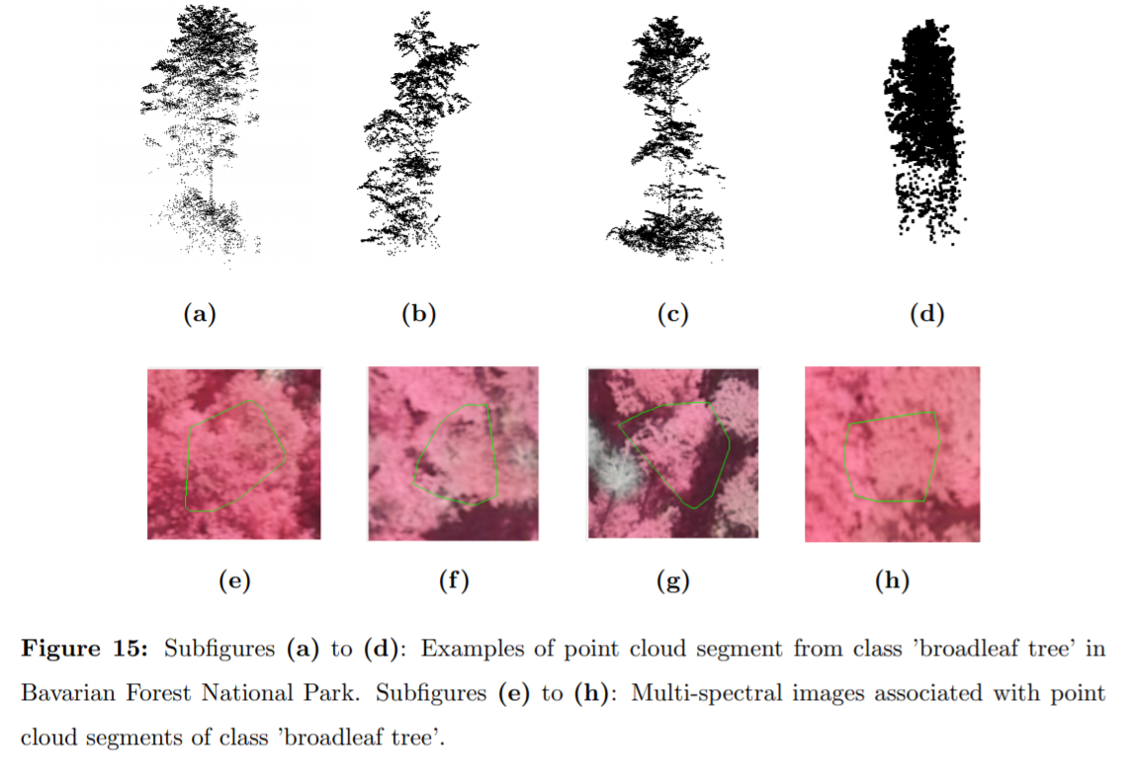

* Bavarian Forest National Park (source: <https://de.wikipedia.org/wiki/Plattenhausenriegel>)

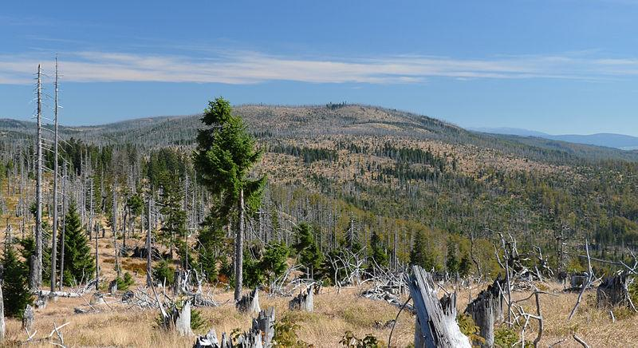

* AWS Architecture



* classification using deep learning

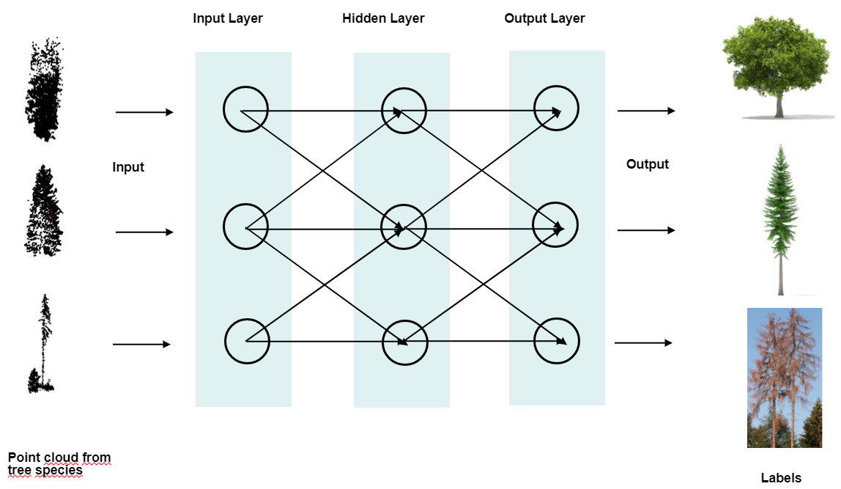

# *About the Digital Transformation Lab*

*Standard description of the DTLab To be completed by DTLab team.*