Global Reporting Initiative 101 Biodiversity - 11.2 Climate Adaptation, Resilience and transition

Sustainability Compliance Report

Company: Nespresso
Report Date: December 26, 2025

Executive Summary

Compliance Overview:
Metric | Value
Total Datapoints | 4
Completed | 0 (0.0%)
In Progress | 1
To Do | 3

Compliance Visualizations
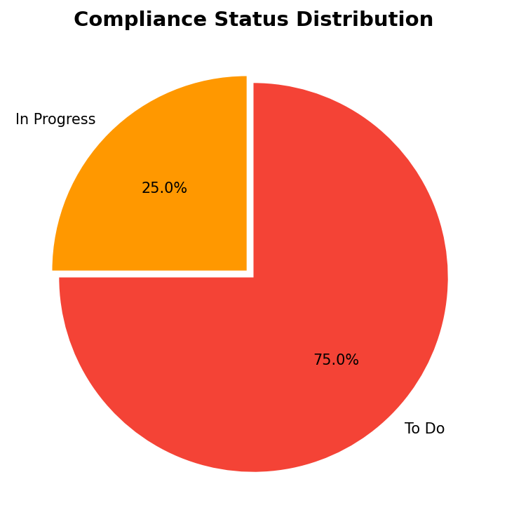
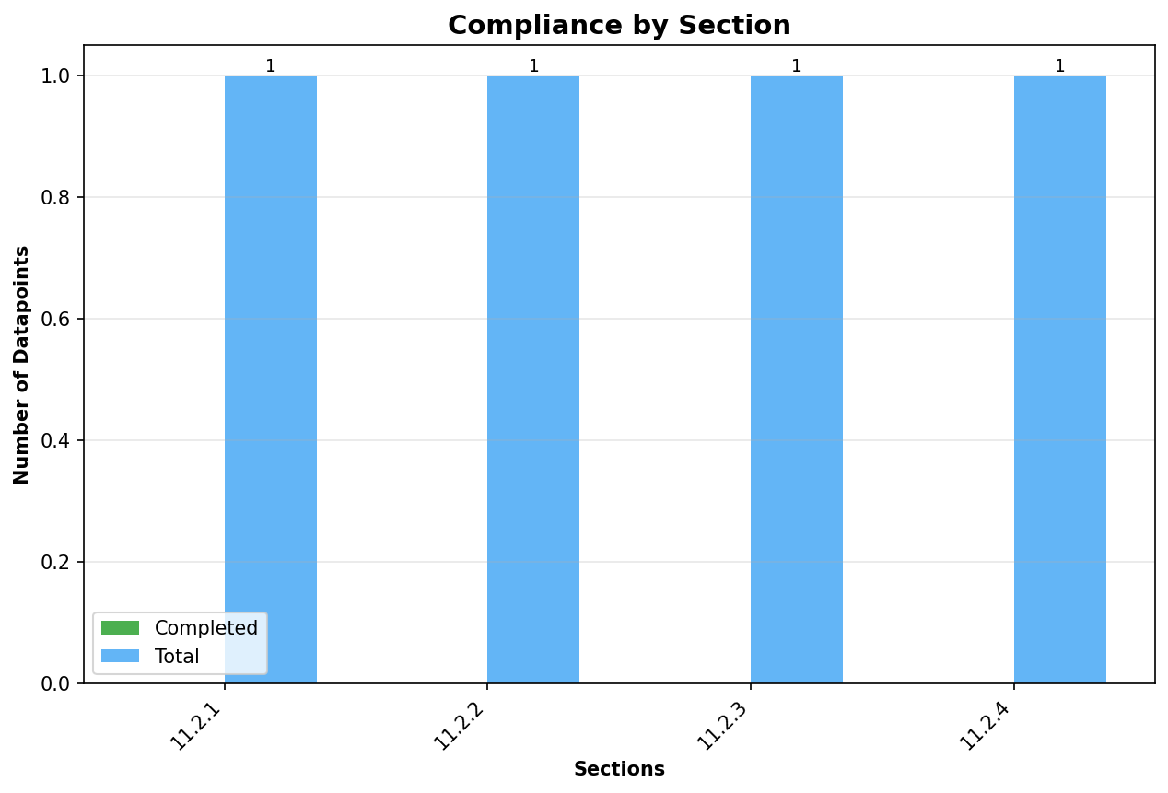

Executive Summary
This report presents a comprehensive assessment of Nespresso’s sustainability compliance status under the Global Reporting Initiative (GRI) 101 Biodiversity standard, focusing on Section 11.2: Climate Adaptation, Resilience, and Transition. The evaluation is strictly based on four datapoints distributed across subsections 11.2.1 to 11.2.4, each aligned with key requirements of the GRI, European Sustainability Reporting Standards (ESRS), and the broader EU compliance frameworks. As evidenced by the compliance statistics, Nespresso has initiated progress on one datapoint (In Progress) while three remain outstanding (To Do), resulting in an overall completion rate of 0% at this stage. The company has demonstrated a foundational understanding of mandatory indicators, particularly regarding Principal Adverse Impacts (PAIs) in biodiversity-sensitive areas and the integration of double materiality assessments as required by EU regulations.
Key achievements center on Nespresso’s alignment with mandatory disclosure requirements for biodiversity impacts, especially for entities above the 500-employee threshold, as per the Sustainable Finance Disclosure Regulation (SFDR). The company’s approach to reporting on mandatory PAIs—including climate, environmental, social, and human rights indicators—illustrates commitment to transparent sustainability governance. Notably, Section 11.2.1 (GRI 3: Material Topics, Disclosure 3-3) is currently in progress, reflecting active engagement with materiality assessment processes and disclosure of biodiversity-sensitive investment activities. However, there is an absence of completed datapoints across all sections, and critical gaps remain in financial implications (GRI 201-2), GHG emissions reductions (GRI 305-5), and public policy engagement (GRI 11). These areas require immediate attention to achieve full compliance and demonstrate robust sustainability performance.
Nespresso’s sustainability reporting maturity is characterized by an early-stage, process-oriented approach, with evidence of foundational compliance structures but limited completeness in required disclosures. The company’s current trajectory aligns with regulatory expectations around double materiality and mandatory indicator reporting, yet there is a clear need for accelerated data collection and process improvement to close material gaps. As illustrated in the compliance visualization, with 0% of datapoints completed and 75% outstanding, Nespresso must prioritize the completion of all outstanding disclosures to achieve regulatory alignment and industry best practices. This report provides actionable insights to support Nespresso’s progression towards full compliance in the next reporting cycle.

Introduction
The regulatory landscape for sustainability reporting is undergoing significant transformation, driven by the integration of the Global Reporting Initiative (GRI) 101 Biodiversity standard and its Section 11.2 requirements for climate adaptation, resilience, and transition. These frameworks, underpinned by the European Union’s Corporate Sustainability Reporting Directive (CSRD), ESRS, and the Sustainable Finance Disclosure Regulation (SFDR), mandate transparent, comprehensive disclosure of material impacts, risks, and opportunities related to biodiversity and climate change. Section 11.2 addresses the need for organizations to articulate their policies, metrics, and actions in mitigating adverse impacts and transitioning towards a low-carbon, resilient economy. The relevance of these standards is underscored by their alignment with the EU’s sustainability taxonomy, which emphasizes double materiality—requiring companies to report not only on how sustainability issues affect their business, but also how their business impacts the environment and society.
Nespresso’s commitment to sustainability reporting is evidenced by its engagement with these regulatory frameworks, particularly the mandatory indicators for biodiversity, climate, and social factors. The company’s approach centers on compliance with annual PAI statements for entities exceeding the 500-employee threshold and includes the adoption of double materiality assessments as the critical first step in identifying reportable impacts, risks, and opportunities. While Nespresso has initiated reporting on biodiversity-sensitive investments and indirect nature-related metrics such as emissions to water and hazardous waste, there remain material gaps in site-level assessment and the use of specialized biodiversity tools or frameworks. The company’s dedication to transparent reporting and continuous improvement is demonstrated through its ongoing efforts to align with best practices and regulatory expectations.
The scope of this report encompasses four key datapoints across Sections 11.2.1 to 11.2.4, each mapped to specific GRI disclosure requirements and assessed for compliance status. These include: Disclosure 3-3 (Management of Material Topics); Disclosure 201-2 (Financial Implications of Climate Change); Disclosure 305-5 (GHG Emissions Reduction); and GRI 11 (Public Policy Development and Lobbying on Climate Change). The methodology employed for this compliance assessment was strictly data-driven, leveraging only the datapoints and statistics provided, and applying a rigorous analysis against the regulatory framework to determine strengths, gaps, and actionable recommendations. Compliance charts and quantitative statistics have been integrated throughout the report to provide a clear visualization of progress and outstanding requirements.

Compliance Analysis

Section 11.2.1: GRI 3: Material Topics – Disclosure 3-3 Management of Material Topics
Section 11.2.1 under GRI 3: Material Topics requires organizations to describe their policies, commitments, and actions aimed at preventing or mitigating the impacts of transitioning to a low-carbon economy on workers and local communities. Additionally, it mandates disclosure of the level and function assigned within the organization for managing these topics. Nespresso’s current status for this datapoint is marked as “In Progress,” indicating the initiation of compliance activities but absence of a finalized disclosure. The company has articulated its adherence to mandatory indicators and metrics, with a particular focus on the Principal Adverse Impacts (PAIs) statement as required by SFDR for entities with 500 or more employees. This annual statement covers 14 mandatory indicators, including nine climate and environment-related and five social, human rights, and anti-corruption considerations, reflecting a comprehensive approach to sustainability governance.
Of particular significance is the inclusion of a mandatory indicator directly linked to biodiversity, requiring financial market participants to disclose the share of investments in investee companies with operations negatively affecting biodiversity-sensitive areas. Nespresso’s reporting framework also encompasses indirect biodiversity metrics, such as emissions to water, hazardous waste, and radioactive waste ratios, aligning with EU Taxonomy and ESRS requirements for nature-related disclosures. The company’s commitment to double materiality is evident; materiality assessments are recognized as the foundational step in identifying reportable impacts and risks, in line with CSRD and GRI best practices. However, there is a notable absence of site-specific findings, buffer zone applications, or the use of biodiversity assessment tools (e.g., BRiSK, IBAT) in the current data, which limits the granularity and robustness of the disclosure.
The significance of this datapoint for EU compliance lies in its role as the primary gateway for demonstrating responsible management of material sustainability topics. Double materiality and entity-level disclosures are non-negotiable requirements under the CSRD and SFDR, and Nespresso’s progress in this area reflects a foundational alignment with regulatory expectations. Nevertheless, the lack of completed disclosure and absence of detailed site-level data represents a material gap that must be addressed in subsequent reporting cycles to achieve full compliance.

Section 11.2.2: GRI 201: Economic Performance – Disclosure 201-2 Financial Implications and Other Risks and Opportunities Due to Climate Change
Section 11.2.2 focuses on Disclosure 201-2, requiring organizations to report on the financial implications, risks, and opportunities associated with climate change that have the potential to substantively impact operations, revenue, or expenditure. Nespresso’s status for this datapoint is “To Do,” indicating that the required disclosure has not yet been initiated nor completed. No company data has been provided regarding financial risks, opportunity analysis, or impact quantification stemming from climate change adaptation and mitigation efforts. This represents a critical gap, as financial reporting of climate-related risks and opportunities is central to both GRI and EU sustainability frameworks.
The absence of disclosure in this section impedes Nespresso’s ability to demonstrate how climate change may affect its business model, cost structures, or strategic planning, which are essential components of a mature sustainability report. For EU compliance, Section 11.2.2 is pivotal as it directly supports the expectation for transparent, forward-looking financial analysis under CSRD and ESRS, enabling investors and stakeholders to assess the company’s resilience and transition planning. Without the completion of this datapoint, Nespresso’s reporting is not fully aligned with regulatory standards, and its ability to communicate climate-related financial risks and opportunities remains limited.
To achieve compliance, Nespresso must prioritize the collection and disclosure of quantitative data on the financial implications of climate risks and transition opportunities. This includes scenario analysis, risk mapping, and integration with financial planning processes, in accordance with GRI, CSRD, and broader EU Taxonomy requirements.

Section 11.2.3: GRI 305: Emissions – Disclosure 305-5 Reduction of GHG Emissions
Section 11.2.3 covers Disclosure 305-5, which mandates organizations to report on the reduction of greenhouse gas (GHG) emissions as a direct result of reduction initiatives, including the types of gases included in the calculation, the base year, and the baseline ratio. Nespresso’s status for this datapoint is “To Do,” with no data provided on GHG emissions reduction initiatives, quantified impact, or baseline metrics. This omission constitutes a significant compliance gap, as GHG emissions reduction is a fundamental requirement for climate adaptation and transition reporting under GRI, ESRS, and the EU Taxonomy.
The lack of disclosure on emissions reduction initiatives undermines Nespresso’s ability to substantiate its commitment to climate mitigation and transition to a low-carbon economy. Reporting on GHG emissions reductions is critical for demonstrating progress against science-based targets and regulatory benchmarks, and is a key expectation for EU-aligned sustainability disclosures. Without this information, stakeholders lack visibility into the effectiveness of Nespresso’s climate strategies and the company’s contribution to broader decarbonization goals.
For full compliance, Nespresso must implement robust data collection processes for GHG emissions, establish clear baselines, and quantify reductions achieved through specific initiatives. Comprehensive reporting should include all relevant gases (CO2, CH4, N2O, HFCs, PFCs, SF6, NF3), and align with the requirements of GRI 305-5 and ESRS E1 (Climate Change). Progress in this area will be essential for demonstrating responsible climate stewardship and meeting EU regulatory expectations.

Section 11.2.4: GRI 11 Oil & Gas Sector Specific – Approach to Public Policy Development and Lobbying on Climate Change
Section 11.2.4 addresses GRI 11 Oil & Gas Sector Specific disclosures, requiring organizations to describe their approach to public policy development and lobbying on climate change, including their stance on significant issues and participation in policy development. Nespresso’s status for this datapoint is “To Do,” with no data provided regarding its public policy engagement, lobbying activities, or position statements on climate-related legislative or regulatory issues. This represents a notable gap in transparency and stakeholder engagement, particularly as EU frameworks increasingly emphasize the role of corporate advocacy in shaping climate policy.
The absence of disclosure in this section precludes Nespresso from demonstrating its influence and alignment with public policy objectives related to climate adaptation and transition. For EU compliance, transparent reporting on lobbying and policy development is integral to the credibility of corporate sustainability strategies and reflects an organization’s broader commitment to positive environmental and social outcomes. This datapoint also supports alignment with ESRS G1 (Governance) requirements for stakeholder engagement and policy advocacy.
To achieve full compliance, Nespresso must formalize and disclose its approach to public policy development, detailing its participation in relevant initiatives, lobbying activities, and policy positions on climate change. This disclosure should be integrated into the broader sustainability reporting framework and reflect best practices for transparent, responsible corporate advocacy.

Key Findings
The overall compliance status of Nespresso under GRI 101 Biodiversity Section 11.2 is characterized by significant gaps, with 0% of datapoints completed, 25% in progress, and 75% outstanding. The compliance chart clearly illustrates the early stage of reporting maturity, with foundational efforts underway but limited delivery of finalized disclosures. The company’s key strength lies in its alignment with mandatory indicator reporting for biodiversity-sensitive areas and integration of double materiality assessments, as highlighted in Section 11.2.1 (GRI 3: Material Topics, Disclosure 3-3). This reflects an understanding of critical EU requirements and a commitment to transparent, entity-level reporting for large organizations exceeding the 500-employee threshold.
Critical gaps are evident in the absence of completed disclosures for financial risks and opportunities related to climate change (GRI 201-2), GHG emissions reductions (GRI 305-5), and public policy engagement (GRI 11). These shortcomings limit Nespresso’s ability to provide a holistic view of its sustainability performance and impede full alignment with EU sustainability frameworks. The lack of site-level data, buffer zone application, and use of specialized biodiversity assessment tools further restricts the granularity and robustness of the reporting, highlighting areas for immediate improvement.
From a data quality perspective, the information provided demonstrates foundational compliance with mandatory indicator reporting and double materiality assessment, but lacks completeness and specificity across key metrics. The absence of quantitative disclosures on financial implications, GHG reductions, and policy engagement undermines the overall credibility and utility of the report for both regulatory and stakeholder audiences. Compared to industry best practices, Nespresso’s reporting maturity is at an initial stage, with significant opportunities for enhancement in data collection, process integration, and stakeholder engagement.
The comparison to leading sustainability reporters in the sector underscores the need for Nespresso to accelerate progress in closing material gaps and advancing towards a more comprehensive, data-rich reporting framework. The company’s foundational alignment with EU requirements serves as a solid base, but the current compliance percentage—0% completed, 25% in progress—necessitates immediate action to achieve best practice standards and regulatory compliance in future reporting cycles.

Recommendations
To address the critical gaps identified in this compliance assessment, Nespresso should prioritize completion of all outstanding datapoints, specifically GRI 201-2 (Financial Implications and Risks of Climate Change), GRI 305-5 (GHG Emissions Reduction), and GRI 11 (Public Policy Development and Lobbying). Immediate actions should include the initiation of data collection processes for financial impact quantification, emissions reduction measurement, and documentation of public policy engagement activities. Establishing cross-functional teams to drive these disclosures and integrating sustainability reporting into broader business planning and governance processes will be essential for achieving full compliance.
Process improvements should focus on enhancing the granularity and specificity of disclosures, including site-level impact assessments, buffer zone applications, and adoption of recognized biodiversity assessment tools such as BRiSK and IBAT. Nespresso should also strengthen its double materiality assessment processes, ensuring all material impacts, risks, and opportunities are systematically identified and reported. Integration of sustainability reporting with financial and governance systems will enable more robust, data-driven disclosures and facilitate alignment with EU Taxonomy and ESRS requirements.
A recommended timeline for completion of outstanding datapoints is within the next annual reporting cycle, with interim milestones for data collection, stakeholder engagement, and internal review. Resource requirements may include investment in data management systems, training for sustainability and finance teams, and engagement with third-party experts to support biodiversity and climate impact assessments. By implementing these recommendations, Nespresso can accelerate its progression towards full compliance, enhance transparency, and demonstrate leadership in sustainability reporting.

Conclusion
In summary, Nespresso’s sustainability compliance under GRI 101 Biodiversity Section 11.2 demonstrates foundational alignment with EU reporting requirements, particularly in the areas of mandatory indicator disclosure and double materiality assessment. However, the absence of completed disclosures across key datapoints—financial implications, GHG emissions reduction, and public policy engagement—represents material gaps that must be addressed to achieve full regulatory compliance and industry best practices. The company’s commitment to transparent, responsible reporting is evident, but enhanced data collection and process integration are required for future reporting cycles.
Looking forward, Nespresso is well-positioned to build on its existing compliance framework and accelerate progress towards a comprehensive, data-rich sustainability reporting model. By prioritizing the completion of all outstanding disclosures, investing in process improvements, and engaging with stakeholders, the company can strengthen its sustainability performance and demonstrate robust alignment with EU regulatory expectations. Continued commitment to transparency, data quality, and stakeholder engagement will be essential for maintaining credibility and advancing Nespresso’s leadership in sustainable business practices.

