**Warehouse Management System**

**CSCI 5448 Project: Part 2**

**Team:** Max Hollingsworth

Jonathan Magiera

Dan Prendergast

**Title:** Warehouse Management System

**Project Summary**

***Description:*** A system that allows warehouse personnel to manage the inventory and operations of an automated warehouse. The warehouse includes the following features:

* 3 truck loading docks for receiving incoming pallets of products
* 1 shipping center for packaging and shipping outgoing products
* 16 storage shelves
* 4 autonomous forklifts for moving pallets from the loading docks to storage shelves
* 4 autonomous robots to move individual products from the shelves to the shipping center

***Actors:***

* Warehouse Operator – directs the movement of forklifts, robots, and products around the warehouse
* Inventory Manager – responsible for monitoring inventory levels and ordering products from warehouse suppliers
* Customer Service Representative – enters orders that are placed by phone (Stretch Functionality)
* Customer – places orders on the website (Stretch Functionality)
* Warehouse Robots
  + Autonomous Forklift – moves pallets of products around the warehouse
  + Retrieval Robot – moves individual products from the warehouse shelves to the shipping center when product orders are received

**Project Requirements**

1. ***User/Functional Requirements***

|  |  |  |  |  |
| --- | --- | --- | --- | --- |
| **ID** | **Requirement** | **Topic Area** | **Supports Use Case(s)…** | **Actor** |
| U-01 | The system shall depict the layout of the warehouse floor, including the locations of the loading docks, storage shelves, QA inspection area, and shipping center. | Pallet Management | 1, 2, 8, 9 | WO, LDS, QA, R, OS, SC |
| U-02 | The system shall show the following information to the Warehouse Operator: | Pallet Management | (n/a) | (n/a) |
| U-03 | - which product is currently on each shelf | Pallet Management | 1, 2, 8, 9 | WO, LDS, QA, R, OS, SC |
| U-04 | - quantity of the product currently on each shelf | Pallet Management | 1, 2, 8, 9 | WO, LDS, QA, R, OS, SC |
| U-05 | - the next pallet to be offloaded from the truck | Pallet Management | 1, 2 | WO, LDS, QA, R |
| U-06 | - the next pallet to be moved from the QA Inspection Area | Pallet Management | 1, 2 | WO, LDS, QA, R |
| U-07 | - which product is on each pallet | Pallet Management | 1, 2 | WO, LDS, QA, R |
| U-08 | - quantity of the product on each pallet | Pallet Management | 1, 2 | WO, LDS, QA, R |
| U-09 | The system shall allow the Warehouse Operator to select a pallet to move. | Pallet Management | 1 | WO, LDS, QA, R |
| U-10 | The system shall allow the Warehouse Operator to select an empty shelf as the pallet's destination. | Pallet Management | 1 | WO, LDS, QA, R |
| U-11 | The system shall allow the Warehouse Operator to select the QA Inspection Area as the pallet's destination. | Pallet Management | 1 | WO, LDS, QA, R |
| U-12 | The system shall send a command to an autonomous forklift to move pallets based on the Warehouse Operator's input. | Pallet Management | 1 | WO, LDS, QA, R |
| U-13 | The system shall indicate to the Warehouse Operator the following conditions: | Pallet Management | (n/a) | (n/a) |
| U-14 | - when an autonomous forklift is “busy” | Pallet Management | 1, 2 | WO, LDS, QA, R |
| U-17 | - when an autonomous forklift is malfunctioning | Pallet Management | 1, 3 | WO, LDS, QA, R |
| U-18 | - when an autonomous forklift is operational | Pallet Management | 1, 4 | WO, LDS, QA, R |
| U-19 | When a pallet is delivered to a shelf, the system shall update the shelf contents (product and quantity). | Pallet Management | 1 | WO, LDS, QA, R |
| U-21 | The system shall allow the Warehouse Operator to cancel a "move pallet" task before the autonomous forklift has picked up the pallet. | Pallet Management | 2 | WO, R |
| U-22 | The system shall allow the Warehouse Operator to take a robot (autonomous forklift or retrieval robot) out of service. | Pallet Management | 3 | WO, R |
| U-23 | The system shall allow the Warehouse Operator to place a robot (autonomous forklift or retrieval robot) in service. | Pallet Management | 4 | WO, R |
| U-24 | Upon receipt of an order, the system shall automatically send a command to a retrieval robot to retrieve the product from the shelf and move it to the warehouse shipping center. | Order Fulfillment | 8 | Online Order System |
| U-25 | The system shall indicate the following conditions: | Order Fulfillment | (n/a) | (n/a) |
| U-26 | - when a retrieval robot is "busy" | Order Fulfillment | 8, 9 | OS, SC, R, CS |
| U-29 | - when a retrieval robot is malfunctioning | Order Fulfillment | 8, 9, 3 | OS, SC, R, CS, WO |
| U-30 | - when a retrieval robot is operational | Order Fulfillment | 8, 9, 4 | OS, SC, R, CS, WO |
| U-31 | When a product is delivered to the Shipping Center, the system shall update the total number of that product shipped. | Order Fulfillment | 8 | OS, SC, R |
| U-33 | The system shall show the following product information to the Inventory Manager: | Inventory Management | (n/a) | (n/a) |
| U-34 | - product ID | Inventory Management | 5, 6, 7 | IM |
| U-35 | - product type | Inventory Management | 5, 6, 7 | IM |
| U-38 | - quantity on hand | Inventory Management | 5, 6, 7 | IM |
| U-39 | - quantity on order | Inventory Management | 5, 6, 7 | IM |
| U-40 | - total number sold | Inventory Management | 5, 6, 7 | IM |
| U-41 | The system shall allow the Inventory Manager to place orders for new product shipments from the suppliers. | Inventory Management | 5 | IM |
| U-42 | The system shall allow the Inventory Manager to define the following order specifications: | Inventory Management | (n/a) | (n/a) |
| U-43 | - product ID | Inventory Management | 5 | IM |
| U-44 | - quantity | Inventory Management | 5 | IM |
| U-45 | - delivery date | Inventory Management | 5 | IM |
| U-46 | The system shall allow the Inventory Manager to add a new product to the inventory database. | Inventory Management | 6 | IM |
| U-47 | The system shall allow the Inventory Manager to remove a product from the inventory database. | Inventory Management | 7 | IM |
| U-49 | The system shall simulate an interface to the Online Order System for test/demonstration purposes. | System Test | 8, 13 | SC, R |
| U-50 | The system shall simulate loading dock operations (i.e., arrival of delivery trucks and scanning incoming pallets) for test/demonstration purposes. | System Test | 1 | WO, LDS, R |
| U-51 | The system shall simulate QA inspection operations (i.e., scanning inspected pallets) for test/demonstration purposes. | System Test | 1 | WO, QA, R |

[Warehouse Operator = WO, Inventory Manager = IM, Loading Dock Sup = LDS, QA Inspector = QA, Order System = OS, Robot = R, Shipping Center = SC, Customer = C, Customer Service = CS]

1. ***Stretch User/Functional Requirements***

|  |  |  |  |  |
| --- | --- | --- | --- | --- |
| **ID** | **Requirement** | **Topic Area** | **Supports Use Case(s)…** | **Actor** |
| S-1 | Upon receipt of a returned product, the system shall automatically send a command to a retrieval robot to place the product on a shelf with similar products. | Return Processing | 9 | CS, R |
| S-2 | When a returned product is restocked on a shelf, the system shall update the shelf contents (product and quantity). | Return Processing | 9 | CS, R |
| S-3 | The system shall display the following information to the Customer and the Customer Service Representative: | Order Placement | (n/a) | (n/a) |
| S-4 | - product ID | Order Placement | 10, 11, 12 | C, CS |
| S-5 | - product type | Order Placement | 10, 11, 12 | C, CS |
| S-6 | - price | Order Placement | 10, 11, 12 | C, CS |
| S-7 | The system shall allow the Customer and the Customer Service Representative to place an order by specifying the following: | Order Placement | (n/a) | (n/a) |
| S-8 | - product ID | Order Placement | 10 | C, CS |
| S-9 | - quantity | Order Placement | 10 | C, CS |
| S-10 | - customer name | Order Placement | 10 | C, CS |
| S-11 | - customer address | Order Placement | 10 | C, CS |
| S-12 | The system shall allow the Customer Service Representative to edit or cancel a customer's order. | Order Placement | 11, 12 | CS |

[Warehouse Operator = WO, Inventory Manager = IM, Loading Dock Sup = LDS, QA Inspector = QA, Order System = OS, Robot = R, Shipping Center = SC, Customer = C, Customer Service = CS]

1. ***Non-Functional Requirements***

|  |  |  |
| --- | --- | --- |
| **ID** | **Requirement** | **Topic Area** |
| NF-01 | The system shall demonstrate 99.9% service availability during business hours. | Availability |
| NF-03 | The user interface (UI) shall be intuitive as determined by usability testing involving warehouse employees rating the UI on a Likert scale. | Usability |
| NF-04 | Inventory database read and write operations shall occur in less than 0.2 seconds. | Performance |
| NF-05 | Warehouse robots shall receive commands in less than 0.1 seconds. | Performance |
| NF-06 | Warehouse robot status shall be displayed in less than 0.1 seconds. | Performance |

1. ***Business Requirements***

|  |  |  |  |
| --- | --- | --- | --- |
| **ID** | **Requirement** | **Topic Area** | **Actor** |
| B-01 | Loading Dock Supervisors shall ensure pallets are within forklift weight capabilities before scanning QR codes. | Pallet Management | LDS |
| B-02 | Only one pallet shall be stored on a single warehouse shelf. | Pallet Management | WO, R |
| B-03 | Orders to suppliers shall specify that pallets must contain only one product ID/type. | Inventory Management | IM |
| B-04 | 20% of incoming pallets shall be inspected by the QA department. | QA | WO, QA, R |
| B-05 | All systems under development shall include basic simulation of external actors/interfaces for test and demonstration purposes. | System Test | LDS, QA, OS, R |
| B-06 | Only customer service representatives shall be capable of editing or cancelling orders. | Order Placement | CS |

[Warehouse Operator = WO, Inventory Manager = IM, Loading Dock Sup = LDS, QA Inspector = QA, Order System = OS, Robot = R, Shipping Center = SC, Customer = C, Customer Service = CS]

**Use Case Diagram**

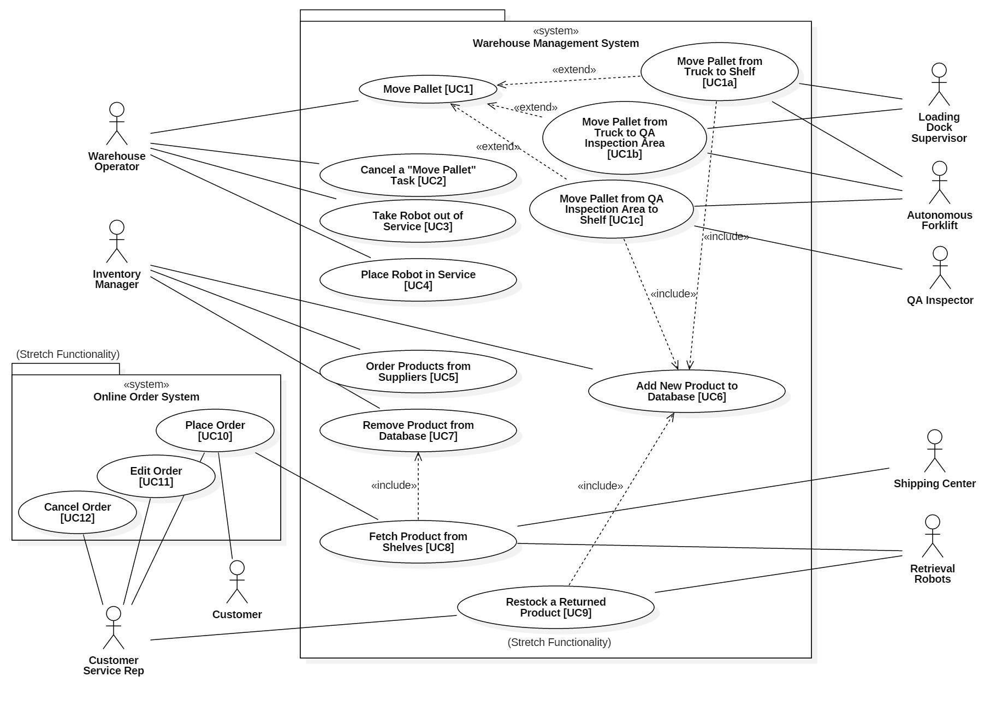

**UI Mockup**

1. ***Warehouse Operator UI***

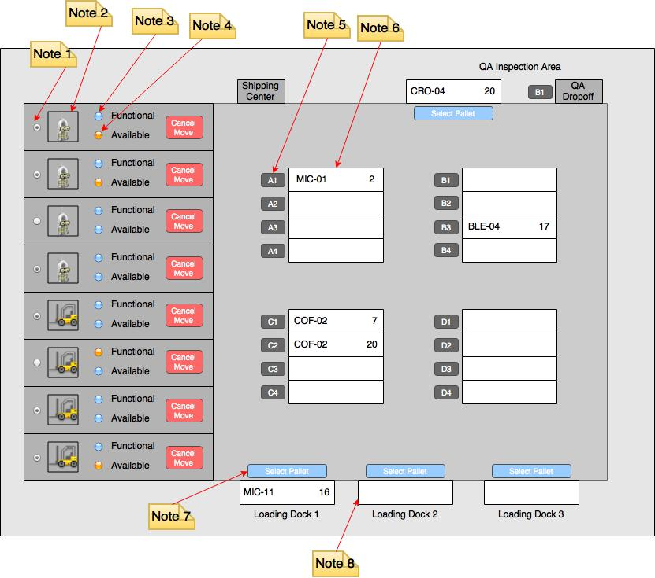

Note 1: Radio button used to take robot out of service or place into service.

Note 2: Image identifies type of robot (i.e. autonomous forklift or retrieval robot.

Note 3: LED indicates whether robot is function (blue) or malfunctioning (orange/red).

Note 4: LED indicates whether robot is available (blue) or busy (orange/red).

Note 5: Button used to select destination shelf for pallet. Destination is selected after selecting the pallet to move (see Note 7).

Note 6: Shelf indicating contents. Product ID is on the left and product quantity is on the right. A shelf with no text inside indicates that the shelf is empty.

Note 7: Button used to select the pallet to move. Destination is selected next (see Note 5).

Note 8: Empty loading dock. When a truck arrives and the Loading Dock Supervisor scans the first pallet, the loading dock is populated with pallet information (product ID and quantity).

1. ***Inventory Manager UI***

The inventory manager’s UI will be a command line interface (CLI). A “printInventory” command will result in a formatted table on the CLI. Various commands with arguments will be used to place orders to warehouse suppliers, add products to the inventory, and remove products from the inventory.

**Data Storage**

The Warehouse Management System will use a MySQL database for the inventory backend. Connectivity between the application and the database will be through the Java Database Connectivity (JDBC) API. The JDBC (the inventory) object will persist, as the data should be readily accessible by the Inventory Managers, as well as other actors.

**Class Diagram** (see next page)

