TasteMatch
1. Determine a project
Project: TasteMatch – Food and Restaurant Recommendation System
TasteMatch is a web-based application that recommends restaurants and food to users based on their taste preferences, budget, dietary preferences, and favorite cuisines.

2. Start working on the project
After the project proposal is approved by the instructor, development will begin by analyzing requirements, designing the database and system, developing the interface and backend, testing the system, and documenting the development process.

3. Type of application
TasteMatch will be a web application accessible through a web browser.
It will have:
- User interface
- User registration/login
- Food and restaurant database
- Recommendation system
- Search and filtering
- Favorites
- Reviews and ratings
- Administrator dashboard

4. Business-life usage
TasteMatch can be used in the food and restaurant business.
Restaurants can use the system to:
- Promote their food and services.
- Understand customer preferences.
- Receive customer ratings and reviews.
- Identify popular food categories.
- Provide personalized recommendations to customers.
Customers can use it to discover restaurants and food that match their preferences.

5. Project complexity and software engineering logic
The project will be sufficiently complex because it involves:
- User authentication
- Role-based access
- Database management
- CRUD operations
- Search and filtering
- Recommendation/matching algorithm
- Ratings and reviews
- Data validation
- Error handling
- Testing
- Version control
- Software engineering documentation
The recommendation algorithm will calculate a matching percentage between a user's preferences and available restaurants/food.
Example:
Cuisine preference: Japanese 40%
Budget preference: ₱₱ 25%
Spice preference: Medium 15%
Diatary preference: Non-vegetarian 10%
Rating preference: 4+ stars 10%
Total Match: 92%

6. Individual or two-developer team
Team: Five developers

Developer 1: [Harries Basa] Developer 1: [Jose Maria Quiambao]
Developer 1: [Travis Cabasal] Developer 1: [Daniel john Montealegre]
Developer 2: [Aaron Bosales]

7. Team Notification
The TasteMatch project will be developed by a team of two developers.
Both developers will work together throughout the planning, design, development, testing, documentation, and presentation of the project.
Team Members:
- Developer 1: [Your Name]
- Developer 2: [Partner's Name]
Both team members will notify the instructor by email to confirm that they have chosen to work together as a two-developer team.
Email: rahfael.vistan@aura.edu.ph
Suggested message:
Good day, Sir Rafael.
We would like to inform you that we have decided to work together as a two-developer team for our Software Engineering project, TasteMatch – Food and Restaurant Recommendation System.
Team Members:
- [John Daniel Montealegre]
- [Jose Maria Quiambao]
We will work together on the development, testing, documentation, and presentation of the project.
Thank you.
Respectfully,
[John Daniel Montealegre] & [Jose Maria Quiambao]

8. GitHub/Bitbucket
The project will be managed using GitHub for source-code management.
The repository will contain:
- Source code
- Database files
- Documentation
- README
- Project versions
- Development branches

9. Git operations
The project will use proper Git operations such as:
git clone
git add
git commit
git push
git pull
git branch
git merge
Example workflow:
Create Feature
↓
Create Branch
↓
Develop Feature
↓
Test
↓
Commit
↓
Push to GitHub
↓
Merge into Main

10. Code-management information
Git and GitHub documentation will be used to learn and apply proper source-code management practices, including branching, commits, merging, pull requests, versioning, and repository management.

11. GitBash/code management
Git Bash will be used to execute Git commands and manage the project repository.
Example:
git init
git add .
git commit -m "Initial TasteMatch project"
git branch
git push origin main
12. Software versioning
TasteMatch will follow semantic-style versioning.
Example:
v1.0.0 – Initial project
v1.0.1 – Fixed login bugs
v1.0.2 – Fixed UI issues
v1.1.0 – Added user preferences
v1.2.0 – Added restaurant database
v1.3.0 – Added recommendation algorithm
v1.4.0 – Added favorites and reviews
v2.0.0 – Final release
The version history will be documented in GitHub.

13. Project layout and summary
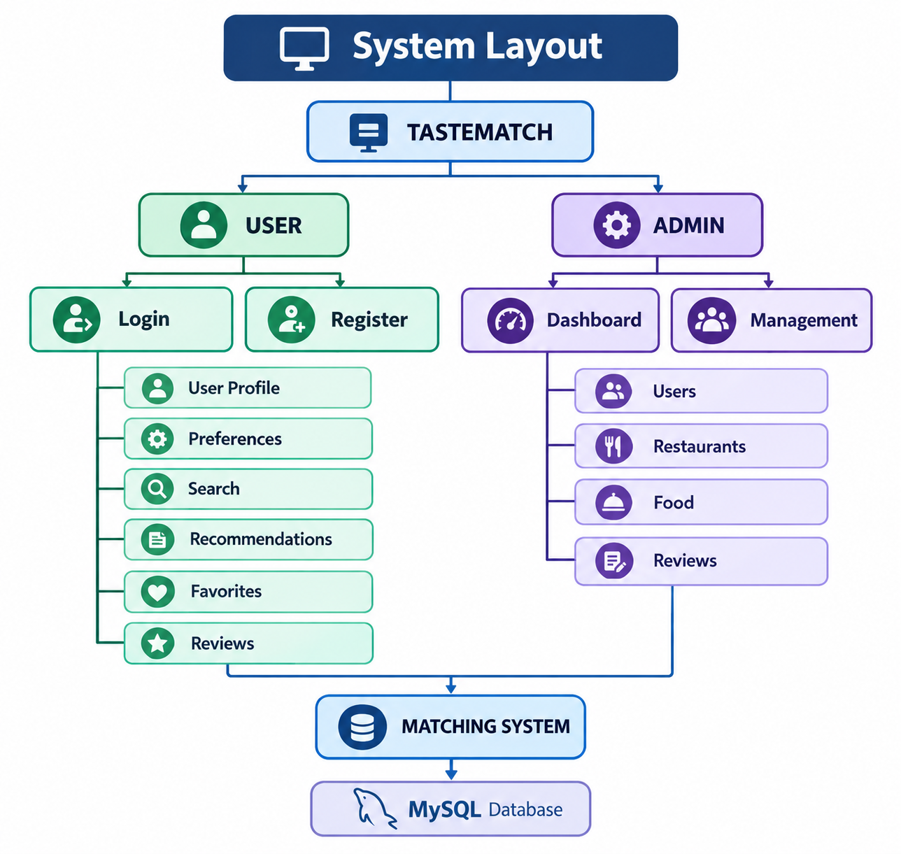
Project Summary
TasteMatch is a food and restaurant recommendation system designed to help users find food and restaurants based on their personal preferences. The system collects information such as preferred cuisine, budget, dietary requirements, spice level, and ratings. It then processes these preferences and provides recommendations with a matching score.
An administrator will manage users, restaurants, food items, and reviews.

14. Submission to instructor
The project layout and summary will be sent to:
Email: rahfael.vistan@aura.edu.ph
Suggested subject:
Software Engineering Project Proposal – TasteMatch

15. Programming language and database
Programming language:
- HTML
- CSS
- JavaScript
- PHP
Database:
- MySQL
Development tools:
- Visual Studio Code
- Git
- Git Bash
- GitHub
If your existing project uses a different backend, we can change this section to match it.

16. Software engineering approaches and methodologies
The project will apply the Agile Software Development methodology.
Development will be divided into stages/sprints:

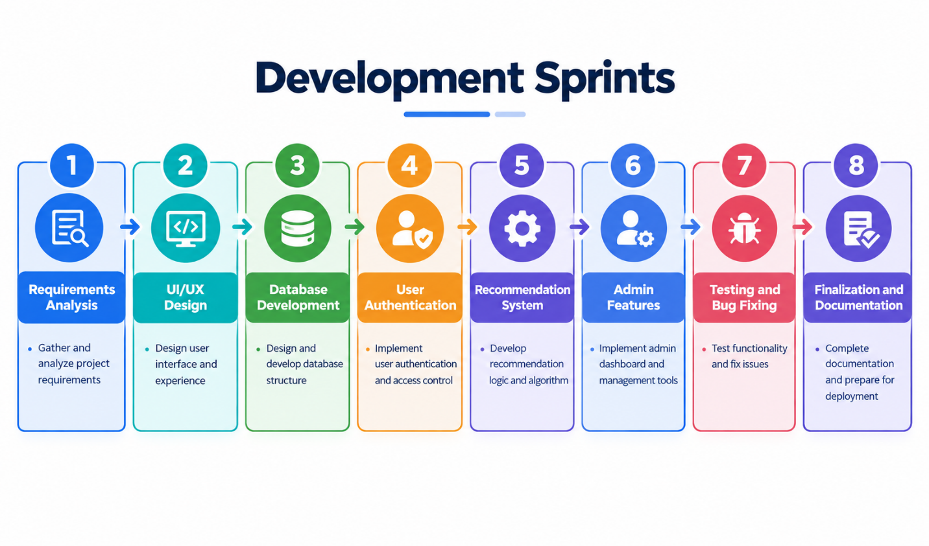
17. Detailed project report
The final report will include the following:
Chapter 1 – Introduction
- Background
- Problem Statement
- Objectives
- Scope
- Limitations
- Significance
Chapter 2 – Requirements Analysis
- Functional requirements
- Non-functional requirements
- User requirements
- System requirements
Chapter 3 – System Design
- System architecture
- Use Case Diagram
- Activity Diagram
- Sequence Diagram
- Class Diagram
- Entity Relationship Diagram
- Database design
- UI design
Chapter 4 – Implementation
- Technologies used
- Frontend development
- Backend development
- Database implementation
- Recommendation algorithm
- GitHub implementation
Chapter 5 – Testing
- Test cases
- Unit testing
- Integration testing
- System testing
- User acceptance testing
- Bug reports
Chapter 6 – Version Control
- GitHub repository
- Commit history
- Branches
- Merging
- Version releases
Chapter 7 – Conclusion
- Results
- Problems encountered
- Solutions
- Future improvements

18.
19. Selected Software Development Model
Model: Incremental development with reuse-oriented practices.
Explanation: TasteMatch is suitable for incremental development because it can be delivered in usable parts. The first increment provides the home page and recipe categories; the next adds recipe detail pages; the next adds sign-in/sign-up and Firebase authentication; later increments add profile, saved recipes, comments/reviews, and account settings. Each increment can be tested before the next is added.
Why: The project has distinct features and many recipe pages that share a common layout. Reuse-oriented development is also practical because category pages, recipe detail pages, navigation, authentication components, and styling can reuse common HTML/CSS/JavaScript patterns. This reduces repeated work and makes updates more consistent.

20. Full User Stories
US-01 Browse categories: As a visitor, I want to view recipe categories so that I can quickly find food ideas. Acceptance: home page displays categories; selecting a category opens its recipe list; each listed recipe can be opened.
US-02 View recipe: As a visitor, I want to view a recipe's ingredients and instructions so that I can prepare it. Acceptance: recipe page displays title, image when available, ingredients, steps, and related navigation.
US-03 Register: As a new user, I want to create an account using my email and password so that I can access personal features. Acceptance: required fields are validated; Firebase creates the account; success or a readable error is shown.
US-04 Sign in / Google sign-in: As a registered user, I want to sign in with email/password or Google so that I can access my profile. Acceptance: valid credentials authenticate; invalid credentials show an error; signed-in state is reflected in the interface.
US-05 Reset password: As a user who forgot a password, I want to request a reset email so that I can regain access. Acceptance: a valid email is accepted and Firebase sends the reset message when configured.
US-06 Save recipe: As a signed-in user, I want to save a recipe so that I can find it later. Acceptance: save action requires authentication; saved list and count update; duplicate saves are prevented or handled.
US-07 Manage saved recipes: As a user, I want to view, search, and remove saved recipes so that my list stays organized. Acceptance: saved recipes appear in profile; search filters visible entries; remove action updates the list.
US-08 Comment/review: As a signed-in user, I want to submit a recipe comment or review so that I can share feedback. Acceptance: empty comments are rejected; valid comments display with author/time where available; inappropriate content can be reported or moderated.
US-09 Profile/settings: As a user, I want to view my account details and settings so that I can manage my account. Acceptance: profile shows current account details and tabs; changes are validated and saved where supported.
US-10 Sign out: As a signed-in user, I want to sign out so that my account is protected on a shared device. Acceptance: Firebase session ends and protected profile actions require signing in again.

21. Detailed Test Cases
TC-01 Home page: Precondition: application opened. Steps: open index.html; inspect category cards; select Breakfast. Expected: home page loads without broken layout and Breakfast page opens.
TC-02 Recipe details: Steps: open a recipe from a category; inspect ingredients and preparation instructions. Expected: correct recipe content and navigation display.
TC-03 Registration validation: Steps: submit blank fields, malformed email, and weak/missing password. Expected: form validation or Firebase error prevents successful registration.
TC-04 Successful registration: Steps: enter valid test email/password and submit. Expected: account is created and signed-in view/state appears.
TC-05 Invalid sign-in: Steps: submit incorrect credentials. Expected: user remains unauthenticated and sees a useful error.
TC-06 Google sign-in: Steps: click Google sign-in and complete provider flow. Expected: authenticated user returns to the application; if provider is not enabled, a clear failure is shown.
TC-07 Password reset: Steps: click Forgot Password, enter registered email, submit. Expected: confirmation is shown and reset email is sent if Firebase email settings are enabled.
TC-08 Save recipe: Precondition: signed in. Steps: save a recipe. Expected: saved state and profile count update and item appears in Saved Recipes.
TC-09 Remove/search saved: Steps: search a saved item; remove it; clear search. Expected: search filters correctly and removed item no longer appears.
TC-10 Comments: Steps: submit blank comment then valid comment. Expected: blank is rejected; valid comment appears once and persists according to configured storage.
TC-11 Profile access: Steps: open profile signed out, then signed in. Expected: unauthenticated user is asked to sign in or redirected; signed-in user sees profile data.
TC-12 Sign out: Steps: click Sign Out, then try to open profile. Expected: session is cleared and protected features are unavailable until sign-in.
TC-13 Responsive layout: Steps: inspect home, category, sign-in, and profile at desktop and mobile widths. Expected: content remains readable, controls do not overlap, and navigation is usable.
TC-14 Firebase unavailable: Steps: disable network or use invalid Firebase configuration in a test environment. Expected: app does not falsely report successful auth/save and presents a failure or retry path.
TC-15 Basic security/input: Steps: enter HTML/script-like text in comment/profile fields. Expected: input is displayed as text, not executed; backend rules restrict unauthorized data access.

22. Full Requirements Definition
Purpose: Provide a convenient web application for discovering recipes and managing personal recipe activity.
Scope: Included: public home/category browsing, recipe detail pages, account registration/sign-in, Google sign-in where enabled, password reset, profile, saved recipes, and recipe comments/reviews where implemented. Excluded: food delivery, payment processing, medical/nutrition diagnosis, and guaranteed nutritional accuracy.
Users: Guest/visitor, registered user, and administrator/moderator (administrative moderation is a proposed role unless implemented separately).
Operating environment: Modern desktop or mobile browser with internet access; HTML5, CSS, JavaScript, and Firebase services configured for the project.
Constraints: Internet required for hosted Firebase functions and remote fonts/assets; Firebase provider settings and database security rules must be configured; recipe data accuracy depends on content supplied by project owners.
Dependencies: Firebase Authentication, Firebase project configuration, browser JavaScript support, and available network connection.
Success criteria: Users can browse categories and recipe details; account workflows return accurate feedback; authenticated users can access personal features; layout is usable on common screen sizes.

23. Nonfunctional Requirements
Usability: Navigation labels and buttons must be understandable; important actions should provide visible feedback.
Performance: Home and category pages should render within 3 seconds on a typical broadband connection, excluding unusually slow external resources.
Reliability: Authentication and data operations must report success only after service confirmation; errors should not erase existing user data.
Security: Use Firebase Authentication; restrict user-specific data through database security rules; do not expose private credentials; validate and safely render user input.
Compatibility: Support current versions of Chrome, Edge, Firefox, and mobile browsers.
Maintainability: Use consistent page structure, reusable styles/scripts, descriptive filenames, and comments for important logic.
Accessibility: Provide labels for inputs, keyboard-operable controls, readable contrast, meaningful image alt text, and visible focus indicators.
Scalability: Recipe lists and user-generated content should be organized so additional categories and recipes can be added without redesigning the entire application.

24. Nonfunctional Requirements Metrics Table
Performance: Initial main content visible within 3 seconds under normal broadband testing; individual local navigation should respond within 1 second.
Availability: Target 99% monthly availability for hosted service dependencies, subject to Firebase/service-provider availability.
Usability: At least 4 of 5 test users can locate a recipe and save it without assistance in a small usability test.
Compatibility: Pass core workflows on latest stable Chrome, Edge, Firefox, and one Android/iOS mobile browser.
Security: All protected database paths deny unauthenticated or unauthorized access in Firebase Rules tests; no user input executes as script.
Reliability: In 20 repeated test runs of core browse/sign-in/save workflows, no unhandled application error.
Accessibility: All form fields have accessible labels; all primary actions are keyboard reachable; text contrast should meet WCAG AA targets where practical.
Maintainability: Shared styles and repeated page elements use consistent naming; new category can be added by following documented page template.

25. Full Requirements for Each System Part
A. Home and navigation: Display TasteMatch brand, tagline, home/profile navigation, hero message, and category cards. Selecting a card opens its matching category page.
B. Category pages: Display recipes grouped by category (Breakfast, Lunch, Dinner, Appetizers, Soups, Desserts, Beverages, Cravings). Each recipe link opens the corresponding recipe detail.
C. Recipe detail: Display recipe name, relevant image, ingredients, preparation instructions, and links/navigation back to categories. Content must be readable and must not misrepresent allergens or nutrition.
D. Authentication: Support account registration, email/password sign-in, sign-out, password reset, and Google sign-in if enabled in Firebase. Display validation and service errors.
E. User profile: Display authenticated user's name/email and profile dashboard tabs such as saved recipes, created recipes, and account settings. Do not expose another user's private data.
F. Saved recipes: Allow authenticated user to save, view, search/filter, and remove recipes. Keep each user's saved list private and consistent across sessions when persistence is configured.
G. Comments/reviews: Allow users to submit and view recipe feedback where enabled. Validate nonempty content, show author/date where available, and apply moderation/security controls.
H. Firebase integration: Initialize the configured Firebase app once; observe authentication state; synchronize user session information; handle network and provider errors.

26. Structured Requirements: Recipe Save Function
REQ-SAVE-01: The system shall display a Save control on eligible recipe pages for signed-in users.
REQ-SAVE-02: When a guest selects Save, the system shall request authentication and shall not create a user-specific saved record.
REQ-SAVE-03: For an authenticated user, the system shall store the recipe identifier and user identifier in the user's authorized saved-recipe collection.
REQ-SAVE-04: The system shall prevent duplicate saved entries for the same user and recipe.
REQ-SAVE-05: The system shall show confirmation only after the save operation succeeds.
REQ-SAVE-06: If saving fails, the system shall preserve the previous state and display an error/retry option.
REQ-SAVE-07: The profile shall retrieve and display only the current user's saved recipes.
REQ-SAVE-08: Removing a saved recipe shall require an explicit user action and update the display after successful deletion.

27. Tabular Computation of Functions/Models
Saved count: Count distinct saved recipe records belonging to the authenticated user. Formula: SavedCount = number of authorized saved records.
Created count: Count recipes created by the current user, if recipe creation is enabled. Otherwise display 0 or hide the metric.
Reviews count: Count comments/reviews authored by the current user and associated with recipes.
Recipe search: For each recipe, compare normalized search text against title/category; show item when the query is contained in the searchable text.
Category listing: Filter recipe records by category value and display matching recipes.
Authentication status: If Firebase currentUser exists, state = Signed In; otherwise state = Guest/Signed Out.
Profile display name: Use Firebase displayName when available; otherwise derive a display label from the email prefix or show 'User'.
Recipe detail: Retrieve/display recipe title, image path, ingredient list, and preparation steps using the selected recipe's identifier.

28. Detailed Scenarios
Scenario 1: Find a recipe: Actor: Guest. User opens home, reviews categories, selects Dinner, chooses a recipe, and reads ingredients/instructions. Result: recipe details are displayed.
Scenario 2: Register and sign in: Actor: New user. User opens account page, switches to Sign Up, enters required details, submits, and receives success/error feedback. On success, authenticated view and profile access become available.
Scenario 3: Save a recipe: Actor: Registered user. User signs in, opens a recipe, selects Save, and later opens Profile > Saved Recipes. Result: saved recipe appears in the list.
Scenario 4: Search saved recipes: Actor: Registered user. User enters a keyword in the saved-recipe filter. Result: matching saved items remain visible; clearing the search restores the full list.
Scenario 5: Leave a review: Actor: Registered user. User opens a recipe, enters a comment, and submits. Result: valid feedback appears; empty or rejected content produces a validation message.
Scenario 6: Sign out: Actor: Registered user. User selects Sign Out. Result: Firebase session ends and profile-only functions require authentication again.

29. Use Cases for the Project
UC-01 Browse recipe categories: Primary actor: Guest or registered user. Goal: find recipes by category. Precondition: app is available. Main flow: open home, choose category, select recipe, view details. Alternative: category has no entries; show an empty-state message.
UC-02 View recipe details: Actor: Guest or registered user. Main flow: select recipe card/link; system displays recipe information. Postcondition: recipe details are visible.
UC-03 Create account: Actor: Guest. Main flow: open sign-in page, choose Sign Up, complete required fields, submit; system validates and creates account through Firebase. Alternative: invalid/duplicate email returns an error.
UC-04 Sign in: Actor: registered user. Main flow: enter email/password or choose Google provider; system authenticates and shows signed-in state. Alternative: invalid credentials or provider error.
UC-05 Manage saved recipes: Actor: registered user. Main flow: save recipe, open profile, search or remove saved item. Postcondition: saved collection reflects changes.
UC-06 Manage profile: Actor: registered user. Main flow: open profile, view account information, use available tabs/settings. Postcondition: profile information is displayed or updated.
UC-07 Submit recipe comment: Actor: registered user. Main flow: open recipe, write feedback, submit; system validates and stores/displays comment. Alternative: blank or disallowed comment is rejected.
UC-08 Sign out: Actor: registered user. Main flow: select Sign Out; system ends session and returns to guest state.

30. Context UML Diagram
Description: TasteMatch is the system boundary. External entities are Guest, Registered User, Firebase Authentication, Firebase data service (if configured), and browser/device.
Diagram (text form): Guest -> TasteMatch: browse categories / view recipes / register\nRegistered User -> TasteMatch: sign in / save / comment / profile / sign out\nTasteMatch <-> Firebase Authentication: create account, authenticate, reset password, observe session\nTasteMatch <-> Firebase data service: read recipes, save recipes, retrieve profile data, store comments (where configured)\nTasteMatch -> Browser: render pages, forms, recipe cards, and feedback
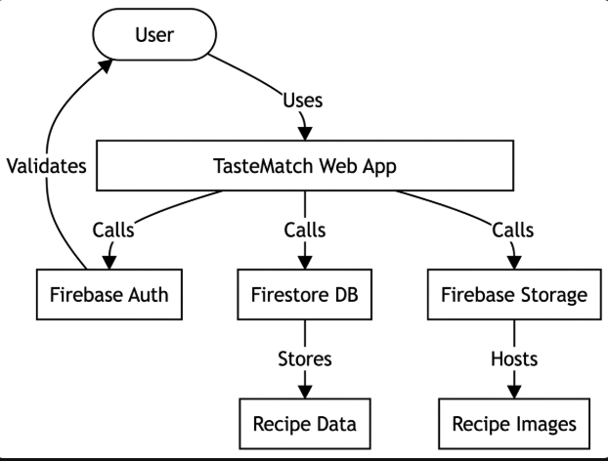

31. Detailed Process Model UML Diagram
Activity flow: Start -> Open website -> Display home/categories -> [Choose action?] Browse category -> Select recipe -> Display recipe details -> [Sign in required for personal action?] Yes: open sign-in -> validate credentials -> Firebase authentication -> authenticated session -> perform save/comment/profile action -> show result -> return to browsing -> End.
Exception flows: Invalid form -> show validation message -> allow correction. Firebase/network failure -> show error/retry -> retain safe current view. Sign out -> clear authenticated state -> return to guest browsing.
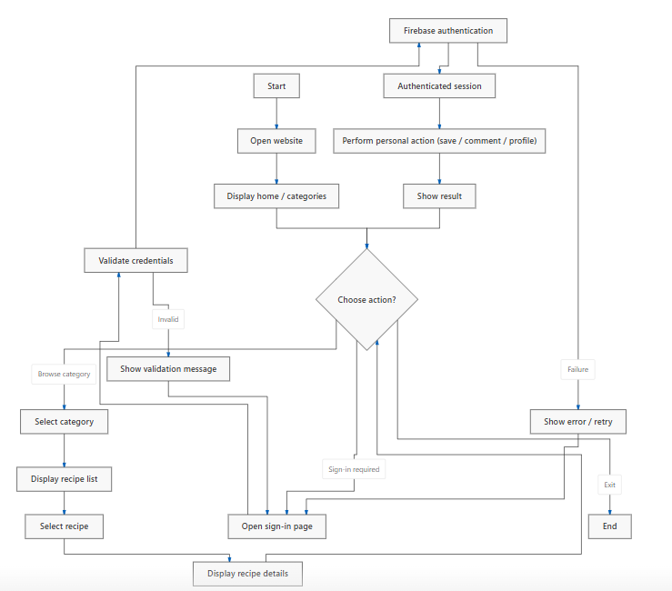
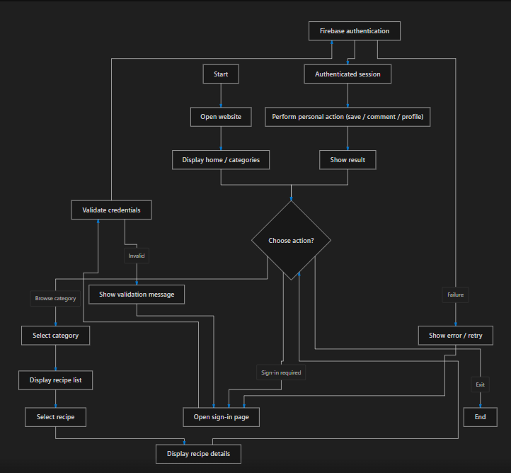

32. Use Case UML Diagram
Actors: Guest, Registered User (specializes Guest browsing permissions), Firebase Authentication (external service), and Moderator/Admin (proposed if moderation is implemented).
Use cases: Browse Categories; View Recipe; Register; Sign In; Google Sign In; Reset Password; Save Recipe; View Saved Recipes; Search Saved Recipes; Remove Saved Recipe; View Profile; Manage Settings; Submit Comment/Review; Sign Out.
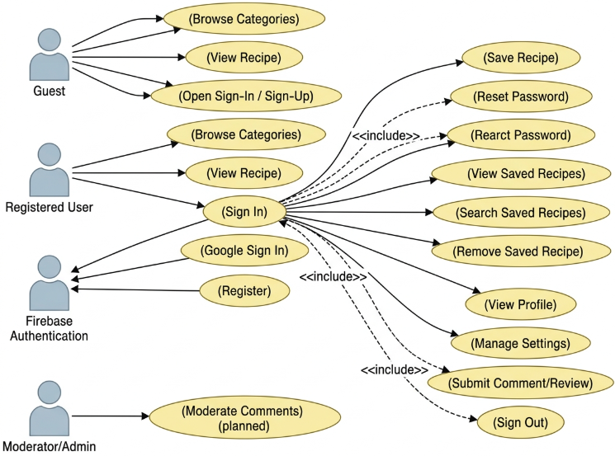
Relationships: Registered User inherits guest browse/view use cases. Save, profile, comment, and sign-out use cases require authenticated user. Sign In includes credential/provider validation. Save Recipe includes checking authentication and duplicate status.

33. Tabular Description of Use Cases
UC-01: Browse categories Guest/User Home page available Select category Recipe list shown
UC-02: View recipe Guest/User Recipe exists Select recipe Details shown
UC-03: Register Guest Not signed in Complete registration form Account created or error shown
UC-04: Sign in Guest Account/provider available Submit credentials/provider Session authenticated or error shown
UC-05: Save recipe Registered User Signed in; recipe exists Select Save Recipe stored and confirmation shown
UC-06: Manage saved list Registered User Signed in View/search/remove saved item List updated
UC-07: Submit review Registered User Signed in; recipe open Enter and submit review Review validated and displayed/stored
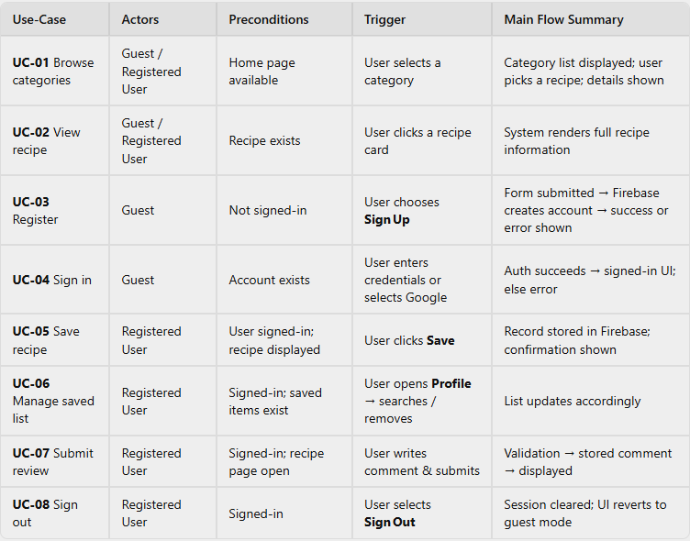
UC-08: Sign out Registered User Signed in Select Sign Out Session cleared
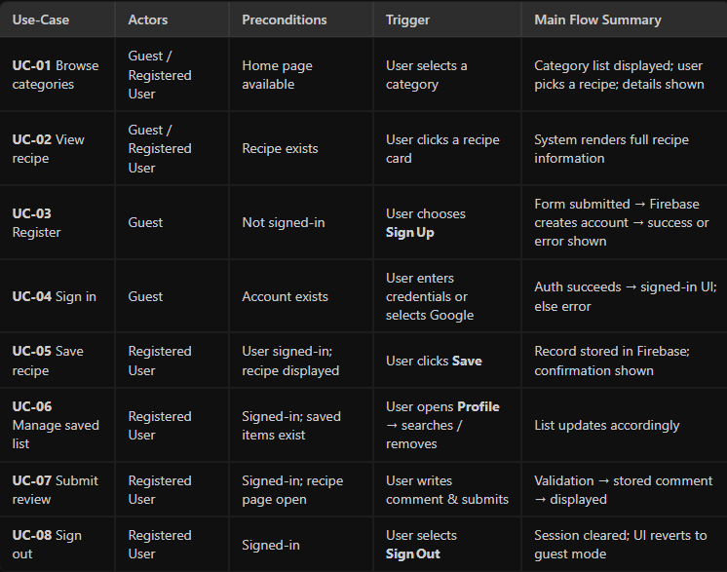

34. Use Cases of Each Agent
Guest: Browse home; explore categories; view recipe details; open sign-in/sign-up page; register; request password reset.
Registered User: All guest actions plus sign in, Google sign-in (if enabled), save recipe, view/search/remove saved recipes, view profile, use account settings, submit comments/reviews, and sign out.
Firebase Authentication: Validate identity credentials, create user account, handle provider authentication, send password reset email, and notify the app of auth-state changes.
Moderator/Admin (planned): Review reported comments, hide or remove inappropriate content, and manage recipe content. This role should only be represented as implemented if an admin interface and authorization rules exist.
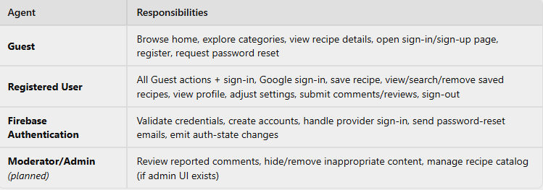
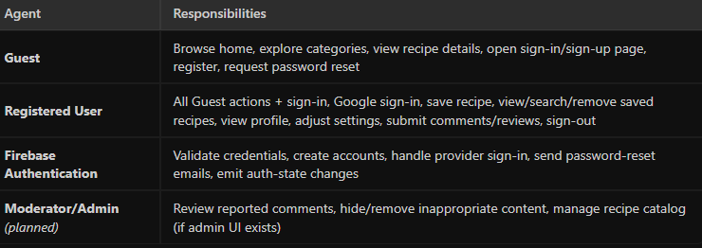

35. Sequence Diagrams of Every Main Action
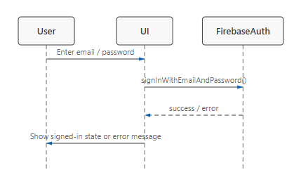
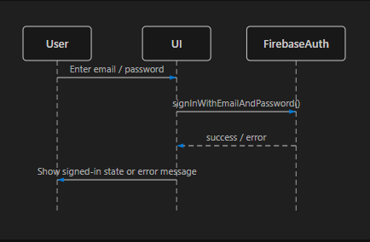
Sign in: User -> Sign-in page: enter credentials; Sign-in page -> Firebase Auth: signInWithEmailAndPassword; Firebase Auth -> Sign-in page: success/error; page -> User: show account state or error.

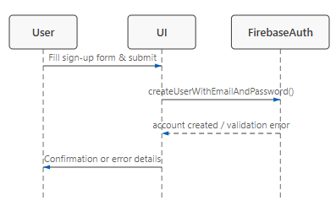
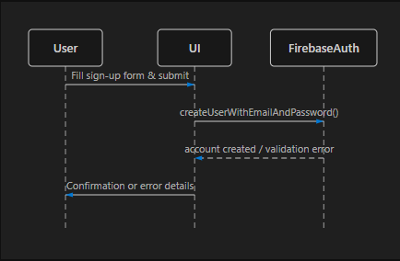
Register: User -> Sign-up form: submit details; form -> Firebase Auth: createUserWithEmailAndPassword; Firebase Auth -> form: account result; form -> User: confirmation or validation error.

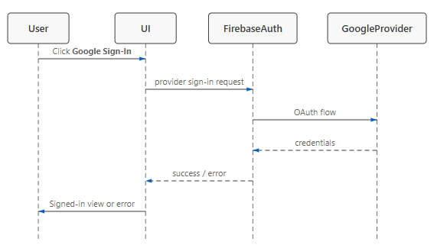
Google sign-in: User -> page: select Google; page -> Firebase Auth: provider sign-in; Firebase -> provider/user: authorization; Firebase -> page: credential/result; page -> User: signed-in view or error.
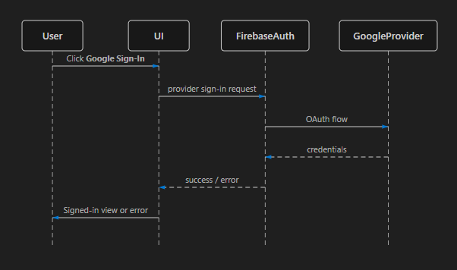

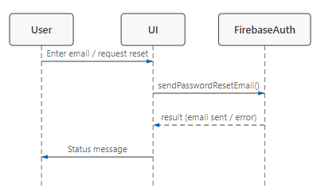
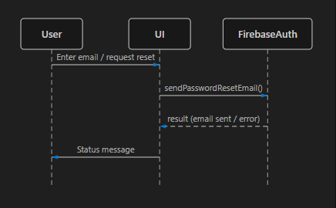
Reset password: User -> page: enter email/request reset; page -> Firebase Auth: sendPasswordResetEmail; Firebase -> page: result; page -> User: status message.

Save recipe: User -> recipe page: select Save; page -> Auth: check current user; page -> data service: create saved record; data service -> page: success/failure; page -> User: update saved state.
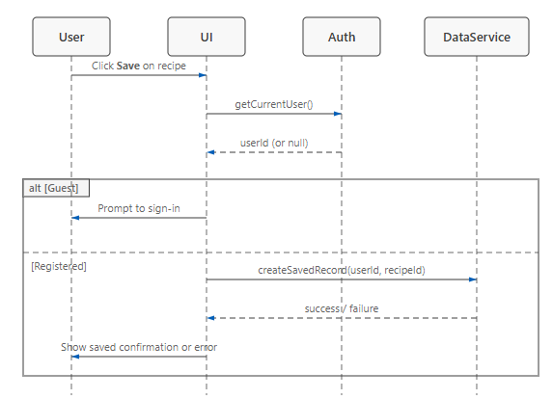
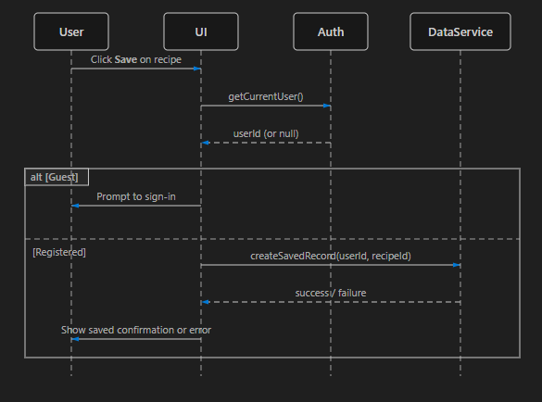

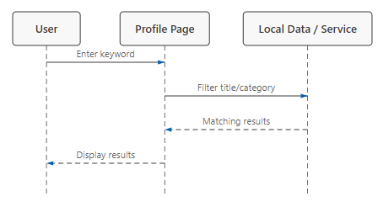
Search saved recipes: User -> profile: enter keyword; profile -> local displayed list/data: filter title/category; profile -> User: matching results.

Remove saved recipe: User -> profile: select Remove; profile -> data service: delete authorized saved record; service -> profile: result; profile -> User: update list.
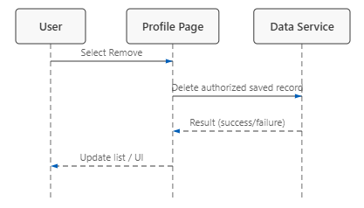

Submit comment: User -> recipe: submit text; page -> validation: check nonempty/content; page -> data service: store comment; service -> page: result; page -> User: show comment or error.
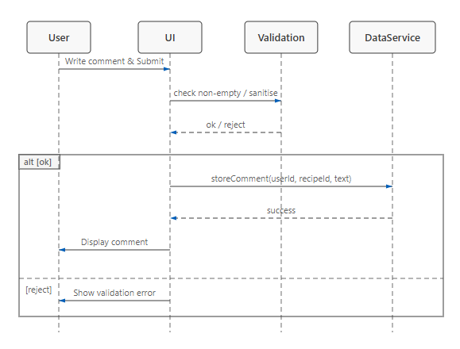
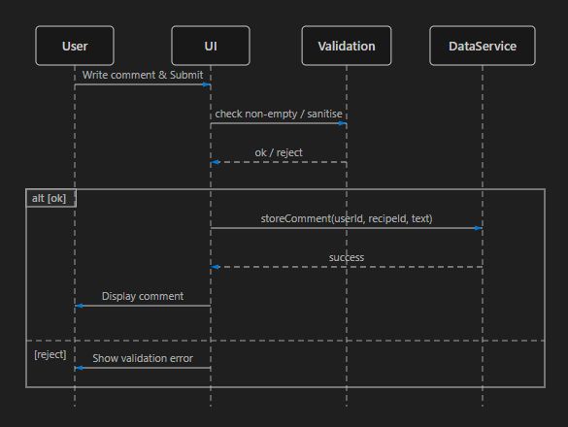

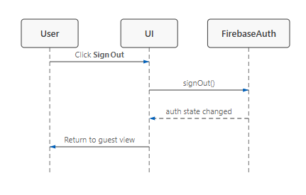
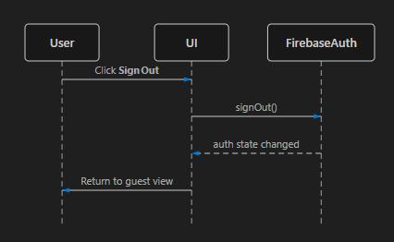
Sign out: User -> page: click Sign Out; page -> Firebase Auth: signOut; Firebase -> page: auth state changed; page -> User: guest state.

36. Class Associations
Classes: User, Recipe, Category, SavedRecipe, Review, AuthService, RecipeService, ProfileService, and TasteMatchUI.
Associations: Category contains 0..* Recipes; each Recipe belongs to 1 Category. User owns 0..* SavedRecipe records; each SavedRecipe references 1 User and 1 Recipe. User authors 0..* Reviews; each Review references 1 User and 1 Recipe. TasteMatchUI uses AuthService, RecipeService, and ProfileService. AuthService communicates with Firebase Authentication; services communicate with Firebase data storage where configured.
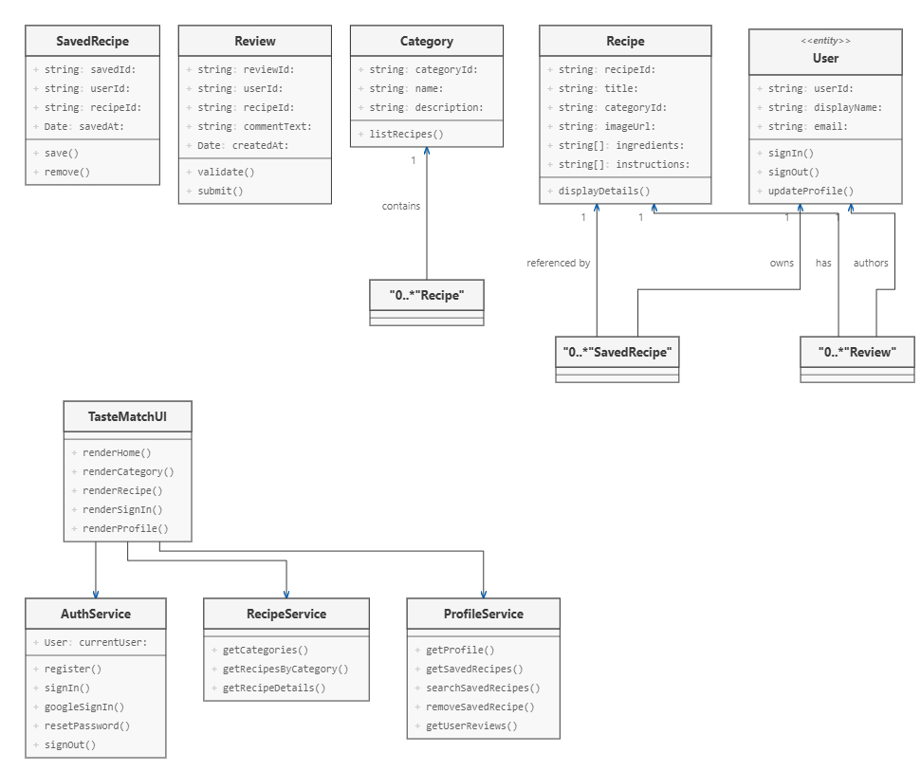
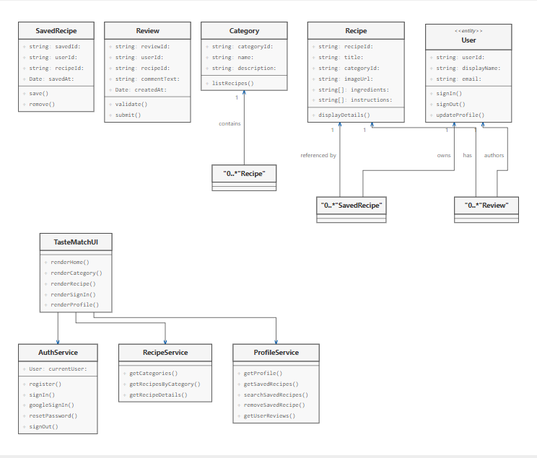

37. Class Models
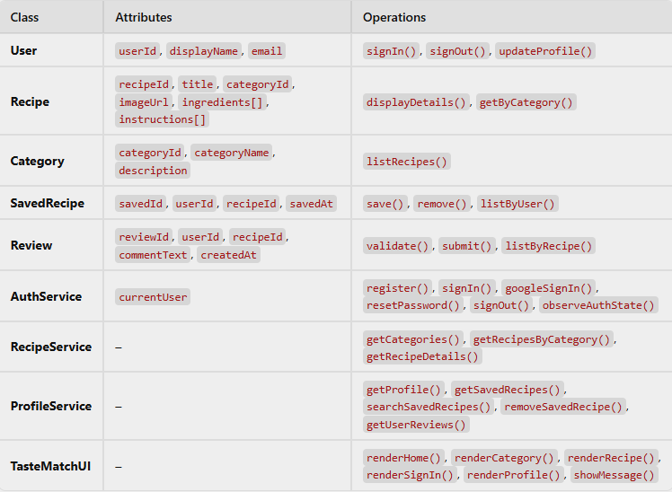

38. Generalization Hierarchy
User hierarchy: User (general) -> Guest and RegisteredUser. Guest can browse and view recipes. RegisteredUser inherits browsing permissions and adds saved recipes, profile, reviews, and sign-out.
Content hierarchy: Content (general) -> Recipe and Review. Recipe has recipe details; Review has user feedback and timestamp.
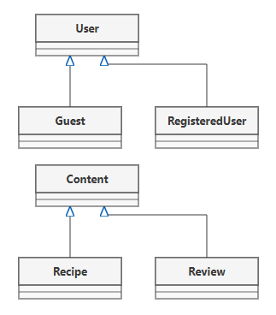
Note: These are logical domain classes for documentation. They do not imply that JavaScript uses formal class inheritance in every supplied page.

39. Aggregation Associations
Category aggregates Recipe: One Category groups many Recipes; deleting or renaming a category should not unintentionally delete recipe content unless explicitly designed.
Recipe aggregates Review: A Recipe may have many Reviews. Each review belongs to one recipe.
User aggregates SavedRecipe: A User may have many SavedRecipe records. Saved records are user-specific and should be deleted or made inaccessible when the account is removed.
User aggregates Review: A User may author many Reviews. Ownership and deletion rules should be enforced by the data service.
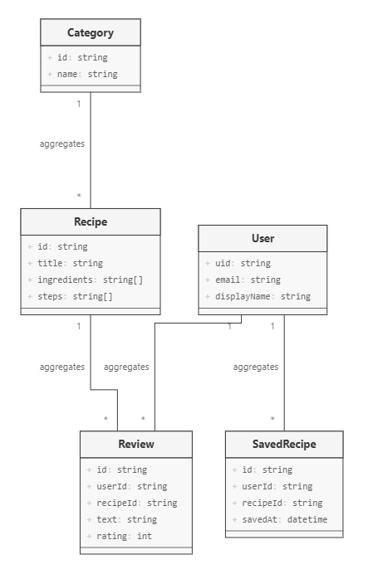

40. Activity Model
Browse activity: Initial -> Load home -> Display categories -> Select category -> Load category recipes -> Select recipe -> Display details -> Decision: another recipe? Yes returns to category; No ends.
Account activity: Open account -> choose Sign In/Sign Up -> enter data -> validate -> decision: valid? No show error and retry; Yes contact Firebase -> decision: success? No show error; Yes display authenticated state -> access profile/personal features.
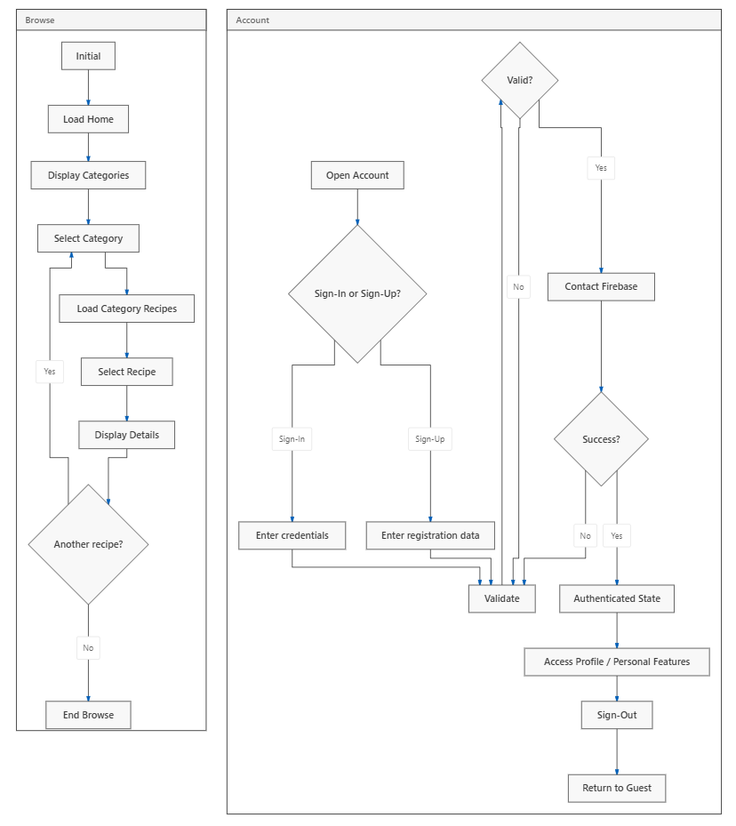
Save activity: Open recipe -> click Save -> check authenticated -> if guest prompt sign-in; if signed in check existing saved record -> create if absent -> show success; on error show retry.

41. Application Process Model
Client process: Browser loads HTML/CSS/JavaScript pages and assets; user navigates among home, category, recipe, account, and profile views.
Authentication process: Account form sends authentication requests to Firebase; Firebase returns result and auth-state listener updates the current user state.
Recipe process: Category navigation selects the relevant recipe page; recipe page displays static or configured recipe content.
Personal data process: Profile requests current user's saved recipes/reviews/settings from the configured storage layer; actions must be scoped to the signed-in user's identity.
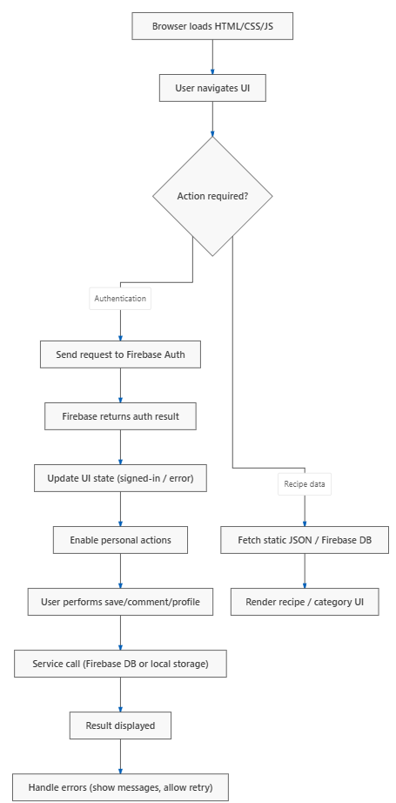
Error process: Validation or service errors are converted to clear messages; the interface remains usable and does not report an unconfirmed operation as successful.

42. State Diagram
States: Guest; Registration In Progress; Sign-in In Progress; Authenticated; Viewing Recipe; Managing Saved Recipes; Submitting Review; Signing Out; Error.
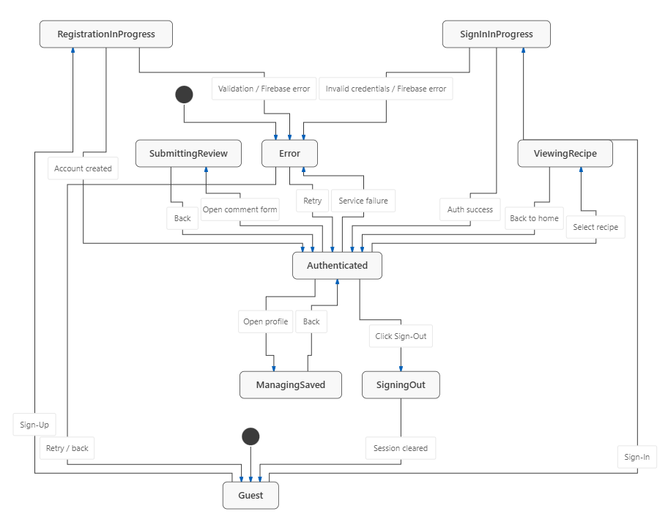
Transitions: Guest -> Registration In Progress (Sign Up); Registration -> Authenticated (account created) or Error; Guest -> Sign-in In Progress (Sign In); Sign-in -> Authenticated or Error; Authenticated -> Viewing Recipe; Authenticated -> Managing Saved Recipes; Authenticated -> Submitting Review; Authenticated -> Signing Out -> Guest; Error -> prior form/state after retry.

43. Structured Forms of Application States
Guest state: Public categories and recipe details available; profile-specific actions require authentication.
Registration/sign-in state: Form fields active; submit button triggers validation and authentication request; duplicate submissions should be prevented while request is pending.
Authenticated state: Current user identity is available; profile and personal actions are enabled.
Loading state: Show progress or disabled submit control while a request is pending.
Success state: Show confirmation only after service confirms operation; update affected UI data.
Error state: Display concise explanation; retain user-entered non-sensitive fields when safe; allow correction/retry.
Signed-out state: Clear user-specific interface data and require authentication for protected operations.
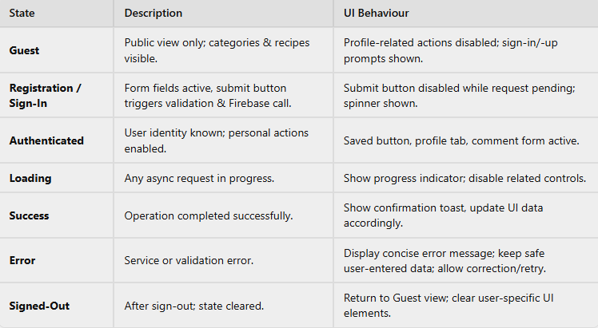

44. Software Architecture
Architecture: Three logical layers: Presentation layer (HTML/CSS pages and browser UI); Application logic layer (JavaScript event handlers, validation, navigation, recipe and profile operations); Service/data layer (Firebase Authentication and configured Firebase data storage; static recipe content/assets in project files).
Data flow: User action -> UI event handler -> validation/business logic -> Firebase or local/static recipe source -> result -> UI update.
Deployment: Static web files are hosted or opened through a web server; Firebase services are accessed over the internet. Production deployment should use HTTPS and restrictive Firebase security rules.
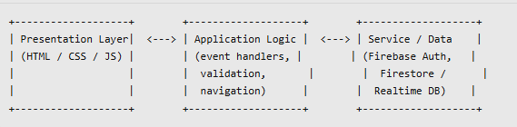

45. Context Diagram
System boundary: TasteMatch Web Application.
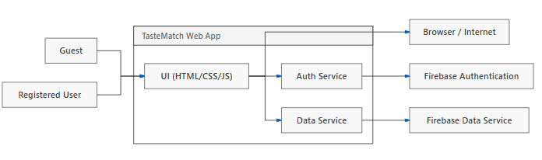
External entities and flows: Guest: requests categories and recipe pages; TasteMatch returns recipe content. Registered User: sends sign-in, save, review, and profile actions; receives status and personal data. Firebase Authentication: receives credential/provider requests and returns auth status. Firebase data service: receives authorized saved-recipe/review/profile operations and returns records/results. Browser/Internet: delivers pages and connects to hosted services.

46. High-Level Architecture
1. User interface: Home, category pages, recipe detail pages, sign-in/sign-up page, profile dashboard.
2. Application services: Navigation, form validation, authentication-state handling, recipe selection, saved-list filtering, comment handling.
3. External services: Firebase Authentication for account identity; Firebase database/storage only for features whose data persistence is configured.
4. Static resources: Recipe HTML pages, images, stylesheets, JavaScript files, and shared configuration.
Cross-cutting concerns: Input validation, error handling, access control, responsive design, accessibility, and privacy.
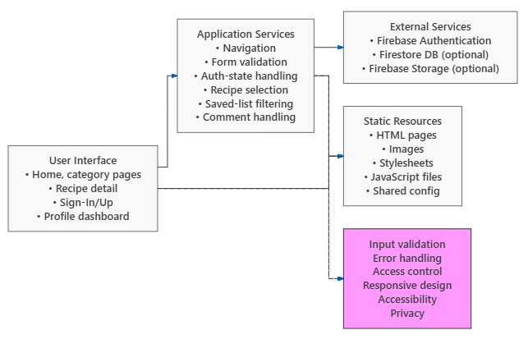

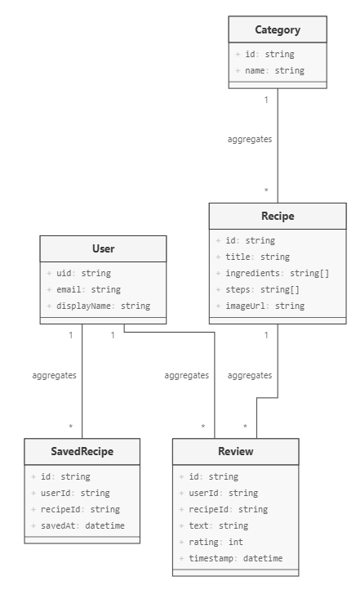
47. Object Classes
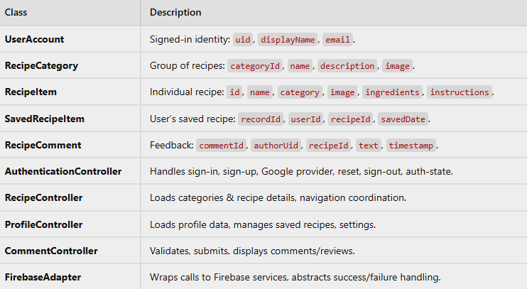

48. Detailed Usage Scenario
Scenario: User saves a dinner recipe: 1. Registered user opens TasteMatch home page. 2. User selects Dinner. 3. System displays dinner recipes. 4. User opens a recipe such as Sinigang na Isda. 5. System displays recipe details. 6. User selects Save. 7. System checks the current Firebase user. 8. If signed out, system asks the user to sign in; otherwise it checks whether the recipe is already saved. 9. System stores the saved-recipe record for that user. 10. System displays confirmation after success. 11. User opens Profile > Saved Recipes. 12. System retrieves the user's saved list and displays the recipe. 13. User may search or remove it. 14. System updates the list after a successful removal.
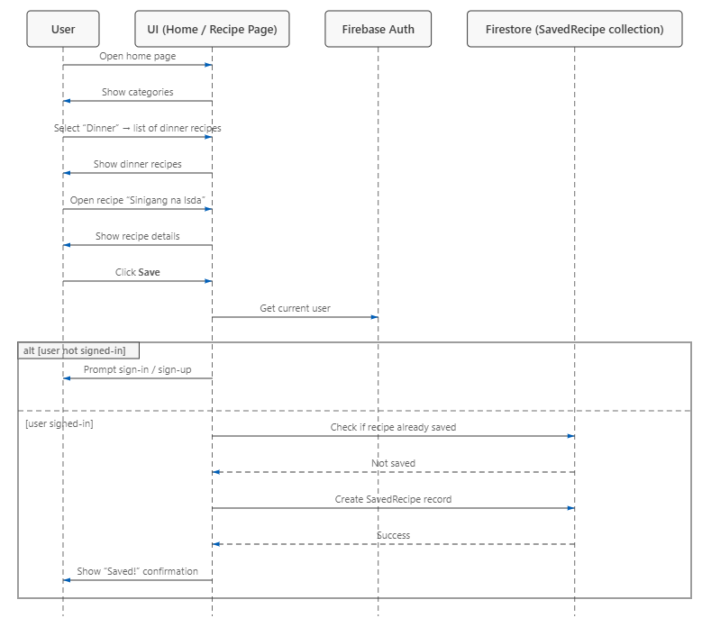

49. Reliability Terminology
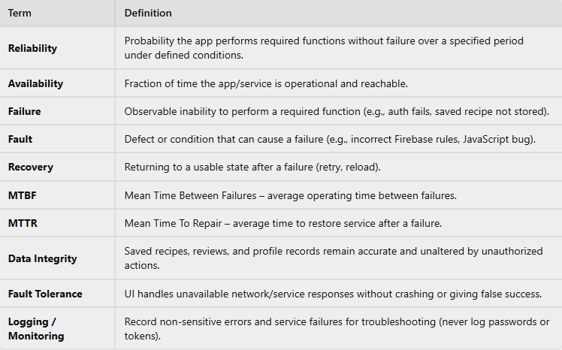

50. Safety Terminology
