COMP 4981 Assign 3 Test Document

Test Plan

client:
    - Run client
    - open connection dialog
    - connect to server
    - send message and receive echo from server.
    - Connect 2nd client, send message, receive echo on first client.

server:
    - accept connection from client, print message.
    - Receive message, echo to connected clients, print messages
    - client disconnects, print message.

Client Tests

- run client
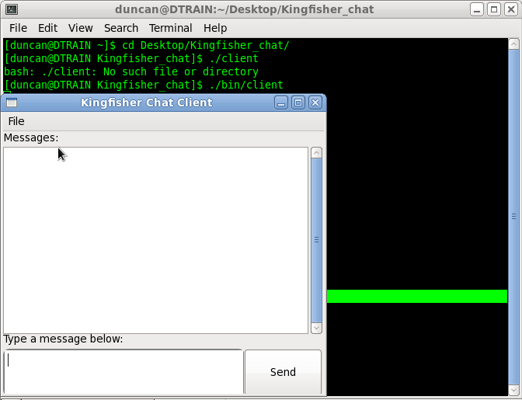
client runs.

- Open connection dialog.

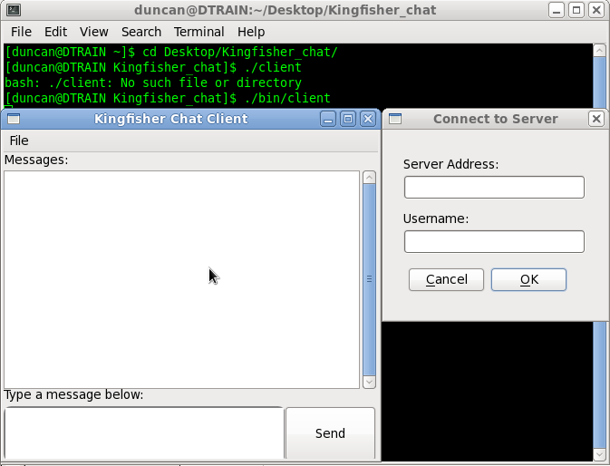

3. connect to server

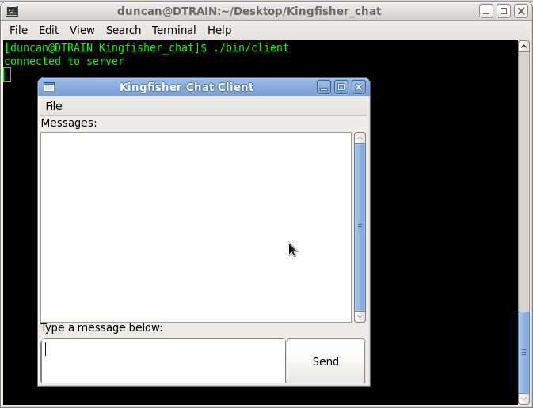
successfully connected.

- send message and receive echo from server.

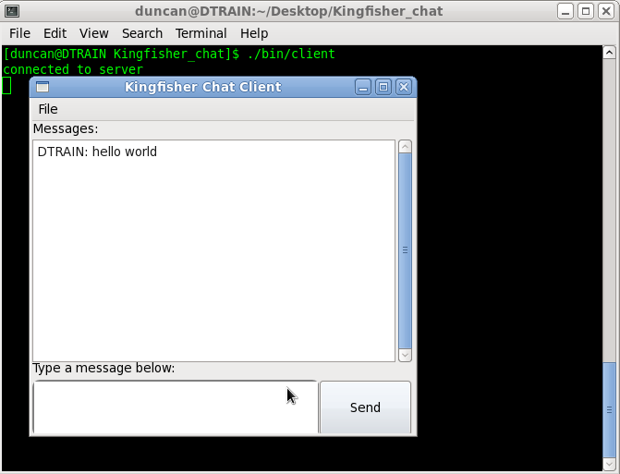
Echo received successfully.

- Connect 2nd client, and send message to first client

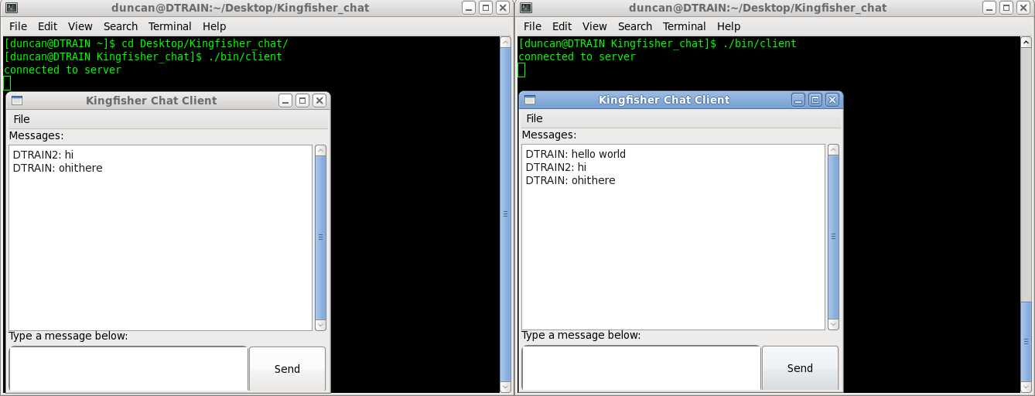
successful communication across multiple clients

Server Tests

- Accept connection from client, print message.
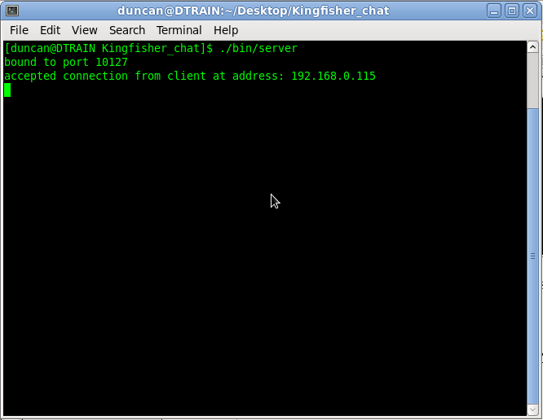

- receive message, echo to connected clients, print messages for both events.

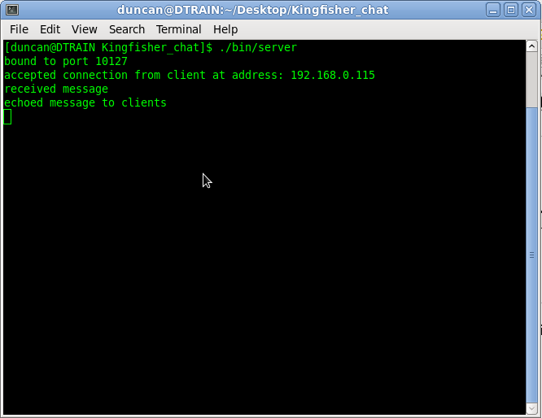

Both messages printed

3. Print message when clients disconnect.

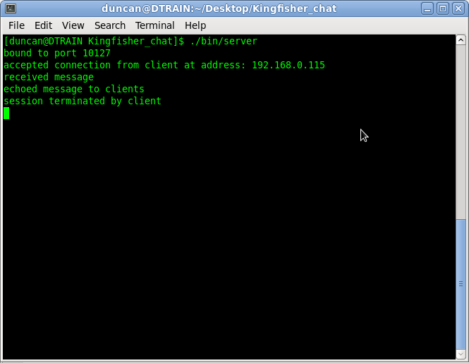
Termination message printed.

