**What is the .NET MAUI technology stack?**

* .NET provides a series of platform-specific frameworks for creating apps: .NET for Android, .NET for iOS (and iPadOS), .NET for Mac, and WinUI 3 (leveraging the Windows App SDK).
* These frameworks all have access to the same .NET 6 Base Class Library (BCL) ( a library provides a set of pre-built classes, types, and functions that developers can use when building applications)
* The BCL depends on the .NET runtime to provide the execution environment for your code:
* Android, iOS, macOS: Mono
* Windows: Win32
* The BCL enables applications running on different types of devices to share common business logic, but the various platforms have different ways of defining an application's user interface ( so we have to craft the UI for each platform separately using the appropriate platform-specific framework)
* .NET MAUI provides a single framework for building the UIs for mobile and desktop applications.

## How does .NET MAUI work?

* .NET MAUI abstracts a UI element's implementation from its logical description. You can describe the UI using XAML, a platform-neutral language based on XML.
* .NET MAUI always generates native code for the target device, so you get optimal performance. .NET MAUI uses "handlers" specific to each platform and UI element to carry out an operation. These handlers are accessed indirectly through a control-specific interface provided by .NET MAUI, such as IButton for a button.

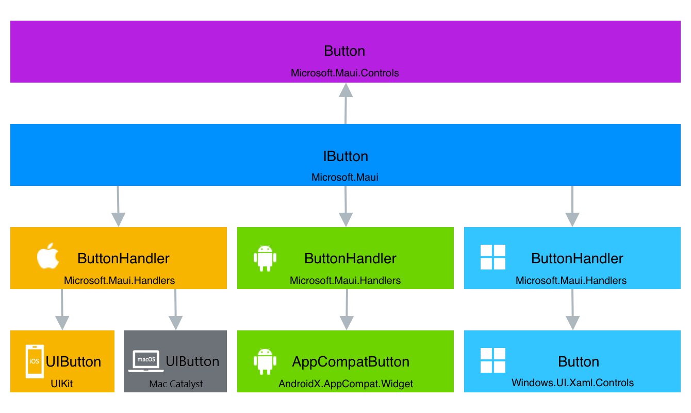

## .NET MAUI project structure

* App.xaml: Manages app configuration and lifecycle events.
* App.xaml.cs: Contains code for app-level logic.
* AppShell.xaml: If used, it defines the app's navigation structure
* MainPage.xaml: Defines the main user interface of the app.
* MainPage.xaml.cs: define the logic for the various event handlers and other actions that are triggered by the controls on the page..
* MauiProgram.cs: Contains the Main() method to initialize and start the app.
* Platforms: Separate projects for Android, iOS, macOS, and Windows, each containing platform-specific code and resources.
* Resources Folder: Contains assets like images, sounds, fonts, and documents used by the app.