**DELHI TECHNOLOGICAL**

**UNIVERSITY**



**ITY-546**

**DEV OPS AND ML OPS**

**PRACTICAL FILE**

**Submitted To: Submitted By:**

Ms. Shivani Pathania Kinjal Raykarmakar

Department of Information Technology 24/ISY/19 Delhi Technological University 2nd Semester  
 Delhi Technological University

**INDEX**

|  |  |  |  |
| --- | --- | --- | --- |
| **S. No.** | **Experiment** | **Date** | **Sign** |
| 1 | Introduction to DevOps and MLOps: Understand the basic principles, differences, and lifecycle of both |  |  |
| 2 | Setting Up Git: Install Git, create repositories, and practice version control with basic commands (commit, push, pull) |  |  |
| 3 | Branching and Merging in Git: Create and manage multiple branches, merge changes, and resolve conflicts |  |  |
| 4 | Infrastructure as Code with Ansible: Write a simple Ansible playbook to install software (e.g., Apache) on a local/virtual machine |  |  |
| 5 | Continuous Integration with GitHub Actions: Set up a simple CI pipeline that runs tests automatically on push |  |  |
| 6 | Containerization with Docker: Build and run a Docker image for a sample application, exploring Dockerfile creation, container management, and pushing images to a registry |  |  |
| 7 | Orchestration with Kubernetes: Deploy containerized workloads on a Kubernetes cluster, covering Pods, Deployments, Services, and scaling via rolling updates |  |  |
| 8 | ML Experiment Tracking with MLflow: Log experiments, hyperparameters, metrics, and artifacts using MLflow to enable reproducibility and model comparison |  |  |
| 9 | Model Deployment with Kubeflow: Automate end-to-end ML workflows (training, validation, serving) within a Kubernetes environment using Kubeflow Pipelines |  |  |
| 10 | Observability and Logging in MLOps: Implement monitoring and logging (e.g., Prometheus, Grafana, ELK) to track performance, resource utilization, and application logs in ML pipelines |  |  |

**Experiment 1**

**Aim**

Introduction to DevOps and MLOps: Understand the basic principles, differences, and lifecycle of both

**Theory**

Today's software development and machine learning practices demand efficient processes, inter-team collaboration, and automation to manage complex systems effectively. Two practices that have emerged to address these demands are DevOps and MLOps.

**DevOps**

DevOps is a technical and cultural movement that closes the gap between software development and IT operations. Historically, both teams operated in silos, which resulted in slow delivery, unreliable environments, and deployment failures. DevOps strives to dismantle these silos by encouraging cooperation, continuous feedback, and end-to-end automation.

*Major Objectives of DevOps:*

* **Faster Deployment**: Build, testing, and release automation to ship features quickly.
* **Better Quality**: Regular testing and monitoring to identify problems early.
* **Scalability**: Infrastructure as Code (IaC) and containerization enable scaling applications with ease.
* **Reliability**: Continuous monitoring keeps systems stable and responsive.

*DevOps Lifecycle:*

* **Plan**: Determine features, objectives, and project scope.
* **Develop**: Writing and managing application code.
* **Build**: Compile code and create executable artifacts.
* **Test**: Automated and manual testing for assurance of quality.
* **Release**: Deployment to production environments.
* **Operate**: Monitoring and upkeep of systems in real-time.
* **Monitor**: Gathering data, logs, and performance metrics.

These tools such as *Git*, *Jenkins*, *Docker*, *Kubernetes*, and *Ansible* are commonly utilized in DevOps pipelines.

**MLOps**

MLOps refers to the application of DevOps practices to machine learning systems. Although sharing similar philosophy, MLOps mitigates special issues that emerge owing to the data-driven and experimentation-based nature of ML development.

Machine learning models are not simply code—they depend significantly on data, model training, and performance testing. In contrast to standard software, ML models can get worse over time due to changing data distributions (referred to as model drift). MLOps practices seek to ensure models are versioned, tested, deployed, and monitored regularly.

*MLOps Lifecycle:*

* **Data Collection & Preparation**: Collecting and cleaning data sets.
* **Model Development**: Developing and testing ML models.
* **Model Training**: Training the model with data.
* **Model Evaluation**: Performance validation through metrics (accuracy, precision, etc.).
* **Model Deployment**: Deploying the model through APIs or integrating it into apps.
* **Model Monitoring**: Monitoring predictions, performance, and drift.
* **Model Retraining**: Periodically updating the model with new data.

Some of the popular MLOps tools are *MLflow*, *Kubeflow*, *TensorFlow Extended (TFX)*, *DVC (Data Version Control)*, and *Seldon Core*.

**Differences**

|  |  |  |
| --- | --- | --- |
| **Category** | **DevOps** | **MLOps** |
| Main Focus | Application development and delivery | Managing the ML lifecycle and model operations |
| Artifacts | Application code | Code, datasets, trained models, and metrics |
| Automation | Build, test, deploy | Data pipeline automation, training, and model deployment |
| Testing | Unit & integration tests | Data validation, model validation, performance tests |
| Monitoring | System performance, errors | Model accuracy, prediction quality, drift detection |
| Reusability | High (same code runs consistently) | Harder (data changes may require retraining) |

MLOps can be considered a superset of DevOps with additional complexity due to the involvement of large datasets, model behavior, and continuous evaluation needs.

**Conclusion**

In this experiment, we learned the basic principles of DevOps and MLOps. We discovered that both have common such as automation, CI/CD, and monitoring but with the introduction of data and model management, MLOps has other challenges. Having an understanding of their lifecycle differences aids in creating more efficient workflow for application and machine learning development. This forms the basis of learning more about real-world DevOps and MLOps implementations in subsequent experiments.

**Experiment 2**

**Aim**

Setting Up Git: Install Git, create repositories, and practice version control with basic commands (commit, push, pull)

**Theory**

Version control is a cornerstone of modern software development. Whether you're working solo or with a team, being able to track changes, collaborate effectively, and roll back when something breaks is crucial. That’s where Git comes in.

Git is a distributed version control system developed by Linus Torvalds (yes, the creator of Linux!) in 2005. Unlike older systems, Git gives every developer a full copy of the repository — history and all — making it incredibly fast, reliable, and flexible.

Git is used for:

* Track every change made to your code
* Work in parallel with teammates without stepping on each other's toes
* Easily roll back to a previous version if something goes wrong
* Integrates with platforms like GitHub, GitLab, and Bitbucket for remote collaboration

**Experiment**

***Installing git***

*For Windows:*

* Installer can be found in official Git website

*For Linux:*

sudo apt update

sudo apt install git

***Creating a Local Repository***

mkdir my-repo

cd my-repo

git init

***Making a commit***

git add hello.txt

git commit -m "Initial commit with hello.txt"

***Pushing to GitHub***

git remote add origin https://github.com/kinjalrk2k/my-repo.git

git branch -M main

git push -u origin main

***Pulling changes***

git pull origin main

**Outputs**

*Creating a Local Repository*

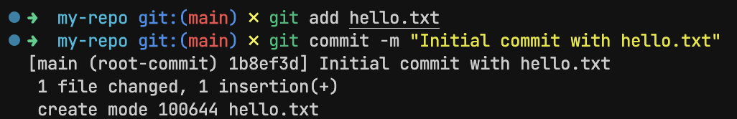*Making a commit*

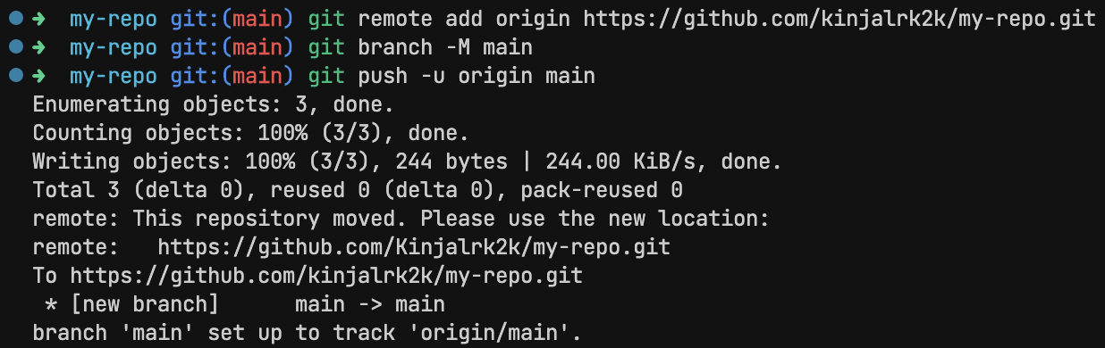*Pushing to GitHub*

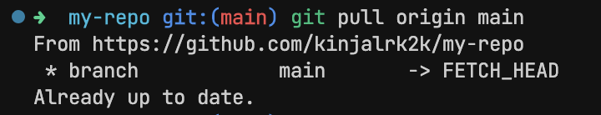*Pulling changes*

**Conclusion**

In this lab, we successfully set up Git on our local machine, created a repository, and practiced essential version control commands like commit, push, and pull. These may seem like small steps, but they form the foundation of professional software development.

**Experiment 3**

**Aim**

Branching and Merging in Git: Create and manage multiple branches, merge changes, and resolve conflicts

**Theory**

Working with branches in Git is one of the most powerful ways to manage changes in your project — especially when working in teams. Imagine being able to experiment freely without breaking the main codebase. That’s the magic of branching.

A branch in Git is like a parallel universe of your code. You can create a new branch, make changes, test things out, and when you're happy with it, you can merge it back into the main project. All without disrupting the original version.

By default, Git starts you off on the main (or master) branch. But as your project grows, you'll often find yourself creating branches for:

* New features (feature/login-system)
* Bug fixes (fix/button-alignment)
* Experiments (test/new-ui)

Once you've made changes in a branch and want to incorporate them into another branch (usually main), you perform a merge. Git tries to automatically combine the changes. But sometimes, it might need help — that’s when you’ll run into merge conflicts, which you’ll resolve manually.

**Experiment**

***Creating new branch***

git branch feature-1

***Switch to new branch***

git checkout feature-1

***Merge back to main***

git checkout main

git merge feature-1

***Merge conflict***

git merge feature-update

# Merge conflicts are manually fixed in the editor

git add welcome.txt

git commit -m "Resolved merge conflict between main and feature-update"

**Outputs**

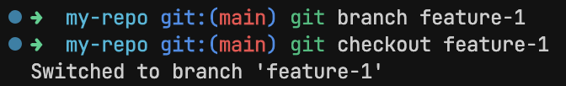*Creating and switching branch*

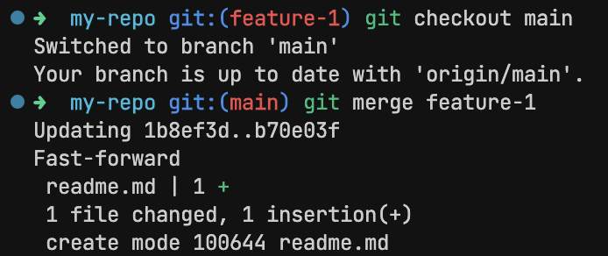*Merging back to main*

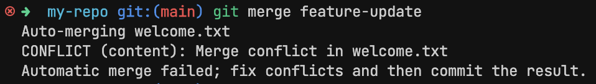*Merge conflicts*

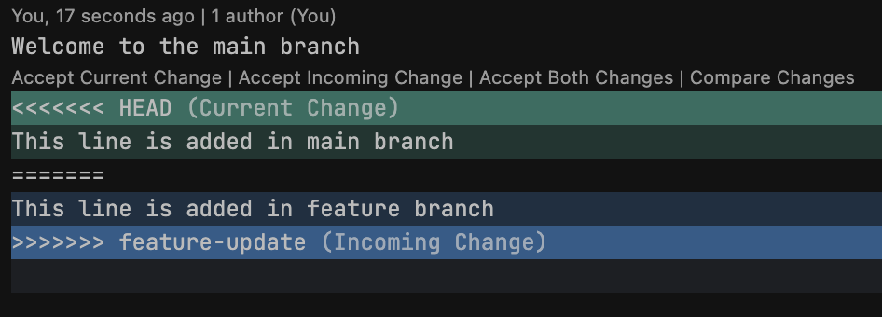*Inspecting merge conflicts in editor*

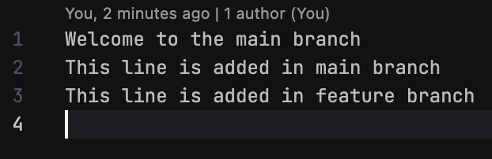*Fixing merge conflicts in editor*

*Resolved merge conflict*

**Conclusion**

In this lab, we explored the core concepts of branching and merging in Git, which are foundational to collaborative and safe software development. We learned how to create branches for isolated development, merge changes back into the main branch, and resolve conflicts when changes overlap.

**Experiment 4**

**Aim**

Infrastructure as Code with Ansible: Write a simple Ansible playbook to install software (e.g., Apache) on a local/virtual machine

**Theory**

Managing infrastructure manually can quickly become inefficient and error-prone, especially as systems scale. That’s where Infrastructure as Code (IaC) comes in. With IaC, we define and manage our server infrastructure using machine-readable configuration files rather than manual processes. One of the most popular tools for IaC is Ansible.

Ansible is an open-source automation tool used for configuration management, application deployment, and task automation. It’s agentless, meaning it doesn’t require any special software to be installed on the target systems — just SSH and Python.

Ansible uses YAML-based files called playbooks to describe the desired state of a system. These playbooks are easy to read and write, making Ansible very approachable even for beginners.

*Common Ansible Use Cases:*

* Installing and configuring software
* Managing users and permissions
* Automating routine system tasks
* Deploying applications to multiple servers

In this lab, we’ll use Ansible to install Apache HTTP Server on a local or virtual machine using a simple playbook.

**Experiment**

***hosts.ini***

[local]

localhost ansible_connection=local

***apache-install.yml***

---

- name: Install Apache Web Server

hosts: local

become: yes

tasks:

- name: Ensure Apache is installed

apt:

name: apache2

state: present

update_cache: yes

- name: Ensure Apache is running

service:

name: apache2

state: started

enabled: yes

***Running***

ansible-playbook -i hosts.ini apache-install.yml

***Verify***

systemctl status apache2

**Outputs**

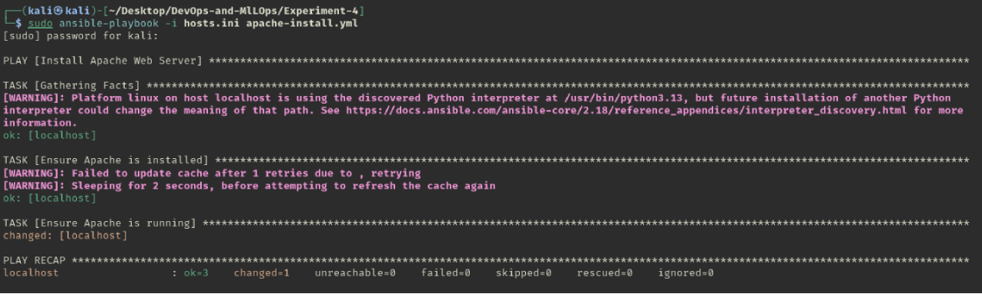*Running Ansible playbook*

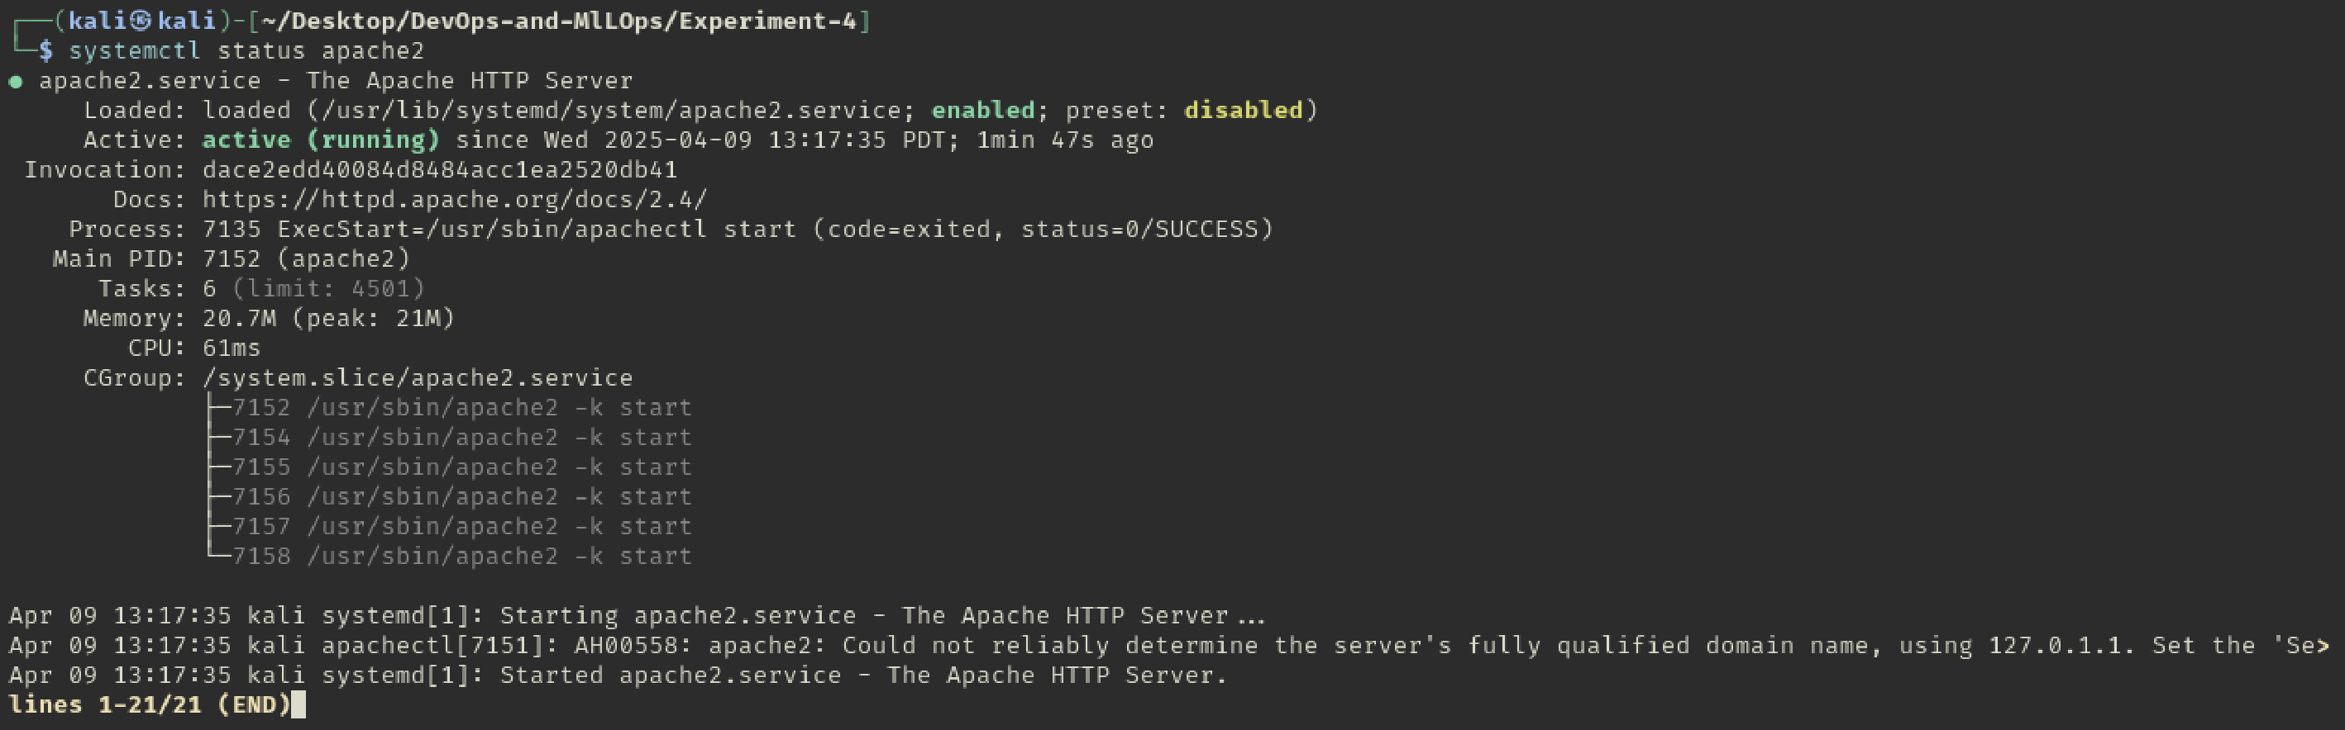*Verifying installation of Apache*

**Conclusion**

In this lab, we took a hands-on approach to understanding Infrastructure as Code using Ansible. By writing a simple playbook to install Apache, we saw how system configuration tasks that normally involve multiple steps can be automated and standardized using just a few lines of YAML.

**Experiment 5**

**Aim**

Continuous Integration with GitHub Actions: Set up a simple CI pipeline that runs tests automatically on push

**Theory**

Modern software development isn't just about writing code — it’s also about ensuring that code works consistently, reliably, and automatically. That’s where Continuous Integration (CI) comes into play.

Continuous Integration is a development practice where developers integrate code into a shared repository frequently — sometimes several times a day. Each integration is then verified by an automated build and test process, allowing teams to detect problems early.

CI helps developers catch issues before they reach production, streamlining collaboration and maintaining code quality.

GitHub Actions is a feature built into GitHub that allows you to automate workflows — right from your repository. It lets you set up CI/CD pipelines that can automatically:

* Run tests when you push code
* Build your application
* Deploy to production
* Send alerts or messages
* And much more

GitHub Actions uses simple YAML-based workflows, making it accessible even for beginners. It also integrates tightly with your repository, so everything stays in one place — no external tools needed.

**Experiment**

***main.py***

def add(a, b):

return a + b

***test_main.py***

from main import add

def test_add():

assert add(2, 3) == 5

***Workflow file - .github/workflows/python-tests.yml***

name: Python CI

on: [push]

jobs:

test:

runs-on: ubuntu-latest

steps:

- name: Checkout code

uses: actions/checkout@v3

- name: Set up Python

uses: actions/setup-python@v4

with:

python-version: "3.10"

- name: Install dependencies

run: |

python -m pip install --upgrade pip

pip install pytest

- name: Run tests

run: |

pytest

**Outputs**

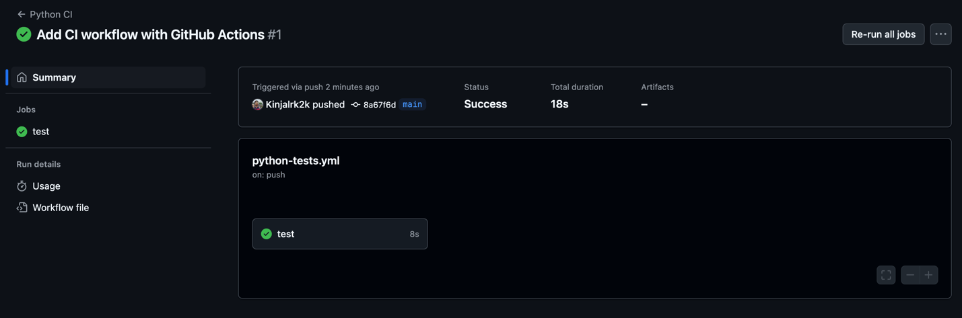*CI tests running on GitHub Actions*

**Conclusion**

In this lab, we successfully set up a Continuous Integration pipeline using GitHub Actions, where every code push automatically triggered a test run. We wrote a basic test, defined a CI workflow, and verified it on GitHub — all within a few minutes.

**Experiment 6**

**Aim**

Containerization with Docker: Build and run a Docker image for a sample application, exploring Dockerfile creation, container management, and pushing images to a registry

**Theory**

Imagine you're working on an application that runs perfectly on your machine, but when your teammate tries it — it breaks. Different OS, different dependencies, or even slightly different versions can all lead to frustrating bugs. This is exactly the problem that Docker was designed to solve.

Docker is a platform that enables you to package applications — along with all their dependencies — into standardized containers. These containers can run anywhere: your laptop, a cloud server, or even inside a CI/CD pipeline.

A Docker container is like a lightweight, standalone box that contains everything an application needs to run: code, runtime, system tools, libraries, and settings.

*Reasons to use Containers*

* Consistency across environments — no more "it works on my machine"
* Isolation — containers run separately from each other and the host system
* Portability — you can move containers across environments effortlessly
* Efficiency — they’re faster and lighter than full virtual machines

**Experiment**

***Building a sample application***

*app.py*

from flask import Flask, request, jsonify

app = Flask(__name__)

@app.route("/", methods=["GET"])

def echo():

return jsonify({"headers": dict(request.headers)})

if __name__ == '__main__':

app.run(host='0.0.0.0', port=9000)

*requirements.txt*

flask

*Dockerfile*

FROM python:3.10-slim

WORKDIR /app

COPY . .

RUN pip install -r requirements.txt

EXPOSE 9000

CMD ["python", "app.py"]

***Building Docker Image***

docker build -t flask-echo-headers-server .

***Running Docker Container***

docker run -p 9000:9000 flask-echo-headers-server

***Pushing to Registry***

docker login

docker tag flask-echo-headers-server kinjal2209/flask-echo-headers-server

docker push kinjal2209/flask-echo-headers-server

**Outputs**

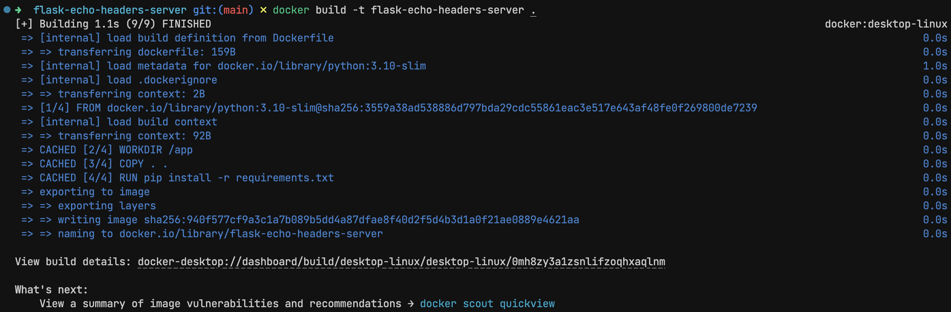*Building Docker Image*

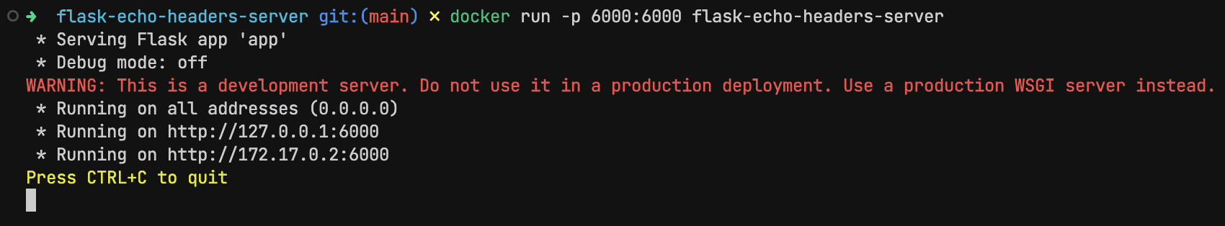*Running Docker Container*

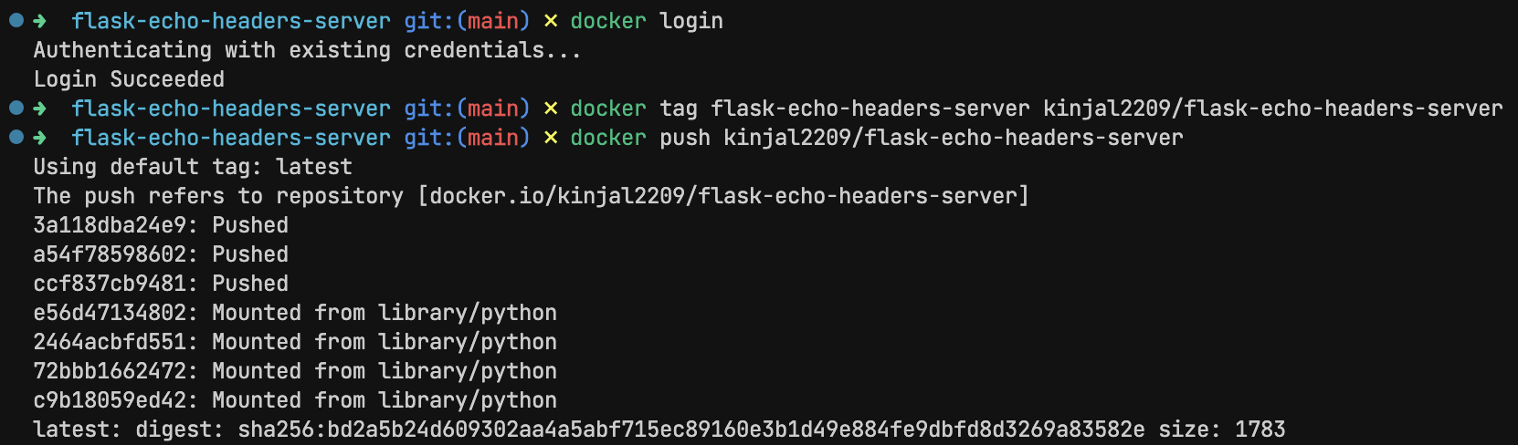*Pushing to Registry*

**Conclusion**

In this lab, we explored containerization using Docker — from writing a Dockerfile to running and pushing an image. We saw how Docker packages applications into isolated containers that can run consistently across different environments.

**Experiment 7**

**Aim**

Orchestration with Kubernetes: Deploy containerized workloads on a Kubernetes cluster, covering Pods, Deployments, Services, and scaling via rolling updates

**Theory**

As applications become more complex — with multiple containers, services, and environments — managing them manually can become nearly impossible. That’s where Kubernetes comes in. Often referred to as “K8s” Kubernetes is the industry-standard platform for orchestrating containerized applications at scale.

Kubernetes is an open-source container orchestration system developed by Google and now maintained by the Cloud Native Computing Foundation (CNCF). Its primary role is to automate deployment, scaling, and management of containerized applications.

It doesn’t just run containers — it handles the entire lifecycle of an application, ensuring availability, stability, and scalability in a production environment.

**Experiment**

***Startup Minikube for local Kubernetes cluster***

minikube start

***Kubernetes setup***

*deplyment.yaml*

apiVersion: apps/v1

kind: Deployment

metadata:

name: flask-echo-headers-server

spec:

replicas: 2

selector:

matchLabels:

app: flask-echo-headers-server

template:

metadata:

labels:

app: flask-echo-headers-server

spec:

containers:

- name: web

image: flask-echo-headers-server

imagePullPolicy: Never

ports:

- containerPort: 9000

*service.yaml*

apiVersion: v1

kind: Service

metadata:

name: flask-echo-headers-service

spec:

selector:

app: flask-echo-headers-server

ports:

- protocol: TCP

port: 80

targetPort: 9000

type: NodePort

***Build docker container within minikube***

eval $(minikube docker-env)

docker build -t my-k8s-app .

***Deploy service***

kubectl apply -f deployment.yaml

kubectl apply -f service.yaml

kubectl port-forward service/flask-echo-headers-service 8080:80

***Scaling***

kubectl scale deployment flask-echo-headers-server --replicas=5

***Rolling deployments***

kubectl apply -f deployment.yaml

kubectl rollout status deployment/flask-echo-headers-server

**Outputs**

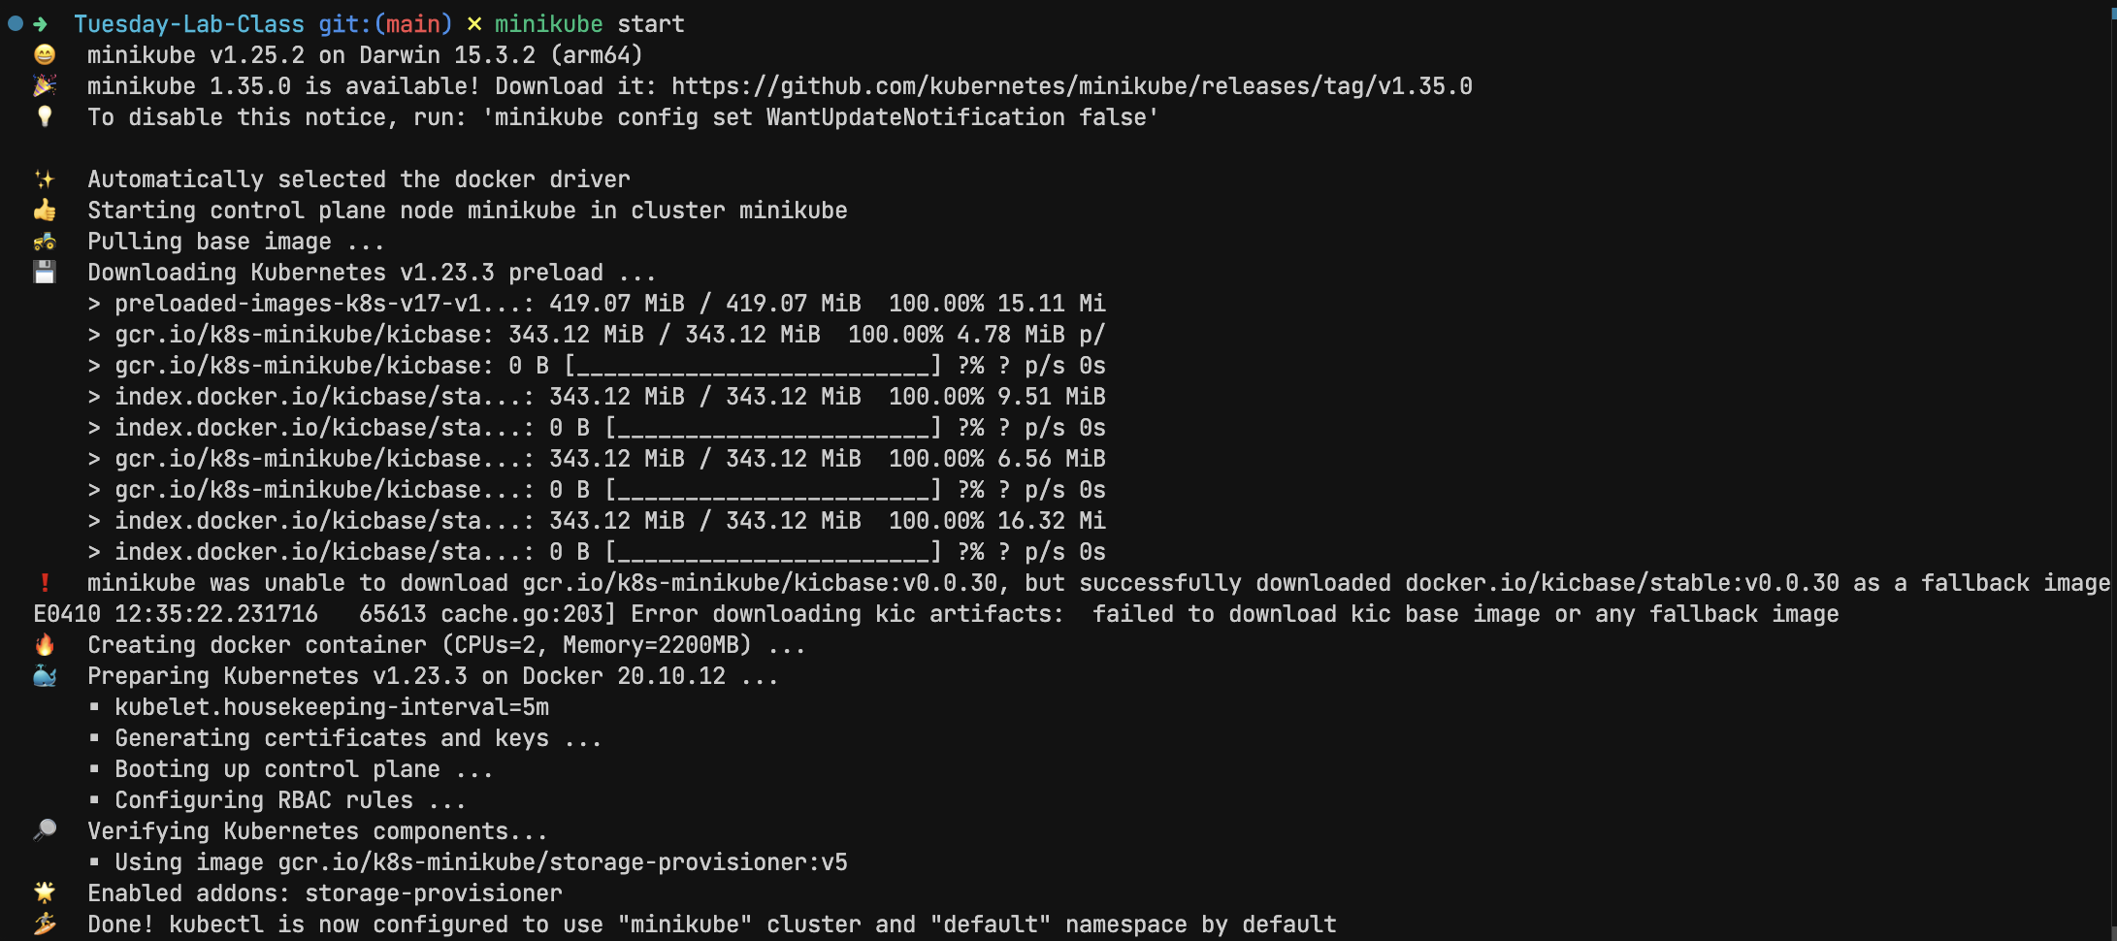*minikube starting*

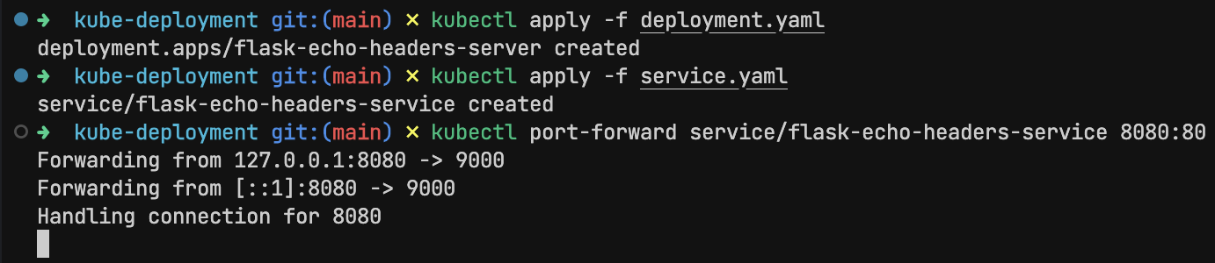*Deploying service*

*Scaling*

*Rolling deployments*

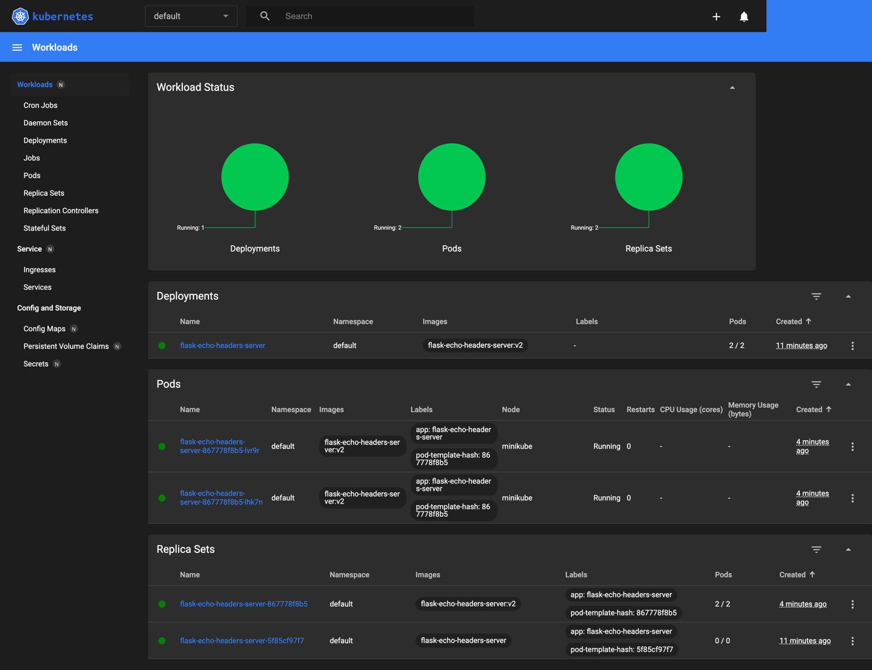*Minikube dashboard*

**Conclusion**

In this lab, we stepped into the world of container orchestration with Kubernetes. We learned how to:

* Create and manage pods using deployments
* Expose our app using services
* Perform rolling updates for smooth, zero-downtime deployments
* Scale applications with just one command

**Experiment 8**

**Aim**

ML Experiment Tracking with MLflow: Log experiments, hyperparameters, metrics, and artifacts using MLflow to enable reproducibility and model comparison

**Theory**

In machine learning, especially in real-world projects, we rarely build just one model. We often try out different algorithms, tweak hyperparameters, and change training data to improve performance. Over time, this leads to multiple versions of models — and without a structured way to keep track, it's nearly impossible to reproduce results or understand which version worked best.

That’s where MLflow becomes essential.

MLflow is an open-source platform that helps manage the end-to-end machine learning lifecycle. One of its core modules, MLflow Tracking, is specifically built for logging and organizing machine learning experiments. With MLflow, you can log key aspects like:

* Hyperparameters used in training (e.g., learning rate, batch size)
* Metrics like accuracy, RMSE, or loss
* Artifacts such as trained models or output plots
* Code versions and environments

This creates a reliable history of experiments, making it easy to reproduce past results and compare models side by side.

**Experiment**

***Setup MLflow***

pip install mlflow

mlflow ui

***ML experiment***

import mlflow

import mlflow.sklearn

from sklearn.ensemble import RandomForestRegressor

from sklearn.metrics import mean_squared_error

from sklearn.datasets import load_diabetes

from sklearn.model_selection import train_test_split

# Load dataset

X, y = load_diabetes(return_X_y=True)

X_train, X_test, y_train, y_test = train_test_split(X, y, test_size=0.2)

# Set experiment

mlflow.set_experiment("Diabetes Regression")

# Start a new MLflow run

with mlflow.start_run():

# Set hyperparameters

n_estimators = 150

max_depth = 6

# Train model

model = RandomForestRegressor(n_estimators=n_estimators, max_depth=max_depth)

model.fit(X_train, y_train)

# Predict and evaluate

preds = model.predict(X_test)

rmse = mean_squared_error(y_test, preds, squared=False)

# Log everything

mlflow.log_param("n_estimators", n_estimators)

mlflow.log_param("max_depth", max_depth)

mlflow.log_metric("rmse", rmse)

mlflow.sklearn.log_model(model, "model")

**Outputs**

*Running ML experiment*

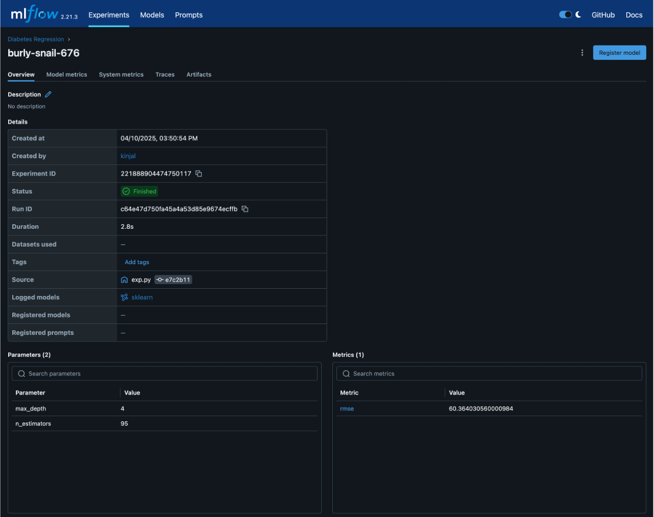*Logging hyperparameters, metrics and artifacts*

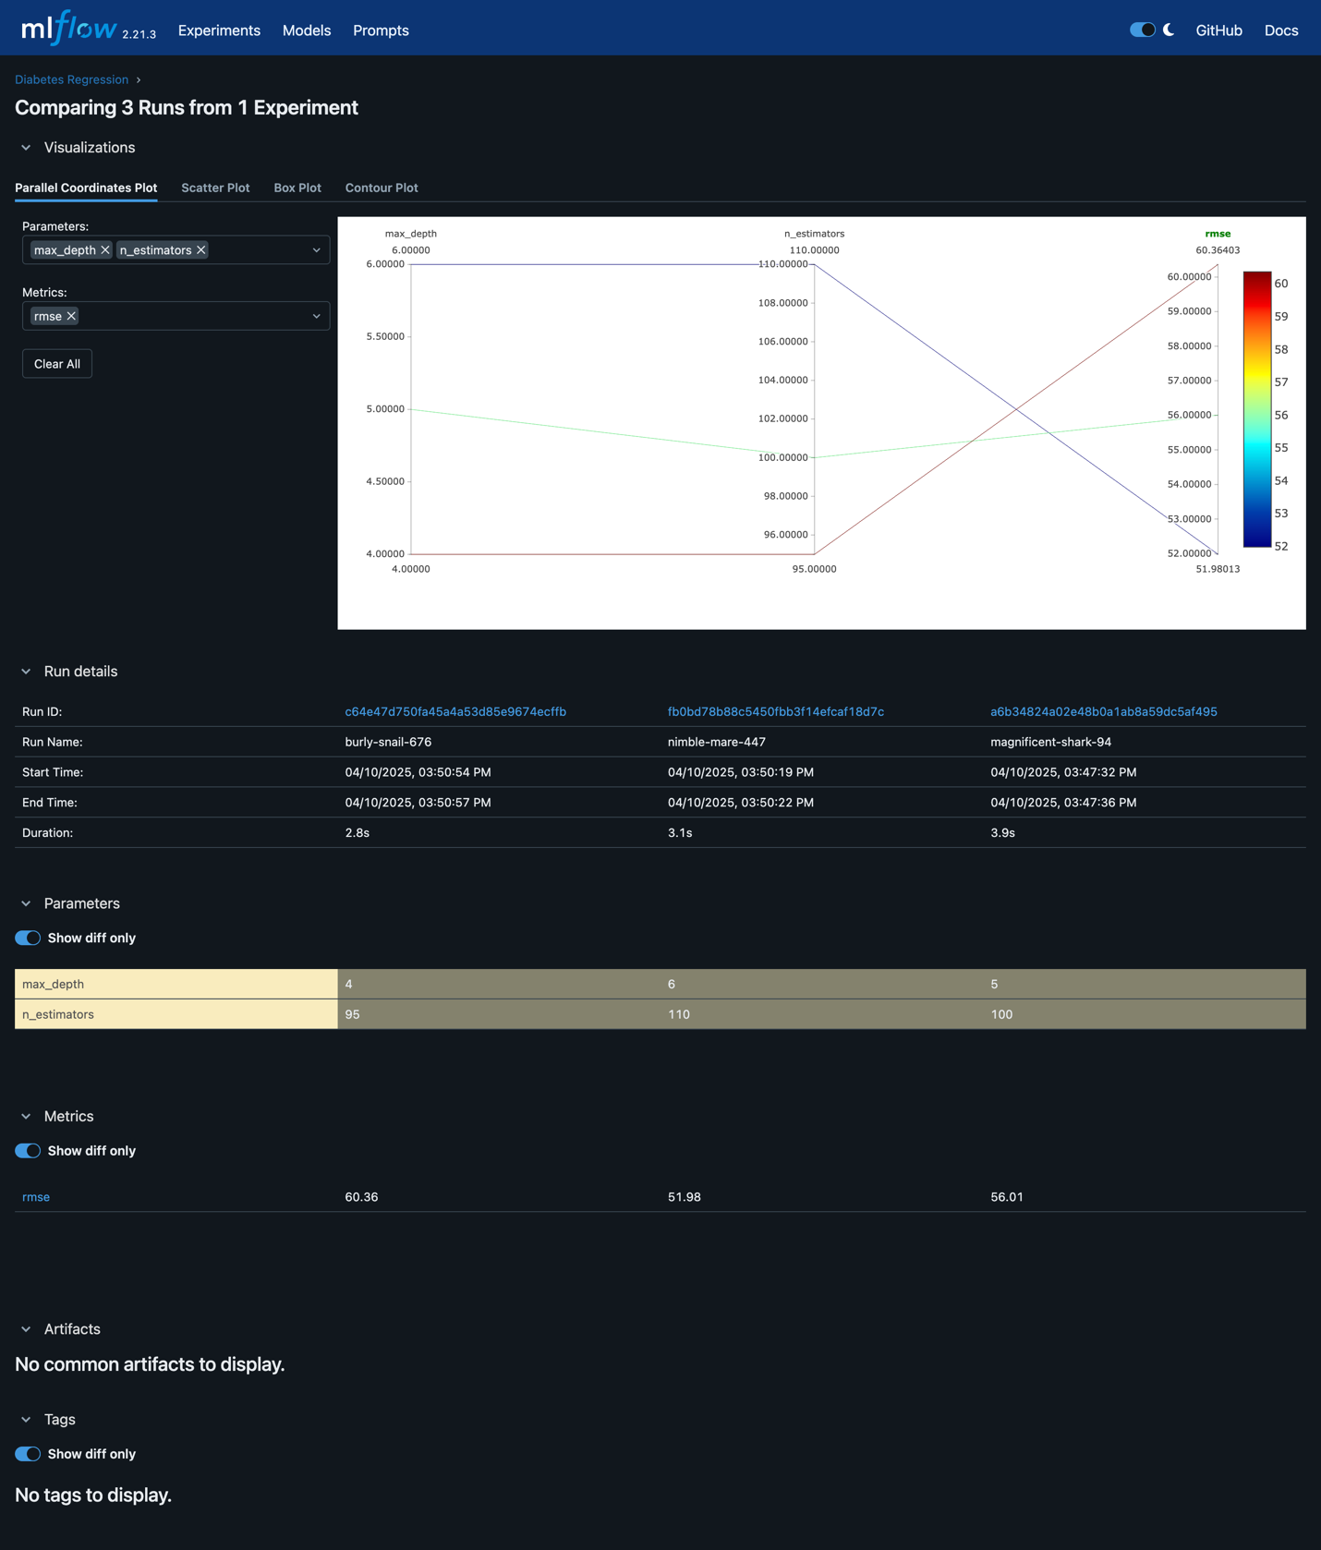*Model comparison*

**Conclusion**

In this lab, we learned how to use MLflow to bring structure, traceability, and transparency into the machine learning workflow. By logging experiments with hyperparameters, evaluation metrics, and trained models, MLflow makes it incredibly easy to:

* Reproduce previous model results with confidence
* Compare different model runs quickly and visually
* Collaborate with teammates on model development
* Scale from local experiments to team-wide MLOps pipelines

**Experiment 9**

**Aim**

Model Deployment with Kubeflow: Automate end-to-end ML workflows (training, validation, serving) within a Kubernetes environment using Kubeflow Pipelines

**Theory**

Machine learning models go through many stages — from data preprocessing and model training to validation and finally deployment. Managing all these steps manually becomes increasingly complex and error-prone, especially when teams are working on multiple models or deploying frequently. That’s where Kubeflow Pipelines come into play.

Kubeflow is an open-source MLOps platform built on Kubernetes. It provides a set of tools that make it easier to develop, orchestrate, deploy, and manage ML workflows in a scalable and reproducible way — all while leveraging Kubernetes' strengths like scalability and container orchestration.

Kubeflow Pipelines is a core component of Kubeflow that helps automate ML workflows as a series of steps. Each step can be a containerized operation — like loading data, training a model, validating it, or deploying it. These steps are defined as DAGs (Directed Acyclic Graphs) and run seamlessly in Kubernetes.

**Experiment**

***Pipeline***

import kfp

from kfp import dsl

from kfp.dsl import component, Input, Output, Dataset, Model

@component(

packages_to_install=["pandas"]

)

def download_data(output_dataset: Output[Dataset]):

import os

import pandas as pd

url = "https://raw.githubusercontent.com/sharmaroshan/Heart-UCI-Dataset/refs/heads/master/heart.csv"

df = pd.read_csv(url)

os.makedirs(output_dataset.path, exist_ok=True)

df.to_csv(os.path.join(output_dataset.path, "heart.csv"), index=False)

@component(

packages_to_install=["pandas", "scikit-learn"]

)

def preprocess_data(input_dataset: Input[Dataset], output_dataset: Output[Dataset]):

import pandas as pd

from sklearn.model_selection import train_test_split

import os

df = pd.read_csv(input_dataset.path + "/heart.csv")

X = df.drop("target", axis=1)

y = df["target"]

X_train, X_test, y_train, y_test = train_test_split(X, y, test_size=0.2, random_state=42)

train_df = X_train.copy()

train_df["target"] = y_train

test_df = X_test.copy()

test_df["target"] = y_test

os.makedirs(output_dataset.path, exist_ok=True)

train_df.to_csv(output_dataset.path + "/train.csv", index=False)

test_df.to_csv(output_dataset.path + "/test.csv", index=False)

@component(

packages_to_install=["pandas", "scikit-learn", "joblib"]

)

def train_model(preprocessed_dataset: Input[Dataset], model_output: Output[Model]):

import pandas as pd

from sklearn.linear_model import LogisticRegression

import joblib

import os

df = pd.read_csv(preprocessed_dataset.path + "/train.csv")

X_train = df.drop("target", axis=1)

y_train = df["target"]

model = LogisticRegression(max_iter=1000)

model.fit(X_train, y_train)

os.makedirs(model_output.path, exist_ok=True)

joblib.dump(model, model_output.path + "/model.joblib")

@component(

packages_to_install=["pandas", "scikit-learn", "joblib"]

)

def evaluate_model(preprocessed_dataset: Input[Dataset], model_input: Input[Model]):

import pandas as pd

import joblib

from sklearn.metrics import classification_report

df = pd.read_csv(preprocessed_dataset.path + "/test.csv")

X_test = df.drop("target", axis=1)

y_test = df["target"]

model = joblib.load(model_input.path + "/model.joblib")

y_pred = model.predict(X_test)

report = classification_report(y_test, y_pred)

print("Classification Report:\n", report)

@dsl.pipeline(

name="heart-disease-pipeline",

description="Heart Disease Prediction Pipeline"

)

def heart_disease_pipeline():

raw_data = download_data()

preprocessed = preprocess_data(

input_dataset=raw_data.outputs["output_dataset"]

)

trained_model = train_model(

preprocessed_dataset=preprocessed.outputs["output_dataset"]

)

evaluate_model(

preprocessed_dataset=preprocessed.outputs["output_dataset"],

model_input=trained_model.outputs["model_output"]

)

from kfp.v2 import compiler

compiler.Compiler().compile(

pipeline_func=heart_disease_pipeline,

package_path="heart_pipeline.yaml",

)

**Output**

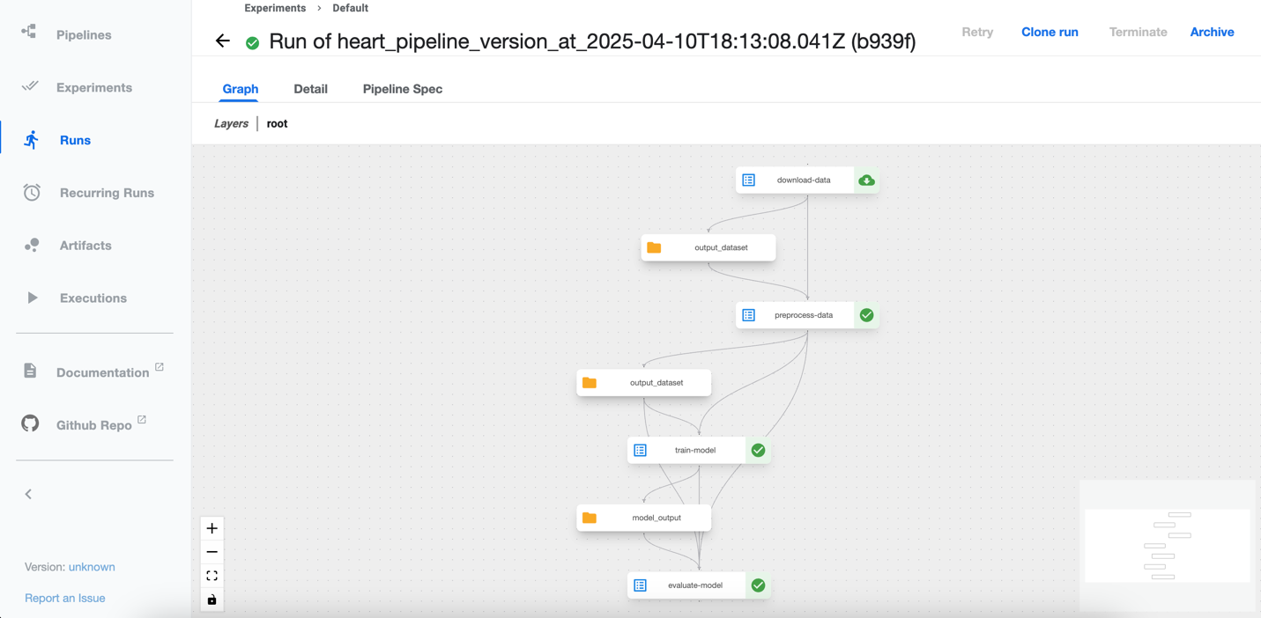*Running Experiment on Kubeflow*

**Conclusion**

In this lab, we successfully built and ran a simple ML pipeline using Kubeflow Pipelines on Kubernetes. By breaking the ML workflow into discrete, containerized steps, Kubeflow enabled:

* Automation of repetitive and error-prone tasks
* Reproducibility of results across environments and team members
* Scalability using Kubernetes’ native orchestration
* Model comparison and tracking through UI and logs

This approach not only simplifies deployment but also ensures that models are built and delivered in a production-ready, version-controlled, and collaborative manner — making it ideal for modern MLOps workflows.

**Experiment 10**

**Aim**

Observability and Logging in MLOps: Implement monitoring and logging (e.g., Prometheus, Grafana, ELK) to track performance, resource utilization, and application logs in ML pipelines)

**Thoery**

In MLOps, deploying a model is just the beginning. Ensuring its reliable operation in production is where the real challenge lies. For that, observability becomes a critical capability — it helps teams understand what’s happening within their ML systems and pipelines at any given time.

Where monitoring tracks known metrics (like CPU, memory, accuracy), observability provides the ability to explore unknowns — such as unexpected behavior or drift in the pipeline — by analyzing logs, metrics, and traces.

* Track resource usage: Helps identify bottlenecks in ETL steps, model training, and serving.
* Detect failures early: Alerts when a DAG step or batch job fails.
* Understand system health: Monitor data ingestion rates, latency, and throughput.
* Improve collaboration: Easier debugging across teams (data engineers, ML engineers, ops).

**Experiment**

***Docker setup for the entire stack***

version: "3.8"

services:

airflow:

build: ./airflow

container_name: airflow

environment:

- AIRFLOW__CORE__EXECUTOR=SequentialExecutor

- AIRFLOW__CORE__LOAD_EXAMPLES=False

- AIRFLOW__WEBSERVER__RBAC=True

volumes:

- ./airflow/dags:/opt/airflow/dags

- ./airflow/logs:/opt/airflow/logs

ports:

- "8080:8080"

- "8793:8793" # Prometheus exporter

command: >

bash -c "airflow db init &&

airflow users create --username admin --password admin --firstname Admin --lastname User --role Admin --email admin@example.com &&

airflow webserver & airflow scheduler"

prometheus:

image: prom/prometheus:latest

volumes:

- ./prometheus/prometheus.yml:/etc/prometheus/prometheus.yml

ports:

- "9090:9090"

grafana:

image: grafana/grafana:latest

ports:

- "3000:3000"

depends_on:

- prometheus

environment:

- GF_SECURITY_ADMIN_USER=admin

- GF_SECURITY_ADMIN_PASSWORD=admin

elasticsearch:

image: docker.elastic.co/elasticsearch/elasticsearch:7.17.10

environment:

- discovery.type=single-node

ports:

- "9200:9200"

kibana:

image: docker.elastic.co/kibana/kibana:7.17.10

ports:

- "5601:5601"

depends_on:

- elasticsearch

filebeat:

image: docker.elastic.co/beats/filebeat:7.17.10

volumes:

- ./filebeat/filebeat.yml:/usr/share/filebeat/filebeat.yml

- ./airflow/logs:/usr/share/airflow/logs

depends_on:

- elasticsearch

- kibana

***Prometheus setup***

global:

scrape_interval: 5s

scrape_configs:

- job_name: "airflow"

static_configs:

- targets: ["localhost:9090"]

**Filebeat setup**

filebeat.inputs:

- type: log

enabled: true

paths:

- /usr/share/airflow/logs/**/*.log

output.elasticsearch:

hosts: ["http://elasticsearch:9200"]

setup.kibana:

host: "kibana:5601"

***Running***

docker-compose up -d

**Outputs**

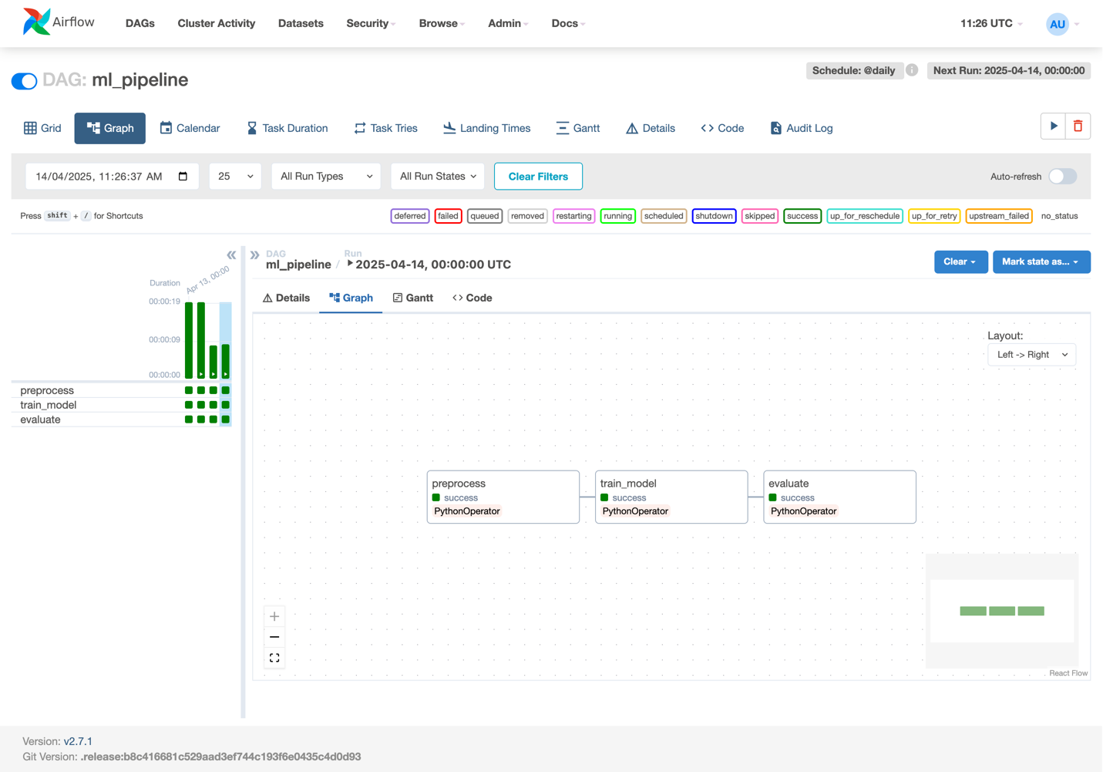

*Airflow DAG*

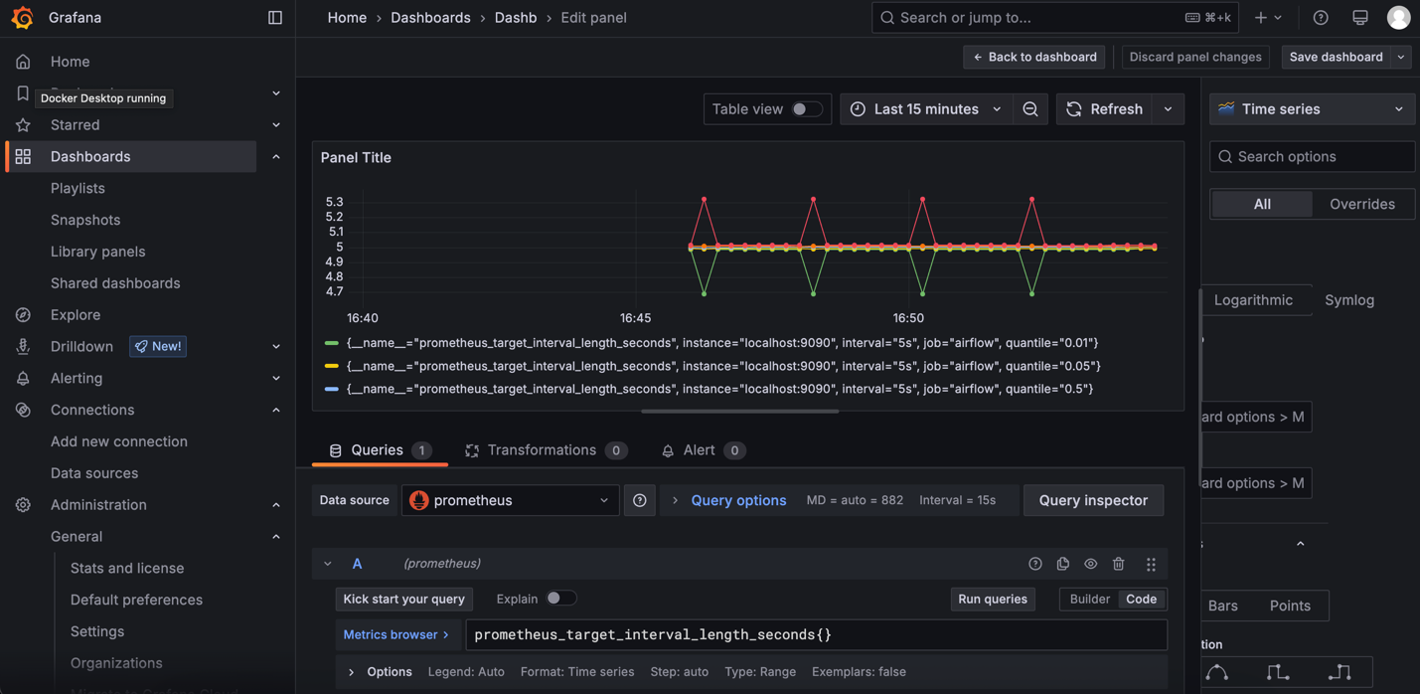*Grafana dashboard*

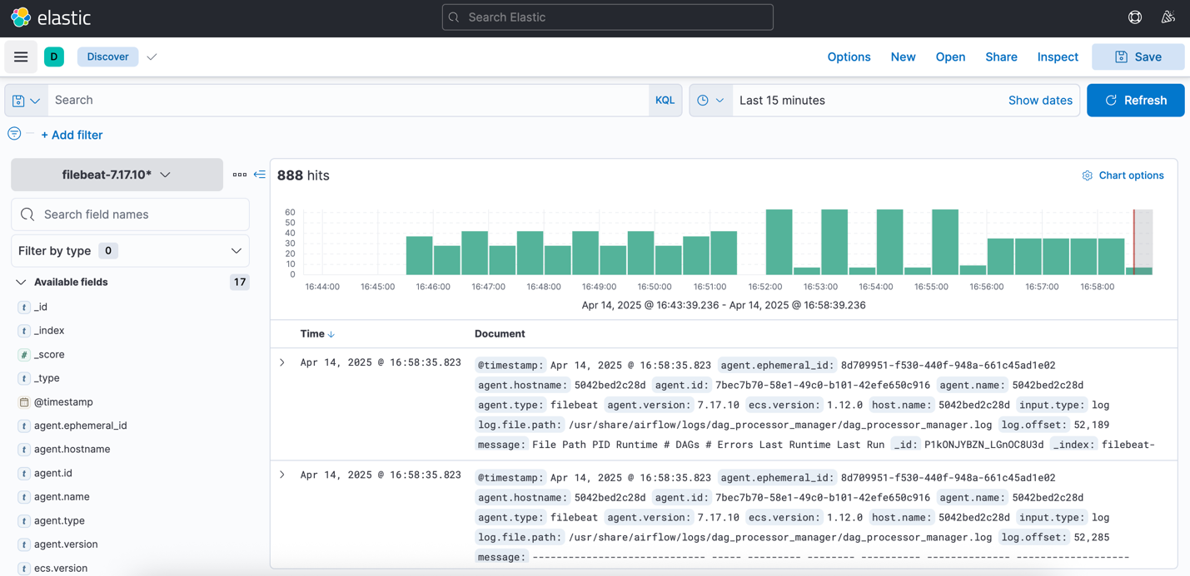*Kibana Dashboard*

**Conclusion**

This experiment brings practical observability into MLOps workflows. Rather than treating pipelines as black boxes, tools like Prometheus and ELK open them up to inspection — from performance bottlenecks to silent failures.

* By combining metrics, logging, and visual dashboards, teams can:
* Debug faster
* Prevent issues proactively
* Maintain healthy ML pipelines in production

Observability isn’t just for ops anymore — it's a foundational skill for ML engineers who want to own their models beyond deployment.