**UNIVERSITY OF ECONOMY OF FINANCE HCMC. Ho Chi Minh City**

**FACULTY OF INFORMATION TECHNOLOGY**

**COURSE PROJECTS**

**SUBJECT: WEBSITE PROGRAMMING**

**TOPIC: WEBSITE SELL AIR TICKETS**

*Students perform*

1. *Luu Tru Vy -205051010*
2. *Nguyen Thi Huynh Nhu - 205051960*
3. *Tran Ngoc Huy - 205051774*
4. *Tran Cong Bao - 205050567*

City. Ho Chi Minh – 2021

# TABLE OF CONTENTS

**TABLE OF CONTENTS 1**

**LIST OF IMAGES 3**

**COMMENT 4**

**FOREWORD 1**

**CHAPTER 1. PROJECT OVERVIEW 2**

**1. PROJECT MISSION 2**

**1.1. ASP.NET MVC6 Model Application 2**

**1.2. Purpose 2**

**2. PROBLEM DESCRIPTION 2**

**3. PROJECT STRUCTURE 3**

**4. PARTICIPATION MEMBERS 3**

**CHAPTER 2. USE CASE VIEW 4**

**1. USE CASE DIAGRAM 4**

**1.1 Function Diagram Administrator 4**

**1.2 Functional Diagram System User 4**

**1.3 Functional Diagram Customer 6**

**2. USE CASE DESCRIPTION 6**

**2.1. UC 01 Login 6**

**2.2. UC 02 Statistics 7**

**2.3 UC 03 Flight Management 8**

**2.4 UC 04 User Management 9**

**2.5 UC 05 Book tickets 10**

**2.6 UC 06 Ticket Confirmation 10**

**CHAPTER 3. LOGICAL VIEW 12**

**1. CLASS DIAGRAM (CLASS DIAGRAM) 12**

**CHAPTER 4: INTERFACES 13**

**1. Login interface 13**

**2. Homepage Interface 13**

**3. Ticket Search Interface 14**

**4. Flight List Interface ( Customer ) 14**

**5. Interface when the customer has made a booking (Employee) 15**

**6. Flight management interface (Admin) 15**

**7. User management interface (Admin) 16**

**CONCLUSION AND DEVELOPMENT DEVELOPMENT 17**

**1. CONCLUDE 17**

**2. DEVELOPMENT 17**

**REFERENCES 18**

**PROJECT LINK 19**

**LINK VIDEO DEMO 19**

**TASK PLAN 20**

# LIST OF IMAGES

**Image 1 : Administrator Function Diagram 4**

**Image 2 : System User Functional Diagram 5**

**Image 3 : Customer Functional Diagram 6**

**Image 4 : Class Diagram 12**

**Image 5 : Login Interface 13**

**Image 6 : Home Interface 13**

**Image 7 : Ticket Search Inteface 14**

**Image 8 : Flight List Interface 14**

**Image 9 : Booking Confirmation Interface 15**

**Image 10 : Flight Management Interface 15**

**Image 11 : Statistical Interface 16**

# COMMENT

1. Form

1. Content

Score: Appearance (30%) Content (70%) Summary:

May Day 202

Lecturers

Pham Duc Duy

# FOREWORD

Nowadays, the application of information technology and computerization is considered as one of the decisive factors in the activities of governments, organizations, as well as companies; it plays a very important role, can make strong breakthroughs. The construction of websites to serve the unique needs of organizations, companies and even individuals, nowadays, is not strange. With a few simple steps, anyone can become the owner of a website that introduces anything they are interested in: a website about themselves and their family, or a website presenting their collections. Collection of pictures of cars…. For the aviation industry in particular, building a website to help support business and management activities is indispensable. The activity of an airline ticketing agent will be enhanced and expanded if a good website is built. Realizing that the travel demand of passengers by plane is increasing day by day, if buying in the usual way, it will be very time consuming and laborious. Starting with this idea, I made "Building a website to sell airline tickets.

# CHAPTER 1. PROJECT OVERVIEW

## PROJECT MISSION

### **ASP.NET MVC6 Model Application**

### Purpose

* Create a website application to sell airline tickets.

## PROBLEM DESCRIPTION

 System" selling air tickets :

Due to the development needs of social networks and , partly because people do not have much time to go directly to the counter to make transactions directly. Realize that, along with the slogan "time is gold, silver is silver". “We decided to build an online ticketing system so that when traveling by plane is fast, now buying tickets is also much faster and easier than before.

In addition, when buying at the website we will provide customers with the best service, with the right price and many incentives when you have links to the objects that our website provides. You can also know all the day trips of all domestic airlines and the special thing is that when buying tickets at the website you can refund or exchange tickets 1-2 days before the flight date.

When buying tickets on our website, you will be provided with the addresses of restaurants and hotels with the best prices

This project will build and develop an "online ticket sales" system for customers who need to travel quickly and safely.

Object:

1. Admin: login, manage purchase tickets, sell tickets, cancel tickets, update flight times, hotels, promotions, revenue statistics.
2. Users: including members and employees: book tickets, cancel tickets, view booking history, view flight information, search for flights.

Only the staff can confirm the booking

1. Customers: View flight information, book tickets, register for members.

With the above system, the team will use ASP.NET MVC6 technology and Microsoft SQL Server database management system to install and develop the flight booking management system.

## PROJECT STRUCTURE

Consists of 4 chapters:

* Chapter 1: Overview of the project.
* Chapter 2: Use Case View.
* Chapter 3: Logical View.
* Chapter 4: Interfaces.

## PARTICIPATION MEMBERS

|  |  |  |  |
| --- | --- | --- | --- |
| Stt | First and last name | Mssv | Email |
| first | Liu Zhiwei (leader) | *205051010* | vylt220 @uef.edu.vn |
| 2 | Nguyen Thi Huynh Nhu | 205051960 | Nhunth420 @uef.edu.vn |
| 3 | Tran Ngoc Huy | 205051774 | [huytn20 @uef.edu.vn](mailto:huytn20@uef.edu.vn) |
| 4 | Tran Cong Bao | 205050567 | baotc20@uef.edu.vn |

# CHAPTER 2. USE CASE VIEW

## USE CASE DIAGRAM

### Function Diagram Administrator

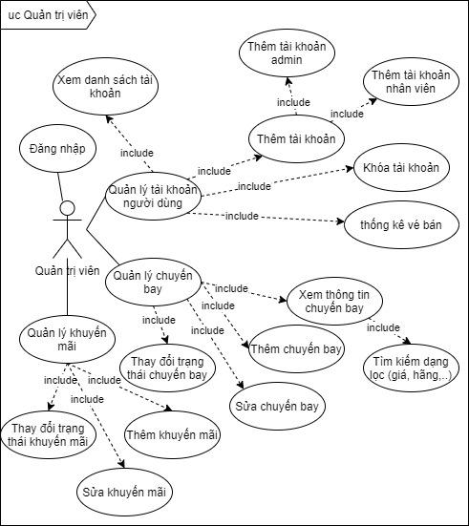

Image 1: Administrator Function Diagram

### Functional Diagram System User

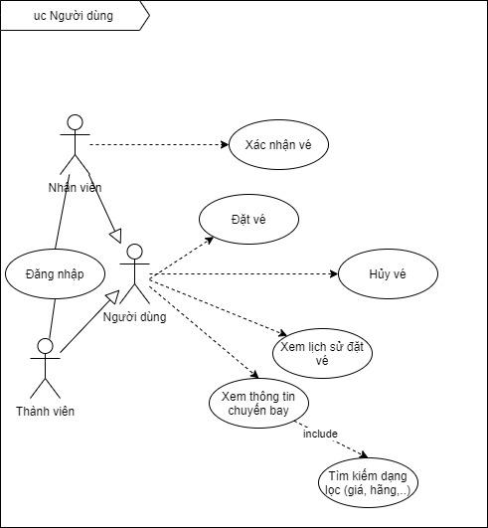

Image 2: System User Functional Diagram

### Functional Diagram Customer

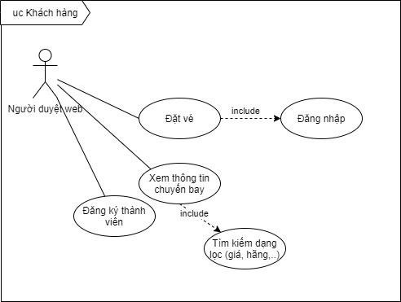

Image 3: Customer Functional Diagram

## USE CASE DESCRIPTION

### UC 01 Login

|  |  |
| --- | --- |
| **Use Case ID** | UC 01 |
| **Use Case Name** | Log in |
| **Describe** | Someone who already has an account |
| **Actor (Actor)** | Administrators, employees, members |
| **Pre-conditions** | * Registered account * The account has been authorized. |
| **Flow of events** | * **Main (Basic)**  1. The user visits the website. 2. User enters login account and selects login command. 3. The system successfully authenticates the login information, functions permissions and allows the user to access the application. 4. The system records the successful login operation.   Alternative (Alternative)   * **Exception (Exception)**  1. The system validates the credentials failed and displays a message. 2. The user chooses to cancel the login. 3. The user selects the command to retrieve the password (only for management accounts) |
| **Post-conditions** | * User successfully logged into the application * The system recognizes the successful login operation |
| **Extend** |  |

### UC 02 Statistics

|  |  |
| --- | --- |
| **Use Case ID** | UC 02 |
| **Use Case Name** | Statistical |
| **Describe** | As the admin, I want to see the statistical categories of the website. |
| **Actor (Actor)** | Administrators. |
| **Pre-conditions** | Account logged in |
| **Flow of events** | * **Main (Basic)**  1. The administrator selects the statistics command. 2. The administrator selects the list of statistics to view. 3. The system processes and sends the corresponding data to the screen at the request of the administrator.   Alternative (Alternative)   * **Exception (Exception)**  1. The system does not retrieve the data. 2. The system reported no data found. |
| **Post-conditions** |  |
| **Extend** |  |

### 2.3 UC 03 Flight Management

|  |  |
| --- | --- |
| **Use Case ID** | UC 03 |
| **Use Case Name** | Flight Management |
| **Describe** | As an admin, I want flight updates. (add, pause, edit information). |
| **Actor (Actor)** | Administrators |
| **Pre-conditions** | Login with admin account. |
| **Flow of events** | * **Main (Basic)**  1. The administrator selects the flight management command. 2. The administrator chooses the update method (add, change status, edit flight information). 3. System processed and updated successfully. 4. The system recognizes the update successfully.   Alternative (Alternative)   * **Exception (Exception)**  1. Update failed. 2. The system notifies the cause of the failure. |
| **Post-conditions** |  |
| **Extend** |  |

### 2.4 UC 04 User Management

|  |  |
| --- | --- |
| **Use Case ID** | UC 04 |
| **Use Case Name** | Manage member |
| **Describe** | As an Administrator, I want to manage customers who have registered as a member.  Includes examples:   1. Add employee account, member 2. Lock account. 3. Ticket statistics confirmed . 4. View a list of accounts. |
| **Actor (Actor)** | Administrators |
| **Pre-conditions** | Login with admin account. |
| **Flow of events** | * **Main (Basic)**  1. The administrator selects the user management command. 2. Select the method to perform. 3. The system processes and returns the results. 4. The system records the changed data. ( if any )   **Alternate (Alternative** )   * **Exception (Exception)**  1. The system did not find the data or the update failed. 2. The system says no data found or update error. |
| **Post-conditions** |  |
| **Extend** |  |

### 2.5 UC 05 Book tickets

|  |  |
| --- | --- |
| **Use Case ID** | UC 05 |
| **Use Case Name** | Book tickets |
| **Describe** | As a user, I want to book a plane ticket.  Includes tasks:   1. View flight information. 2. Book tickets. |
| **Actor (Actor)** | Manage |
| **Pre-conditions** | * User account logged in |
| **Flow of events** | **Main (Basic)**   1. User selects flight or view flights. 2. Click "book tickets" 3. Enter booking information. 4. Click “Confirm Booking”. 5. Notice "booking successful".   **Alternative (Alternative)**  **Exception (Exception)** |
| **Post-conditions** |  |
| **Extend** |  |

### 2.6 UC 06 Ticket Confirmation

|  |  |
| --- | --- |
| **Use Case ID** | UC 06 |
| **Use Case Name** | Ticket confirmation |
| **Describe** | As an employee who wants to confirm that the ticket has been successfully booked.. |
| **Actor (Actor)** | Staff |
| **Pre-conditions** | Employee account logged in |
| **Flow of events** | * **Main (Basic)**  1. User selects Confirm Ticket. 2. Select the ticket you want to confirm. 3. Enter booking information. 4. Click “confirm” 5. Processing system. 6. Returns message.   **Alternative (Alternative)**   * **Exception (Exception)**  1. Validation failed. |
| **Post-conditions** |  |
| **Extend** |  |

# CHAPTER 3. LOGICAL VIEW

## CLASS DIAGRAM (CLASS DIAGRAM)

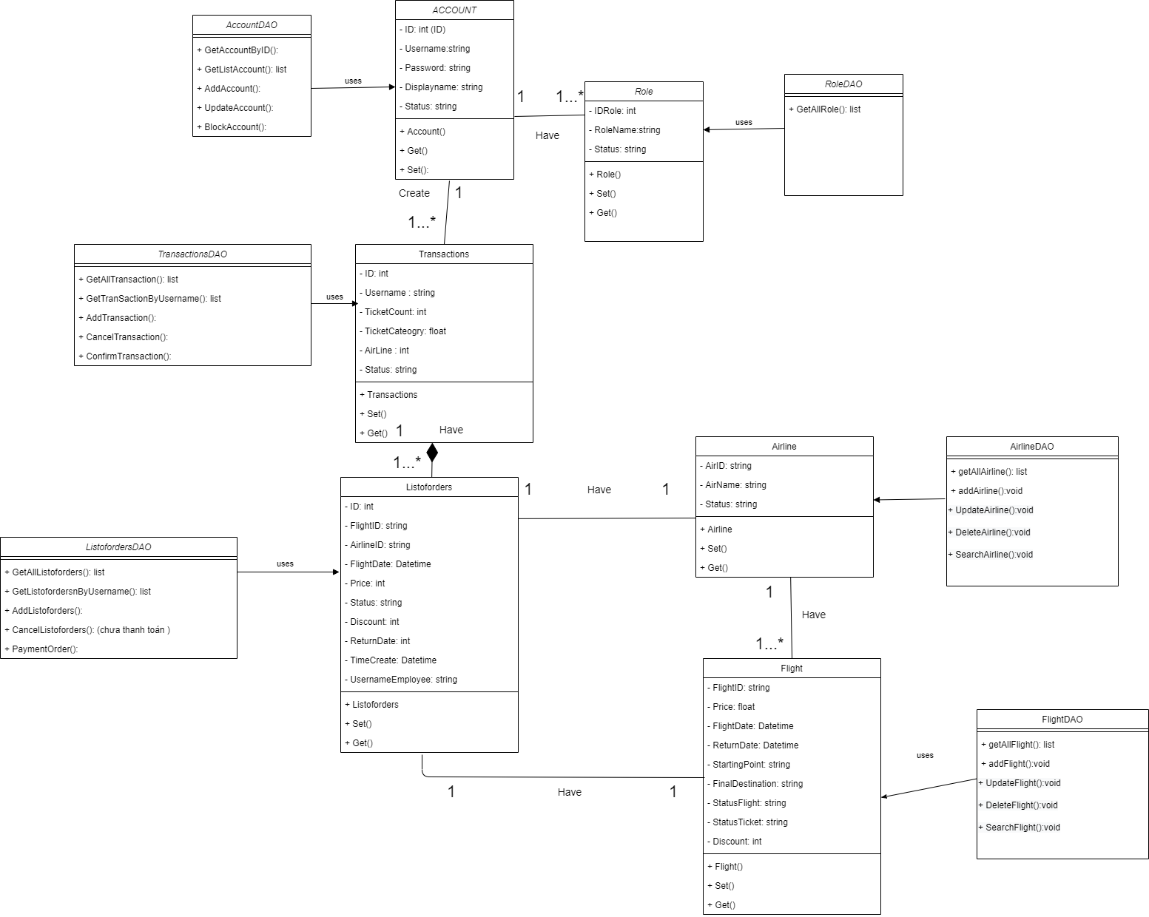

Image 4: Class Diagram

# CHAPTER 4: INTERFACES

## Login interface

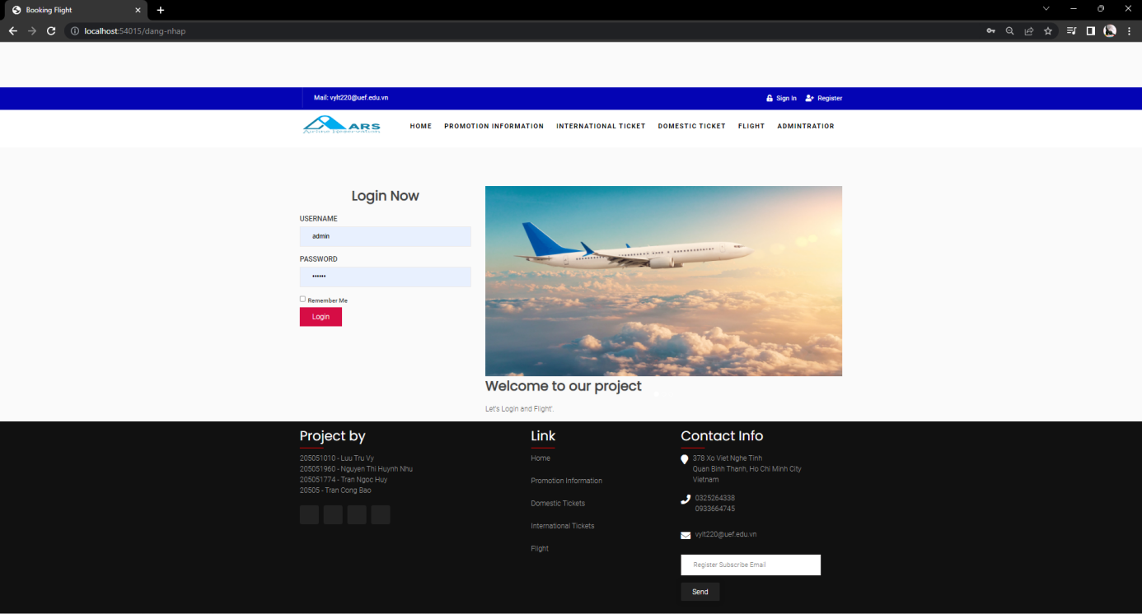

Image 5: Login Interface

## Homepage Interface

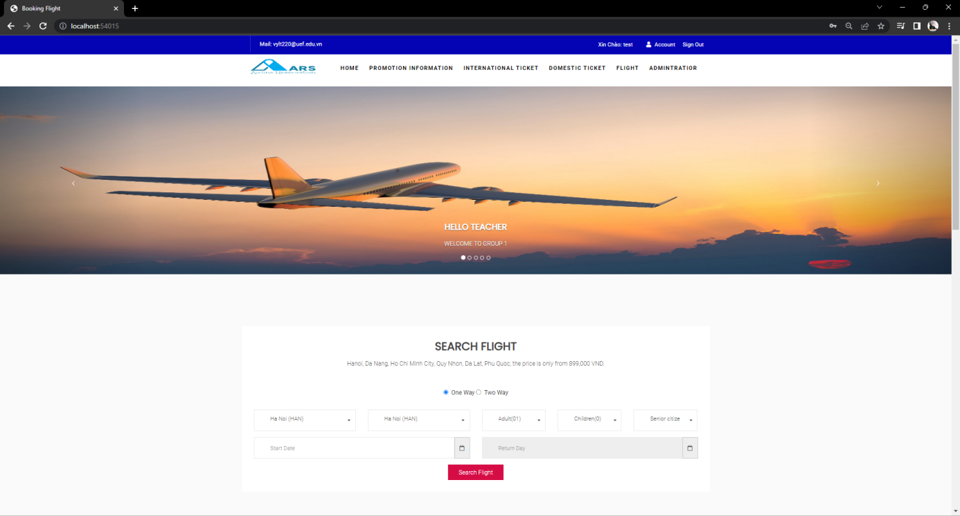

Image 6: Home Interface

## Ticket Search Interface

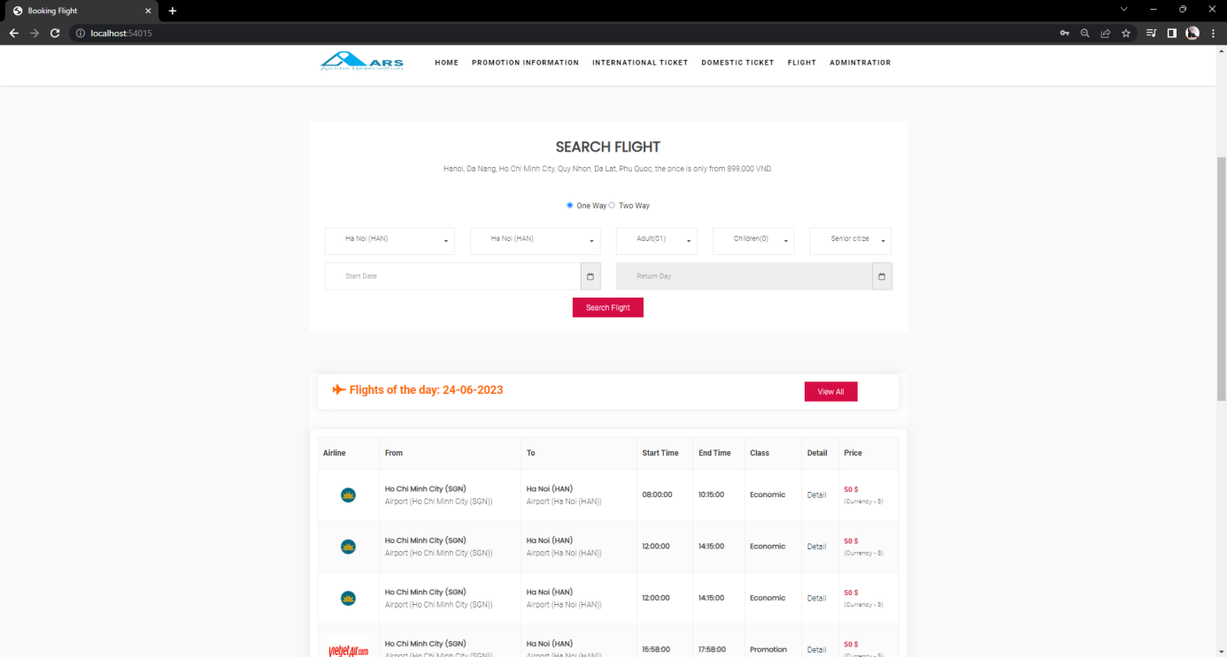

Image 7: Ticket Search Inteface

## Flight List Interface ( Customer )

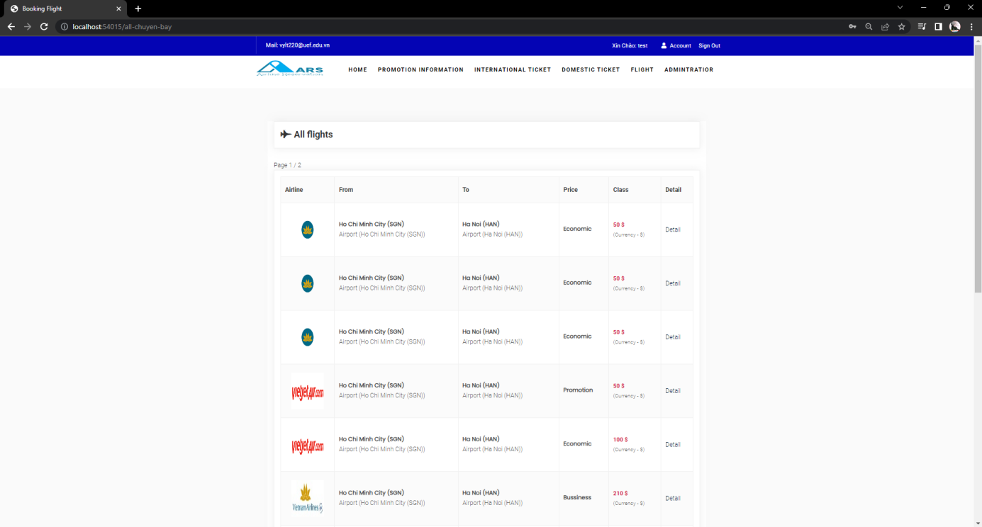

Image 8: Flight List Interface

## Interface when the customer has made a booking (Employee)

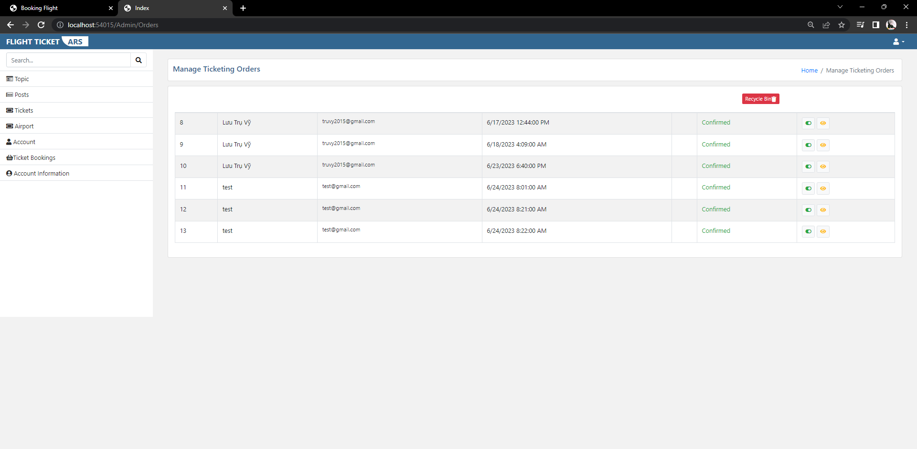

Image 9: Booking Confirmation Interface

## Flight management interface (Admin)

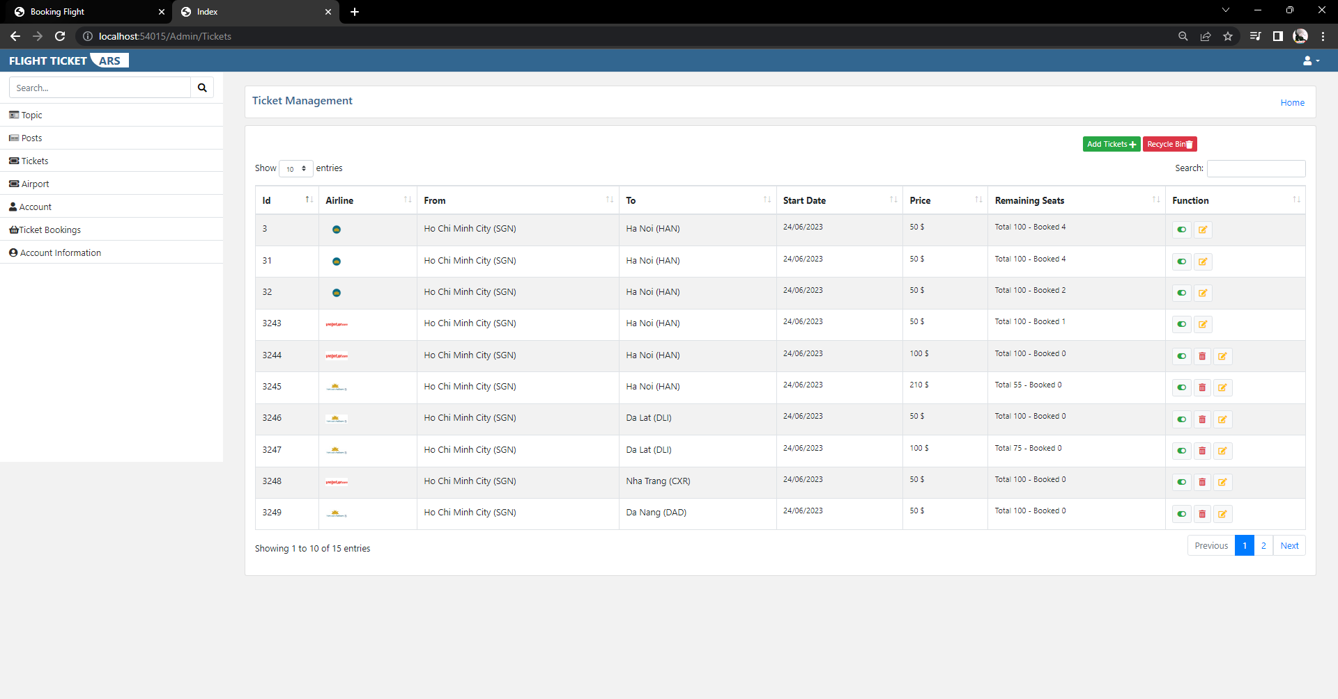

Image 10: Flight Management Interface

## User management interface (Admin)

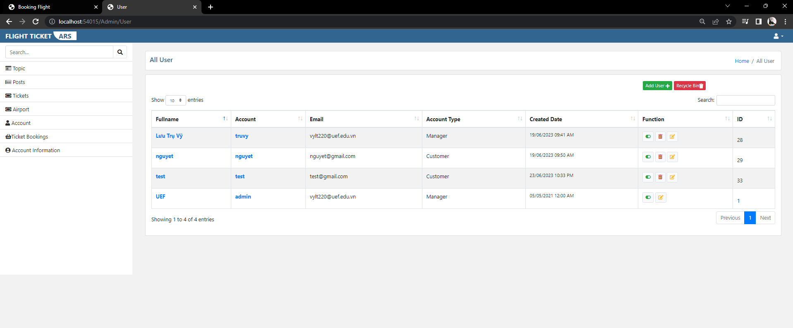

Image 11: Statistical Interface

# CONCLUSION AND DEVELOPMENT DEVELOPMENT

## CONCLUDE

Over time, with the dedicated teaching of Ms. Dang Thi Kim Giao, we have gained more knowledge about the ASP.NET MVC 6 model . From there, there is a basis for completing the final project of the course. Our group's project is: Website selling airline tickets.

Because of the limited time, our group's project still has many shortcomings. Hope you will give us more suggestions so that our team will continue to improve.

## DEVELOPMENT

Today with the development of information technology era. The demand for air travel is increasing day by day. Therefore, companies will need intermediary websites to sell air tickets. We will try to learn new knowledge about the website to develop a more complete website.

# REFERENCES

1. [https://www.traveloka.com/en-vn/](https://www.traveloka.com/vi-vn/)
2. <https://w3layouts.com/>
3. <https://tedu.com.vn/khoa-hoc-mien-phi/khoa-hoc-lap-trinh-aspnet-mvc-25.html>

# PROJECT LINK

<https://github.com/DTV181/WebFinalReport>

# LINK VIDEO DEMO

<https://youtu.be/hCmSNmbib6Y>

# TASK PLAN

|  |  |  |  |  |  |  |
| --- | --- | --- | --- | --- | --- | --- |
| **Project**  **Group 3** | | **Project name**  **Website selling airline tickets** | | **Preparation day** | | **Prepare a plan ( Luu Zhuwei )** |
| **Stt** | **Mission** | | **Start day** | **Finish day** | **Executing member's name** | **Status** |
| first | System design analysis | | June 7, 2023 | June 18, 2023 | **Luu Tru Vy, Nguyen Thi Huynh Nhu, Tran Ngoc Huy, Tran Cong Bao** | Complete |
| 2 | Create a database | | June 9, 2023 | June 18, 2023 | **Luu Tru Vy, Nguyen Thi Huynh Nhu, Tran Ngoc Huy, Tran Cong Bao** | Complete |
| 3 | Create controllers | | Complete |
| 4 | Create models | | Complete |
| 5 | Link interfaces to functions | | Complete |
| 6 | View interface and feedback | | Complete |
| 7 | Project Management | | Complete |
| 8 | Design login and registration interface | | June 9, 2023 | June 18, 2023 | **Luu Tru Vy, Nguyen Thi Huynh Nhu, Tran Ngoc Huy, Tran Cong Bao** | Complete |
| 9 | Design of functional admin interfaces | | 95% |
| ten | Design user interfaces | | 95% |
| 11 | Design employee interfaces | | 95% |
| twelfth | Upload hosting | | June 18, 2023 | June 18, 2023 | **Luu Tru Vy, Nguyen Thi Huynh Nhu, Tran Ngoc Huy, Tran Cong Bao** | Complete |