Operating Systems
Croitoru Dan
FAF-101

Report
Laboratory Work Nr.1

Theory
An operating system (OS) is a collection of software that manages computer hardware resources and provides common services for computer programs. The operating system is a vital component of the system software in a computer system. Application programs require an operating system to function.
Time-sharing operating systems schedule tasks for efficient use of the system and may also include accounting for cost allocation of processor time, mass storage, printing, and other resources.
For hardware functions such as input and output and memory allocation, the operating system acts as an intermediary between programs and the computer hardware, although the application code is usually executed directly by the hardware and will frequently make a system call to an OS function or be interrupted by it. Operating systems can be found on almost any device that contains a computer—from cellular phones and video game consoles to supercomputers and web servers.
Examples of popular modern operating systems include Android, BSD, iOS, Linux, Mac OS X, Microsoft Windows, Windows Phone, and IBM z/OS. All these, except Windows and z/OS, share roots in UNIX.

Goal
- set up build environment
- launch hello world OS successfully with the message displayed on screen.

Reaching The Goal
In order to successfully complete this laboratory work we have to make sure that we are armed and ready to deal with compiling and mounting the image that will be booted.
Now we have to check if the system has make and gcc instaled. It is easily checked by running the command make -v and gcc -v. In both cases we get a positive result, now we're ready to compile the files. But before this, we should keep in mind that we're running a x64 machine, and several changes are needed here. In order to compile a 32bit application we have to modify the Makefile, and to add these parameter to the CFLAGS, -m32.
At this moment we're ready to compile the files. We firstly run make clean in the working directory, and this is what we should get.
dan@laptop:~/Dropbox/UTM Personal/SEM 5/LABS/ACSO/lesson1$ make clean
rm -f main.o kernel.elf helloworld.img
We see that files are ready to be compiled. Now let's run make.
dan@laptop:~/Dropbox/UTM Personal/SEM 5/LABS/ACSO/lesson1$ make
gcc -c -O -I. -m32 -c -o main.o main.c
ld -o kernel.elf main.o -dN -Ttext 0x101080 -melf_i386
./bootmaker helloworld.ini helloworld.img -floppy
whoohah!echo "\n"
wc helloworld.img
5 26 8704 helloworld.img
Operation succed ! A new .img file was born this moment ! Now let's mount it and boot.
I'll be using VirtualBox for this purpose.
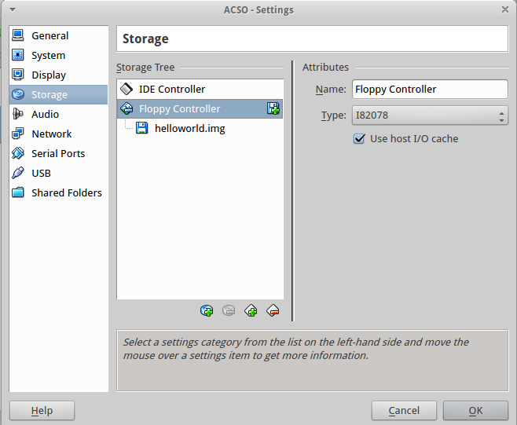

I created a new virtual machine with no storage drive, and mounted the image file in a Floppy Controller. Now let's boot.
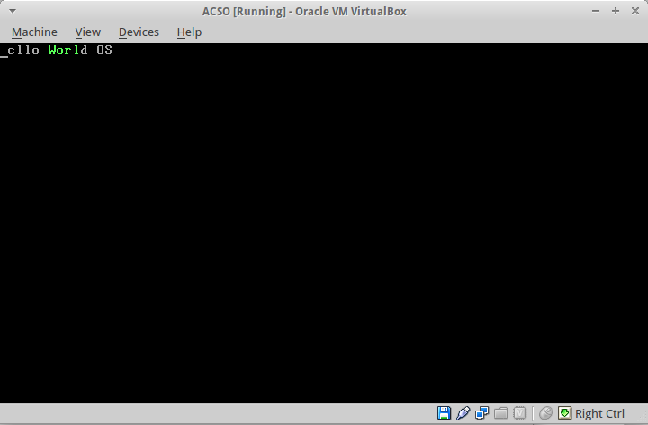

That's it ! It Works.

Questions
- what is the role of an operating system?
As is mentioned in theory part an operating system is a toolbox of software that manages the hardware and provides common services for computer programs.
- what is a boot process?
Is a process when a set of processes are performed, like checking the recognizing/checking the hardware.
- how to make a drive bootable?
Till this moment the only way I made drives bootable was by changing the priority of in BIOS. After lurking more about this, I found that in order to make a drive bootable, we have to make it carry a boot sector with the byte sequence 0x55, 0xAA in bytes 511 and 512 respectively.
- why we didn’t use printf in hello world example?
Because printf is a function implemented in stdio library. We're not using any libraries, just working with memory and assembly code. Hardcore.

Conclusion
In this laboratory work, first time in my life I dealt with compiling a personal OS, and booting it. Also working with raw C/Assembly code. The laboratory gave me the basic knowledge about the booting process, and how does the OS work in general.

Bibliography
- http://en.wikipedia.org/wiki/Operating_system

