Personal Portfolio Website Plan

Your Name: Derek Tillman

Ideas for your website
Determine how you will use your personal portfolio website to showcase your skills.
Idea 1: Have multiple tabs to go to for more information about myself

Idea 2: having photos and maybe videos of some things that I do

Idea 3: keep them organized and neat

Idea 4: figure out how to get add a keyboard navigation to make things easier to get to

Idea 5: add text resizing somehow so it’s easier for people to read and see

Website Plan
Topic | Questions | Answers
Purpose of Website | What is the purpose and goal of the website? | The purpose of the website is to have you understand and know more about me
Target Audience | Describe the target audience (age, gender, demographics) | For all audience
Graphics | What graphics will you use on the website? | Maybe a drag or drop-down motion to get to the page faster
Color | What colors will you use within the site to enhance the purpose and brand? | Multiple colors: blue, purple, pink, black, and white
Accessibility | How will the website accommodate people with disabilities? | Imma try to add text resizing and keyboard navigation
Project Timeline | Identify the project timeline | Timeline within the last 3 years

Wireframe
Sketch the wireframe for your home page below.

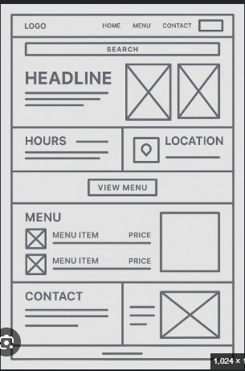

Site map
Create a site map for the website below.
Have the Home page with small instructions about myself. Then multiple table: About, Contact, Hobbies.
The about tab: Is going to have all the information about academic, as in high school I went to and up to now. Also, I am going to talk about how I got into coding
Hobbies Tab: This tab is going to be what I like to do in my free time and the things I love doing
Contact tab: Will have all different ways to contact

