Design Document

AUTHORING

**TEAM MAMBERS:** Rabia Ejaz

Danilo Torres

****Syed Usman

**DATE:** March, 07, 2017

**COURSE:** EECS 2311

## PROFESSOR: Bil Tzerpos

CONTENTS

1.0 INTRODUCTION 3

1.1 Purpose 3

1.2 Scope 3

1.3 Background 3

1.5 Constraints 4

2.0 SEQUENCE DIAGRAMS 4

3.0 CLASS DIAGRAM 5

4.0 INPUTS 8

5.0 OUTPUTS 9

6.0 GLOSSARY 9

7.0 REFERENCES 9

## 

1.0 INTRODUCTION

This design document is prepared by TEAM 5 to describe the layout and flow of the project. It will include sequence and class diagrams, as well as inputs and outputs.

##### 1.1 Purpose

The purpose of this document is to portray the overall functionality of the project and the interaction between components. This allows for an easy understanding of the code implementation which simplifies the maintenance required.

##### 1.2 Scope

The aim of this document is to represent the structure of the code, while highlighting only the important functionality.

##### 1.3 Background

The braille project has been worked on for a full term and is now complete. The design document looks at how each component worked on in the past interact with each other. Such components include the player and simulator.

##### 1.5 Constraints

Some constraints include

* Diagrams should be manually done, not generated.
* Design should not be overcomplicated.
* Time constraint (Due April 5).
* Should cover all important components.

2.0 Sequence diagrams

Here is a general sequence diagram for the project:

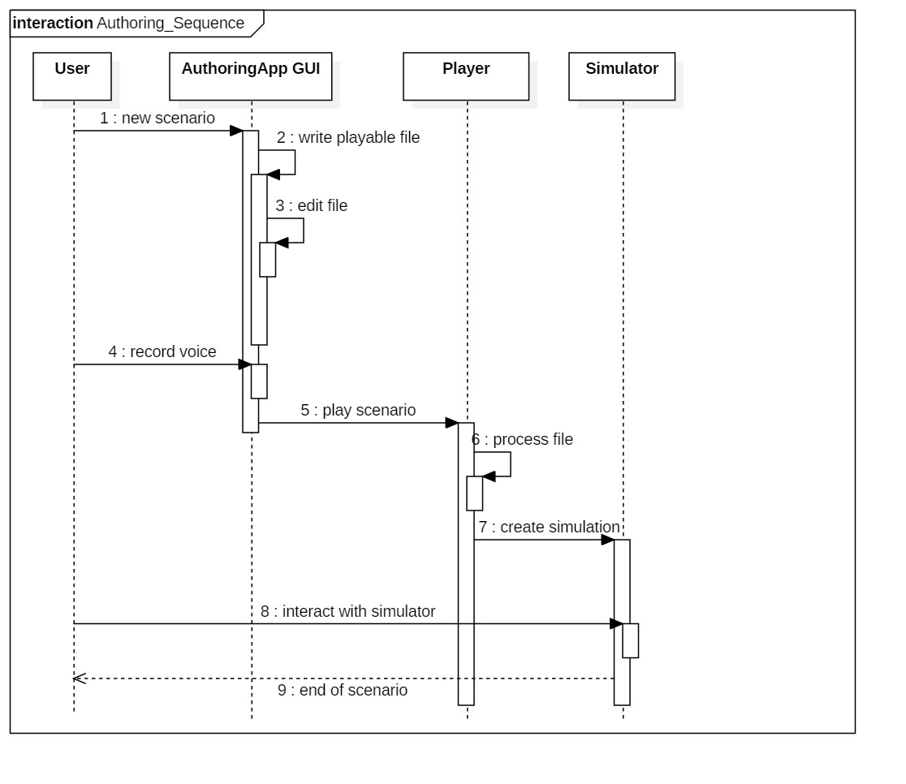

The authoring app contains several functions. Here is an example of a sequence diagram for one of such functions (recording):

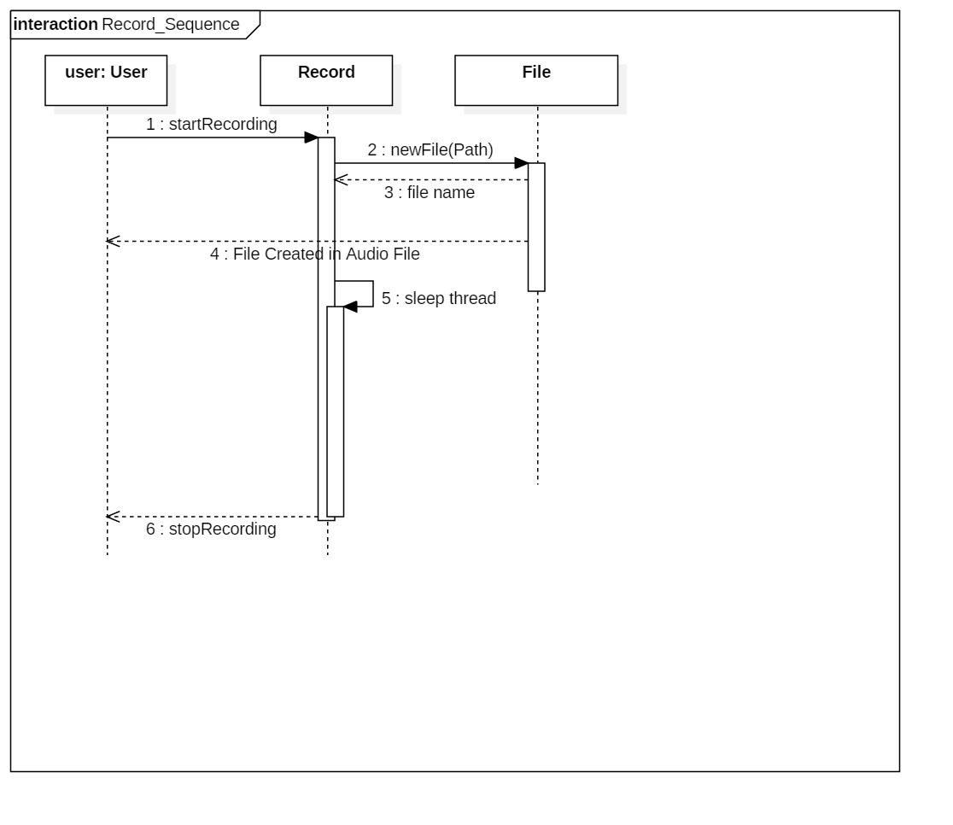

3.0 CLASS DIAGRAM:

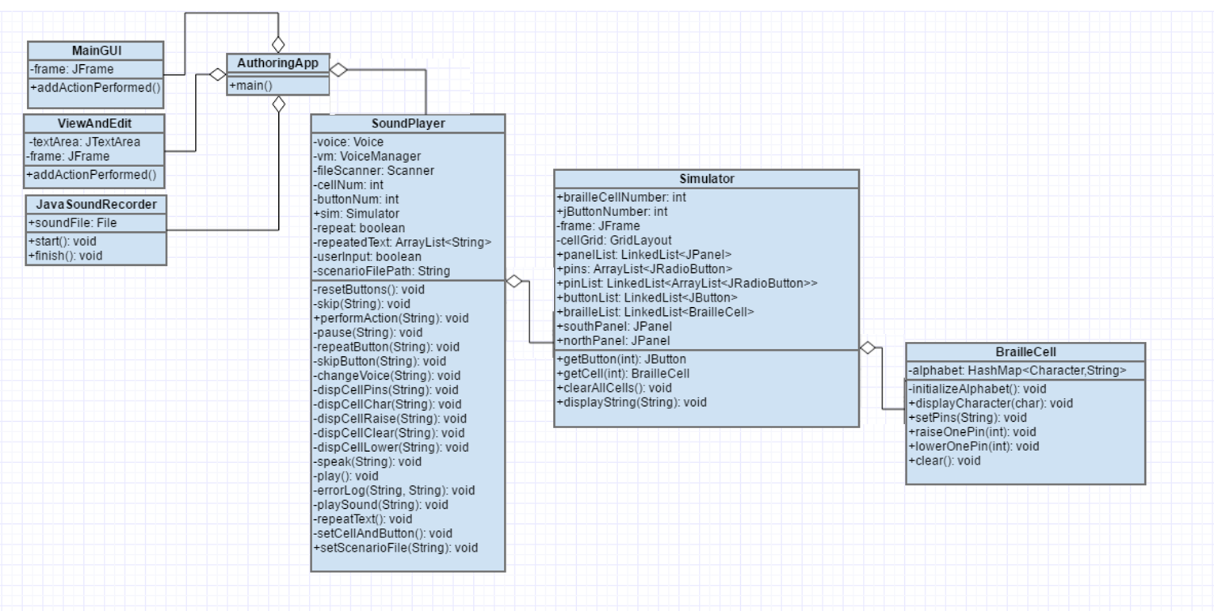

4.0 inputs

The user interacts with the GUI implemented in the Authoring app to input information. They are able to input commands as well as parameters for the code through a user-friendly environment.

5.0 OUTPUTS

The user receives messages through the GUI and is able to play scenarios through a simulator of the braille device.

6.0 GLOSSARY

|  |  |
| --- | --- |
| WORDS | DEFINITIONS |
| API | Application Programming Interface |
| GUI | Graphical User Interface |

7.0 REFERENCES

The sequence diagrams were created with StarUML and all information for this document was obtained from the course.