



**TEAM MAMBERS:** Rabia Ejaz

Danilo Torres

Syed Usman

**DATE:** March, 07, 2017

**COURSE:** EECS 2311

## PROFESSOR: Bil Tzerpos

CONTENTS

1.0 INTRODUCTION 3

1.1 Purpose 3

1.2 Scope 3

1.3 Background 3

1.5 Constraints 4

2.0 DIAGRAM OF GUI 4

3.0 BUTTON INSTRUCTIONS 4

4.0 BEGINNERS SCENARIO FILE 9

5.0 GLOSSARY 10

6.0 REFERENCES 11

## 

## 

1.0 INTRODUCTION

This user manual is prepared by TEAM 5 to explain in detail how to use the Authoring App GUI to create and play custom scenarios. Descriptions for each button as well as an example of an ideal scenario file are included in this document.

##### 1.1 Purpose

The purpose of this manual is to eliminate any confusion towards the GUI in order to allow the user to easily create their own scenarios.

##### 1.2 Scope

Our aim is to cover how to use every button in our GUI and inform the user on every assumption required from them.

##### 1.3 Background

This is part of the Authoring phase of our EECS 2311 Braille Project. To create scenarios for the braille device, the user must interact with a GUI which is explained in the user manual.

##### 1.5 Constraints

* The user may not follow instructions completely.
* The user might make errors that cannot be handled by the code.
* Time constraint (Due April 5).

2.0 DIAGRAM OF GUI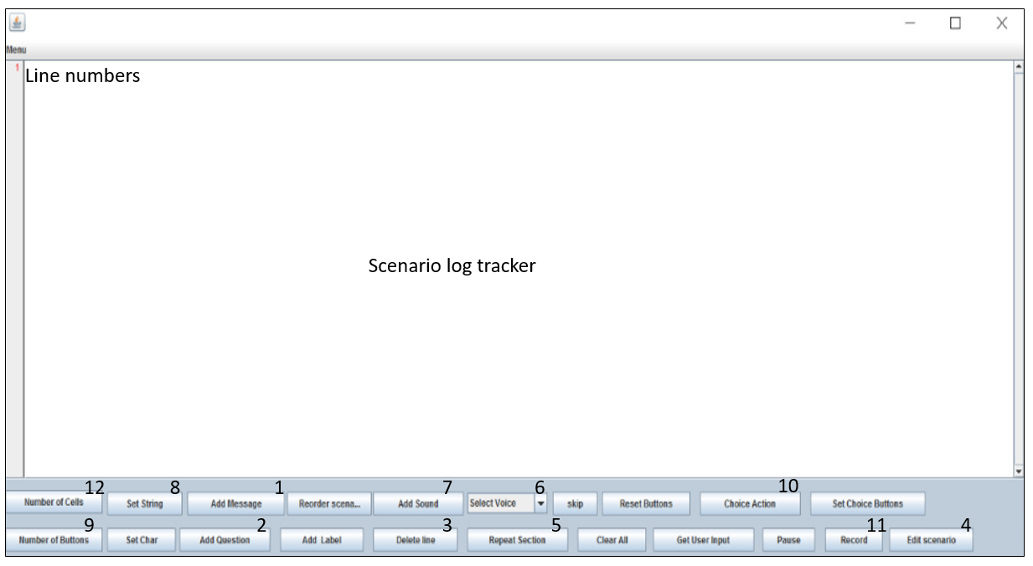

3.0 BUTTON INSTRUCTIONS

## Following are the instructions on how to use complicated buttons in the GUI.

**1. Message Button:**

**DESCRIPTION**: Adds message to the file.

*Instructions*;

* Press the Add Message button

* Add the text you want as message

* Press ok

**2. Question button:**

**DESCRIPTION**: Add question to the file.

*Instructions;*

* Press the Add Question button

* Add the text you want as question

* Press ok

**3. Delete button:**

**DESCRIPTION**: Delete buttons deletes Message: ,Question: ,Voice: ,String: ,Char: and sound: from the file.

*Instructions;*

* Press delete line button

* Enter the line number you want to delete

* Press ok

**Notice:**

* Delete button will only delete the lines that start with

Message: Question: String: Voice: Char: sound:

If the user tries to delete the line which doesn't starts in the following way nothing will happen. They would have to enter the line number that starts in the following manner.

While entering the line number be sure to enter the collect line number. If the user enters a line number that does not exist, nothing will happen.

**4. Edit button:**

**DESCRIPTION**: Edit buttons edits Message: , Question: , Voice: , String: , Char: and sound: from the file

*Instructions;*

For lines starting with Message: , Question: , Char: , String:

* Press edit scenario button

* Enter the line number you want to edit

* Enter the new message

* Press ok

For the line starting with sound:

* Press edit scenario button

* Enter the line number that has the sound

* Dont type anything in the message are just press ok

* A window will appear with sounds to select

* Select the sound and press ok

For the line starting with Voice:

* Press edit scenario button
* Enter the line number that has the voice
* Type in just the voice number you want out of 1-4
* Press ok

**Notice:**

* Edit button will only edit the lines that start with

Message: Question: String: Voice: Char: sound:

If the user tries to edit the line which doesn't starts in the following way nothing will happen. They would have to enter the line number that starts in the following manner.

While entering the line number be sure to enter the collect line number. If the user enters a line number that does not exist, nothing will happen.

**5. Repeat Button:**

**DESCRIPTION**: Adds ‘start repeat’ & ‘stop repeat’ to the file

*Instructions;*

* Press repeat section button

* In the window that appears press the start repeat button. Remember the stop repeat button will not work until a repeat is started.

* To stop the repeat press the repeat section button again and click the stop repeat button.

* After the button is pressed a new window will appear asking for the button to be set to access repeat. Type in the button number and press ok.

**6. Voice button**

**DESCRIPTION**: Sets a voice that will read out the text. There are 4 voices to choose from.

*Instructions;*

*Select on the drop down menu which voice you would like to choose (these voices depend on what you have downloaded on your system).

**7. Sound Button**

**DESCRIPTION**: Adds sound to the file. There are 5-6 preloaded sounds. The user can add further sounds using the recorder app built in the authoring app.

*Instructions;*

* Press the add sound button

* A window will open

* Select the sound file from the list

* Press ok

**8. Set String button**

**DESCRIPTION**: Set the string entered on braille cell.

*Instructions;*

* Press the Set String button

* A window will open

* Enter the text to display on braille cell

* Press ok

**Notice:**

The word being entered shouldn’t have more letters in it than the cells being assigned. Eg: cell assigned 3 then the word should be 3 letters long

**9. Add Buttons**

**DESCRIPTION**: Adds number of button specified to the braille cell

*Instructions;*

* Press the Number of Buttons

* Enter the number of buttons you want to add

* Press ok

**10. User Input Button**

**DESCRIPTION**: This button is placed at the point where the user input is expected

*Instructions;*

* Press the Get User Input button.

**11. Recorder button:**

**DESCRIPTION**: This button opens the recorder

*Instructions;*

* Press the recorder button

*Press play to start recording

*Press stop to stop recording

*Enter file name

**12. Add Cells button:**

**DESCRIPTION**: Adds number of cells specified to the braille cell

*Instructions;*

* Press the Number Of Cells button

* Enter the number of cells you want to add

* Press ok

13.Set Character button:

Description: Sets the character on the cell specified

Instructions;

* Press the Set Char Button
* In the new window enter the cell number to display character on and also enter the character to be displayed
* Press ok

14.Reset Button:

Description: It resets all the button. Basically any functionality assigned to a button will be removed.

Instruction;

* Press the Reset Buttons, button.

15.Pause Button:

Description: Adds a pause in the scenario to be played. Time specified is in seconds.

Instruction;

* Press the pause button
* In the window that appears enter the time to pause
* press ok

16.Set Choice Button:

Description:This buttons basically assigns the button for correct and incorrect choice. Eg; The user asks a question. The user then gave 2 possible answer. One of them is correct while the other is incorrect. The Set Choice button would then specify a button on the braille cell as correct and the other one as incorrect.

Instruction;

* Press the Set Choice Button
* In the window that appears enter the button number for both correct/incorrect cases
* Press ok

17.Choice Action Button:

Description:This button creates scenario to be played once the user gets a correct or incorrect answer. When the user presses the correct or incorrect button there has to be some scenario played telling them whether they got it right or wrong. This button creates those scenario.

Instruction;

* Press the Choice Action Button
* In the window that appears enter the message and sound you want in the correct/incorrect scenario.
* Press ok

18.Clear All Button:

Description: This button clears anything that was set on the braille cell. It could be String or character.

Instruction;

* Press the Clear All Button

19.Add Label Button:

Description: This button is a bit complicated to understand. What this button is actually creates a label. The label could be anything eg:”NEXTT”. Anything that comes under this label will be part of this label. To get to this label the user actually has to assign a button which when pressed will skip everything and start doing what's under this label.

Instructions;

* Press the Add Label Button
* Enter the label and press ok

20.Skip:

Description:This button is used to assign a button to skip to a label. The button assigned in this part, if pressed will jump to label entered.

Instruction;

* Press the Skip button
* In the window that appears enter the button number to be assigned for skipping
* Enter the label that you want to skip to on button press
* Press ok

4.0 Beginners SCENARIO FILE

How to make a Beginners scenario file:

Here we will be telling you how to actually make the scenario file in steps. The file is the most basic file you could make.

1. The first step should be to set buttons and cells

2. Next the user should set the string or character on braille cell

3. Then the user should set the voice that would read out the text

4. The user should start the repeat at this point if he wants(optional)

5. Now the user should enter all the messages/questions he wants read out.

6. The user should stop the repeat at this point if need be(optional)

7. The user should specify the button for the correct/incorrect choices set in messages/question

8. The user should press the userinput button at this point

9. The user should describe the scenario to be played if the correct/incorrect option is chosen

10. The user should clear the display at this point to set a new display

11. The user should reset buttons at this point

12. The user should set a new char/string again at this point

13. The user should set a new voice if need be at this point(optional)

14. Start repeat if need be(optional)

15. The user should enter messages/question again at this point

16. Stop repeat if need be(optional)

17. The user should specify the button for the correct/incorrect choices set in messages/question

18. The user should press the userinput button at this point

19. The user should describe the scenario to be played if the correct/incorrect option is chosen

20. The user could end the scenario at this point or could continue forward following the above step

5.0 SOME USEFUL TIPS:

The app is designed to give the user a lot of freedom. Because of this freedom the user might make mistake. Following are some useful tips to avoid any errors:

1. Always start by setting the number of buttons and cell
2. Always set a voice before typing any message or question
3. Avoid using the choice action button before using the set choice button

5.0 GLOSSARY

|  |  |
| --- | --- |
| WORDS | DEFINITIONS |
| API | Application Programming Interface |
| GUI | Graphical User Interface |

6.0 REFERENCES

No outside references were used for the making of this manual.