# **LAB04 Broadcast Receiver**

MainActivity.java  
public class MainActivity extends AppCompatActivity {  
  
 private TextView tvContent;  
 private BroadcastReceiver smsReceiver;  
 private IntentFilter filter;  
  
 @Override  
 protected void onCreate(Bundle savedInstanceState) {  
 super.onCreate(savedInstanceState);  
 setContentView(R.layout.*activity_main*);  
  
 tvContent = findViewById(R.id.*tv_content*);  
  
 // xin quyền runtime cho Android 6.0+  
 if (ActivityCompat.*checkSelfPermission*(this, Manifest.permission.*RECEIVE_SMS*)  
 != PackageManager.*PERMISSION_GRANTED*) {  
 ActivityCompat.*requestPermissions*(this,  
 new String[]{Manifest.permission.*RECEIVE_SMS*}, 100);  
 }  
  
 initBroadcastReceiver();  
 }  
  
 private void initBroadcastReceiver() {  
 smsReceiver = new BroadcastReceiver() {  
 @Override  
 public void onReceive(Context context, Intent intent) {  
 Bundle bundle = intent.getExtras();  
 if (bundle != null) {  
 Object[] pdus = (Object[]) bundle.get("pdus");  
 if (pdus != null) {  
 for (Object pdu : pdus) {  
 SmsMessage sms = SmsMessage.*createFromPdu*((byte[]) pdu);  
 String sender = sms.getDisplayOriginatingAddress();  
 String body = sms.getMessageBody();  
  
 // Hiển thị  
 Toast.*makeText*(context, "Bạn có tin nhắn mới!", Toast.*LENGTH_SHORT*).show();  
 tvContent.setText("From: " + sender + "\nContent: " + body);  
 }  
 }  
 }  
 }  
 };  
 filter = new IntentFilter("android.provider.Telephony.SMS_RECEIVED");  
 }  
  
 @Override  
 protected void onResume() {  
 super.onResume();  
 registerReceiver(smsReceiver, filter);  
 }  
  
 @Override  
 protected void onStop() {  
 super.onStop();  
 unregisterReceiver(smsReceiver);  
 }  
}

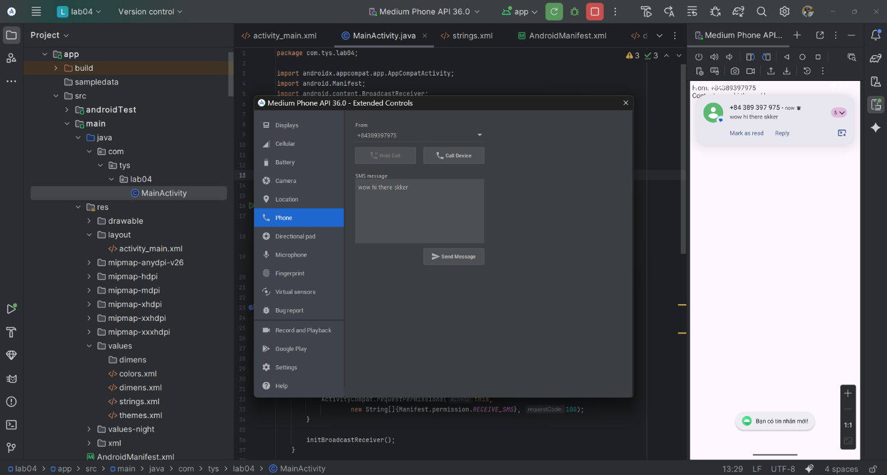

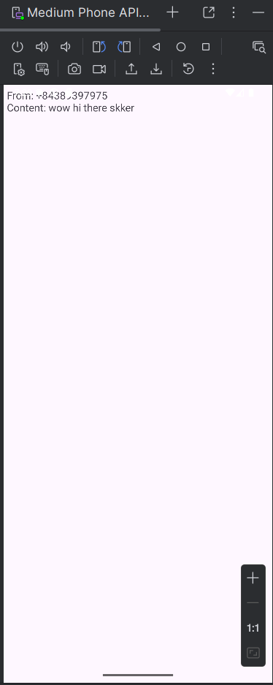

PowerActivity.java

package com.tys.lab4;

import android.os.Bundle;

import androidx.appcompat.app.AppCompatActivity;

public class PowerActivity extends AppCompatActivity {

@Override

protected void onCreate(Bundle savedInstanceState) {

super.onCreate(savedInstanceState);

setContentView(R.layout.activity_bai2);

}

}

PowerStateChangeReceiver.java  
package com.tys.lab4;

import android.content.BroadcastReceiver;

import android.content.Context;

import android.content.Intent;

import android.widget.Toast;

public class PowerStateChangeReceiver extends BroadcastReceiver {

@Override

public void onReceive(Context context, Intent intent) {

if (Intent.ACTION_POWER_CONNECTED.equals(intent.getAction())) {

Toast.makeText(context, "Điện thoại đang cắm sạc", Toast.LENGTH_SHORT).show();

} else if (Intent.ACTION_POWER_DISCONNECTED.equals(intent.getAction())) {

Toast.makeText(context, "Điện thoại đã rút sạc", Toast.LENGTH_SHORT).show();

}

}

}

