Môn: Lập trình đa nền tảng
Tên: Nguyễn Thành Danh
MSSV: 1150080046
Lab: Thực hành Lab07

Bài tập 1: Custom Button
Tạo các custom button vào res/drawable (phần này em đã tham khảo web https://www.journaldev.com/19850/android-button-design-custom-round-color)
Bao gồm các file:
- btn_bg_selector.xml → thay đổi màu nền khi nhấn
- btn_bg_selector_disabled.xml → trạng thái disabled
- btn_drawable_selector.xml → thay đổi icon khi nhấn
- btn_left_selector.xml, btn_right_selector.xml → icon emoji trái/phải thay đổi khi nhấn
- btn_shape_round.xml → nút bo tròn
- btn_shape_gradient.xml → gradient màu
- btn_selector_shape.xml → kết hợp shape + selector (màu thay đổi khi nhấn)
Tạo activity_baitap1.xml
<?xml version="1.0" encoding="utf-8"?>
<LinearLayout xmlns:android="http://schemas.android.com/apk/res/android"
android:layout_width="match_parent"
android:layout_height="match_parent"
android:orientation="vertical"
android:gravity="center"
android:padding="16dp"
android:background="#FFFFFF">

<TextView
android:layout_width="wrap_content"
android:layout_height="wrap_content"
android:text="Custom Button"
android:textSize="28sp"
android:textStyle="bold"
android:textColor="#2196F3"
android:layout_marginBottom="24dp"/>

<LinearLayout
android:layout_width="match_parent"
android:layout_height="wrap_content"
android:orientation="horizontal"
android:weightSum="2"
android:layout_marginBottom="30dp">

<LinearLayout
android:layout_width="0dp"
android:layout_height="wrap_content"
android:layout_weight="1"
android:orientation="vertical"
android:gravity="center_vertical">

<TextView
android:layout_width="wrap_content"
android:layout_height="wrap_content"
android:text="Selectors"
android:textStyle="italic|bold"
android:textSize="18sp"
android:layout_marginBottom="8dp"/>

<Button
android:id="@+id/btnColoredSelector"
android:layout_width="wrap_content"
android:layout_height="wrap_content"
android:text="Colored Selector"
android:background="@drawable/btn_bg_selector"
android:padding="8dp"
android:layout_margin="8dp"
android:textColor="@android:color/white"/>

<Button
android:id="@+id/btnColorDisabled"
android:layout_width="wrap_content"
android:layout_height="wrap_content"
android:text="Color Selector Disabled"
android:background="@drawable/btn_bg_selector_disabled"
android:padding="8dp"
android:layout_margin="8dp"
android:textColor="@android:color/white"
android:enabled="false"/>

<Button
android:id="@+id/btnDrawableSelector"
android:layout_width="48dp"
android:layout_height="48dp"
android:background="@drawable/btn_drawable_selector"
android:layout_margin="8dp"/>

<Button
android:id="@+id/btnLeftEmoji"
android:layout_width="48dp"
android:layout_height="48dp"
android:background="@drawable/btn_left_selector"
android:layout_margin="8dp"/>
</LinearLayout>

<LinearLayout
android:layout_width="0dp"
android:layout_height="wrap_content"
android:layout_weight="1"
android:orientation="vertical"
android:gravity="center_vertical">

<TextView
android:layout_width="wrap_content"
android:layout_height="wrap_content"
android:text="Shapes"
android:textStyle="italic|bold"
android:textSize="18sp"
android:layout_marginBottom="8dp"/>

<Button
android:id="@+id/btnRoundShape"
android:layout_width="wrap_content"
android:layout_height="wrap_content"
android:text="ROUND SHAPE"
android:background="@drawable/btn_shape_round"
android:padding="8dp"
android:layout_margin="8dp"
android:textColor="@android:color/black"/>

<Button
android:id="@+id/btnGradientShape"
android:layout_width="wrap_content"
android:layout_height="wrap_content"
android:text="SHAPE WITH GRADIENT"
android:background="@drawable/btn_shape_gradient"
android:padding="8dp"
android:layout_margin="8dp"
android:textColor="@android:color/black"/>

<Button
android:id="@+id/btnSelectorShape"
android:layout_width="wrap_content"
android:layout_height="wrap_content"
android:text="SELECTOR SHAPE"
android:background="@drawable/btn_selector_shape"
android:padding="8dp"
android:layout_margin="8dp"
android:textColor="@android:color/white"/>

<Button
android:id="@+id/btnRightEmoji"
android:layout_width="48dp"
android:layout_height="48dp"
android:background="@drawable/btn_right_selector"
android:layout_margin="8dp"/>
</LinearLayout>
</LinearLayout>
</LinearLayout>

Kết quả: giao diện custom button (bài tập 1)
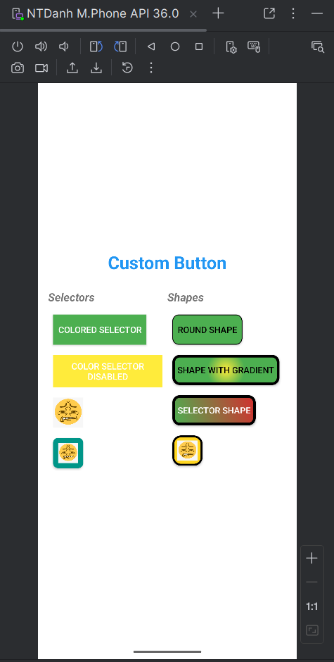
Bài tập 2: cải tiến bài tập 1, thêm custom toast và dialog
Sử dụng lại layout của bài tập 1, thêm 2 button custom toast và dialog
activity_baitap2.xml:
<-- code activity_baitap1.xml -->
<LinearLayout
android:layout_width="match_parent"
android:layout_height="wrap_content"
android:orientation="horizontal"
android:gravity="center"
android:layout_marginTop="40dp">
<Button
android:id="@+id/btnCustomToast"
android:layout_width="120dp"
android:layout_height="120dp"
android:background="@drawable/btn_custom_toast"
android:text="Custom\nToast"
android:textColor="#FFFFFF"
android:textSize="18sp"
android:textStyle="bold"
android:layout_marginEnd="40dp"
android:elevation="12dp"/>
<Button
android:id="@+id/btnCustomDialog"
android:layout_width="120dp"
android:layout_height="120dp"
android:background="@drawable/btn_custom_dialog"
android:text="Custom\nDialog"
android:textColor="#FFFFFF"
android:textSize="18sp"
android:textStyle="bold"
android:elevation="12dp"/>
</LinearLayout>
Tạo layout custom_toast.xml:
<ImageView
android:layout_width="40dp"
android:layout_height="40dp"
android:src="@drawable/cool"
android:layout_marginEnd="12dp"/>
<TextView
android:layout_width="wrap_content"
android:layout_height="wrap_content"
android:text="Custom Toast"
android:textColor="#FFFFFF"
android:textSize="18sp"
android:textStyle="bold"/>

layout custom_dialog.xml:
<TextView
android:layout_width="match_parent"
android:layout_height="wrap_content"
android:text="Custom Dialog"
android:textSize="24sp"
android:textStyle="bold"
android:gravity="center"
android:textColor="#2196F3"
android:layout_marginBottom="16dp"/>
<ImageView
android:layout_width="80dp"
android:layout_height="80dp"
android:src="@drawable/cringe"
android:layout_gravity="center"
android:layout_marginBottom="16dp"/>
<EditText
android:layout_width="match_parent"
android:layout_height="wrap_content"
android:hint="Nhập text..."
android:layout_marginBottom="24dp"/>
<Button
android:id="@+id/btnCloseDialog"
android:layout_width="match_parent"
android:layout_height="wrap_content"
android:text="Đóng"
android:backgroundTint="#F44336"
android:textColor="#FFFFFF"/>

Code hàm xử lý cho bài tập 2:
Baitap2Activity.java:
protected void onCreate(Bundle savedInstanceState) {
super.onCreate(savedInstanceState);
setContentView(R.layout.activity_baitap2);
Button btnToast = findViewById(R.id.btnCustomToast);
Button btnDialog = findViewById(R.id.btnCustomDialog);
btnToast.setOnClickListener(v -> {
LayoutInflater inflater = getLayoutInflater();
View layout = inflater.inflate(R.layout.custom_toast, null);
Toast toast = new Toast(getApplicationContext());
toast.setGravity(Gravity.CENTER, 0, 0);
toast.setDuration(Toast.LENGTH_LONG);
toast.setView(layout);
toast.show();
});
btnDialog.setOnClickListener(v -> {
LayoutInflater inflater = getLayoutInflater();
View dialogView = inflater.inflate(R.layout.custom_dialog, null);
AlertDialog dialog = new AlertDialog.Builder(Baitap2Activity.this)
.setView(dialogView)
.setCancelable(false)
.create();
dialogView.findViewById(R.id.btnCloseDialog).setOnClickListener(close -> dialog.dismiss());
dialog.show();
});
}

Kết quả DEMO:
Giao diện bài tập 2:
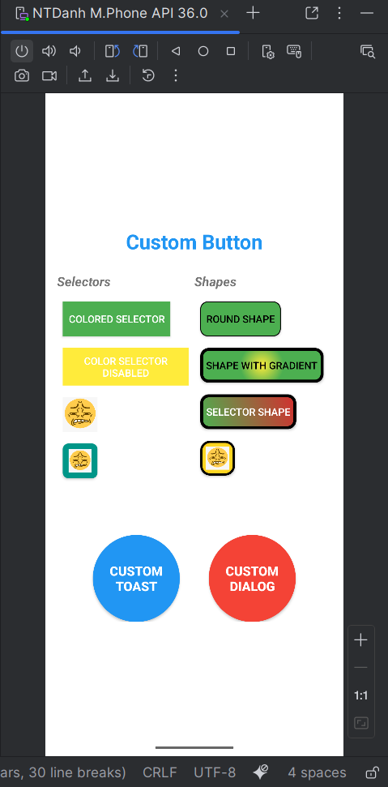
Khi nhấn nút Custom Toast tạo Toast mới hiển thị 3 giây.
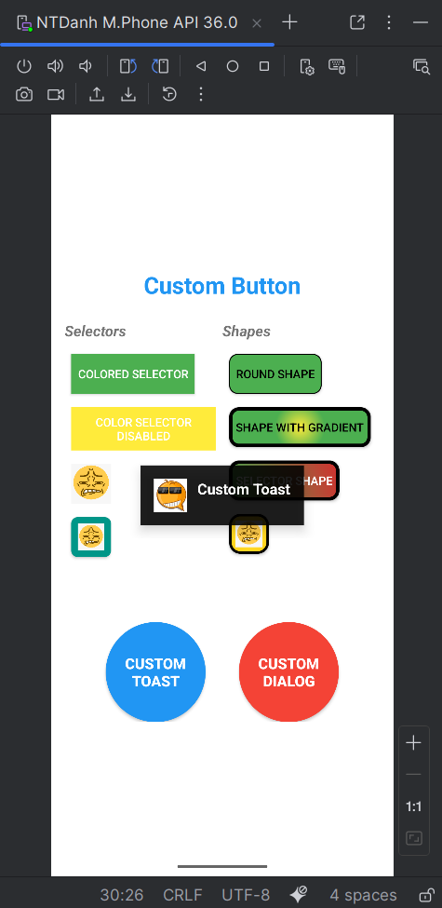

Khi nhấn nút Custom Dialog tạo AlertDialog đóng khi nhấn nút đóng bên trong.
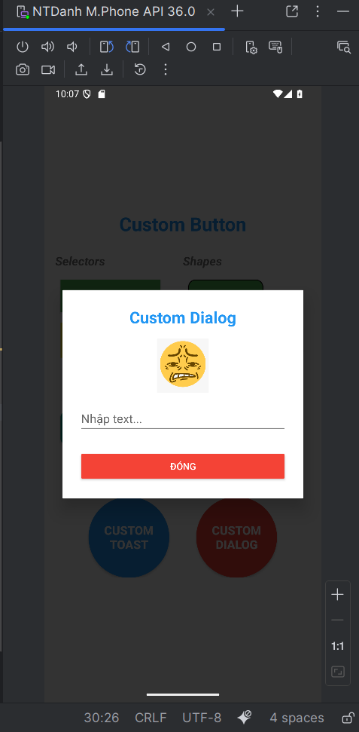

Bài tập 3: RGB, CMY – SEEKBAR
Tạo layout activity_baitap3.xml bao gồm 3 seekbar:
<SeekBar
android:id="@+id/sbRed"
android:layout_width="match_parent"
android:layout_height="wrap_content"
android:max="255"
android:progress="255"
android:progressDrawable="@drawable/seekbar_red"
android:thumb="@drawable/thumb_custom"
android:layout_marginBottom="16dp"/>
<SeekBar
android:id="@+id/sbGreen"
android:layout_width="match_parent"
android:layout_height="wrap_content"
android:max="255"
android:progress="0"
android:progressDrawable="@drawable/seekbar_green"
android:thumb="@drawable/thumb_custom"
android:layout_marginBottom="16dp"/>
<SeekBar
android:id="@+id/sbBlue"
android:layout_width="match_parent"
android:layout_height="wrap_content"
android:max="255"
android:progress="0"
android:progressDrawable="@drawable/seekbar_blue"
android:thumb="@drawable/thumb_custom"
android:layout_marginBottom="30dp"/>

Tạo 3 file seekbar 3 màu blue, green, red.
Ví dụ: tạo file res/drawable/seekbar_blue.xml:
<item android:id="@android:id/background">
<shape android:shape="rectangle">
<corners android:radius="10dp"/>
<solid android:color="#B0BEC5"/>
</shape>
</item>
<item android:id="@android:id/progress">
<clip>
<shape android:shape="rectangle">
<corners android:radius="10dp"/>
<gradient android:startColor="#2196F3" android:endColor="#64B5F6"/>
</shape>
</clip>
</item>

Tạo nút hiệu ứng kéo seekbar thumb_custom.xml (drawable)
<shape xmlns:android="http://schemas.android.com/apk/res/android"
android:shape="oval">
<size android:width="32dp" android:height="32dp"/>
<solid android:color="#FFFFFF"/>
<stroke android:width="4dp" android:color="#000000"/>
</shape>

Code view CMY activity_baitap3.xml:
<LinearLayout
android:layout_width="match_parent"
android:layout_height="100dp"
android:orientation="horizontal"
android:layout_marginBottom="20dp">
<View
android:id="@+id/viewC"
android:layout_width="0dp"
android:layout_height="match_parent"
android:layout_weight="1"
android:background="#00FFFF"
android:layout_marginEnd="8dp"
android:elevation="4dp"/>
<View
android:id="@+id/viewM"
android:layout_width="0dp"
android:layout_height="match_parent"
android:layout_weight="1"
android:background="#FF00FF"
android:layout_marginHorizontal="8dp"
android:elevation="4dp"/>
<View
android:id="@+id/viewY"
android:layout_width="0dp"
android:layout_height="match_parent"
android:layout_weight="1"
android:background="#FFFF00"
android:layout_marginStart="8dp"
android:elevation="4dp"/>
</LinearLayout>

Thêm textview Value để khi kéo màu seekbar sẽ hiển thị giá trị màu:
<TextView
android:id="@+id/tvValue"
android:layout_width="match_parent"
android:layout_height="wrap_content"
android:text="R: 255 | G: 0 | B: 0"
android:textSize="20sp"
android:textStyle="bold"
android:gravity="center"
android:textColor="#1976D2"
android:background="#EEEEEE"
android:padding="12dp"/>

Thêm viewcolor để khi kéo màu trên các seekbar sẽ hiển thị màu theo giá trị:
<View
android:id="@+id/viewColor"
android:layout_width="match_parent"
android:layout_height="180dp"
android:background="#FF0000"
android:layout_marginBottom="30dp"
android:elevation="8dp"/>

Code hàm updateColor() file Baitap3Activity.java:
private void updateColor() {
int r = sbRed.getProgress();
int g = sbGreen.getProgress();
int b = sbBlue.getProgress();
int color = Color.rgb(r, g, b);
viewColor.setBackgroundColor(color);
int c = 255 - r;
int m = 255 - g;
int y = 255 - b;
viewC.setBackgroundColor(Color.rgb(0, m, y));
viewM.setBackgroundColor(Color.rgb(r, 0, y));
viewY.setBackgroundColor(Color.rgb(r, g, 0));
tvValue.setText(String.format("R: %d | G: %d | B: %d", r, g, b));
}
Tóm tắt chức năng updateColor():
- Lấy giá trị hiện tại của 3 SeekBar
- Tạo màu RGB và tô vào ô lớn (viewColor)
- Tính 3 giá trị C, M, Y = 255 – R/G/B
- Tô đúng 3 màu Cyan, Magenta, Yellow vào 3 ô nhỏ
- Cập nhật dòng chữ hiển thị giá trị RGB realtime

Cuối cùng hàm onCreate() nạp layout activity_baitap3:
protected void onCreate(Bundle savedInstanceState) {
super.onCreate(savedInstanceState);
setContentView(R.layout.activity_baitap3);
sbRed = findViewById(R.id.sbRed);
sbGreen = findViewById(R.id.sbGreen);
sbBlue = findViewById(R.id.sbBlue);
viewColor = findViewById(R.id.viewColor);
viewC = findViewById(R.id.viewC);
viewM = findViewById(R.id.viewM);
viewY = findViewById(R.id.viewY);
tvValue = findViewById(R.id.tvValue);
SeekBar.OnSeekBarChangeListener listener = new SeekBar.OnSeekBarChangeListener() {
@Override
public void onProgressChanged(SeekBar seekBar, int progress, boolean fromUser) {
updateColor();
}
@Override public void onStartTrackingTouch(SeekBar seekBar) {}
@Override public void onStopTrackingTouch(SeekBar seekBar) {}
};
sbRed.setOnSeekBarChangeListener(listener);
sbGreen.setOnSeekBarChangeListener(listener);
sbBlue.setOnSeekBarChangeListener(listener);
updateColor();
}

Kết quả: Giao diện bài tập 3
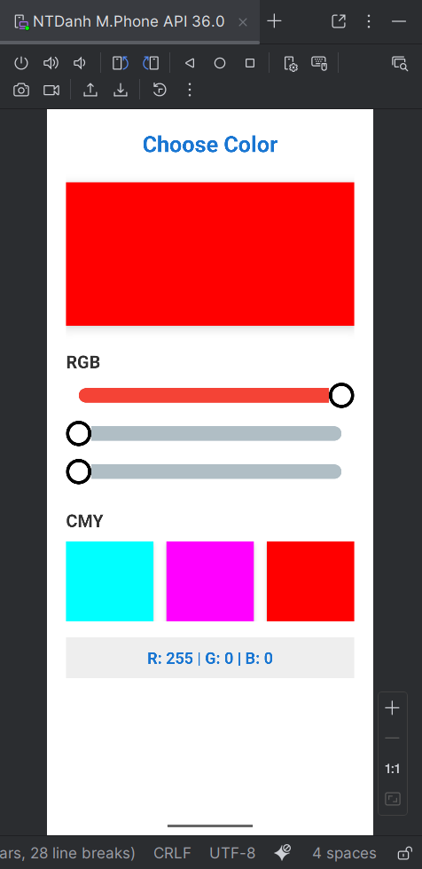
Thay đổi các giá trị RGB trên seekbar:
