Môn: Lập trình đa nền tảng
Tên: Nguyễn Thành Danh
MSSV: 1150080046
Lab: Thực hành Lab02

Bài 1: viết code để mỗi khi chạy lên sẽ ra một màu nền khác nhau và 1 icon khác nhau.
File m001_act_splash.xml
<ImageView
android:id="@+id/img_icon"
android:layout_width="128dp"
android:layout_height="128dp"
android:src="@drawable/pepe1"
tools:ignore="ContentDescription" />
<TextView
android:layout_width="wrap_content"
android:layout_height="wrap_content"
android:layout_marginTop="10dp"
android:fontFamily="sans-serif-light"
android:text="@string/app_name"
android:textColor="@color/white"
android:textSize="24sp" />

File M001ActSplash.java
public class M001ActSplash extends AppCompatActivity {
private LinearLayout mainLayout;
private ImageView imgIcon;
private Random random = new Random();
@Override
protected void onCreate(Bundle savedInstanceState) {
super.onCreate(savedInstanceState);
setContentView(R.layout.m001_act_splash);
mainLayout = findViewById(R.id.main_layout);
imgIcon = findViewById(R.id.img_icon);
// Thay đổi màu nền ngẫu nhiên
int[] colors = {
R.color.red,
R.color.green,
R.color.blue,
R.color.yellow,
R.color.purple
};
int randomColor = colors[random.nextInt(colors.length)];
mainLayout.setBackgroundColor(getResources().getColor(randomColor, null));
// Thay đổi icon ngẫu nhiên
int[] icons = {
R.drawable.pepe1,
R.drawable.pepe2,
R.drawable.pepe3
};
int randomIcon = icons[random.nextInt(icons.length)];
imgIcon.setImageResource(randomIcon);
}
}

Kết quả DEMO rerun app nhiều lần:
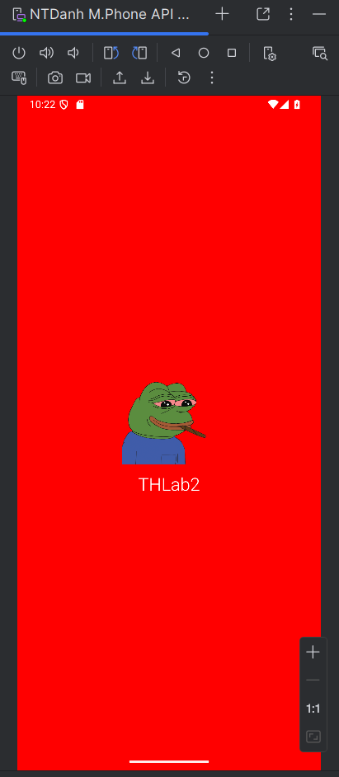
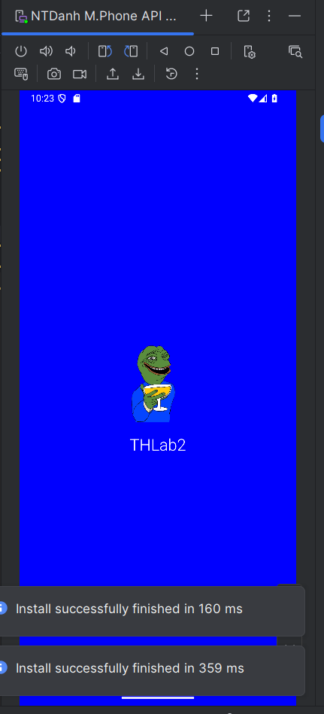

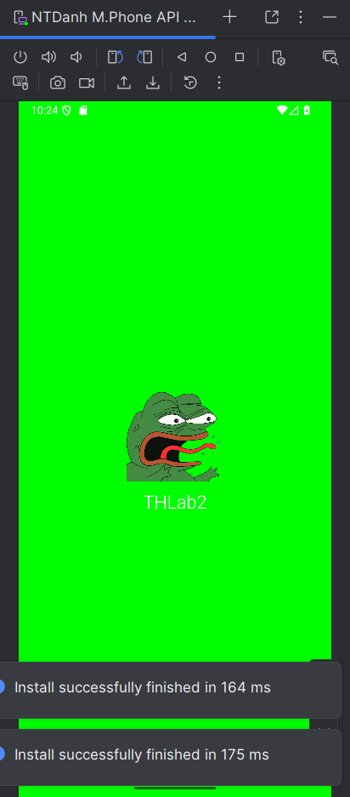
Bài 2: sử dụng Custom ProgressBar để làm giao diện đẹp hơn.
File m001_act_splash.xml

<LinearLayout
android:layout_width="match_parent"
android:layout_height="match_parent"
android:gravity="center"
android:orientation="vertical">
<ImageView
android:layout_width="128dp"
android:layout_height="128dp"
android:src="@drawable/pepe1"
tools:ignore="ContentDescription" />
<TextView
android:layout_width="wrap_content"
android:layout_height="wrap_content"
android:layout_marginTop="10dp"
android:fontFamily="sans-serif-light"
android:text="@string/app_name"
android:textColor="@color/white"
android:textSize="24sp" />
</LinearLayout>
<include layout="@layout/item_loading" />

File M001ActSplash.java
public class M001ActSplash extends AppCompatActivity {
@Override
protected void onCreate(Bundle savedInstanceState){
super.onCreate(savedInstanceState);
setContentView(R.layout.m001_act_splash);
}
}

Kết quả DEMO:

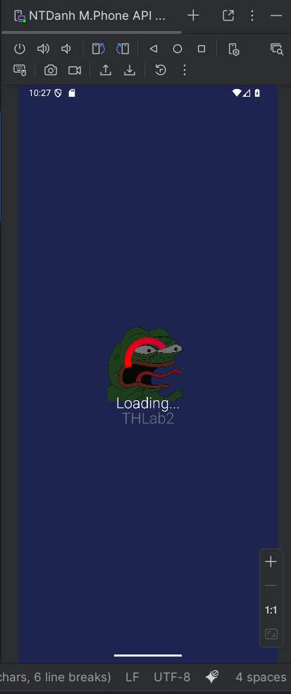
Bài 3: Lập trình để khi bấm vào icon (phone) thì chuyển về cuộc gọi, sử dụng Intent.

File m001_act_profile.xml
<!-- Header (ảnh nền, tên, avatar) -->
<FrameLayout
android:layout_width="match_parent"
android:layout_height="350dp">
<ImageView
android:layout_width="match_parent"
android:layout_height="300dp"
android:scaleType="centerCrop"
android:src="@drawable/bg_connor"
tools:ignore="ContentDescription" />
<TextView
android:layout_width="wrap_content"
android:layout_height="wrap_content"
android:layout_gravity="bottom"
android:layout_marginStart="70dp"
android:layout_marginBottom="80dp"
android:fontFamily="sans-serif"
android:text="@string/txt_name"
android:textColor="@color/white"
android:textSize="40sp" />
<ImageView
android:layout_width="80dp"
android:layout_height="80dp"
android:layout_gravity="end|bottom"
android:layout_marginEnd="20dp"
android:layout_marginBottom="20dp"
android:background="@drawable/bg_oval"
android:padding="20dp" />
</FrameLayout>
<!-- Phone section -->
<TableRow
android:layout_width="match_parent"
android:layout_height="wrap_content"
android:padding="20dp">
<ImageView
android:id="@+id/img_phone1"
android:layout_width="60dp"
android:layout_height="60dp"
android:padding="10dp"
android:src="@drawable/ic_phone"
app:tint="@color/blue"
tools:ignore="ContentDescription" />
<LinearLayout
android:layout_width="match_parent"
android:layout_height="wrap_content"
android:layout_marginStart="5dp"
android:orientation="vertical">
<TextView
android:id="@+id/txt_phone1"
android:layout_width="match_parent"
android:layout_height="wrap_content"
android:text="@string/txt_phone1"
android:textColor="@color/gray_dark"
android:textSize="20sp" />
<TextView
android:id="@+id/txt_title_mobile"
android:layout_width="match_parent"
android:layout_height="wrap_content"
android:layout_marginTop="5dp"
android:text="@string/txt_title_mobile"
android:textColor="@color/gray_mid"
android:textSize="18sp" />
<View
android:layout_width="match_parent"
android:layout_height="0.5dp"
android:layout_marginTop="30dp"
android:background="@color/gray_mid" />
</LinearLayout>
</TableRow>
<!-- Email section -->
<TableRow
android:layout_width="match_parent"
android:layout_height="wrap_content"
android:padding="20dp">
<ImageView
android:id="@+id/img_email"
android:layout_width="60dp"
android:layout_height="60dp"
android:padding="10dp"
android:src="@drawable/ic_email"
app:tint="@color/blue"
tools:ignore="ContentDescription" />
<LinearLayout
android:layout_width="match_parent"
android:layout_height="wrap_content"
android:layout_marginStart="30dp"
android:orientation="vertical">
<TextView
android:id="@+id/txt_email"
android:layout_width="match_parent"
android:layout_height="wrap_content"
android:text="@string/txt_email"
android:textColor="@color/gray_dark"
android:textSize="20sp" />
<TextView
android:layout_width="match_parent"
android:layout_height="wrap_content"
android:layout_marginTop="5dp"
android:text="@string/txt_title_mobile"
android:textColor="@color/gray_mid"
android:textSize="18sp" />
</LinearLayout>
</TableRow>

File M001ActProfile.java
@Override
protected void onCreate(Bundle savedInstanceState) {
super.onCreate(savedInstanceState);
setContentView(R.layout.m001_act_profile);
imgPhone1 = findViewById(R.id.img_phone1);
txtPhone1 = findViewById(R.id.txt_phone1);
// bấm icon gọi
imgPhone1.setOnClickListener(v -> makePhoneCall());
txtPhone1.setOnClickListener(v -> makePhoneCall());
}
private void makePhoneCall() {
String phoneNumber = txtPhone1.getText().toString().trim();
phoneNumber = phoneNumber.replaceAll("[^0-9]+", "");
if (phoneNumber.isEmpty()) {
Toast.makeText(this, "Phone number is empty", Toast.LENGTH_SHORT).show();
return;
}
if (ContextCompat.checkSelfPermission(this, Manifest.permission.CALL_PHONE)
!= PackageManager.PERMISSION_GRANTED) {
ActivityCompat.requestPermissions(
this,
new String[]{Manifest.permission.CALL_PHONE},
REQUEST_CALL_PHONE
);
return;
}
// Cấp quyền -> gọi
Intent callIntent = new Intent(Intent.ACTION_CALL);
callIntent.setData(Uri.parse("tel:" + phoneNumber));
try {
startActivity(callIntent);
} catch (SecurityException e) {
Toast.makeText(this, "Call failed: " + e.getMessage(), Toast.LENGTH_SHORT).show();
}
}
// Kết quả xin quyền
@Override
public void onRequestPermissionsResult(int requestCode,
@NonNull String[] permissions,
@NonNull int[] grantResults) {
super.onRequestPermissionsResult(requestCode, permissions, grantResults);
if (requestCode == REQUEST_CALL_PHONE) {
if (grantResults.length > 0 && grantResults[0] == PackageManager.PERMISSION_GRANTED) {
// user vừa cho quyền -> gọi tiếp
makePhoneCall();
} else {
Toast.makeText(this, "Permission CALL_PHONE denied", Toast.LENGTH_SHORT).show();
}
}
}

Kết quả DEMO:
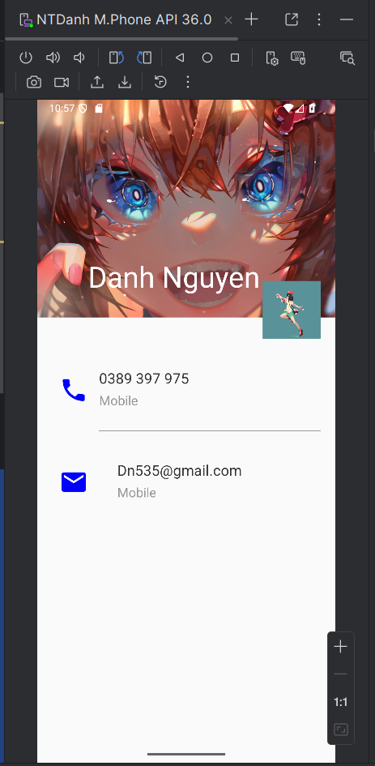
Bấm vào icon phone để gọi tới:
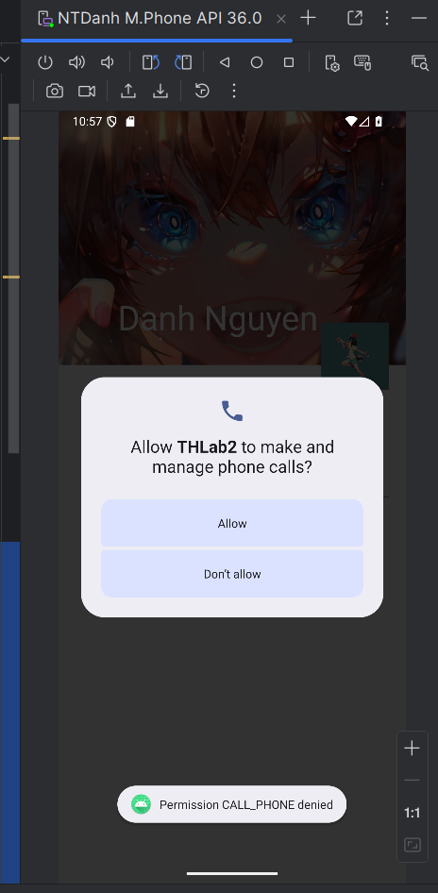
Cấp quyền và gọi:
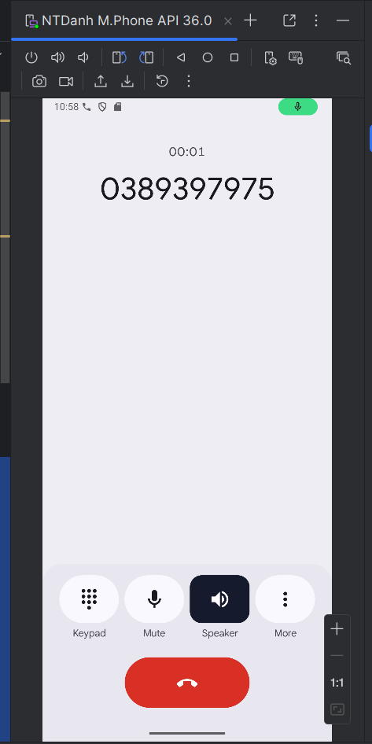
Bài 4:
File activity_main.xml:
<TextView
android:layout_width="wrap_content"
android:layout_height="wrap_content"
android:text="Lab 2 Menu"
android:textSize="24sp"
android:textColor="@color/black"
android:layout_marginBottom="32dp" />
<Button
android:id="@+id/btn_splash"
android:layout_width="match_parent"
android:layout_height="wrap_content"
android:text="Go to Splash Screen"
android:layout_marginBottom="16dp" />
<Button
android:id="@+id/btn_profile"
android:layout_width="match_parent"
android:layout_height="wrap_content"
android:text="Go to Profile Screen" />
File MainActivity.java
@Override
protected void onCreate(Bundle savedInstanceState) {
super.onCreate(savedInstanceState);
setContentView(R.layout.activity_main);
Button btnSplash = findViewById(R.id.btn_splash);
Button btnProfile = findViewById(R.id.btn_profile);
// Nút chuyển sang Splash Screen
btnSplash.setOnClickListener(v -> {
Intent intent = new Intent(MainActivity.this, M001ActSplash.class);
startActivity(intent);
});
// Nút chuyển sang Profile Screen
btnProfile.setOnClickListener(v -> {
Intent intent = new Intent(MainActivity.this, M001ActProfile.class);
startActivity(intent);
});
}

Kết quả DEMO:
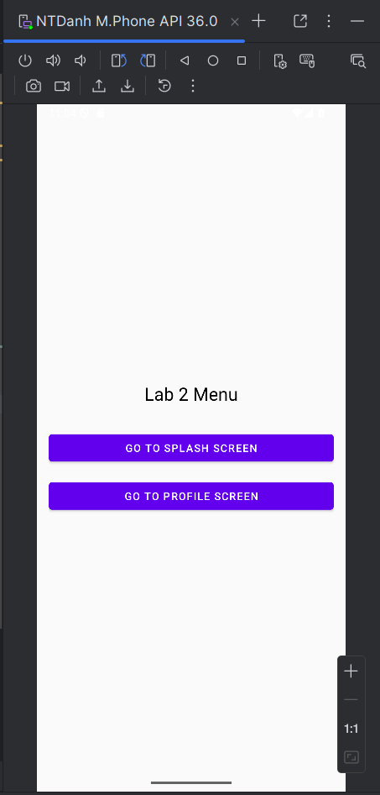

Nhấn vào GO TO SPLASH SCREEN:
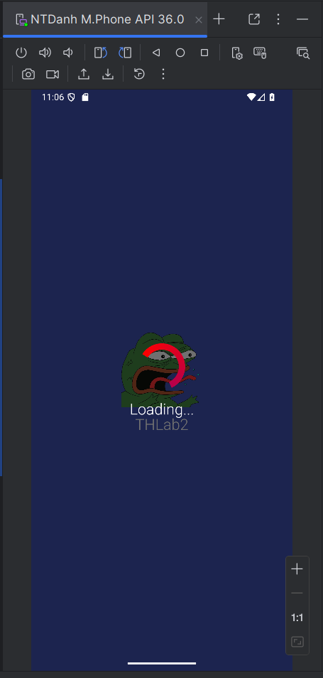

Nhấn vào GO TO SPLASH PROFILE SCREEN:
