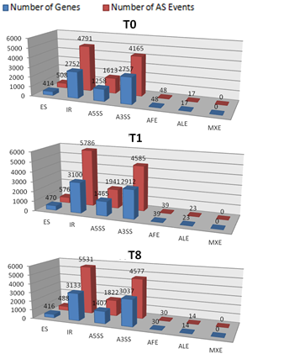

**Additional file 5. Alternative splicing events discovered by RNA-seq.** Blue bars indicated numbers of genes with alternative splicing events and red ones indicated alternative splicing event number in each sample.