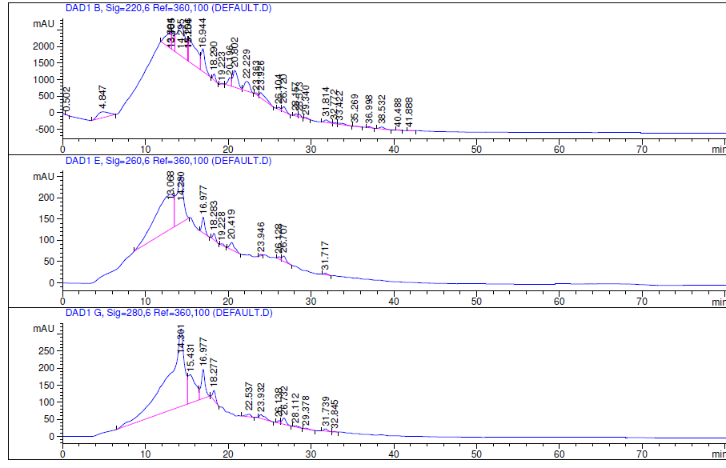

**Additional file 8. Peptides fractions separated profiles by SCX.** The above one shown OD220, OD260 and OD280 profiles, respectively.