clc;
clear all;
Score = 0;
People = 0;
Lug=0;
for i=.5:.01:.75
for P=10:1:100
C=P*i;
Q = (P*(.125))+(C);
if Q<35
S=(100*P)+(50*C);
Score = [Score S];
People = [People P];
Lug = [Lug C];
end
end
end
figure (1)
plot(Score)
legend('Score')
figure (2)
plot(People)
hold on
plot(Lug)
hold on
legend('People','Lug')
WW = max(Score);
SCell=num2cell(Score);
L=cellfun(@(x) find(x==WW),SCell,'Un',0);
Location= find(not(cellfun('isempty',L)));
SL=Score(Location);
PL=People(Location);
LL=Lug(Location);
LR=LL/PL;
PW=55-LL;
TennisW = PL*.125;
Load = TennisW+LL;
planeW = 40-Load;
slx=['Max Score = $',num2str(SL)];
plx=['Max People = ',num2str(PL)];
llx=['Max Luggage = ',num2str(LL)];
lrx=['Luggage Ratio = ',num2str(LR)];
pwx=['Plane Weight = ',num2str(planeW)];
disp(slx)
disp(plx)
disp(llx)
disp(lrx)
disp(pwx)
Max Score = $6902.5
Max People = 55
Max Luggage = 28.05
Luggage Ratio = 0.51
Plane Weight = 5.075
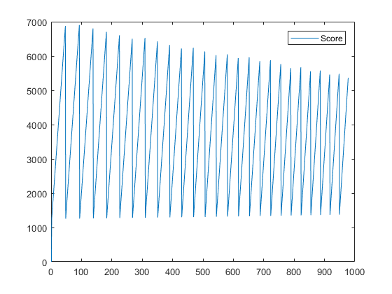
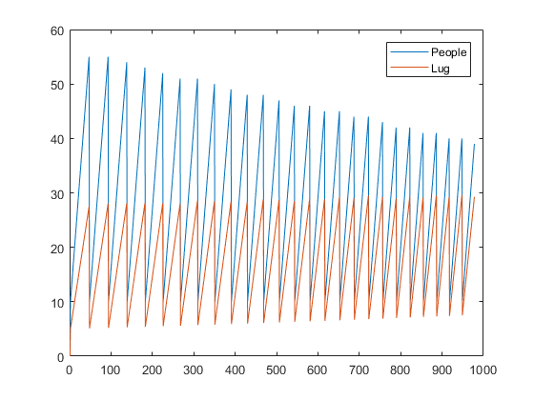
Published with MATLAB® R2017b

