I2C:

Synchronous master-slave protocol
- m-l can send-receive data
- bidirectional, half-duplex
- run at dif speed
2 wire:
serial clock SCL
serial data SDA
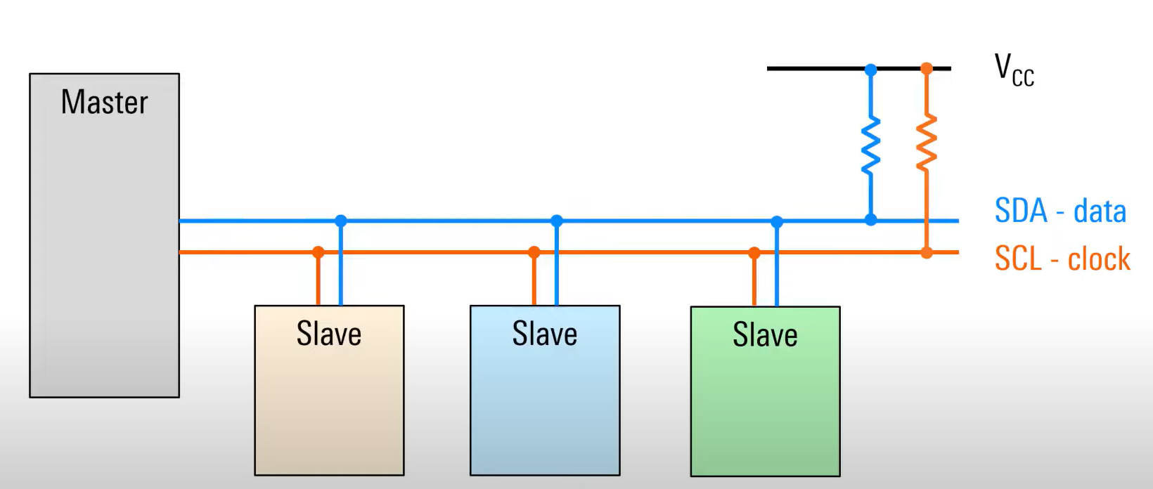

IC2 frame:
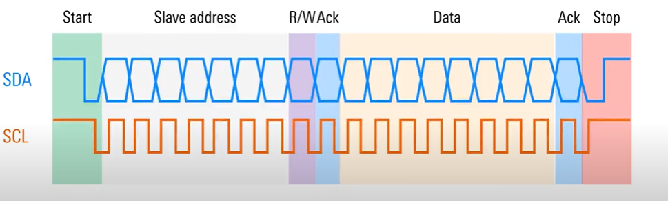
- Start
First pull SDA low then pulls SCL low
- Slave address
- R/W Ack
0-master want to write data to slave
1-master want to read date from slave

- Data
- Ack
- Stop
SDA transition when SCL high = stop condition

Timing relationship between SDA & SCL:
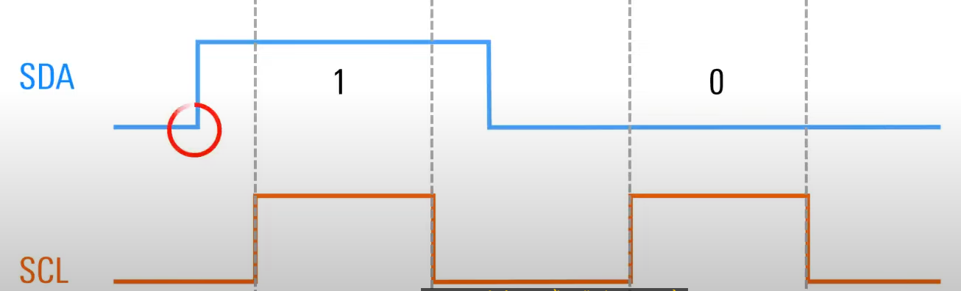
SDA only transitions while SCL low

Multi-data byte:
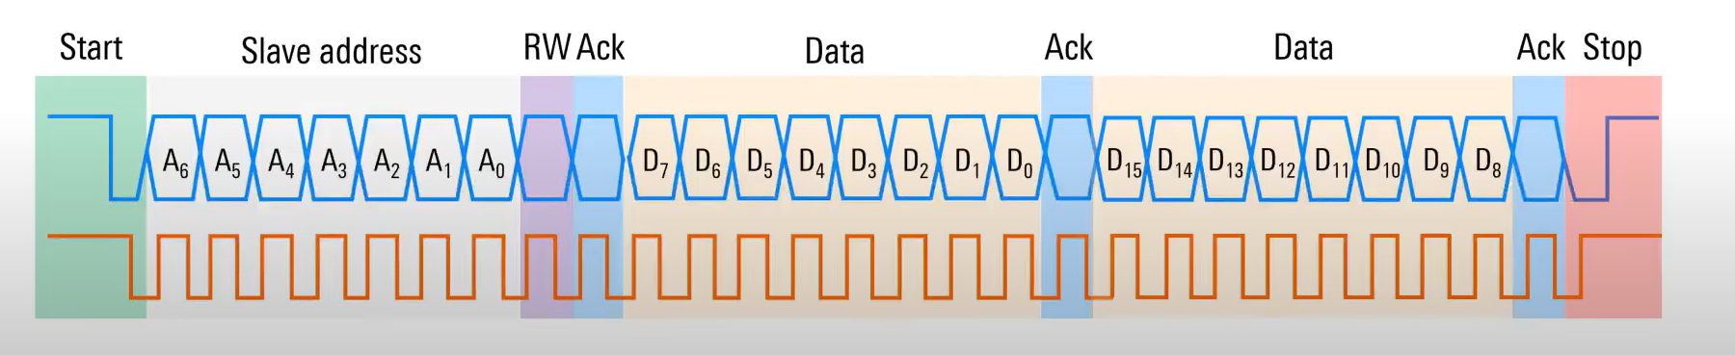
=>require FIFO

