Vehicle Rental Agency Database using MongoDB
Project Report

Introduction
The Vehicle Rental Agency Database Management System is developed using MongoDB and Spring Boot to manage vehicle rental operations efficiently. The system handles customers, vehicles, reservations, locations, and administrators.

Outcome
Efficient storage and retrieval of rental information, scalable NoSQL architecture, fast query processing, and practical implementation of MongoDB CRUD operations.

Tools Used with Versions
Java JDK 17+
Spring Boot 3.x
MongoDB 6.x
Maven 3.8+
Postman (Latest)
VS Code / IntelliJ IDEA (Latest)

Output Screenshots

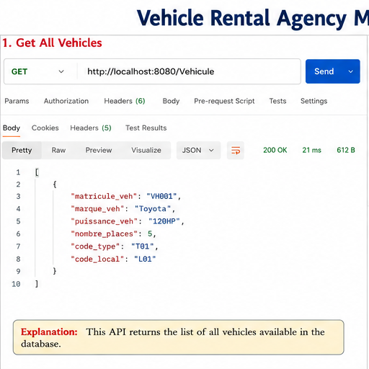

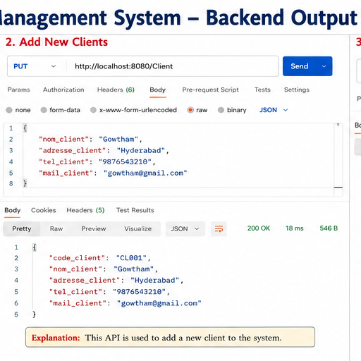

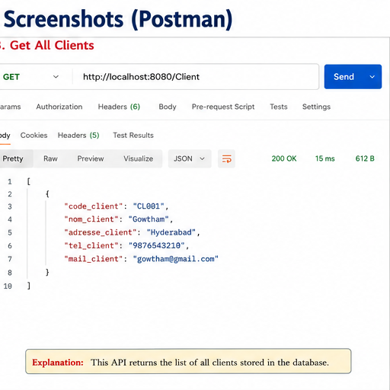
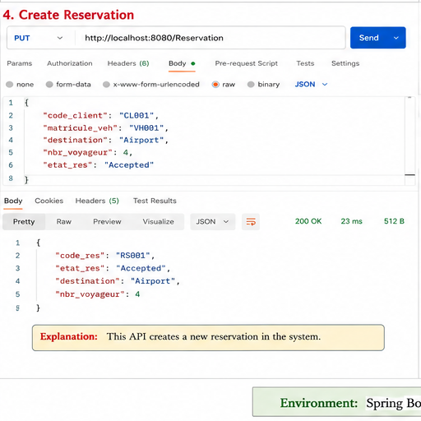

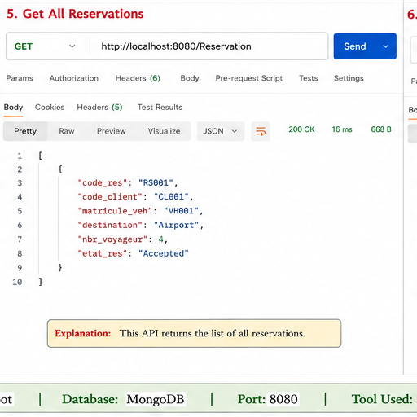
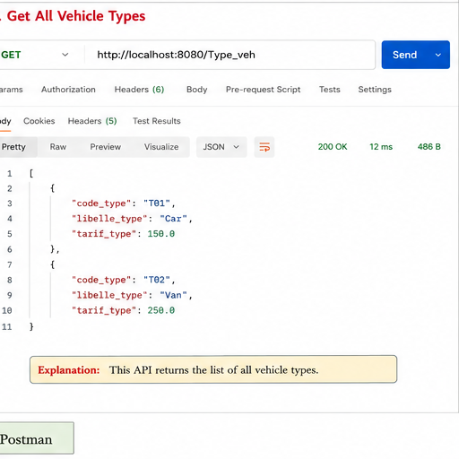
Explanation: These screenshots demonstrate successful implementation and testing of the Vehicle Rental Agency Database.

Summary
The project demonstrates integration of MongoDB with Spring Boot to create a complete Vehicle Rental Management System. REST APIs enable efficient management of customers, vehicles, and reservations.

Conclusion
The Vehicle Rental Agency Database Management System successfully fulfills rental business requirements using MongoDB's scalable NoSQL architecture and Spring Boot's robust API framework. Future enhancements can include authentication, payments, analytics, and mobile support.

