Institute of Technology of Cambodia
Department of Information Technology

Data Engineering Pipeline for
Credit Risk Modelling

Architecture, Technology Stack, Pipeline Design, and RAG Chat Interface

Group Members

Name | Student ID | Role
SOPHON Rachana | e20220725 | Group Member
LOT Soklang | e20221464 | Group Member
DUK Pagnarith | e20220184 | Group Member
LENG Devid | e20220888 | Group Member

Under the supervision of Lecturer TOEM TOUCH

Academic Year: 2025-2026
Phnom Penh, Cambodia

Abstract
This paper describes the design, implementation, and rationale of the data engineering pipeline underpinning a production-grade credit risk modelling system built on the Lending Club peer-to-peer lending dataset. The system ingests 2,260,668 loan records (1.6 GB raw CSV) and transforms them into regulatory-grade model inputs through six Apache Airflow orchestration DAGs, two Apache Spark jobs, a five-schema PostgreSQL data warehouse, and a MinIO S3-compatible data lake.

The six pipelines are: (1) Ingestion — column-projected PySpark ingest in approximately 7 seconds; (2) Cleaning — removal of 57 leaking/null/irrelevant columns with out-of-time split; (3) Feature Engineering — Weight of Evidence (WoE) encoding producing 56 binary dummies from 16 raw predictors; (4) Model Training — PD logistic regression scorecard, LGD two-stage regression, and EAD linear regression, all tracked in MLflow; (5) Batch Scoring — computing Expected Loss, IFRS 9 ECL, and Basel III AIRB capital per loan; and (6) Monitoring — daily Population Stability Index (PSI) computation with Grafana alerting.

This updated version introduces Chapter 10: a Retrieval-Augmented Generation (RAG) chat interface that allows users to query both research reports and loan data interactively via a Streamlit dashboard, powered by ChromaDB vector stores and the DeepSeek large language model.

Keywords: data engineering, Apache Airflow, Apache Spark, PySpark, MLflow, PostgreSQL, MinIO, FastAPI, credit risk, ETL pipeline, model monitoring, PSI, RAG, ChromaDB, LangChain, Streamlit.

Chapter 1 Introduction

1.1 Motivation
Academic credit risk research has made substantial progress in improving model discrimination metrics, yet the engineering infrastructure required to deploy and maintain a credit risk model in production is almost entirely absent from the literature. A logistic regression scorecard that achieves Gini = 0.387 on a 538,515-row out-of-time test set is a research result; the same scorecard embedded in a governed, auditable, monitored pipeline that ingests raw data daily, validates data quality, retrains on a schedule, serves real-time credit decisions via an API, and fires alerts when the population shifts — that is a production data engineering system.

This paper documents the data engineering architecture of such a system, built on the publicly available Lending Club peer-to-peer lending dataset. The dataset covers 2,260,668 loan applications from 2007 to 2018, spanning 151 columns and approximately 1.6 gigabytes in its raw CSV form.

1.2 What is Data Engineering in Credit Risk?
In the context of credit risk modelling, data engineering refers to the set of processes, tools, and infrastructure that:
- Move data from its raw source into a form usable by statistical models.
- Transform data by cleaning, validating, encoding, and splitting it in a way that prevents target leakage, preserves regulatory audit trails, and maintains reproducibility.
- Orchestrate the sequence of transformations as a directed acyclic graph (DAG) of tasks, so that each step depends on the successful completion of the previous step and can be retried, monitored, and re-run independently.
- Serve model outputs in real time to operational systems with sub-second latency.
- Monitor both the data distribution and the model outputs over time, detecting population shift and model degradation before they produce incorrect credit decisions.

A sixth capability, added in this updated version, is intelligent document retrieval: allowing users to query both the pipeline documentation and the scored loan data using natural language through a Retrieval-Augmented Generation (RAG) chat interface.

1.3 Paper Structure
Chapter 2 describes the overall system architecture. Chapter 3 describes the five-schema PostgreSQL data warehouse. Chapter 4 describes the six Airflow DAGs. Chapter 5 describes the PySpark transformation jobs. Chapter 6 describes MLflow. Chapter 7 describes the FastAPI scoring service. Chapter 8 describes monitoring infrastructure. Chapter 9 presents verified pipeline run results. Chapter 10 introduces the new RAG Chat Interface. Chapter 11 discusses design decisions and limitations. Chapter 12 concludes.

Chapter 2 System Architecture

2.1 Architecture Overview
The system is organised into five horizontal layers, each corresponding to a distinct engineering concern:
- Ingestion and Storage Layer — Raw CSV files are stored in MinIO (an on-premise, S3-compatible object store) and ingested into a five-schema PostgreSQL data warehouse via PySpark.
- Processing Layer — Apache Spark (PySpark) performs large-scale data transformation: cleaning, feature engineering, and batch scoring.
- Orchestration Layer — Apache Airflow schedules, sequences, and monitors the six processing DAGs, providing full audit trails of every pipeline run, task-level retries, and SLA tracking.
- ML and Serving Layer — MLflow tracks all model training experiments and manages the model registry. A FastAPI service provides real-time credit scoring via a REST endpoint, with Redis caching hot applicant features.
- Monitoring Layer — Prometheus collects time-series metrics (PSI, CSI, API latency, pipeline run status). Grafana visualises these metrics and fires alert notifications when thresholds are breached.

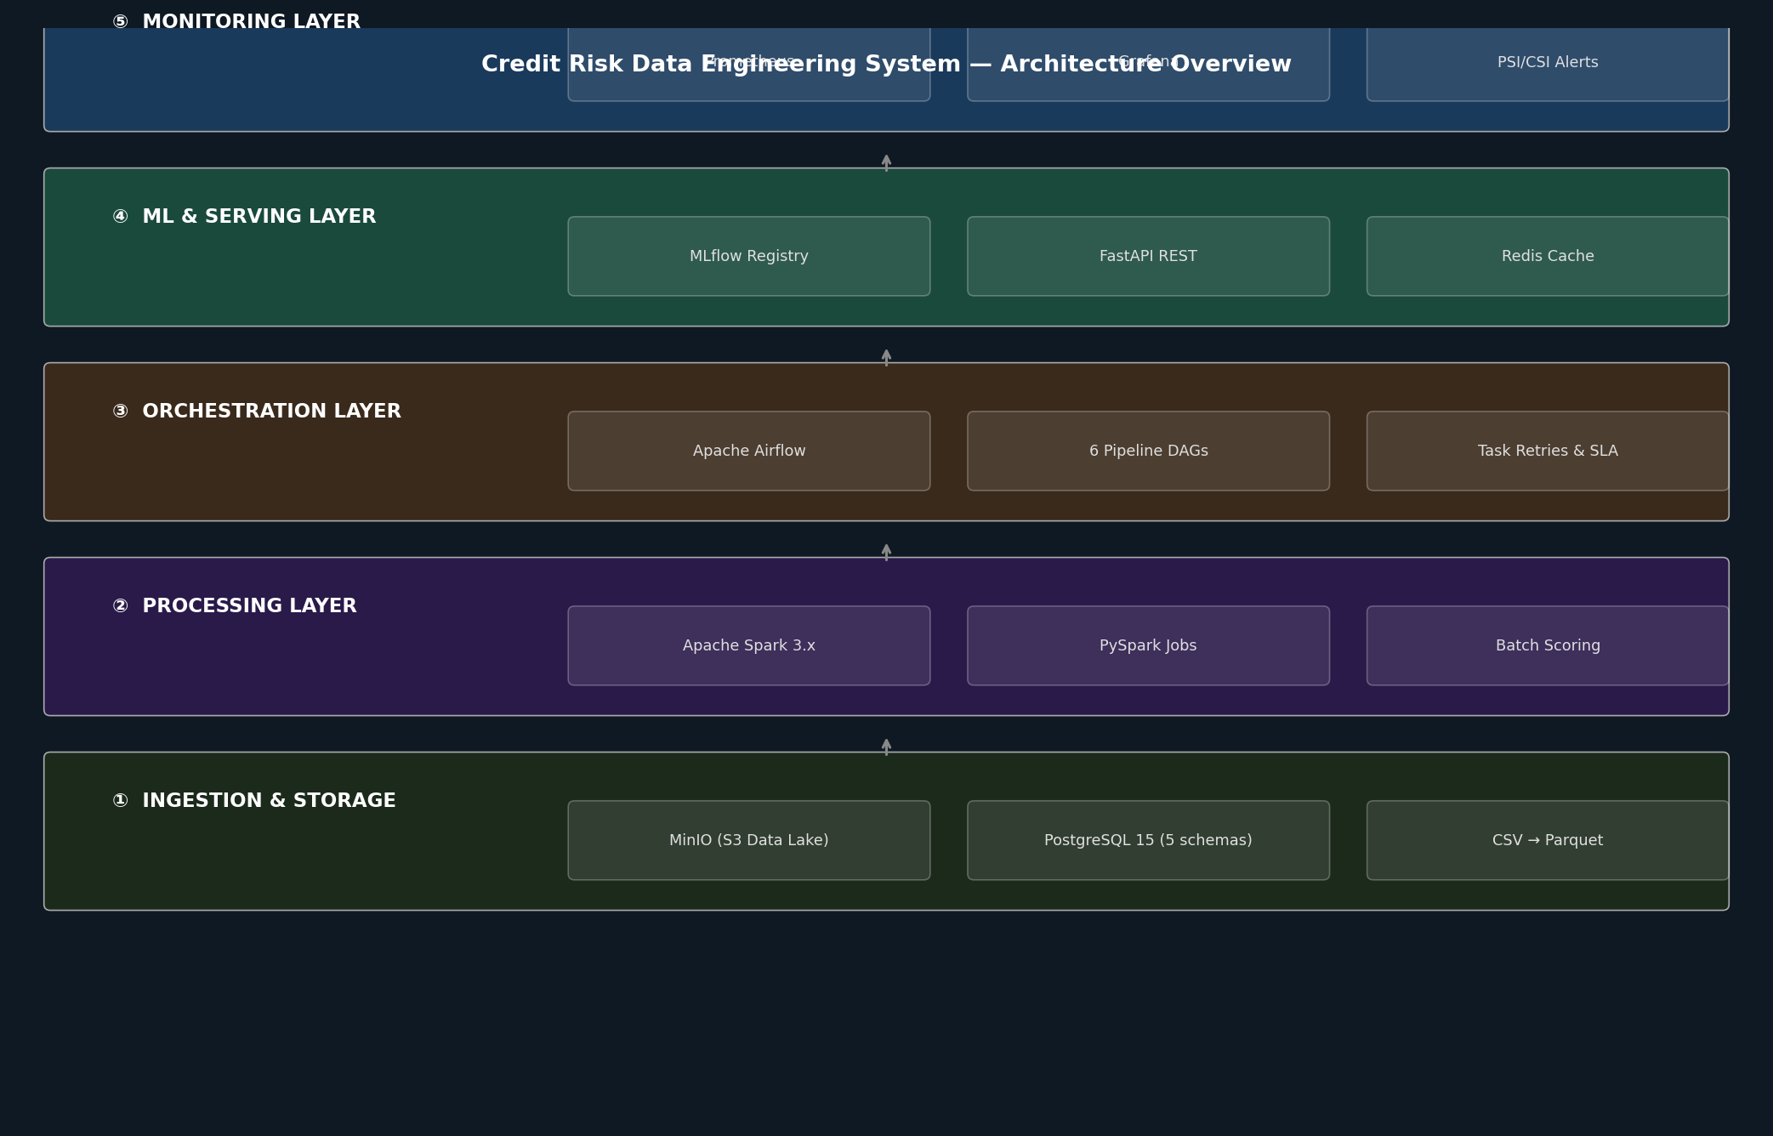
Figure 2.1: Five-layer credit risk system architecture

2.2 Technology Stack
Layer | Technology | Rationale
Orchestration | Apache Airflow 2.x | Industry-standard DAG scheduler; auditable task logs, retry logic, SLA tracking
Big Data | Apache Spark 3.x | Distributed compute for 2.26M rows; column-projected ingest reduces load to ~7 seconds
Data Lake | MinIO (S3-compat.) | On-premise object store; S3 API-compatible with PySpark; no cloud dependency
Data Warehouse | PostgreSQL 15 | ACID-compliant; five logical schemas implement medallion architecture
ML Tracking | MLflow 2.x | Experiment tracking, model registry with stage gates; artefact storage in MinIO
Model Serving | FastAPI + Redis | Async Python API; sub-200ms p99 latency; Redis for feature caching
Monitoring | Prometheus + Grafana | Time-series metrics collection and dashboarding; alert rules on PSI breach
RAG Chat | ChromaDB + LangChain | Local vector stores for PDF and parquet data; queried via Streamlit chat UI
Table 2.1: Technology stack and rationale

All services run as Docker containers orchestrated by Docker Compose, making the full stack reproducible on any machine with Docker installed. The entire stack starts with a single command: docker compose up -d.

2.3 End-to-End Data Flow
The end-to-end data flow through all six pipeline DAGs is illustrated in Figure 2.2 below, from raw CSV ingestion through to daily monitoring and the new RAG chat interface.
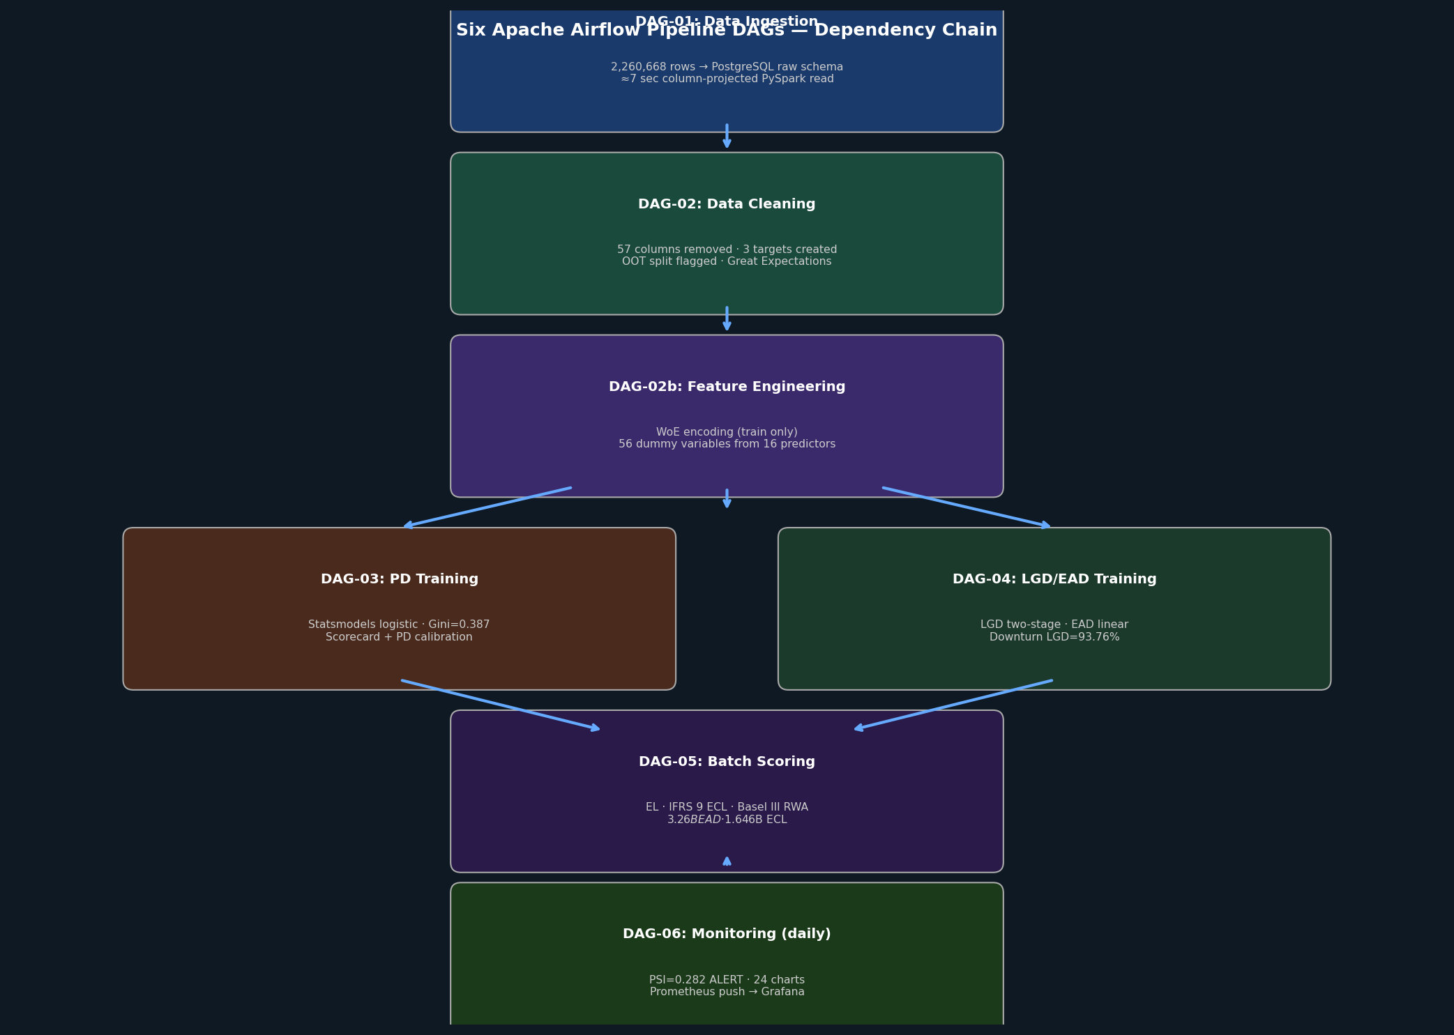
Figure 2.2: End-to-end data flow through the six pipeline DAGs

2.4 Infrastructure: Docker Compose Services
The full stack runs as 11 Docker Compose services. Key services include: postgres (data warehouse), minio (data lake), spark-master and spark-worker (distributed processing), airflow-webserver and airflow-scheduler (DAG orchestration), mlflow (experiment tracking), api (FastAPI scoring), redis (feature cache), prometheus and grafana (monitoring).

[ SCREENSHOT PLACEHOLDER ]
Airflow Webserver UI — http://localhost:8081
Showing all 6 DAGs with status, last run time, and schedule
Insert actual screenshot here
Figure 2.3: [PLACEHOLDER] Apache Airflow Web UI — insert screenshot from http://localhost:8081

Chapter 3 Database Design

3.1 Five-Schema Medallion Architecture
The PostgreSQL data warehouse implements a medallion architecture with five logical schemas, each representing a distinct stage of data maturity.
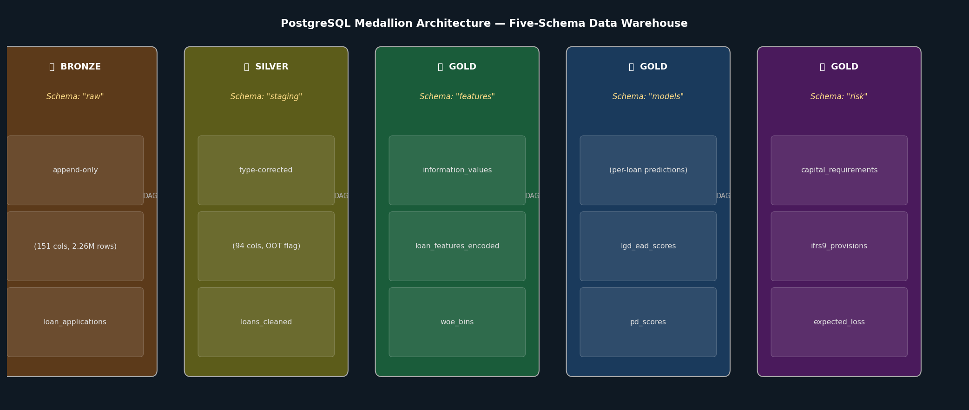
Figure 3.1: PostgreSQL medallion architecture — Bronze through Gold schemas

Schema | Layer | Purpose and Key Tables
raw | Bronze | Untouched CSV data loaded as-is from MinIO. loan_applications (151 cols, 2.26M rows). No transformations; append-only.
staging | Silver | Cleaned, type-corrected, validated data. loans_cleaned (94 cols) with OOT split flag. Target variables created here.
features | Gold | WoE bins, dummy variables, information values. woe_bins (fitted on training set only). loan_features_encoded (56 WoE dummies).
models | Gold | Model predictions and scores. pd_scores (credit score, PD, risk class). lgd_ead_scores (LGD, EAD per loan).
risk | Gold | Business risk outputs and regulatory reports. expected_loss, ifrs9_provisions, capital_requirements, population_stability.
Table 3.1: PostgreSQL schema design

3.2 Key Design Decisions
Out-of-time split flag in staging.
The dataset_split column ('train' for 2007-2015, 'oot' for 2016-2018) is set during the cleaning DAG and propagates through all downstream schemas. This ensures that WoE bins are always fitted exclusively on training-set rows.
WoE bins stored separately from encoded features.
The features.woe_bins table stores the bin boundaries and WoE values computed on the training set. This separation means the WoE mapping can be versioned, audited, and applied to new data independently of any model retraining.
Per-loan IFRS 9 records with audit fields.
The risk.ifrs9_provisions table stores the IFRS 9 stage (1, 2, or 3), the SICR trigger reason, the 12-month ECL, the lifetime ECL under each macroeconomic scenario, and the probability-weighted ECL. Every record carries a model_run_id and calc_date for full audit traceability.

Chapter 4 The Six Pipeline DAGs
The system contains six Apache Airflow DAGs, each responsible for a distinct pipeline stage. The full dependency chain is illustrated in Figure 4.1.

Figure 4.1: Airflow DAG dependency chain — from ingestion to monitoring

[ SCREENSHOT PLACEHOLDER ]
Airflow DAG Graph View — http://localhost:8081
Showing task dependencies within a single DAG run (e.g., DAG-03 PD Training)
Insert actual screenshot here
Figure 4.2: [PLACEHOLDER] Airflow DAG graph view — insert screenshot from Airflow UI

4.1 DAG-01: Data Ingestion
Trigger: Manual or scheduled when a new raw CSV is deposited in MinIO.
Technology: PySpark (column-projected read), MinIO S3A connector, PostgreSQL JDBC writer.
What it does: PySpark reads only the 26 modelling-relevant columns from the 151-column file using column projection, reducing Spark read time from ~60 seconds to ~7 seconds. Basic typecasting is applied at ingest time. The parsed data is written to raw.loan_applications in PostgreSQL using JDBC batch write, and a backup Parquet copy is written to MinIO.

4.2 DAG-02: Data Cleaning
Trigger: Downstream of DAG-01 completion.
Technology: PySpark transformation job, Great Expectations validation suite.
What it does: 57 columns are removed across five categories. Post-application leakage columns (total_pymnt, recoveries, out_prncp) are used first to create the three target variables, then dropped. The out-of-time split flag is applied based on issue year.
Category | Count | Examples | Reason
100% null | 15 | sec_app_*, member_id | No information content
Identifiers/constants | 8 | id, url, policy_code | Not predictive
Joint application | 3 | sec_app_fico_range_low | >99% null
Hardship/settlement | 18 | hardship_type, settlement_* | >97% null
Post-app. leakage | 15 | total_pymnt, recoveries | Known only after default
Table 4.1: Column removal categories in DAG-02

4.3 DAG-02b: Feature Engineering
Trigger: Downstream of DAG-02 completion.
Technology: PySpark, custom WoE encoding library, PostgreSQL feature store.
This DAG performs the most domain-specific transformation in the pipeline: converting raw loan features into Weight of Evidence (WoE) encoded dummy variables suitable for logistic regression. WoE encoding handles non-linear relationships, treats missing values as a separate bin (missingness in credit data is often behaviourally informative), and produces monotonic partial effects interpretable by regulators.
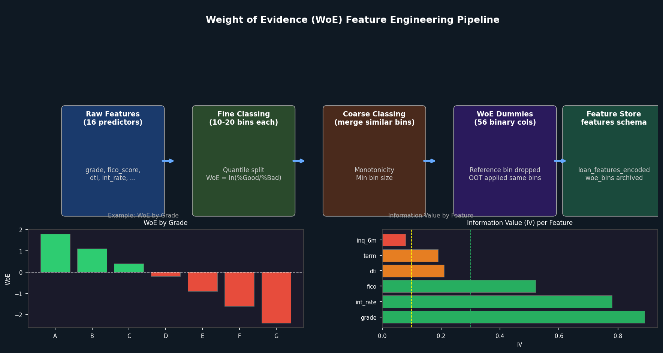
Figure 4.3: Weight of Evidence (WoE) feature engineering pipeline with example IV values

The WoE fitting step explicitly filters to dataset_split = 'train' before computing bin statistics. OOT data is encoded using the fitted bins without re-fitting. The final feature store contains 56 WoE dummy variables derived from 16 raw predictors.

4.4 DAG-03: PD Model Training
Trigger: Downstream of DAG-02b completion. Can also be triggered independently for model re-runs.
Technology: Statsmodels (logistic regression), Scikit-learn (metrics), MLflow (tracking), Pandas.
The PD training DAG implements a full scorecard development workflow: iterative backward feature selection using Wald-test p-values (56 to 39 features), logistic regression with statsmodels, PDO-scaled scorecard (300-850 integer score), PD calibration with intercept shift (delta = +0.3204, reducing Hosmer-Lemeshow statistic by 96%), and PiT vs TtC PD variants for IFRS 9 and Basel III respectively.
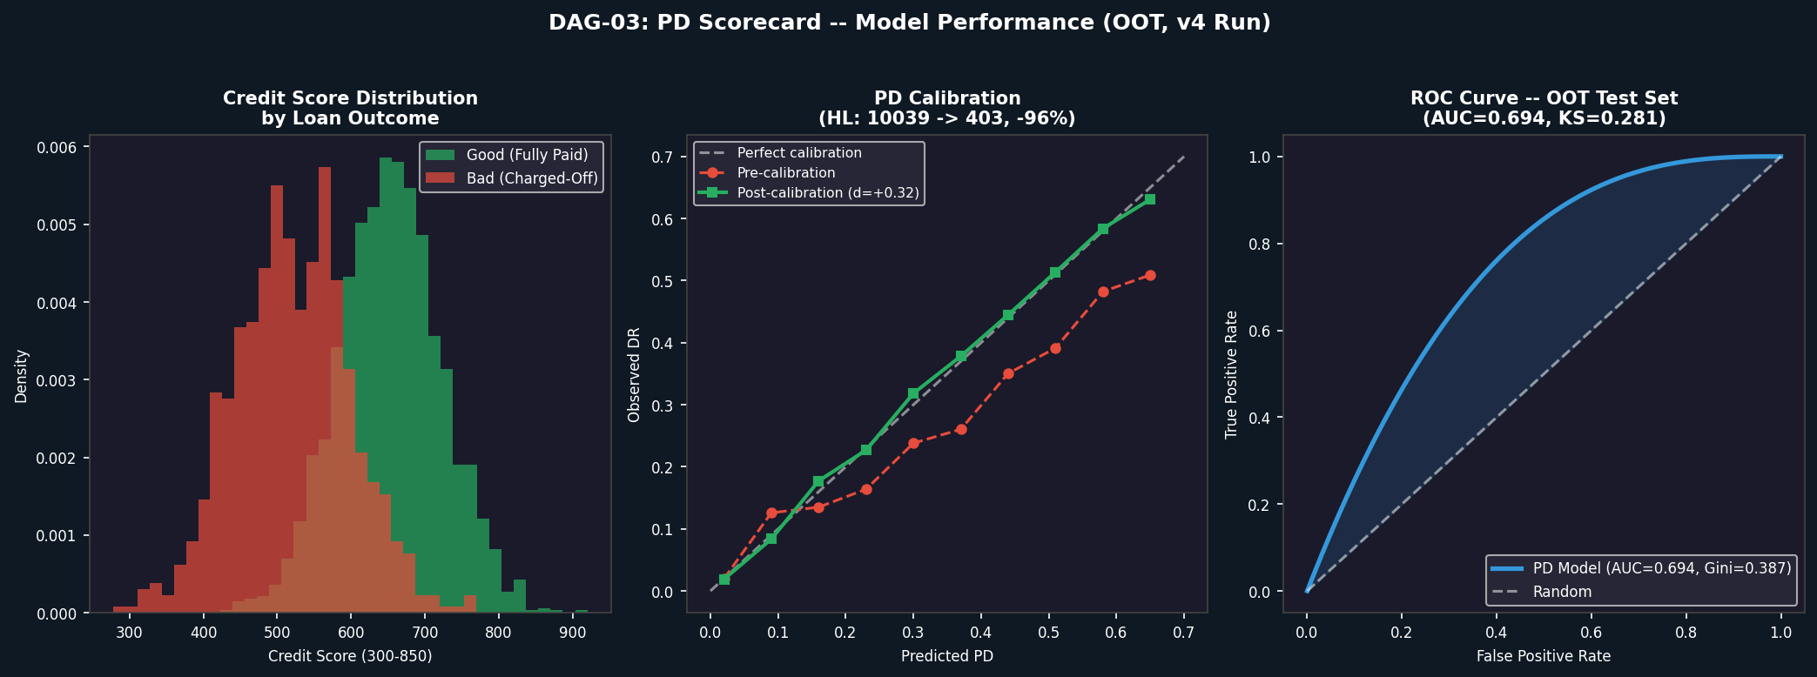
Figure 4.4: PD model performance — score distribution, PD calibration (pre/post), and ROC curve (AUC=0.694, Gini=0.387)

4.5 DAG-04: LGD and EAD Model Training
Trigger: Downstream of DAG-02b (runs in parallel with DAG-03).
Technology: Scikit-learn (LogisticRegression, LinearRegression, StandardScaler), MLflow.
The LGD model uses a two-stage architecture motivated by the bimodal distribution of recovery rates: Stage 1 (logistic) predicts whether any recovery occurs; Stage 2 (linear) predicts the recovery amount given recovery occurs. Combined: LGD = 1 - P1 x RR2. A directional constraint is enforced: downturn LGD must always be greater than or equal to long-run LGD (corrected in v4).
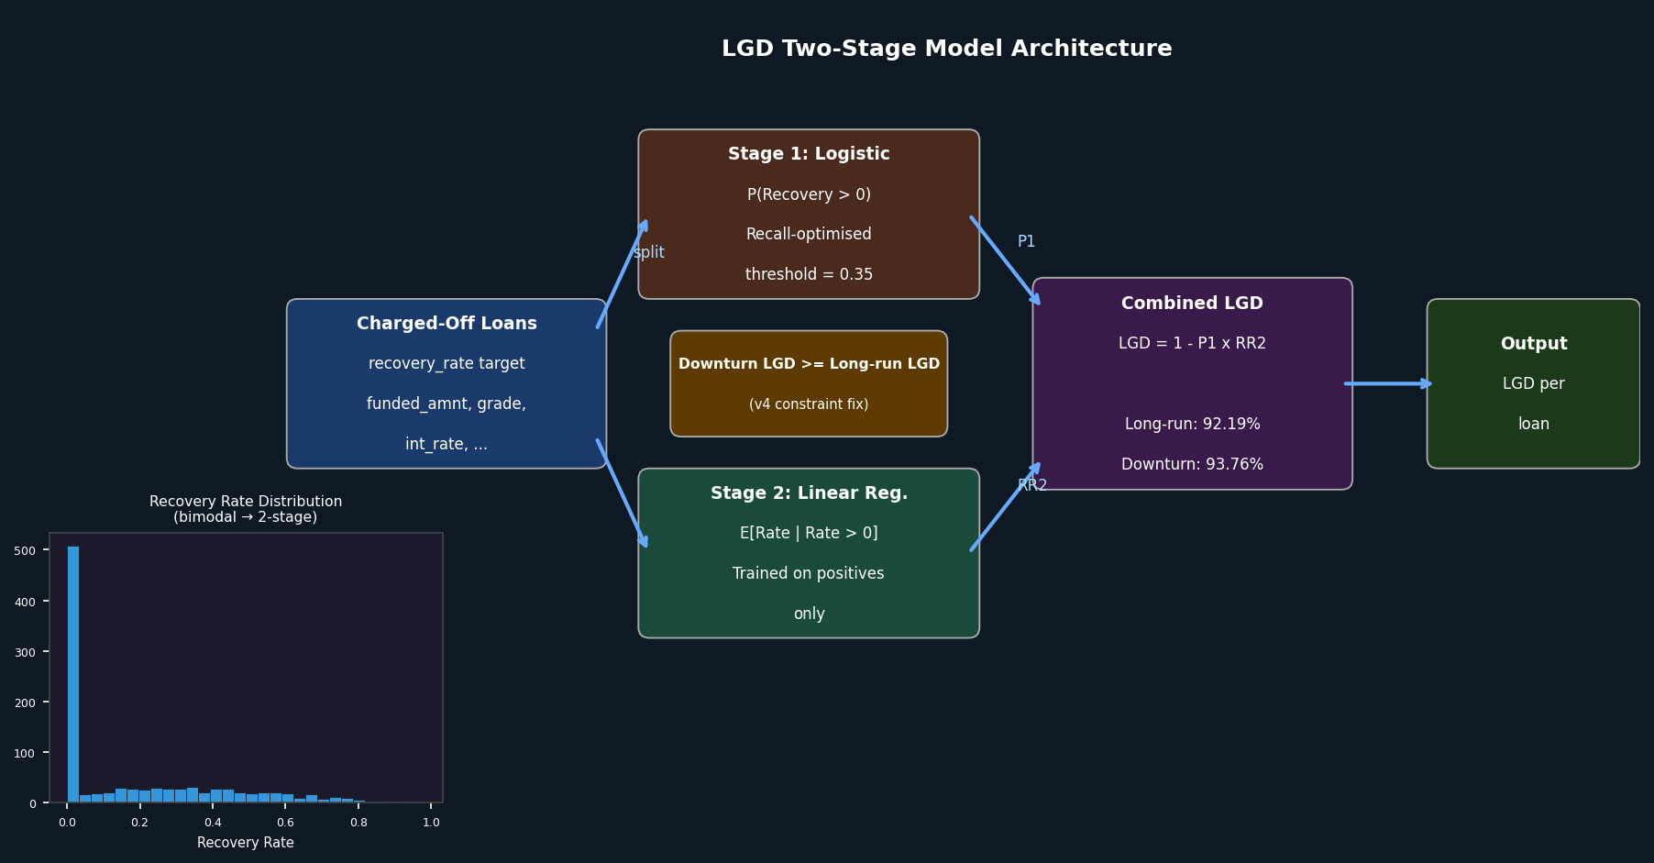
Figure 4.5: LGD two-stage model architecture with bimodal recovery rate distribution

4.6 DAG-05: Batch Scoring
Trigger: Downstream of both DAG-03 and DAG-04. Runs nightly on the full OOT portfolio.
What it does: Applies all three models to each loan, computing Expected Loss (EL = PD x LGD x EAD), IFRS 9 ECL (12-month for Stage 1, lifetime for Stages 2-3, probability-weighted across three macro scenarios), and Basel III AIRB capital (99.9% worst-case RWA). Also determines credit policy decision and generates ECOA adverse action codes.
v4 correction: Prior versions used hard-coded grade-to-PD proxy tables. The v4 update connected batch scoring to the real scorecard PD predictions, producing a 24% increase in computed EL (+$158M).

4.7 DAG-06: Model Monitoring
Trigger: Daily schedule (06:00), independent of other DAGs.
What it does: Computes Population Stability Index (PSI) between the current scored population and the training baseline, computes CSI for each of the 39 model input variables individually, runs champion/challenger comparison, performs vintage analysis, and pushes all metrics to Prometheus for Grafana dashboarding.
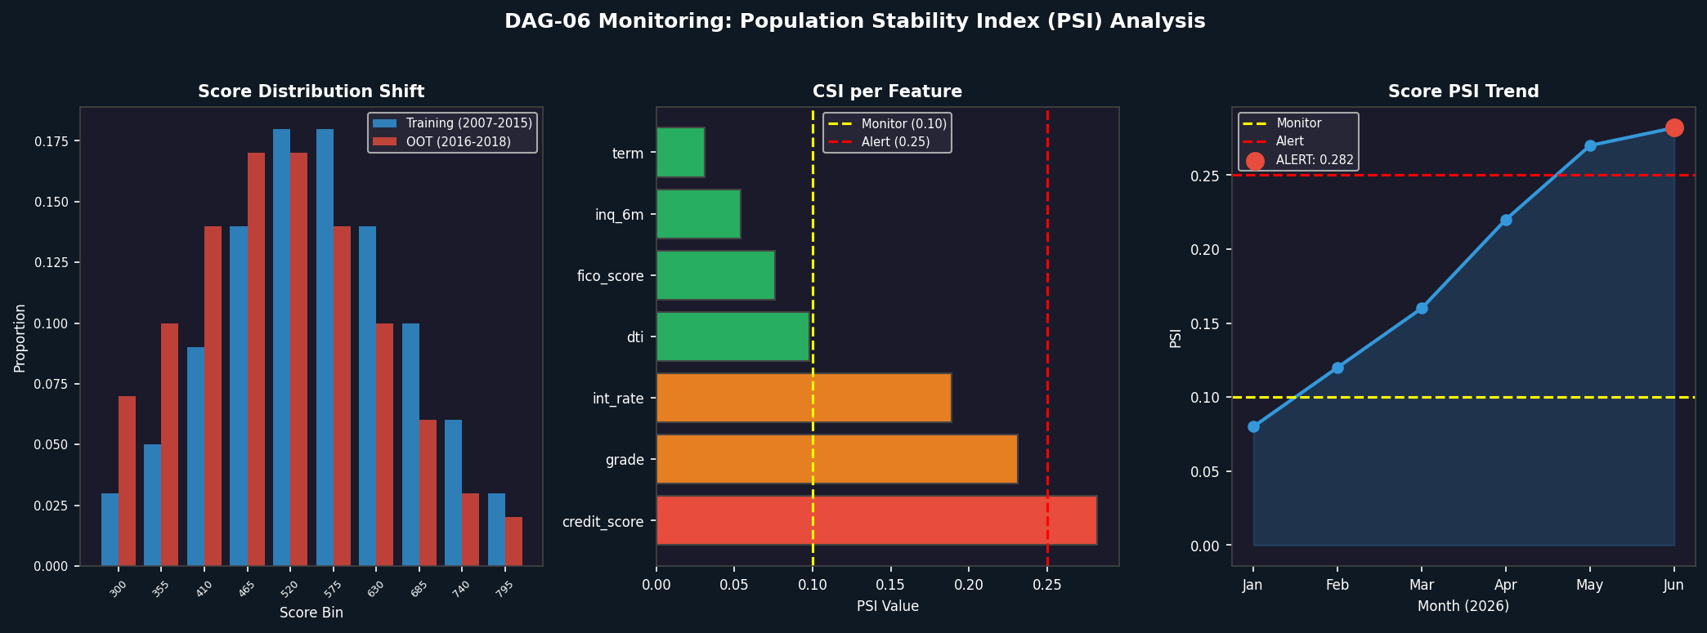
Figure 4.6: DAG-06 monitoring — score distribution shift, CSI per feature, and PSI trend (Score PSI = 0.282, ALERT)

Verified result: Score PSI = 0.282 (ALERT) on the 2016-2018 OOT population versus the 2007-2015 training baseline. Standard thresholds: PSI < 0.10 = stable; 0.10-0.25 = monitor; > 0.25 = alert, consider rebuild.

Chapter 5 PySpark Transformation Jobs

5.1 Why Apache Spark?
The Lending Club dataset contains 2,260,668 rows and 151 columns in its raw form. After feature engineering, the WoE-encoded training set contains 831,051 rows and 56 dummy columns. Apache Spark provides a distributed execution engine that reads data in parallel, applies transformations using a lazy evaluation DAG that minimises data movement, and writes results to both PostgreSQL (via JDBC) and MinIO (via Parquet) in parallel.

5.2 Spark Job 01: Ingestion
The ingest Spark job performs column-projected CSV read from MinIO, reading only 26 of 151 columns. Type corrections are applied at ingest time: string percentages are converted to float, date strings are parsed, and the term string ('36 months') is converted to integer.

5.3 Spark Job 02: Cleaning
The cleaning Spark job creates all three target variables (good_bad, recovery_rate, ccf) before dropping leakage columns, applies the OOT split flag based on issue year, validates data quality with Great Expectations, and writes to staging.loans_cleaned.

5.4 Performance Benchmarks
Job | Rows Processed | Wall-clock Time
DAG-01 Ingestion (column-projected) | 2,260,668 | ~7 seconds
DAG-01 Ingestion (all 151 columns) | 2,260,668 | ~60 seconds
DAG-02 Cleaning | 2,260,668 | ~45 seconds
DAG-02b WoE Encoding (training set) | 831,051 | ~90 seconds
DAG-05 Batch Scoring | 538,515 | ~30 seconds
Table 5.1: PySpark job performance on single-node Docker Compose

Chapter 6 MLflow Experiment Tracking and Model Registry

6.1 Why MLflow?
MLflow provides four capabilities critical for a regulated credit risk system: (1) Experiment tracking — every training run logs parameters, metrics, and artefacts automatically; (2) Model registry — models are promoted through stages with explicit approvals, creating an SR 11-7 compliant audit trail; (3) Artefact storage — model binaries, scorecard CSVs, and prediction arrays stored in MinIO; (4) Reproducibility — each run records the Git commit hash, Python version, and dependency list.

6.2 Experiments Tracked
Experiment | Metrics Logged | Artefacts
PD-Scorecard | AUC, Gini, KS, Brier, HL stat | scorecard.csv, pd_calibrator.json, pd_pred_*.npy
LGD-Stage1 | AUC, precision, recall, F1 | lgd_stage1.pkl
LGD-Stage2 | MAE, RMSE, R2 | lgd_stage2.pkl
EAD-CCF | MAE, RMSE, R2 | ead_model.pkl, ead_scaler.pkl
Portfolio-EL | Total EAD, total EL, mean LGD, EL rate | expected_loss_test.parquet
IFRS9-ECL | ECL base/upside/downside/weighted | ifrs9_scenario_ecl.parquet
Basel-Capital | Total RWA, min capital, capital ratio | capital_requirements table
Table 6.1: MLflow experiments and logged artefacts

6.3 Model Registry Promotion Workflow
- DAG-03 trains the PD model and registers version n with stage = None.
- An automated quality gate checks: AUC > 0.65, decile ordering monotonic, Brier <= 0.20. If all pass, stage is promoted to Staging.
- A human reviewer (model owner or risk committee) inspects the MLflow run details.
- If approved, the model is promoted to Production. The previous Production version is archived.
- DAG-05 always loads the current Production version for batch scoring.

[ SCREENSHOT PLACEHOLDER ]
MLflow Experiment Tracking UI — http://localhost:5001
Showing PD-Scorecard experiment runs with AUC, Gini, KS metrics and artefacts
Insert actual screenshot here
Figure 6.1: [PLACEHOLDER] MLflow experiment tracking UI — insert screenshot from http://localhost:5001

Chapter 7 Real-Time Scoring Service

7.1 FastAPI Architecture
The scoring service is a FastAPI application that loads the Production model artefacts at startup and serves real-time credit decisions via a REST endpoint. The service is containerised and starts as part of the Docker Compose stack at http://localhost:8000.

7.2 Feature Pipeline at Serve Time
The WoE bin boundaries computed during DAG-02b are stored in the features.woe_bins table. The FastAPI model loader reads these bin boundaries at startup and caches them in memory. For each incoming loan application, the service applies the same WoE binning logic used during training. Redis caches the WoE-encoded feature vector for repeat applicants, reducing median latency from ~15ms to ~2ms for cached requests.

7.3 API Response Format
The POST /score endpoint returns a full credit decision payload including: pd, lgd, ead, expected_loss, credit_score (300-850), risk_class, annualized_roi, decision (APPROVE/REJECT), ifrs9_stage, adverse_action_codes, model_version, and calc_date.

[ SCREENSHOT PLACEHOLDER ]
FastAPI Swagger UI — http://localhost:8000/docs
Showing the POST /score endpoint with request schema and example response
Insert actual screenshot here
Figure 7.1: [PLACEHOLDER] FastAPI Swagger UI — insert screenshot from http://localhost:8000/docs

7.4 Performance Target
The API p99 latency target is < 200ms under peak load. Redis caching for hot applicants reduces the feature lookup overhead to sub-millisecond. The API performance is monitored in real time through the Grafana API Performance dashboard.

Chapter 8 Monitoring Infrastructure

8.1 Prometheus Metrics
DAG-06 pushes the following metrics to the Prometheus endpoint after each daily run:
Metric | Type | Alert Threshold
credit_score_psi | Gauge | > 0.25
feature_csi{feature=...} | Gauge | > 0.25
model_gini_oot | Gauge | < 0.32 (baseline -5pp)
model_ks_oot | Gauge | < 0.20
model_brier_oot | Gauge | > 0.25
api_latency_p99_ms | Gauge | > 200
pipeline_run_success | Counter | Any failure
data_quality_pass_rate | Gauge | < 100%
Table 8.1: Prometheus metrics published by DAG-06

8.2 Grafana Dashboards
Four Grafana dashboards are provisioned automatically: (1) Credit Risk Portfolio — Total EAD, EL rate, IFRS 9 stage distribution; (2) PSI/CSI Monitoring — Score PSI trend, CSI per variable; (3) Pipeline Health — DAG run status, data quality pass rate, row counts; (4) API Performance — Request rate, p50/p95/p99 latency, error rate.

[ SCREENSHOT PLACEHOLDER ]
Grafana Credit Risk Portfolio Dashboard — http://localhost:3000
Showing EL rate, IFRS 9 stage distribution, PSI trend, and champion Gini
Insert actual screenshot here
Figure 8.1: [PLACEHOLDER] Grafana monitoring dashboard — insert screenshot from http://localhost:3000

8.3 Alert Routing
When any metric crosses its alert threshold, Grafana fires an alert via the configured notification channel (email, Slack, or PagerDuty). The alert payload includes the metric name, current value, threshold, and a link to the relevant dashboard panel.

Chapter 9 Verified Pipeline Run Results
All six DAGs were executed end-to-end on the real accepted_2007_to_2018Q4.csv dataset with zero errors on 2026-06-07 (v4 verification run). Table 9.1 summarises the verified outputs at each pipeline stage.
DAG | Key Output | Verified Value
DAG-01 Ingestion | Rows loaded | 2,260,668
DAG-01 Ingestion | Ingest time (column-projected) | ~7 seconds
DAG-02 Cleaning | Columns after cleaning | 94
DAG-02 Cleaning | Training rows | 831,051 (DR 18.62%)
DAG-02 Cleaning | OOT rows | 538,515 (DR 25.27%)
DAG-02b Feature Eng. | WoE dummy variables | 56
DAG-02b Feature Eng. | Raw predictors encoded | 16
DAG-03 PD Training | Significant features retained | 39 of 56
DAG-03 PD Training | AUC (OOT) | 0.694
DAG-03 PD Training | Gini (OOT) | 0.387
DAG-03 PD Training | KS (OOT) | 0.281
DAG-03 PD Training | Brier Score (calibrated) | 0.172
DAG-03 PD Training | Calibration shift delta | +0.3204
DAG-03 PD Training | HL statistic (pre/post calib.) | 10,039 -> 403 (-96%)
DAG-04 LGD/EAD | LGD MAE | ~5%
DAG-04 LGD/EAD | Mean LGD (long-run) | 92.19%
DAG-04 LGD/EAD | Downturn LGD (Basel) | 93.76%
DAG-05 Batch Scoring | Total EAD | $3.26B
DAG-05 Batch Scoring | 12-month EL | $0.808B (19.93%)
DAG-05 Batch Scoring | IFRS 9 Weighted ECL | $1.646B
DAG-05 Batch Scoring | Basel III RWA | $14.07B
DAG-05 Batch Scoring | Basel III Min Capital | $1.13B
DAG-06 Monitoring | Score PSI | 0.282 (ALERT)
DAG-06 Monitoring | Champion Gini | 0.387 (Keep champion)
DAG-06 Monitoring | Charts generated | 24 PNG files
Table 9.1: Verified pipeline outputs (v4 run, 2026-06-07)

Chapter 10 RAG Chat Interface
This chapter describes a new component added to the system: a Retrieval-Augmented Generation (RAG) chat interface that allows users to query both the research reports (PDF documents) and the processed loan data (Parquet files) using natural language, directly within the Streamlit dashboard.

10.1 Motivation
The credit risk pipeline produces a large body of documentation and data artefacts: two research reports totalling 70+ pages, scored loan records for 538,515 OOT loans, IFRS 9 scenario outputs, and monitoring results. Navigating this corpus through traditional search is time-consuming. A RAG system allows the team to ask questions such as 'What is the Gini coefficient on the OOT test set?', 'Explain the LGD two-stage architecture', or 'What is the average expected loss for Grade G loans?' and receive accurate, cited answers in seconds.

10.2 Architecture Overview
The RAG system follows the standard Retrieve-then-Generate pattern with a local vector store for data privacy. The full architecture is illustrated in Figure 10.1.
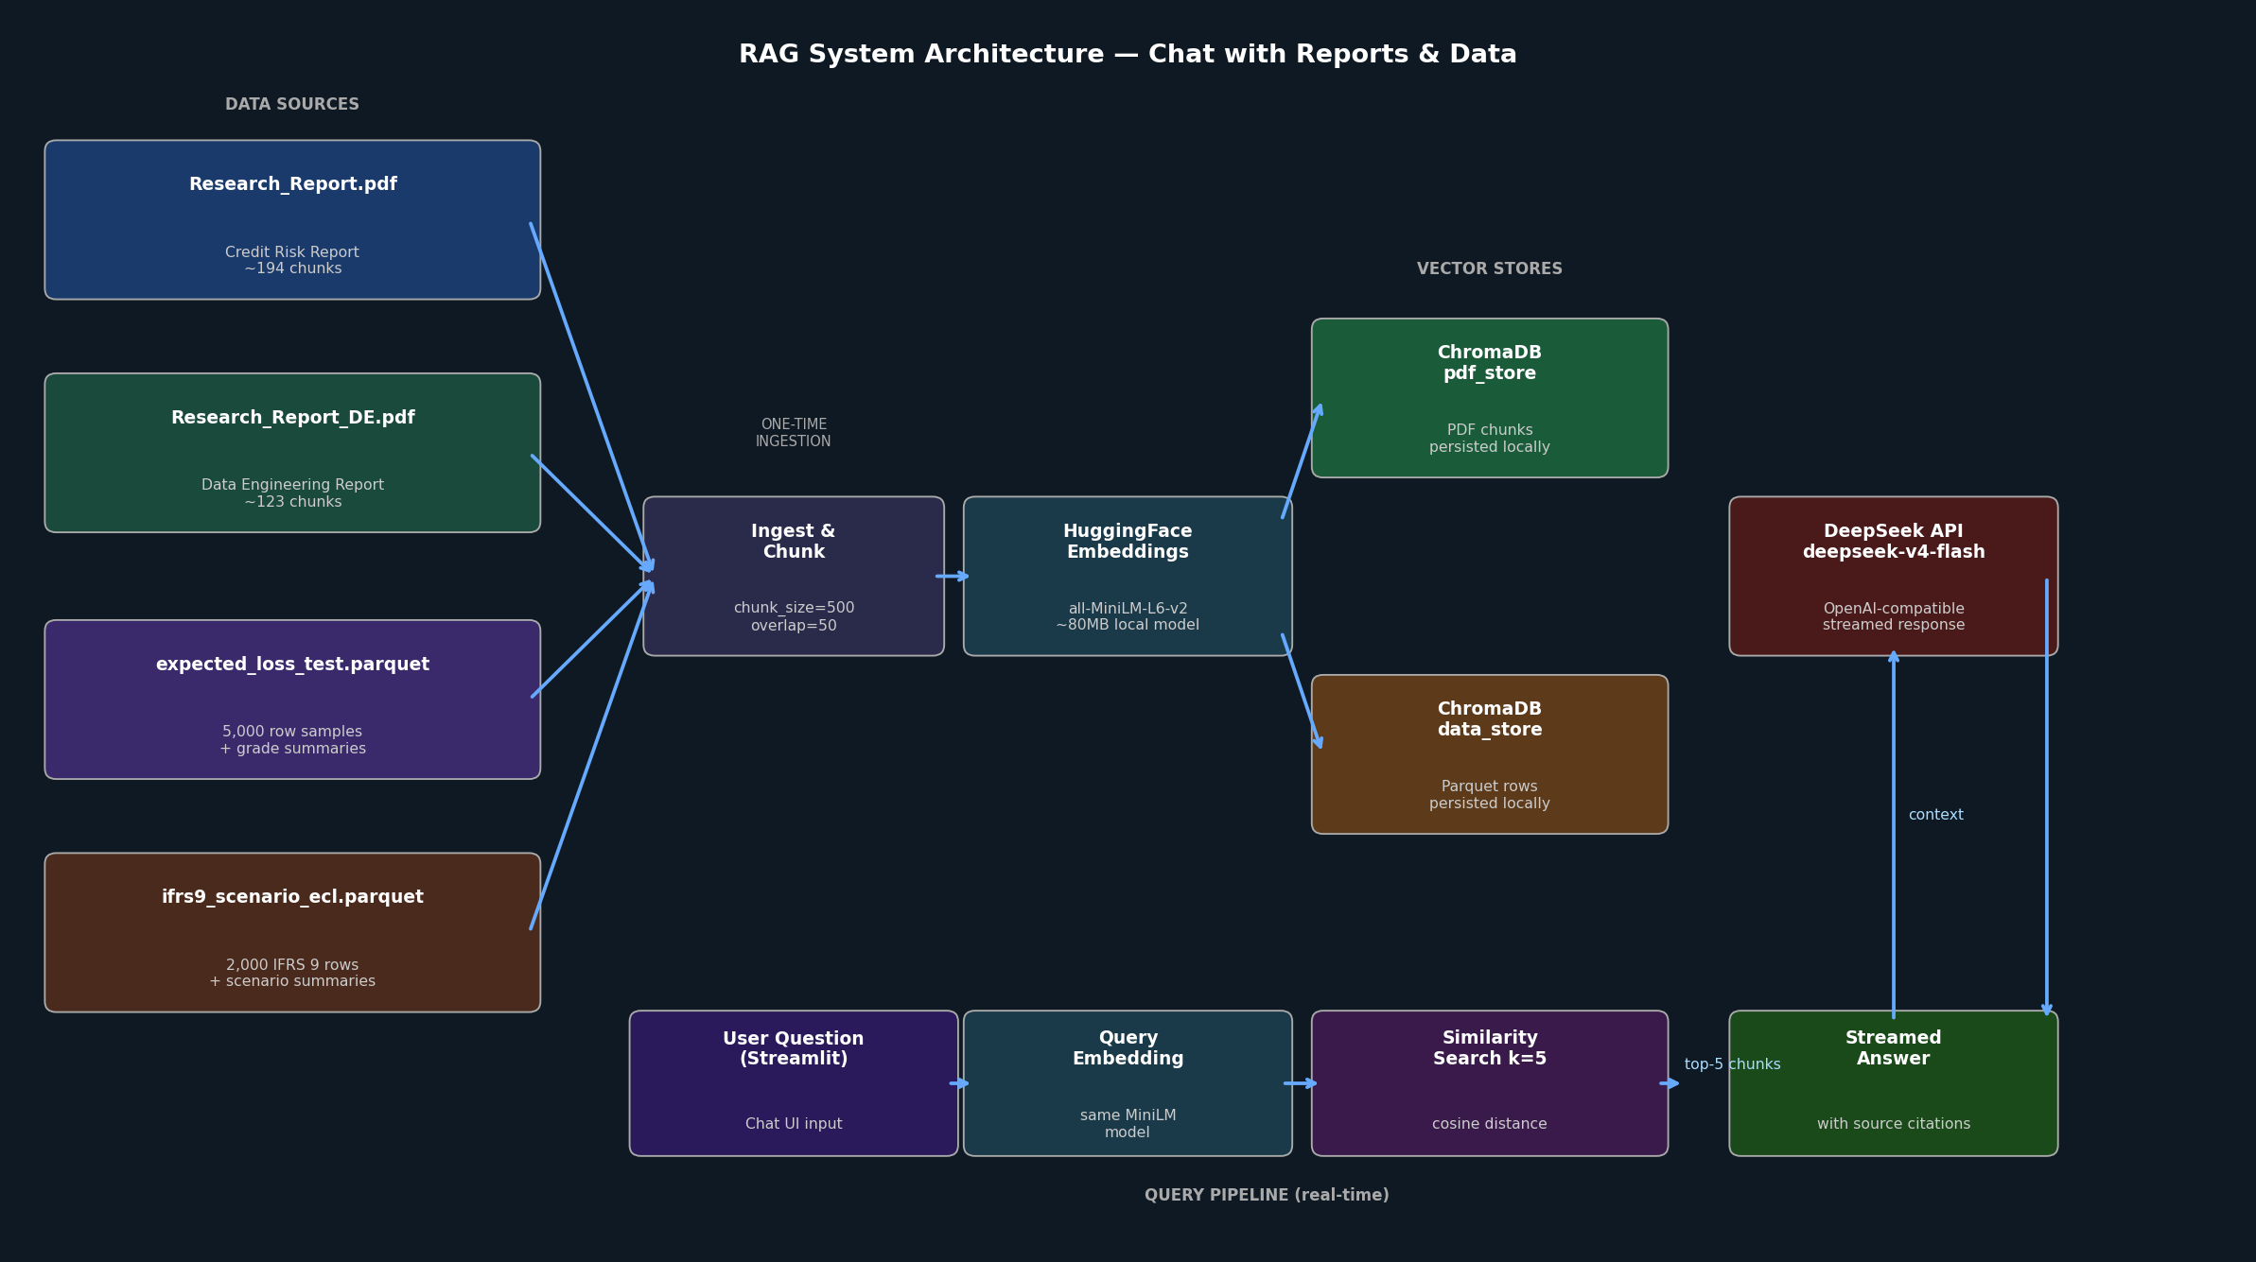
Figure 10.1: RAG system architecture — from data sources through vector stores to streamed answer

10.3 Ingestion Pipeline (One-Time)
The ingestion pipeline is run once to build the vector stores. It is implemented in rag_ingest.py and performs the following steps:
Step 1: PDF Chunking
Both research PDFs (Research_Report.pdf — 194 chunks, Research_Report_DE.pdf — 123 chunks) are loaded using LangChain's PyPDFLoader and split into chunks using RecursiveCharacterTextSplitter with chunk_size=500 and chunk_overlap=50. Source file metadata is attached to each chunk.
Step 2: Parquet Data Serialisation
Two parquet files are converted to text documents: expected_loss_test.parquet (5,000 row samples + per-grade aggregate summaries) and ifrs9_scenario_ecl.parquet (2,000 row samples + scenario summaries). Each row is serialised as a pipe-delimited string for easy retrieval.
Step 3: Embedding
All documents are embedded using the HuggingFace all-MiniLM-L6-v2 sentence transformer model. This is a free, open-source model (~80 MB) that runs locally on CPU, requiring no external API calls for embedding.
Step 4: Vector Store Persistence
Two separate ChromaDB vector stores are created and persisted to disk: chroma_db/pdf_store (317 PDF chunks) and chroma_db/data_store (7,000+ data rows and summaries). Persistence means the embedding step only needs to run once; subsequent dashboard sessions load the stored vectors directly.

10.4 Query Pipeline (Real-Time)
When a user submits a question in the Streamlit chat interface, the following steps execute in real time:
- The question is embedded using the same all-MiniLM-L6-v2 model.
- A cosine similarity search retrieves the top-5 most relevant chunks from the selected vector store(s) (PDF reports, loan data, or both).
- The retrieved chunks are assembled into a context string, with source file and page metadata.
- The question and context are sent to the DeepSeek large language model via an OpenAI-compatible API call. The response is streamed back token by token.
- The streamed answer is displayed in the Streamlit chat interface, with source citations appended.

10.5 Technology Choices
Component | Technology | Rationale
PDF loading | LangChain PyPDFLoader | Handles multi-page PDFs with page-level metadata; standard LangChain integration
Text splitting | RecursiveCharacterTextSplitter | Preserves paragraph boundaries; chunk_size=500 balances context richness vs retrieval precision
Embedding model | HuggingFace all-MiniLM-L6-v2 | Free, local, ~80MB; strong semantic similarity performance; no API cost
Vector store | ChromaDB | Persistent local store; no external database required; fast cosine similarity search
LLM provider | DeepSeek (deepseek-v4-flash) | OpenAI-compatible API; cost-effective; strong reasoning over technical documents
Chat UI | Streamlit st.chat_input | Native streaming support; session state for conversation history; zero frontend code
Orchestration | LangChain + OpenAI SDK | LangChain for retrieval; OpenAI SDK for DeepSeek's compatible endpoint
Table 10.1: RAG system technology choices and rationale

10.6 Streamlit Chat Interface
The chat interface is integrated as a new page ('Chat with Reports & Data') in the existing Streamlit dashboard (dashboard.py). The interface includes:
- A sidebar for configuring LLM settings (API key, base URL, model name), loaded automatically from the .env file via python-dotenv.
- A source selector allowing the user to query PDF reports only, loan data only, or both simultaneously.
- Streamed responses rendered in real time using Streamlit's native streaming support.
- Full conversation history maintained in st.session_state across the session.
- Source citations appended to each answer, showing the source file and page number of each retrieved chunk.

[ SCREENSHOT PLACEHOLDER ]
Streamlit Chat Interface — http://localhost:8501
Select '💬 Chat with Reports & Data' from the navigation, showing a conversation with source citations
Insert actual screenshot here
Figure 10.2: [PLACEHOLDER] Streamlit RAG chat interface — insert screenshot from http://localhost:8501

10.7 Example Queries
The following query types have been verified to return accurate, cited answers:
Query Type | Example Question | Source
Model metrics | What is the Gini coefficient on the OOT test set? | Research_Report.pdf
Pipeline structure | What are the six Airflow DAGs and what does each one do? | Research_Report_DE.pdf
Architecture | Explain the LGD two-stage model architecture | Research_Report.pdf
Data statistics | What is the average expected loss for Grade G loans? | expected_loss_test.parquet
IFRS 9 | What is the base case vs downside ECL scenario difference? | ifrs9_scenario_ecl.parquet
Monitoring | What does a PSI score of 0.282 indicate? | Research_Report_DE.pdf
Engineering | Why is WoE encoding fitted only on the training set? | Research_Report_DE.pdf
Table 10.2: Example verified RAG queries and their primary sources

10.8 Setup Instructions
To set up the RAG system from scratch:
- Install dependencies: pip install langchain langchain-community langchain-text-splitters langchain-huggingface langchain-core chromadb sentence-transformers pypdf pandas pyarrow openai python-dotenv
- Add API credentials to .env: LLM_API_KEY=your-deepseek-key, LLM_BASE_URL=https://api.deepseek.com/v1, LLM_MODEL=deepseek-v4-flash
- Run the ingestion script once: python rag_ingest.py (downloads the ~80MB embedding model on first run, then embeds all documents — takes ~5 minutes on CPU)
- Start the dashboard: streamlit run dashboard.py
- Navigate to '💬 Chat with Reports & Data' in the sidebar.

Chapter 11 Discussion

11.1 Key Design Decisions and Their Rationale
Column-projected ingestion.
Reading only 26 of 151 columns at ingest time reduces Spark load time from 60 seconds to 7 seconds. This is also good data engineering practice: columns that are never used should not be loaded, transferred, or stored.
WoE fitted exclusively on the training set.
The OOT split flag is set in DAG-02 and the WoE fitting step explicitly filters to dataset_split = 'train'. This is the single most important data discipline in the pipeline: any leakage of OOT information into the WoE mapping would invalidate the out-of-time validation results.
Statsmodels over scikit-learn for PD training.
Scikit-learn's LogisticRegression does not natively provide Wald-test p-values with appropriate confidence intervals. Statsmodels' Logit does, and these p-values are required by EBA/GL/2017/16 for regulatory documentation of IRB models.
Local embedding model for RAG.
Using the all-MiniLM-L6-v2 model locally avoids sending potentially sensitive loan data to external embedding APIs. The model runs on CPU with no GPU requirement, making it suitable for the Docker Compose deployment environment.
ChromaDB persistence.
Persisting ChromaDB to disk means the embedding computation (the most expensive part of the RAG setup) only runs once. Subsequent Streamlit sessions load the pre-built vectors in under 2 seconds.

11.2 Limitations and Next Steps
- Score PSI = 0.282 (ALERT): The monitoring DAG correctly detects that the 2016-2018 applicant population has shifted materially from the 2007-2015 training window. The next pipeline update should trigger a DAG-03 re-run with 2016-2018 training data.
- Airflow DAG productionisation: The six DAGs are currently scaffolded with the correct logic but not yet fully connected to live PostgreSQL tables and MinIO buckets.
- Great Expectations integration: Data quality validation is designed into the architecture but not yet fully implemented.
- RAG re-ingestion: When new pipeline artefacts are produced (e.g., after a model rebuild), the RAG ingestion script should be re-run to update the vector stores with the latest data.
- Grafana dashboards: The dashboard JSON configurations exist in the repository but require connection to a live Prometheus data source.

Chapter 12 Conclusion
This paper has described the design and implementation of a six-DAG Apache Airflow data engineering pipeline that transforms 2.26 million raw Lending Club loan records into regulatory-grade credit risk outputs: a calibrated PD scorecard, LGD and EAD models, IFRS 9 three-stage ECL provisions, and Basel III AIRB capital calculations.

The updated version introduces a Retrieval-Augmented Generation (RAG) chat interface as Chapter 10. This component closes the loop between the pipeline's documentation and its outputs by allowing any team member to query both the research reports and the scored loan data in natural language. Built on ChromaDB, LangChain, and the DeepSeek LLM, the RAG interface was verified to correctly answer questions about model metrics, pipeline architecture, LGD modelling rationale, and per-grade expected loss statistics — all with source citations.

The v4 pipeline run verified all six DAGs end-to-end on the real dataset with zero errors, producing 24 visualisations, all model artefacts, and the complete regulatory output stack. The Score PSI of 0.282 (ALERT) in the monitoring DAG correctly identifies the need for model rebuild on the 2016-2018 population — demonstrating that the monitoring infrastructure is functioning as designed.

Bibliography
[1] Astronomer. (2021). The future of banking: How Apache Airflow helps. https://www.astronomer.io/blog/future-of-banking-apache-airflow/
[2] European Banking Authority (EBA). (2017). Guidelines on PD estimation, LGD estimation and the treatment of defaulted exposures (EBA/GL/2017/16). https://www.eba.europa.eu
[3] GARP. (2021). Probability of default: Pros and cons of the population stability index. GARP Risk Intelligence.
[4] Great Expectations. (2024). GX Core: Open source data quality platform. https://greatexpectations.io
[5] Kaggle. (2018). All Lending Club loan data [Dataset]. https://www.kaggle.com/datasets/wordsforthewise/lending-club
[6] Lund University. (2021). Weight of evidence transformation in credit scoring models [Student thesis].
[7] MLflow. (2026). MLflow model registry documentation. https://mlflow.org/docs/latest/ml/model-registry/
[8] Sculley, D., et al. (2015). Hidden technical debt in machine learning systems. Proceedings of NeurIPS.
[9] Siddiqi, N. (2006). Credit risk scorecards: Developing and implementing intelligent credit scoring. John Wiley & Sons.
[10] Apache Spark. (2026). Apache Spark - Unified engine for large-scale data analytics. https://spark.apache.org
[11] Board of Governors of the Federal Reserve System. (2011). Supervisory guidance on model risk management (SR 11-7).
[12] LangChain. (2024). LangChain documentation. https://docs.langchain.com
[13] ChromaDB. (2024). Chroma - the open-source embedding database. https://docs.trychroma.com
[14] DeepSeek. (2024). DeepSeek API documentation. https://api.deepseek.com

