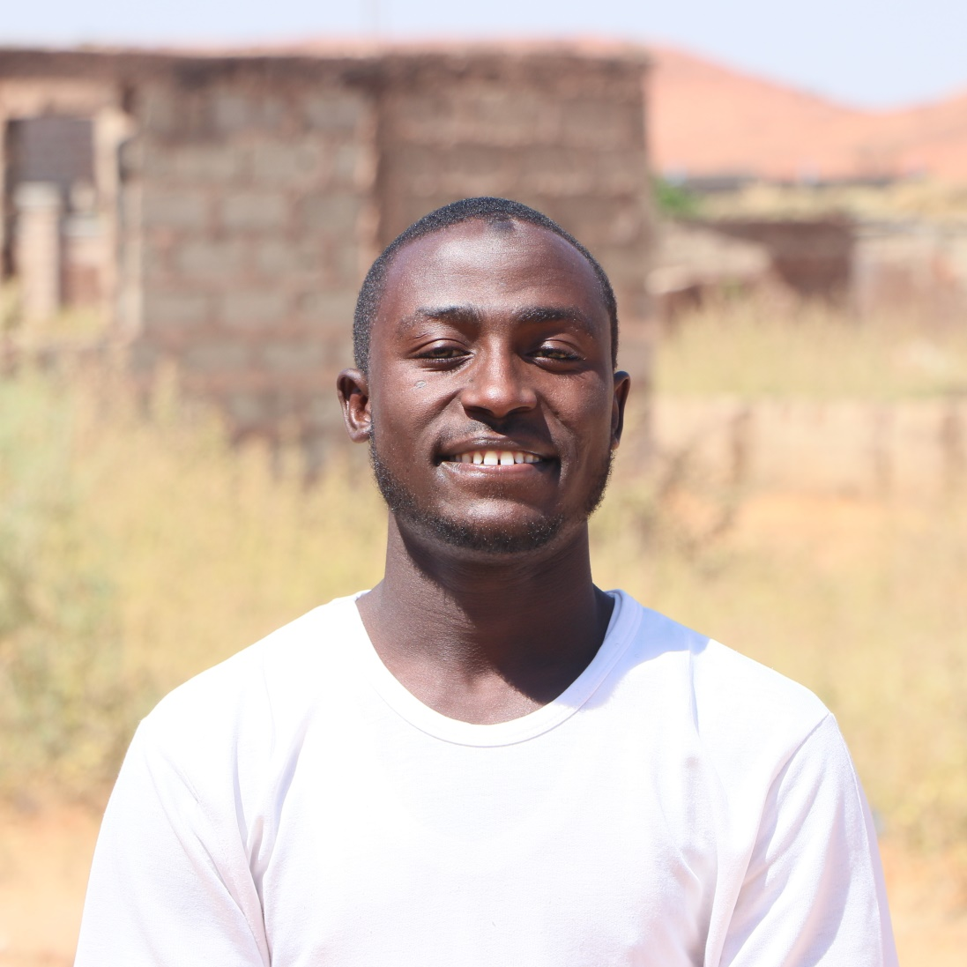

Hello, My Name is JABIR MUHAMMAD SANI, and I am a Web Developer. I specialize in creating and maintaining websites and web applications using technologies such as HTML, CSS, JAVASCRIPT, and various Programming Languages. I enjoy solving problems and creating visually pleasing and user-friendly designs for the web.