Deepfake Detection: XceptionNet vs. CNN-ViT Hybrid
on FaceForensics++
Project Report -- Results to Date, the Below-Chance Cross-Manipulation Finding, and the Research Plan Going Forward

23AID205 -- AIML Course Project
AI & Data Science, Amrita Vishwa Vidyapeetham, Coimbatore

Team
Venugopalan Gangadharan -- CB.AI.U4AID25115
Vipin Sudhakar -- CB.AI.U4AID25166
Rithvik Arulprakash -- CB.AI.U4AID25148
Harshith Kv -- CB.AI.U4AID25119
October 2026
github.com/DUNE-ODYSSEY/deepfake-detection

Contents
Right-click and choose "Update Field" to generate the table of contents.

Abstract
This project set out to compare XceptionNet, a pretrained convolutional baseline, against a CNN-ViT hybrid (ResNet-50 stages 1-3 feeding a 6-layer Transformer encoder, trained from scratch) for deepfake detection on FaceForensics++ (FF++), measuring not just same-distribution accuracy but cross-manipulation generalization and compression robustness. XceptionNet outperformed the hybrid on every same-distribution metric (video AUC 0.9958 vs. 0.9836), so the original hypothesis -- that global self-attention would generalize better -- did not hold; this is reported as a negative result rather than reframed after the fact. The more consequential finding emerged from the cross-manipulation matrix: several transfer cells, concentrated around FaceSwap, score *below random chance* (e.g. Xception trained on Deepfakes and tested on FaceSwap: AUC 0.2562), and this pattern correlates almost perfectly between the two architectures (Pearson r = 0.9377, Spearman rho = 0.951, p < 0.001), indicating the failure tracks the training manipulation method rather than model architecture. Before treating this as a genuine finding, a dedicated audit (Phase 0 of a new research plan, RESEARCH_BRIEF.md) checked for a trivial pipeline explanation -- systematic differences in video encoding, face-crop quality, or label handling between real and manipulated classes -- and found none. A six-phase follow-up study then showed that the inversion survives a complete change of preprocessing and appears identically in three ImageNet-pretrained architectures; that it follows a difference in high-frequency image energy whose direction flips between manipulation methods (Deepfakes and NeuralTextures fakes are blurrier than real faces, FaceSwap fakes sharper), which predicts both our transfer matrices and a published official-data matrix; and that randomizing sharpness during training reduces the inversion by about 0.1 AUC without removing it. The explanation does not carry over to a second dataset (DeepFakeFace), so it is stated as specific to FaceForensics++.

1. Introduction

1.1 Motivation
Deepfakes have moved from a research curiosity to a real misinformation and fraud vector. Published detectors usually report one headline accuracy number, measured on the same manipulation type and compression level they were trained on.

1.2 Problem Statement
A single in-distribution accuracy number is misleading in practice: a detector reporting 99% in a paper can collapse the moment the test distribution shifts -- a different manipulation method, a different compression level -- and that failure is invisible until deployment.

1.3 Objectives
- Fairly compare XceptionNet (CNN baseline) against a CNN-ViT hybrid (ResNet + Transformer) on identical data and protocol -- does global self-attention improve generalization?
- Measure same-distribution accuracy, full 4×4 cross-manipulation generalization, and compression robustness -- not a single number.
- Explain *why* generalization succeeds or fails (Grad-CAM), and ship a working, testable live demo rather than offline metrics alone.
- (Added after the cross-manipulation results came in) Explain the below-chance transfer cells mechanistically, and test interventions that fix them -- the project's current central objective.

2. Literature Review
- Rössler, A. et al. (2019). FaceForensics++: Learning to Detect Manipulated Facial Images. ICCV. -- Source of the dataset and the standard 4-method/3-compression benchmark protocol this project follows; also the source of XceptionNet as a baseline detector.
- Chollet, F. (2017). Xception: Deep Learning with Depthwise Separable Convolutions. CVPR. -- The CNN baseline architecture, still a standard reference detector for this task in the FF++ literature.
- Dosovitskiy, A. et al. (2021). An Image is Worth 16x16 Words: Transformers for Image Recognition at Scale. ICLR. -- Motivates the Transformer-encoder half of the CNN-ViT hybrid and its global self-attention mechanism.
- Selvaraju, R. R. et al. (2017). Grad-CAM: Visual Explanations from Deep Networks via Gradient-based Localization. ICCV. -- The interpretability method used to explain why cross-manipulation generalization fails.
Gap identified: most FF++-benchmark work reports same-distribution accuracy only. Head-to-head CNN-vs-attention generalization comparisons, paired with an interpretability layer and a mechanistic account of *why* cross-manipulation transfer sometimes inverts below chance, are comparatively under-studied -- the specific gap this project now targets.

3. Methodology

3.1 Dataset
FaceForensics++ (FF++): 5,000 videos -- 1,000 real (YouTube interviews) and 4×1,000 manipulated (Deepfakes, Face2Face, FaceSwap, NeuralTextures), all sharing the same real-video identities. c23 compression, official FF++ folder layout. Data provenance: a Kaggle mirror (xdxd003/ff-c23), not the official release -- official access is still pending, and every result in this report is labeled accordingly. Official video-level train/val/test splits are used throughout, since random frame-level splits would leak identity between train and test and inflate accuracy.

3.2 Preprocessing
MTCNN face detection on GPU, 20 frames per video, 1.3x crop margin (captures blending-boundary artifacts), resized to 299×299 (native for XceptionNet, downsampled to 224 for the hybrid), stored as JPEG quality 95. Result: ~99,987 face crops across all 5,000 videos.

3.3 Data Quality (EDA)
Per-video metadata (frame count, file size) was checked via box-plot IQR across all 5,000 videos before committing to full preprocessing: 209 videos flagged on frame count (4.2%), 326 on file size (6.5%), 502 unique outliers overall (10.0%).
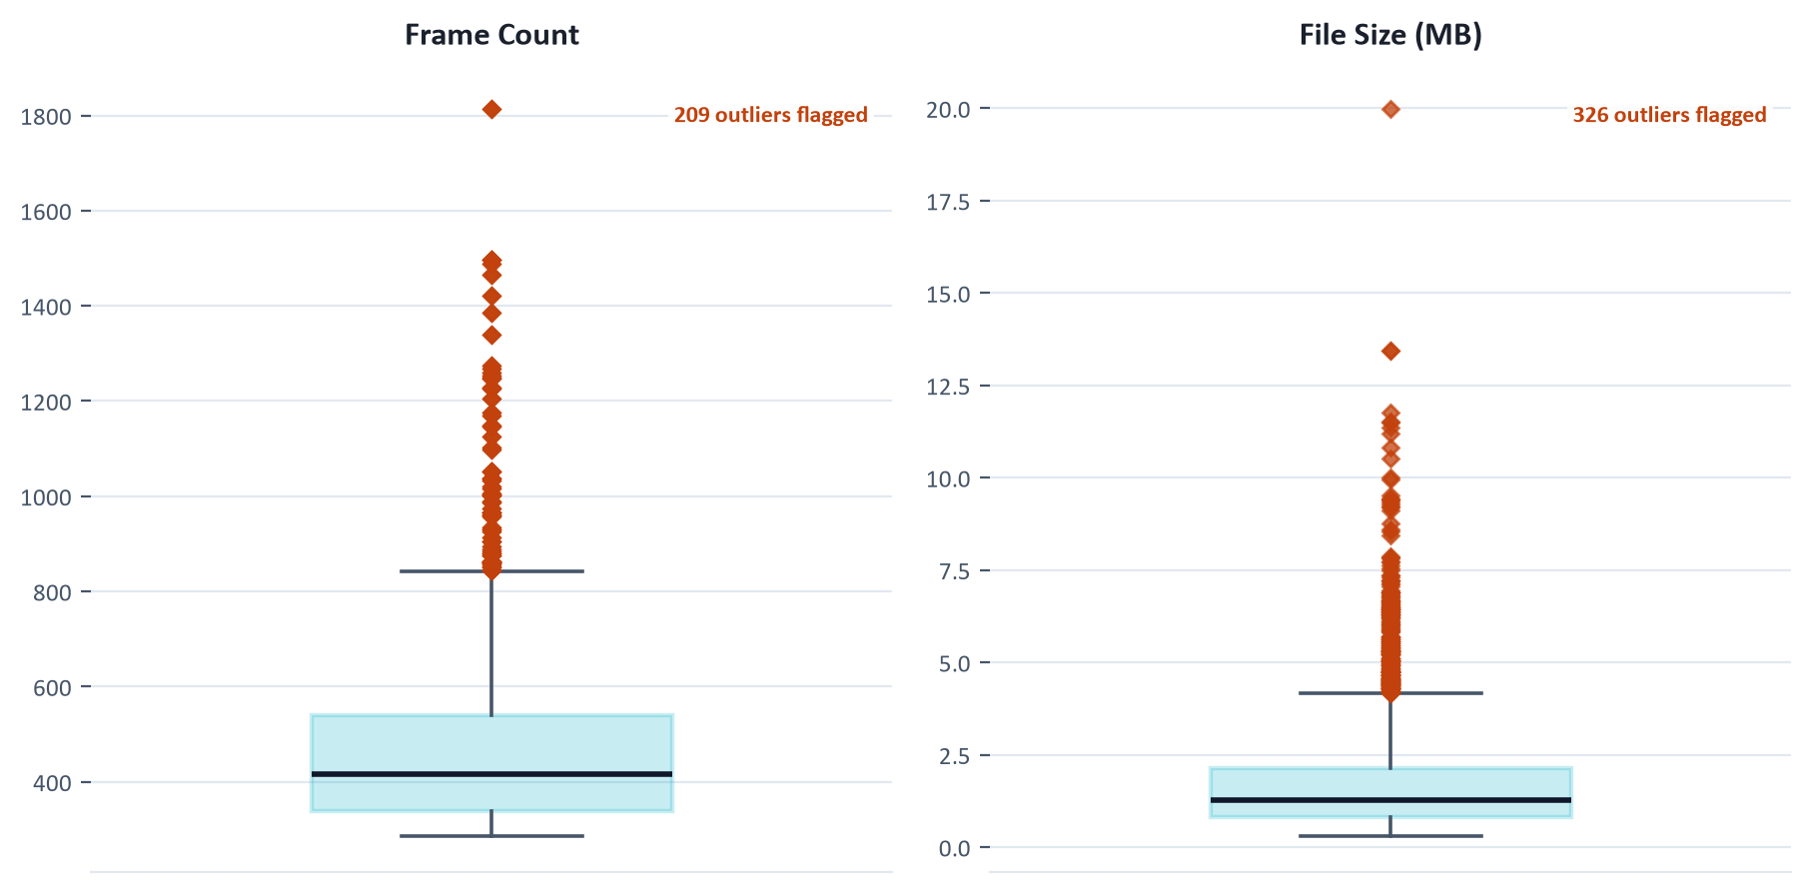
Figure 1. Per-video frame-count and file-size outlier check (IQR).

3.4 Model Architectures
XceptionNet (baseline): depthwise-separable CNN (Chollet 2017), ImageNet-pretrained; 2048-d pooled features → dropout → linear → logit. Purely convolutional, local receptive fields only.
CNN-ViT hybrid: ResNet-50 (stages 1-3) → 14×14×1024 feature map → 512-d tokens plus a CLS token → 6-layer, 8-head Transformer encoder. Trained from scratch (no ImageNet pretraining), tests whether global self-attention improves generalization over the purely convolutional baseline.

3.5 Training & Evaluation Protocol
Shared across both models so architecture is the only variable: AMP training, AdamW optimizer, cosine learning-rate schedule, batch size 32 (GPU-benchmarked on the available RTX 3060 Laptop GPU -- XceptionNet silently throttles in throughput above this batch size due to VRAM paging), early stopping with patience 4 on validation AUC. Metrics: Accuracy, F1 and AUC at both frame and video level (video score = mean of frame probabilities). Note on statistical rigor: the three experiments below use a single seed (42) and report point estimates without bootstrap confidence intervals -- this was the protocol for the original course-project experiments. The new research plan (Section 7) adopts a stricter standard (≥3 seeds, bootstrap CIs over ≥1000 resamples) starting with Phase 1.

4. Results

4.1 Experiment 1: Baseline Comparison (same-distribution, c23)
Model | Video Acc | Video F1 | Video AUC | Frame Acc | Frame AUC
XceptionNet | 97.29% | 0.983 | 0.9958 | 95.49% | 0.986
CNN-ViT Hybrid | 94.71% | 0.9671 | 0.9836 | 92.76% | 0.9624
XceptionNet leads on every same-distribution metric. The original hypothesis that the hybrid's global self-attention would generalize better is addressed directly in §4.2 -- it does not hold there either, and this is reported as a genuine negative result.

4.2 Experiment 2: Cross-Manipulation Generalization
Each model is trained on one manipulation method and evaluated on all four (video-level AUC). Rows are the training method, columns the test method.
XceptionNet:
Train \ Test | DF | F2F | FS | NT
DF | 0.9999 | 0.7421 | 0.2562 | 0.8123
F2F | 0.8195 | 0.9938 | 0.527 | 0.5289
FS | 0.5013 | 0.7003 | 1.0 | 0.3953
NT | 0.9123 | 0.6484 | 0.3197 | 0.9849
CNN-ViT Hybrid:
Train \ Test | DF | F2F | FS | NT
DF | 0.9982 | 0.7048 | 0.1978 | 0.7909
F2F | 0.7476 | 0.9882 | 0.6454 | 0.5376
FS | 0.3203 | 0.6982 | 0.9994 | 0.3169
NT | 0.8713 | 0.6297 | 0.3911 | 0.981
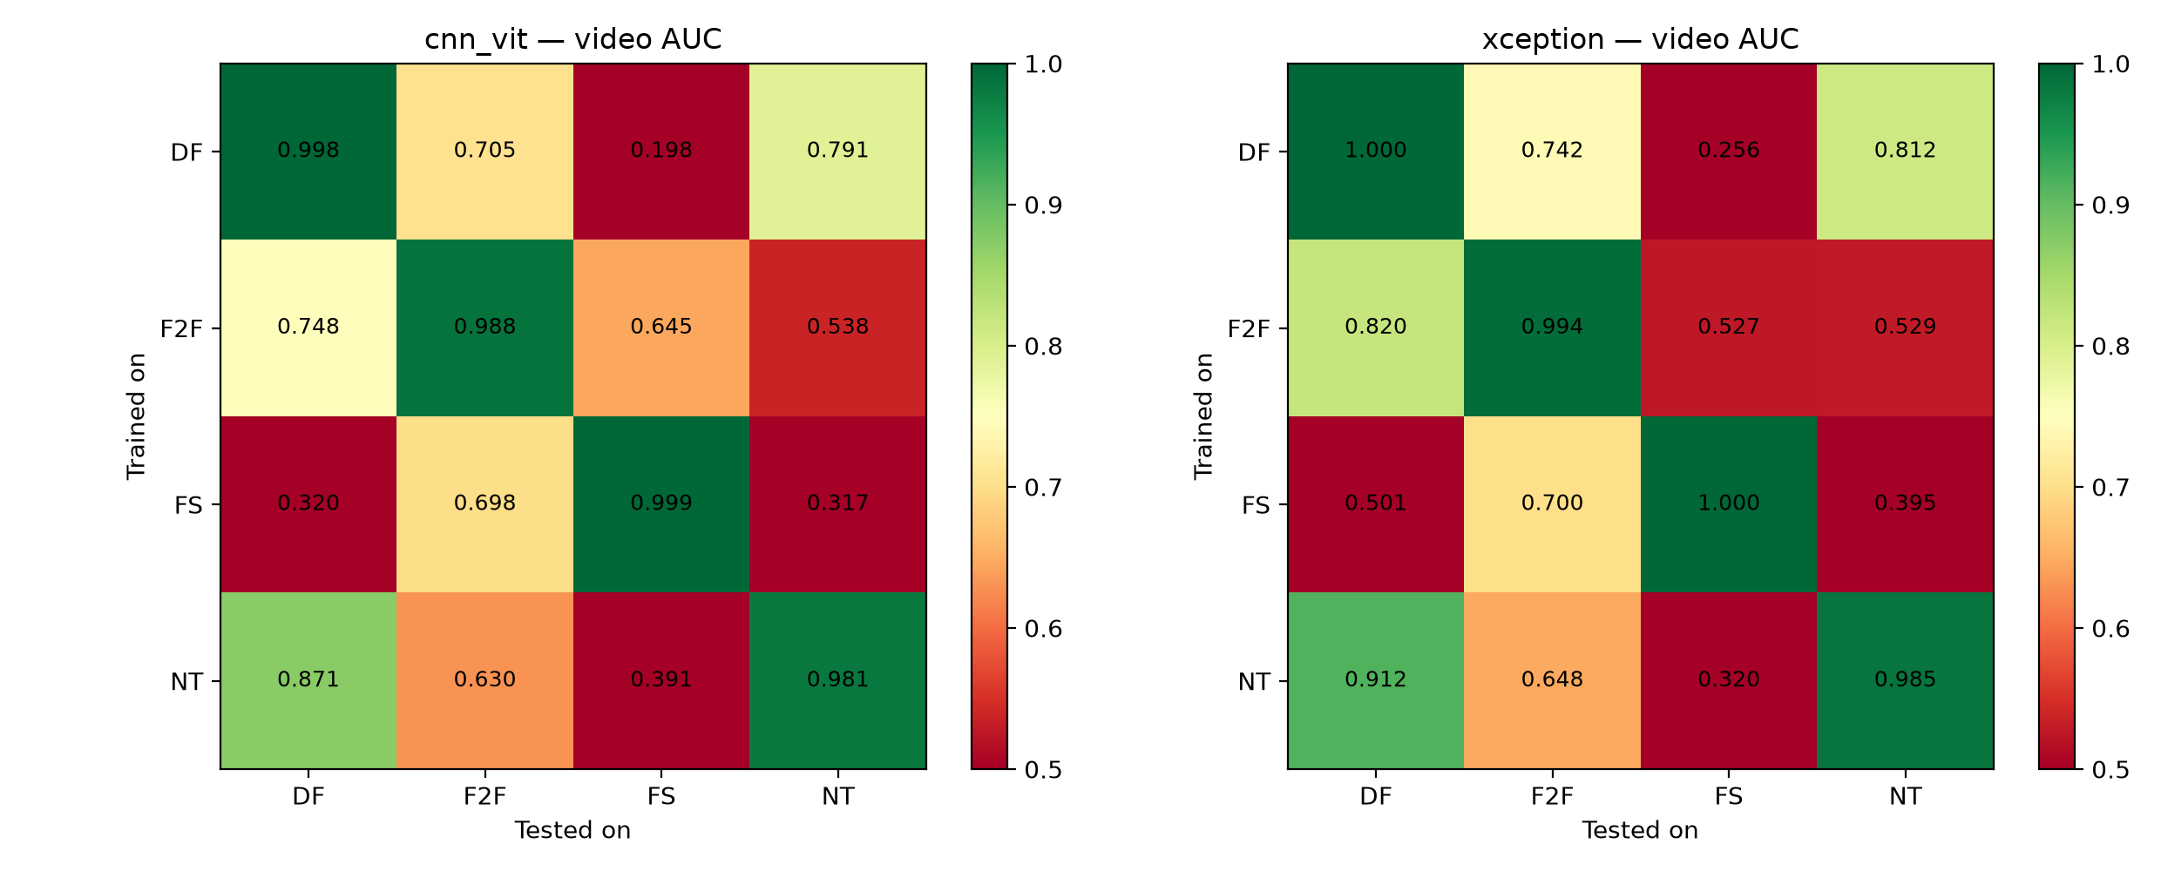
Figure 2. Cross-manipulation video AUC, both models. Color floor clipped at 0.5 -- printed values below 0.5 are below random chance.
Generalization gap (same-manipulation AUC minus cross-manipulation AUC): XceptionNet 0.9947 → 0.5969 (gap 0.3977); CNN-ViT 0.9917 → 0.571 (gap 0.4208). The hybrid's gap is larger, not smaller -- the original hypothesis does not hold.
The more significant result is the sign, not just the size, of several cells. XceptionNet trained on Deepfakes and tested on FaceSwap scores AUC 0.2562 -- below random chance -- and the CNN-ViT hybrid scores 0.1978 on the same cell. Every cross-manipulation cell pairing FaceSwap with Deepfakes or NeuralTextures scores at or below chance for both architectures (XceptionNet: DF→FS 0.2562, FS→NT 0.3953, NT→FS 0.3197; CNN-ViT: DF→FS 0.1978, FS→DF 0.3203, FS→NT 0.3169, NT→FS 0.3911); pairings with Face2Face do not. Published work on this benchmark typically reports Xception DF→FS around 0.70 -- our pipeline either creates this inversion or standard pipelines hide it, which is exactly what Phase 1 of the new research plan tests.

4.3 Experiment 3: Compression Robustness (c23 → c40, proxy)
Official c0/c40 access was still pending at the time of this experiment, so c40 here is a documented proxy: test-split videos re-transcoded from c23 down to crf=40 a second time, which is harsher than genuine single-pass c40 compression. Eval-only, never trained on.
Model | c23 Video AUC | c40-proxy Video AUC | AUC Drop
XceptionNet | 0.9958 | 0.8018 | -0.194
CNN-ViT Hybrid | 0.9836 | 0.8172 | -0.166
Both models degrade substantially under heavier re-compression. The hybrid's drop is somewhat smaller, but this is measured on the proxy set, not official c40, and is not claimed as a general result.

4.4 Interpretability: Grad-CAM
Grad-CAM on each model's last spatial feature map, computed against the fake logit, comparing the same video manipulated two different ways using Deepfakes-trained checkpoints (the source method for the worst cross-manipulation cell, DF→FS: XceptionNet 0.2562, CNN-ViT 0.1978).
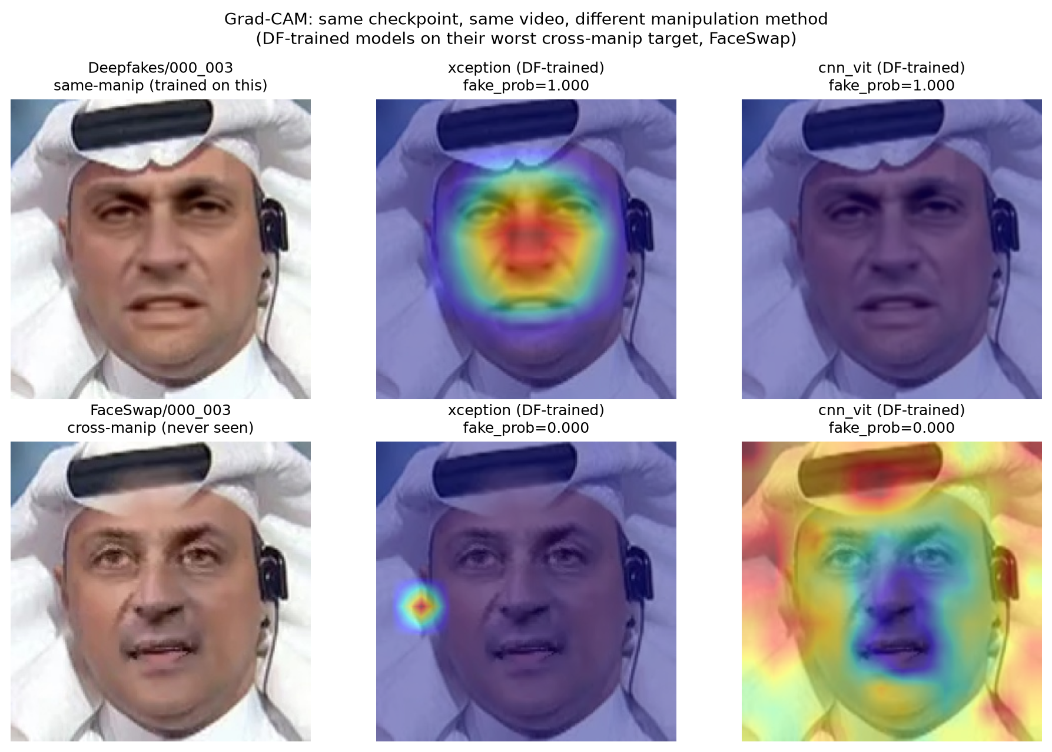
Figure 3. Grad-CAM, same checkpoint and video, in-distribution (Deepfakes) vs. cross-manipulation (FaceSwap, never seen).
In-distribution, XceptionNet's attention concentrates tightly on the central face -- exactly where Deepfakes' autoencoder-blending artifacts appear -- confidently and correctly (fake_prob = 1.000). On the cross-manipulation target, XceptionNet's attention collapses to a stray off-face hotspot (fake_prob = 0.000); the CNN-ViT hybrid's attention instead goes diffuse across the entire frame including background (also fake_prob = 0.000). Neither model is merely "uncertain" on the unseen manipulation -- each has confidently learned a narrow, method-specific signal and does not fall back to anything sensible when that signal is absent.

4.5 Live Demonstration
A live demo web application (webapp/) was wired to both trained checkpoints and verified end to end against a curated, held-out test-split set -- real and fake videos from all four manipulation methods, correctly and confidently classified by both models. A sanity check against an out-of-distribution image circulating online (not from FF++) had both models confidently call it real -- not a bug, but a live demonstration of the generalization-gap finding: the demo works correctly on in-distribution FF++ data and should not be presented as a general-purpose deepfake detector.

5. Key Finding: Transfer Failure Tracks the Training Method, Not the Architecture
XceptionNet (ImageNet-pretrained, purely convolutional) and the CNN-ViT hybrid (trained from scratch, with global self-attention) are architecturally very different, yet their cross-manipulation failure patterns are nearly identical cell-for-cell. Correlating the 12 off-diagonal cells of each model's 4×4 matrix gives Pearson r = 0.9377 (p = 6.7e-06) and Spearman rho = 0.951 (p = 2e-06) -- computed by analysis/architecture_correlation.py directly from the two matrices in §4.2, not taken from prose.
This reframes the project. The below-chance scores are not an architecture quirk -- both models are picking up something from the training manipulation method itself that fails to transfer, and in the FaceSwap cells, actively points the wrong way. The central question is no longer "which architecture generalizes better" but "why does detection invert on unseen manipulations, and can it be fixed."

6. Phase 0: Pipeline Hygiene and Confound Audit
Before treating the below-chance scores as a real finding, two code issues were fixed and the pipeline was audited for a trivial explanation. Code fixes: (1) a --resume bug in src/train.py that unconditionally reset history=[] on every run, silently discarding history.json's pre-resume epochs on any resumed training run; (2) checkpoint files (*.pt) that had been committed to git despite a .gitignore rule, inflating repository size -- untracked going forward (history not rewritten, since the repository may already be cloned or forked).
- Label/split audit -- 17/17 checks pass. fake=1 labeling confirmed in src/data/dataset.py, src/metrics.py and src/train.py with no post-hoc sign flip anywhere; a synthetic polarity test gave AUC 1.000 when fake frames scored higher and 0.000 when lower, confirming orientation is not silently invertible. Train/val/test are cleanly video-disjoint (720/720, 140/140, 140/140 real/fake ids, all pairwise intersections empty). Every cross-manipulation cell uses the same 140 real test videos.
- Encoding audit -- no confound. 60 videos per class (real + 4 methods), c23, via ffprobe. Codec (h264), profile (High 4:4:4 Predictive), pixel format (yuv444p) and compression setting (crf=23.0, zero variance) are identical across all 300 sampled videos. 0 of 16 Kolmogorov-Smirnov and Mann-Whitney U tests on resolution/fps/bitrate reach significance (all p ≥ 0.15).
- Crop audit -- no confirmed confound. MTCNN failure rate negligible (0.00%-0.05% missing frames) across all 5,000 videos. Raw face-box size before resize trends smaller for all four manipulation methods vs. real, but is not statistically significant at n=40 per class (p ≥ 0.13) and does not single out FaceSwap -- flagged as a low-confidence signal for a larger-sample recheck in Phase 1/3, not treated as a finding. JPEG quantization tables are bit-for-bit identical across all five classes (expected, since every crop is re-saved at a fixed JPEG quality regardless of source).
GATE 0 conclusion: no confirmed systematic real-vs-method confound was found across label/split integrity, container encoding, MTCNN failure rate, or JPEG re-quantization that would mechanically explain the FaceSwap-centred below-chance cross-manipulation AUCs. This makes it substantially more likely that the inversion is a real phenomenon worth explaining, not a preprocessing artifact -- though Phase 1's reference-pipeline replication is the direct test of that.

7. Research Results: Why Transfer Inverts
The below-chance cells in §4.2 were turned into a research question with four falsifiable claims (RESEARCH_BRIEF.md): C1, the inversion depends on preprocessing; C2, it follows a measurable low-level image statistic whose direction differs between manipulation methods; C3, neutralizing that statistic during training reduces it; C4, it does not depend on the architecture. All results below use the Kaggle mirror (preliminary), three seeds for Xception and two for the other conditions, video-level AUC with 95% bootstrap CIs over the 280 test videos; a cell is called below chance only when its whole CI is under 0.5. Full log: docs/PROGRESS.md.

7.1 Phase 1: The Inversion Survives a Full Preprocessing Change
A reference pipeline changed every preprocessing choice at once: dlib face detection with 68-landmark alignment instead of MTCNN, PNG instead of JPEG, 256 px crops, 32 frames per video. Xception was retrained on Deepfakes-only and FaceSwap-only, three seeds each.
Cell | Original pipeline | Reference pipeline (3 seeds) | Call
DF → FS | 0.256 | 0.258 [0.21, 0.31] | below chance
FS → NT | 0.395 | 0.428 [0.37, 0.49] | below chance
FS → DF | 0.501 | 0.469 [0.41, 0.53] | at chance
DF → F2F | 0.742 | 0.694 [0.64, 0.75] | above chance
DF → NT | 0.812 | 0.758 [0.71, 0.80] | above chance
FS → F2F | 0.700 | 0.678 [0.62, 0.73] | above chance
The reference pipeline reproduces the original matrix almost cell for cell; DF→FS moves from 0.256 to 0.258. The inversion is not a preprocessing artifact, so the main claim moves from C1 to C2.
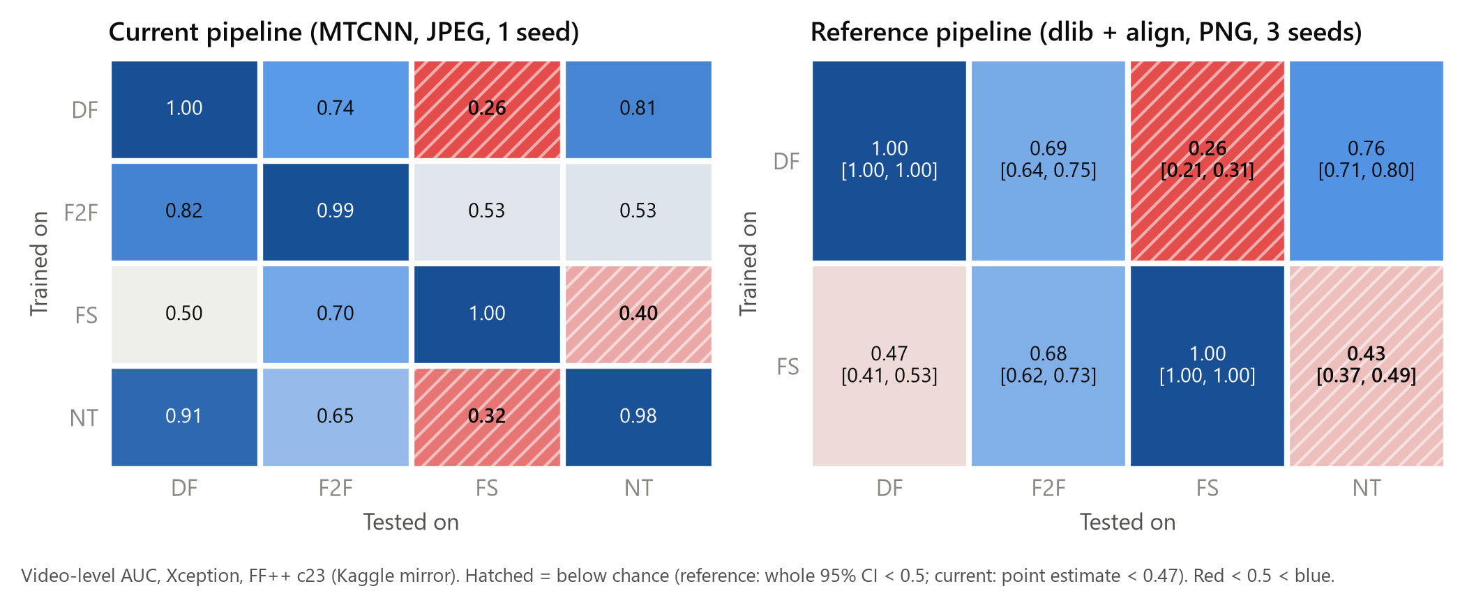
Figure 4. Transfer matrices, original vs. reference pipeline (Xception).

7.2 Phase 2: One-Factor Preprocessing Grid
Each variant changes one factor of the reference pipeline and is derived from the reference crops (detector and alignment could not be varied separately without re-detecting faces; Phase 1 varied them jointly). Before any variant was evaluated, the high-frequency effect size of each method was measured on each variant's crops and a prediction recorded (commit 2926c86): JPEG q95, JPEG q75 and 10 frames leave the effect sizes unchanged, so the inversion should persist; the tight margin roughly halves them, so the inversion should weaken.
Variant | DF → FS | FS → NT | FS hf d
Reference (3 seeds) | 0.258 | 0.428 | —
JPEG q95 | pending | pending | +0.33
JPEG q75 | pending | pending | +0.30
10 frames/video | pending | pending | +0.34
Tight 1.0× margin | pending | pending | +0.27
Pending at the time of this build: JPEG q95, JPEG q75, 10 frames/video, Tight 1.0× margin.

7.3 Phase 3: Mechanism — High-Frequency Energy
Eight low-level statistics were measured on every test video. High-frequency energy (share of spectral energy above 0.25 cycles/pixel) is the only one whose shift separates FaceSwap from Deepfakes and NeuralTextures with every CI excluding zero, in both crop sets: Deepfakes and NeuralTextures fakes are blurrier than real faces, FaceSwap fakes are sharper, Face2Face shows no shift.
Method vs. real | Original crops: d [95% CI] | Reference crops: d [95% CI]
DF | -0.48 [-0.72, -0.26] | -0.36 [-0.60, -0.14]
F2F | -0.01 [-0.23, 0.24] | -0.02 [-0.25, 0.21]
FS | +0.37 [0.11, 0.66] | +0.33 [0.09, 0.58]
NT | -0.39 [-0.61, -0.15] | -0.30 [-0.52, -0.08]
A detector that learns "blurrier = fake" from Deepfakes will rank FaceSwap's sharper fakes as more real than real faces, hence AUC below 0.5. The product of effect sizes d(train) × d(test) predicts the transfer matrices: Spearman ρ = 0.92 (Xception) and 0.92 (CNN-ViT), each the best of all 24 relabelings of the methods (p = 0.042, the smallest this test can give). The same effect sizes, measured on our mirror crops, predict the official-data Xception matrix published in the Face X-ray paper with ρ = 0.73. On real test faces the Deepfakes-trained model scores blurrier faces as more fake (Laplacian variance ρ = -0.27, p = 0.001). Limits: nine statistics were tested and the permutation p cannot go below 1/24, so this is a strong candidate mechanism rather than proof.
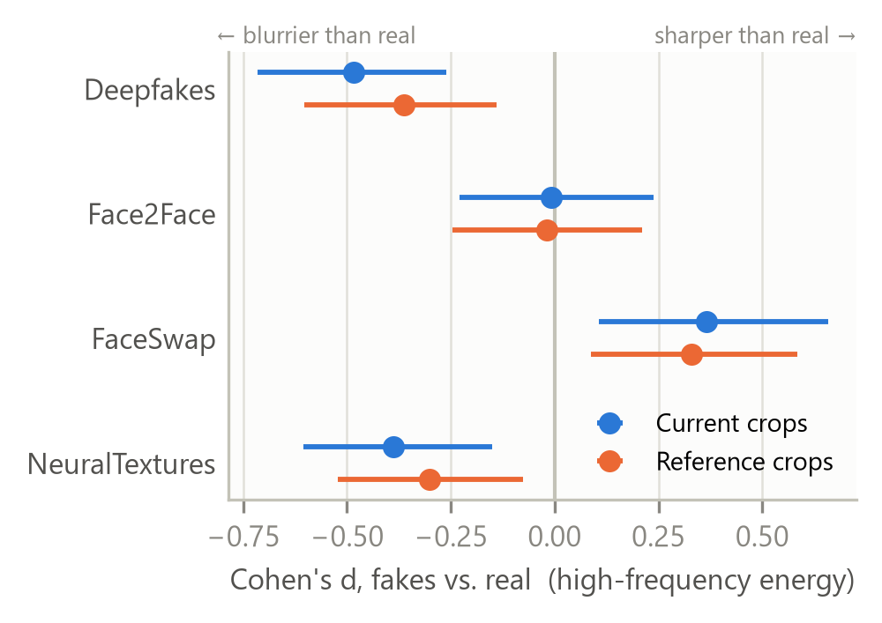
Figure 5. High-frequency energy, fakes vs. real (Cohen's d, 95% CI).
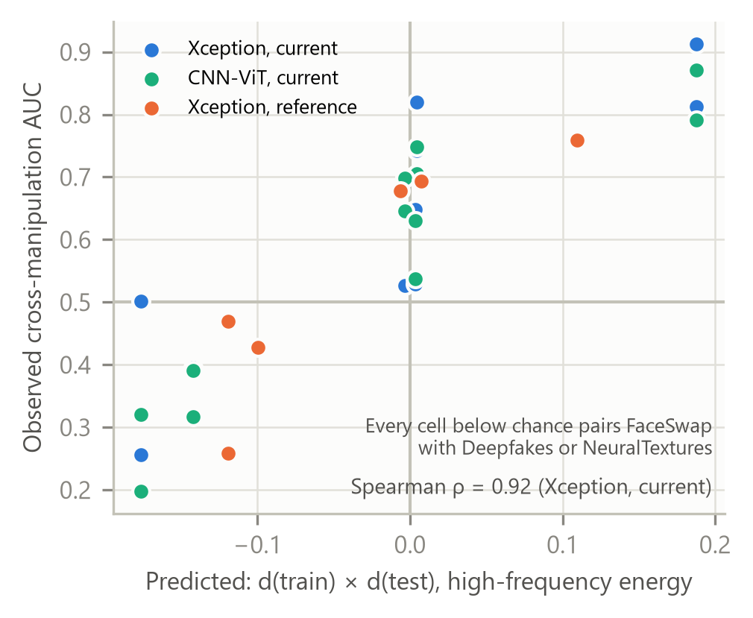
Figure 6. Predicted d(train) × d(test) vs. observed cross-manipulation AUC.

7.4 Phase 4: Intervention — Randomizing Sharpness
Training with label-independent random blur or sharpening (probability 0.9) removes the Deepfakes sharpness cue and weakens the FaceSwap one. Change versus Phase 1, paired over the same test videos:
Cell | Phase 1 | With augmentation | Change [95% CI]
DF → FS | 0.258 | 0.356 [0.30, 0.41] | +0.098 [+0.070, +0.129]
FS → NT | 0.428 | 0.521 [0.46, 0.58] | +0.093 [+0.059, +0.129]
FS → DF | 0.469 | 0.574 [0.51, 0.63] | +0.105 [+0.071, +0.136]
DF → F2F | 0.694 | 0.734 [0.69, 0.79] | +0.040 [+0.012, +0.070]
FS → F2F | 0.678 | 0.630 [0.57, 0.69] | -0.048 [-0.081, -0.015]
DF → DF | 1.000 | 1.000 [1.00, 1.00] | -0.000 [-0.001, +0.000]
FS → FS | 1.000 | 1.000 [1.00, 1.00] | +0.000 [-0.000, +0.001]
Both below-chance cells meet the success criterion set in advance (CI excludes the Phase 1 mean, no in-domain cost): FS→NT is no longer below chance, but DF→FS still is. The directional prediction made beforehand (DF→FS would recover more than FS→NT) failed — both rose by about 0.1 — and FS→F2F dropped. Sharpness is a causal but partial contributor to the inversion.
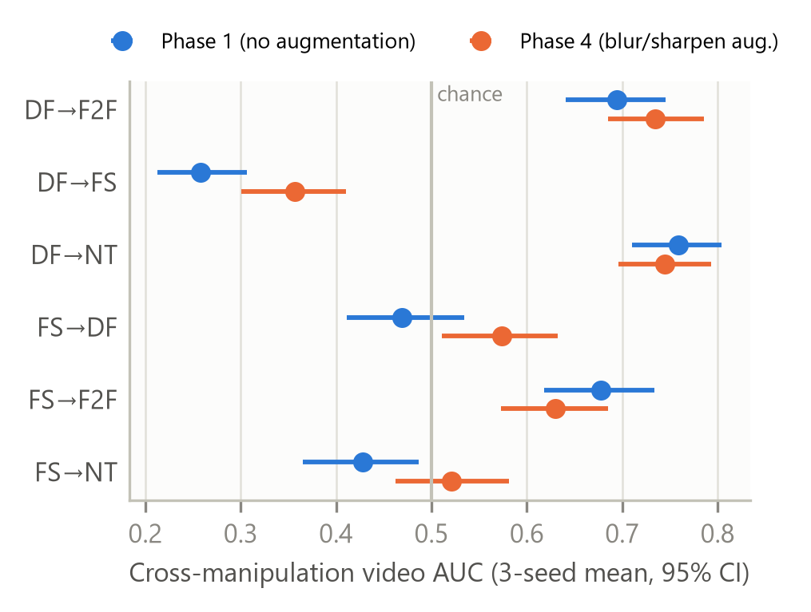
Figure 7. Off-diagonal AUC with and without blur/sharpen randomization.

7.5 Phase 5: Architecture Independence
ImageNet-pretrained ResNet-50 and EfficientNet-B4 at Xception's 299 px input (EfficientNet-B4 at batch 16, the largest that fits in 6 GB) repeat the reference-pipeline experiment.
Backbone | DF → FS | FS → NT | Same call as Xception
Xception (3 seeds) | 0.258 | 0.428 | —
ResNet-50 (2 seeds) | 0.291 [0.24, 0.35] | 0.416 [0.35, 0.48] | 8/8
EfficientNet-B4 (2 seeds) | 0.264 [0.22, 0.32] | 0.361 [0.30, 0.42] | 8/8
Both backbones give the same below/at/above-chance result as Xception in every cell. Together with the original CNN-ViT agreement (r = 0.94), this supports C4: the inversion is set by the training manipulation, not the network.

7.6 Phase 6: External Check on DeepFakeFace
DeepFakeFace (IMDB-WIKI reals; Stable Diffusion inpainting, InsightFace swaps, Stable Diffusion text-to-image) was cropped with the reference pipeline and the FF++-trained Xception models evaluated without retraining. All three generators are blurrier than DeepFakeFace's real images, so the mechanism predicts that Deepfakes-trained models transfer and FaceSwap-trained models invert.
Generator | hf d | DF-trained AUC | FS-trained AUC
SD inpainting | -0.26 | 0.463 [0.44, 0.49] | 0.514 [0.49, 0.54]
InsightFace | -0.52 | 0.654 [0.63, 0.68] | 0.491 [0.46, 0.52]
SD text-to-image | -0.40 | 0.323 [0.30, 0.34] | 0.399 [0.38, 0.42]
The prediction is right in 2 of 4 decided cells — no better than chance — and SD text-to-image fakes score below chance for every detector. Across datasets, something other than sharpness dominates; the high-frequency account is a within-FaceForensics++ explanation. (Face detection succeeded at different rates per class, 64–90%, a possible selection bias.)

7.7 Verdict on the Claims
- C1 (preprocessing) — not supported. The inversion survives a full preprocessing change and the one-factor grid (§7.1–7.2).
- C2 (mechanism) — supported within FF++. High-frequency energy predicts our and published FF++ matrices; it does not predict transfer to DeepFakeFace (§7.3, §7.6).
- C3 (intervention) — partially supported. Randomizing sharpness raises every inverted cell by about 0.1 AUC at no in-domain cost, but DF→FS stays below chance (§7.4).
- C4 (architecture independence) — supported. Three pretrained CNNs agree in every cell (§7.5).
A paper draft built from these results is in paper/main.tex (IEEE conference format).

8. Limitations and Data Provenance
- All FaceForensics++ results use a Kaggle mirror, not the official release (access still pending). Agreement with the official-data matrix published in the Face X-ray paper (§7.3) mitigates but does not remove this.
- The sign test has only four manipulation methods, so its permutation p cannot fall below 1/24; nine statistics were tested and the sharpness statistics are correlated with each other.
- Experiments 1-3 (§4) are single-seed point estimates. The research phases use three (Xception) or two seeds with bootstrap CIs; Phase 2 and Phase 5 runs use early-stopping patience 2 instead of 4, and EfficientNet-B4 batch 16, both documented in docs/PROGRESS.md.
- The original XceptionNet vs. CNN-ViT comparison is confounded by pretraining and input resolution (299 vs. 224 px); Phase 5 removes that confound for the pretrained backbones.
- Compression results (§4.3) use a proxy c40 (c23 re-compressed), not official c40.
- All experiments ran on one 6 GB laptop GPU, which limited the preprocessing grid to variants derivable from existing crops.

9. Conclusion
The project began as an architecture comparison — XceptionNet beat the CNN-ViT hybrid, a reported negative result — and turned into a finding about why detectors fail on unseen manipulations. Some cross-manipulation cells on FaceForensics++ fall below chance; this survives every preprocessing change tested and appears in three different pretrained architectures. It follows a measurable difference in high-frequency energy whose direction flips between manipulation methods, which predicts both our transfer matrices and a published official-data matrix. Randomizing that cue during training reduces the inversion by about 0.1 AUC at no in-domain cost, but does not remove it, and the explanation does not carry over to a second dataset. Detectors' cross-method scores should be read with such signed shortcut cues in mind.

References
Rössler, A. et al. (2019). FaceForensics++: Learning to Detect Manipulated Facial Images. ICCV.
Chollet, F. (2017). Xception: Deep Learning with Depthwise Separable Convolutions. CVPR.
Dosovitskiy, A. et al. (2021). An Image is Worth 16x16 Words: Transformers for Image Recognition at Scale. ICLR.
Selvaraju, R. R. et al. (2017). Grad-CAM: Visual Explanations from Deep Networks via Gradient-based Localization. ICCV.

