1. MN-DUNE
2. Python Database Upload Tool

Version 1.1

Marvin Marshak

Hajime Muramatsu

Alex Wagner

Urbas Ekka

# Table of Contents

**Table of Contents**

Table of Contents 2

Introduction 3

Setup 4

Prerequisites 4

Installation 4

User Configuration 5

Obtaining a PKCS12 Certificate 5

Configuring Access to the HWDB 6

Viewing the configuration 6

Setting a PKCS12 certificate 6

Setting the HWDB server 7

Tutorial 8

Example 1 (Simple) 8

Preparing Component Types For Uploading 8

Configuring the Datasheet 9

Organizing HW Item Data in Spreadsheets 11

Defining Encoders 12

Defining a Docket 15

Uploading a HW Item 16

Example 2 (Adding a Test) 19

Uploading an HW Item with Tests 21

Example 3 (Complex Case) 22

HW Item Datasheet 22

HW Item Data 23

HW Item Encoder 24

Test Datasheet 25

Test Data Spreadsheets 27

Test Encoders 29

Docket 31

Uploading the Docket 32

# Introduction

The DUNE HWDB is set up to provide a repository for diverse hardware components and their associated tests, where the data requirements may be drastically different from one component type to the next.

To accommodate this, the database provides free-form JSON/YAML “Specifications” and “Datasheet” fields, where each group can define their own structures. It is therefore helpful for us to provide tools for the various consortia to manage this complexity.

The Python Database Upload Tool is a utility to help with this complexity. It allows consortia to define those structures, map them to tabular data contained in CSV or Excel files, and upload that data into the HWDB.

# Setup

## Prerequisites

* Linux/MacOS system with Anaconda installed. This tool has not been tested in a pure Windows environment, but it works fine with Windows using WSL/Ubuntu. Anaconda may be downloaded at <https://www.anaconda.com/download>.
* A Fermilab Services account
* A PKCS12 certificate for the Fermilab account. Visit [https://cilogon.org](https://cilogon.org/) to obtain this certificate.
* The user must have access to the HWDB database. (This may take 24 hours after your Services account is activated.)
* The tool is used in conjunction with the HWDB Web UI. Familiarity with the Web interface is required for setting up hardware items and tests to receive uploaded data. Once these have been set up, subsequent users will not necessarily need to know how to use the Web interface.

The Web UI can be found at the following URLs:

|  |  |
| --- | --- |
| Development | [https://dbweb9.fnal.gov:8443/cdbdev/index](https://dbwebapi2.fnal.gov:8443/cdbdev/index) |
| Production | <https://dbweb9.fnal.gov:8443/cdb/index> |

## Installation

Follow these instructions to install the utility:

* Download the Version-1.1 branch from   
  <https://github.com/DUNE/DUNE-HWDB-Python> to a location of your choosing.
* If your default shell is BASH, add the following to the end of your “.bashrc” file (or other shell startup script), using, of course, the actual name of the directory of the extracted contents. (Modify these instructions as necessary if you are using a different shell.)  
    
  export PATH=<install location>:$PATH  
  export PYTHONPATH=<install location>/lib:$PYTHONPATH

## User Configuration

### Obtaining a PKCS12 Certificate

Before the upload tool can be used, users need to download a PKCS12 certificate for their fermilab account.

1. In your browser, go to [https://cilogon.org](https://cilogon.org/)
2. If you have never visited CILogon before, it may ask you to select an identity provider. Choose “Fermi National Accelerator Laboratory” and click “Logon”
3. The browser will redirect to the Fermilab authentication page. Authenticate using one of the methods offered.
4. The browser will now return to the CILogon page. Choose “Create Password-Protected Certificate”
5. Choose a password to be associated with your PKCS12 certificate. Note that this does not have to match the password for your Fermilab Services account.
6. Click “Get New Certificate.” A new certificate will be generated for you to download.
7. Click “Download Certificate.” The new certificate will be downloaded to the directory your browser is currently set for downloading files. (On Windows, this will typically be your “Downloads” folder.) The file will be named “usercred.p12” if this is the first certificate you’ve downloaded, or “usercred (<number>).p12” if you have downloaded previous certificates.
8. Make a note of the location of the PKCS12 certificate. If you will be using the Upload Tool on a Linux system, you may need to move the file to an accessible location. You may rename this file to avoid ambiguity if you will have multiple users on your system, e.g., to “<your username>.p12”.

### Configuring Access to the HWDB

Use the “hwdb-configure” command to configure access to the HWDB.

#### Viewing the configuration

To view the current configuration, enter “hwdb-configure” with no parameters. If the configuration utility has never been called before, the tool will automatically create a directory “$HOME/.sisyphus” containing a default configuration using the DEVELOPMENT version of the HWDB.

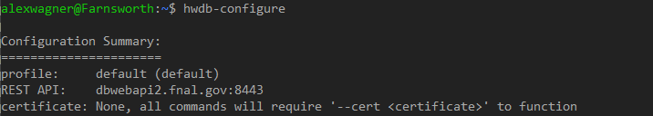Figure 1: Using hwdb-configure to display the current configuration

Note 1: The first time running hwdb-configure, the file might not have executable perrmissions set corrrectly. You can get around this by calling the script explicitly via bash, i.e., “bash <path-to-file>/hwdb-configure”. The script will automatically update the excecutable permissions on itself and other scripts in that directory, and you will no longer need to invoke the script via bash.

Note 2: If you are using Ubuntu on Windows using WSL, it is possible for GitHub to erroneously translate line endings to DOS-style instead of UNIX-style. If, when running the script, you get an error saying “/bin/bash^M: bad interpreter: No such file or directory,” then this is probably the reason. The fastest way to fix this is to open the script using vim, running the command “set ff=unix”, and saving and exiting the file. Contact us if you need help doing this.

#### Setting a PKCS12 certificate

To use the PKCS12 certificate downloaded from CILogon, supply the location of downloaded certificate and the password you created using “--cert” and “--password” parameters.

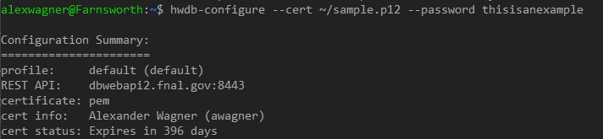Figure 2: Using hwdb-configure to add a user's certificate

The configuration utility will automatically extract a PEM certificate from the P12 file using the password provided (or raise an error if the password is incorrect) and store it in the “$HOME/.sisyphpus” directory. The password used is not retained by the system after configuration!

WARNING: Please note that the PEM certificate is unencrypted and not password protected, and it can now be used to access the HWDB without a password! The configuration utility does attempt to set the “$HOME/.sisyphus” directory to only be readable by the owner, but it may be worthwhile to check the permissions to see that they were set correctly. In general, use good security practices in handling the PEM file!

#### Setting the HWDB server

To set the utility to point to a different HWDB server (e.g., production), use the “--rest-api” parameter.

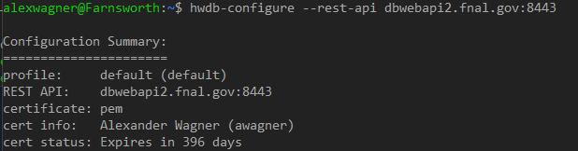Figure 3: Using hwdb-configure to change the REST API server location

The addresses for the two currently-available servers are as follows:

|  |  |
| --- | --- |
| Development | dbwebapi2.fnal.gov:8443 |
| Production | dbweb9.fnal.gov:8443 |

The examples provided in this document are only currently available on the Development server. It is highly recommended that new Component Types are tested on the Development server before being deployed to Production.

# Tutorial

The following examples demonstrate the general usage of the Upload Tool. After installing the application, these examples can be found under ${INSTALL_DIR}/Examples/upload-docket/Tutorial.

For these examples, the HW Item and Test datasheets already exist in the development database. For your own items and tests, you will need to edit these yourself. Please refrain from changing the HW Item and Test Definition datasheets in the Web UI for the Component Types used in these examples!

Note that you will need to change the serial numbers in the spreadsheets between tests!

## Example 1 (Simple)

For this example, we will upload a HW Item to the database, with no test data. The HW Item will have a simple datasheet, consisting only of (field, value) pairs.

### Preparing Component Types For Uploading

Uploading HW Item data to the database requires four things:

* The Datasheet of the Component Type must be configured in the Web Interface to contain the structure of the data you wish to upload.
* The data to be uploaded must be contained in spreadsheets (CSV or Excel files)
* An encoder must be created in JSON format describing how spreadsheet data is translated into the Datasheet for the item. (If the structure is simple, the encoder is very straightforward.)
* A docket file must be created in JSON format listing the spreadsheets containing data and the encoder(s) to use

### Configuring the Datasheet

For this example, the Datasheet has already been configured. The Datasheet has three fields: “Color”, “Comment”, and “Widget ID”.

Note that the intent here was to suppose that the HW Item’s serial number is internally known as “Widget ID”, so it has been added to the Datasheet to reflect that. Note that this is merely an aesthetic choice, and it is not necessary if you are sufficiently happy with it only being known as “Serial Number.”

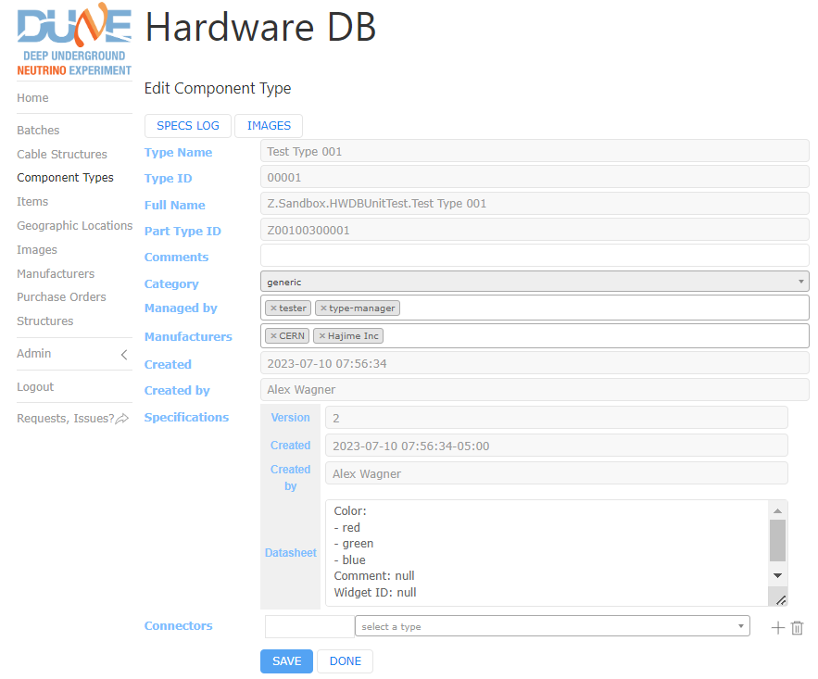Figure 4: Example 1 HW Item Datasheet

Note the following about datasheets:

* The Datasheet is in YAML format. The same content may be formatted in multiple ways in YAML. Don’t be alarmed if, after saving the Specification, the Datasheet is formatted differently than it was inputted.
* Dictionary-type data is by definition unordered, so the list of fields given will likely not appear in the same order after it is saved.
* Field names are case-sensitive.
* If a field is listed in the Datasheet, it is required to be in the data to be uploaded. (It is acceptable for it to be blank or null in the spreadsheet, but it must be accounted for.)
* The database will accept fields that are not listed. This leaves the possibility of putting leaving the Datasheet empty and still uploading data into it anyway. It is not recommended to do this, as the functionality is subject to change.
* If a field is defined as a list, the database will expect that the uploaded data for that field will be one of the items in that list. E.g., if the field is defined as “Color: [red, green, blue]”, then the submitted data must be one of the three values.
* If a field is expected to contain complex data such as a list or dictionary (or even a nested hierarchical structure of lists and dictionaries, this structure does not need to be defined here (for the reason above that it will be interpreted as multiple-choice). Just use “field_name: null”.

### Organizing HW Item Data in Spreadsheets

HW Items to be uploaded must be organized in spreadsheets. These may be in CSV or Excel format. If you use Excel format, the file may contain multiple sheets, because when the docket file is created, it is possible to specify which worksheet in the file to use.

The spreadsheet **must** contain the following column headers. Note that they are case-sensitive and should not contain any extra spaces before or after the name. Item data should be supplied in the second row and beyond.

* “External ID” – The database will assign the External ID when the item is uploaded, so leave this blank. (Future: supplying an External ID will make the tool attempt to edit an existing item instead of adding a new one.)
* “Country” – Every item needs to have a country of origin (along with an institution ID) in order for the database to define the full Part ID, e.g. “D00501342003-00002-US125”. The country may be supplied as any of the following:
  + The two-letter country code, e.g., “US”
  + The full name of the country, e.g., “United States”
  + The country code in parentheses, followed by the full name, e.g., “(US) United States”

Please refer to EDMS ID 2505353 for a list of country codes.

* “Institution” – Similarly to Country, the Institution is required for the database to define the full Part ID. The institution may be supplied in the following ways:
  + The numeric institution code, e.g., “186”
  + The full name of the institution, e.g., “University of Minnesota Twin Cities”
  + The institution code in parentheses, followed by the full institution name, e.g., “(186) University of Minnesota Twin Cities”

Please refer to EDMS ID 2505353 for a list of institution codes.

* “Manufacturer” – The manufacturer must be in the list of manufacturers configured for the Component Type. Similar to Country and Institution, it may be given as the manufacturer’s ID, the manufacturer name, or a combination, e.g., “27”, “CERN”, or “(27) CERN”.
* “Serial Number” – This should be some number that uniquely identifies the HW Item (within the given Component Type) prior to it being assigned an External ID. The HWDB itself will allow a serial number to be used multiple times, but the Upload Tool will not. Be warned that editing a serial number through the Web Interface, although allowed, may confuse the Upload Tool when attempting to add secondary information to a HW Item, such as test results.
* The remaining column headers should correspond with the fields listed in the Datasheet. Note that the choice to put “Widget ID” in the Datasheet results in the same serial number data under two differently-named columns.
* It is possible, if you wish, to define structured data for one or more of the fields. In this case, the data can be added in separate sheets or as additional columns in the main sheet. See instructions and examples later in this document to see how to do this.

Here is the HW Item spreadsheet for this example:

Figure 5: Example 1 HW Item Spreadsheet

### Defining Encoders

An Encoder is a JSON document that maps a spreadsheet to a Datasheet in a HW Item or a Test for a HW Item.

It is possible to define an Encoder inline in a Docket file, but since Encoders are intended to be reused, this document will only cover the case where Encoders are isolated into their own files.

Here is the encoder file “encoders.json” for this example:

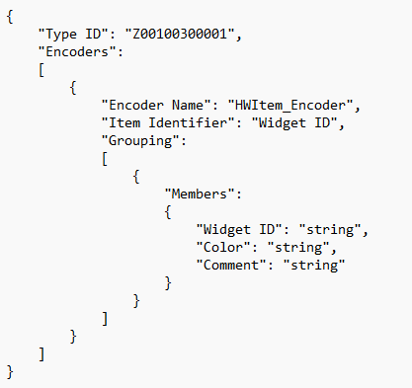Figure 6: Example 1 HW Item Encoder

The Encoder file is required to be formatted as follows:

* The top level must be a dictionary
* The top level dictionary must contain a “Type ID” field which specifies the Type ID for the Component Type
* The top level dictionary must contain an “Encoders” field which contains a list
* Each item in the list specifies a different Encoder. For simple cases, this may be a single item.
* Each Encoder is a dictionary which contains the following entries:
  + “Encoder Name” – this is how the Docket file will identify which Encoder to use.
  + “Item Identifier” – if the data in the Datasheet were thought of as an entry in a table, the Item Identifier is the field that would be the key. It may help to explain that this is somewhat of a throwback to before we felt confident that the Serial Number didn’t have some predetermined use outside of the end user’s control. In the future, we may make this field optional and assume “Serial Number” as the default.
  + “Grouping” – this contains a list of “group” objects. All the user-defined columns in the spreadsheet must belong to a group. The groups define the hierarchy represented by the columns in the spreadsheet. For simple cases, the data would most likely be “flat,” and would only require a single group, but a more complicated item may contain fields that are themselves lists of records with their own fields. This can be achieved by using multiple groups. This will be illustrated later in this document.
* Each “group” must contain a “Members” field, which contains the user-defined columns for the HW Item.
* A “group” is also allowed to define a “Name”, a “Key” containing one or more of the members in that group, and a “Lock Keys” boolean value. These are more useful for Test Encoders than for Item Encoders, and will be explained there.

### Defining a Docket

A Docket is a JSON document that specifies which spreadsheets should be encoded and uploaded to the HWDB.

Here is the docket file “docket.json” for this example:

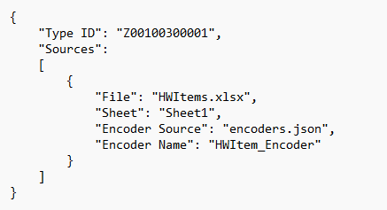Figure 7: Example 1 Docket File

The Docket file is required to be formatted as follows:

* The top level must be a dictionary
* The top level dictionary must contain a “Type ID” field which specifies the Type ID for the Component Type
* The top level dictionary must contain a “Sources” field which contains a list.
* Each item in the list is a dictionary object that specifies a source
* Each source may contain the following fields:
  + “File” – the absolute or relative location of a CSV or Excel spreadsheet. If the location is relative, the tool will first check relative to the directory containing the Docket file. If not found, it will then check relative to the current working directory in the shell invoking the tool. File globbing is allowed. If the pattern matches more than one file, the order in which the files will be processed is not guaranteed.
  + “Sheet” – if the file(s) are Excel, “Sheet” specifies which worksheet name or number will be used. If no sheet is specified, only the first sheet will be used. If the file is CSV, “Sheet” is ignored.
  + “Encoder Source” – the absolute or relative location of an Encoder file containing the Encoder to be used. If the Encoder is specified later in the Docket file, “Encoder Source” is not needed.
  + “Encoder Name” – the name of the Encoder specified in either “Encoder Source” or later in the Docket file
* The top level dictionary may also contain an “Encoders” field governed by the same rules as the Encoder file.

### Uploading a HW Item

Once you have created a Docket and Encoder, have defined the Datasheet in the HWDB Web Interface, and have a spreadsheet containing HW Item information to be uploaded, you are now ready to use the Upload Tool to upload your HW Items.

Invoke the Upload tool in your shell with “hwdb-upload-docket”. The Upload Tool will scan the Docket for sources and process them using the specified Encoders. At this point, it will NOT upload the results to the database. Instead, it will output its results to “item-receipt.json” for you to review to make sure that the encoding produced what you expected.

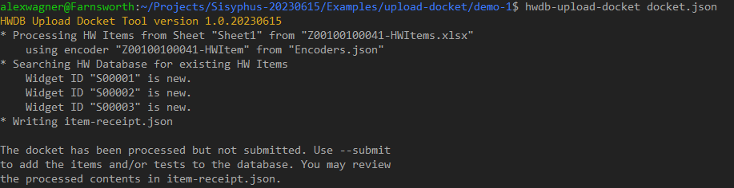Figure 8: Using hwdb-upload-docket to preview upload

Here is the contents of the “item-receipt.json” file:

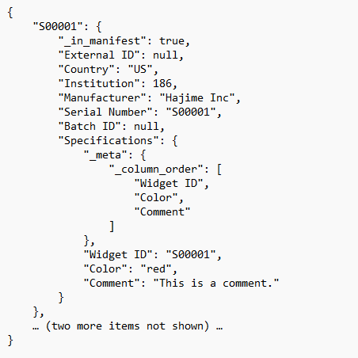Figure 9: item-receipt.json

If the contents of “item-receipt.json” looks correct, you may then invoke “hwdb-upload-docket” again, this time adding the parameter “--submit”. The Upload Tool will attempt to upload the items to the database and it will report whether the attempt was successful. PLEASE NOTE that when using “--submit”, the tool processes the docket from the beginning. It does not read or use what was previously written in “item-receipt.json”.

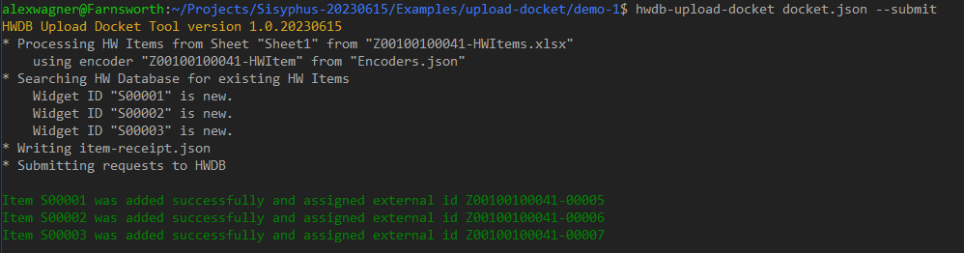Figure 10: Using hwdb-upload-docket to upload data

The tool will automatically check for existing serial numbers and will not attempt to add them again if you invoke the tool a second time:

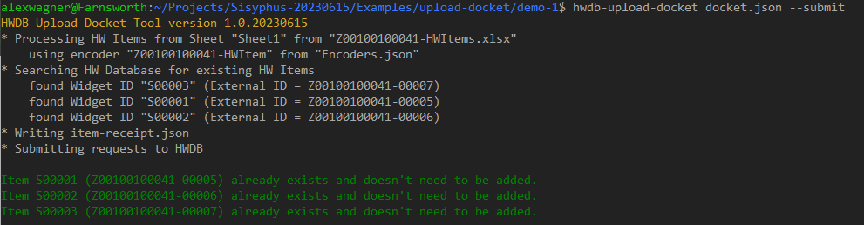Figure 11: Attempting to add HW Items a second time

## Example 2 (Adding a Test)

Let’s add a new Test Type for our Component Type.

We will create a test named “Bounce”, with the Datasheet as shown:

.

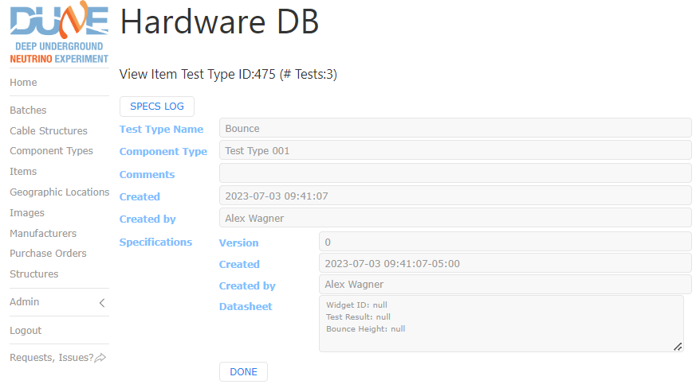Figure 12: Example 2 HW Item Test Specification

The spreadsheet “Test_Bounce.xlsx” is as follows:

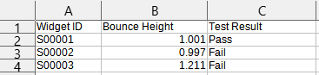Figure 13: Example 2 Test Spreadsheet

We will add a second encoder to “encoders.json”:

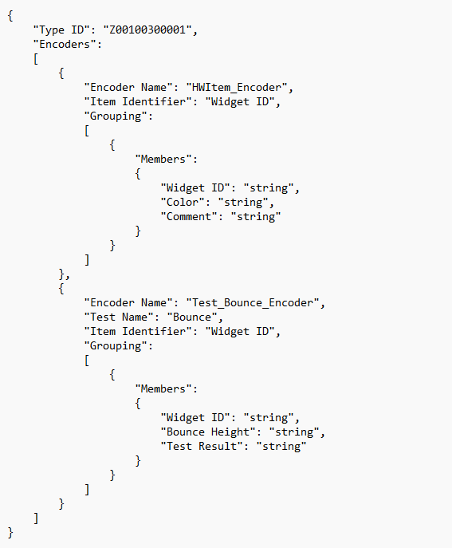Figure 14: Example 2 Encoder File

Finally, we’ll add the test spreadsheet to “docket.json”:

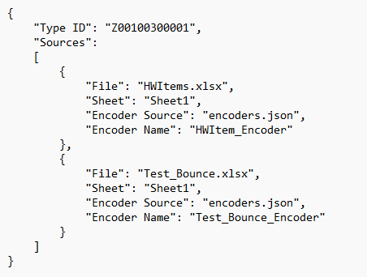Figure 15: Example 2 Docket File

### Uploading an HW Item with Tests

We may now upload this example:

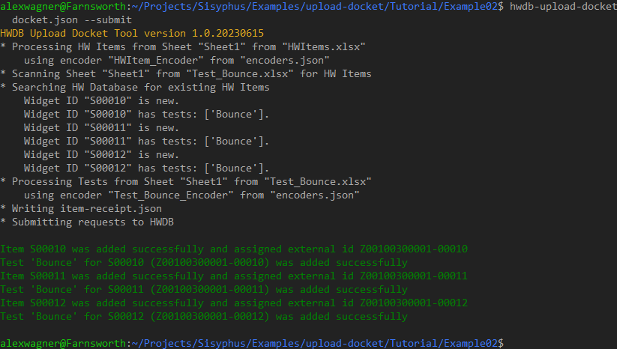Figure 16: Example 2 Uploading the Data

## Example 3 (Complex Case)

The Upload Tool is able to handle more complex situations than the ones previously described.

Let’s consider the following example.

### HW Item Datasheet

Suppose we have a component type representing a “widget,” and each widget contains several “doodads.” One possibility, of course, is to make “doodad” a completely different component type in the database, and then link them as subcomponents, but let’s suppose that the doodads are intrinsic enough to the widget that it doesn’t make sense to consider them as entirely separate entities, but important enough to be represented individually in the widget specification.

The specification, therefore, might be best represented as a hierarchical structure instead of a simple list of fields and values, e.g.,

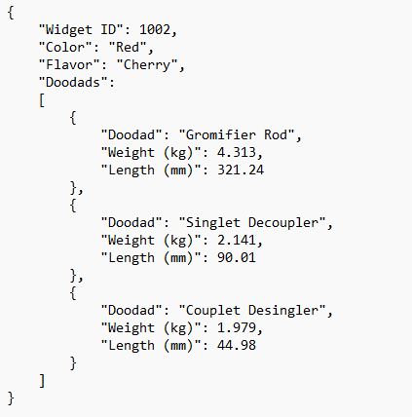Figure 17: Example 3 HW Item Structure

For this sort of hierarchical structure, only the top-level fields need to be represented in the Datasheet for the HW Item:

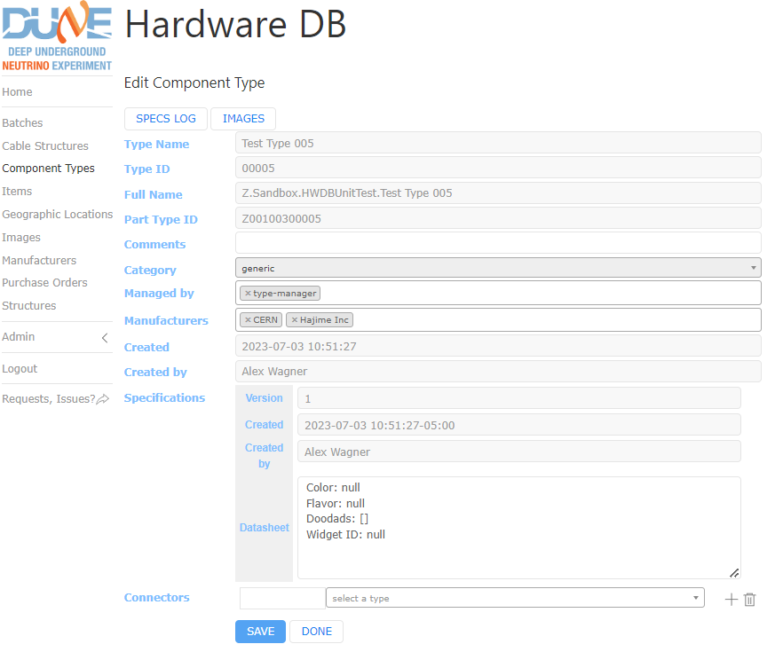Figure 18: Example 3 HW Item Specifications

### HW Item Data

The HW Item spreadsheet needs to reflect the hierarchical structure of the data. One fairly intuitive way is to have the top-level and secondary-level fields as columns in the same sheet, repeating the top-level values as needed to indicate that the secondary-level values are subordinate to them:

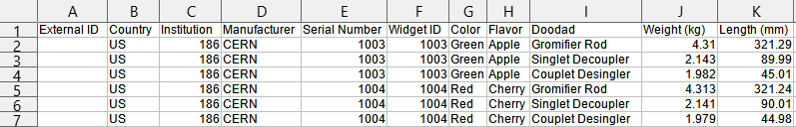Figure 19: Example 3 HW Item Data

The utility does allow, however, for duplicate information for the top-level data to be eliminated in subsequent rows:

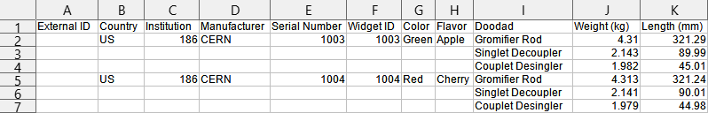Figure 20: Example 3 HW Item Data, "sparse" format

Either format may be used (with no changes to the encoder), but the code in the Tutorials directory uses the second.

### HW Item Encoder

It is possibly confusing that the field “Doodads” (plural) from the Datasheet does not appear in our spreadsheet. “Doodads” here specifies a container or “Grouping” for the secondary-level data.

Because of the two-level hierarchy, our HW Item encoder for this example must contain two groups. The first group specifies which fields belong to the top-level structure, and which of those fields is best suited to act as a “key” for those data. In this case, “Color” and “Flavor” do not appreciably contribute to uniquely identifying a set of data, so “Widget ID” is the only reasonable choice. We have given the first group a name of “Specifications,” because that is where the data belongs in the HW Item record in the HWDB, but it is completely optional to give the first group a name, and giving it a different name will not affect the functionality of the upload tool.

Because our Datasheet has the secondary-level data under “Doodads”, the second group must be named that as well. Because this is the final grouping for this example, it is not strictly necessary to identify a key, because there are no further levels of data that need it to determine their place in the structure.

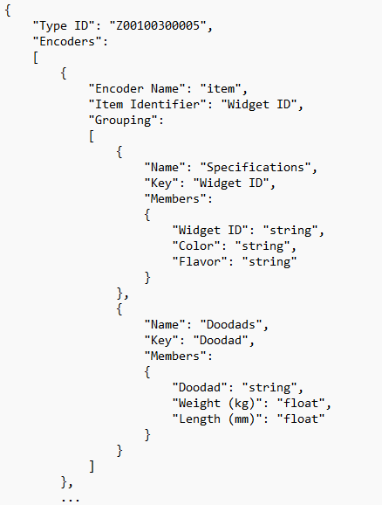Figure 21: Example 3 HW Item Encoder

### Test Datasheet

For this example, let’s make the “Bounce” test more complex.

Let’s suppose that the widget is dropped at several different temperatures at a number of different heights. At each temperature, we are summarizing the results of the various heights into a single average value. We therefore have two different sheets, one with the average value, and another containing the details that were summarized. (We could still have done these as a single sheet, but we’ll do it as separate sheets for the sake of an example.)

To further complicate matters, let’s suppose that our detail sheets contain only one HW Item each, while our summary sheet contains multiple HW Items.

The desired resulting data structure may appear as follows:

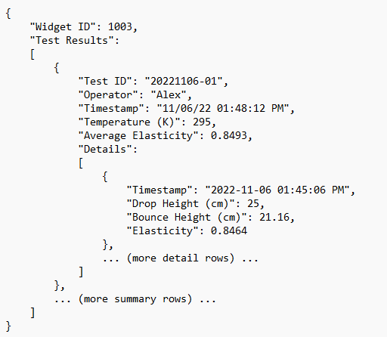Figure 22: Example 3 Test Data Structure

In the Web UI, the Datasheet for this is very simple. We only need the top-level fields; in this case, “Widget ID” and “Test Results”.

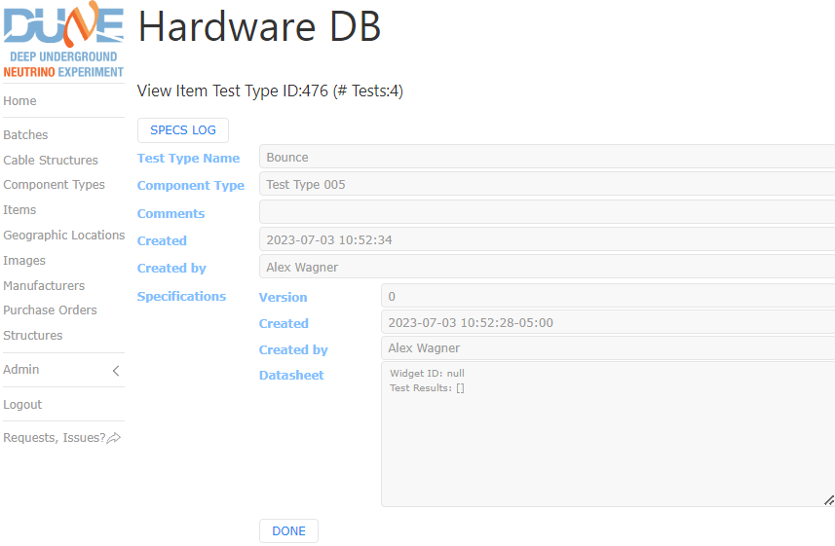Figure 23: Example 3 Test Specification

### Test Data Spreadsheets

The test data for this example is contained in three spreadsheets. The format for the two subtables is the same.

Note that since the subtable rows need to attach to the main table, enough of the main table columns need to be duplicated in the subtable to indicate ownership.

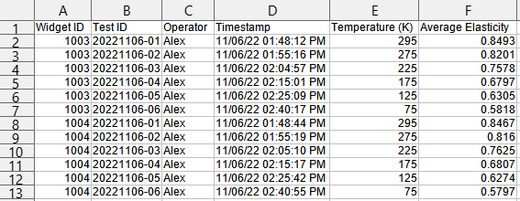Figure 24: test-bounce.xlsx

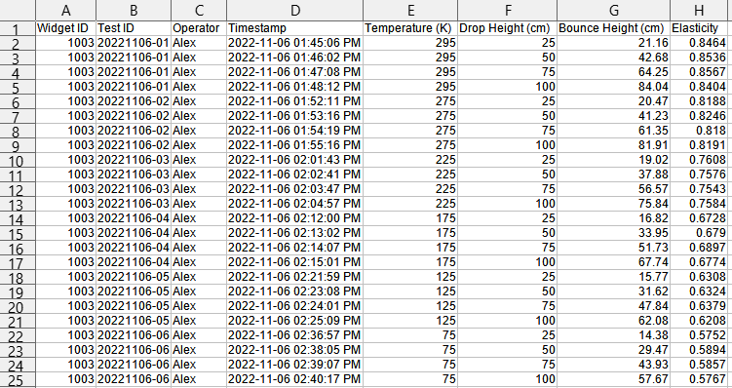Figure 25: test-bounce-subtable-1003.xlsx

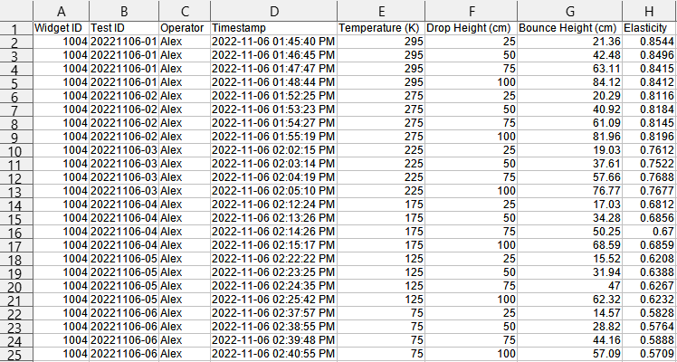Figure 26: test-bounce-subtable-1004.xlsx

### Test Encoders

We need two encoders for tests for this example.

The first encoder manages the main sheet.

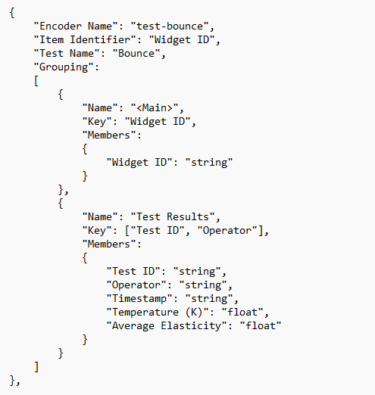Figure 27: "test-bounce" encoder

The second encoder manages the detail. Note that the “grouping” of the main sheet is duplicated, at least as far as the “key” fields go. This is necessary for the “detail” contained in the rows to find the place in the structure hierarchy where it belongs.

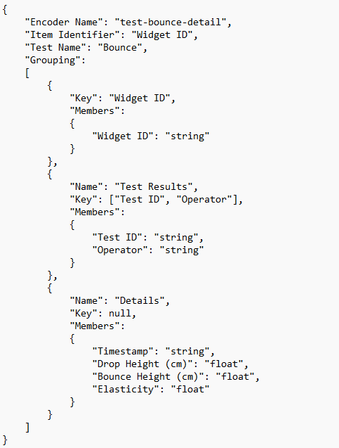Figure 28: "test-bounce-detail" encoder

### Docket

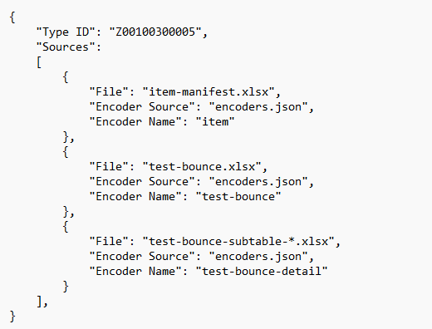Figure 29: docket.json

Note that since there is more than one detail sheet, and they are similarly-named, we are able to use file globbing to include all files matching a pattern.

### Uploading the Docket

We are now ready to upload the data to the database!

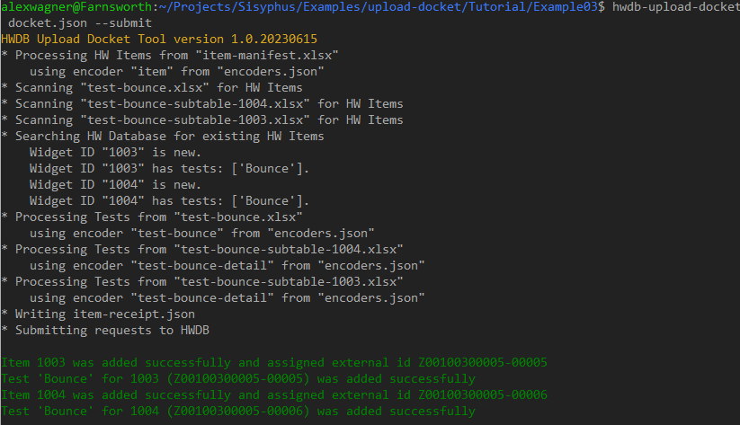Figure 30: Example 3 Uploading Data

# “Advanced” Docket Tool

In version 1.1, we added a new tool that allows for the uploading of HW Items without requiring an Encoder (though it still requires a Docket). This tool will eventually incorporate all the functionality of the original “hwdb-upload-docket” and will completely replace that utility.

The new tool can only be used to upload HW Items whose specifications consist entirely of key-value pairs. It will fetch the specifications and assume the columns in the spreadsheet correspond to these keys.

It is also able to connect subcomponents to an HW Item. If the HW Item specification includes subcomponents, the tool will look for columns named the same as the “functional position” for each subcomponent.

Finally, the new tool is able to actually update HW Items instead of only adding them. You are now able to, using the Web interface, bulk-add items and use the newly-assigned PIDs instead of using serial numbers.

Consult “AdvancedDocket.docx” for a quick-start for using this utility. Note that although the test generator produces Test sheets, the tool does not process these at this time.