
Concurrent Programming (082025-MKA)
INDIVIDUAL ASSIGNMENT

Name | OOI DUN TZI
TP Number | TP071308
Intake Code | APU2F2502CS(DA)
Lecturer Name | TS. DR. MAYTHEM KAMAL ABBAS AL-ADILEE

Contents
1.0 Introduction 3
2.0 Basic Requirements Met 4
2.1 Short Explanation of Concurrency Concepts Implemented 7
3.0 Additional Requirements Met 10
3.1 Short Explanation of Additional Concurrency Concepts 12
4.0 Requirements Which Were NOT Met 15
5.0 Conclusion 16

Introduction
The Aisa Pacific Airport Air Traffic Control (ATC) simulation system will be aimed at simulating and controlling the airline operations in a small airport environment that is only featured with a single runway and three gates. The project is targeted at the management of six planes trying to land, dock, refuel, loading passengers and taking off with the preservation of operational safety and efficiency having a limited number of resources at the airport. In addition, the simulation is concurrent in Java language the processes are synchronized with each other, semaphores, atomic operations and multithreads are used to simulate the real world where there are several planes facing limited resources of the airport. Moreover, this project involves random airplane arrivals, emergency landing, and fuelling constraints to provide the simulation of the real air traffic management problems, in this simulation demonstrates efficient concurrency management, synchronization control, and priority management in the multi-threaded key environment.

2.0 Basic Requirements Met
Only 1 Runway for All Planes to Land and Depart
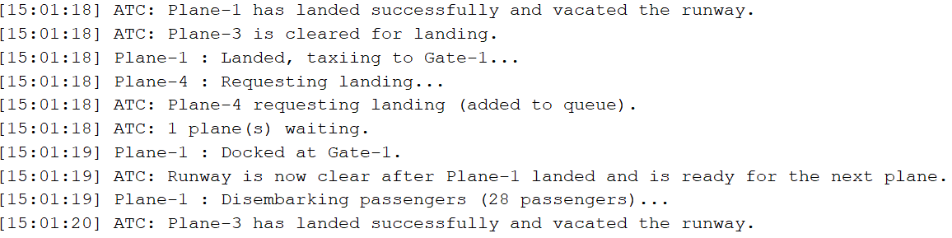
Figure 1: Runway for All Planes
To achieve this demand is to install a single shared runway in the system that was controlled with a “synchronized (runwayLock)” within the ATC class. In addition, the landing and take off operations are carried out on a common runway so that a plane can be in the same runway at a given time. Consequently, the synchronization does not allow two or more planes to land or take off at the same time to simulate a one-runway airport.
Maximum of 3 Airplanes on the Airport Grounds
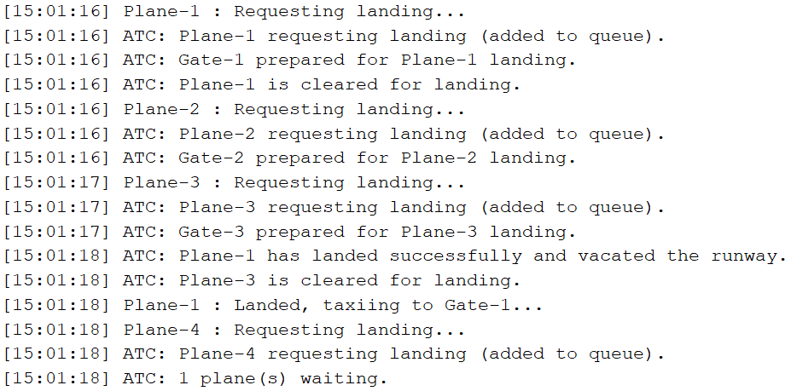
Figure 2: Maximum 3 Airplanes
ATC class brings this rule by maintaining a counter of the number of planes on the ground in the form of a counter named as “planesOnGround”. In addition to this, the total number that can be allocated to gated is set to three, which is the airport capacity and no new airplane is permitted to land unless one of the gates is available. This is to make sure that there is no time there will be more than three planes on the airfield grounds.

Sequential Process from Landing to Takeoff
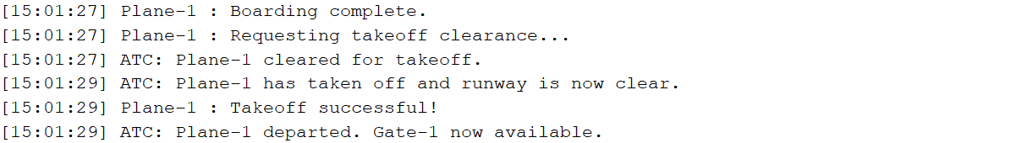
Figure 3: Sequential Process
The operational cycle will start with each of the planes with the requesting landing, landing on the runway, taxing to the gate, disembarking passengers, refueling, boarding new passengers and only taking off. These sequences are implemented by the Plane class “run()” method, with appropriate “Thread.sleep()” to delays between each stage to simulate the real time operation and ground handling duration at real life situation.
Time Simulation for Each Step
Figure 4: Time Simulation
In this system, time delays on each process are simulated by the use of “Thread.sleep()”. As an illustration, runway operations require several seconds, disembarking and loading passengers are dependent on the number of passengers multiplied with the planned average time required to set in disembarking and loading, and refuelling contains a planned delay also. These timing operations represent the real aircraft turnaround.

No Ground Waiting Area for Planes
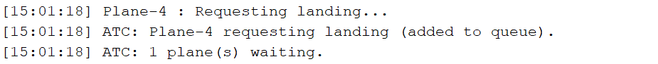
Figure 5: No Ground Waiting
This requirement is met by designing the system to only allow planes land when a gate is available, if all the gates are occupied those incoming planes will be required to wait in the air until one of the gates becomes free by implement “landingQueue” in the ATC class. Therefore, there is not any plane able to land on the ground without any gate assignment, to ensuring the simulation follows the real world limitation of a small airport without ground holding areas.
Concurrent Events for All Ground Operations
Figure 6: Concurrent Events for All Ground Operations
Concurrency is achieved through Java multithreading by design it in each plane operates as a separate thread, this allowing multiple ground activities such as the passenger disembarkation, refuelling, and boarding able to occur simultaneously across different gates. To achieve this requirement the synchronization and semaphore also need to ensure that shared resources like the runway and refuelling truck are safely managed without collisions or resource conflicts at the processing

2.1 Short Explanation of Concurrency Concepts Implemented
Thread Based Concurrency (Multithreading)
Concept: Each plane and the ATC control system is run on the separate threads to achieve the multiple planes to perform landing, disembarking, refuelling, boarding, and take off activities at the same time.
Explanation: Each plane will be operated independently, and the ATC runs in parallel, which enabling simultaneous execution of events. Such as the multiple planes being serviced at different gates while another is landing.
Code Example from CCP.java:
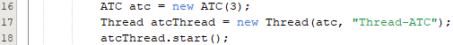
Figure 7: CCP Thread Based
Synchronization for Shared Resources (Runway and Gates)
Concept: The synchronized blocks in Java are preventing more than one plane is on the runway or is being assigned to the same gate at once.
Explanation: The “synchronized (runwayLock)” block only guarantees that only one plane can be land or take off at a time, to achieve the safe operation on a single runway as required by the basic requirement.
Code Example from ATC.java:
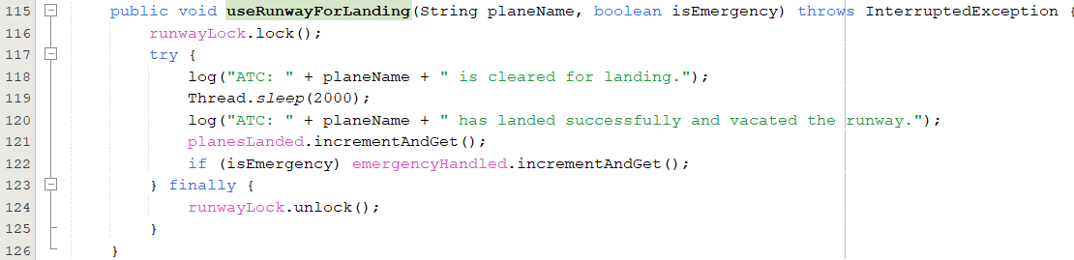
Figure 8: ATC Synchronization

Wait–Notify Mechanism for Plane Landing Clearance
Concept: This system using the “wait()” and “notify()” to coordinate the communication between planes that waiting for landing clearance and the ATC that grants the permission for landing.
Example: When plane requested for landing it will get pause from the “wait()” until the ATC explicitly grants the landing permission and this will use the “notify()” to proceed the process. This is for getting simulation of realistic ATC communication and sage sequencing of landing request.
Code Example from Plane.java:
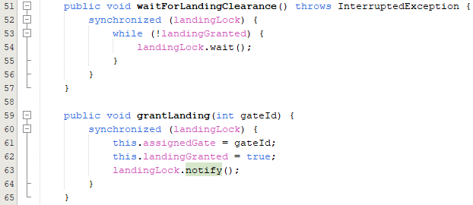
Figure 9: Plane Wait & Notify
Atomic Variables for Safe Counter Updates
Concept: Whenever planes landed or planes on the ground will be updated safely using the “AtomicInteger”, is to ensure that multiple threads can modify these values without synchronization errors.
Explanation: “AtomicInteger” will be take care about the atomic operation for incrementing and reading these shared counters, to ensuring the accuracy in tracking the number of planes that already on the ground and total operation has been completed.
Code Example from ATC.java
Figure 10: ATC Atomic Variable
Shared Lock for Gate Management
Concept: A common lock object makes sure that there is no race between access to the landing queue and the assignment of the gate when several planes are wanting to land simultaneously.
Explanation: This synchronization helps in avoiding the occurrence of inconsistent states in case multiple planes attempt to land at the same time by locking the queue management process and the gate management process.
Code Example from ATC.java:
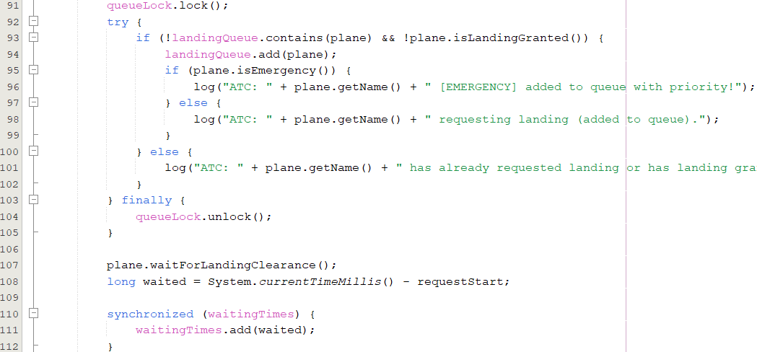
Figure 11: ATC Share Lock

3.0 Additional Requirements Met
Single Refuelling Truck for All Aircraft
Figure 12: Single Refuelling Truck
This is met by the application of a semaphore that has a single permit to indicate the single refuelling truck at the disposal of all the planes. Therefore, when an aircraft completes the process of unloading passengers and orders refuelling, it has to take the semaphore and continue with the procedure. In case the truck is occupied by another plane then the request plane thread will automatically wait until the semaphore is again available. This is to avoid instances of two planes possibly being refuelling at the same time with the precise modelling of a single refuelling truck serving a group of aircraft in series
Simulated Congestion Scenario with Emergency Landing
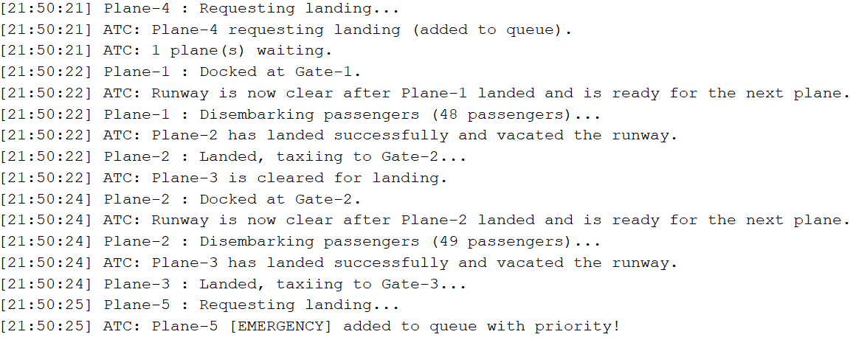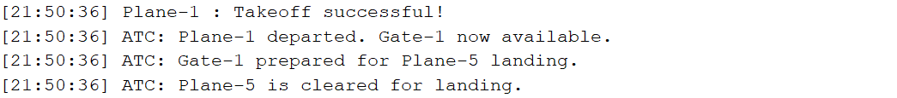
Figure 13: Simulation Congestion Scenario
The congestion scenario requirement is met by simulating many planes seeking to land while all gates are completely filled, while also incorporating an emergency landing mechanism that prioritises them. For example, one plane may enter the waiting queue for landing while all gates are full, causing the plane to be blocked for further assignments, if the plane does not have permission to land but an emergency plane is on its way, the emergency plane will be placed at the front of the landing queue using the priority-based structure. The ATC thread will then priorities the emergency plane landing clearance ahead the waiting planes. This effectively demonstrates congestion handling and emergency prioritization in a realistic ATC environment.

Sanity Checks and Statistics After Simulation
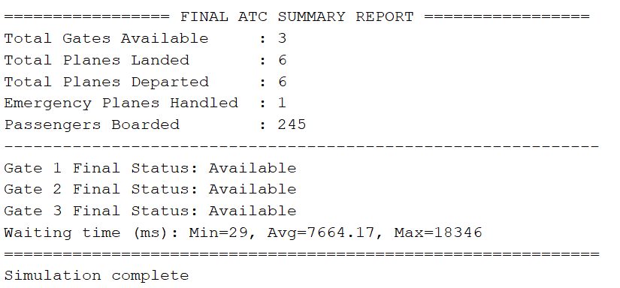
Figure 14: Sanity Check & Statistics
The last of the simulation, the ATC will perform post run sanity checks and print the final statistics to verify the correctness of the system state. Once all the planes have departed, the system will check that no gate remains occupied, to ensure all resources are properly released. Moreover, it also calculates and prints statistical information including the maximum, average, and minimum waiting times for all planes during landing and services, as well as the number of the planes served, and total passengers boarded. As a result, this verification step confirms that the airport operations concluded correctly and provides useful performance insights about the simulation.
Simulation Setup and Assumptions
Figure 15: Simulation Setup & Assumptions
To get the satisfy of the simulation conditions, six planes are generated to land at the airport, the arrival times spaced randomly by 2 seconds using the “Thread.sleep(rand.nextInt(200))”. Additionally, each of the planes can only carry maximum of 50 passengers, and it is assumed that passengers are always ready to embark and disembark immediately, meaning there are no delays inside the terminal. These assumptions simplify the passenger flow and allow focus on concurrency aspects such as the runway usage, refuelling, gate assignment, and emergency handling.

3.1 Short Explanation of Additional Concurrency Concepts
Semaphore for Refuelling Truck Control
Concept: A “Semaphore” with a single permit is used to enforce exclusive access to the single refuelling truck so that only one plane can get refuel at any time.
Explanation: This implements the “only one refuelling truck” additional requirement, by getting this requirement a plane will needed to “acquire()” the semaphore before refuelling and “release()” it after finish use. This which able to blocks other planes from refuelling concurrently and queues them at the semaphore level.
Code Example from ATC.java:
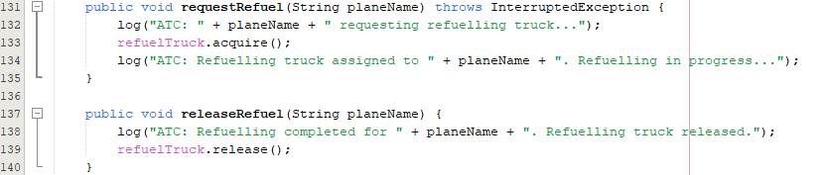
Figure 16: ATC Semaphore

Priority Queue for Emergency Landing Management
Concept: The ATC system is designed to give the emergency planes first priority at all times compared with the normal planes in the landing process through a priority queue system.
Explanation: The “getNextPlane()” method examines the queue of landing planes in terms of emergency planes which are then given immediate landing clearance. In case there are no emergency planes, the plane that has gotten there first is chosen. This is to guarantee that the emergency landings are accommodated in a fast manner and other planes are orderly.
Code Example from ATC.java:
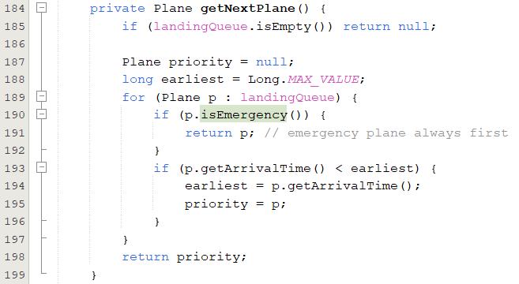
Figure 17: ATC Priority Queue

Atomic Variables for Thread Safe Counters and Statistics
Concept: The atomic directives used to monitor shared numeric values like “planesOnGround”, “planesLanded”, “planesDeparted”, “emergencyHandled”, “totalPassengers” are tracked in a thread safe, lock free manner using “AtomicInteger” counters.
Explanation: These counters are often updated by several threads and atomic variables guarantee that all incrementation as well as reading operations occur atomically without having to add extra sync blocks. This method has corrected statistics and eliminates race conditions.
Code Example from ATC.java:
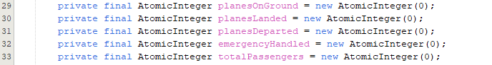
Figure 18: ATC Atomic Variable

Randomized Arrival and Thread Based Concurrency
Concept: Planes and the ATC run as separate threads, which is new plane threads are started at randomized intervals “(Thread.sleep(rand.nextInt(2000)))” to simulate arrivals every 2 seconds.
Explanation: This produces the asynchronous arrival pattern specified in the additional requirements and deliverables. As a result, multiple plane threads plus the running ATC thread will create the concurrent environment where having queueing, refuelling, and gate operations interleave naturally.
Code Example from CCP.java:
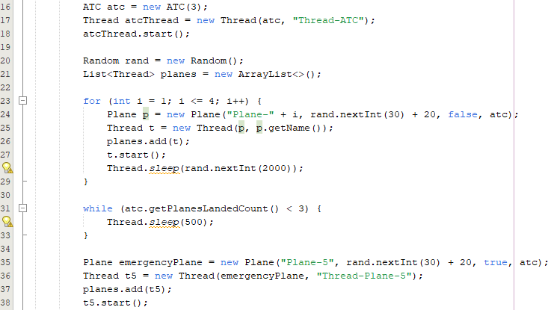
Figure 19: CCP Randomized Arrival & Thread Based Concurrency

4.0 Requirements Which Were NOT Met
All the basic and the additional requirements been met.

5.0 Conclusion
In conclusion, ATC Simulation System is an effective system, which fulfils all the functions it was developed to accomplish. In this system, it can demonstrate that the operation of the airport able to take place safely and comfortably even in situations when numerous factors occur simultaneously. Moreover, the system ensures that there are no conflicts in the use of shared resources such as the runway, gates, and refuelling truck by ensuring that synchronization locks, semaphores, and atomic variables are used appropriately. Furthermore, emergency landing option and the level of details in the reports make the simulation more realistic and complete. Lastly, the final outcomes provide a clear understanding of such crucial data as waiting times, number of passengers and the state of each gate conditions. In general, this project provides a fair understanding of how the air traffic control system operates, and it illustrates how the concurrency tools of Java are able to complete numerous tasks running simultaneously without any issues.

