
Data Structures (082025-LKK)
GROUP ASSIGNMENT
Name  TP Number | OOI DUN TZI  TP071308
Name  TP Number | YAP BOON SIONG  TP070171
Name  TP Number | CHEAH JUN HENG  TP071767
Name  TP Number | CHEN XIN ZE  TP081210
Intake Code | APU2F2502CS(DA)
Lecturer Name | Mr. Lee Kim Keong

Table of Contents
1.0 Introduction 3
2.0 Workload Matrix Table with Signature 3
3.0 Theoretical Explanation 4
3.1 Common Theoretical Explanation 4
3.1.1 Overview 4
3.1.2 Sample Code 4
3.1.3 Common Operations in Both Data Structures 5
3.1.4 Example of Common Usage 8
3.1.5 Theoretical Significance 9
3.2 Dynamic array theoretical explanation 10
3.2.1 DynamicArray class and key functions 10
3.2.2 Theoretical operations 11
3.2.3 Application in the resume to job matching system 11
3.2.4 Theoretical Advantages and Limitations 11
3.2.5 Summary of Theoretical Dynamic Array 12
3.3 Linked List Theoretical Explanation 13
3.3.1 Structure and Implementation 13
3.3.2 Application in the resume to job matching system 15
3.3.3 Theoretical Advantages and Limitations 16
3.3.4 Summary of Theoretical Linked List 16
3.4 The Algorithm of Linked List and Array-Based Implementations 17
3.4.1 Search Algorithm 17
3.4.2 Filtering Algorithm 18
3.4.3 Sorting Algorithm 19
4.0 Input-Output Screenshots 21
5.0 Summary Discussions 25
5.1 Execution Time Comparison 25
5.2 Memory Consumption Comparison 27
5.3 Critical Evaluation of the Code 28
6.0 Conclusion and Reflection 29

1.0 Introduction
The Job Matching System simulator will be implemented to help establish effective relationship between job seekers and employers in the contemporary job market. Therefore, the project is expected to imitate a platform that can be used to match candidates with a job opportunity based on the information provided in their resumes. To accomplish this project this system has been put in place with the use of the C++ tool of programming highlighting the use of basic data structures and algorithms such as arrays and linked lists, which also incorporated search, filtering and sorting process. Consequently, this has been able to handle and process job and candidate data. In addition, the project will be conducted on the basis of comparing the different implementation strategies in order to test the performance regarding time complexity and memory usage. On the other hand, this simulation shows that the correct choice of data structure is important when the efficiency and accuracy of software are to be maximized and eventually lead to the creation of intelligent job matching systems in real world recruitment systems.

2.0 Workload Matrix Table with Signature
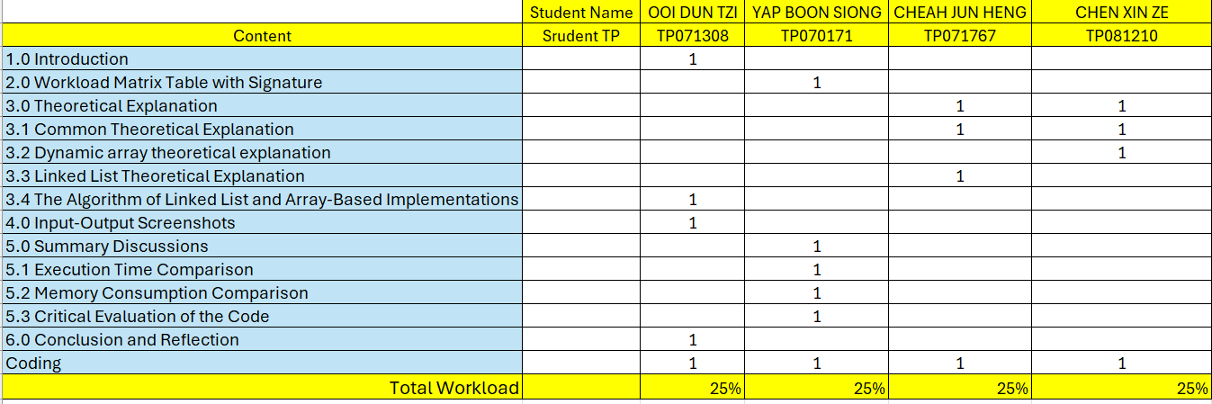

3.0 Theoretical Explanation

3.1 Common Theoretical Explanation

3.1.1 Overview
For punctuality and precision, within the project's scope, dynamic arrays and linked lists were utilized and distributed separately ln each folder, saves to resume, and job descriptions associated to CSV files. These structures became the bases of the system and helped to manage system memory and facilitate the matching process. It allows to index all the resumes and refine to specific skills or recall a set of job descriptions to compute a match score. These tuned structures are essential in the algorithm's core architecture, as they aid the mark-up of the separating the constituent documents and the representative tokens, employed to stage the system processing with respects to the requirements towards each candidate, along with the match score. Thus, there are now two refined set of functions or files processes one "Resume to Job" aligned differently than "Job to Resume" due to processing logic as a linked structure or array-based set, but with core functions remaining aligned.

3.1.2 Sample Code
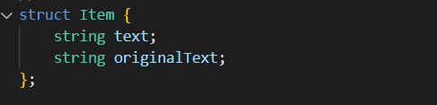
Figure 1: structure code
In the project, therefore, the “common.h” header file, in which all the commonly used data structures and utilities are included, is the basis. The main component of the system is the Item struct - the fundamental of our text system. It is essentially a combination of two disciplines:
- originalText – preserves the raw text from the CSV file for accurate display.
- text – stores a normalized, lowercase version used for consistent internal processing and case-insensitive matching.
This dual representation helps the system match efficiently and keeps the user output easy to read.

3.1.3 Common Operations in Both Data Structures
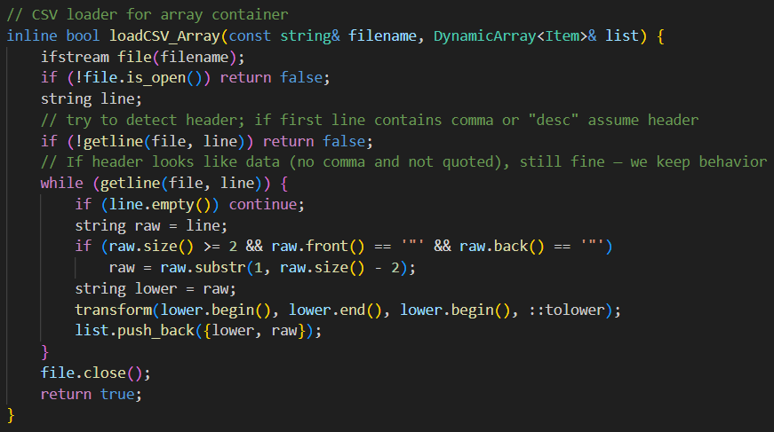
Figure 2: Sample code array insertion
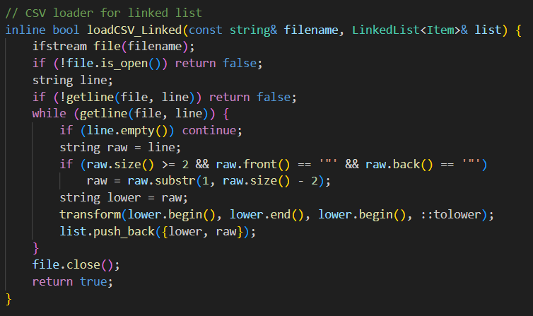
Figure 3: Sample code linked list insertion
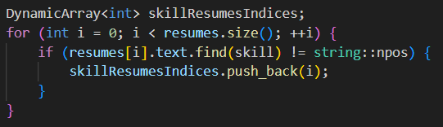
Figure 4: Sample code array traversal and searching
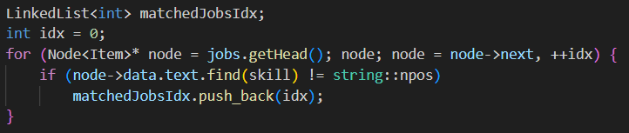
Figure 5: Sample code linked list traversal and searching
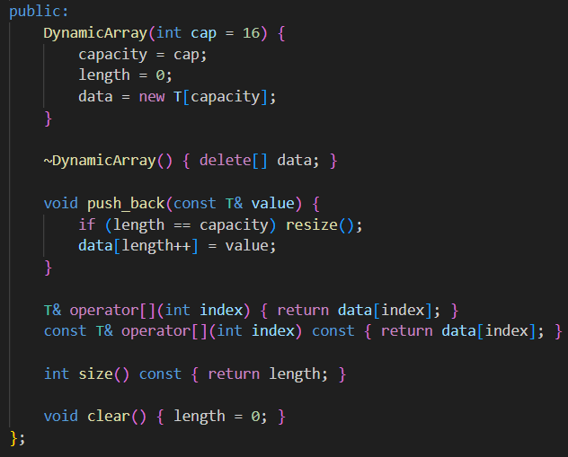
Figure 6: Sample code array memory clearing
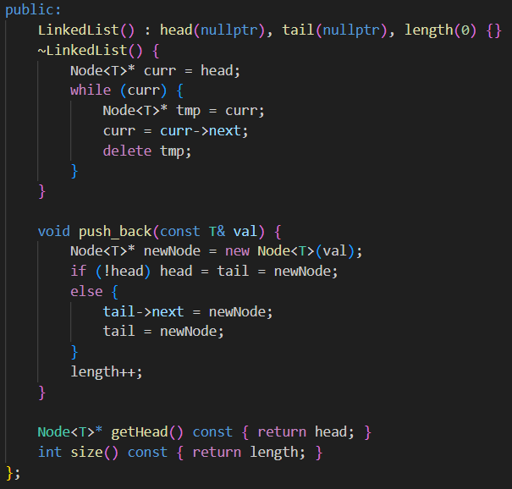
Figure 7: Sample code linked list memory clearing
The Dynamic Array as well as Linked List implementations carry out nearly similar logical steps in the resume to job matching process. Their workflow is the same despite that their internal memory is managed differently. The major shared operations are:
Insertion: The data contained in the CSV files is read and inserted into the containers using the “push_back()” function.
- Dynamic Array: They are added to a continuous memory block. Once the capacity is exceeded, the “resize()” function automatically doubles the storage space and transfers all the elements that were already in the storage space into the newly created block. Constant Time is used in average insertion and Linear Time is used in resizing temporarily.
- Linked List: Every new element is added via the formation of a node and linking the node with the tail node. As there is no resizing needed, the insertion is always Constant Time.
Traversal and Searching: The two data structures have a sequential access (Linear Time) when accessing and processing keywords and skills.
- Dynamic Array: Loops are performed using indexing of every element, and contiguous memory is used as an additional benefit to achieve efficient cache access.
- Linked List: It utilizes pointer navigation to navigate through the nodes visiting all the records in a sequence.
Memory Clearing: To avoid memory leaks on completion of processing, the two structures deallocate the stored information.
- Dynamic Array: When processing is finished the internal memory array is deleted.
- Linked List: Frees each one of the nodes separately to free all the dynamically allocated memory.
The logical workflows of both data structures share the same logic such as loading --> filtering --> searching --> matching, the only difference being the memory usage and access processes. The Dynamic Array has an advantage of being faster with index-based access whereas the Linked List has an advantage of having flexibility in the allocation of memory and both give the same results in the resume to job matching system.

3.1.4 Example of Common Usage
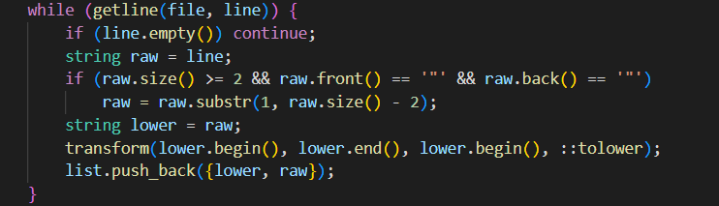
Figure 8: common load file transform lowercase code
During initialization, the system reads job and resume data from CSV files and stores them as Item objects in either a Dynamic Array or Linked List. The workflow proceeds like this:
- The program reads each non-empty line from the file.
- Quotation marks, if present, are removed using “substr()” to clean the text.
- The text is duplicated into a lowercase version using “transform()” with “::tolower”.
- Both the original and lowercase versions are bundled into an Item object.
- The Item is inserted into the container using “push_back”, building the dataset for filtering and matching.
This uniform procedure ensures that both array and linked list models handle data consistently.

3.1.5 Theoretical Significance
Theoretically, both Dynamic Array implementation and the Linked List implementation exhibit similar behaviour in their algorithms, particularly in their traversal and search operation, which are Linear Time. This makes them ideal in sequential access tasks like a keyword search and similarity checking, vital phases of the resume to job matching system. Sequential access provides a good compromise between performance and simplicity since all records must be checked.
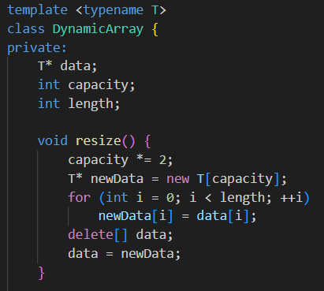
Figure 9: Sample code array template
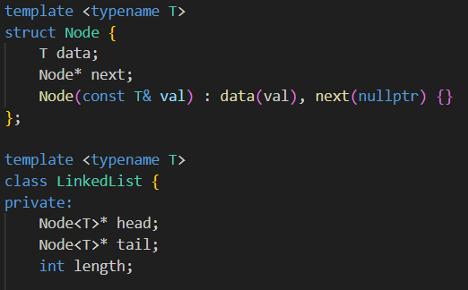
Figure 10: Sample code linked list template
The two structures are based on C++ templates, and they can contain various types of data such as integers, strings, or even complex data types such as "Item" without rewriting the logic. This facilitates flexibility, reusability and maintenance. The abstraction class of “Item” also evidences encapsulation since it contains the original and lowercase forms of the text which allows the same matching algorithm to be applied to each of the two data structures.
In general, these implementations emphasize that the same matching algorithm can be performed effectively with different storage mechanisms. Their internal structures are different, but both apply reversed yet conceptually equivalent reasoning to the same goal.

3.2 Dynamic array theoretical explanation

3.2.1 DynamicArray class and key functions
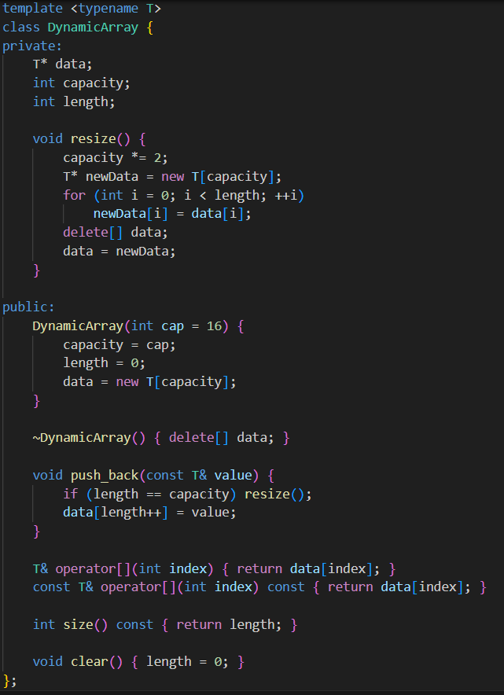
Figure 11: Sample code DynamicArray Class
The “DynamicArray” is a C++ template that could be used to store any type of data such as integers, strings, and complex Items. Its key features include:
- Automatic Resizing “resize()”: A new memory block with twice the capacity is created and once the array is full all the existing elements in the array are copied. Linear Time is required in this operation.
- Appending Data “push_back()”: Quickly adds new data to the end of the array and has an average insertion time of Constant Time.
- Element Access “operator[]”: Allows for quick accessing randomly to the elements by using index in Constant Time.
This design enables the resume to job matching system to dynamically handle resumes, job descriptions and filtered results with a high performance, flexibility, and simplicity.

3.2.2 Theoretical operations
- Insertion: Performs quickly on average in Constant Time, will takes Linear Time to complete when array facing full capacity or resizing.
- Traversal: Sequential access using index based in Linear Time.
- Search: All the elements are searched with the keyword, and the performance is in Linear Time.
- Memory: Data is stored in memory that is contiguous, enhancing the use of the CPU cache as well as enables faster traversal over the memory than the linked lists that use pointers to maintain the order of the data.
The Dynamic Array is particularly efficient in the resume to job matching process where it is necessary to scan many keywords and compare texts too often.

3.2.3 Application in the resume to job matching system
Dynamic Array keeps datasets of resumes to job descriptions that have been loaded in CSV files. It enables:
- Rapid filtering of key words by line-by-line search of all the elements.
- Quick access to records with using index.
- Flexible storage, which can automatically be increased or decreased to accommodate any volume of data.
The matching process spins around all the elements in the array to match the skill keywords and calculate the similarity percentage which are highly effective in handling large text data sets with consistent performance.

3.2.4 Theoretical Advantages and Limitations
Advantages:
- Quick access to records: Access any record rapidly through its index.
- Smooth scanning of data: Checking records with effectively.
- Automatic resizing: Expand and shrink without manual adjustments.
- Convenient and user-friendly: Using basic framework that is easily adopted.
Limitations:
- Resizing can slow down temporarily: All the elements must be copied.
- Needs sustained memory space: Harder when duelling very large data.
- Updating or deleting data midway: Slowing the process because elements need to be shifted.
Nevertheless, even with these drawbacks, the Dynamic Array is still a good option to this resume to job matching system because of its speed, simplicity and consistency in sequential processing of data.

3.2.5 Summary of Theoretical Dynamic Array
Theoretically, the Dynamic Array demonstrates some of its most important principles such as automatic memory management, based on dynamic resizing, efficient random access, through index-based addressing, and fast sequential access, based on text-based operations. The design allows it to perform highly in tasks that require frequent access and comparison of data and so it can be well adapted in applications that require large volume of records to be processed and compared efficiently such as in resume to job matching.

3.3 Linked List Theoretical Explanation

3.3.1 Structure and Implementation
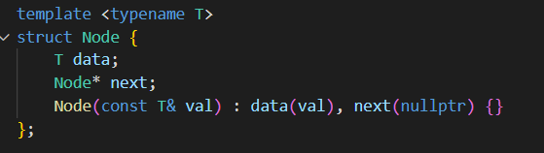
Figure 12: structure code
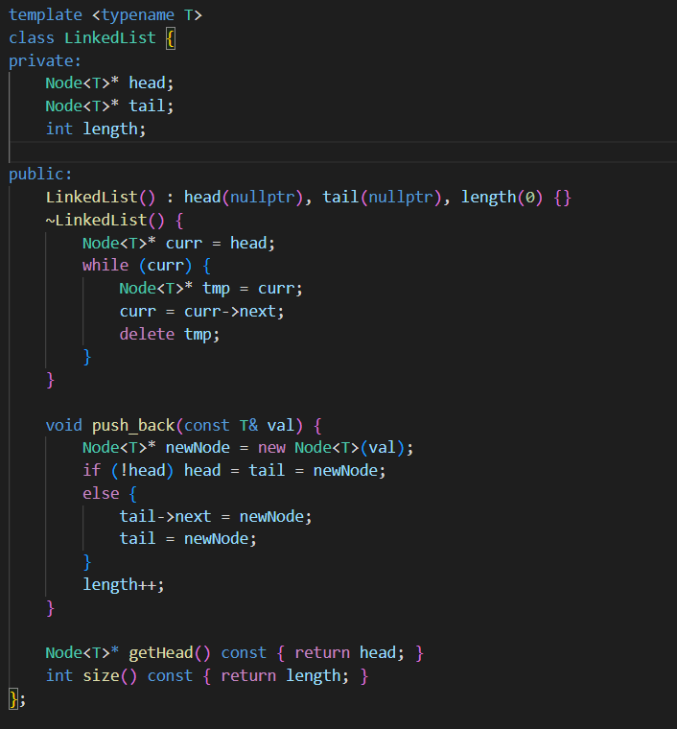
Figure 13: template code
The linked list is built using a Node struct and a LinkedList class, working together to store and manage data dynamically without needing continuous memory space.
Nodes struct:
- Basic unit of the list.
- Holds data (T) and a pointer (next) to the next node.
- Enables dynamic memory allocation and flexible growth
LinkedList class:
- Manages all nodes using head, tail, and length.
- “push_back()” adds new nodes at the end efficiently.
- Destructor cleans up memory to prevent leaks.
Overall:
- Combines node links with management functions.
- Provides a simple, efficient structure for storing sequential data.
The Linked List showcases different types of performances in its basic operations. The insertion operation ‘push_back’ creates a new node and appends it to the end in Constant Time by tail pointer updating. Traversal and search take longer since the pointer moves in a linear time access from the node to the head. The destructor also linear time to free the list's memory so it doesn't leak. Delete does the same to each node without and memory freeing. The list's length is the only measure which is also retained in the internal counter accessible in constant time. The Linked List is different from arrays in the sense of random access absent in the list.

3.3.2 Application in the resume to job matching system
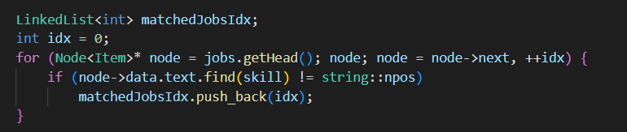
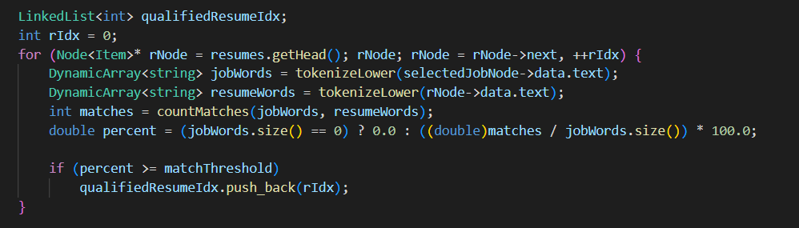
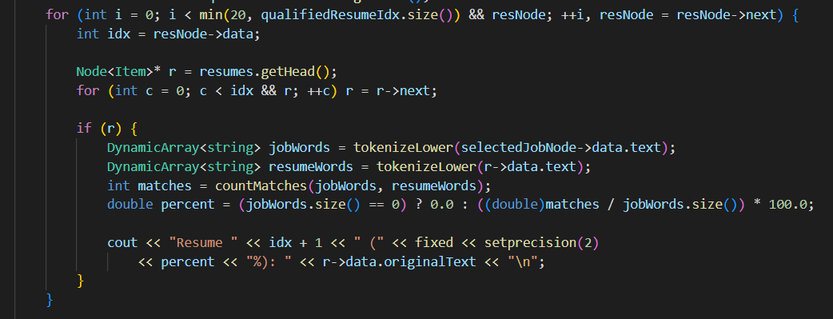
Figure 14: matching system code
The linked list is used in three key processes:
- Filtering: The system traverses job or resume nodes from the head, checking for keyword matches. Indices of successful matches are appended to a result list dynamically using “push_back()”.
- Matching: For each resume node, text tokenization and comparison against job requirements are performed. Qualified resumes above the threshold are stored in another linked list of indices.
- Displaying Results: The program traverses both the result list and main resume collection to display matched records sequentially.

3.3.3 Theoretical Advantages and Limitations
Advantages:
- Does not need resizing or pre-allocation — it grows naturally as new data is added.
- Adding new items at the end is very fast.
- Good for handling data when the size keeps changing.
Limitations:
- Searching or going through the list takes more time because it checks one node at a time.
- Cannot jump directly to an element; you must start from the beginning.
- Requires a bit more memory since each node contains a pointer to the next node.
- Data is not stored next to each other in memory, which can make it a bit slower.
In general, linked lists more flexible but slower when it comes to scanning large amounts of data when compared to Dynamic Arrays.

3.3.4 Summary of Theoretical Linked List
The resume to job matching system would benefit from the ability to work with flexible data sets which the linked list supports with its flexible, dynamically allocated structure. While the list is slower to traverse because of its sequential nature, the list maintains its efficiency because data does not need to be reallocated for insertion and expansion. Filtering and result collection are possible with the traversable, dominating structure which is supportive of the node-centric design.

3.4 The Algorithm of Linked List and Array-Based Implementations

3.4.1 Search Algorithm
The search algorithm in this system has the task of searching through all job descriptions or resumes and filtering out entries that have certain keywords of skills being requested by the user. This is the basis of the job matching mechanism in the stage 1 of operation.
Array Based Implementation
With array based implementation a linear search strategy is used in a “DynamicArray<int>” structure. All the job records will be accessed in a specific order, and the program will compare lowercase version of the job description with the input skill of the user to identify a match.
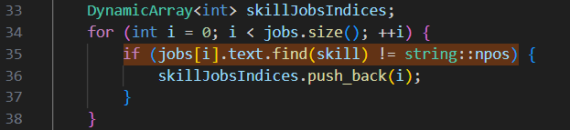
Figure 15: Array Based Search Implementation
Upon finding a match the relevant job index is recorded in a second dynamic array, which will be later filtered. The contiguous memory layout of the array allows the elements to be accessed randomly in constant time, but the entire process of searching all of the job records takes linear time.
Linked List Based Implementation
In the linked list based implementation the system adopts the same linear search approach as the array model. However, it relies on node traversal instead of index based access.
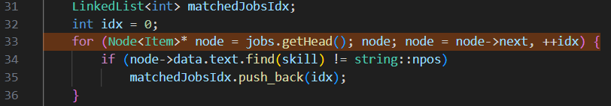
Figure 16: Linked List Based Search Implementation
The linked list is also searched and in each “node”, it is checked whether it contains the given keyword and those “nodes” that have the required keyword are then noted down. As opposed to arrays, linked lists lack direct indexing and hence all elements have to be traversed one after another, which makes their time complexity with respect to every search. Despite a similar amount of complexity as the array based model, the overhead associated with the traversal process in linked lists is caused by the use of a pointer based navigation, which results in a slight decrease in execution efficiency.

3.4.2 Filtering Algorithm
Once identifying jobs are identified using the skill keyword, the system will go through the resume filtering, each resume will be compared with the desired job description to establish the percentage of similarity. Resumes that fulfil or above the user defined threshold are stored to be sorted and listed later and the ones who fall below the set threshold are discarded.
Array Based Implementation
Within array based implementation, the system is repeated through resumes structure, “DynamicArray<int>” and the similarity percentage between each resume and the selected job is calculated. In addition, the calculated value of each resume is matched with the threshold set by the user.
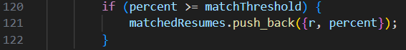
Figure 17: Array Based Filtering Implementation
When the percentage of similarity equals or is greater than the threshold, the relevant resume is saved in a new dynamic array called “matchedResumes”. Such a strategy will help to keep only the most applicable resumes to process. This filtering process is efficient because of the ability to look up the index of the array directly, and the overall time complexity is linear time.
Linked List Based Implementation
The same logic applies in the linked list version, except that the traversal is done by using the nodes of the list and not by using the indices, which means that all data in the resume are stored as a text in each node of the "LinkedList<Item>" resumes and the algorithm calculates the match percentage of the job with the resume and inserts it conditionally.
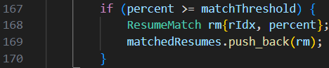
Figure 18: Linked List Based Filtering Implementation
In this part, dynamic addition to the end of the “LinkedList<ResumeMatch>” structure which contains all the qualifying resumes is done using the push back method. Furthermore, linked list contiguous memory is not needed and the insertion operations are flexible and efficient. This node oriented filtering is such that there is allocation of memory to resumes that satisfy the criteria set by the user. Even though there is a small increase in traversal since accessing pointers is slower than accessing arrays, the logic and final result are identical to the array version.

3.4.3 Sorting Algorithm
Once the resumes have been matched with the chosen job, the sorting algorithm is used by displaying the resumes in a descending order with respect to the percentage of match in order to have the best fit candidates at the top.
Array Based Implementation
In the array based implementation, an array is sorted by hand using a nested loop comparison, either in the logic of the Selection Sort or the Bubble Sort.
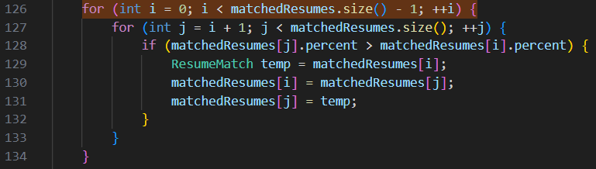
Figure 19: Array Based Sorting Implementation
Based on the direct index based access capability and the efficient swapping of elements in the array, the complexity of the whole process is due to the repetitive pairwise comparisons involved in sorting all the elements.

Linked List Based Implementation
In the implementation using the linked list, sorting is done with the help of a Bubble Sort algorithm that does not physically rearrange data but swaps the data between adjacent nodes.
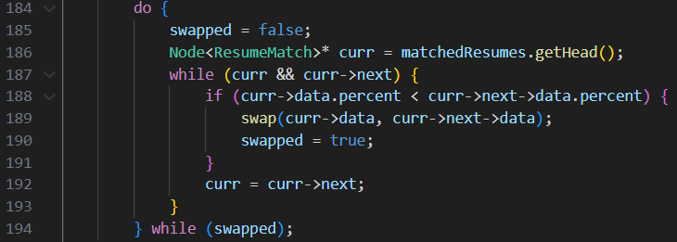
Figure 20: Linked List Based Sorting Implementation
This technique maintains the integrity of the node structure while updating only the data values. Even though the functional performance is equivalent to array based sorting, and linked list sorting will be slower because of the sequential traversal of nodes in a Linked list structure.

4.0 Input-Output Screenshots
Table 1: Input Output of Link List and Array
Link List and Array  (Job to Resume) | Link List and Array  (Resume to job)
Link List:  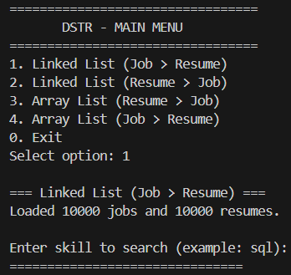  Array:  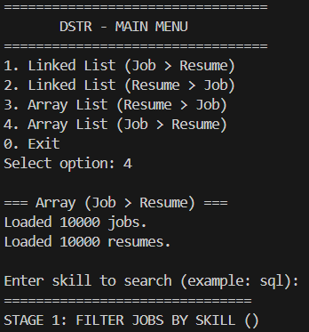 | Link List:  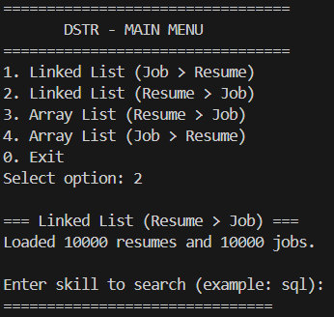  Array:  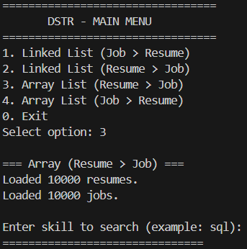
Discription:
The system is initiated by the DSTR-MAIN MENU where all the four system models, such as Linked List (Job to Resume), Array (Job to Resume), Linked List (Resume to Job), and Array (Resume to Job) are used as the main interface to access the rest of the system. The users are allowed to choose their preferred model by typing in numbers 1-4 or to get out of the application they should type 0. After selecting a model, the program will ask the user to enter a particular keyword in the skill that willing to found in job description or resume, to start the process of job matching.

Link list:  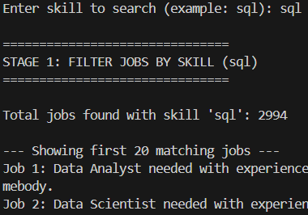  Array:  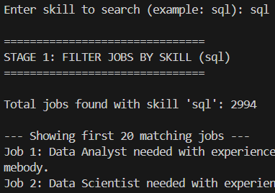 | Link List:  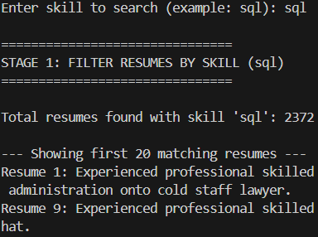  Array:  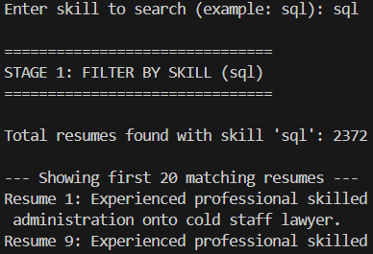
Discription:
In Stage 1, the program will filter the CSV file on the skill keyword that has been typed by the user. Depending on the model chosen, the system will be searching job descriptions or resumes which contain the targeted skill. After the search, the algorithm presents the total amount of matches that have been found and the first 20 results with the help of their details and their index numbers are provided. Then the user would be asked to decide whether to display all relevant results by typing in yes “y” or no “n”. Furthermore, will show the summary of Stage 1 with the sought skill and the overall number of matches discovered.

Link list:  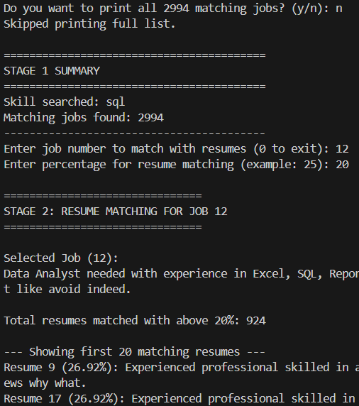 Array:  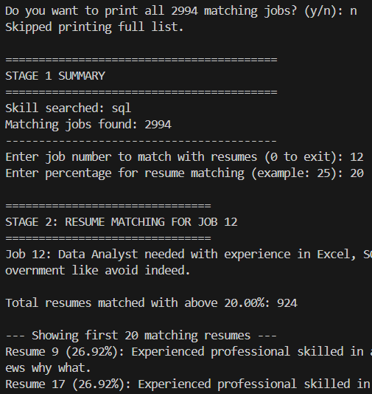 | Link list:  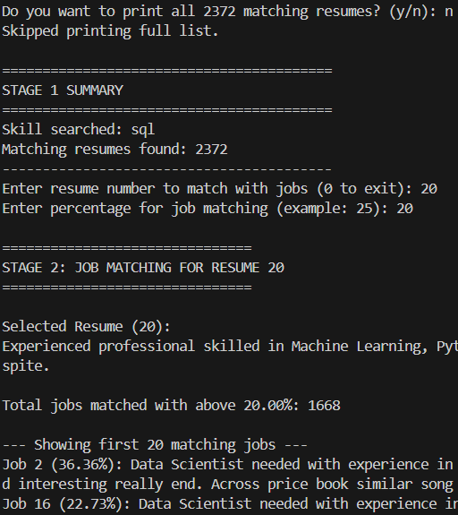 Array:  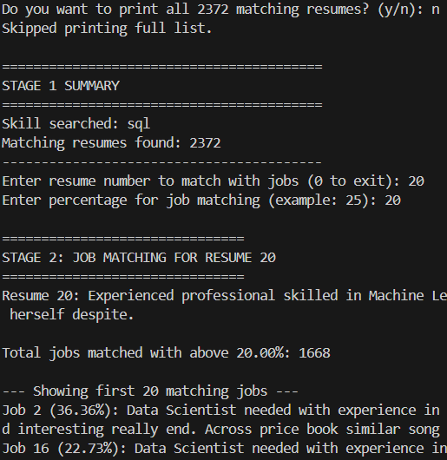
Discription:
In Stage 2, the user chooses one of the presented objects either a job or a resume by typing the number associated with it then specifies a corresponding threshold percentage such as 20%. Depending on the chosen model, the system compares the chosen item with all the entries available in the opposite category. The algorithm will then list the top 20 results that match or are above the set threshold in descending order of matching percentage, where the highest matches will be listed first, and the rest of the results with matching details will follow.

Link list:  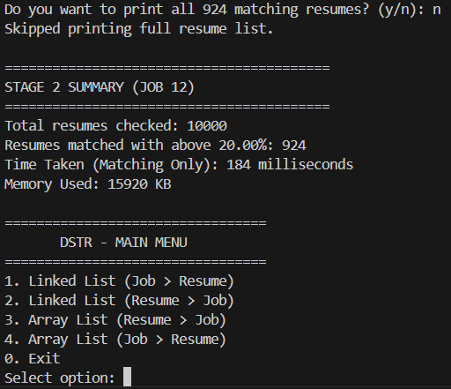  Array:  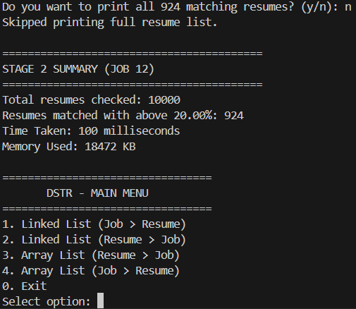 | Link list:  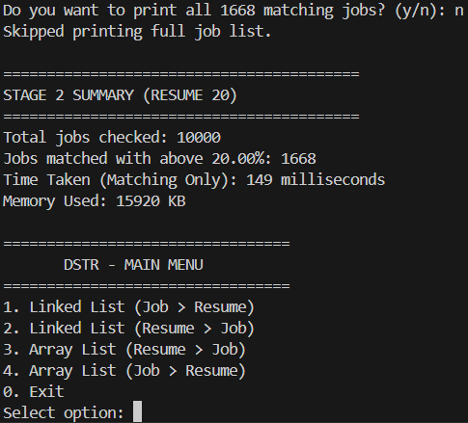 Array:  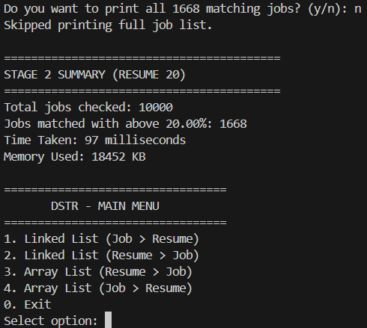
Discription:
By the end of Stage 2 the application gives the user an option of whether all matching results should be shown or not. Then will be showing summarized and the total records processed, the number of matches found, the percentage match applied and the total processing time, which only considers the execution time of the system but not the delay of user input. The summary also displays the overall memory usage in the process and therefore users can determine the efficiency of the system in utilizing resources. Once the summary has been shown, the program will take a user to the main menu where one can use other models or close the application.

5.0 Summary Discussions

5.1 Execution Time Comparison
The measured time was used to fit the array based and linked list based job matching component execution time which utilized the clock “C++ std::chrono::highresolutionclock” function. This measure used had all the major operations involved including tokenization, word comparison, and percentage matching. The same system was tested so as to be consistent with datasets of 1,000, 5,000, and 10,000 records and results were recorded in milliseconds (ms).
It was conducted in a two-step algorithm which involved. Stage 1 screening resumes that contained the skill requested by the user (SQL) with a view to reducing unnecessary comparisons whereas Stage 2 involved job-resume matching with a similarity threshold of 25% which was considered close. This was more efficient in the sense that only relevant data was considered.
Array List Time Execution Testing
Table 2: Array List Time Execution Testing Output Table
Dataset Size (1000) | Dataset Size (5000) | Dataset Size (10000)
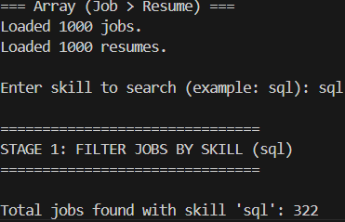  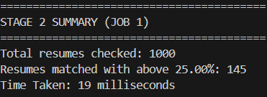 | 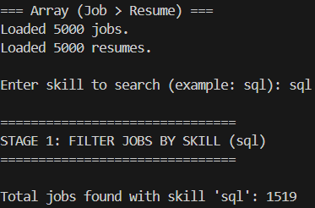  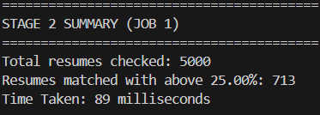 | 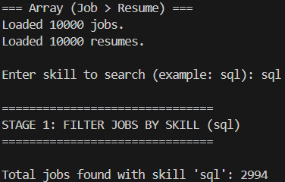  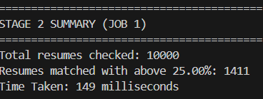

Linked List Time Execution Testing
Table 3: Linked List Time Execution Testing Output Table
Dataset Size (1000) | Dataset Size (5000) | Dataset Size (10000)
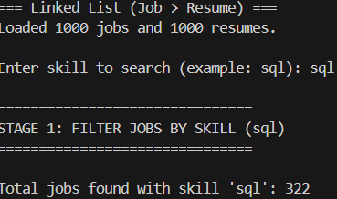  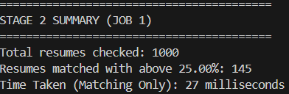 | 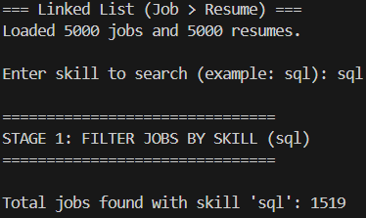  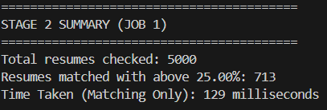 | 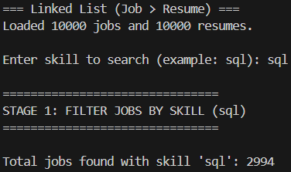  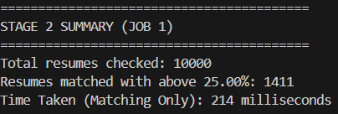
As Table 2 indicates, the array-based implementation was always the best with respect to all the dataset sizes compared to the linked list variant of the implementation. In case of 1,000 records, the array version took 19 ms to complete against 27 ms in case of the linked list. When 5,000 records are used, it required more time, 89 ms and 129 ms, respectively, and in the case of 10,000 records, array-based method took 149 ms and 214 ms, respectively.
The results are summarized in the table below:
Table 4: Time Execution Testing Summary Table
Dataset Size | Array List (ms) | Linked List (ms) | Difference (ms)
1,000 | 19 | 27 | 8
5,000 | 89 | 129 | 40
10,000 | 149 | 214 | 65
Overall, the array-based arrangement was much more time efficient because it had a more contiguous memory allocation that allowed it to access data more quickly on the sequential access as well as leveraging the CPU cache better. By comparison, the linked list involved extra pointer reading and discontinuous memory access, leading to an increase in overhead when the dataset size was large.

5.2 Memory Consumption Comparison
In order to compare both the array-based and linked-list based job matching components in terms of space efficiency, the memory consumption of the components was obtained via the Windows API function GetProcessMemoryInfo(). This command can be used to find the size of the working set which is currently being used in kilobytes (KB) by the process during execution. Measurements were performed right after loading of datasets into memory, making sure that no data structure allocation operation (just matching operations) had impact on result.
Array List Memory Consumption Testing
Table 5:Array List Memory Consumption Output Table
Dataset Size (1000) | Dataset Size (5000) | Dataset Size (10000)
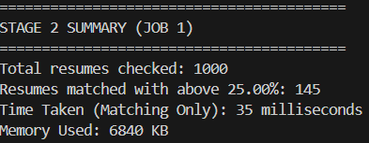 | 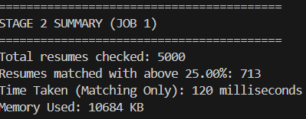 | 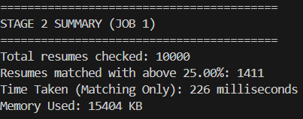
Linked List Memory Consumption Testing
Table 6: Linked List Memory Consumption Output Table
Dataset Size (1000) | Dataset Size (5000) | Dataset Size (10000)
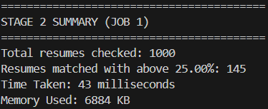 | 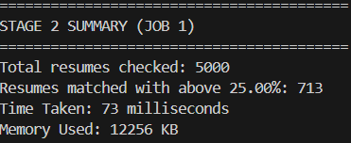 | 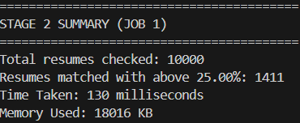
The table 2 results illustrate that the implementation of the Array List will always consume a little less memory compared to Linked List implementation at all the data size. In the case of a dataset of 1,000 records, the Array List used 6,840 KB of data, whereas the Linked List used 6,884 KB, which is a rather close 44 KB difference. But the disparity was increased to 1,572 KB and 2,612 KB as the datasets size went larger to 5,000 records and 10,000 records, respectively.
The results are summarized in the table below:
Table 7: Memory Consumption Testing Summary Table
Dataset Size | Array List Memory (KB) | Linked List Memory (KB) | Difference (KB)
1,000 | 6,840 | 6,884 | 44
5,000 | 10,684 | 12,256 | 1,572
10,000 | 15,404 | 18,016 | 2,612
The findings reveal that the array-based implementation always consumed less memory as compared to the linked list with all sizes of datasets. This is due to the fact that arrays place elements in memory sequentially, and they do not need additional storage of pointers as well as fragmentation. Conversely, linked lists move the memory blocks of each node independently, adding overhead in the form of pointer and leading to inefficient use of memory as the dataset increases. Generally, arrays are efficient in terms of memory where there is a large, non-changing set of data whereas linked lists are more efficient when handling dynamic data where there are frequent additions or removals of data despite the higher memory utilisation.

5.3 Critical Evaluation of the Code
The code that is developed is highly structured in terms of modularity and correctly written core data structure and the distinctions between array based and linked list implementation are well defined. It is an effective estimate of execution time and memory consumption, which gives sound evidence to performance comparison. The code is not only well structured, but also contains reusable pieces of code, including CSV loading code, tokenization code, and word-matching code, which make the code easier to read and maintain.
However, there are few limitations with the system. The current matching algorithm is based on the idea of an exact word matching with zero regard of semantic and keyword weighting, which restricts its precision in the context of job matching in the real life. Moreover, the extra overhead on large sets of data is added due to the linked list traversal besides the lack of further optimization or parallel processing yields lower speed as the data size grows. Despite these weaknesses, the code can achieve its purpose of showing and contrasting the operational differences of array and linked list structures in a controlled and measurable environment.

6.0 Conclusion and Reflection
In conclusion, the job matching system proves to be a practical application and theoretical distinction between the Dynamic Arrays and Linked Lists in handling and processing the data of resume to job and job to resume matching. Based on the comparison, it can be observed that both structures yield the same functional objectives, though the Dynamic Array has a higher performance of both execution time and memory efficiency compared to the Linked List which has more flexibility on dynamic data management. The project points to the significance of choosing the appropriate data structure depending on the particular need like speed, memory consumption, and data flexibility, also repeats the importance of data structures and algorithms in the process of creating efficient and scalable systems. Nevertheless, some possible refinements would be to revise the matching algorithm to take into consideration semantic similarity and key weighting, rather than the direct word matching, and carry out the processes in parallel to process more information at once. As a person, this assignment has reinforced my admiration of the relevance of the basic concepts of programming to practical usage and emphasized the significance of performance analysis in software design.

