* Repository Link

<https://github.com/DUOYUPITT/HW9-ZhehanZhu-ZiyiZhou-DuoYu.git>

* The Commit History Screenshots

Screen shot from Ziyi

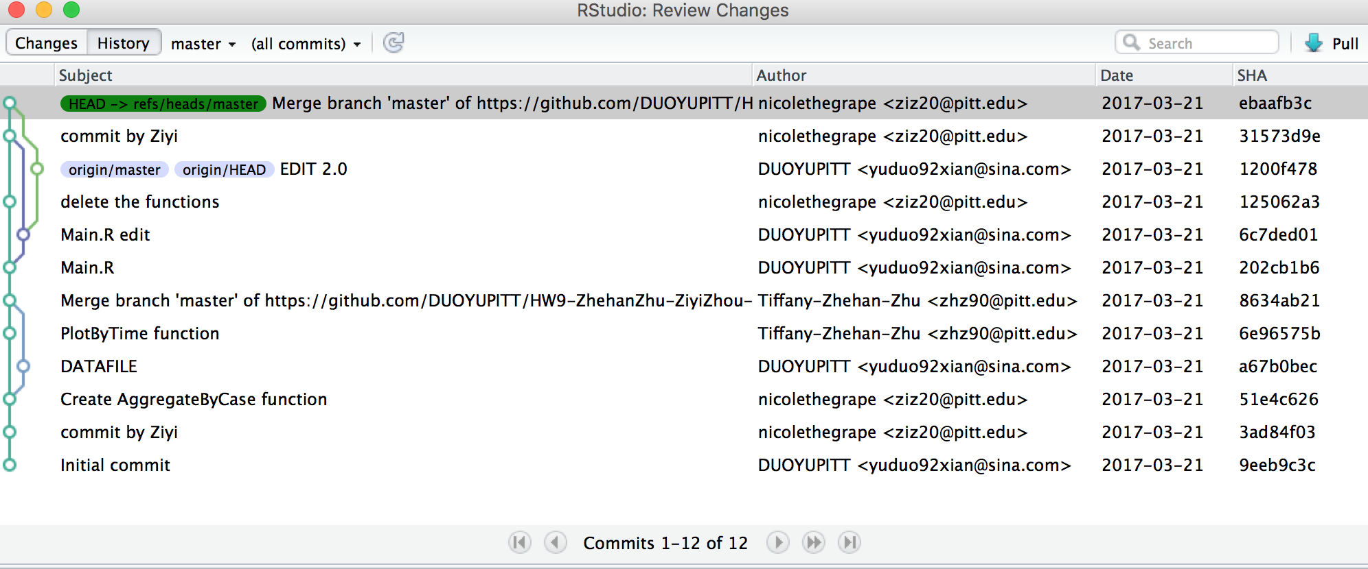

Screen shot from Zhehan

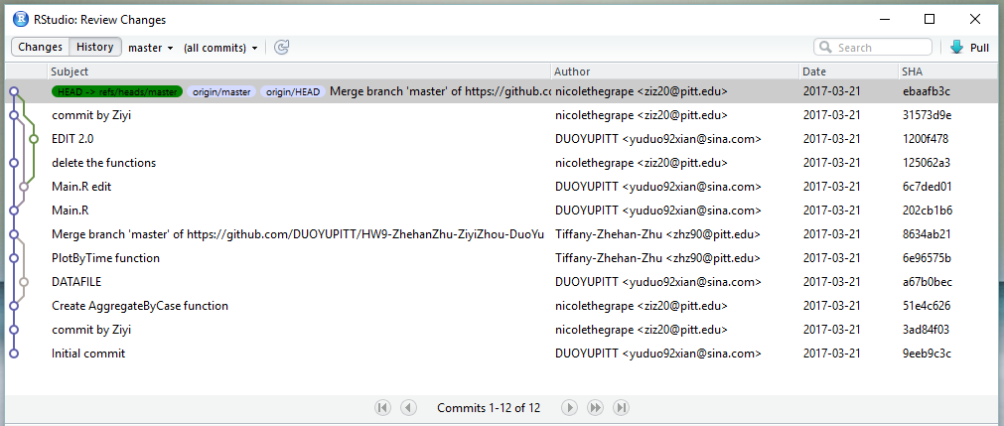

Screen shot from Duo

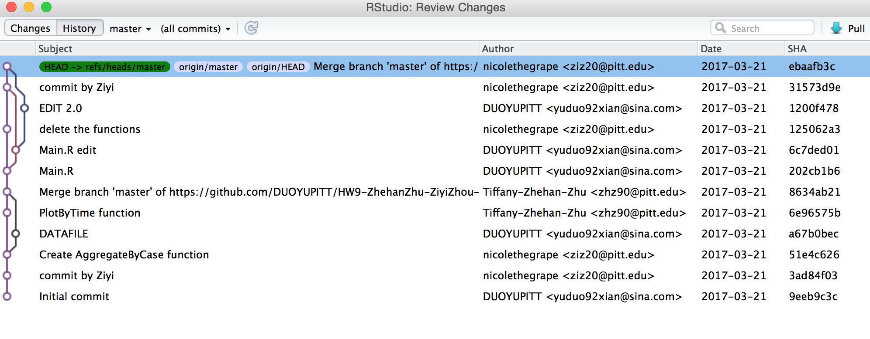

* The problems we occur:

1. We still had the merge problem which didn’t allow us to pull, but we solved the problem by committing the files.
2. When two people are editing the same file at the same time, it caused problem to pull.