Godot – 2D Platformer Game
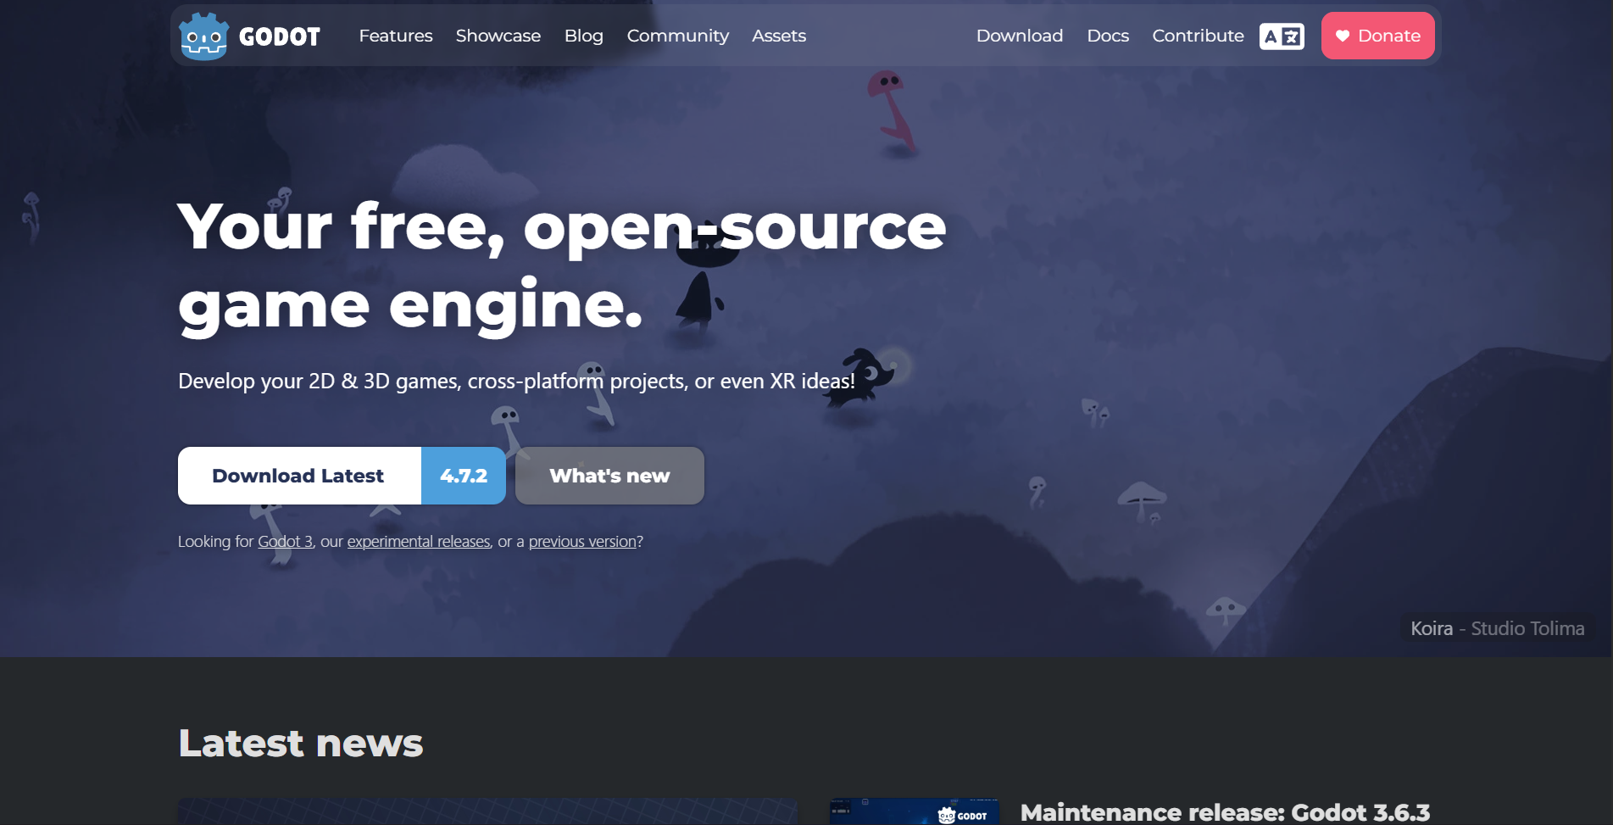
Open the project in Godot
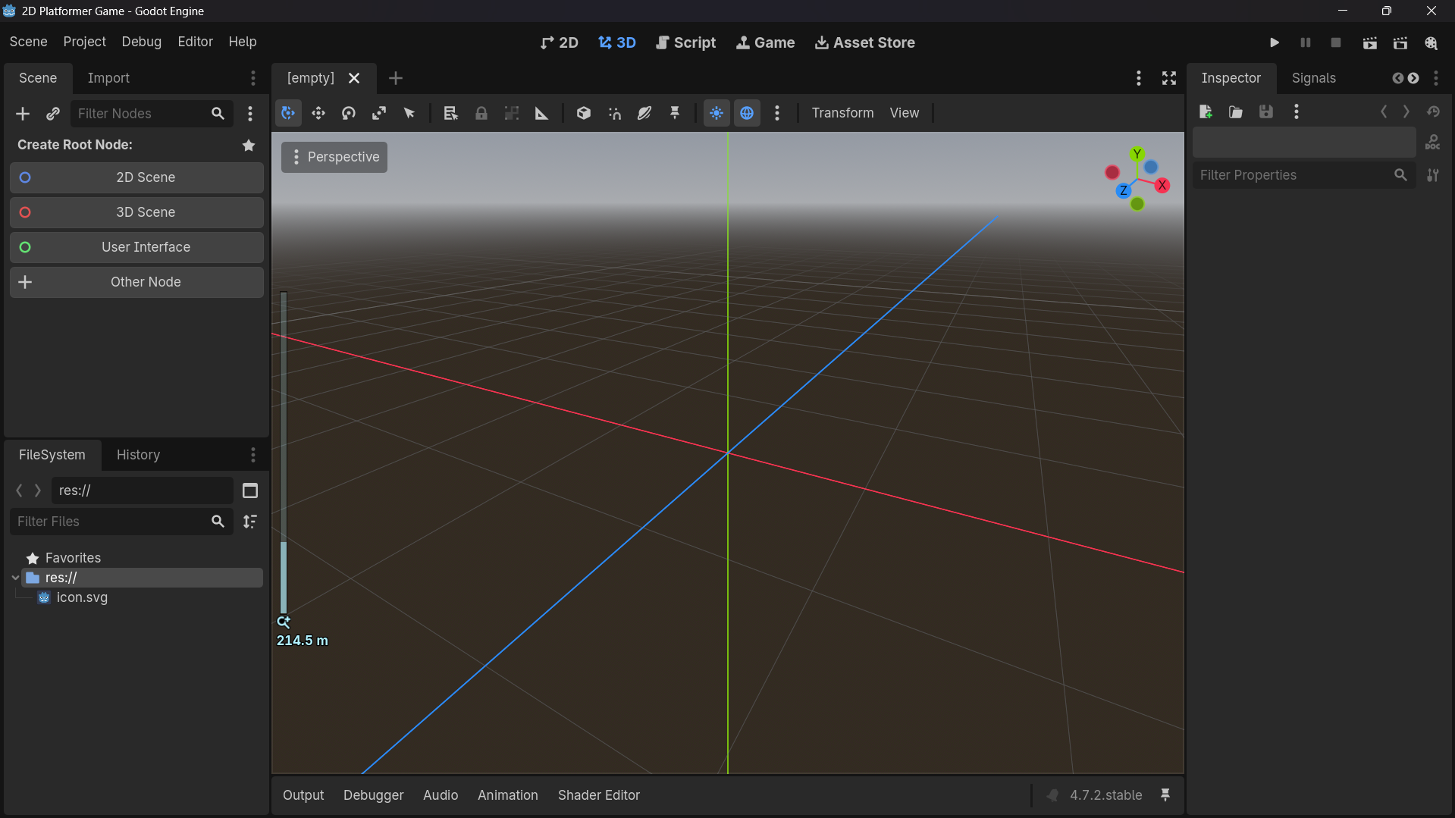
Just download the asset from Brackey’s asset bundle : https://brackeysgames.itch.io/brackeys-platformer-bundle
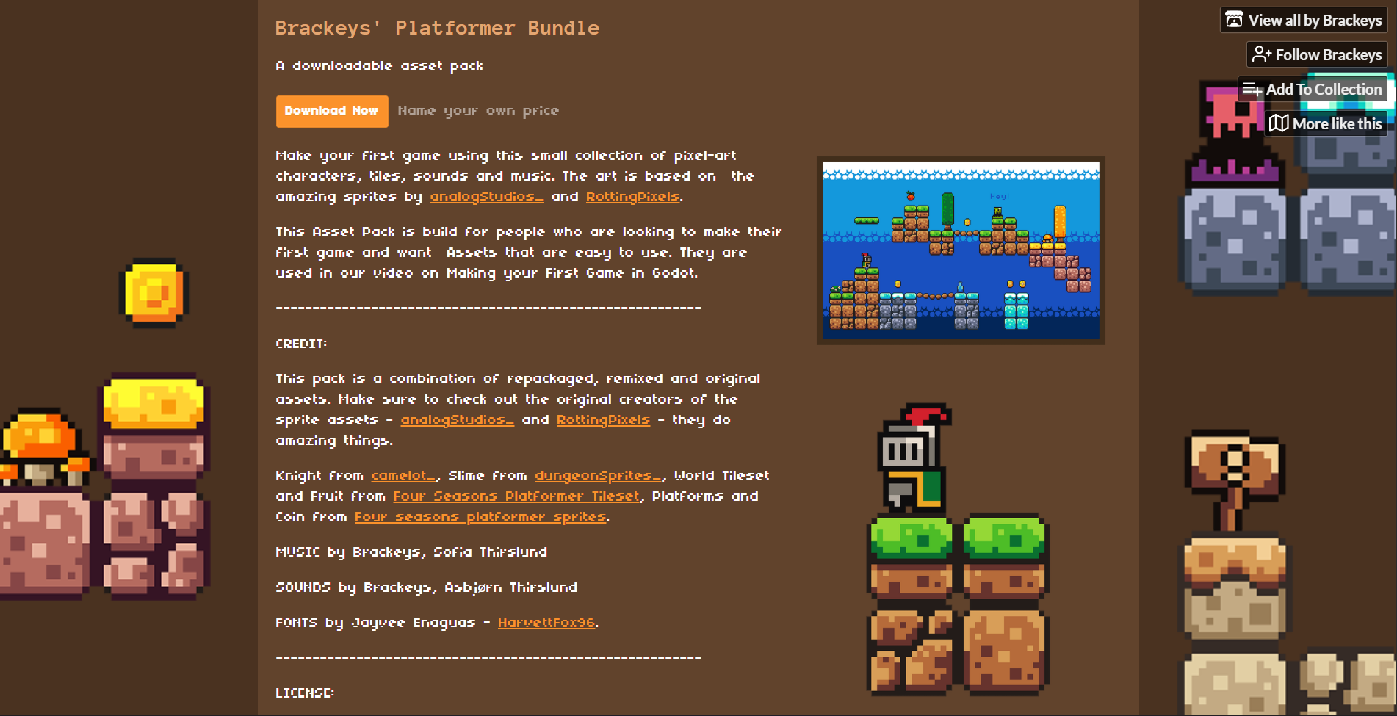
Just import the assets into the folder
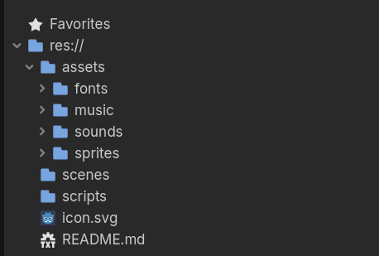
Here nodes are the fundamental building block of your game

Scenes allow us to bundle nodes into the usable packages
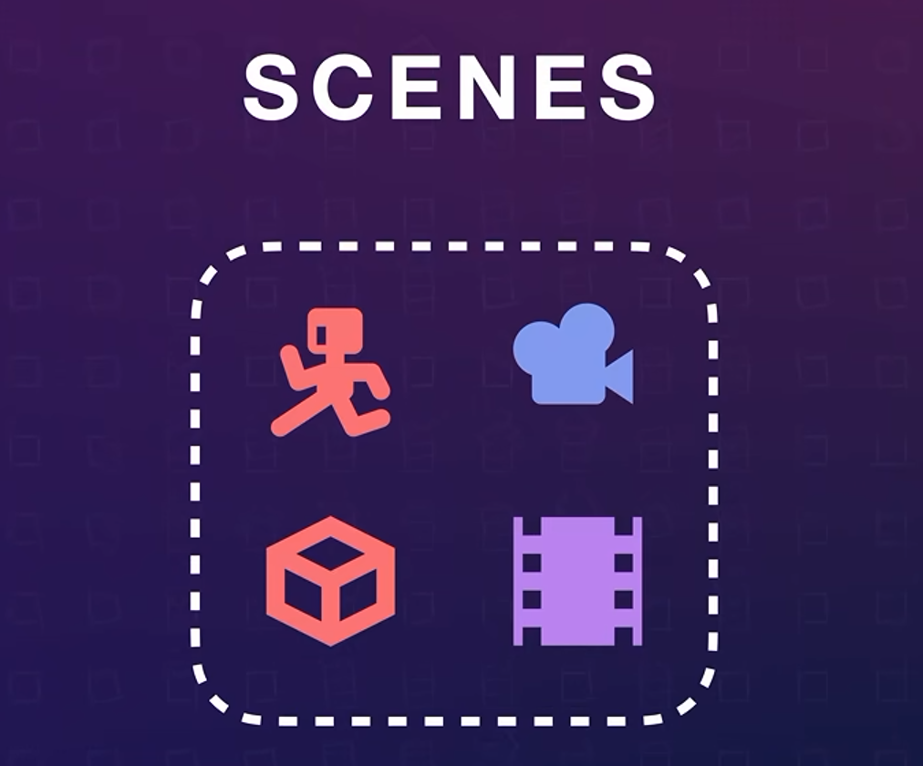
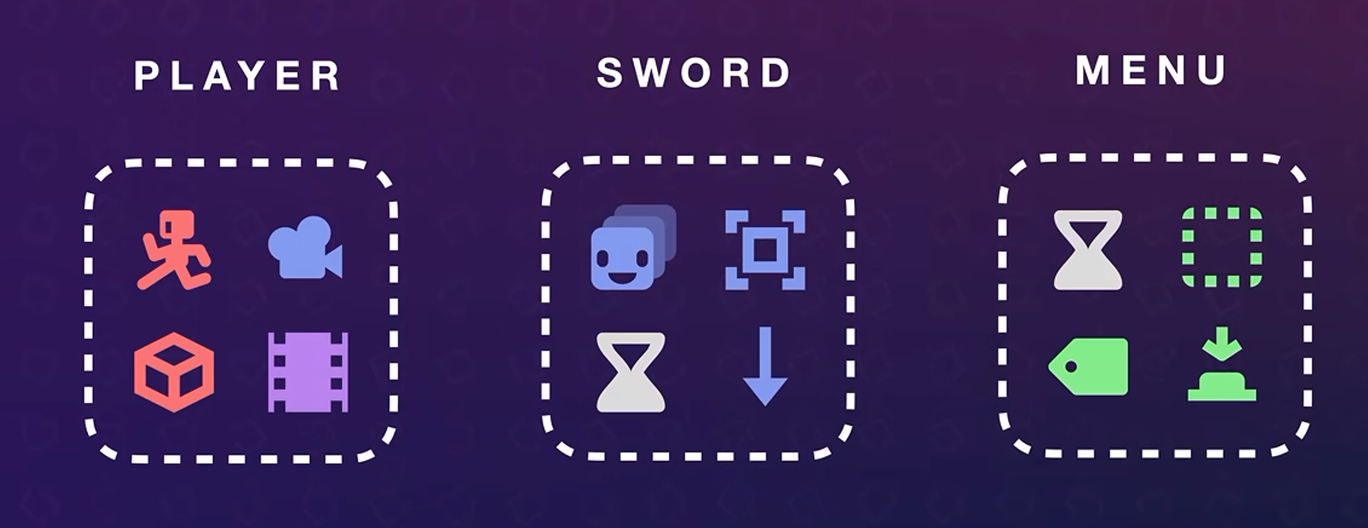
We can put scenes inside of other scenes which is called Nesting
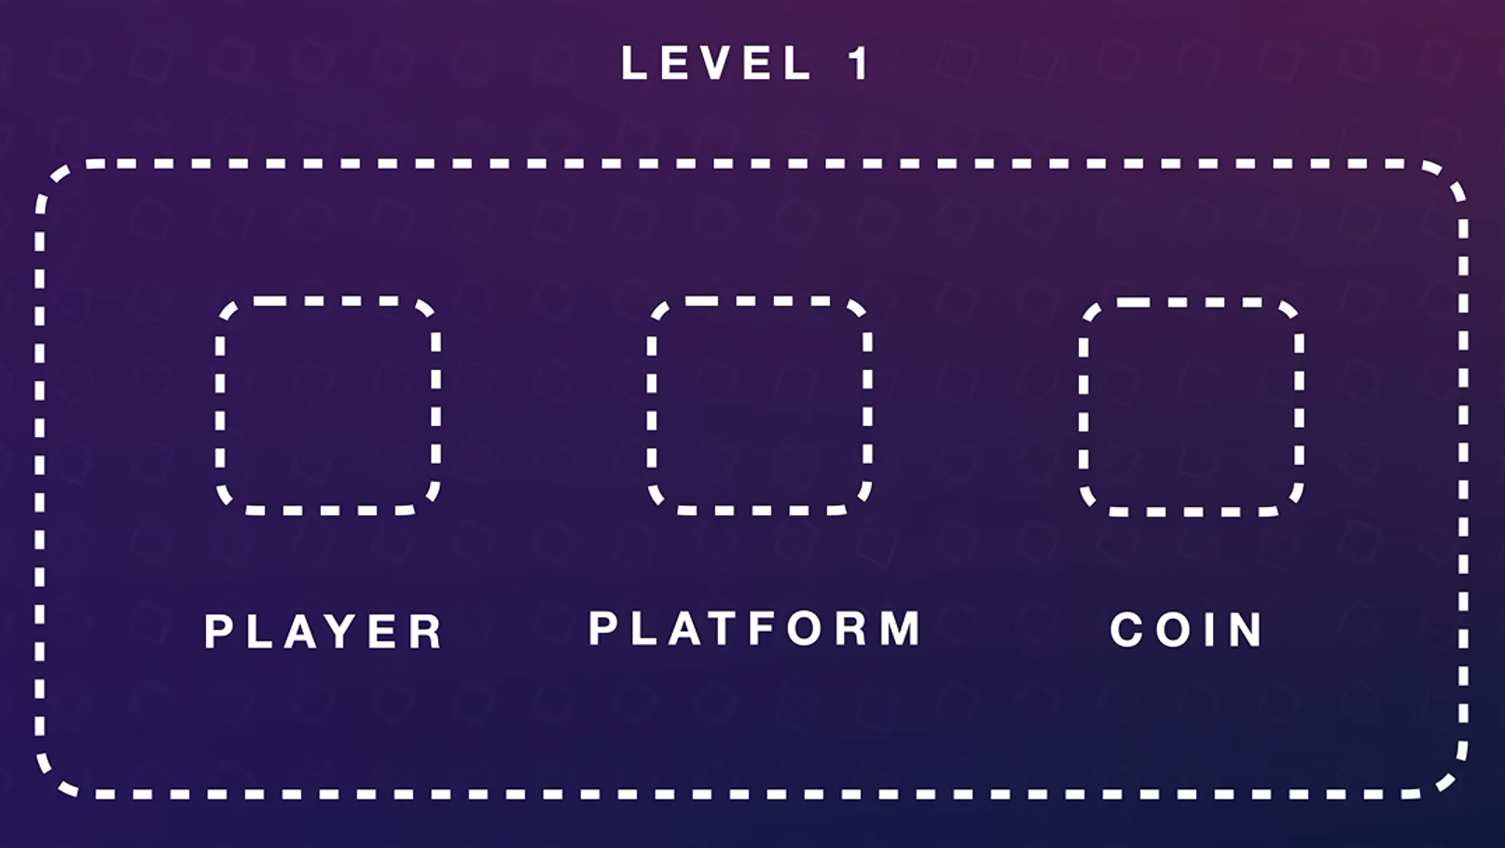
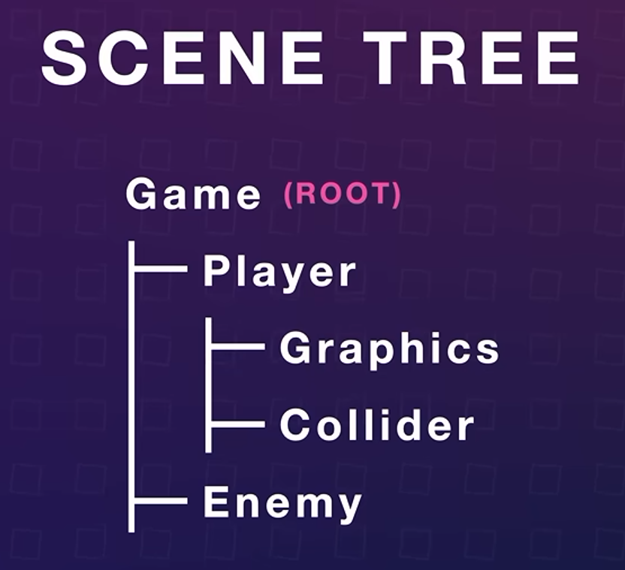
Now create an 2D scene
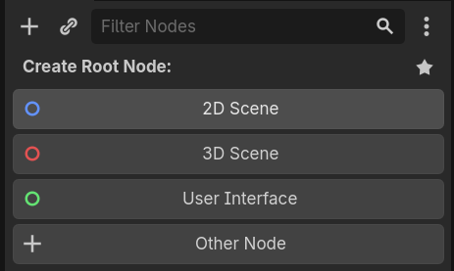
Now create an new scene -> root node -> add the Character Body 2D
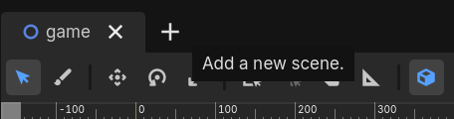
Use key Ctrl + A to add the node
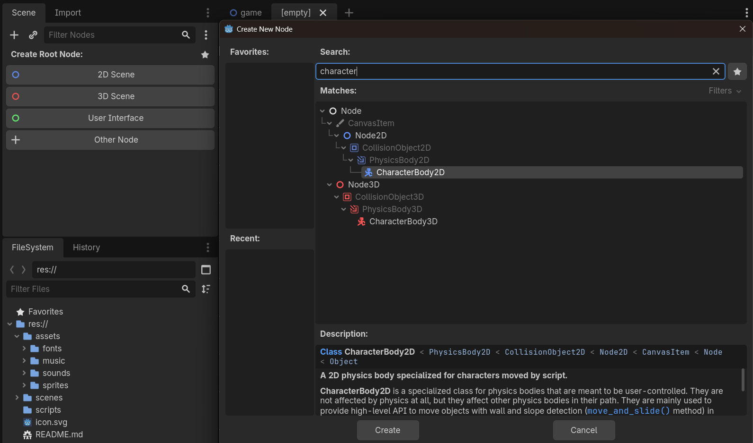
Once done add the Animated Sprite 2D
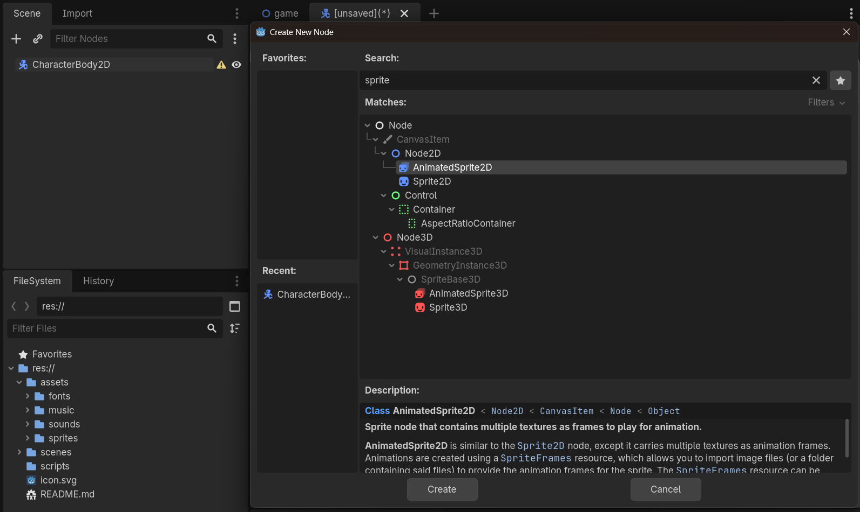
Now select the AnimatedSprite2d -> Inspector -> Animated Sprite 2D -> Sprite frame : add sprite frames
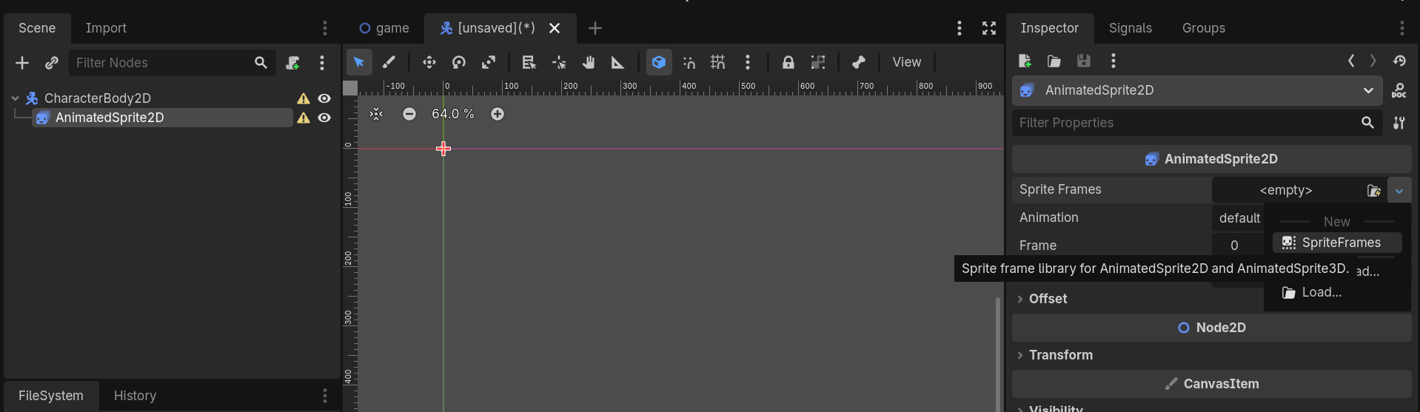
Now we need to add the sprite frames from the sprite sheet
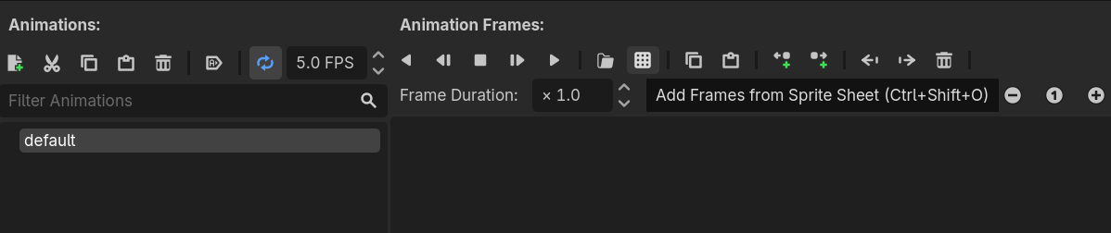
Just open the sprite sheet -> change the grid accordingly
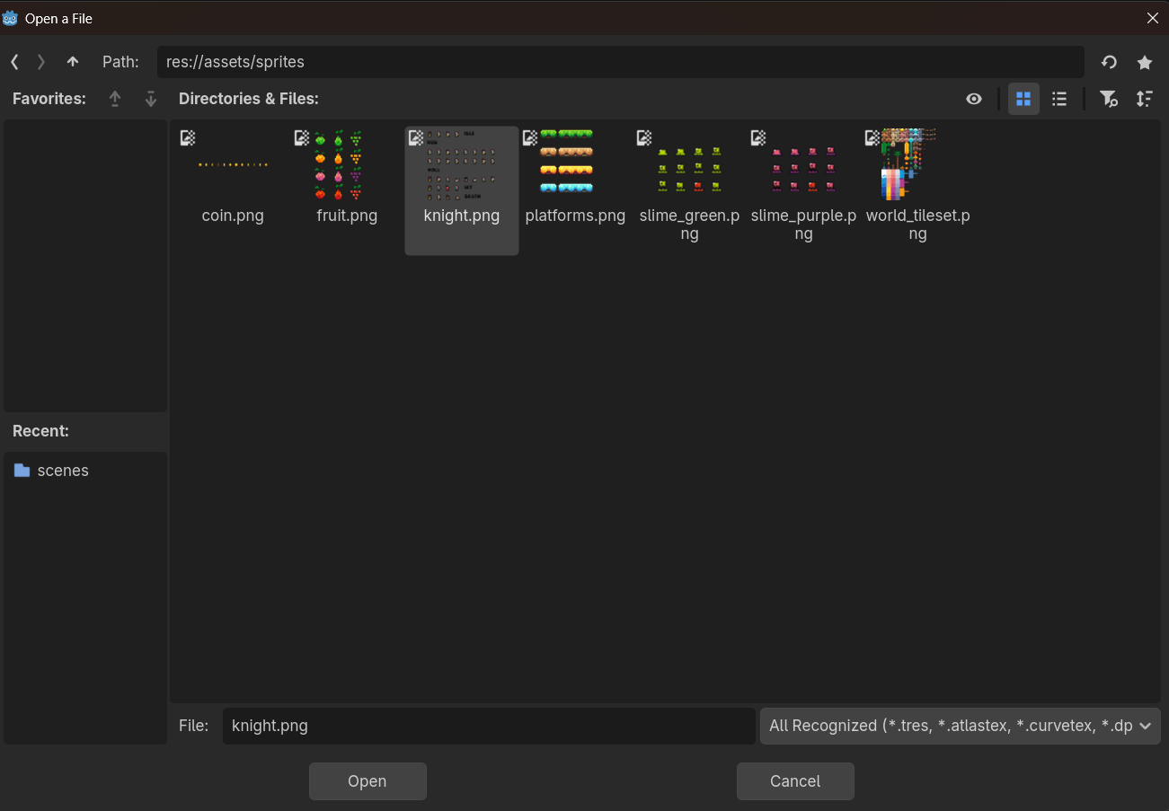
Right now change the horizontal grid and vertical grid to get the induvial sprites
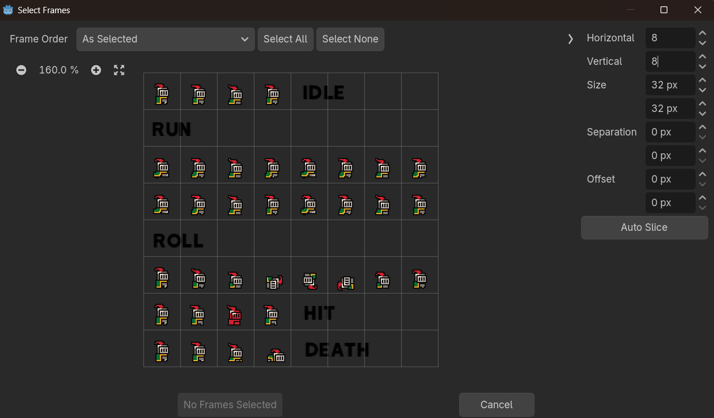
Now add the frames
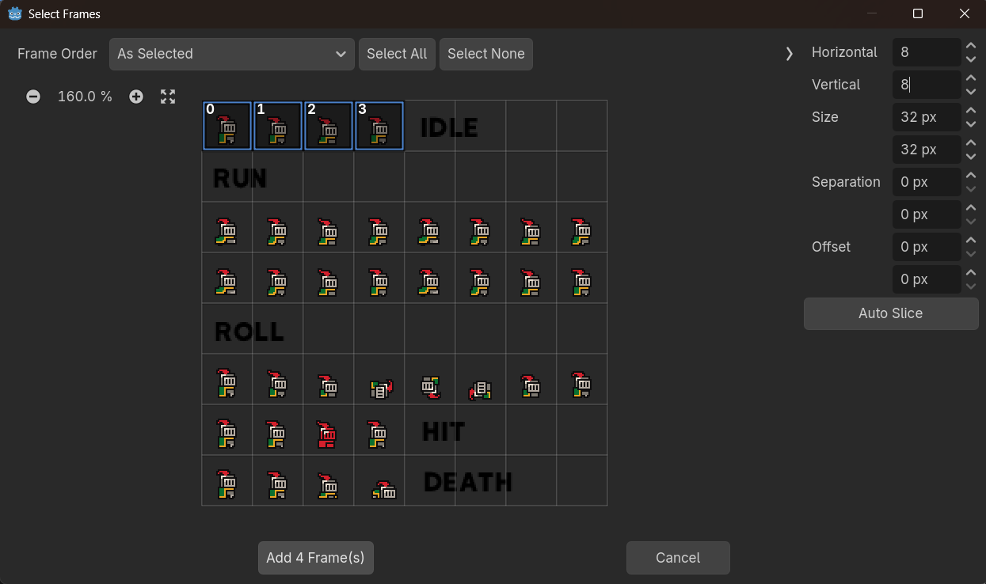
Texture Smoothing while working on an Pixel Art game the sprite edge should look very sharp
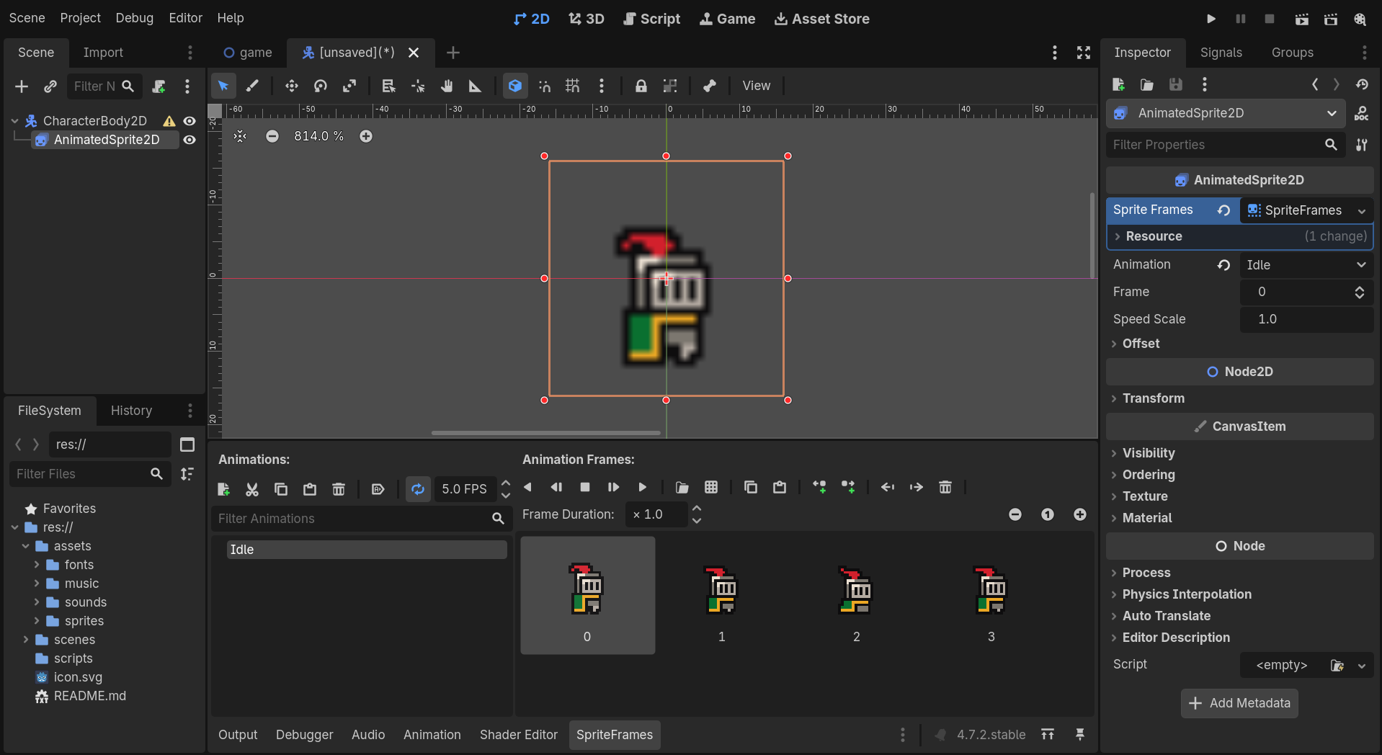
Project Menu -> Project Settings -> Rendering -> Textures -> Canvas Texture : Nearest
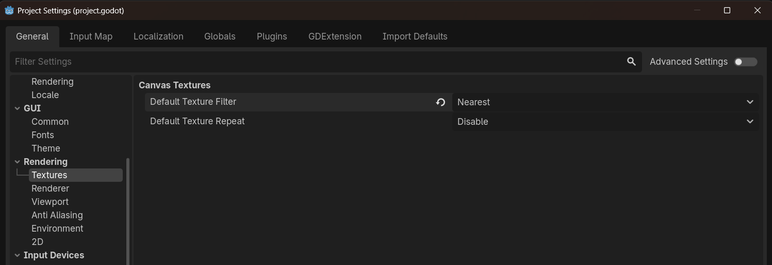
Once done the set the FPS for the animation & the texturing issue get rectified
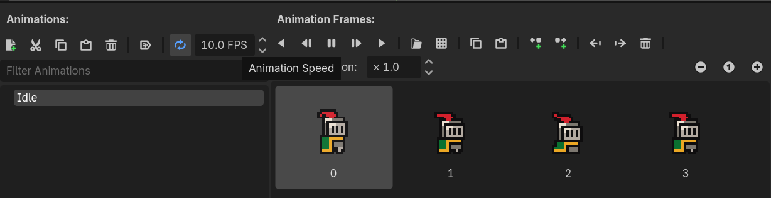
And also enable Auto Play Onload while playing the animation
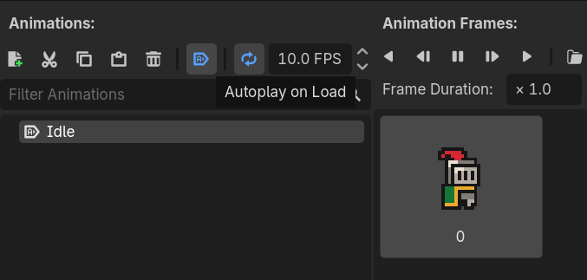
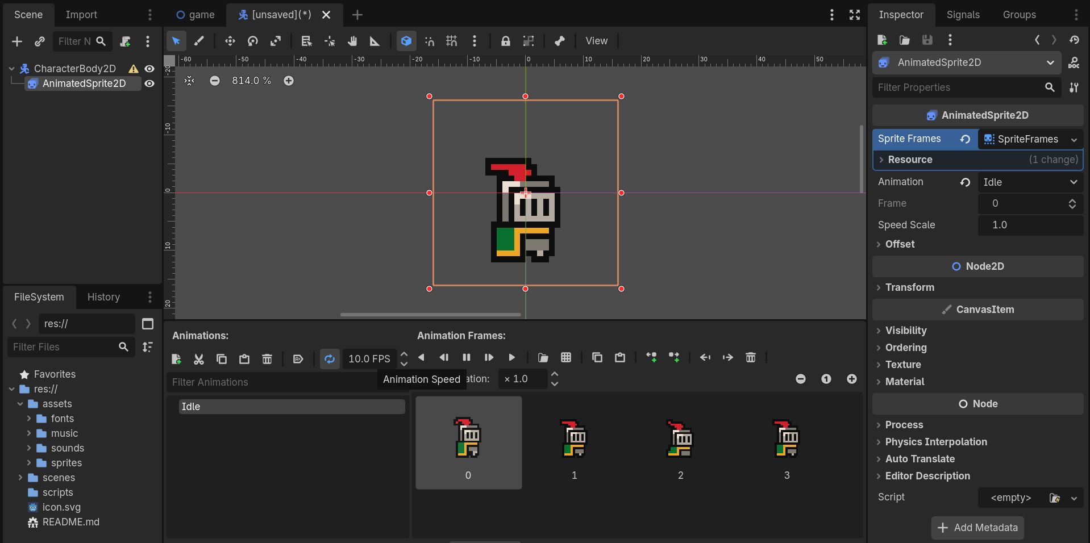
Here is a warning about the Character Body 2D in which this node comes under the physics node which needs a collision which defines the shape in which the physics engine can work with
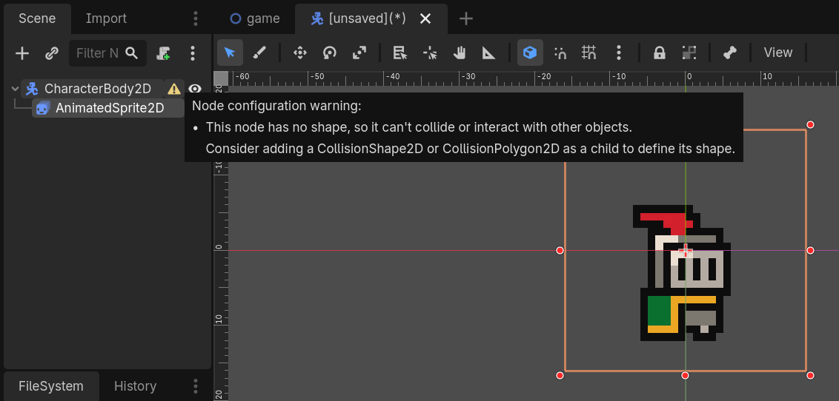
Add the new node -> Collision Shape 2D
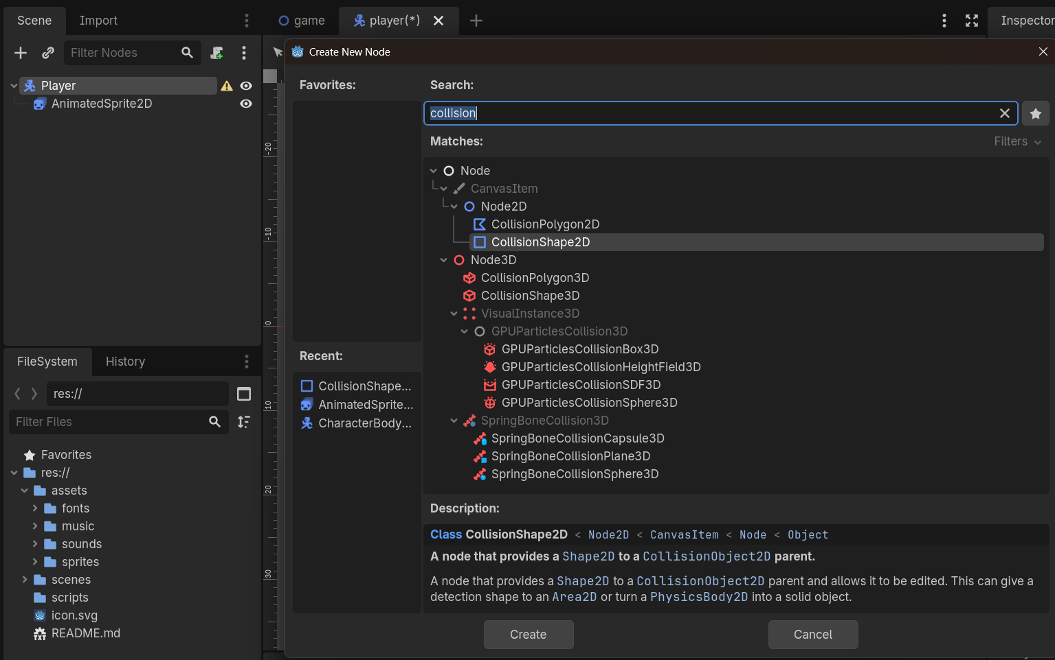
Select the Collision Shape 2D -> Inspector -> Collision Shape 2D -> Shape : Circle Shape 2D
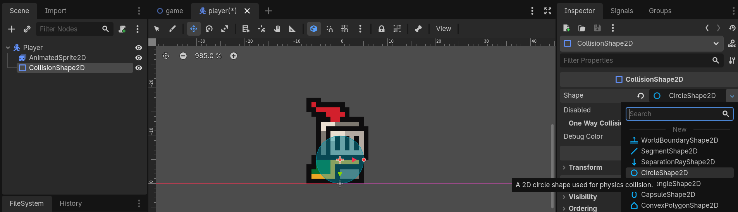
Once done move to the Game scene -> add the player scene into the Game scene + add the Camera 2D node
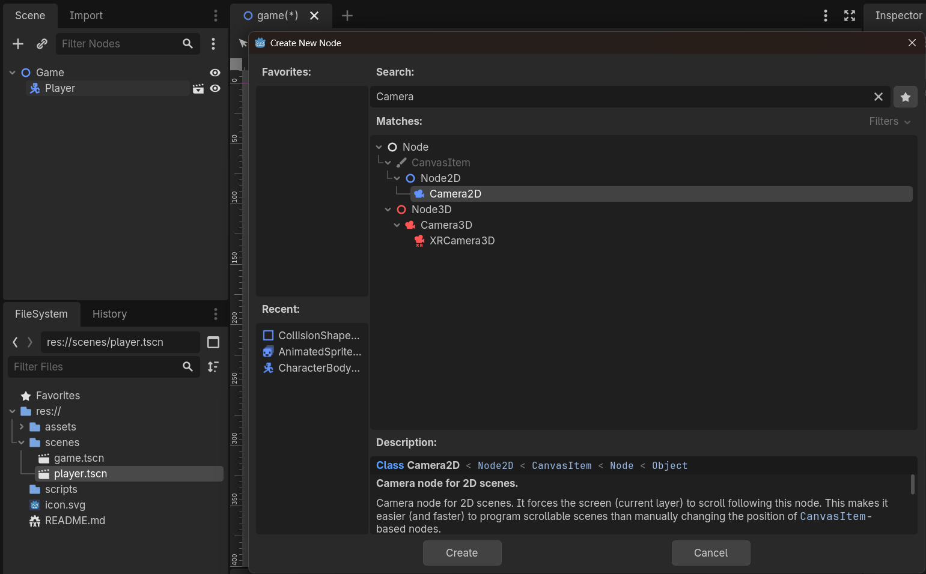
Once added the camera zoom the camera accordingly
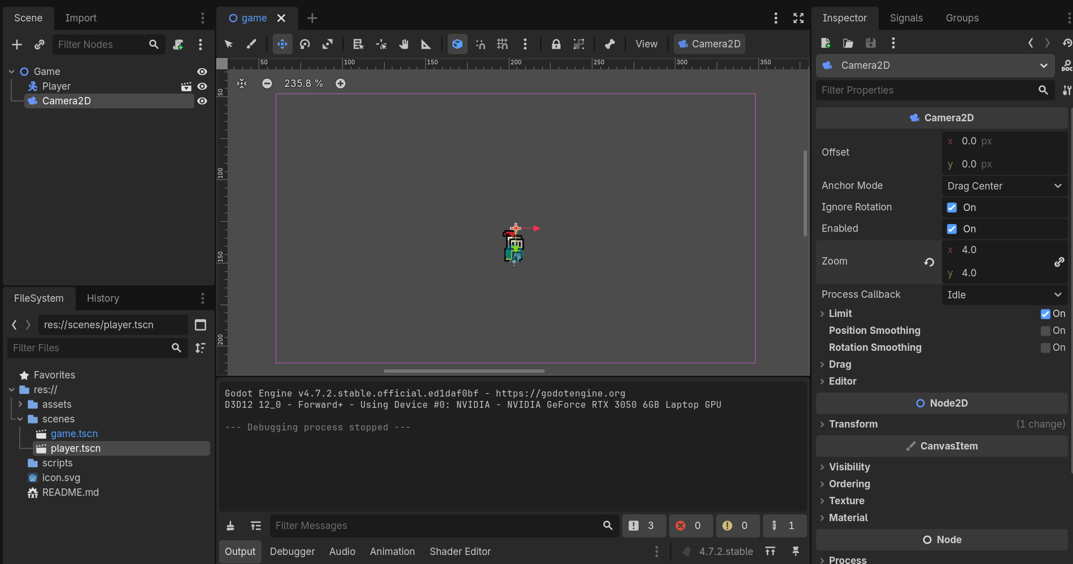
Now add the Player Movement script to the player -> open the Player Scene -> select the player node -> add the script
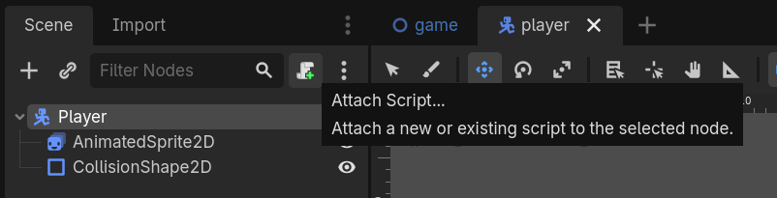
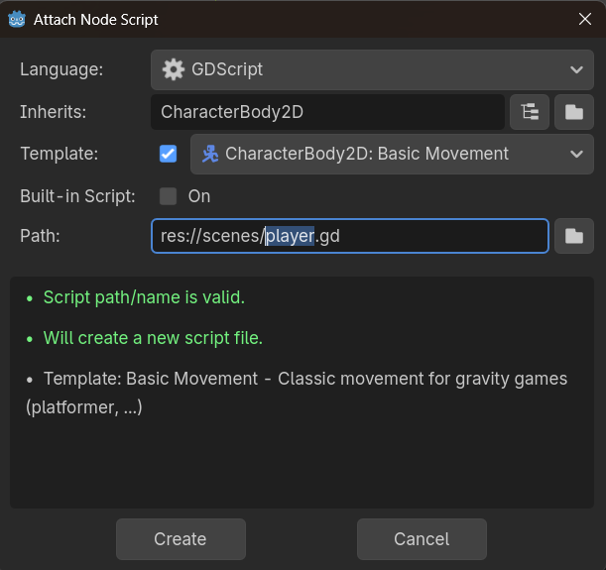
Once done move to the game scene -> add the Static body 2D
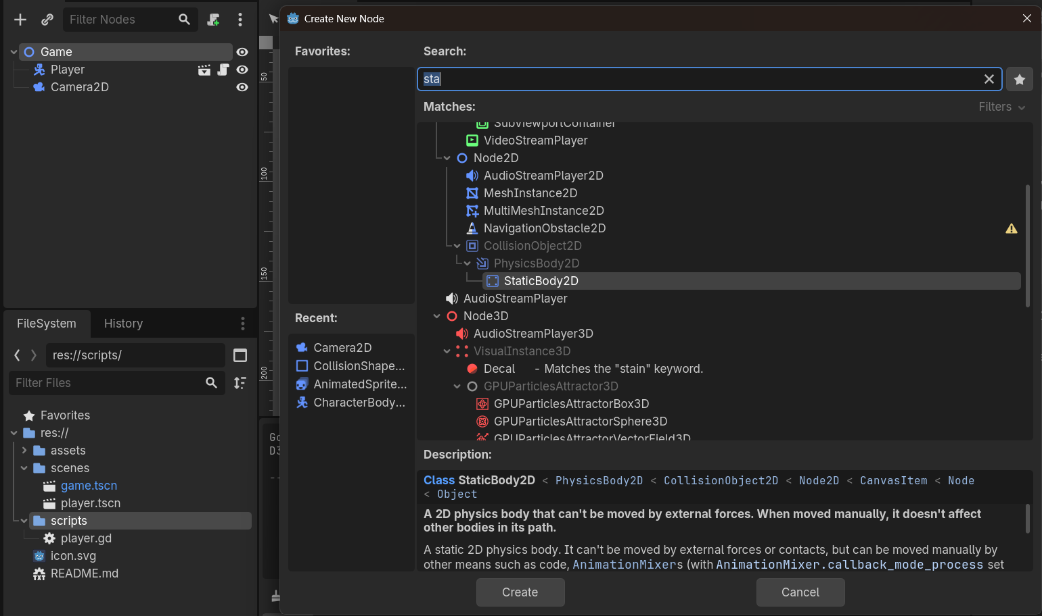
And also add the collision shape to the Static Body 2D
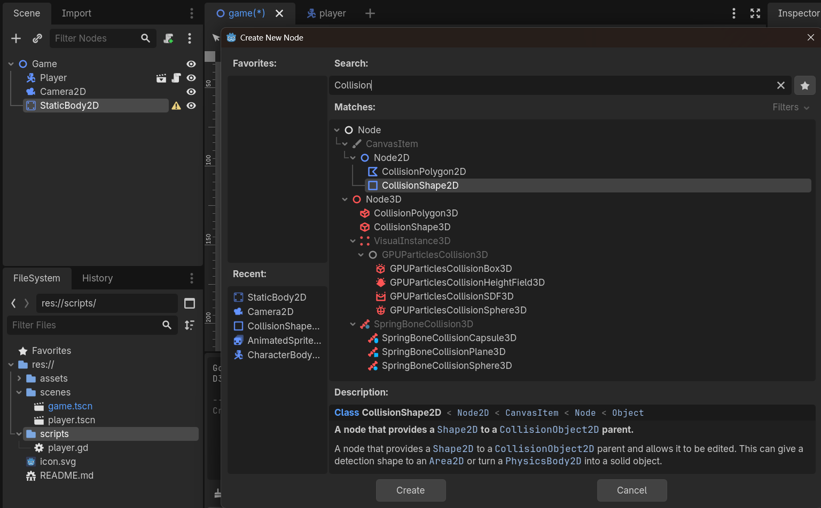
Select Collision Shape 2D -> Inspector -> Collision Shape 2D -> Shape :new world boundary shape
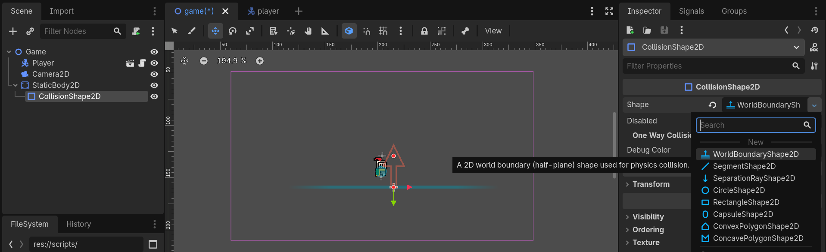
Player Script :
player.gd
extends CharacterBody2D
const SPEED = 130.0
const JUMP_VELOCITY = -300.0

func _physics_process(delta: float) -> void:
# Add the gravity.
if not is_on_floor():
velocity += get_gravity() * delta

# Handle jump.
if Input.is_action_just_pressed("ui_accept") and is_on_floor():
velocity.y = JUMP_VELOCITY

# Get the input direction and handle the movement/deceleration.
# As good practice, you should replace UI actions with custom gameplay actions.
var direction := Input.get_axis("ui_left", "ui_right")
if direction:
velocity.x = direction * SPEED
else:
velocity.x = move_toward(velocity.x, 0, SPEED)

move_and_slide()

World Building
To create an world we use tile map node to create an
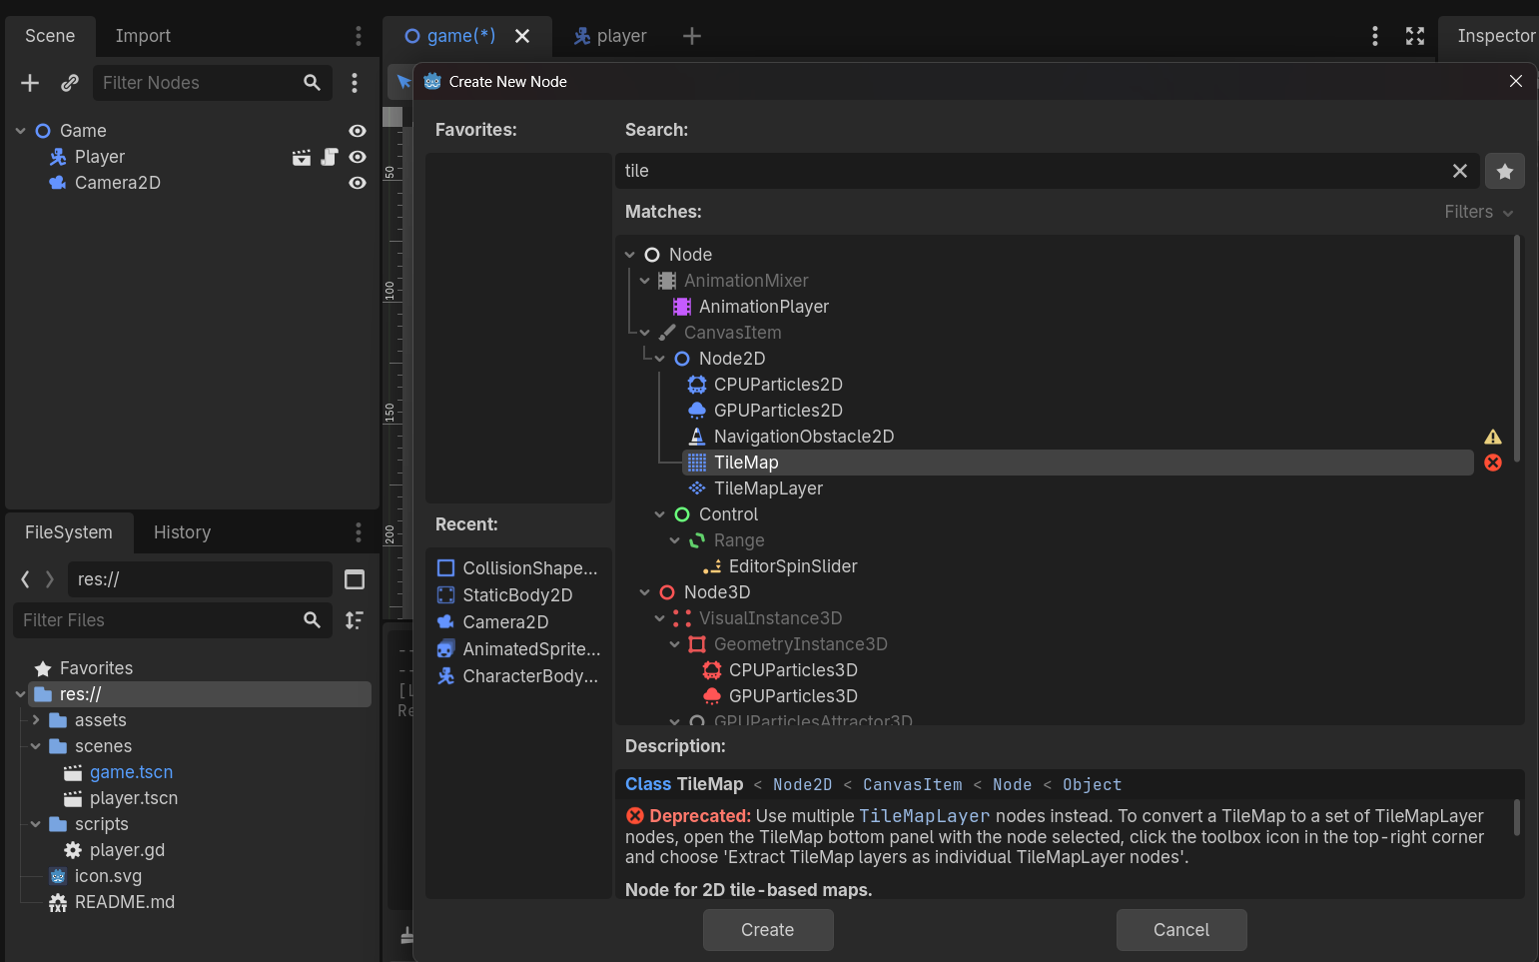
Tiles
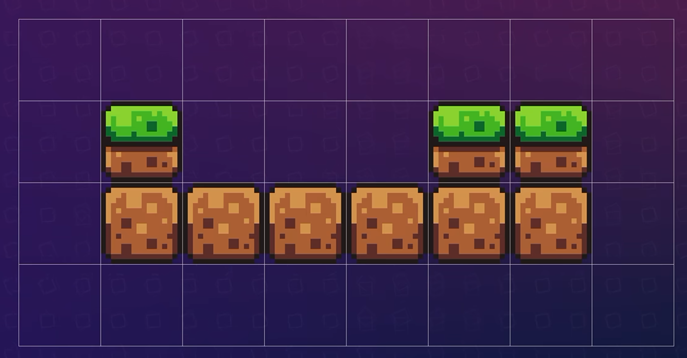
Tileset – Tile set is an collection of Tile to create an tile map
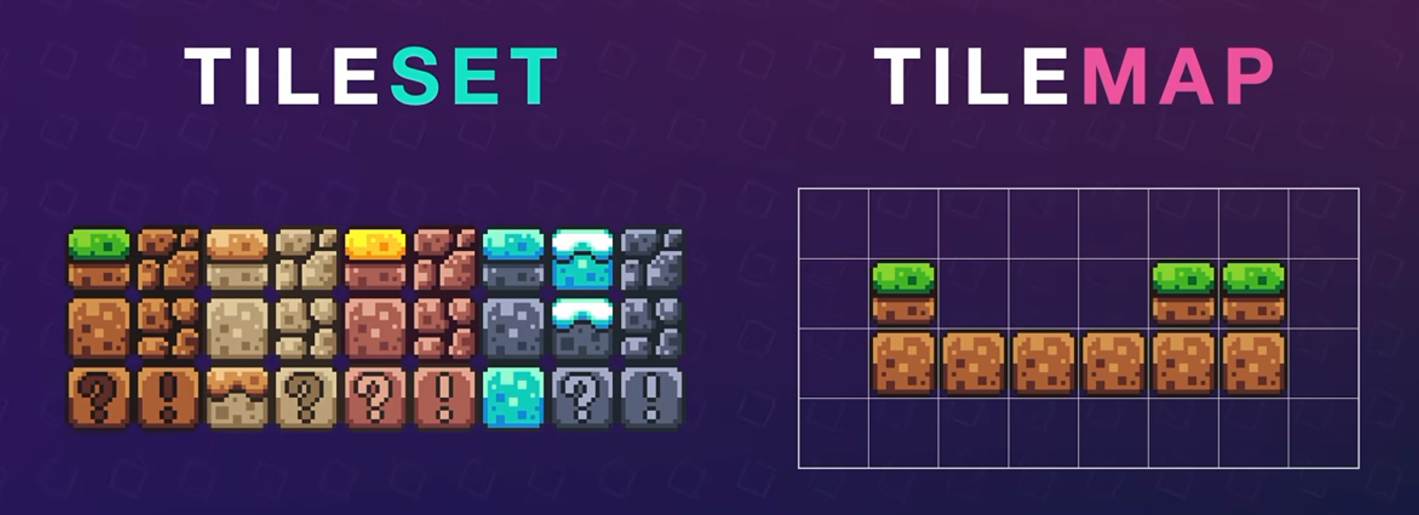
Now select the Tile Map -> inspector -> Tile set assign the Tile set &
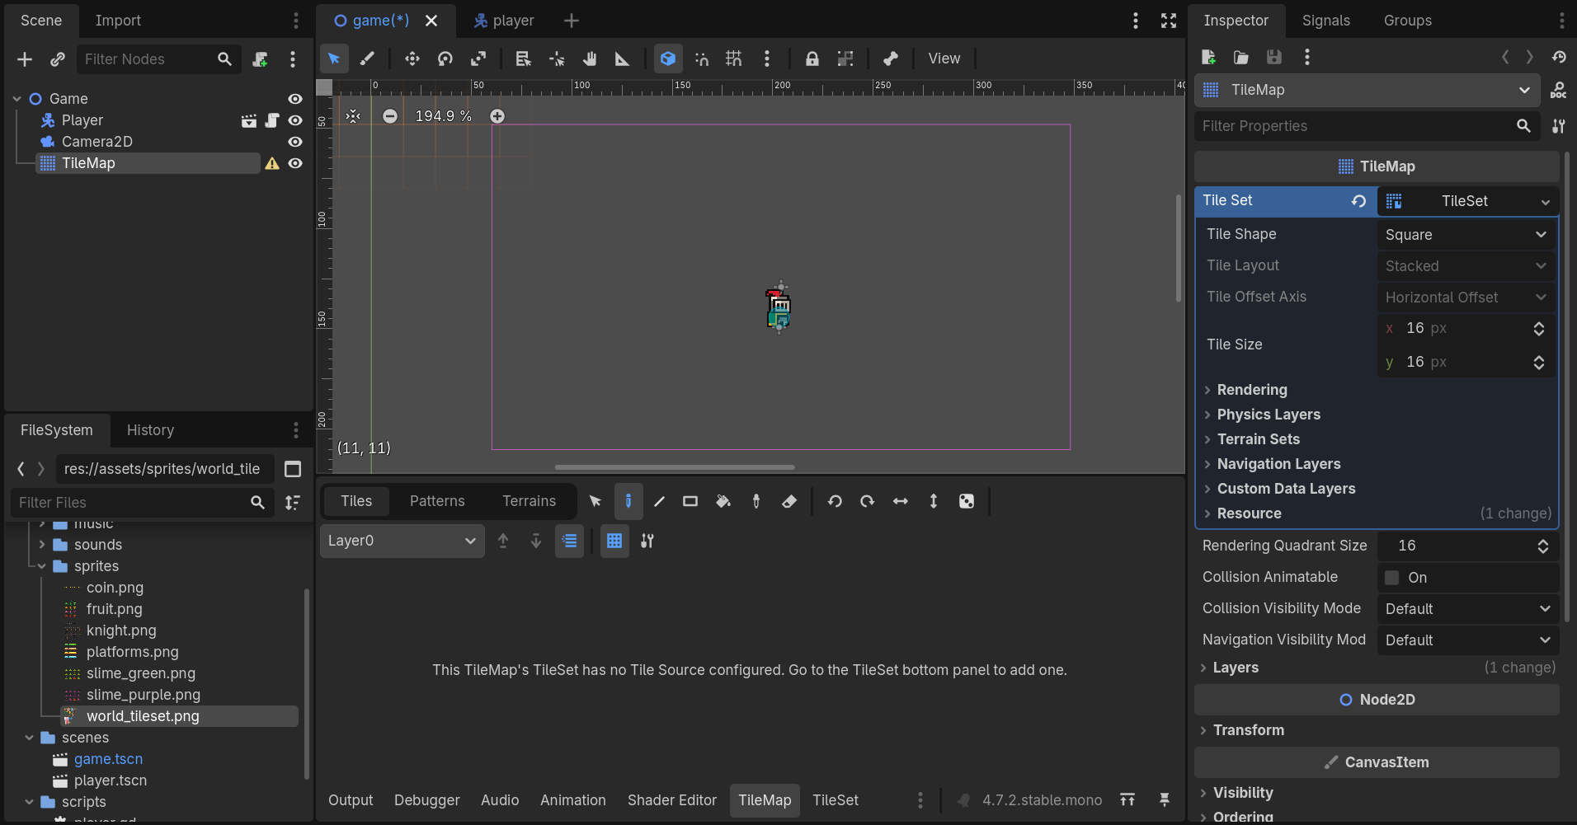
Now select the Tile set -> drag and drop the asset into the Tile Source
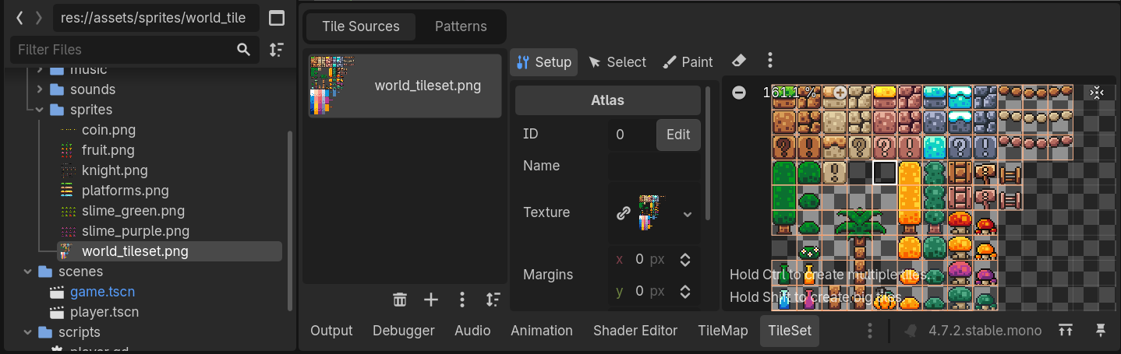
Right now some tiles are splitted we need to make the tile as a single tile [Multiple tile to Single tile] -> switch to TileSet -> select ‘Eraser’ tool -> select the tiles what we are going to convert into single tile -> deselect the erase tool -> use the key Shift + Left mouse key to make the tiles into single tile
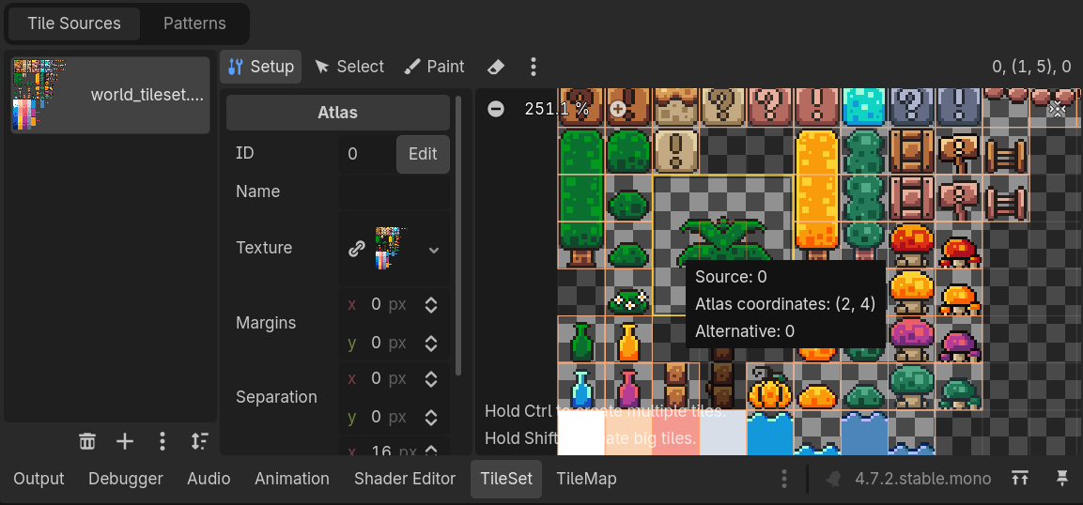
Now just select the Paint tool [Tail Map] to paint the tails on the screen
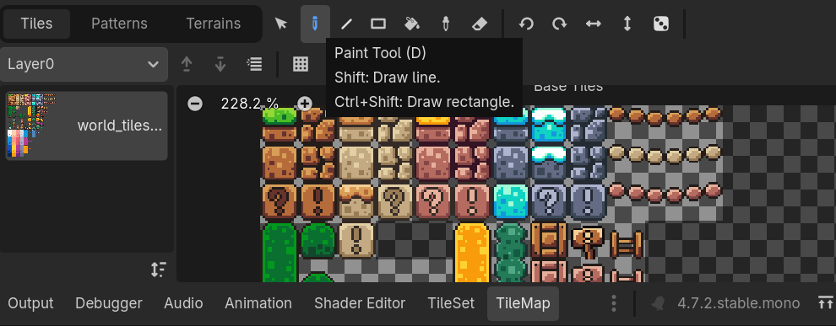
Build the world accordingly
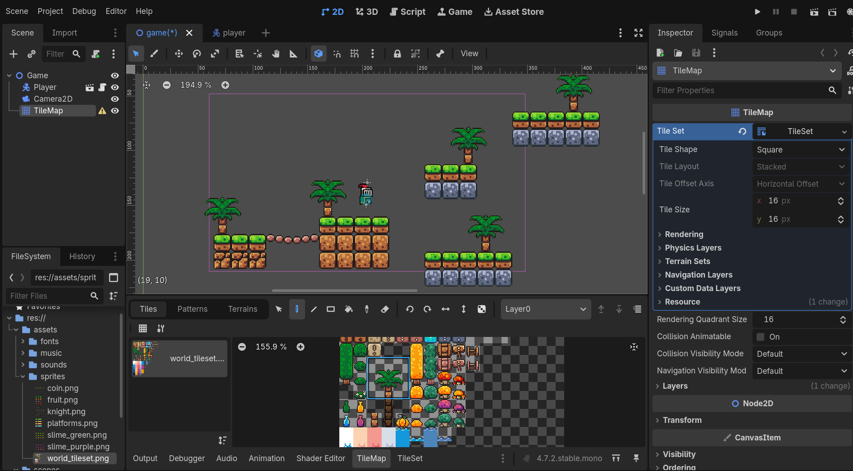
Once done we need to add the Physics Layer [Collider] to the environment select TileMap -> Tile Set -> Physics Layer -> Add element
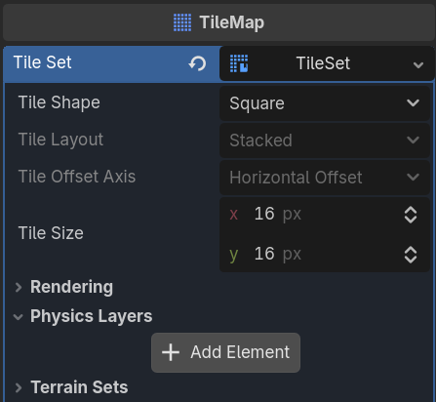
Now select Tile Map -> Tile Set -> Paint -> Paint Properties : Physics Layer 0
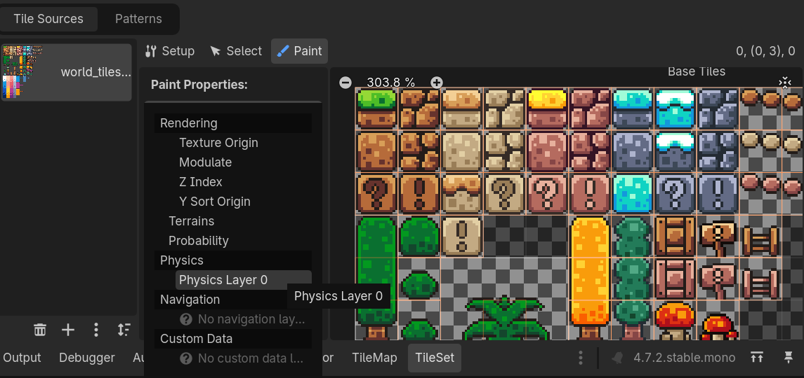
Select the tile to add the physics layer
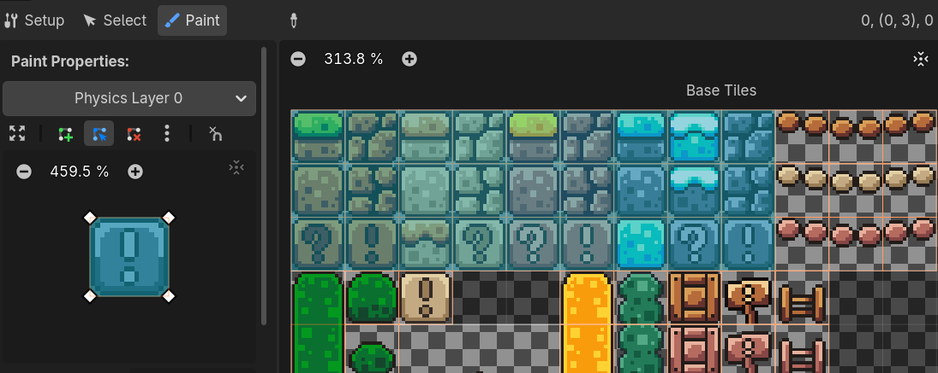
If to remove the physics layer or undo the select tile -> Tile Set ->Paint -> Paint Properties -> select the option Clear or use the key “C”
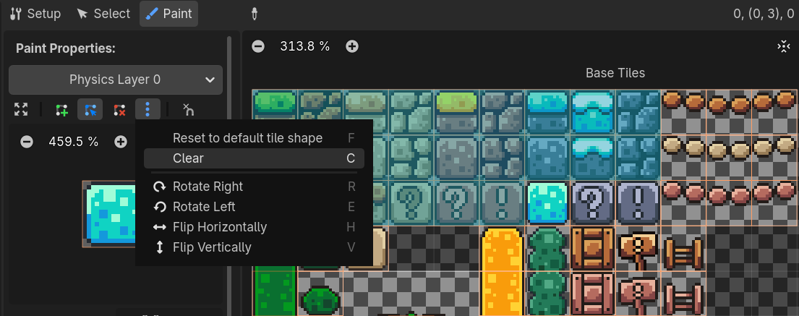
We need to modify the colliders on certain tiles
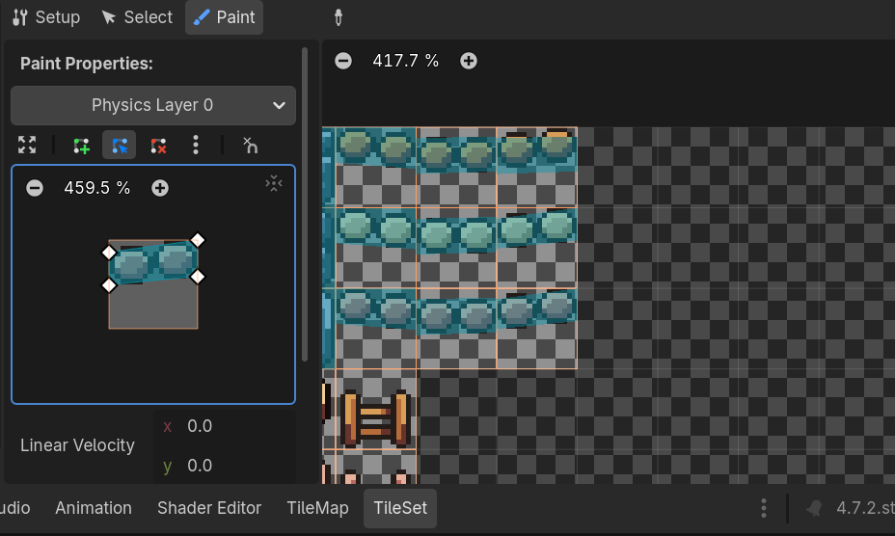
Camera need to follow the player -> move the camera into the child of the player component
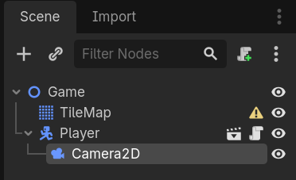
Now select the camera 2D -> inspector -> Position Smoothing : On
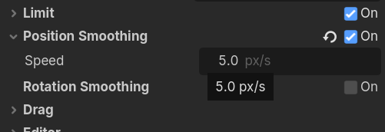
Dynamic Moving Platforms
Now create an new scene -> Add node -> Animatable Body 2D -> add sprite 2D node also as the child & assign the sprites to the node
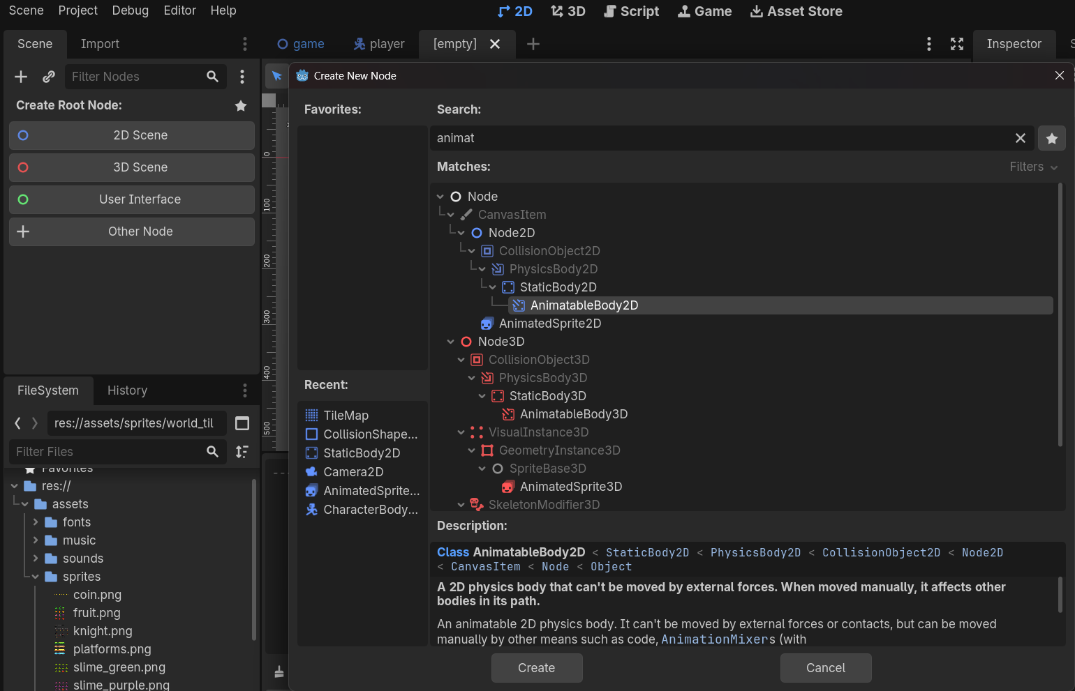
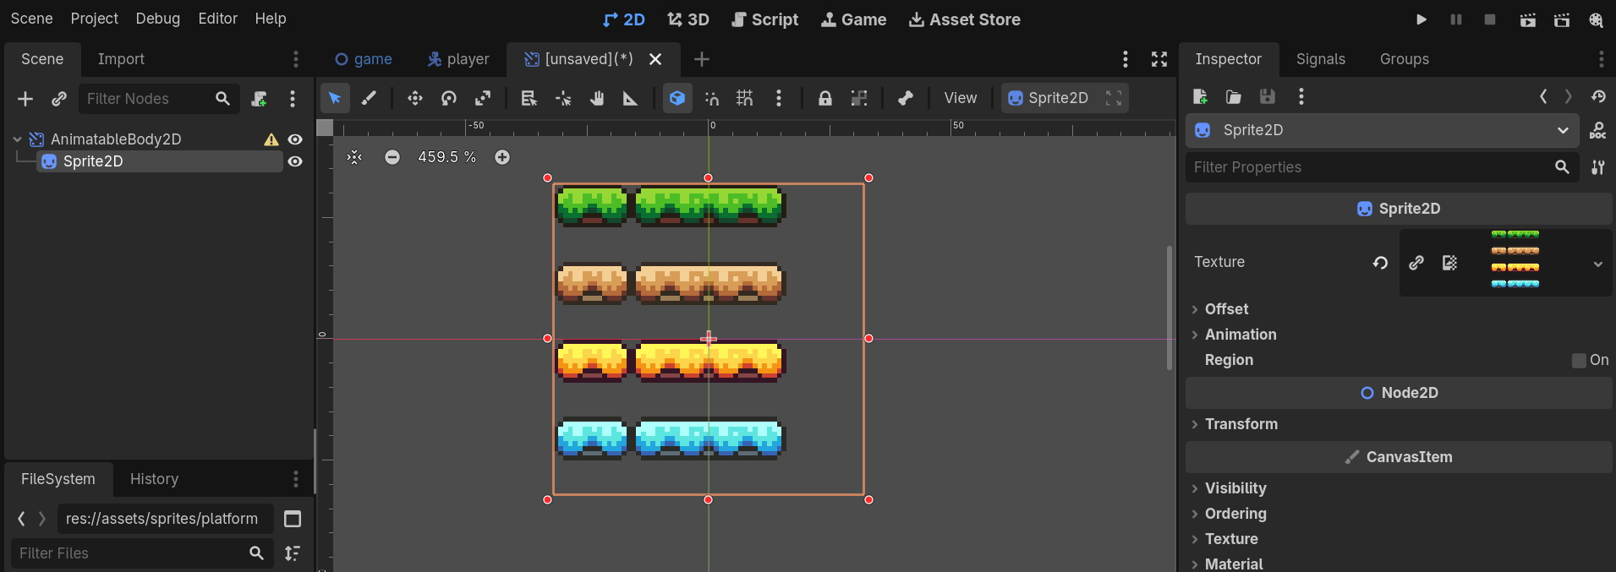
We no need all of these tile we need to show the respective tile what we are going to use as platform -> select Sprite 2D -> inspector -> Region -> enable & Edit region -> Snap Mode : Pixel Snap
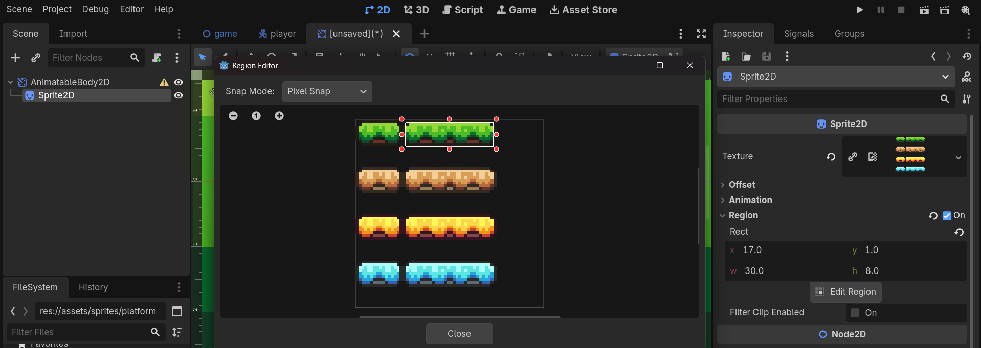
Now select the Animatable Body 2D -> add the node Collision Shape 2D -> select the Collision Shape 2D -> Inspector -> Shape : Rectangle Shape 2D
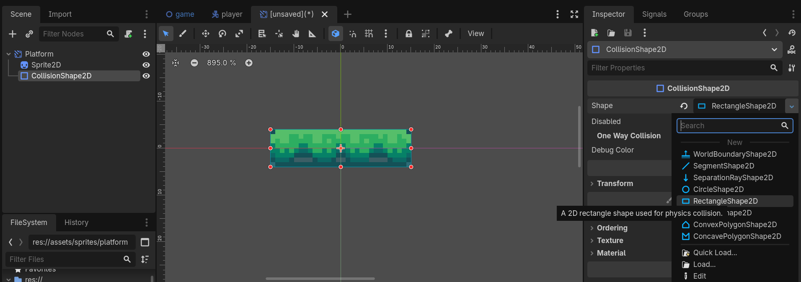
To make the platform collision should be one way enabled -> select Collision shape 2D -> enable : One Way Collision
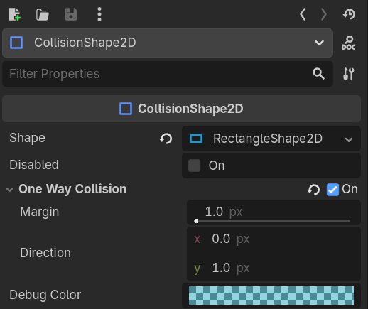
Info bits
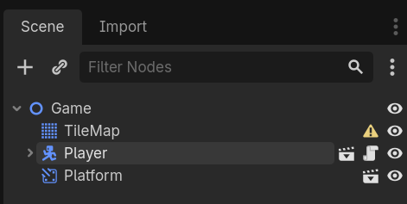
Just visualize the draw order in which player is drawn first comparing to the platform we need to overcome this problem -> open the Player Scene -> select Player -> inspector -> ordering -> ‘Z’ index : something higher like 5
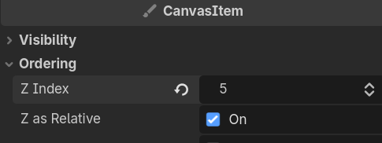
Movement animation to the platform
Select Platform -> add Animation Player node
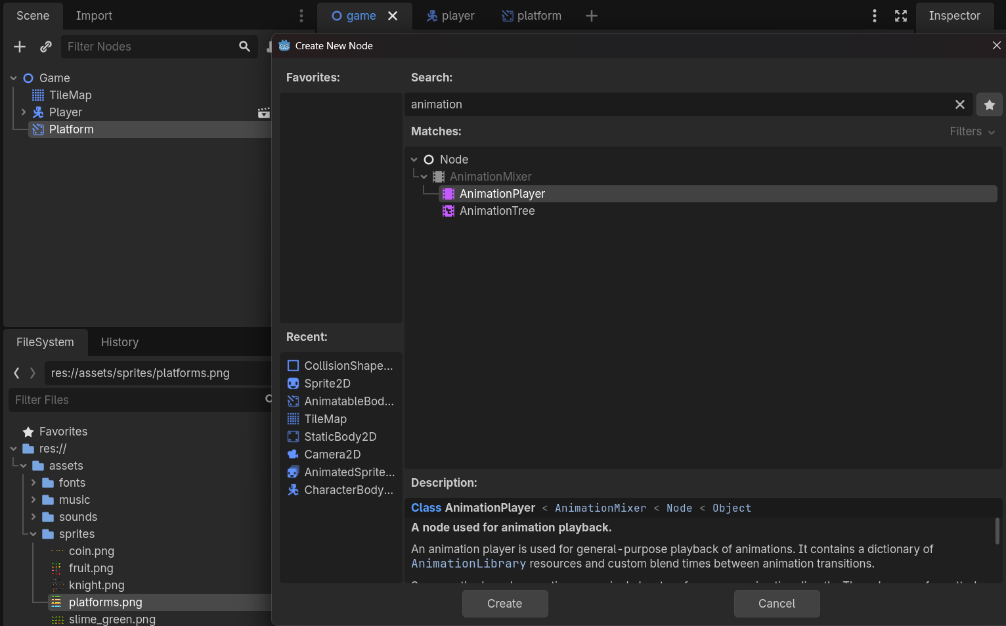
Select the Animation Player from the platform -> add new animation
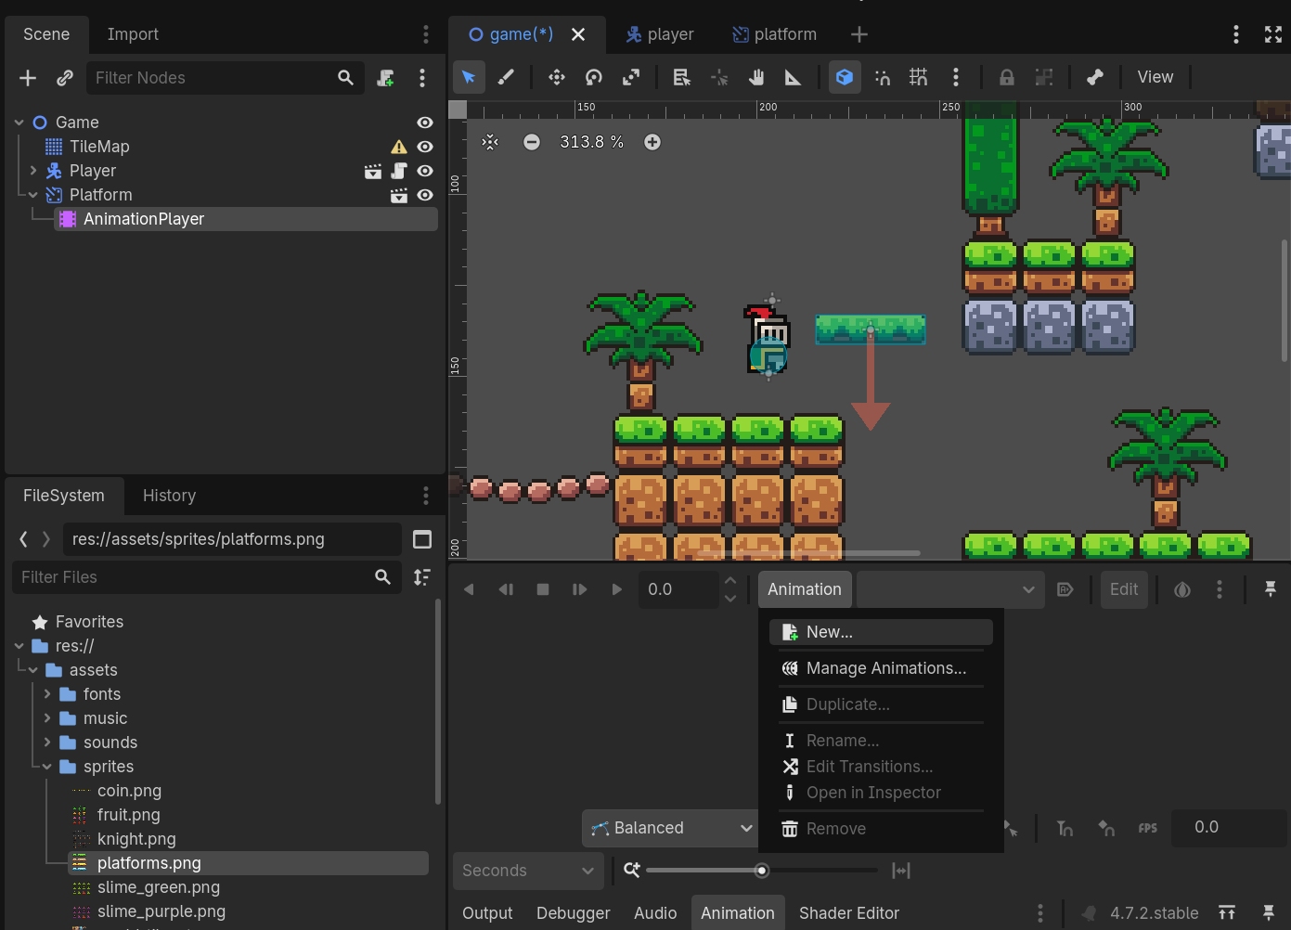
Now select the platform -> Transform create an key frame
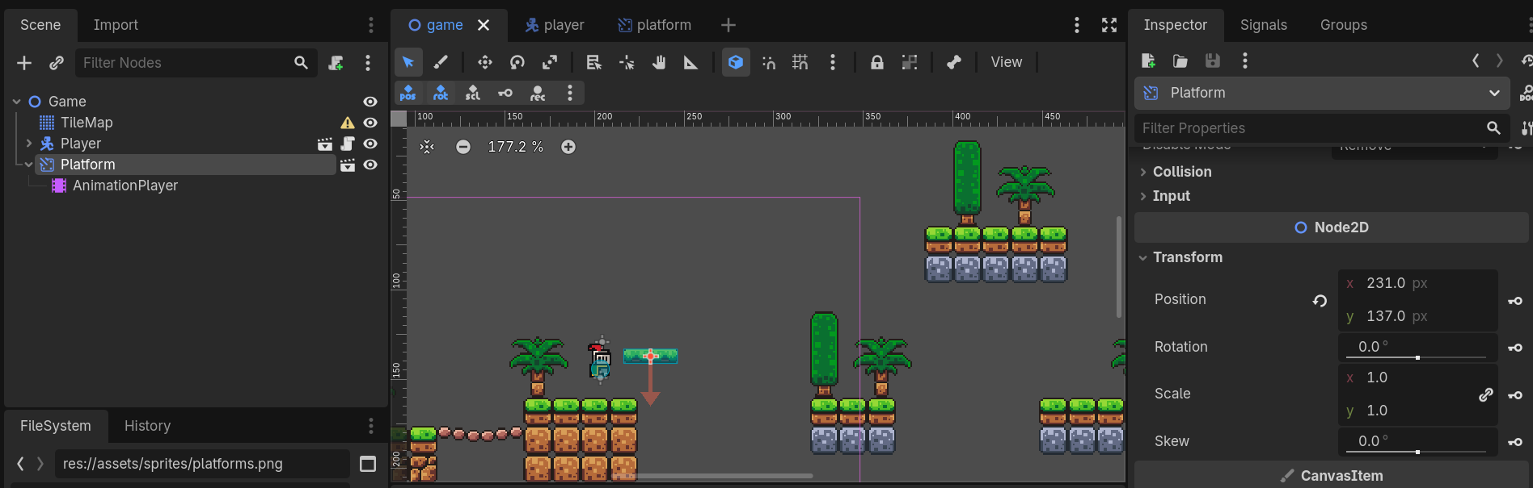
Make the animation for the platform using the keyframe and make as animation looping
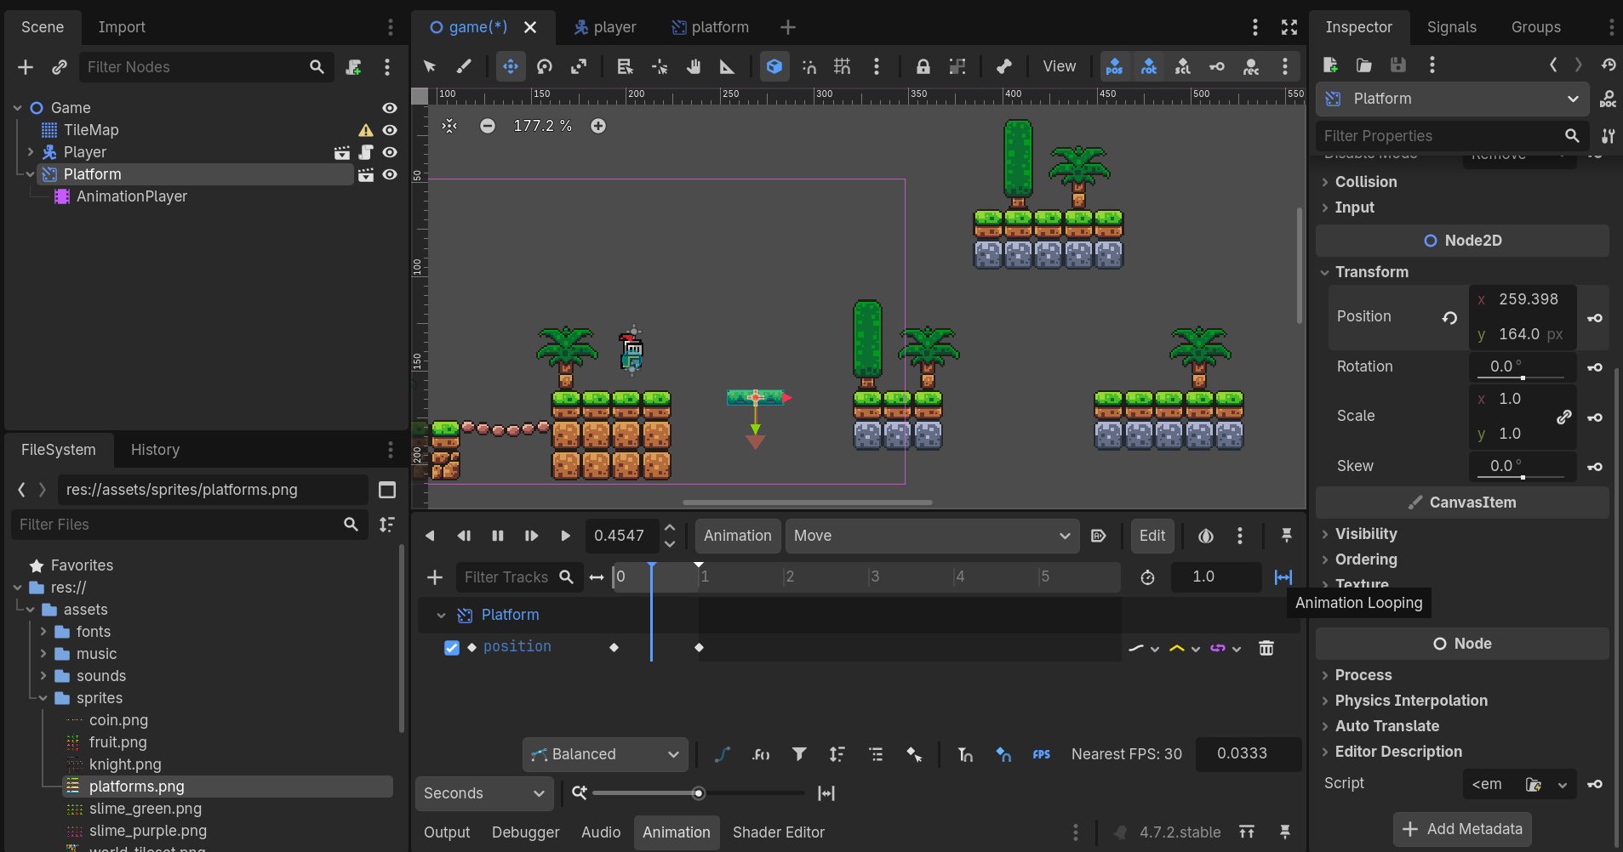
In the animation window we can set the time of the animation delay to be played as well the auto play mode for the animation -> select the platform -> animation -> enable Autoplay On Load
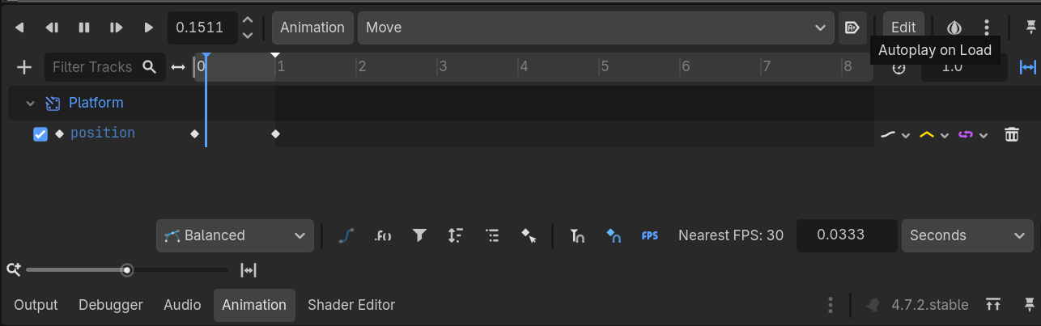
Pickables
Create an new scene -> new node “Area 2D” -> add node “Animated Sprite 2D” -> Animated Sprites -> Inspector add “New Sprite Frames”
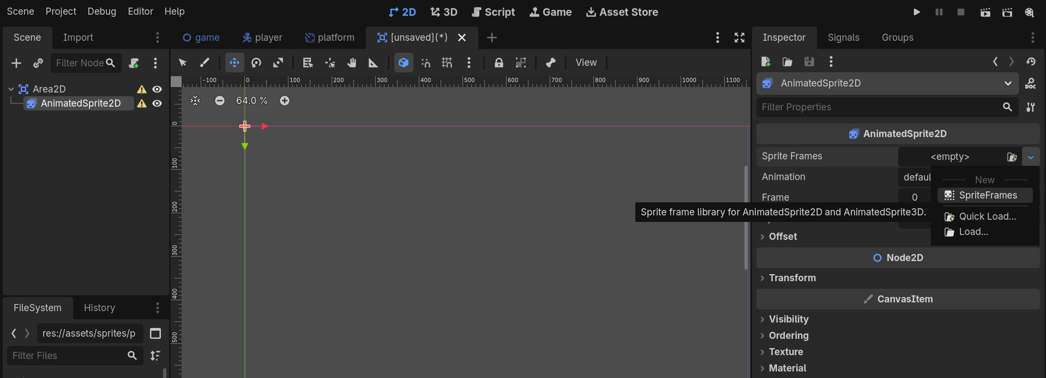
Now add the frames to the animated sprite 2D
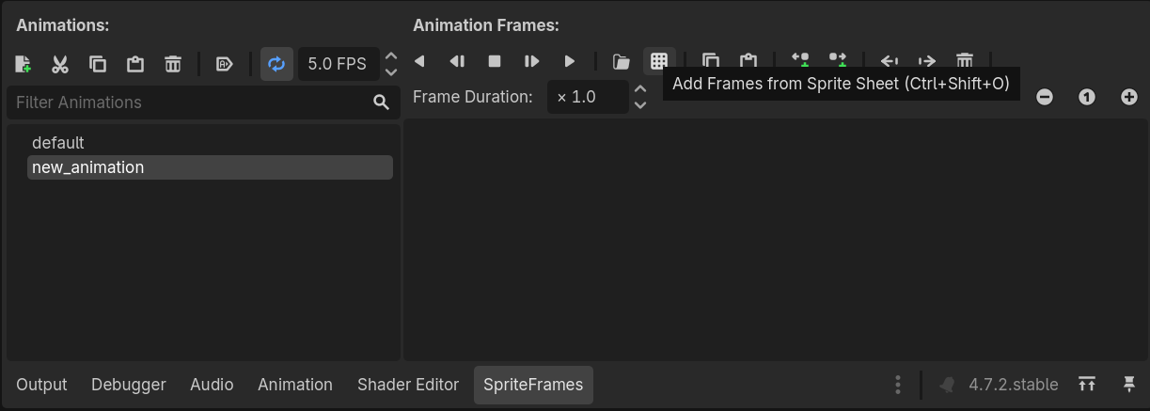
Add the frames
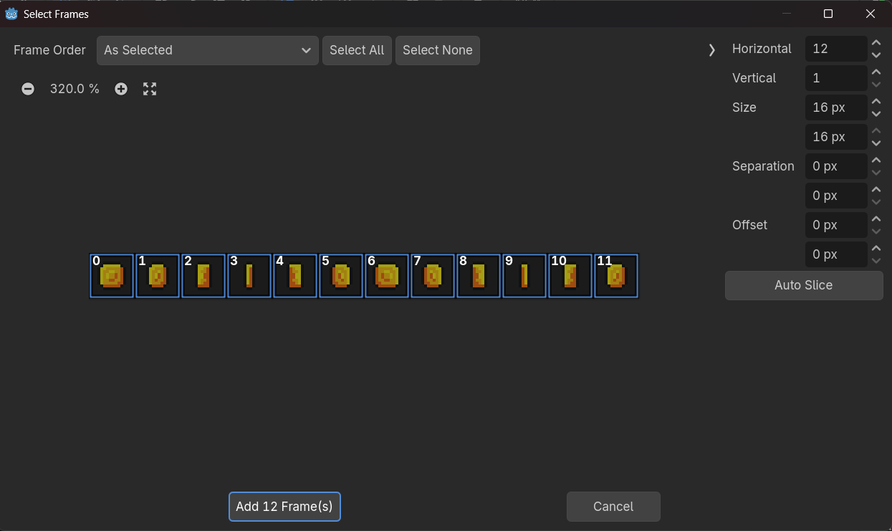
Make the animation autoplay & loop
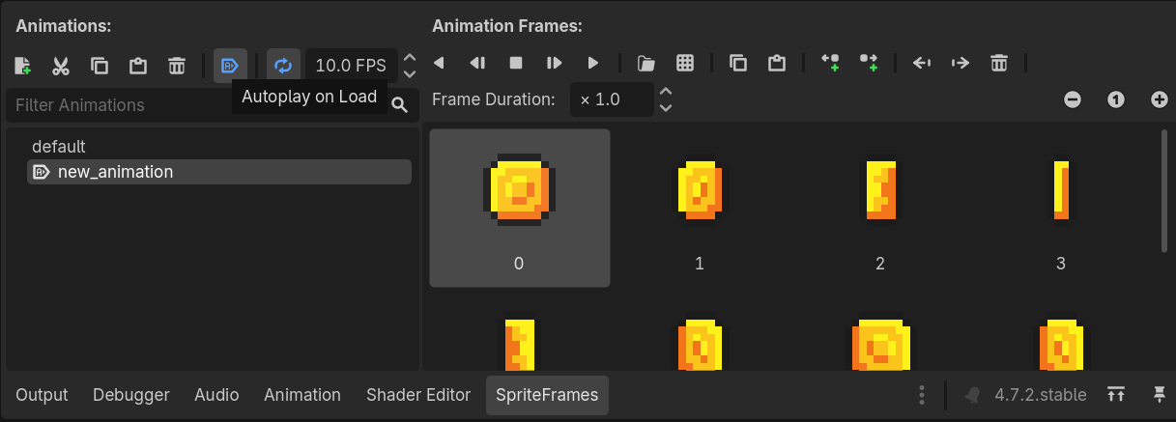
For physics add node collision shape 2d -> inspector Shape : CircleShape2D
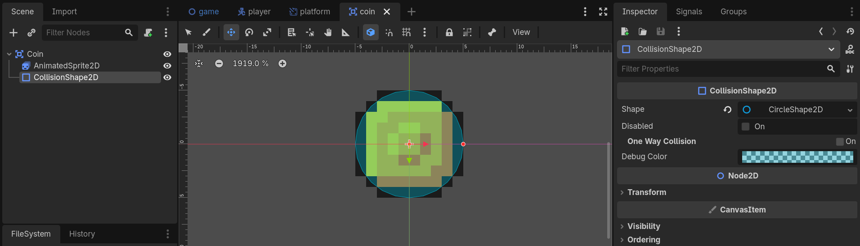
Now create a new script for Coin -> Template : Default

