Unity CI/CD
https://youtu.be/gUZ9YXrJOAo
Usage of CI/CD
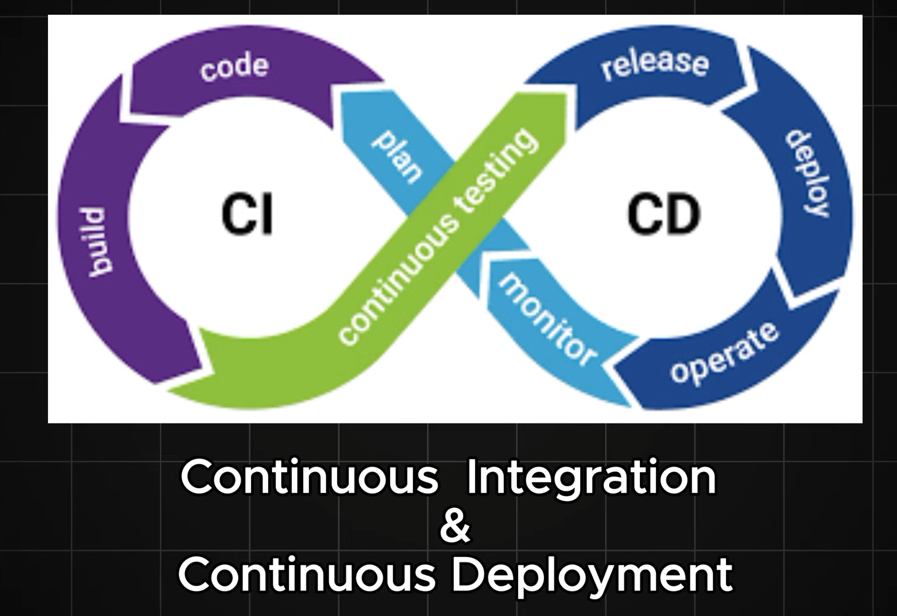
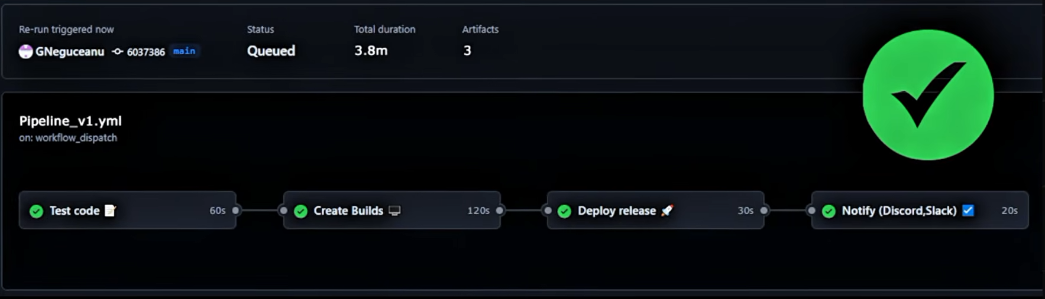
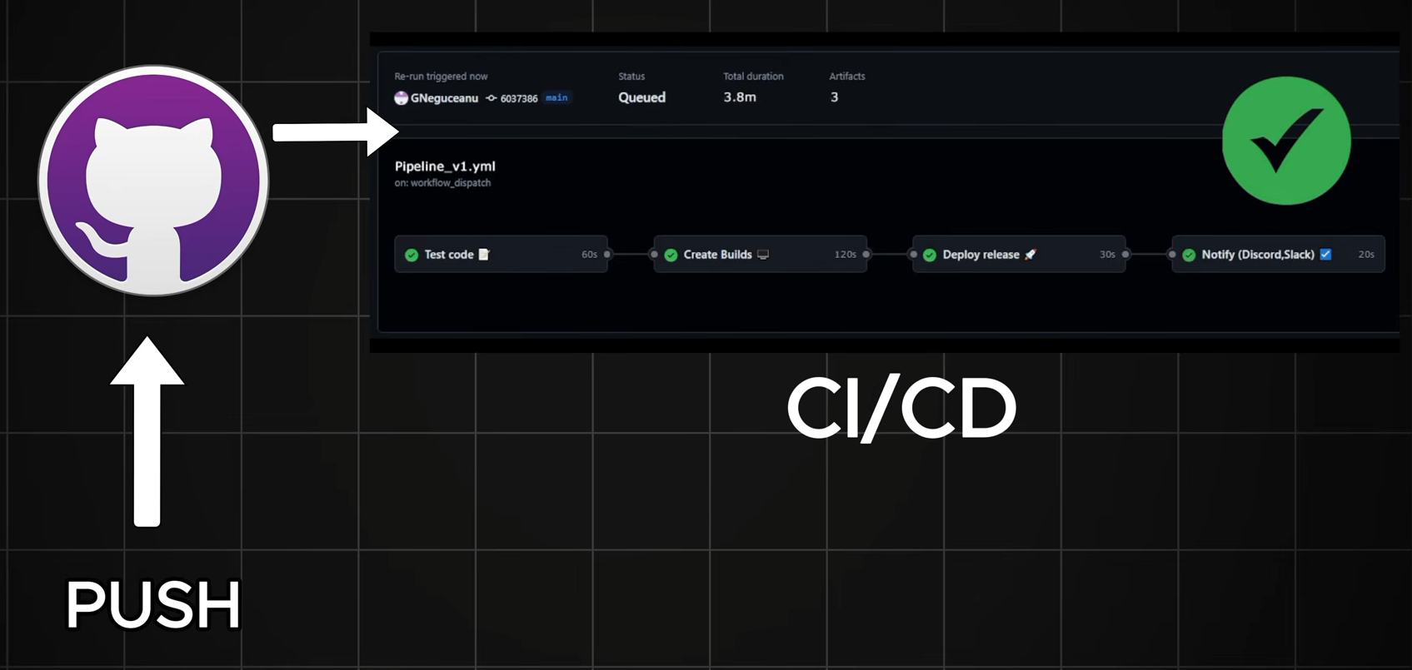

Implementing CI/CD there are couple of options
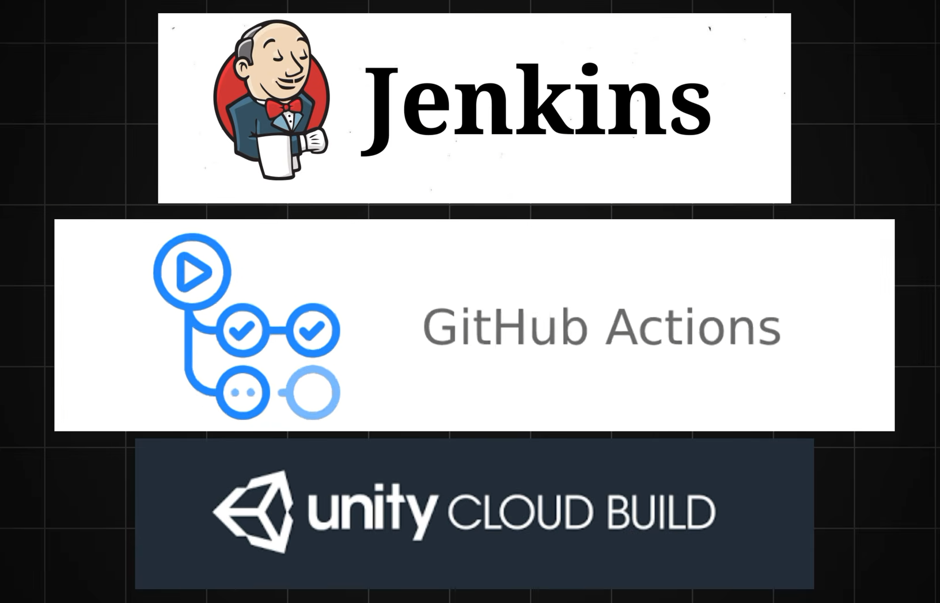
Github Actions
There are three major key components of github actions
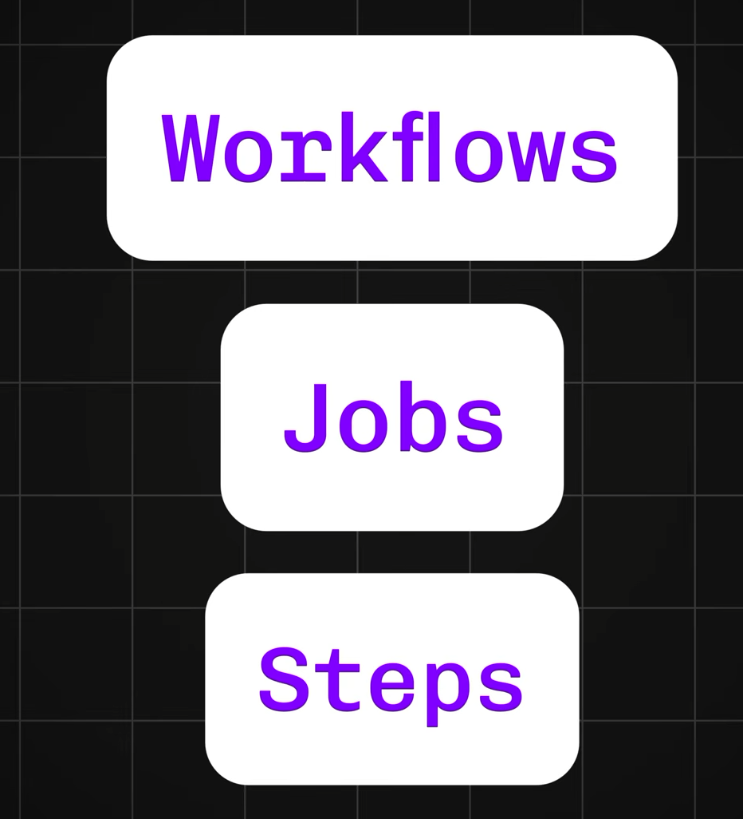
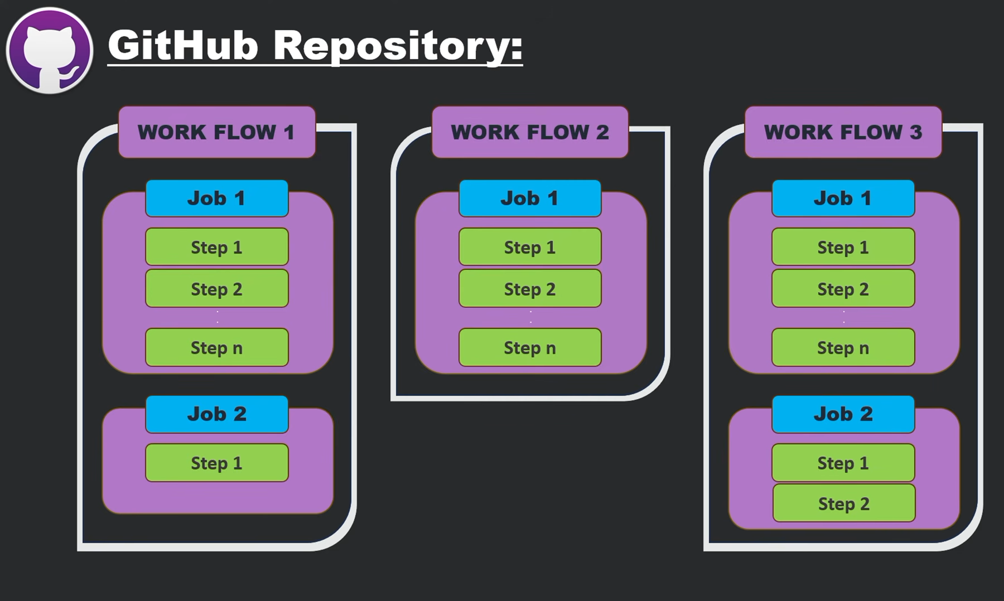
Work Flow – Alternative Task attached to the github repository [Over all process & handles automation]
Jobs – Describing the major tasks [Testing / Deploying]
Steps – Triggering some actions [Downloading the code + installing necessary library]
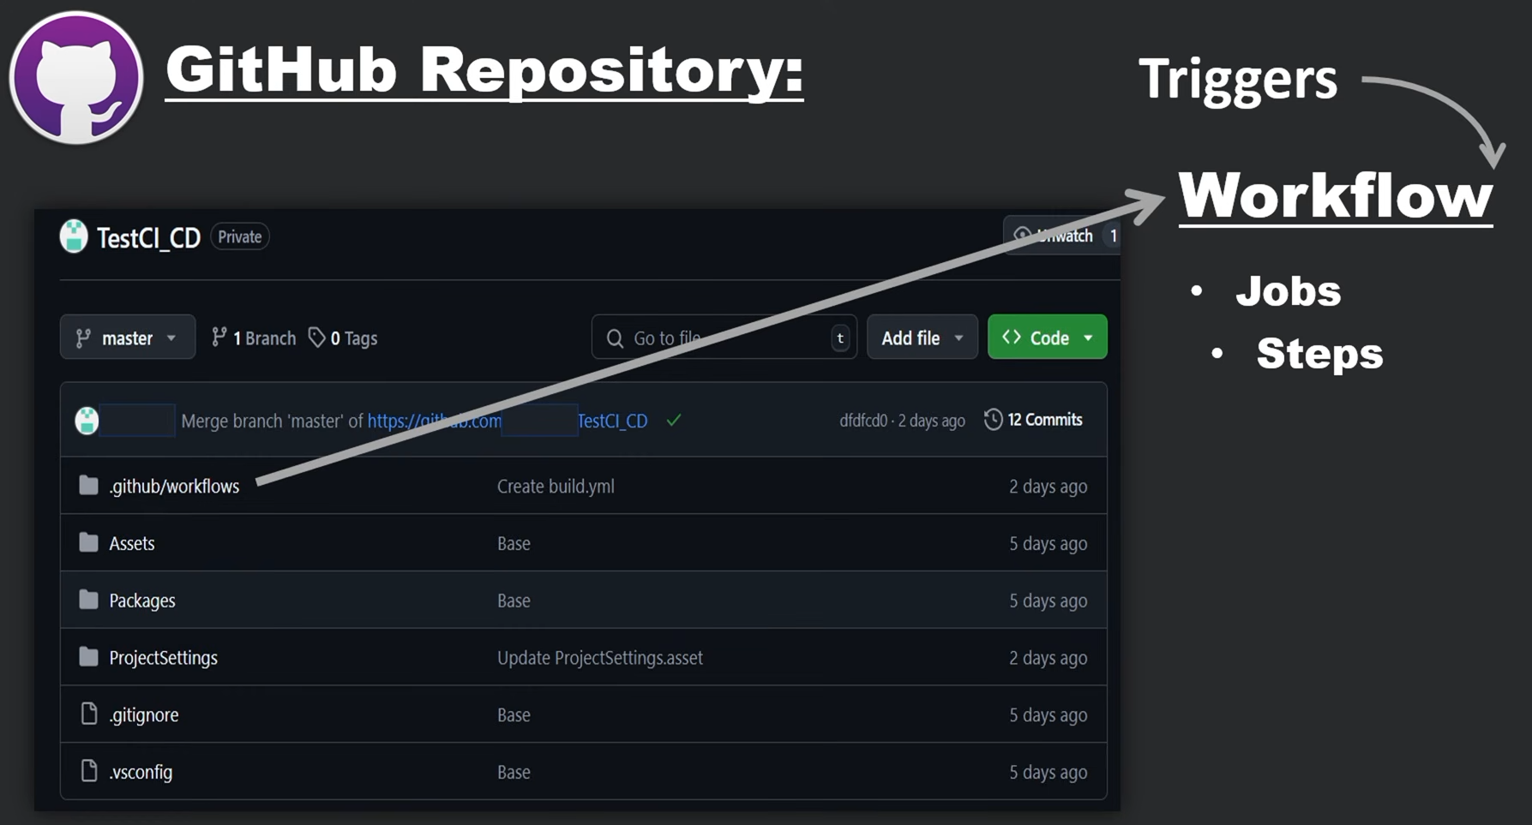
create a repository in the github & add a unity project 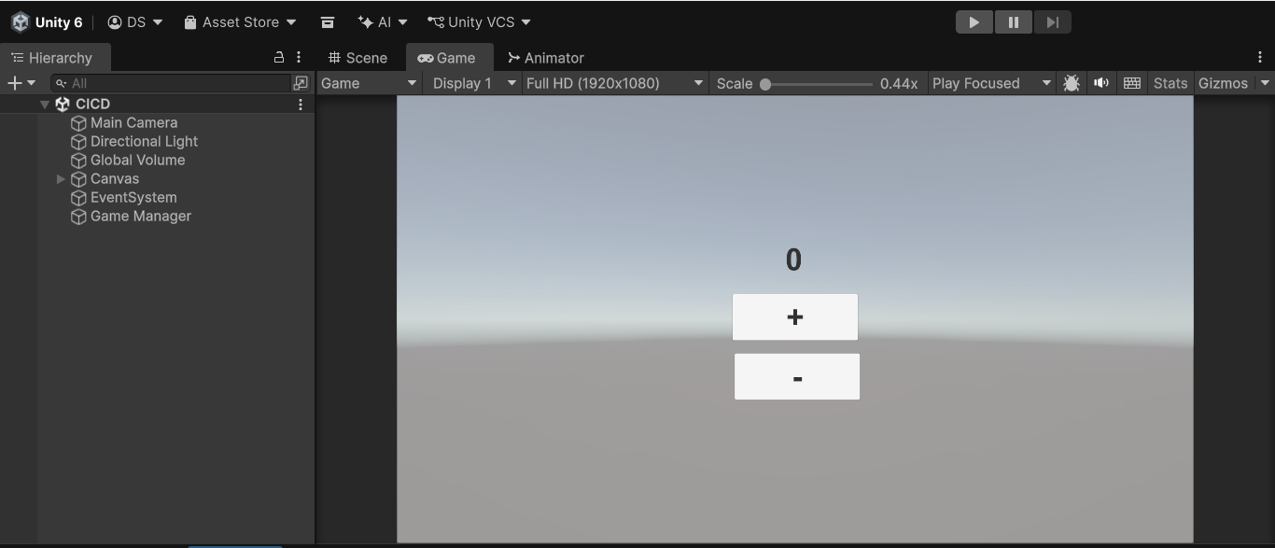
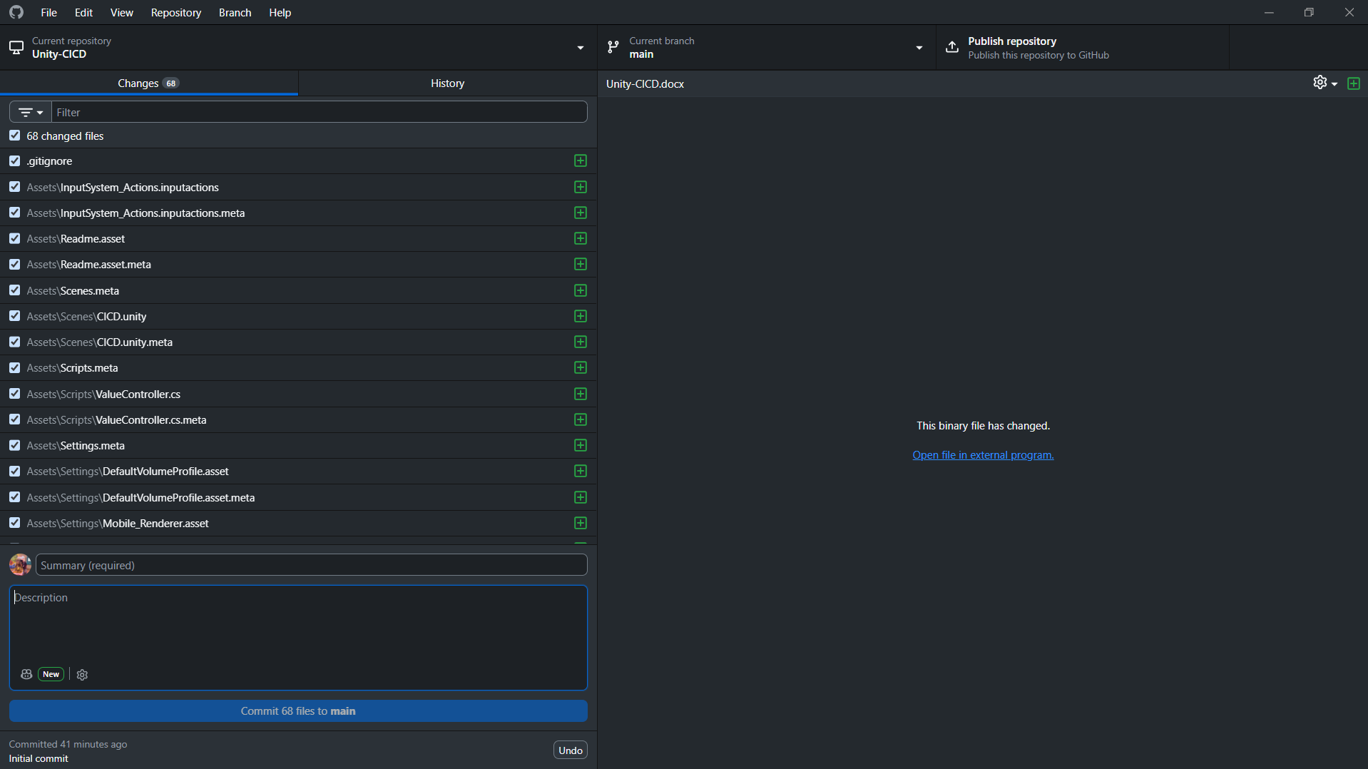
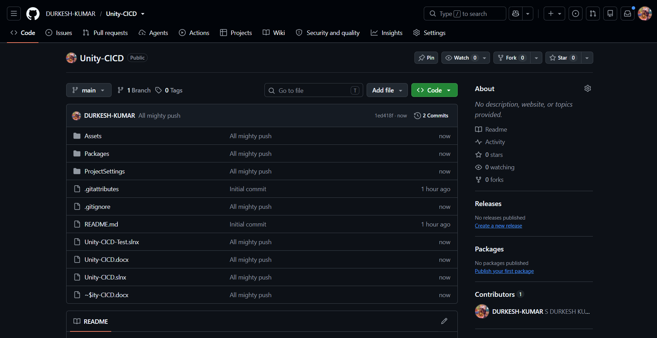
Workflow
Creating the first Workflow -> Actions -> setup the Workflow your self
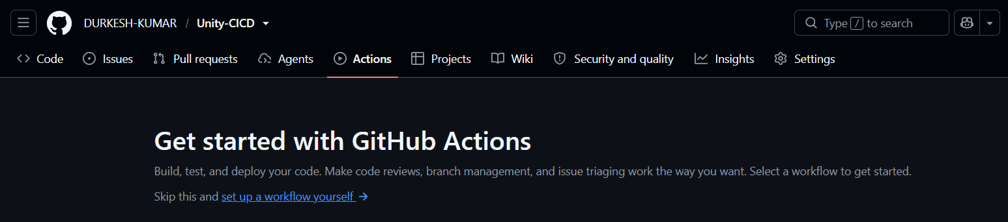
Basic structure of the github actions workflow
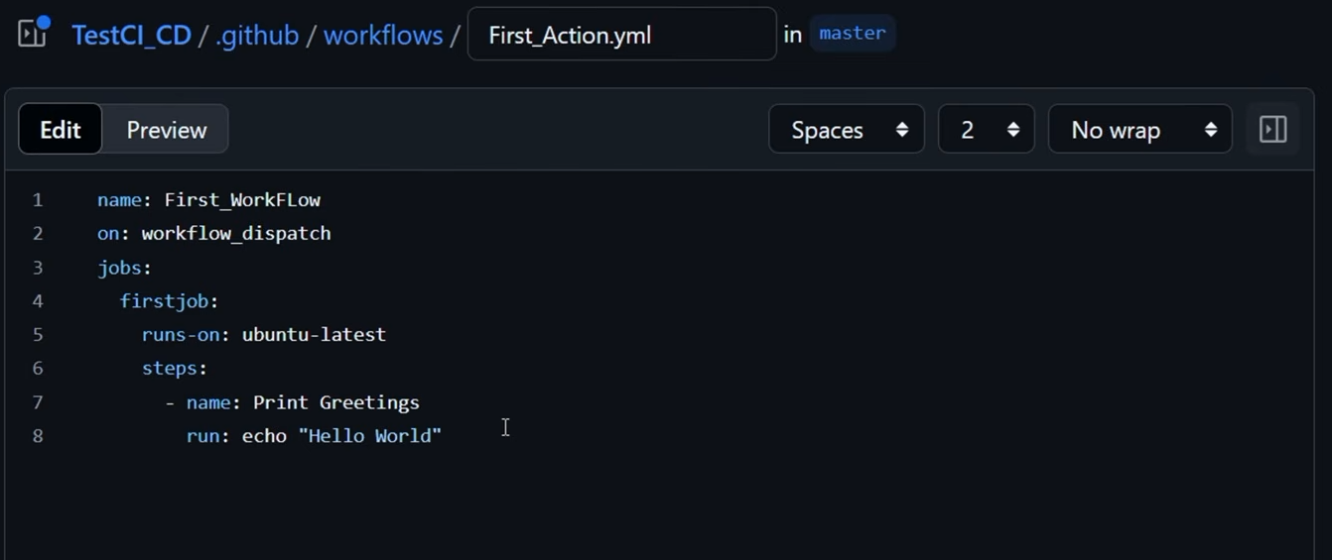
Triggering the workflow -> Actions -> workflow [what we have created] -> run workflow
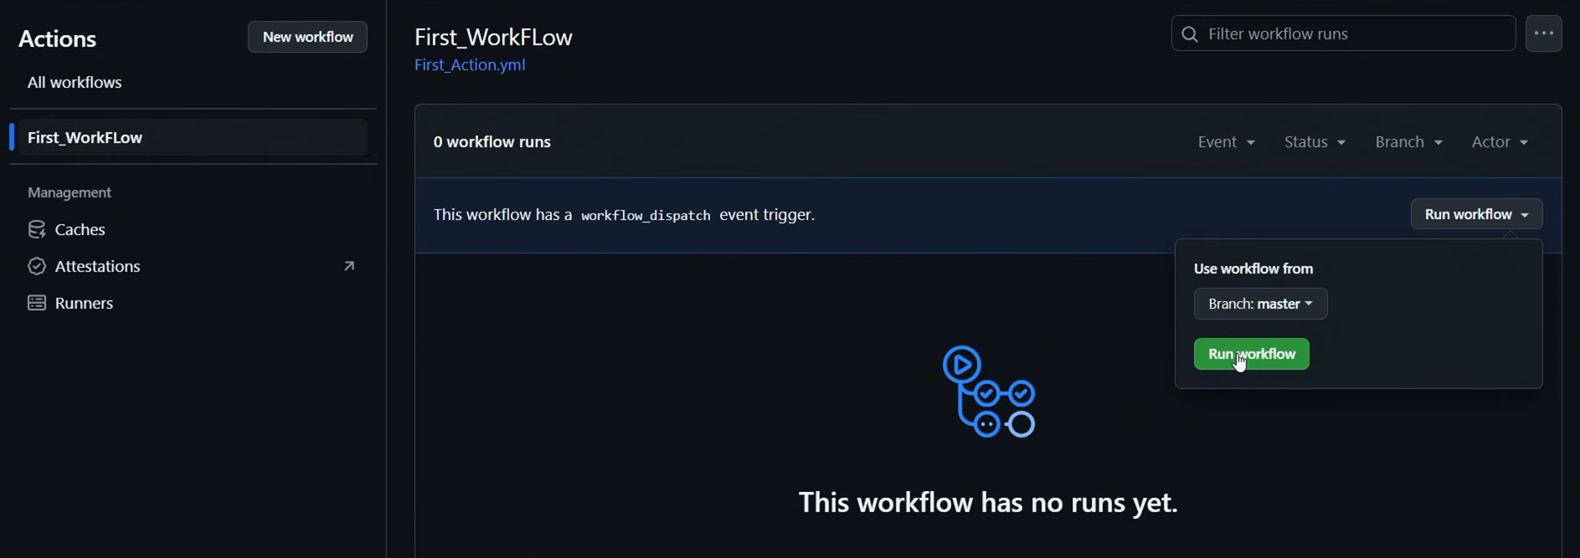
Workflow after succeeded the task
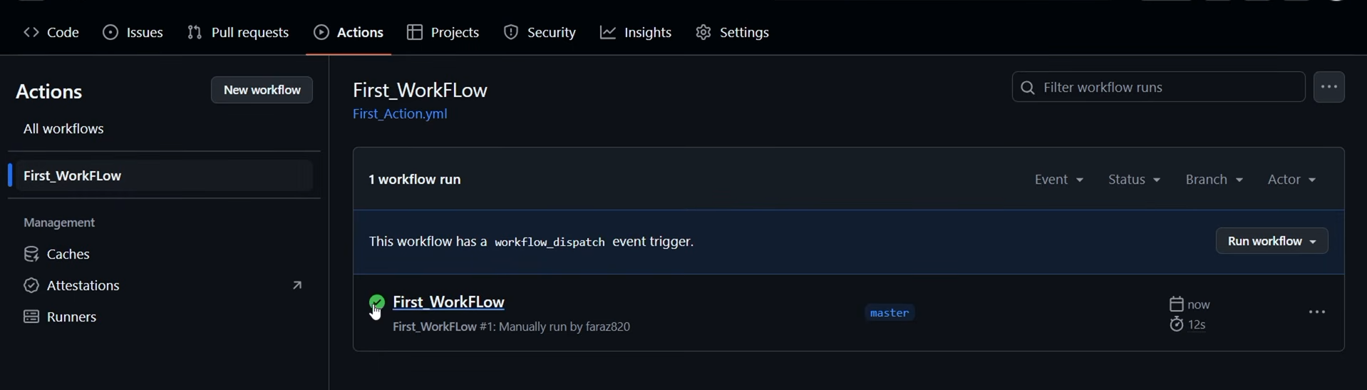
Move to the work flow that what are the task get completed
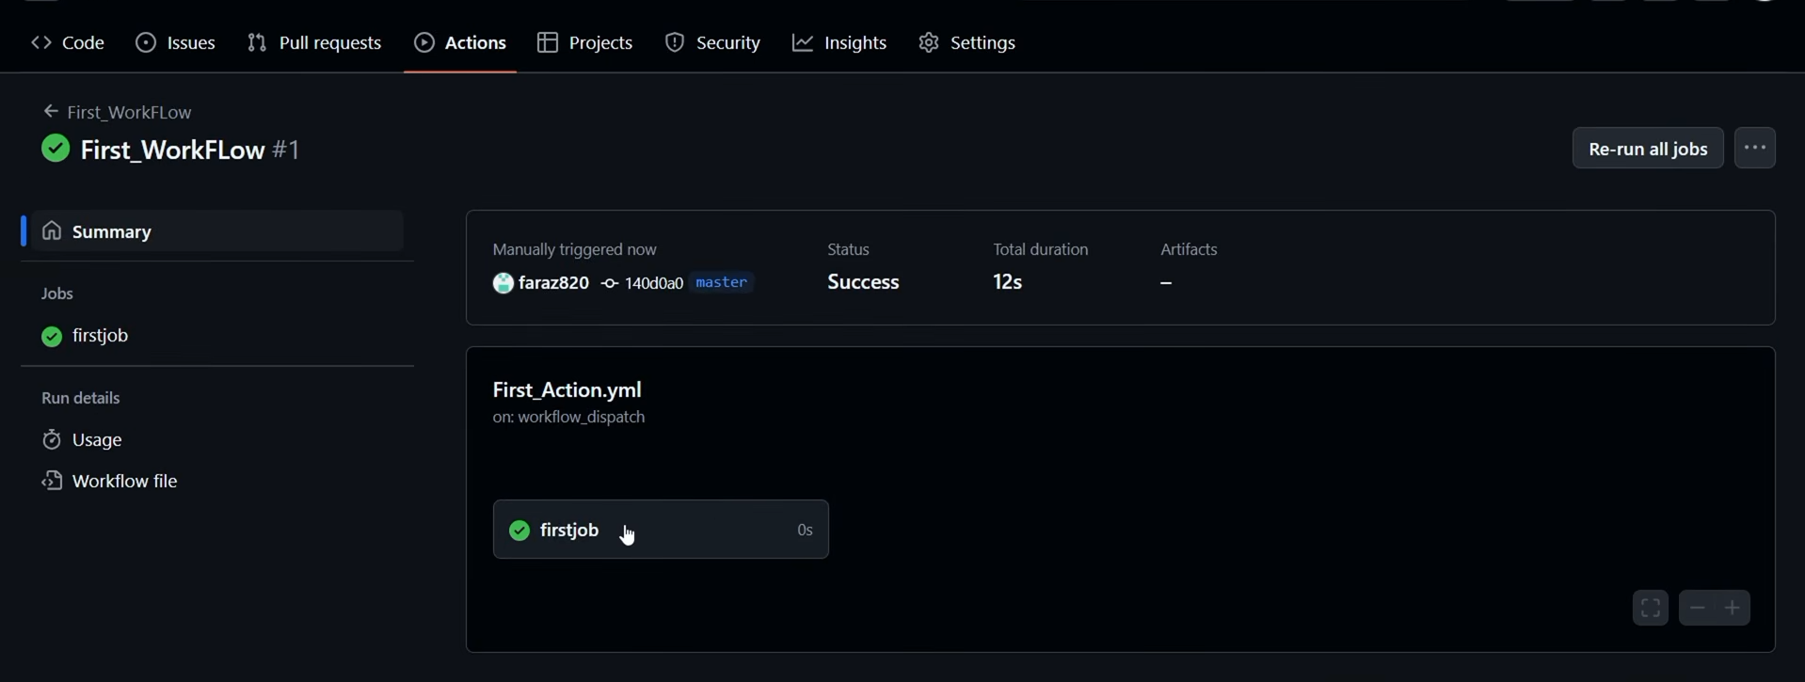
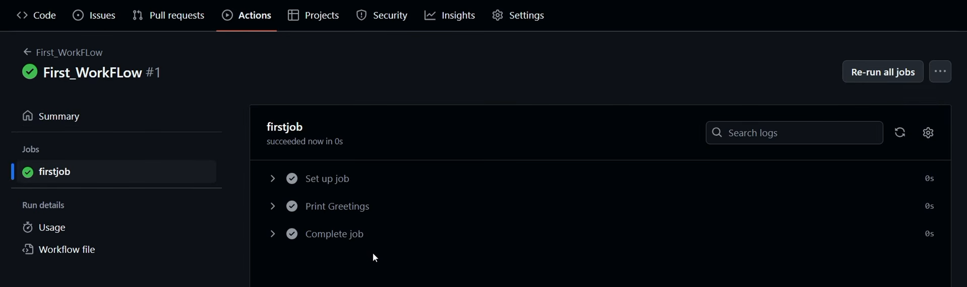
Game CI - https://game.ci/
Game CI is an open source project created by game developers community it helps to automate CI/CD
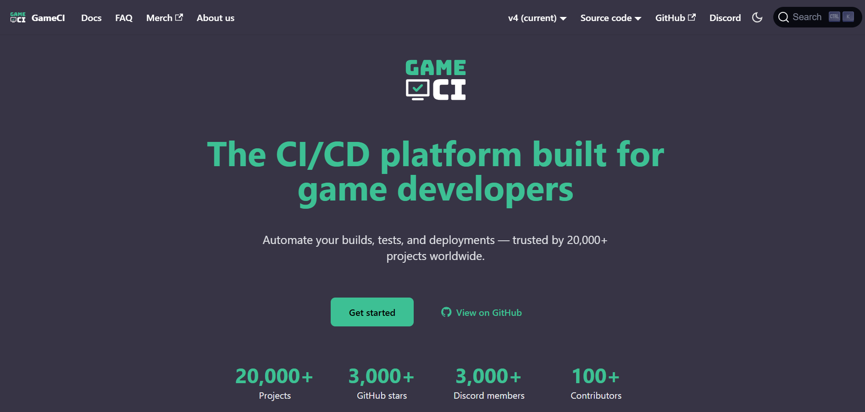
Game CI -> Docs -> Github Default -> Builder
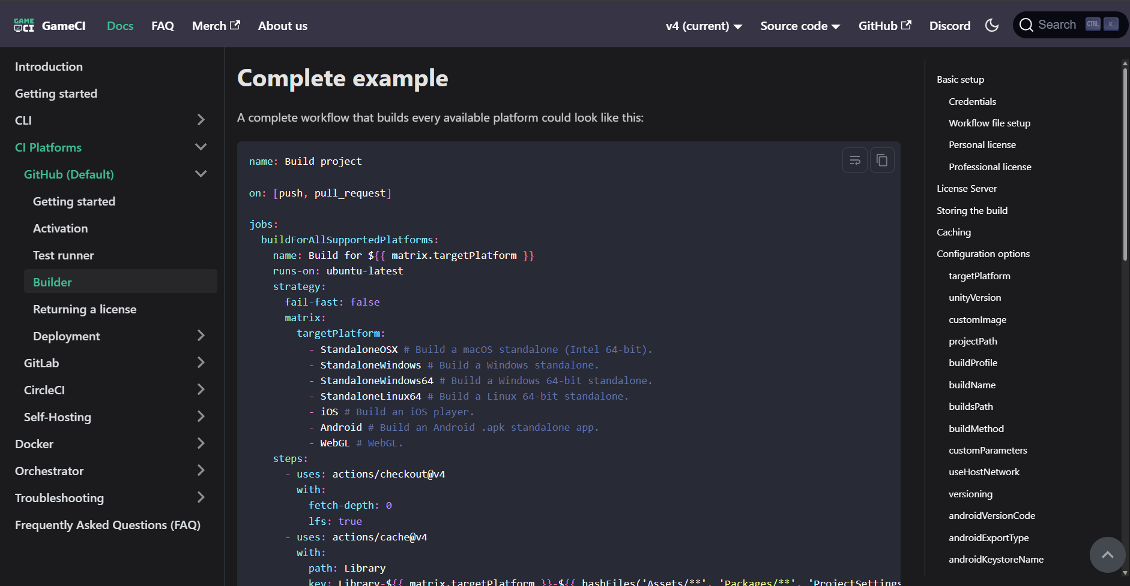
Just copy the Workflow and paste it in the new workflow in the github actions
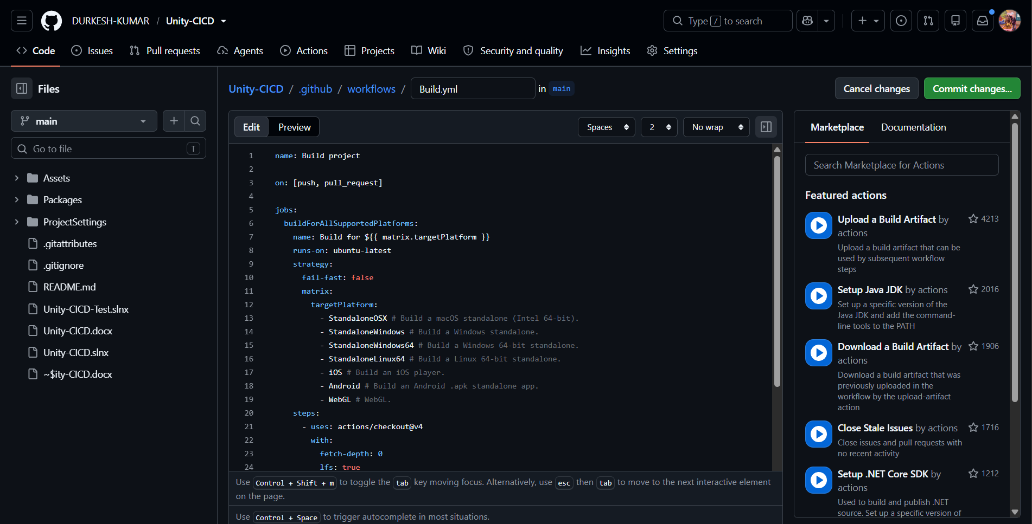
Unity requires the valid licence to verify their users to use the CI/CD setup
To setup the licence -> open Unity Hub -> Unity Licence – Unity_lic.ulf
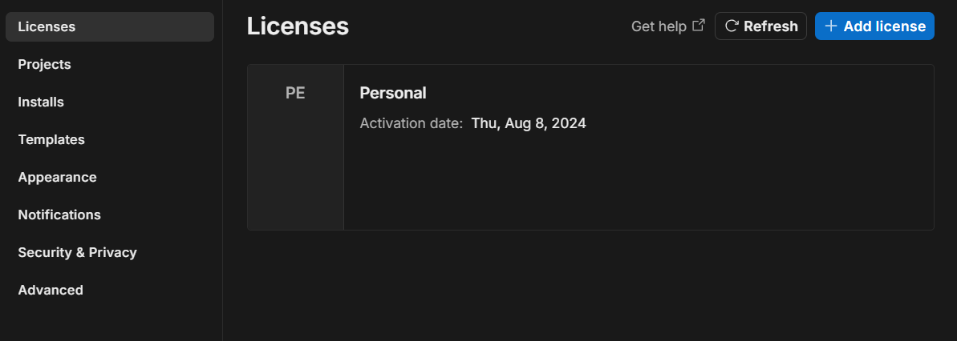
We need to get the Unity_lic.ulf file [C:\ProgramData\Unity\Unity_lic.ulf] which stores the Unity activation/license information so the CI/CD build machine can authenticate Unity and perform automated builds without manual activation.
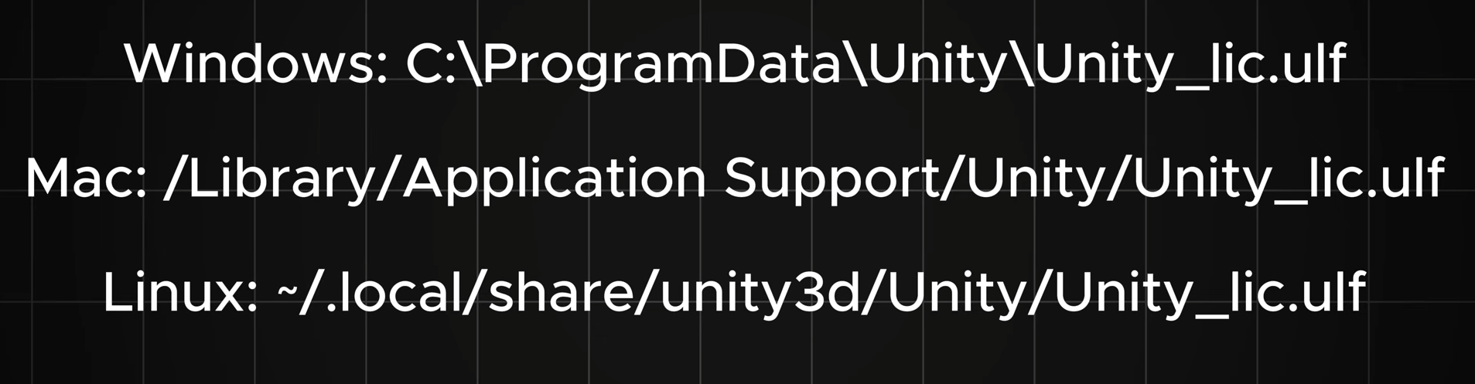
Setting up the Unity Licence for CI
Open github -> settings -> secrets and variables -> actions -> new repository secret -> Unity Licence / email / password
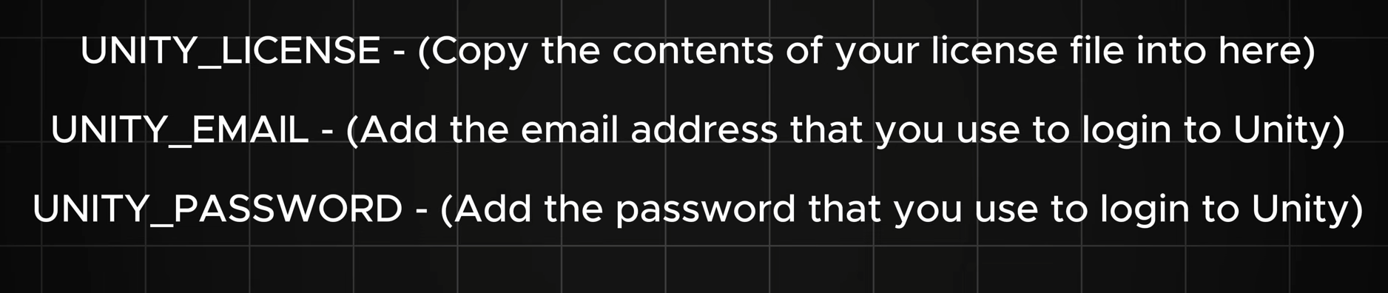
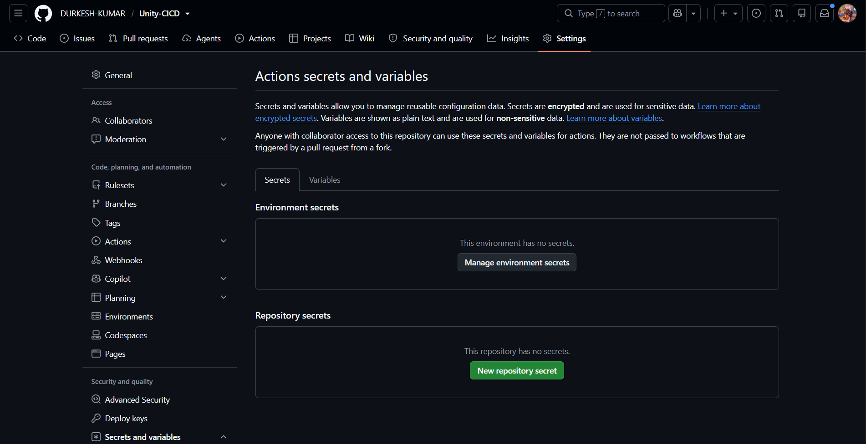
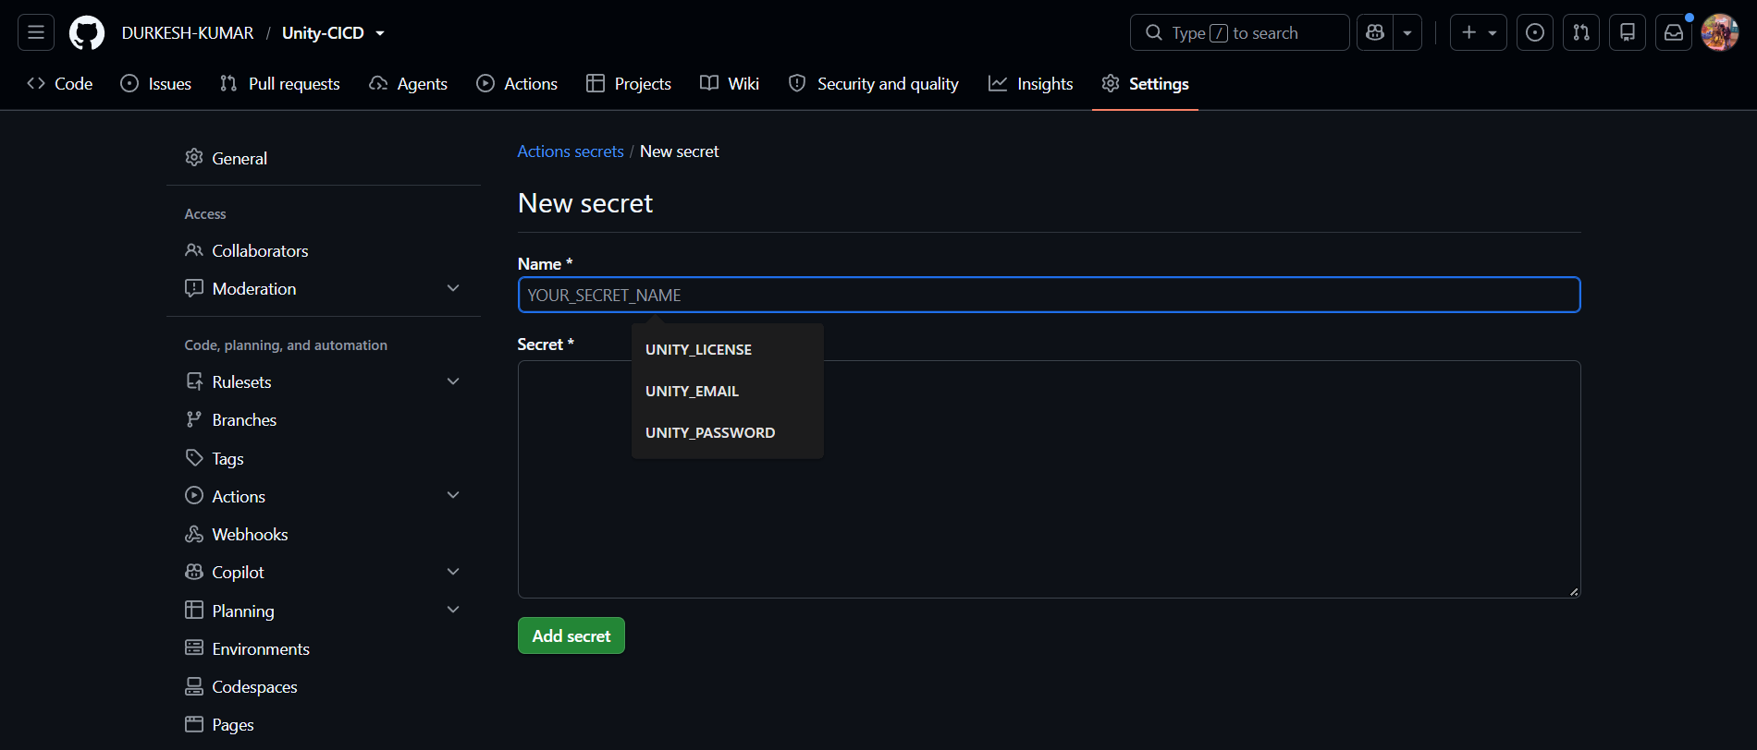
Unity Licence [Unity_lic.ulf]
<?xml version="1.0" encoding="UTF-8"?><root><TimeStamp Value="NhAVIRFi6INbgg=="/>
<License id="Terms">
<MachineBindings>
<Binding Key="1" Value="00342-42909-74813-AAOEM"/>
<Binding Key="2" Value="C83E8_0E_4405EE_01.9"/>
<Binding Key="4" Value="RFgwMDRCS1M="/>
<Binding Key="5" Value="f4:3a:fa:c4:73:02"/>
</MachineBindings>
<MachineID Value="KI6/1npGEbqzleMGe4J9fEXBMgw="/>
<SerialHash Value="0a2df743136b29543103fdf2ebd26843306152f8"/>
<Features>
<Feature Value="33"/>
<Feature Value="1"/>
<Feature Value="12"/>
<Feature Value="2"/>
<Feature Value="24"/>
<Feature Value="3"/>
<Feature Value="36"/>
<Feature Value="17"/>
<Feature Value="19"/>
<Feature Value="62"/>
<Feature Value="60"/>
</Features>
<DeveloperData Value="AQAAAEY0LUU4WDktUUU5Si1IVVNVLUFYMlMtQlNESA=="/>
<SerialMasked Value="F4-E8X9-QE9J-HUSU-AX2S-XXXX"/>
<StartDate Value="2025-04-14T00:00:00"/>
<StopDate Value="2026-11-05T08:18:20"/>
<UpdateDate Value="2026-10-07T07:18:20"/>
<InitialActivationDate Value="2025-04-14T11:42:11"/>
<LicenseVersion Value="6.x"/>
<ClientProvidedVersion Value="2017.2.0"/>
<AlwaysOnline Value="false"/>
<Entitlements>
<Entitlement Ns="unity_editor" Tag="UnityPersonal" Type="EDITOR" ValidTo="9999-12-31T00:00:00"/>
<Entitlement Ns="unity_editor" Tag="DarkSkin" Type="EDITOR_FEATURE" ValidTo="9999-12-31T00:00:00"/>
</Entitlements>
</License><Signature xmlns="http://www.w3.org/2000/09/xmldsig#"><SignedInfo><CanonicalizationMethod Algorithm="http://www.w3.org/TR/2001/REC-xml-c14n-20010315#WithComments"/><SignatureMethod Algorithm="http://www.w3.org/2000/09/xmldsig#rsa-sha1"/><Reference URI="#Terms"><Transforms><Transform Algorithm="http://www.w3.org/2000/09/xmldsig#enveloped-signature"/></Transforms><DigestMethod Algorithm="http://www.w3.org/2000/09/xmldsig#sha1"/><DigestValue>CcsiYrdPN8rcFCiyOX9Ty4umHqE=</DigestValue></Reference></SignedInfo><SignatureValue>WNZpWDKFcOIBp1m3QgUD008cTlaKW0cfwvyvLjzORmLPvDShEXwvk5JWVSz/dwvjSe5MDFv7RrhN
Srjlif/IgtEY3VE9QrEfLyCRsJVPOJ0+SZfNg0VKjLDwRVV+UhRoHlaFMhw0fme70hKV9e5qMc0s
40qS5jGMho89Ya58wf3Pqx0PoSPxVbmpC/gkikyVYne59l2UaQDPi42lcHN+5SPlGdpcfF+AvutG
tMaPqdPhG5fH8bhv8XWxqVMNW5DNS27RzhzCY31Db8Zi+oQ1TWOyhCld9/aGXFdEMsCDh785goBV
5Og8h44s7Dva4/FyxMQ3ZnkHuqdLJ7uOE+1ERw==</SignatureValue></Signature></root>

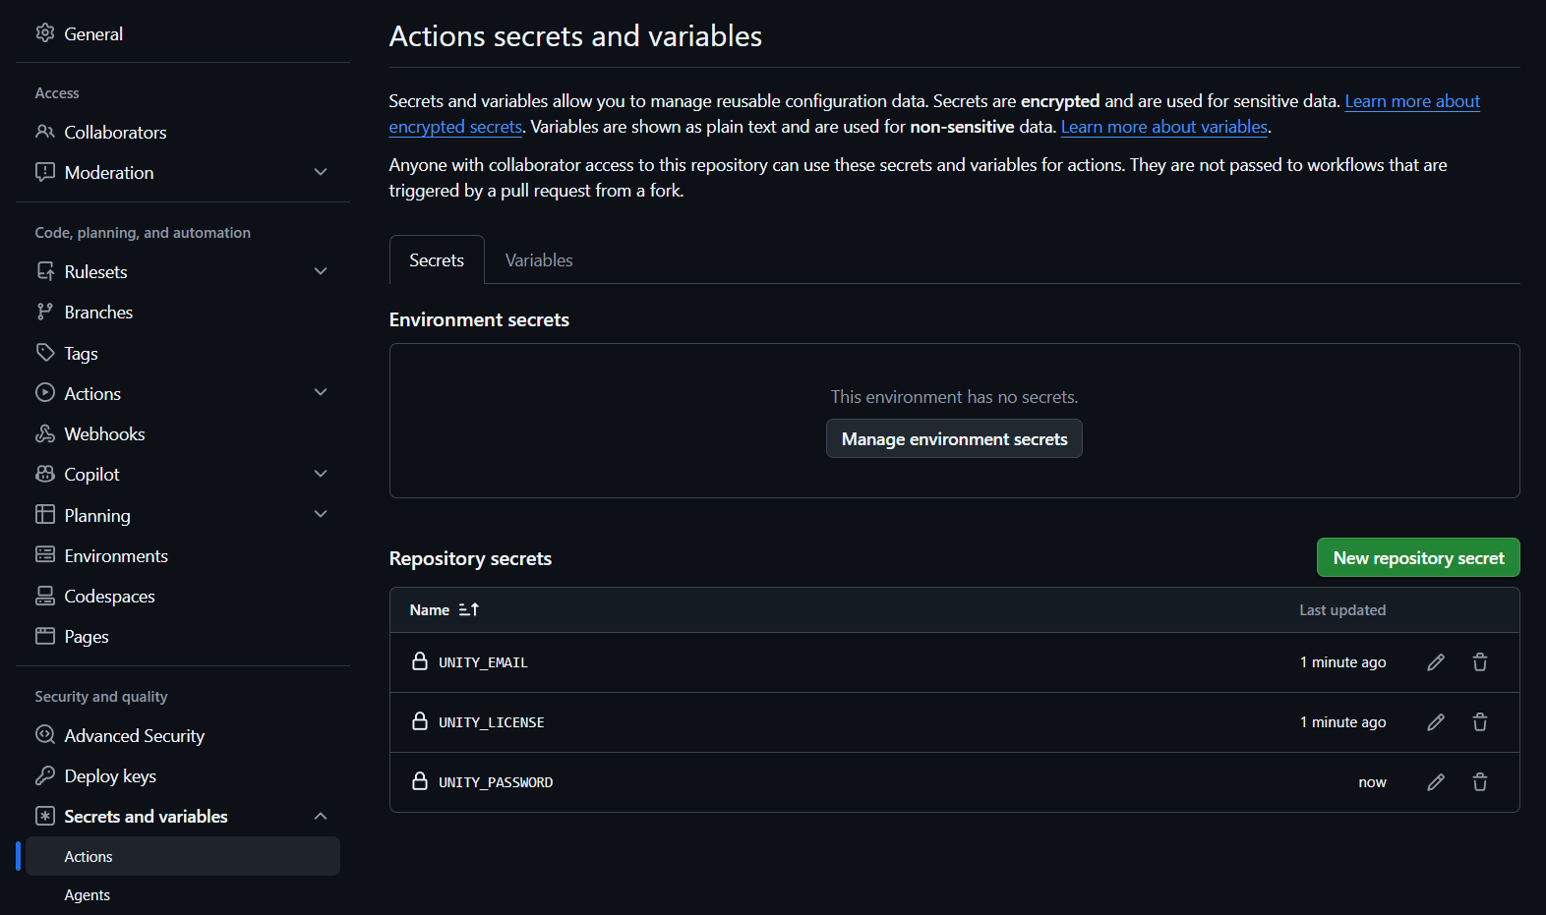
To make some changes in the Workflow file in github action in which when the user push the commit only the build action automatically trigger the build for the particular platform in which we need to specify the platform
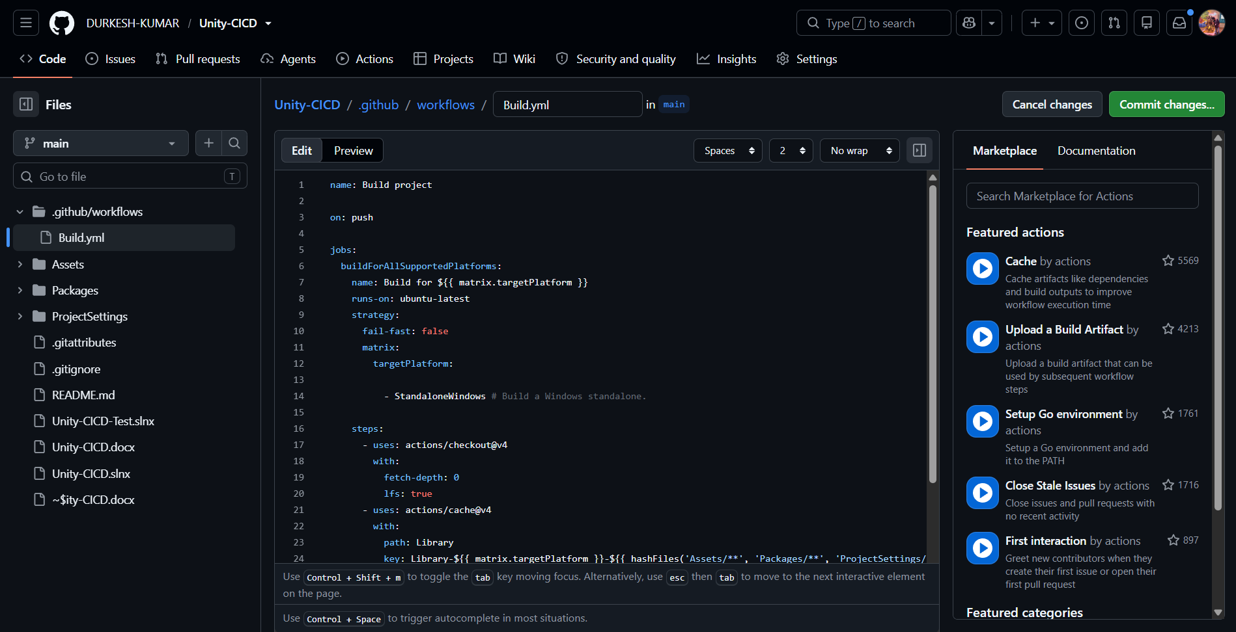
Once done commit the changes and make a push in github

