Modeling Human Activity States Using Hidden Markov Models
Dan Paul Dushime · Machine Learning Techniques II · African Leadership University · 29 October 2026 (individual work)
GitHub repository (dataset, notebook, videos): https://github.com/<your-username>/<repo-name>

1. Background and Motivation

My use case is a phone-only activity tracker for students, to estimate between-study activity minutes and to discover longer periods of inactivity without buying a wearable. It needs to differentiate four states: phone on desk (Still), the student just sitting (Standing), and the “couch potato” extremes of walking and jumping

2. Data Collection and Pre-processing

2.1 Recording protocol
All data was recorded by me using Sensor Logger v1.68. The accelerometer gyroscope and total acceleration were all recorded with nanosecond timestamps. The phone was held at waist level and flat for Walking, Jumping and Standing, and flat on the ground for Still. All activities were recorded 50 times for 5–10s.

Table 1 – Dataset post-cleaning (durations are those measured after trimming)
Activity | Files | Total duration | Mean clip | Video evidence
Still (phone on floor) | 50 | 346 s (5 min 46 s) | 6.9 s | <repo>/blob/main/videos/still.mp4
Standing | 50 | 294 s (4 min 54 s) | 5.9 s | <repo>/blob/main/videos/standing.mp4
Walking | 50 | 398 s (6 min 38 s) | 8.0 s | <repo>/blob/main/videos/walking.mp4
Jumping | 50 | 358 s (5 min 58 s) | 7.2 s | <repo>/blob/main/videos/jumping.mp4

2.2 Sampling rates and harmonisation
Table 2 – Sampling rate
Member | Device | Accelerometer (native) | Gyroscope (native) | After harmonisation
Dan Paul Dushime | Google Pixel 3a (Android 12L) | 50.4 Hz | 100.8 Hz | 50 Hz (both)

Then, for each recorder, we down-sample to a shared fifty Hz time grid, by linear interpolation between points on the interval that all sensors are recorded. Since fifty Hz is the lowest native sampling rate, this does not up-sample the accelerometer (no interpolated points), and since the twenty-five Hz Nyquist frequency of the accelerometer is well above the frequency of any human movement (< twenty Hz), this does not down-sample the gyroscope any course.
Two-point three Cleaning
Sorted by timestamp, duplicate timestamps eliminated. Zero point five is cut off each end of a clip to eliminate the tap that starts/stops recording data. The maximum allowable length of clips is ten seconds. No pause in time stamps was detected, max time gap twenty milliseconds at fifty.
Two-point four Windowing
Features are calculated on windows of one hundred twenty-eight samples (two point five six seconds) with fifty percent overlap (hop of sixty-four samples, or one point two eight seconds). This window length is determined by the fifty Hz sampling rate: two point five six seconds typically contain at least two to four full steps or jumps at a cycle rate of one point five-to-two-point five Hz, so we may obtain a complete sample.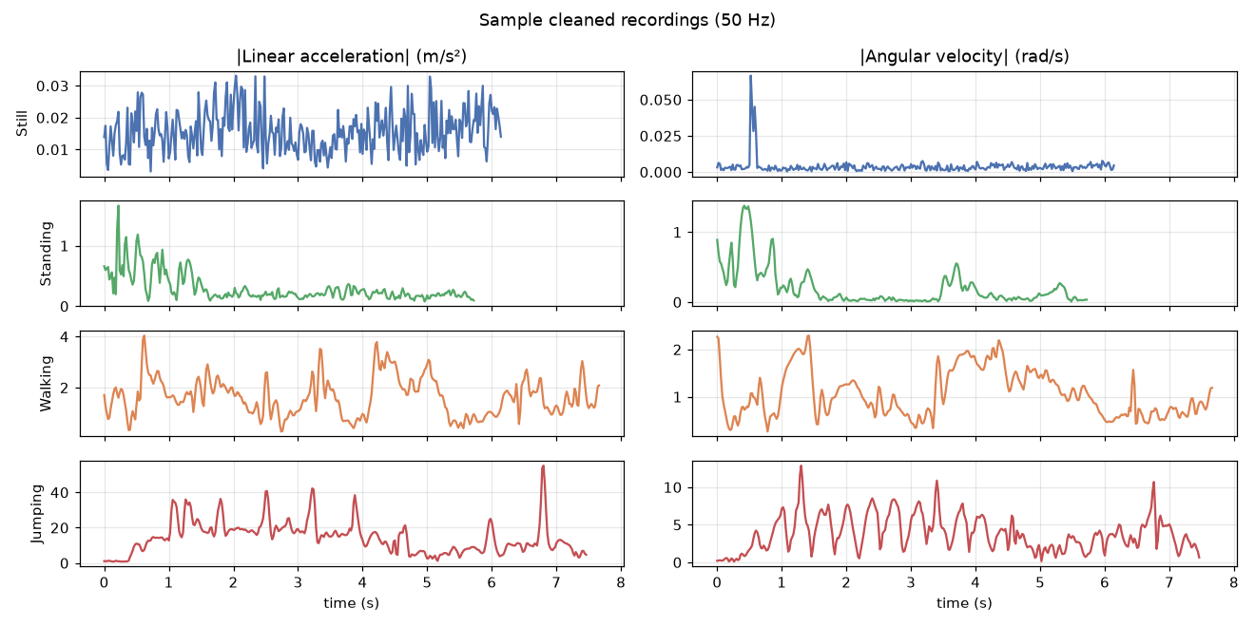
Figure 1 – Cleaned 50 Hz signals: magnitude of linear acceleration (left) and angular velocity (right).

2.5 Feature extraction and normalisation
Table 3 – Extracted features (9 per window: 6 time-domain, 3 frequency-domain from the FFT)
Feature | Domain | Why it separates the activities
acc_std – std of linear-acc magnitude | Time | ≈ 0 when still, small when standing, large walking, very large jumping
acc_sma – signal magnitude area of acc | Time | overall movement intensity, robust to the phone's orientation
gyro_std, gyro_sma – rotation std / SMA | Time | body sway and rotation: zero on the floor, present even when standing
acc_corr_yz – correlation of acc y and z | Time | coordinated vertical/forward motion in jumps and gait vs random noise
tilt_z – gravity on z / |g| (mean) | Time | phone orientation: ≈ 1 when flat (Still, Standing), drops when it swings (Jumping)
dom_freq – dominant FFT frequency | Freq. | step / jump cadence; random for static states
spec_energy – FFT spectral energy | Freq. | energy of the motion: spans 6 orders of magnitude from Still to Jumping
spec_entropy – normalised spectral entropy | Freq. | periodic motion (low entropy) vs sensor noise (high entropy)

The following two things force the features to be more in accordance with the assumption of a Gaussian emission distribution; (1) the android linear accelerations can both have a defined gravity vector (android’s estimate from first startup) removed leading to a very slow decaying offset while the phone remains still, so each axis of each accelerometer is linearly de-trended for every window the intensity features are all log10-transformed as their raw distributions are so heavily skewed. Finally, all features are Z-score normalised so that all features are on the same scale, neither dominating the PCA calculations of the Gaussian distributions, helps the features more Gaussian-like, and unlike min–max scaling is not affected by a single jumping window. As can be seen from Figure 2, the intensity features clearly separated the 4 activities, while dom_freq and acc_corr_yz provide the other two sources of complementary information.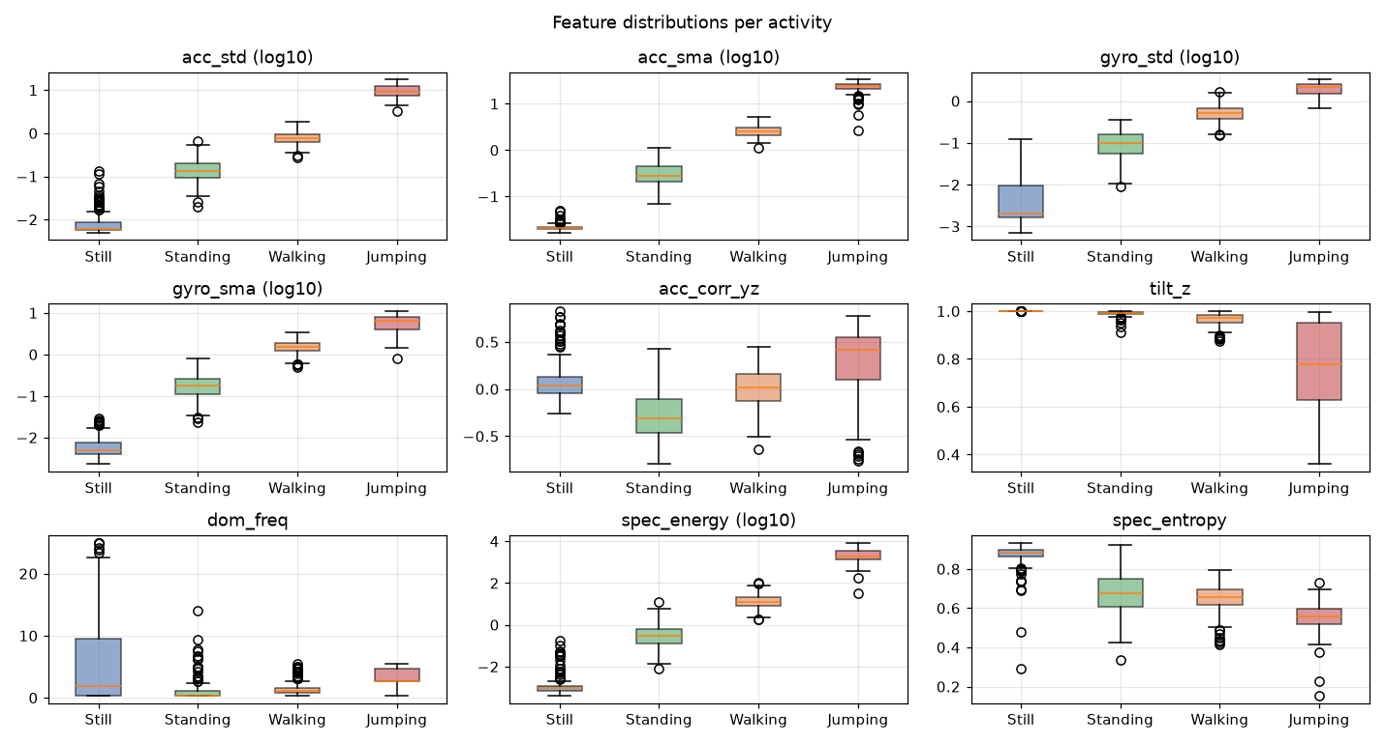
Figure 2 – Distribution of each feature per activity (log10 where noted).

3. HMM Setup and Implementation
Table 4 – HMM components
Element | Definition in this project
Hidden states Z | Still, Standing, Walking, Jumping (K = 4)
Observations X | 9-dimensional Z-scored feature vector of each 2.56 s window
Transitions A | A[i, j] = P(z_t = j | z_t−1 = i) between consecutive windows (1.28 s apart)
Emissions B | multivariate Gaussian N(x | μ_k, Σ_k) per state, full covariance (+0.01·I for stability)
Initial probabilities π | π_k = P(z_1 = k)

Training data for each file, eighty percent of clips were randomly assigned to the training set, leaving twenty percent for the validation set; training windows from the same clip were not assigned to the validation set. Because each clip had only one activity, training clips were concatenated into twenty eight sessions, beginning with Still or Standing, then continuing in the ways in which an activity could change to another phone cannot jump without first being picked up. This gives Baum–Welch actual activity changes to learn A from.

Viterbi decoding gives the best path of states, 1 label per window. These labels can then be used to get sensitivity, specificity and accuracy. It is hard to do to an irrelevant and hard window with Viterbi.

4. Results and Interpretation

4.1 Learned parameters
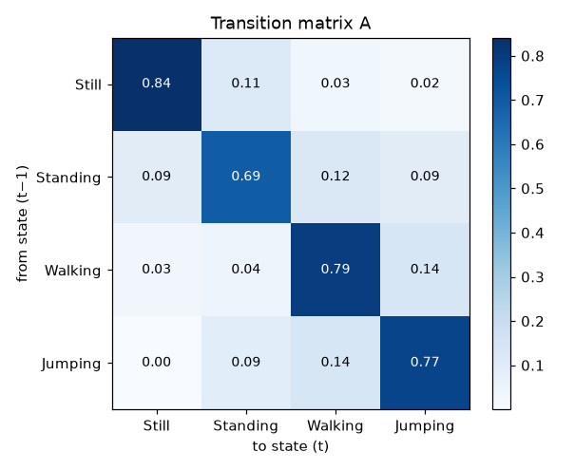 | 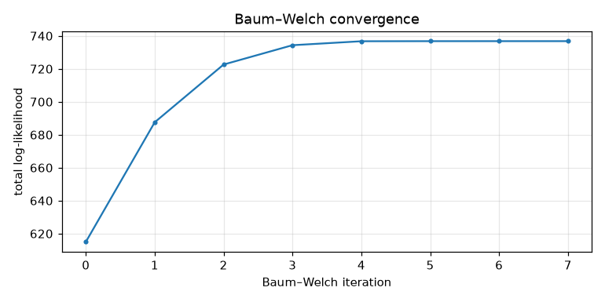
Figure 4 – Learned transition matrix A (left) and Baum–Welch log-likelihood per iteration (right).
notebook).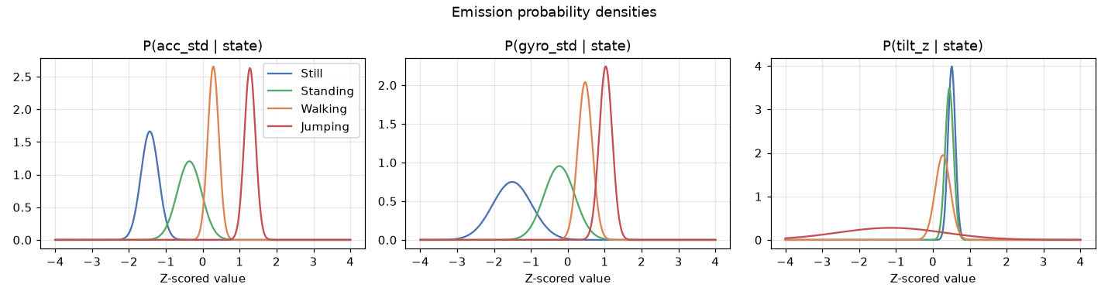
Figure 5 – Emission probability densities P(feature | state) for three key Z-scored features.

4.2 Evaluation on unseen data
In a session separate from the training data, I recorded two continuous sixty-s files, which were not used for training or normalisation. The planned schedule, with segment boundaries fit to the visible transition points in the data; the one to three s phases of picking up or putting down the phone were ignored and not scored.
Table 5 – Performance on the two unseen test recordings (Viterbi decoding)
State (Activity) | Number of Samples (windows) | Sensitivity | Specificity | Accuracy (TP+TN)/N
Still | 18 | 0.944 | 1.000 | 0.986
Standing | 26 | 1.000 | 0.930 | 0.957
Walking | 12 | 0.917 | 1.000 | 0.986
Jumping | 13 | 0.923 | 1.000 | 0.986
Overall | 69 |  |  | 0.957

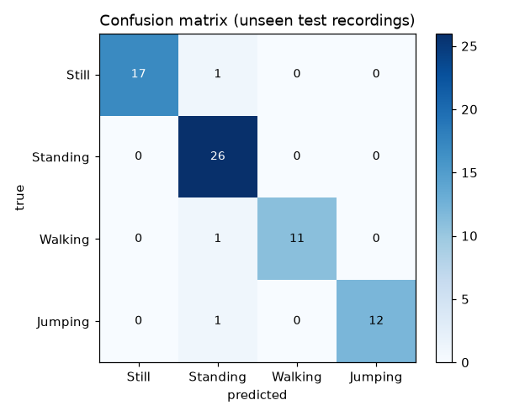
Figure 6 – Confusion matrix on the unseen test recordings (rows: true, columns: predicted).
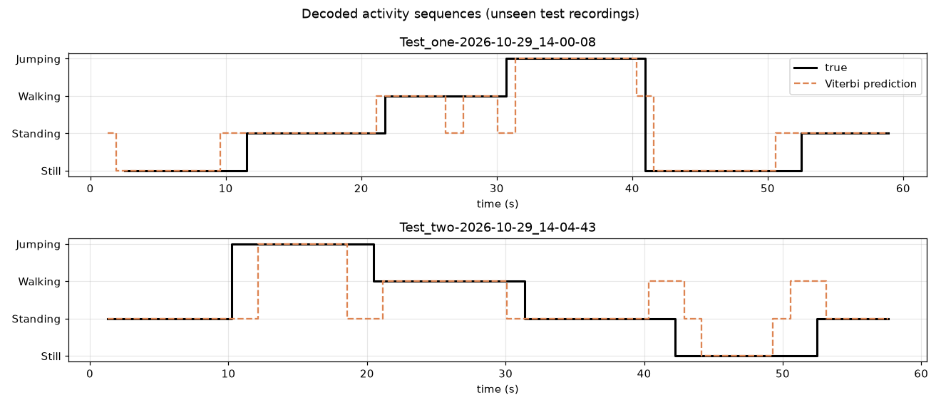
Figure 7 – True (black) vs Viterbi-decoded (orange) activity sequences on the two unseen recordings.

The model shows strong results on new data. The HMM achieves 95.7% accuracy on novel data, with sensitivity of at least 0.92 and specificity of at least 0.93 for each activity on continuous recordings not included in training. Validation on held-out clips results in 100% accuracy, with only 3 out of 69 windows misclassified (all as Standing, see Figure 6). Figure 7 shows the decoded sequence after each activity change (lag 1 window). Initial outcomes were less satisfactory: without detrending, validation accuracy was 76.8% and Still sensitivity was 0.22. This was caused by placing the phone down in Test 1: the linear accelerometer recorded a decaying offset of nearly 1.6 m/s², and the gyroscope showed no movement; these effects did not appear in training clips, so the model did not identify these artefacts and misclassified the segment as Standing. Detrending each window restored accuracy to 95.7%. Because this artefact was not present in the training clips, the estimate is optimistic and ideally should be tested on a third recording.

5. Discussion and Conclusion
- Easiest and hardest: Jumping and Still were easiest: their spectral energies are 6 orders of magnitude apart, and they both have specificity 1.00 (nothing else was ever confusing for). Standing was hardest: Standing overlaps with Still on every intensity feature, and so the 3 unsure windows (a Still window overlapping a pick-up, a slowed-down step of walking, and the beginning of a jump session) all overlay it, giving it the lowest specificity (0.93). Validity of the transition probabilities.
- The big diagonal shows people continuing an activity for a few seconds. The off-diagonals reflect real behaviour: Still → Standing (0.11) is picking the phone up; Standing leads to Walking or Jumping (0.12 / 0.09); Walking and Jumping switch between each other (0.14 / 0.14); and Jumping → Still is 0.00 because nobody puts a phone down mid-jump. The learned stay durations (4–8 s) are much shorter than in real life because they came from 5–10 s clips strung together in a specific sequence. A deployed tracker would need A re-estimated from long, natural recordings.
- Impacts of sensor noise and sampling rate The Android gravity artefact was the biggest error, not noise.

