Eltro MK3 Manual
A Eurorack recreation of the Eltro Tempophon

Table of Contents
Eltro MK3 — Manual 1
What this instrument is 2
Getting sound through it 3
The heart of it: tape speed and drum 3
The rest of the panel 4
Reading the screen 6
Voltage control (CV) 7
MIDI 7
Playing it 8
When something’s wrong 9
At a glance 9

Eltro MK3
A Eurorack recreation of the Eltro Tempophon rotating-head tape machine.

What this instrument is
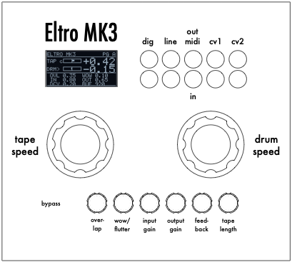
The Eltro MK3 front panel.
In the late 1950s, the German engineer Anton Springer built a remarkable machine in Heidelberg. Labeled as the Tempophon — later also as the “Information Rate Changer” or simply the “Springer machine” — it did something no tape recorder could: it changed the pitch of a sound without changing its speed, and changed its speed without changing its pitch. For the first time, time and pitch came apart.
It achieved this mechanically. A loop of magnetic tape carried the recorded sound past a spinning drum with four playback heads, set 90° apart so that one head was always in contact with the tape. As the drum turned, each head swept a short stretch of tape, handed off to the next, and lifted away. By running the tape at one speed and spinning the head drum at another, the machine read the recording at a relative speed — repeating little tape segments to stretch time, dropping them to compress it, all while pitch was controlled separately by the head motion.
If that sounds otherworldly, it is: the Tempophon gave HAL 9000 his voice in Kubrick’s 2001: A Space Odyssey, most audibly as he slows and warbles in the death scene. It was a favourite of musique concrète composers too.
The Eltro MK3 is a faithful electronic digital recreation of that machine, built for Eurorack. It behaves like the original — same controls, same physics, same sound — so this manual describes it the way you’d describe the real thing: a tape loop, a head drum, playback heads riding on tape. The Eltro MK3 version adds things the original never had such as reverse playback, voltage control, MIDI.

How the recreation maps to the real machine
On the original Tempophon | In the Eltro MK3
Loop of pre-recorded magnetic tape | A continuously re-recorded loop held in a ring buffer in memory (“the tape”)
The recording that’s on the tape | Your live audio input, laid down by a recording head as it comes in
Rotating drum with 4 playback heads at 90° | Four playback heads sweeping the tape loop
Tape transport speed | The tape speed control
Head-drum rotation speed | The drum control
Repeating / dropping tape segments to reconcile the two speeds | The same — done seamlessly, with the heads crossfading as they hand off
Once you picture the tape loop and the spinning heads, the controls explain themselves.

Getting sound through it
- Patch an audio source into line in.
- Patch line out to your mixer or interface.
- Set the bypass switch (far left) to the active position.
- Bring up input gain until you hear signal, and set output gain to taste.
- Set tape speed just around +1.00 and drum near 0.00. You’ll hear your sound played back off the tape loop.
- Slowly turn drum. The pitch shifts while the sound keeps moving through the tape at the same rate. That separation — pitch moving while time holds — is the whole trick the Tempophon was built for.
If nothing comes through, see the When something’s wrong section at the end.

The heart of the Eltro MK3: tape speed and drum speed
Everything the instrument does comes from two speeds: how fast the tape loop runs, and how fast the head drum spins. What you hear is the difference between them — exactly as on the original machine.
Picture it physically: the tape carries your recording past the heads. If the heads spin with the tape at a matching speed, they stay over the same point and the sound stands still. If they move against the tape, they read across it faster or slower than it was recorded, and the pitch shifts.
- Tape speed — how fast the tape loop runs past the heads. This is your time control: how quickly you travel through the recording. Centre detent = the tape is stopped. Turn one way for forward motion, the other for reverse.
- Drum speed — how fast the head drum spins against the tape. Together with tape speed, this sets the pitch. Centre detent = drum stopped.
What you hear, in physical terms:
Tape and drum | What happens
Same speed | Silence / freeze — the heads ride along with the tape, holding one point. (True at any matched speed, including both stopped.)
Drum trailing the tape by the “recording” amount | Plays back at the original pitch
Far apart | Large pitch shift
Drum spinning faster than the tape | The heads read backwards across the tape — reverse
Tape stopped, drum spinning | You sit on one spot of the recording while the pitch sweeps around it
Tape running, drum near centre | You scan through the recording at close to natural pitch
The two big controls are worth living on. Small moves near centre give musical, speech-like inflections (this is how HAL was made); large moves give dramatic sweeps, freezes, and reversals.
The screen shows both speeds with a bar for each. Little letters or symbols may appear beside them — see Reading the screen.

The rest of the panel

Bypass (far left)
Switches the effect in and out; in bypass you hear the dry input. Note that the recording head keeps laying sound onto the tape loop even in bypass, so when you switch the effect back in, the heads pick up on live, current sound last recorded.

The performance controls (Page A)
Left to right across the panel:
Control | What it does, in tape terms
Tape speed | Speed of the tape loop past the heads — the time axis (see above).
Drum speed | Speed of the head drum — sets pitch against the tape (see above).
Overlap | How much neighbouring playback heads blend as they hand off the tape from one to the next. Low = a harder, choppier handoff you can hear; high = a smoother, more washed blend. Higher overlap trades a little sharpness for smoothness — see the note below on how that plays differently when stretching vs. compressing time.
Wow | Adds the gentle speed wobble of real tape — the wow and flutter of a mechanical transport. 0 = steady; up = vintage warble.
Input gain | Level of the sound being laid onto the tape. Bring it up if the input is quiet.
Output gain | Overall output level.
Decay | How long sound persists on the tape loop. The recording head blends new input over what’s already there, so with decay up, earlier passes repeat and fade like a tape echo, building and smearing. Low = the tape wipes clean each lap; high = long feedback tails.
Tape length | How much tape is on the loop — from a very short loop up to about 20 seconds. A short loop is tight and immediate; a long loop gives you more recorded material to roam through.

Head-segment size and drum range (Page B)
A second page holds setup controls you’ll set once and mostly leave. Reach it by serial command p or MIDI CC65 (see below). The knobs use pickup mode: turning a knob does nothing until it passes the stored value, so nothing jumps when you arrive. The bottom of the screen shows which knobs are “live.”
The two most musical Page B controls:
- Segment length — how much tape each head reads before handing off to the next: the length of the tape segments the machine repeats or drops. Short segments sound textured and buzzy; long segments sound smooth and fluid. A recommended default for starting out is around 40ms. This is a major tone control, working hand in hand with overlap.
- Tape range and drum range — how far the tape-speed and drum-speed knobs reach on Page A. Widen them for extreme sweeps, narrow them for fine control.
The remaining Page B knobs configure CV and MIDI, below. Everything on Page B is saved and remembered when you power off.

Reading the screen
The main page shows the current tape speed and drum speed, each with a bar. A small marker may appear beside them:
- c — a CV input is set up to move that control (see CV).
- › (a small right-arrow) — that control is currently being driven by MIDI; the physical knob is ignored until you turn it (see MIDI).
The speed numbers show the actual speed in play, including any CV — so you can watch a patched voltage source move them in real time.
The two screens you’ll see — the performance page (Page A) and the setup page (Page B):
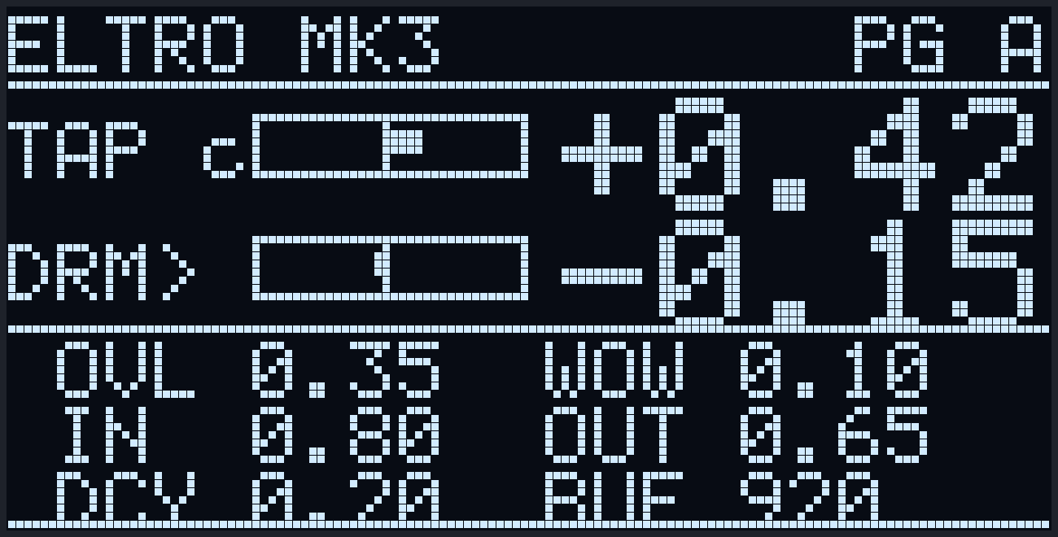
The performance page (Page A): tape and drum gauges with their live speed values on top, and the six secondary controls below. Here a › marks the drum as MIDI-driven and a c marks a CV armed on the tape axis.

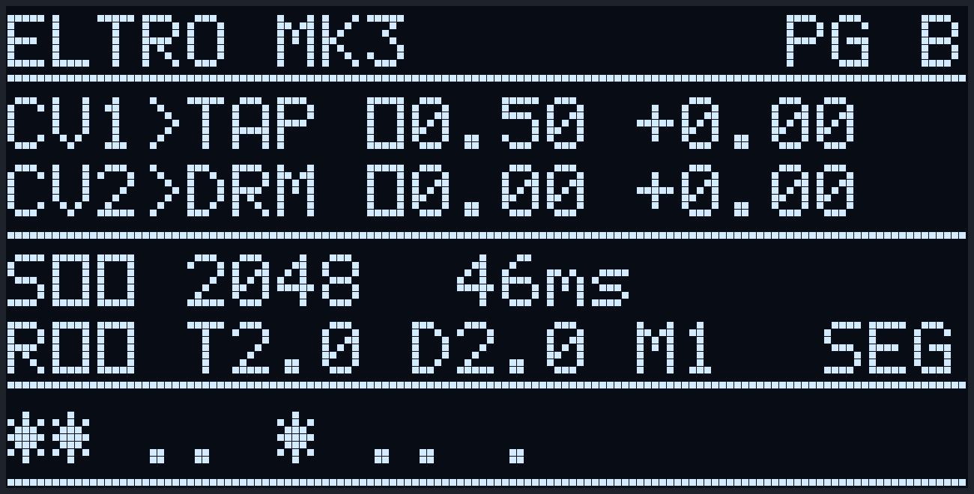
The setup page (Page B): the two CV assignments, segment length, the tape/drum ranges and MIDI channel, and — along the bottom — the pickup markers for each setup knob (*=live, .=waiting).

Voltage control (CV)
Beyond what the original machine could do, the MK3 lets you steer the two speeds with control voltage — patch an LFO, envelope, or sequencer to sweep them hands-free.
- CV 1 moves the tape speed; CV 2 moves the drum.
- On Page B, turn up the CV amount for the input you’re using (and set an offset if you want a fixed shift). At zero amount, CV does nothing.
- When an input is armed, a small c shows beside that control on the main page, and the speed reading moves as the voltage comes in.
Leave the CV amount at zero (page B setting) when nothing is patched to that input — an unconnected input can drift and nudge the speed on its own.

MIDI
The Eltro MK3 both receives and sends MIDI over the two TRS MIDI jacks (in and out), so it fits into a DAW or sequencer rig in both directions. Set the channel on Page B (it’s shown there as M followed by a number); the same channel is used for both receiving and sending.

Receiving (MIDI in)
Drive the Page A controls from a keyboard, sequencer, or DAW. The eight Page A controls respond to these CC numbers on the chosen channel:
CC | Control
102 | Tape speed
103 | Drum
104 | Overlap
105 | Wow
106 | Input gain
107 | Output gain
108 | Decay (feed-back)
109 | Tape length
65 | Switch Page A / B (value 64+ = Page B)
When a control receives MIDI it’s taken over — a small › (right-arrow) shows beside it and the physical knob is ignored until you turn it, at which point your hand takes back control. This is per-control, so you can automate the tape speed from a sequencer while shaping overlap by hand.
The MK3’s MIDI in accepts either type of TRS MIDI cable (Type A or Type B) — you don’t have to match a convention, either works.

Sending (MIDI out)
Turn a Page A knob by hand and the MK3 sends the matching CC (the same CC numbers as the table above), on the Page-B channel, out the MIDI out jack. So you can record a performance into your DAW just by playing the panel, and play it back into the module later.
A few things worth knowing:
- Only physical knob moves are sent. A control that’s currently being driven by incoming MIDI (showing ›) does not echo back out — so looping the MK3 through a DAW and back won’t create a feedback storm.
- It sends knob position, so a move you record and play back reproduces the same sound.
- The MIDI out jack is standard TRS MIDI; use a Type-A TRS cable (or a Type-A TRS→DIN adapter for 5-pin gear).

Playing it
- Live near centre. The tape and drum controls are most expressive close to their centre detents. This is the register where the Tempophon made voices — small inflections of pitch and time.
- Freeze. Match tape and drum speeds and the sound holds on a single point of tape — a drone or a frozen texture.
- Reverse smear. Spin the drum faster than the tape for backward reading; add overlap and decay for a ghostly wash.
- Segment length is your texture knob. Short tape segments buzz and granulate; long ones flow. Set it against overlap to move between gritty and glassy.
- Match overlap to which way you’re stretching time. When you’re stretching time — tape speed between stopped and its natural forward rate (slower than the original), so the machine is repeating segments to fill the gaps — raise the overlap. The extra blend hides the repeated seams and makes the stretched sound noticeably more natural. When you’re running faster than natural (tape speed past unity, dropping segments), that same high overlap reads as a slight blur, so back it off for a cleaner, more defined sound. Rule of thumb: stretching wants more overlap, speeding-up wants less.
- Decay builds worlds. Turned up, the tape loop feeds back on itself — echo tails, swells, and dense clouds.
- A touch of wow gives the whole thing the breath of real tape.

When something’s wrong
No sound - Check bypass is in the active position. - Bring up input gain — the input runs a little quiet and often wants a healthy amount. - Confirm line in and line out are patched. - If tape and drum are at the same speed, silence is correct — that’s the freeze point. Move one of them.
Sound is there but frozen - Tape speed at centre means the tape loop is stopped. Turn it off centre to travel through the recording.
A knob does nothing - Look for a small › (right-arrow) beside it — MIDI has taken it over. Turn the knob to reclaim it. - On Page B, knobs must be turned past their stored value before they respond (pickup mode).
MIDI out isn’t reaching my gear - Confirm the receiving device is set to the same channel shown on Page B. - Remember only hand-moved knobs send — a knob under MIDI control (›) stays silent on the output by design. - Use a Type-A TRS MIDI cable/adapter on the out jack.
Distortion / crackle - Ease off input and/or output gain. High decay also builds up energy on the tape loop and can push into clipping — lower it if things get harsh.
Silence for a while after powering on with a long tape - A long tape loop takes a moment to fill with sound before there’s anything to play back — like a tape spooling up. Give it a few seconds, or use a shorter tape length.

At a glance
Tape speed = time (how fast the tape runs). Drum speed = pitch (the heads against the tape). Same speed = silence. Everything else colours or levels that.
Page A: tape speed · drum · overlap · wow · input gain · output gain · decay (feed-back) · tape length Page B (setup, saved): CV1 amount · CV1 offset · CV2 amount · CV2 offset · segment length · tape range · drum range · MIDI channel
CV 1 → tape speed, CV 2 → drum. MIDI CC 102–109 ↔ the eight Page A controls (received and sent). MIDI in takes either TRS type; MIDI out is Type-A.

