FinGenie – AI Powered Personal Finance Coach using GenAI and LLMs

Divyansh Devgan  dept. of Computer Science and Engineering  Graphic Era Deemed to be University,  Dehradun, India  divyansh.devgan4@gmail.com | Dr. Hemant Pokhariya  dept. of Computer Science and Engineering  Graphic Era Deemed to be University,  Dehradun, India  hemantdoon86@gmail.com
Uddhav Sharma  dept. of Computer Science and Engineering  Graphic Era Deemed to be University,  Dehradun, India  uddhav307@gmail.com | Aditya Rawat  dept. of Computer Science and Engineering  Graphic Era Deemed to be University,  Dehradun, India  adityasinghrawat16@gmail.com

Abstract - The increasing volume of digital transactions has created a growing need for automated financial assistance tools that can help individuals understand and manage their spending behaviour. Traditional budgeting applications often rely on manual inputs or rigid categorization rules, resulting in low user engagement and limited personalization. This work presents FinGenie, an AI-powered personal finance coach that integrates NLP-based transaction analysis, automated expense categorization, interactive visual analytics, and a conversational advisory system powered by Groq LLaMA-3.1. The system processes bank statements uploaded in CSV format, extracts financial insights, generates categorized spending summaries, and provides personalized financial guidance. Experimental evaluation using real-world transaction samples shows that the rule-based categorization system achieves high accuracy for common expenditure types, and the AI assistant provides meaningful and actionable recommendations. This paper presents the architectural design and methodology behind FinGenie, setting the foundation for future enhancements such as machine-learning-based categorization and cloud-based deployment.

Keywords - Personal finance, NLP, expense categorization, LLaMA-3.1, AI assistant, transaction analytics, Streamlit, Pandas.

Introduction
Digital payments, mobile banking, and online shopping have significantly increased the volume of personal financial data generated by individuals. However, despite having access to detailed bank statements, many users struggle to interpret this information and gain meaningful insights about their spending patterns. Putta and Mohan [1] highlight that data-driven financial tools enhance personal budgeting accuracy and improve overall financial literacy.
Recent advancements in intelligent computational models have enabled automatic analysis of structured and unstructured financial data. NLP-based methods have been applied to classify transaction descriptions, as demonstrated by Gupta and Saxena [2], while deep-learning-based frameworks have improved financial trend modeling and behavioural analysis, as described by Goodfellow et al. [3].
To address the need for accessible financial guidance, this work proposes FinGenie, an AI-powered personal finance coach capable of analyzing a user's uploaded transaction history and delivering personalized recommendations. FinGenie uses Streamlit for interactive dashboard creation [4], Pandas for data preprocessing [5], and the Groq LLaMA-3.1 model for AI-driven financial assistance [6]. The system combines analytics, visualization, and conversational AI to provide users with a holistic understanding of their financial behaviour.

I. Related Work
Several studies have explored the use of machine learning and NLP for personal finance management. Expense prediction and behavioural modeling have shown promising results in improving financial self-regulation, as demonstrated by Putta and Mohan [1]. NLP-based text classification plays a crucial role in interpreting raw transaction descriptions. Gupta and Saxena [2] proposed a rule-based and statistical NLP approach to automatically categorize financial entries, significantly reducing manual effort.
Deep learning methods further enhance automated pattern recognition and trend analysis. Goodfellow et al. [3] provided foundational insights into neural architectures that are widely applied in modern financial analytics. Additionally, modern frameworks such as Streamlit [4] and Pandas [5] have enabled rapid development of data-driven applications. Recent advancements in large-language-model inference engines such as Groq LLaMA-3.1 [6] have made real-time personalized advisory systems feasible.
Existing tools in the market often lack personalization, require manual categorization, or provide limited insights. FinGenie addresses these limitations by integrating transaction analytics with an AI-driven conversational module.

II. Problem Statement
Bank statements contain valuable financial information, but users often find it difficult to interpret raw numeric data. Existing budgeting applications suffer from:
- Limited automation in expense categorization
- Minimal personalization or contextual recommendations
- Poor interpretability of financial patterns
- Inability to provide intelligent insights based on actual transaction data

Problem Statement:
To design and develop an AI-powered personal finance assistant that automatically analyzes bank transaction data, categorizes expenses, visualizes spending patterns, and provides personalized financial guidance using NLP and LLM-based conversational models.

III. Proposed System
FinGenie is designed as a modular system that processes user-uploaded financial data and generates actionable insights. The major components include:
- Data Ingestion Module: Accepts CSV statements containing Date, Description, and Amount fields.
- Preprocessing Module: Cleans data, handles missing entries, converts values, and parses dates.
- Categorization Engine: Categorizes transactions using a rule-based NLP approach.
- Analytics and Visualization Module: Computes total expenditure, category summaries, and monthly trends.
- AI Financial Advisor: Uses Groq LLaMA-3.1 to deliver personalized expense reduction tips and financial strategies.
- User Interface: Implements an interactive dashboard using Streamlit.
A high-level system overview is presented below (you can add a block diagram in MS Word):
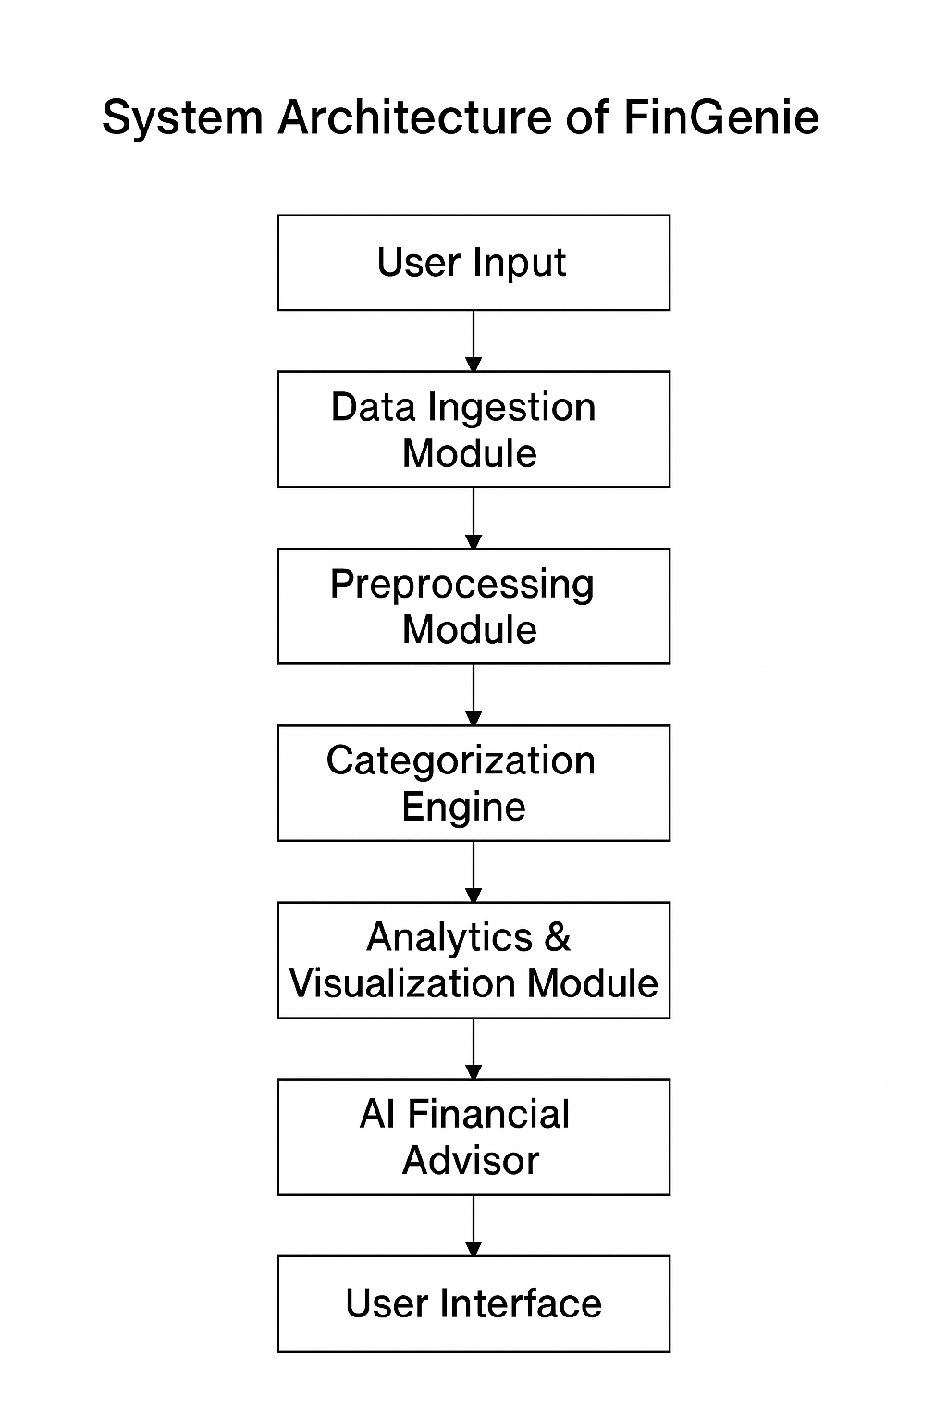
Fig. 1. System Architecture of FinGenie

Methodology
The methodology followed in the design and development of FinGenie consists of several sequential steps:

A. Data Upload and Preprocessing

Users upload their bank statements in CSV format. The system uses Pandas [5] to:
- Convert transaction amounts to numeric format
- Remove missing/invalid entries
- Parse date columns into datetime format
- Separate income and expenses based on amount sign
This preprocessing ensures standardized input for later modules.

B. Transaction Categorization

FinGenie uses a rule-based NLP classifier inspired by Gupta and Saxena [2]. Keywords such as “zomato”, “uber”, “amazon”, “salary” are matched against transaction descriptions to assign categories like:
- Food & Dining
- Transport
- Shopping
- Utilities & Rent
- Investments
- Income
This approach achieves high accuracy for common transaction types and eliminates the need for user-defined labels.

C. Financial Summary Generation

After categorization, the system computes:
- Total spending
- Total income
- Net monthly balance
- Category-wise expenditure
- Monthly spending trend
These metrics form the analytical foundation for visualization and AI recommendations.

D. Visualization

Using Plotly visual tools, the system generates:
- Bar charts for category-wise expenditure
- Line graphs for monthly trends
- KPI-style metrics for income, spending, and balance
This helps users visually understand their spending behaviour.

E. AI Financial Coaching

FinGenie integrates the Groq LLaMA-3.1 model [6] to generate financial advice.
The model receives:
- A structured summary of the user's financial profile
- The user’s query
It responds with personalized, actionable guidance (e.g., “reduce dining expenses,” “set a monthly cap,” “identify recurring charges”).

References
[1] M. L. Putta and P. S. Mohan, “Machine learning-based personal finance management and expense prediction,” IEEE Trans. Comput. Soc. Syst., vol. 7, no. 5, pp. 1248–1258, Oct. 2020.
[2] A. Gupta and R. Saxena, “Automated transaction categorization using natural language processing,” in Proc. 2021 IEEE Int. Conf. on Data Science and Advanced Analytics, Porto, Portugal, Oct. 6–9, 2021, pp. 455–462.
[3] I. Goodfellow, Y. Bengio and A. Courville, Deep Learning, Cambridge, MA, USA: MIT Press, 2016.
[4] Streamlit, “Streamlit documentation,” [Online]. Available: https://streamlit.io/. Accessed on: 27 Nov. 2025.
[5] Pandas Development Team, “Pandas: Python Data Analysis Library,” [Online]. Available: https://pandas.pydata.org/. Accessed on: 27 Nov. 2025.
[6] Groq, “Groq LLaMA-3.1 Instant API Documentation,” [Online]. Available: https://console.groq.com/docs. Accessed on: 27 Nov. 2025.
[7] F. Chollet, “Building deep learning models with Python,” J. Mach. Learn. Res., vol. 18, no. 134, pp. 1–7, 2017.
[8] D. P. Kingma and J. Ba, “Adam: A method for stochastic optimization,” in Proc. 3rd Int. Conf. on Learning Representations (ICLR), San Diego, USA, May 7–9, 2015, pp. 1–15.

