书信格式开头
To whom it may concern,

自我介绍段
- I am [姓名], majoring in [专业名] at the [本科学校全称] ([本科校名缩写]), boasting a GPA of [你的GPA]/[满GPA] and a weighted score of [百分制成绩]/100.
- Beyond my coursework, I have participated in numerous projects and programs, notably [项目成果] in [项目名] at [项目地点].
- I am deeply interested in the [申请专业全称] Master's program at your esteemed university and am eager to apply.

项目经历段1
- I am a person with a strong spirit of [个人品质1].
- In [项目1时间], I took part in [项目1名称] and [项目1内容] with [项目A组员数] other teammates.
- The project features [项目1介绍].
- My key responsibilities were [你的负责内容].
- [细节1].
- [细节1成果].
- [细节2].
- [细节2成果].

项目经历段2
- I am diligent and possess an extensive reservoir of [个人品质2].
- In [项目2时间], [项目2内容].
- [项目2介绍].
- I and another teammate were responsible [你的负责内容].
- [细节1内容].
- [细节2内容].
- [项目2成果].

学习动机段
- I aspire to join your program and am particularly interested in the ‘[你的子分支]’ ([子分支缩写]) track.
- My undergraduate program, with a broad curriculum covering areas like [课程举例], on the one hand, ignited my passion for [子分支缩写]; on the other hand, limited deep specialization in any single area.
- Among many [申请地区] universities, your SE track stands out as the only one that [项目特色1], and uniquely [项目特色2].
- On one hand, [特色1好处].
- On the other hand, [特色2好处],
- providing a beacon of hope for a balanced life amidst a busy future career.

职业目标段
- My career goal is to [职业目标].
- If granted the opportunity to study in this program, I will apply rigorous standards to my academic endeavors, especially in courses related to the [子分支] process and [特色课程] courses.
- I will ensure that my academic performance and course projects will stand as a testament to my strong capabilities in future job applications.
- Beyond the classroom, I am eager to enhance my skills through self-directed online learning and explore practical experiences through summer internships at leading companies during vacations.
- These steps will not only provide practical experience but also enhance my competitiveness in the job market, bridging the gap between academic learning and professional application.

结尾段
Thank you for considering my application. I look forward to the possibility of contributing to and learning from your distinguished program.

书信格式结尾
Yours sincerely,
[你的姓名]

页边距

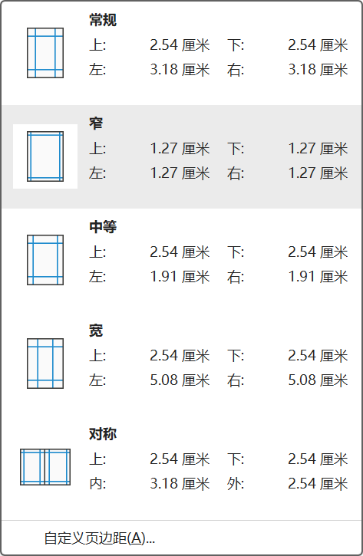
入口：菜单栏 布局 页面设置 页边距 窄
数值：上下左右页边距均为1.27cm
现在的布局就是“窄”，写完动机信后可以增加页边距，但强烈不建议继续缩小页边距。

