





**DOCUMENTATION**

**MEETMINGLER**

## Content

1. Team 2

2. ENCOUNTERED DIFFICULTIES 2

3. Used programs and languages 3

4. Resume 5

5. Idea 5

6. Workflow 5

7. CONCLUSION 5

8. Diagrams showing our database and app structure 6

ER DIAGRAM 6

Sequence DIAGRAM 7

# 1. Team

### Daniil Furnika - [DVFurnika20@codingburgas.bg](mailto:dvfurnika20@codingburgas.bg)

### aLEKSANDAR mANOV – [aemANOV20@CODINGBURGAS.BG](mailto:aemANOV20@CODINGBURGAS.BG)

# 2. ENCOUNTERED DIFFICULTIES

**Thankfully we hardly had any encountered difficulties. Encountered problems & bugs were easily fixed with hard teamwork.**

|  |
| --- |
| Scaling |
| 1-Very Difficult / 10 – Not Difficult |

|  |  |
| --- | --- |
| Communication | 10/10 |
| Teamwork | 10/10 |
| Code | 10/10 |
| Role Distribution | 10/10 |

# Used programs and languages

## C#

For our project, C# powers the backend Web API, handling server-side logic, database operations, and communication between the frontend and backend. Its strong typing and vast library support make it ideal for creating reliable and efficient applications.

## Typescript

TypeScript, a superset of JavaScript, adds static typing and improved development tools to JavaScript. It helps catch errors early and ensures better code maintainability. By using TypeScript, our project benefits from cleaner, more predictable code, especially in complex frontend applications.

## HTML & CSS

* + HTML - is the backbone of the website, structuring its content and defining elements like headings, paragraphs, and forms.
  + CSS - enhances the design by providing styling, colors, layouts, and responsiveness. Together, they create the visual and structural foundation of the user interface.

## Jetbrains Rider

JetBrains Rider is a powerful cross-platform Integrated Development Environment designed for .NET development. It offers rich features such as code analysis, debugging, refactoring, and seamless integration with version control systems. Its speed, intuitive UI, and support for C# make it an excellent choice for developing backend Web APIs.

* **DataGrip**

DataGrip, another JetBrains product, is a robust database management tool. It provides intelligent query suggestions, database schema navigation, and support for various database systems. It simplifies managing, testing, and optimizing database queries, making it an essential tool for backend development.

## Na - Ms Word Png Icon Clipart - Full Size Clipart (#4019240) - PinClipart Word

Microsoft Word or MS Word (often called Word) is a graphical word processing program that users can type with. It is made by the computer company Microsoft. Its purpose is to allow users to type and save documents.

# Resume

MeetMingler is a web application designed for organizing events through a shared calendar. The primary technologies used in the project include C#, TypeScript, JavaScript, CSS, and HTML.

# Idea

The idea behind MeetMingler is to provide users with an easy and efficient way to plan and manage events. By leveraging a shared calendar, users can collaborate and coordinate with each other, ensuring that everyone is on the same page regarding upcoming events and schedules.

# Workflow

Our workflow involves the following steps:

1. Users create an account and log in.
2. Users can create and join different events.
3. Events are displayed on a shared calendar for all participants to view.
4. Users can manage event details, including time, date, and location, and receive notifications about updates or changes.

# CONCLUSION

MeetMingler simplifies the process of event planning and coordination. By using our application, users can ensure that their events are well-organized and efficiently managed, leading to a more streamlined and enjoyable experience for all participants.

# Diagrams showing our database and app structure

# ER DIAGRAM

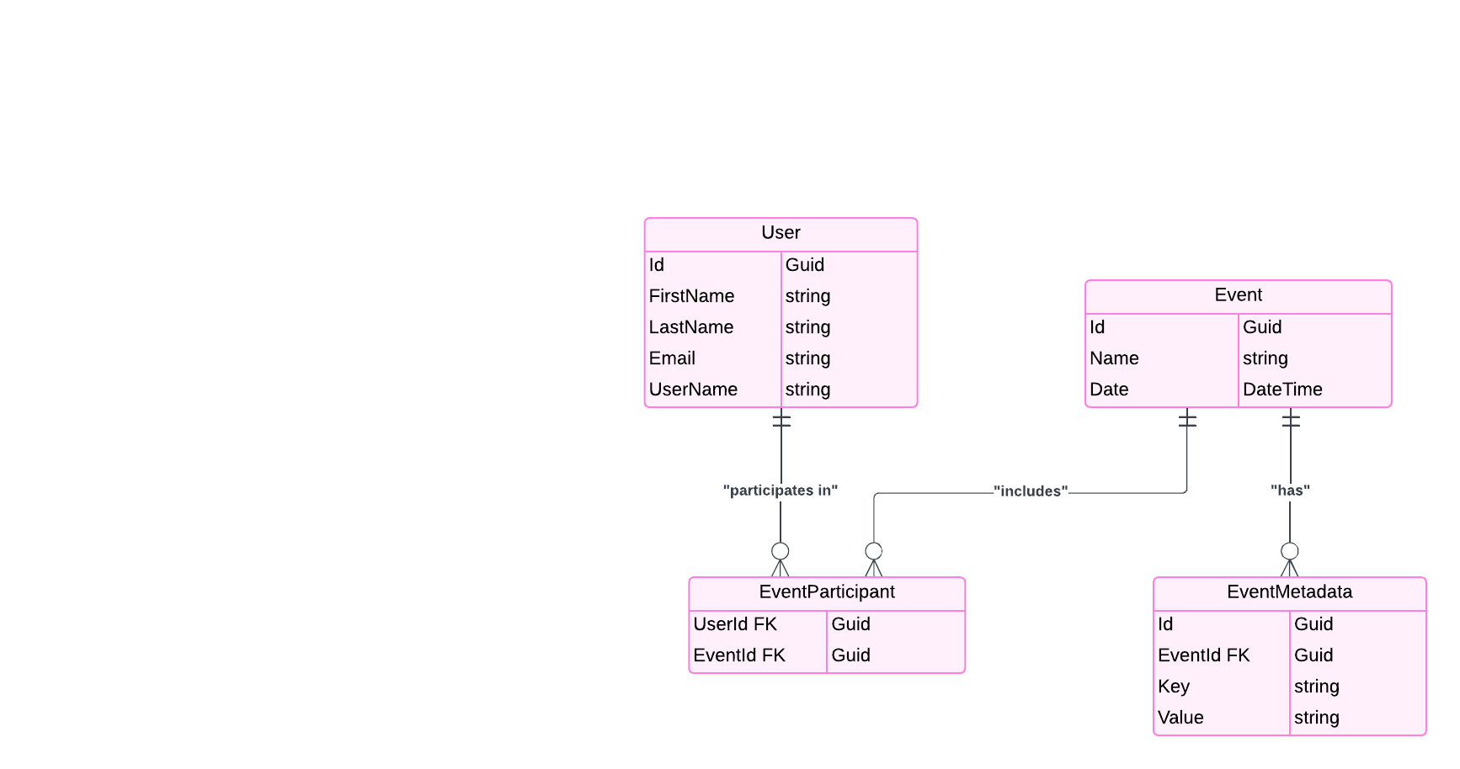

# Sequence DIAGRAM

